Simone Giacomelli, Oleg Borisov and Olivier Chapeau

# Additional document - OMPL Benchmark Results

## Differential Drive Robot with the broken wheel

On the Figure 1, we can see the configuration of the benchmark for the first problem. It is a difficult problem to solve but some algorithms are able to solve it in less than 60 seconds, however as we will see later it is not always the case and sometimes the planners are not able to solve it even with more time.

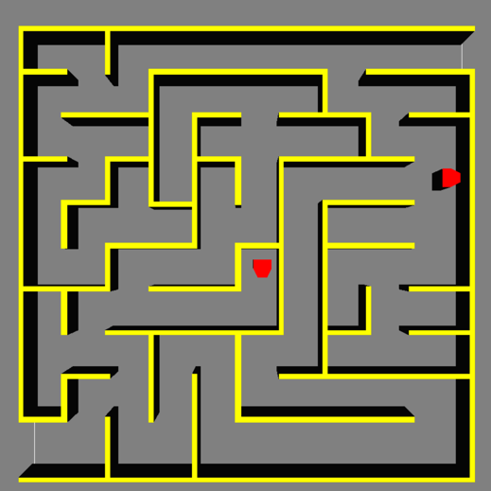

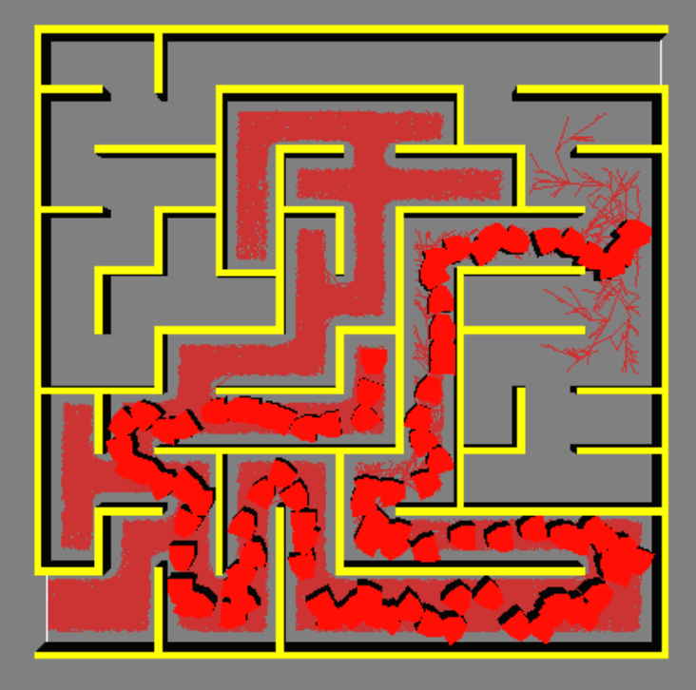

Figure 2 - Problem solved with the RRT algorithm and max time of 60 seconds

Figure 1 - Differential Drive Robot with the broken wheel benchmark configuration

### Results of the benchmark with 60 second

Figure 3 – Planners that solved the problem for 60 seconds

Figure 4 - Time to solve the problem

As we can see on the Figure 3, only the RRT and SST planners where able to solve the problem for 60 seconds. On the other hand we can notice on Figure 4 that RRT and SST solved the problem below 45 seconds, and with around 30000 graph states for SST and 45000 graph states (as we can see on the Figure 5), which is much less than EST and PDST.

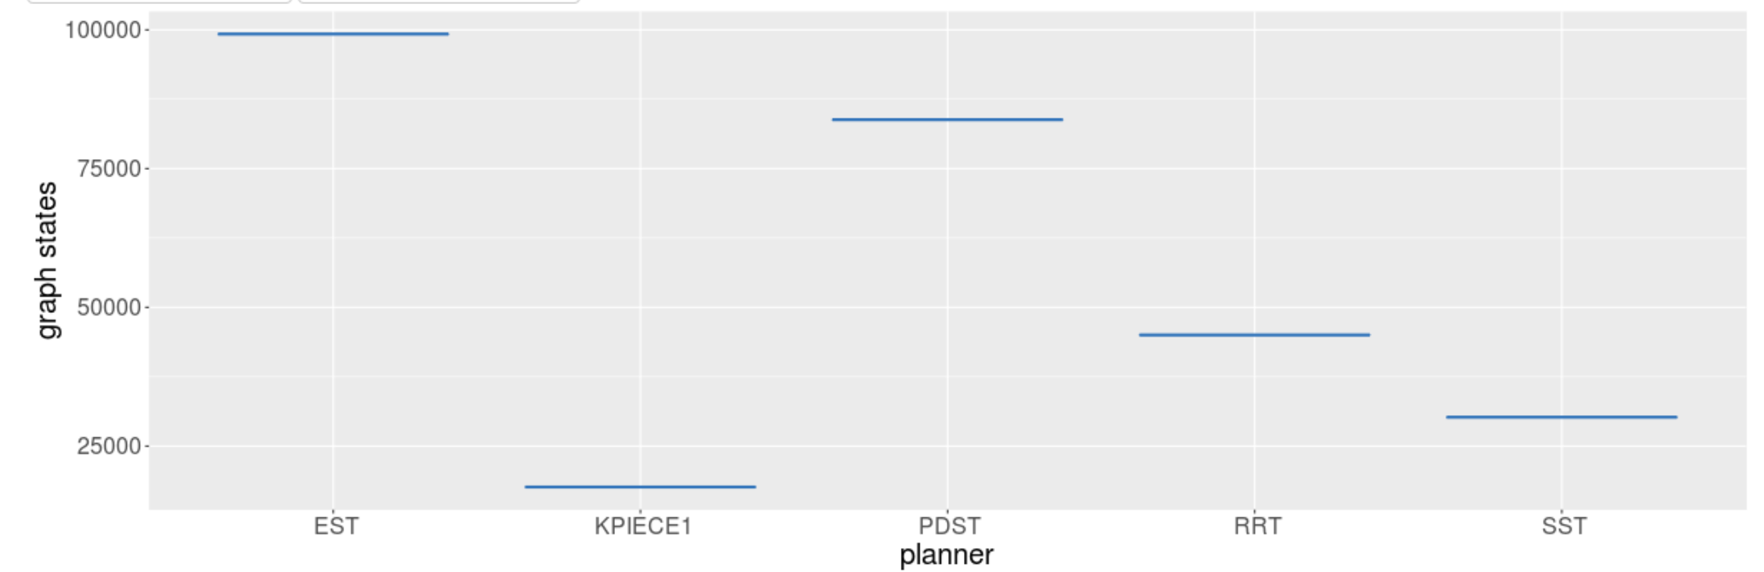

Figure 5 - Graph states

### Results of the benchmark with 120 seconds

For 120 seconds, unexpectedly, no planners were able to solve the task.

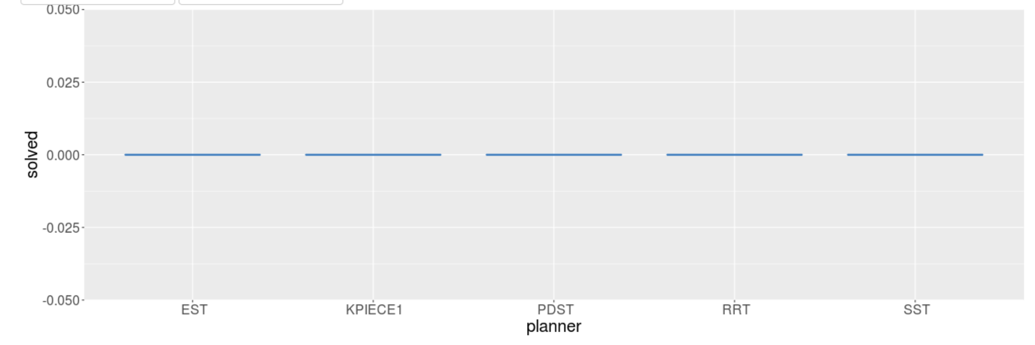

Figure 6 – Planners that solved the problem for 120 seconds