# CSC 340 Software Development Project 1

23 January

Due: 11:59 PM, 8 February 2018

Name: Y M. Liu (Simone)

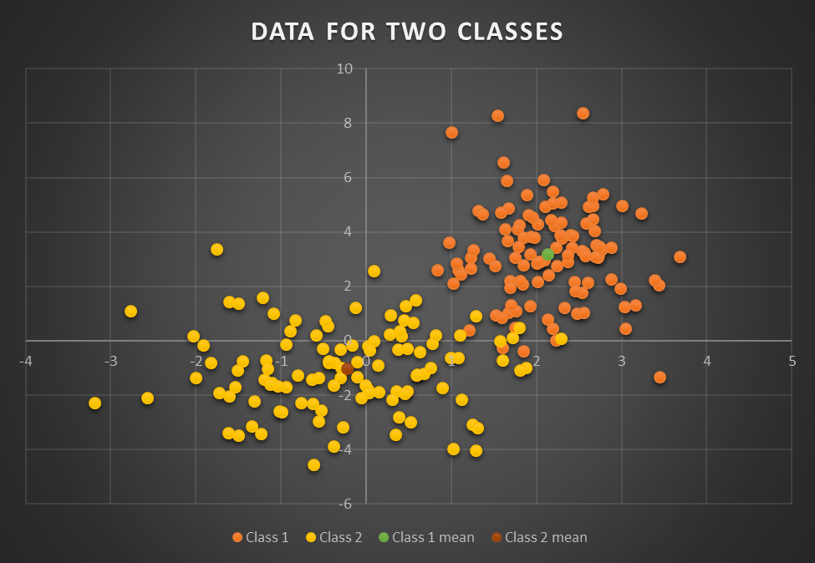

1. Find the *mean* *vectors* **m**1 and **m**2 for each of the classes.

Mean vector **m1** of Class 1:

Mean vector **m2** of Class 2:

1. Find the covariance matrices ****1 and ****2 for the classes.

Covariance matrix **1**of Class 1:   
  
Covariance matrix **2**of Class 2:

1. Find and report the ***determinants***, | ****1| and |** **2|, of the covariance matrices ****1 and ****2 for the classes.

Determinant | ****1| of Class 1: 1.0692535232196974  
  
Determinant | ****2| of Class 2: 2.594915428625533

1. Find and report the ***inverses***, ****1-1 and ****2-1, of the covariance matrices ****1 and ****2 for the classes. WRONG

Inverse matrix ****1-1 of Class 1:   
  
Inverse matrix ****2-1 of Class 2:

1. Find and report the discriminant functions g1(**x**) and g2(**x**) for the classes? Report these with the right-hand side of each equation ***in matrix form***.
2. Into which classes would your classifier place the points **m**1 and **m**2?

|  |  |  |
| --- | --- | --- |
|  | **m1** | **m2** |
| **g1(x)** | -0.7266275621388192 | -12.105113163981919 |
| **g2(x)** | -7.248803117155587 | -1.1699241435408188 |

Point m1 would be in class 1

Point m2 would be in class 2

1. Use your personally implemented matrix manipulation tools to determine how many classification errors occur when you apply the discriminant functions to the example data for each class?
   1. List the ***misclassified*** points separately for each class and provide the values of both discriminant functions g1(**x**) and g2(**x**) for each point (example vector) **x**. (Use a table showing **x**, g1(**x**), and g2(**x**) for each misclassified point **x** to organize this response.)

|  |  |  |  |
| --- | --- | --- | --- |
| **Misclassified points in Class 1** | | | |
| **x1** | **y1** | **g1** | **g2** |
| 1.599019302 | -0.253828327 | -3.226389396112323 | -2.6980421111681485 |
| 1.205375881 | 0.398881465 | -3.3900441122950125 | -2.4473380149251636 |

|  |  |  |  |
| --- | --- | --- | --- |
| **Misclassified points in Class 2** | | | |
| **x2** | **y2** | **g1** | **g2** |
| 1.799171771 | 0.473503489 | -2.171801989153329 | -3.3538105841698536 |
| 2.287938993 | 0.076076615 | -2.3530199249865733 | -4.085551828762768 |
| 1.289376169 | 0.909520062 | -2.7038259859394342 | -2.912779780601433 |
| 1.716910758 | 0.110969495 | -2.6345884139607496 | -3.02245941248818 |

* 1. Summarize your findings by presenting a table of the tallies of correctly and incorrectly classified items. The table should contain one row and one column for each class. In the table, the entry in row j and column k should report the number of objects in class j that the classifier indicates would be in class k.)
     1. How many examples are correctly identified for each class?

**Class 1** has **108** correctly identified points

**Class 2** has **106** correctly identified points

* + 1. How many examples are incorrectly identified for each class?

**Class 1** has **2** incorrectly identified points

**Class 2** has **4** incorrectly identified points

1. Estimate and plot the boundary contour generated by the classifier.
2. Linear systems:
   1. If one a solution exists, use your implementation of Gauss-Jordan Elimination Algorithm to ***estimate the*** ***solution*** for the following linear system:

**Matrix A8x8: 2.0 1.0 -1.0 -1.0 1.0 0.0 -1.0 -1.0 Matrix b: 1.0**

**1.0 0.0 2.0 0.0 -1.0 -2.0 2.0 2.0 -1.0**

**0.0 -2.0 5.0 4.0 -1.0 0.0 3.0 1.0 2.0**

**1.0 1.0 -7.0 3.0 2.0 1.0 -1.0 0.0 -2.0**

**1.0 1.0 2.0 3.0 -2.0 2.0 2.0 9.0 3.0**

**0.0 -3.0 -2.0 2.0 0.0 2.0 4.0 -5.0 -3.0**

**-2.0 5.0 -1.0 1.0 1.0 3.0 0.0 -2.0 4.0**

**1.0 0.0 1.0 1.0 0.0 2.0 1.0 1.0 -4.0**

Please supply your response with the variables in the order [x, y, z, w, a, b, c, d].

|  |  |
| --- | --- |
| x | 5.042759555717787 |
| y | 3.8362621890806685 |
| z | -1.145851801637378 |
| w | 5.52291807894874 |
| a | -21.40251342754341 |
| b | -0.28101371434530775 |
| c | -7.617301976325806 |
| d | -5.240496428012723 |

* 1. What is the determinant of the coefficient matrix A?

= 19177.000000000004

* 1. If they exist, what are
     1. 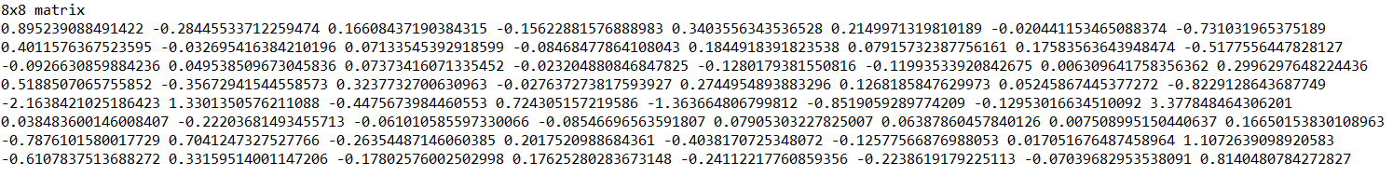The inverse of the coefficient matrix A-1,
     2. The determinant of A-1

= 5.2145799655837684E-5

* + 1. The product of the determinants of A and A-1?   
       0.9999999999999994 1
  1. If A-1 exists, check your system solution results by performing the appropriate matrix multiplication and reporting the results.

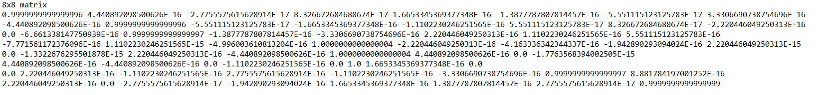

1. If it exists, what is the ***condition number*** for the coefficient matrix for the system given in problem 9?

**Condition number**: 228.55357980914638