PROPOSTA DI GRANT GIOVANI IN CSN5 - Anno 2026

Acronym: | PRISM
Full title: | Precision Room-temperature Instrumentation for high-energy x-ray absorption Spectroscopy Measurements
Applicant: | Simone Manti
Participating units: | INFN Sezione di Frascati

Abstract (2000 caratteri)
X-ray absorption spectroscopy (XAS) is a versatile element-selective technique for probing the electronic and atomic structure of materials. While synchrotron and XFEL facilities provide outstanding performance, their limited accessibility motivates the development of advanced laboratory XAS instrumentation. A current challenge is extending XAS in fluorescence mode beyond 20 keV, where silicon detectors lose efficiency and germanium detectors require cryogenic operation. This limits access to the K-edges of technologically relevant elements such as Mo, Pd, Ag and Sn, which are widely studied in catalysis, electrochemistry, advanced alloys and energy materials. PRISM will develop a high-resolution laboratory hard X-ray spectrometer combining a monochromator crystal with a multichannel cadmium zinc telluride (CZT) detector for precision fluorescence-mode XAS up to 50 keV. Building on my expertise in crystal-based X-ray spectroscopy gained within the VOXES project and SIDDHARTA-2 experiment, PRISM will develop detector architectures, low-noise front-end electronics, calibration procedures and spectral reconstruction algorithms to achieve energy resolution for CZT ≤2% at 22.2 keV and excellent SNR performance at room temperature. The instrument will be validated through fluorescence XAS measurements on reference materials with K-edges above 20 keV, demonstrating accurate edge reconstruction and XANES spectra within laboratory-compatible acquisition times. Once validated, the platform will enable extended in-situ and operando studies of slowly evolving catalytic, electrochemical and energy-related processes. Beyond this proof of concept, PRISM will establish a new detector platform for next-generation laboratory hard X-ray spectroscopy, strengthening INFN expertise in semiconductor radiation detectors, precision X-ray instrumentation and crystal spectroscopy, while providing a complementary laboratory capability to synchrotron and XFEL facilities.
1 State of the art (4000 caratteri) 1
2 Goals and Expected Outcome (2000 caratteri) 2
3 Methodology (10000 caratteri) 2
4 Organisation (4000 caratteri) 6
5 Synergies with Other Activities (3000 caratteri) 7
6 Impact and Spin-offs (3000 caratteri) 8
7 Costs 9
8 Risk Assessment 9
9 References 11

1 State of the art (4000 caratteri)
A central challenge in radiation-detector development is enabling in-situ and operando characterization under realistic conditions. This requires non-destructive, element- and bulk-sensitive measurements of weak signals from thick, heterogeneous or dilute samples, often over long acquisition campaigns [1,2].
X-rays are particularly suited for such investigations because of their high penetration depth relative to other optical techniques, enabling access to the bulk of samples [3]. Among X-ray techniques, X-ray absorption spectroscopy (XAS) directly probes absorption across an element-specific absorption edge [4]. The near-edge region (XANES) is sensitive to oxidation state, electronic structure and coordination geometry, whereas the extended region up to 1 keV above the edge (EXAFS) provides quantitative information on the local atomic environment. XAS can be measured in transmission, from beam attenuation through the sample, or in fluorescence, from the emitted characteristic X-rays. Fluorescence detection is particularly suited to dilute, thick or geometrically constrained samples for which transmission is impractical [5].
Synchrotron facilities are the reference platforms for XAS, as their high brilliance, broad energy tunability and dedicated beamlines enable high-quality spectra with excellent signal-to-noise ratio (SNR) over a wide energy range [6]. However, access to these large-scale facilities is limited and competitive, and the allocated beamtime is often unsuitable for routine characterization, long experimental campaigns, or studies involving hazardous and radioactive samples [7]. These limitations have driven renewed interest in laboratory XAS systems based on conventional X-ray sources [8]. Although laboratory sources provide lower brilliance than synchrotrons, they offer continuous access, flexible sample handling and long measurement times, making them attractive for routine analysis, method development and slowly evolving in-situ or operando processes [9].
Recent advances in source brightness, monochromator crystals and detection technology have enabled an increasing number of XAS and XES measurements to be transferred back to the laboratory [10,11]. Commercial laboratory XAS systems are now available (e.g. Rigaku, Sigray, easyXAFS), confirming the maturity and industrial relevance of the field, although their architecture and substantial cost limit flexibility for customized fluorescence measurements. The VOXES spectrometer [12,13], developed at INFN-LNF from 2015 with a Young Researcher Grant of CSN5, has established expertise in high-resolution von Hamos spectroscopy for extended and dilute X-ray sources. The instrument currently operates mainly in the 5–20 keV range and has recently been upgraded with motorized positioning, energy-dispersive monitoring and mechanical compatibility with transmission XAS measurements [14].
Despite this progress, laboratory fluorescence-XAS above approximately 20 keV remains challenging [15], although this range includes many technologically relevant K-edges of Mo, Pd, Ag and Sn, whose lower-energy L lines are too closely spaced [16]. Silicon-based detectors progressively lose absorption efficiency in the hard-X-ray range, whereas high-purity germanium detectors offer excellent spectroscopic performance but require cryogenic cooling. High-Z compound semiconductors such as CdTe and CdZnTe instead provide high hard-X-ray absorption efficiency and room-temperature operation. Although CZT detectors have been developed for synchrotron, imaging and high-flux applications, their integration into multichannel, energy-resolving laboratory fluorescence-XAS systems remains largely unexplored [17,18]. (Non è molto chiaro il collegamento con VOXES qua...che c’entra? Sono cose molto diverse….)
Addressing this gap requires the development of a dedicated detector system integrating segmented CZT sensors, low-noise electronics, waveform-based reconstruction and high-resolution crystal optics. Such a platform would extend laboratory fluorescence-XAS beyond 20 keV while establishing reusable INFN expertise in hard-X-ray detection and spectroscopy.

2 Goals and Expected Outcome (2000 caratteri)
The main goal of the project is to develop and validate a room-temperature laboratory platform for fluorescence-mode X-ray absorption spectroscopy (f-XAS) above 20 keV, based on a high-resolution monochromator crystal and a custom multichannel CZT detector. The X-ray source, crystal optics, sample geometry, detector, electronics, data acquisition, and simulations will be optimized as an integrated measurement chain for quantitative XANES measurements on samples that are unsuitable for transmission because of their thickness, dilution, or geometry.
The project is organized into three goals (G) and corresponding expected outcomes (EO):
G1: Design, construct and validate the complete XAS instrument in fluorescence mode through end-to-end simulations.
EO1: A commissioned laboratory setup with a frozen source–optics–sample–detector geometry, supported by a validated simulation framework. At the Ag K-edge, predicted and measured count rates will agree within 20%, while spot size and incident-energy resolution will agree within 10%. (Solo?)
G2: Develop and characterize a room-temperature multichannel CZT detection system.
EO2: A calibrated CZT detector with intrinsic efficiency above 90% at 50 keV, energy resolution at the ≤2% level at 25.5 keV, and dead time below 10% at the selected operating rate.
G3: Demonstrate quantitative XANES measurements above 20 keV using the Ag K-edge as benchmark.
EO3: Ag K-edge XANES spectra will be acquired for a metallic Ag reference and for two oxidized Ag compounds with different oxidation states. The measurements will achieve an incident-energy resolution of 10 eV FWHM or better, edge-position reproducibility within 1 eV, an edge-step SNR of at least 20, and an acquisition time below 12 h per spectrum.
Anche qui secondo me si vede male il collegamento tra VOXES e i CZT. Forse serve un paragrafetto iniziale?

3 Methodology (10000 caratteri)

XAS in the laboratory

XAS measures the energy dependence of the linear absorption coefficient, μ(E), across an element-specific core-level absorption edge (see Figure 1). When the incident photon energy reaches the binding energy of a core electron, the absorption probability rises sharply and the resulting photoelectron probes both the unoccupied electronic states and the surrounding atomic structure. The near-edge region (XANES) is sensitive to oxidation state, orbital occupancy and local symmetry, whereas the oscillations above the edge (EXAFS) provide information on coordination numbers, interatomic distances and structural disorder. Laboratory XAS becomes increasingly demanding at hard-X-ray energies because the usable flux from conventional sources decreases and EXAFS requires accurate measurements over a broad energy interval. PRISM will use the Ag K-edge at 25.5 keV as its benchmark, first establishing a robust XANES protocol and then quantifying the EXAFS range achievable within laboratory-compatible acquisition times.
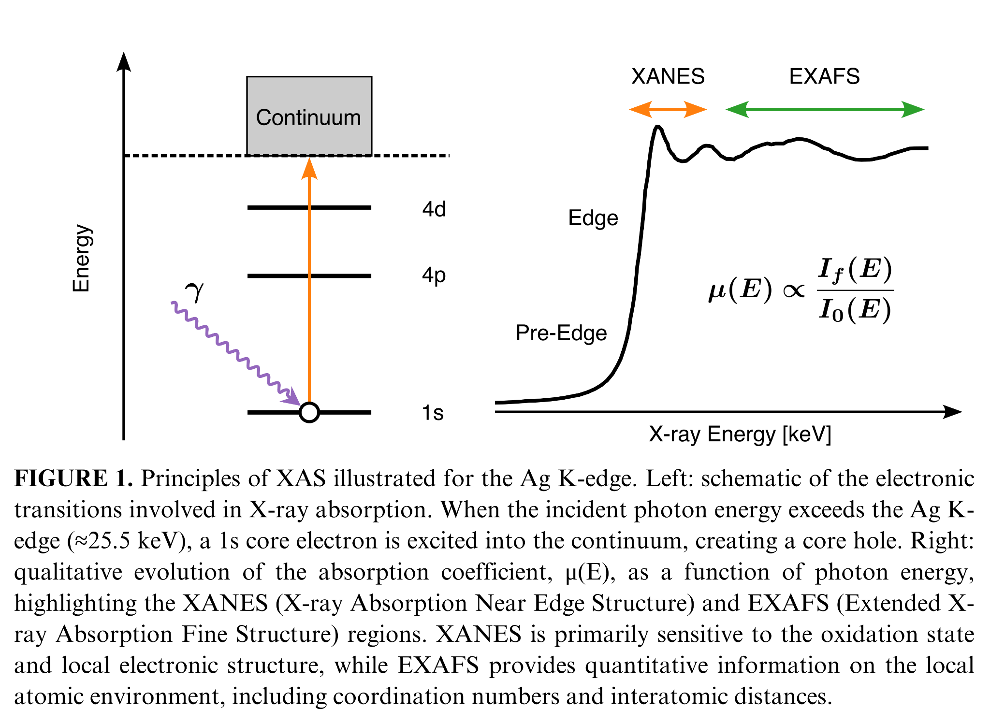
The absorption coefficient μ(E) can be acquired in transmission or fluorescence mode. In a dispersive transmission arrangement, such as that being explored with VOXES, the broad source spectrum passes through the sample and a monochromator crystal spatially separates the transmitted energies onto a position-sensitive detector. Comparison of the spectra acquired with (I) and without (I₀) the sample provides μ(E). This approach is efficient but requires a homogeneous sample with an appropriate transmission thickness. PRISM will instead operate primarily in fluorescence mode. A crystal placed before the sample will select and focus one incident energy at a time, while an energy-resolving detector positioned approximately perpendicular to the incident beam will measure the characteristic fluorescence emitted following core-hole creation. For the Ag K-edge (see Figure 1), I_{f}(E) will be extracted from the Ag Kα line complex at approximately 22.2 keV. This geometry extends XAS to thick, dilute, heterogeneous or geometrically constrained samples that are impractical in transmission. In the thin or dilute limit, after background, live-time and detector-response corrections, the absorption spectrum is proportional to the ratio μ(E) ∝ I_{f}(E) / I₀(E) where I₀(E) is the incident monochromatic intensity. E come ci vai sopra i 20 keV? Hai detto prima che VOXES è limitato...
The incident energy, impinging on the sample, will be selected from the X-ray-tube continuum by Bragg diffraction on a cylindrically bent germanium crystal (ECCO!!! Ma devi sottolineare che questa è la novità che ti permette di salire in energia!) in a VOXES-derived von Hamos geometry. The rotation will be coordinated with the axis motors so that the source–crystal–sample geometry and the position of the focused spot are maintained throughout the scan. At each energy set point, a complete fluorescence spectrum will be acquired for a defined dwell time, and I_{f}(E) will be obtained by fitting or integrating the selected fluorescence line after local-background subtraction. Finer energy steps will be used around the edge and coarser steps in the extended region, while the dwell time will be adapted to the predicted count rate and target statistical uncertainty.
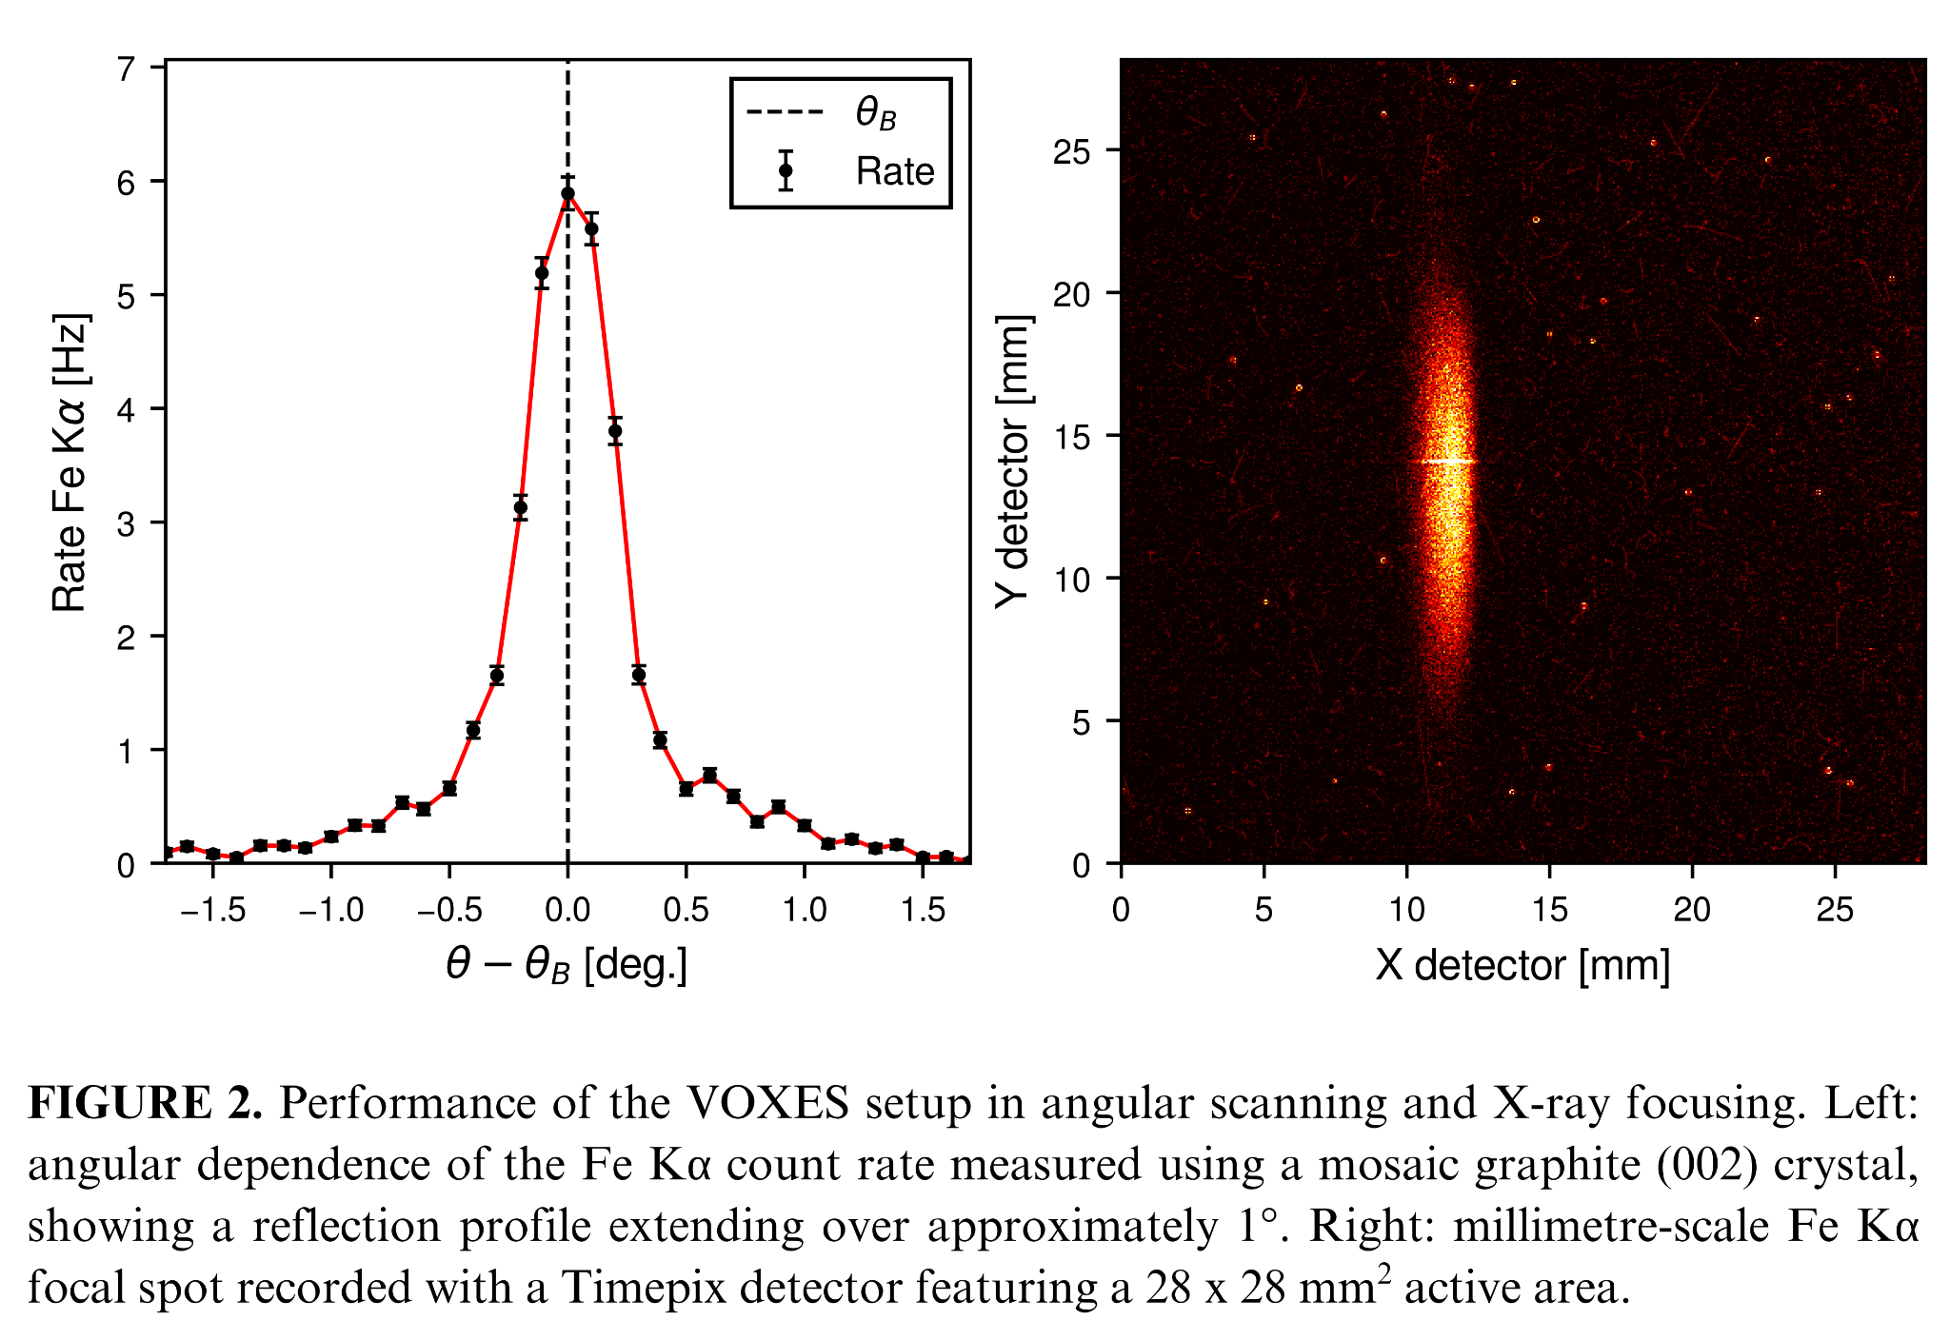The feasibility of the required angular scan and focusing is supported by the existing VOXES experience. For instance, Figure 2 (left) shows the measured Fe Kα rate on the position-sensitive detector as the crystal is rotated through its nominal Bragg angle, demonstrating a controlled Bragg-angle scan. In Figure 2 (right), the same Fe Kα line is shown on a two-dimensional detector, exhibiting millimetric size spot. Although these measurements were performed in an X-ray-emission configuration and do not themselves constitute XAS, they validate two essential instrumental functions for PRISM: precise crystal rotation for energy selection and spatial focusing with a bent crystal. The project will build on this expertise, the available VOXES components and in-kind contributions, specifically the two slits to collimate the flux after the source, existing crystal rotation and translation stages, and the shielded laboratory infrastructure at LNF. Da qualche parte secondo me serve una frase tipo “VOXES is a INFN-branded and in-house developed technology, on wich this project will build on”.

CZT detector and signal reconstruction

To overcome the declining efficiency of silicon detectors above 20 keV and the cryogenic requirements of germanium, PRISM will develop a custom multichannel CZT detector optimized for laboratory fluorescence-XAS in the 20–50 keV range. The design will build on the experience gained within SIDDHARTA (? e chi è? Un tuo amico? Non ne hai mai parlato prima. E qui non ne parlerei proprio….al massimo KAONNIS&VIP), where CZT detectors were tested at the DAΦNE collider under high-flux conditions [19–22].
The baseline CZT detector will consist of a monolithic 2-mm-thick CZT crystal segmented into a 20-pixel linear array with a 500 μm pitch, common cathode and surrounding guard ring [23]. This geometry will increase the active area and collected solid angle, while distributing the fluorescence rate among independent channels to reduce pile-up and enable channel-resolved background monitoring. Each pixel will be coupled to a dedicated low-noise preamplifier. The system will be characterized in terms of efficiency, energy resolution, gain linearity and stability, dead time, rate capability and channel-to-channel uniformity.
Waveforms will be digitized using a 64-channel, 16-bit, 125 MS/s acquisition platform. Although the detector requires 20 primary channels, the larger channel capacity will accommodate guard-ring, synchronization and diagnostic signals, provide margin for future detector expansion, and allow the reuse of an existing firmware and acquisition framework, thereby reducing integration time and technical risk. A detector-response simulation will couple GEANT4 energy-deposition calculations to electric-field and weighting-potential models. Charge transport will then be simulated to generate channel-resolved current pulses including trapping, incomplete charge collection and charge sharing between adjacent pixels. After convolution with the measured front-end response and addition of realistic electronic noise, the synthetic waveforms will be used to develop and validate the reconstruction algorithms. Waveform processing will provide baseline correction, pulse-amplitude estimation, timing extraction and channel equalization. Conventional pulse-shape observables and machine-learning classifiers, adapted from experience with germanium detectors [24] and ongoing (?) CZT tests at the LNF Beam Test Facility [25] (see Figure 3), will be compared for identifying pile-up, saturation, electronic disturbances and distorted pulses, and for correcting charge-sharing and incomplete-charge-collection events.
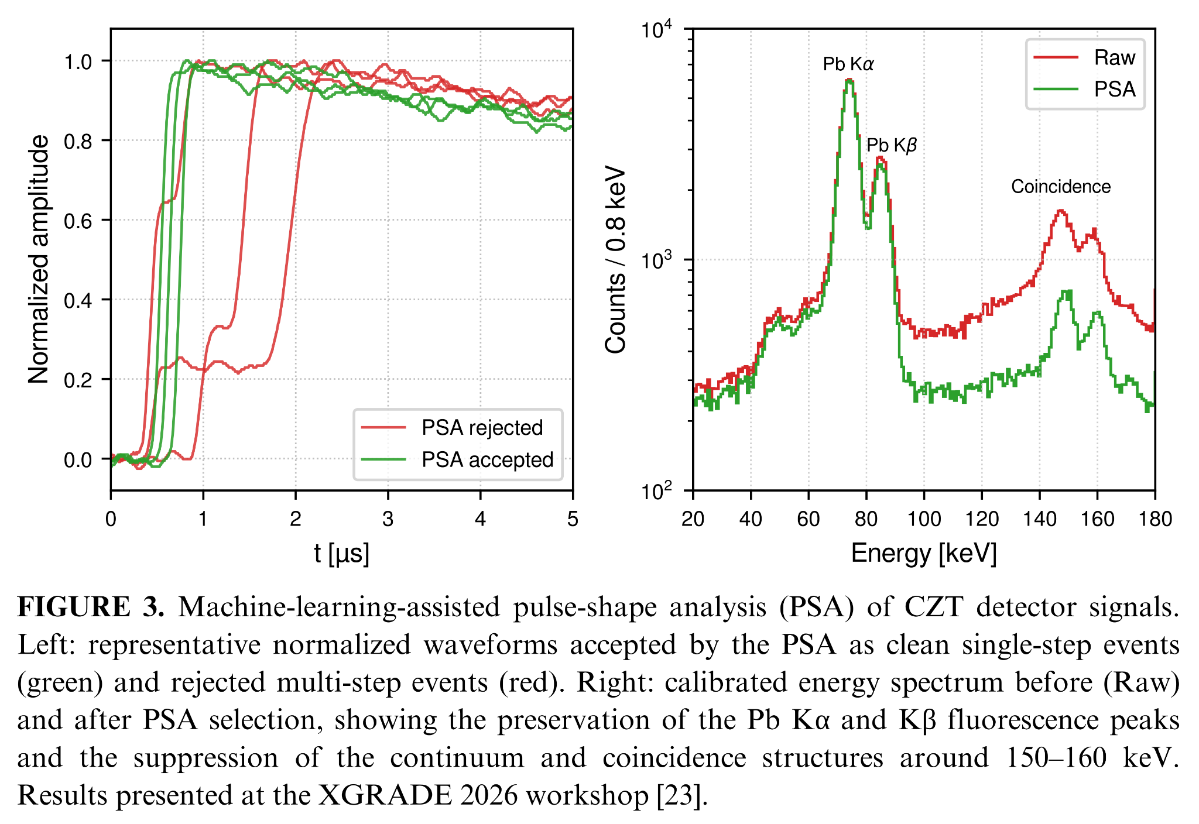
The same CZT detector head will measure both the fluorescence signal I_{f}(E) and the incident intensity I₀(E) through a motorized exchange system. The CZT head and sample holder will each be mounted on independent rotation stages, while a long-travel linear axis will alternate the sample and detector between the two configurations. For I_{f}(E), the sample will be placed at the monochromatic focus and observed by the CZT array at approximately 90∘; for I₀(E), the sample will be translated out and the detector rotated and repositioned into the attenuated direct beam. Calibrated attenuators, shorter dwell times and, when required, reduced tube current or slit aperture will keep the direct-beam rate within the validated linear operating range.

Source to sample simulation
To identify the optimal instrument configuration within the available project budget, PRISM will develop an end-to-end, source-to-detector simulation of the entire spectrometer. The Ag K-edge at approximately 25.5 keV will be used as the reference case for defining the XANES measurement protocol and the required performance in terms of energy resolution, photon flux, SNR and acquisition time. The simulation workflow will consist of two coupled stages. First, SHADOW4 [26] ray-tracing simulations building on the approach previously validated for the VOXES spectrometer [27], which will model photon transport from the X-ray tube through the collimating slits and crystal optics to the sample. Different germanium-based crystal reflections will be investigated in the VOXES-type von Hamos geometry, with the Ge(880) considered as the baseline candidate for measurements around the Ag K-edge [15]. Parametric studies will optimize the crystal material, reflection, curvature radius, dimensions, source–crystal and crystal–sample distances, slit apertures and Bragg geometry. The simulations will quantify the geometrical acceptance, energy bandwidth, photon flux, beam profile and illuminated spot size at the sample, while also evaluating alignment and mechanical tolerances. The SHADOW4 output will then be transferred to GEANT4, which will simulate photon absorption in the sample, fluorescence emission, self-absorption, elastic and inelastic scattering, background contributions and energy deposition in the multichannel CZT detector. The combined simulations will be used in the first months of the project to optimize the source, crystal optics, slit system, sample geometry and detector configuration, balancing count rate, spectral resolution and background rejection. A coordinated motorized scanning scheme will also be defined to vary the incident energy across the Ag K-edge while maintaining the required source–crystal–sample geometry. The final outcome of this activity will be a design freeze specifying the X-ray source, crystal type and dimensions, curvature radius, distances, slit apertures, sample position, CZT geometry, motion stages and required positioning accuracy. A proposed layout of the setup for PRISM is shown in Figure 4, highlighting (not to scale) all the components from the source, the slit system, crystal, sample and the custom CZT detector.
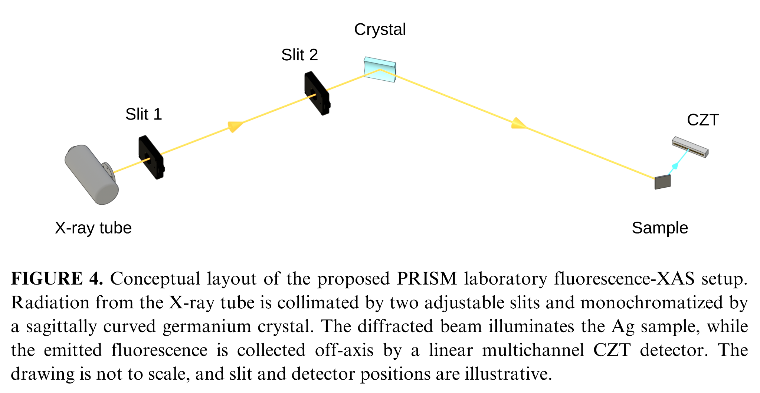

4 Organisation (4000 caratteri)
The PRISM project will have the following organization:

Name | Unit | FTE | Responsibility/WP
Simone Manti | INFN, Section of Frascati | 1.0 | Scientific Coordinator; overall coordination; WP1–WP4
Alessandro Scordo | INFN, Section of Frascati | 0.3 | Crystal optics, ray tracing, integration; WP1/WP3
Massimiliano Bazzi | INFN, Section of Frascati | 0.3 | Electronics/DAQ; WP2
Catalina Curceanu | INFN, Section of Frascati | 0.1 | Scientific review and application validation (Ma te l’ha detto lei????) Mi sembra poco sensato; WP4
Total |  | 1.7 | -

It will be divided into the following Work Packages (WP):

- WP1 – Requirements, simulations and design freeze (M1–M6): The experimental requirements will be defined using an end-to-end SHADOW4–GEANT4 simulation workflow covering the X-ray source, crystal optics, sample and CZT detector. The resulting specifications will establish the final instrument layout and procurement requirements. Dr. Alessandro Scordo will contribute his expertise in crystal optics, ray tracing and VOXES-based spectrometer design.
- WP2 – CZT, front-end, DAQ, calibration and characterization (M4–M15): A multichannel CZT detector and its dedicated low-noise front-end electronics and waveform-recording DAQ will be designed and developed. Channel-by-channel calibration, gain equalization, efficiency measurements and characterization of energy resolution, stability, dead time and pile-up will be performed. Pulse-reconstruction and pulse-shape-analysis methods will be implemented to improve spectral quality and reject distorted events. Massimiliano Bazzi will support the development and validation of the electronics and DAQ chain.
- WP3 – Procurement, mechanics, integration and commissioning (M10–M18): Following the design freeze, the X-ray source, crystal optics, motion stages, slits and mechanical components will be procured and subjected to acceptance tests. The source, monochromator, sample positioning system and CZT detector will then be mechanically and electronically integrated. Commissioning will include alignment, synchronized energy scanning, control-system validation and comparison of the measured flux, spot size and energy resolution with the simulation predictions.
- WP4 – Ag reference samples and realistic sample demonstration (M16–M24): The complete instrument will first be validated through Ag-foil measurements and Ag reference compounds representing different chemical states. Quantitative XANES performance will be assessed in terms of energy calibration, reproducibility, signal-to-noise ratio and agreement with reference spectra. Fluorescence-XAS will subsequently be demonstrated on a realistic thick, diluted or heterogeneous sample, and the accessible operating domain will be mapped. Alessandro Scordo will support the measurements, crystal-optics optimization and interpretation of the experimental results.
The project Milestones (MS) are:
- MS1 – Instrument design frozen (M6). Experimental requirements, complete source–optics–sample–detector geometry and procurement specifications approved.
- MS2 – CZT detection chain validated (M15). Intrinsic efficiency above 90% at 50 keV, energy resolution ≤2% at 25.5 keV, dead time below 10% and residual pile-up below 5% at the selected operating rate.
- MS3 – Integrated instrument commissioned (M18). Synchronized scanning and energy calibration operational; measured rate within 20%, and spot size and energy resolution within 10% of simulation predictions.
- MS4 – Fluorescence XAS capability demonstrated (M24). Ag K-edge XANES obtained with SNR ≥ 20 and edge-position reproducibility within 1 eV; two chemical states discriminated in a realistic sample with a significance of at least 3σ; operating domain documented.
The Work Packages and the Milestones are summarized in the Gantt table in Figure 5:
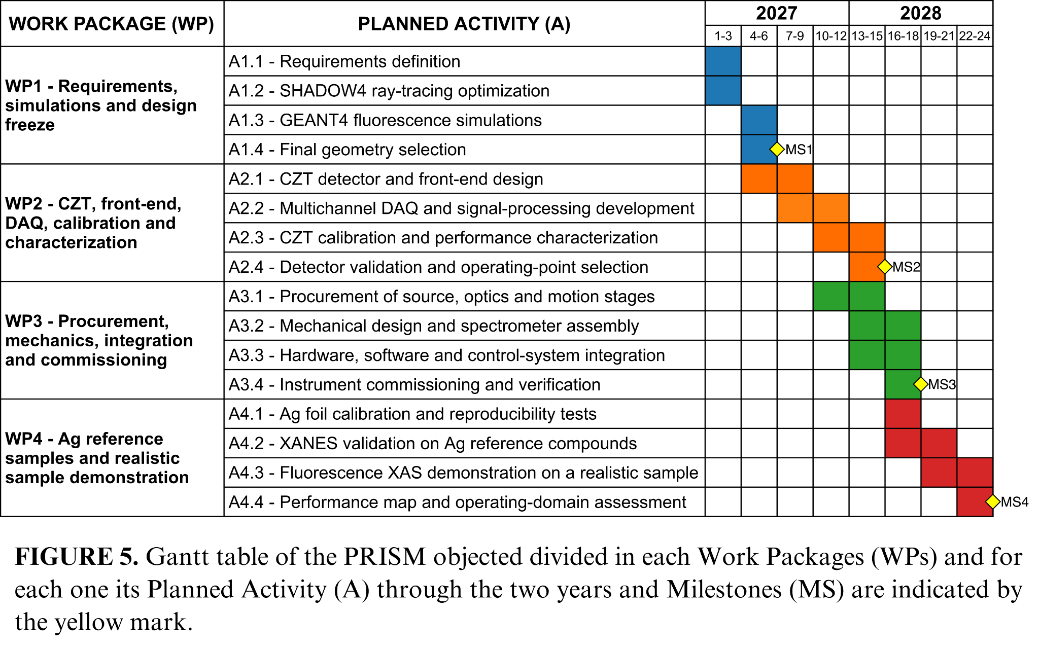

The project Deliverables (D) are:

- D1 – Validated SHADOW4–GEANT4 workflow, frozen instrument design and procurement specifications (M6).
- D2 – CZT calibration and performance-characterization dataset with acceptance report (M15).
- D3 – Ag foil and reference-compound XANES dataset with quantitative validation report (M21).
- D4 – Realistic-sample dataset, operating-domain assessment, documented analysis tools and final project report (M24).

5 Synergies with Other Activities (3000 caratteri)
The PRISM project will establish extensive synergies with various external projects, institutions and
companies.

Other INFN Scientific Committees

- CSN3: PRISM has direct synergies with KAONNIS, building on the experience gained with CZT detectors in the SIDDHARTA experiment at DAΦNE. Additional synergies are expected with the VIP experiment at LNGS, which faces similar challenges in the detection of weak X-ray fluorescence lines above 20 keV [28] and employs related pulse shape analysis techniques [24].
- CSN5: The strongest connection is with VOXES, a former CSN5 Young Researchers project whose expertise in crystal-based X-ray spectroscopy, instrumentation and data analysis provides the technological foundation for PRISM. VOXES will contribute existing equipment and laboratory infrastructure in kind, including facilities for testing and calibration with laboratory X-ray sources. Further synergies are foreseen with SPHINX, particularly in precision angular scanning, optical alignment and the integration of X-ray optics and detectors.
- EuPRAXIA: Future synergies are expected with EuAPS and the AQUA beamline, both targeting XAS measurements in different photon-energy ranges. Developing laboratory-based XAS methods within PRISM will provide complementary expertise, instrumentation and procedures useful for preparing and optimizing future experiments at these facilities.

External institutions and national and international research laboratories

- University of Palermo: PRISM will benefit from the established collaboration with the University of Palermo in the development and testing of CZT detectors within the SIDDHARTA experiment. This synergy will support the optimization of the detector geometry, front-end electronics, calibration procedures and signal-reconstruction methods.
- ENRICH COST Action: PRISM is strongly aligned with the ENRICH COST Action, which promotes a European network for radiation-detection research and its applications to societal challenges. Within this network, the applicant is co-leader of the Working Group on Simulation. A particularly relevant connection is with Manuel Sánchez del Río, leader of the Working Group and principal developer of SHADOW4, the ray-tracing software that will be used to optimize the crystal optics and spectrometer geometry.
- DRESS – (Senti Leonardo/Catalina)

Industry and Private Sector
The following companies have provided letters of support for PRISM, confirming industrial interest in the proposed instrumentation and its technology-transfer potential.
- Due2Lab: Due2Lab will contribute expertise in CZT crystal production and detector integration, strengthening the feasibility and scalability of the multichannel system.
- Rigaku: Rigaku will provide an industrial benchmark for laboratory XAS and support the selection of X-ray sources, optics, and key components.

6 Impact and Spin-offs (3000 caratteri)
PRISM will establish at INFN-LNF a validated laboratory capability for quantitative fluorescence-XAS above 20 keV based on room-temperature multichannel detection. By combining crystal optics, CZT sensors, low-noise electronics and DAQ with SHADOW4-GEANT4 modelling, PRISM will address a regime where efficient non-cryogenic laboratory spectroscopy remains challenging.
For the INFN community, the impact will extend beyond a single instrument. PRISM will valorize the existing VOXES infrastructure and consolidate LNF expertise in semiconductor radiation detectors, precision X-ray spectroscopy, radiation transport and spectral reconstruction. Its modular CZT detection and readout chain, validated source-to-detector models, calibration protocols and performance maps will be reusable by other INFN activities developing hard-X-ray instrumentation. The project will establish a transferable route from predictive simulation and subsystem tests to quantitative validation of an integrated instrument. After laboratory validation, its design rules may inform future facilities such as EuAPS. PRISM will also train young researchers and technical staff across optics, detectors, electronics, simulation and data analysis.
For the wider scientific community, PRISM will expand laboratory access to fluorescence-XAS at the K-edges of technologically relevant elements such as Mo, Pd, Ag and Sn. If its quantitative targets are met, the platform will support sample screening, method development, cell optimization and long in-situ or operando studies of thick, dilute and heterogeneous specimens that are difficult to investigate in transmission. PRISM will complement, not replace, synchrotrons and XFELs: preliminary measurements and protocol optimization can make scarce beamtime more effective, while repeated scans and slowly evolving processes can remain in the laboratory. Beneficiaries include catalysis, electrochemistry, energy materials and advanced alloys. Documented workflows, reference datasets and operating-domain maps will improve reproducibility and help other laboratories assess the approach.
The main technology-transfer opportunities are the modular room-temperature CZT detector, front-end and multichannel DAQ chain; its calibration and pulse-reconstruction methods; the validated source-optics-sample-detector workflow; and the compact hard-X-ray spectrometer architecture. Following experimental validation, these assets may be assessed with INFN technology-transfer structures and X-ray instrumentation companies for protection or co-development. Potential applications include routine materials characterization, quality control and long-duration monitoring of catalysts, batteries and advanced materials. Industrial uptake will remain conditional on demonstrated performance, robustness, manufacturability, cost and market need.

7 Costs
The overall cost of PRISM is 112 k€, where 66 k€ are requested for 2027 and 46 k€ for 2028. The detailed costs are presented in Table I.
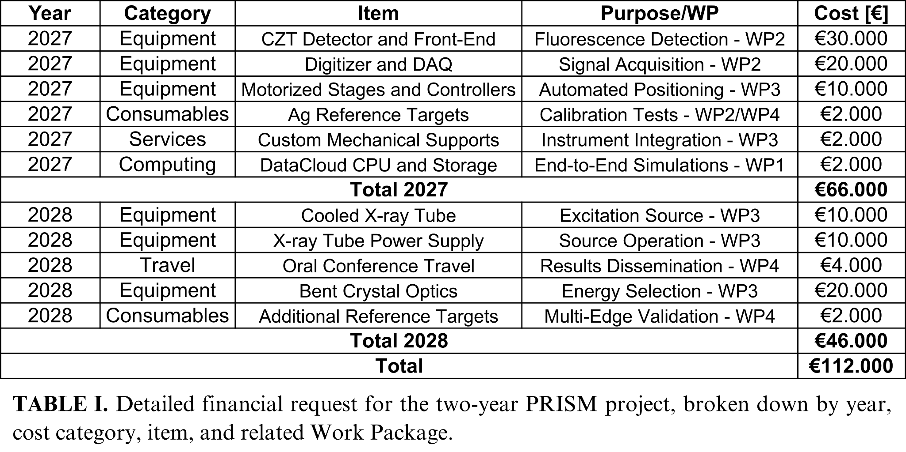
Equipment:
- CZT detector and front-end electronics: custom multichannel detector system for fluorescence measurements in the 20–50 keV range. !!! Questo NON è equipment!!!
- Digitizer and DAQ: multichannel waveform-acquisition system for detector readout, synchronization, and pulse-shape analysis.
- Motorized positioning stages: rotation and translation stages for the sample holder and CZT detector, enabling automated switching between fluorescence, I_{f}(E), and incident-beam, I₀(E), configurations (qua rischi perché secondo me non ci credono che non li hai...).
- Cooled X-ray tube and power supply: tungsten-anode source providing the excitation spectrum required for measurements above 20 keV (idem….).
- Bent germanium crystal optics: custom curved Ge crystals for monochromatization, energy scanning, and focusing of the incident X-ray beam !!! Anche questo NON é equipment!!!.
Consumables:
- Ag reference samples: metallic Ag foils and oxidized Ag powder standards for calibration, energy-scale verification, and XANES validation.
- Additional reference targets: selected materials containing elements with absorption edges above 20 keV, such as Mo, Pd and Sn, for assessing the broader operating range of the instrument.
- Cristalli
- CZT detectors and FE electronics
Services:
- Custom mechanical design and fabrication: development of dedicated supports and interfaces for integrating the sample holder, CZT detector, positioning stages, and associated components into the spectrometer.
Computing:
- CPU and data storage: computing resources for the SHADOW4–GEANT4 simulations and detector-response studies performed in WP1. The request corresponds to approximately 250,000 core-hours, calculated at a rate of €4.11 per 1,000 core-hours, together with the storage required for simulated events, waveforms, and calibration datasets.
Travel:
- Conference participation: travel for the dissemination of project results through an oral presentation. A possible target conference is the European Conference on X-Ray Spectrometry, EXRS 2028, expected to be held in Paris, subject to confirmation of the final conference programme and location.
- Missioni a Palermo? A rigaku? A Due2Lab?

Event organization: (metterei qualcosa per organizzare un workshop alla fine
Publication & dissemination?

In-kind contributions:
- PRISM will benefit from existing VOXES infrastructure and equipment during the development and preliminary integration phases. The estimated in-kind contribution includes an X-ray tube available during the first project year (€10k) (perché solo all’inizio? Magari usa questi 10 k€ per altro), the shielded experimental bunker (€5k) (e pure questo già c’è), existing motorized positioning systems (€15k), and linear translation axes with associated control hardware (€15k). The total estimated in-kind contribution is therefore €45k. Io rivedrei un po’ i costi...magari ti compri un rivelatore bello invece che richiedere cose che hai

8 Risk Assessment
Here I will outline the possible risks (R) in the project in relation to the specific planned activity (A) and describe the possible mitigation.

R1. Delayed delivery of critical components (A3.1–A3.4)
- Risk: Delays in the delivery of crystal optics, mechanics or detector components may postpone integration and commissioning.
- Mitigation: Use compatible in-kind VOXES components, including non-optimized crystals, for preliminary integration and commissioning until the final components become available. Eh...qua gli dici proprio che ce li hai….
R2. Slow CZT Optimization (A2.1–A2.4)
- Risk: Calibration and optimization of the CZT detector and electronics may require longer than planned, delaying laboratory XAS validation.
- Mitigation: Use an in-kind VOXES Si PIN diode to start calibration and reference scans, with reduced efficiency, while CZT optimization continues in parallel.
R3. Inaccuracy of End-to-End Simulations (A1.2–A1.4)
- Risk: SHADOW4–GEANT4 simulations may not accurately reproduce the source, crystal, sample and detector response, affecting the final geometry selection.
- Mitigation: Benchmark the model against analytical calculations and VOXES measurements and maintain direct contact with SHADOW4 developer Manuel Sánchez del Río through COST Action ENRICH WG3.
R4. Excessive XANES acquisition time (A3.3, A4.1–A4.3)
- Risk: Insufficient photon flux or signal-to-background ratio may make XANES measurements longer than planned.
- Mitigation: Optimize scan steps and dwell times and, if necessary, widen the optical slits and shorten the CZT peaking time within the minimum resolution and background-rejection requirements.

9 References
[1] Bonn, M., Domke, K. F., Sulpizi, M., McCrory, C., and Peng, Z. “In situ and operando characterization: Advancing our understanding of functional materials.” J. Chem. Phys., 162(14), 140402, 2025. doi: 10.1063/5.0270688.
[2] Zaera, F. “In-situ and operando spectroscopies for the characterization of catalysts and of mechanisms of catalytic reactions.” J. Catal., 404, 900–910, 2021. doi: 10.1016/j.jcat.2021.08.013.
[3] Fehse, M., Iadecola, A., Simonelli, L., Longo, A., and Stievano, L. “The rise of X-ray spectroscopies for unveiling the functional mechanisms in batteries.” Phys. Chem. Chem. Phys., 23(41), 23445–23465, 2021. doi: 10.1039/D1CP03263A.
[4] Calvin, S. XAFS for Everyone. Boca Raton: CRC Press, 2013. doi: 10.1201/b14843.
[5] Bunker, G. Introduction to XAFS: A Practical Guide to X-ray Absorption Fine Structure Spectroscopy. Cambridge: Cambridge University Press, 2010. doi: 10.1017/CBO9780511809194.
[6] Cai, M., Sun, S., and Bao, J. “Synchrotron Radiation Based X-ray Absorption Spectroscopy: Fundamentals and Applications in Photocatalysis.” ChemPhysChem, 25(10), e202300939, 2024. doi: 10.1002/cphc.202300939.
[7] Bès, R., Ahopelto, T., Honkanen, A.-P., Huotari, S., Leinders, G., et al. “Laboratory-scale X-ray absorption spectroscopy approach for actinide research: Experiment at the uranium L3-edge.” J. Nucl. Mater., 507, 50–53, 2018. doi: 10.1016/j.jnucmat.2018.04.034.
[8] Zimmermann, P., Peredkov, S., Abdala, P. M., DeBeer, S., Tromp, M., et al. “Modern X-ray spectroscopy: XAS and XES in the laboratory.” Coord. Chem. Rev., 423, 213466, 2020. doi: 10.1016/j.ccr.2020.213466.
[9] Praetz, S., Johansen, M., Kober, D., Tesic, M., Schlesiger, C., et al. “Operando laboratory XAS on battery materials using the DANOISE cell in a von Hámos spectrometer.” J. Anal. At. Spectrom., 40(9), 2447–2461, 2025. doi: 10.1039/d5ja00155b.
[10] Malzer, W., Schlesiger, C., and Kanngießer, B. “A century of laboratory X-ray absorption spectroscopy – A review and an optimistic outlook.” Spectrochim. Acta Part B At. Spectrosc., 177, 106101, 2021. doi: 10.1016/j.sab.2021.106101.
[11] Németh, Z., Szlachetko, J., Bajnóczi, É. G., and Vankó, G. “Laboratory von Hámos X-ray spectroscopy for routine sample characterization.” Rev. Sci. Instrum., 87(10), 103105, 2016. doi: 10.1063/1.4964098.
[12] Scordo, A., Curceanu, C., Miliucci, M., Shi, H., Sirghi, F., et al. “VOXES: a high precision X-ray spectrometer for diffused sources with HAPG crystals in the 2–20 keV range.” J. Instrum., 13(04), C04002, 2018. doi: 10.1088/1748-0221/13/04/C04002.
[13] Manti, S., Napolitano, F., Clozza, A., Curceanu, C., Moskal, G., et al. “Enhancing Performances of the VOXES Bragg Spectrometer for XES Investigations.” Condens. Matter, 9(1), 2024. doi: 10.3390/condmat9010019.
[14] Manti, S. and Scordo, A. “Recent Developments of the VOXES Von Hamos X-Ray Spectrometer for Laboratory XES and XAS Studies.” Eng. Innov., 19, 23–29, 2026. doi: 10.4028/p-rQpe9Z.
[15] Yamamoto, T. “Selection of Monochromator Crystal for Pb L-, Br K-, and Ag K-Edge XANES Using a Laboratory-Based Spectrometer.” X-Ray Spectrom., 55(4), 538–544, 2026. doi: 10.1002/xrs.70076.
[16] Schoepfer, V. A. and Lindsay, M. B. J. “X-ray absorption spectroscopy and X-ray diffraction data for molybdenum minerals and compounds.” Data Brief, 45, 108576, 2022. doi: 10.1016/j.dib.2022.108576.
[17] Chun, W.-J., Asakura, K., and Iwasawa, Y. “Application of a CdTe Solid-State Detector to Polarization-Dependent Total-Reflection Fluorescence XAFS Measurements.” J. Synchrotron Radiat., 3(4), 160–162, 1996. doi: 10.1107/S0909049596005250.
[18] Collonge, M., Baussens, O., Busca, P., Fajardo, P., Fischer, P., et al. “Probing the potential of CdZnTe for high-energy high-flux 2D X-ray detection using the XIDer incremental digital integrating readout.” Front. Phys., 12, 2024. doi: 10.3389/fphy.2024.1304570.
[19] Abbene, L., Artibani, F., Bettelli, M., Buttacavoli, A., Principato, F., et al. “First Stability Characterization for a CZT Detection System in an e+e− Collider Environment.” Sensors, 24(23), 2024. doi: 10.3390/s24237562.
[20] Abbene, L., Buttacavoli, A., Principato, F., Gerardi, G., Bettelli, M., et al. “Potentialities of CdZnTe Quasi-Hemispherical Detectors for Hard X-ray Spectroscopy of Kaonic Atoms at the DAΦNE Collider.” Sensors, 23(17), 2023. doi: 10.3390/s23177328.
[21] Scordo, A., Abbene, L., Artibani, F., Bazzi, M., Bettelli, M., et al. “CdZnTe detectors tested at the DAΦNE collider for future kaonic atoms measurements.” Nucl. Instrum. Methods Phys. Res. Sect. Accel. Spectrometers Detect. Assoc. Equip., 1060, 169060, 2024. doi: 10.1016/j.nima.2023.169060.
[22] Artibani, F., Abbene, L., Buttacavoli, A., Bettelli, M., Gerardi, G., et al. “Time-based selection of kaonic atom x-ray events with quasi-hemispherical CZT detectors at the DAΦNE collider.” Meas. Sci. Technol., 37(3), 035108, 2026. doi: 10.1088/1361-6501/ae3203.
[23] Mele, F., Quercia, J., Abbene, L., Benassi, G., Bettelli, M., et al. “Advances in High-Energy-Resolution CdZnTe Linear Array Pixel Detectors with Fast and Low Noise Readout Electronics.” Sensors, 23(4), 2023. doi: 10.3390/s23042167.
[24] Manti, S., Yip, S. h., Bazzi, M., Bortolotti, N., Bragadireanu, M., et al. “Machine-learning-enhanced event selection for BEGe detectors in the VIP experiment.” J. Instrum., 21(1), 2026. doi: 10.1088/1748-0221/21/01/P01036.
[25] Manti, S. and others. Machine Learning background suppression for CZT detectors using Monte Carlo simulations. Palermo, Italy, 2026. https://indico.global/event/16638/contributions/146849/attachments/68437/132618/XGRADE_2026_03_26.pdf.
[26] Del Rio, M. S., Reyes-Herrera, J., Shi, X., and Rebuffi, L. “SHADOW4: the popular ray tracing revived for evolving synchrotron sources in fourth-generation storage rings.” J. Phys. Conf. Ser., 3010(1), 012071, 2025. doi: 10.1088/1742-6596/3010/1/012071.
[27] Scordo, A., De Leo, V., Curceanu, C., Miliucci, M., and Sirghi, F. “Efficiency measurements and simulations of a HAPG based Von Hamos spectrometer for large sources.” J. Anal. At. Spectrom., 36(11), 2485–2491, 2021. doi: 10.1039/d1ja00214g.
[28] Manti, S., Bazzi, M., Bortolotti, N., Capoccia, C., Cargnelli, M., et al. “Testing the Pauli Exclusion Principle across the Periodic Table with the VIP-3 Experiment.” Entropy, 26(9), 2024. doi: 10.3390/e26090752.

