PROPOSTA DI GRANT GIOVANI IN CSN5 - Anno 2026

Acronym: | PRISM
Full title: | Precision Room-temperature Instrumentation for high-energy x-ray absorption Spectroscopy Measurements
Applicant: | Simone Manti
Participating units: | INFN Sezione di Frascati

Abstract (2000 caratteri)
X-ray absorption spectroscopy (XAS) is a versatile element-selective technique for probing the electronic and atomic structure of materials. While synchrotron and XFEL facilities provide outstanding performance, their limited accessibility motivates the development of advanced laboratory XAS instrumentation. A current challenge is extending XAS in fluorescence mode beyond 20 keV, where silicon detectors lose efficiency and germanium detectors require cryogenic operation. This limits access to the K-edges of technologically relevant elements such as Mo, Pd, Ag and Sn, which are widely studied and used in catalysis, electrochemistry, advanced alloys and energy materials. Taking up this challenge, PRISM will develop a high-resolution laboratory hard X-ray spectrometer combining a monochromator crystal with a multichannel cadmium zinc telluride (CZT) detector for precision fluorescence-mode XAS up to 50 keV. Building on my expertise in crystal-based X-ray spectroscopy gained within the VOXES project and SIDDHARTA-2 experiment, PRISM will develop detector architectures, low-noise front-end electronics, calibration procedures and spectral reconstruction algorithms to achieve energy resolution for CZT ≤2% at 22.2 keV and excellent SNR performance at room temperature. The instrument will be validated through fluorescence XAS measurements on reference materials with K-edges above 20 keV, demonstrating accurate edge reconstruction and XANES spectra within laboratory-compatible acquisition times. Once validated, the platform will enable extended in-situ and operando studies of slowly evolving catalytic, electrochemical and energy-related processes. Beyond this proof of concept, PRISM will establish a new detector platform for next-generation laboratory hard X-ray spectroscopy, strengthening INFN expertise in semiconductor radiation detectors, precision X-ray instrumentation and crystal spectroscopy, while providing a complementary laboratory capability to synchrotron and XFEL facilities.

Possibile nuova versione abstract:
Quantitative laboratory fluorescence X-ray absorption spectroscopy (XAS) above 20 keV remains a major challenge in hard X-ray instrumentation. While synchrotron facilities provide outstanding performance, limited accessibility restricts routine characterization, operando studies, and experiments with hazardous or radioactive materials. Laboratory systems are also constrained by detector technology: silicon detectors lose efficiency at hard X-ray energies, while high-purity germanium detectors require cryogenic operation. Therefore, access to K-edges of elements such as Mo, Pd, Ag and Sn remains limited, despite their importance in catalysis, electrochemistry, alloys and energy materials.

PRISM will establish a laboratory platform for quantitative fluorescence-mode XAS above 20 keV by combining high-resolution crystal optics with a room-temperature multichannel cadmium zinc telluride (CZT) detector. PRISM integrates crystal monochromatization, energy-resolving detection, dedicated electronics, waveform reconstruction and SHADOW4-GEANT4 optimization into a single instrument. Building on the expertise I gained from the VOXES project and SIDDHARTA-2 experiment, PRISM will develop the complete detection chain, targeting ≤2% energy resolution at 22.2 keV with high efficiency and signal-to-noise ratio.
The platform will be validated through fluorescence XANES at the Ag K-edge and demonstrated on realistic thick, dilute and heterogeneous samples.

Per ultima frase o questa:
PRISM will bridge the gap between laboratory spectroscopy and large-scale facilities, enabling experiments that are presently impractical because of limited synchrotron access while creating a transferable technological platform for future X-ray instrumentation.
O questa:
Beyond the proof of concept, PRISM will provide INFN with new capabilities in hard X-ray spectroscopy and semiconductor detector instrumentation. Its CZT detector, algorithms, calibration procedures and simulation framework will provide reusable technologies for future X-ray instruments. By bridging laboratory spectroscopy and large-scale facilities, PRISM will enable flexible, high-performance hard X-ray spectroscopy currently inaccessible outside synchrotron beamlines.
1 State of the art (4000 caratteri) 1
2 Goals and Expected Outcome (2000 caratteri) 2
3 Methodology (10000 caratteri) 2
4 Organisation (4000 caratteri) 6
5 Synergies with Other Activities (3000 caratteri) 7
6 Impact and Spin-offs (3000 caratteri) 8
7 Costs 9
8 Risk Assessment 9
9 References 11

1 State of the art (4000 caratteri)
A central challenge in radiation-detector development is enabling in-situ and operando characterization under realistic conditions. This requires non-destructive, element- and bulk-sensitive measurements of weak signals from thick, heterogeneous or dilute samples, often over long acquisition campaigns [1,2].
X-rays are particularly suited for such investigations because of their high penetration depth relative to other optical techniques, enabling access to the bulk of samples [3]. Among X-ray techniques, X-ray absorption spectroscopy (XAS) directly probes absorption across an element-specific absorption edge [4]. The near-edge region (XANES) is sensitive to oxidation state, electronic structure and coordination geometry, whereas the extended region up to 1 keV above the edge (EXAFS) provides quantitative information on the local atomic environment. XAS can be measured in transmission, from beam attenuation through the sample, or in fluorescence, from the emitted characteristic X-rays. Fluorescence detection is particularly suited to dilute, thick or geometrically constrained samples for which transmission is impractical [5].
Synchrotron facilities are the reference platforms for XAS, as their high brilliance, broad energy tunability and dedicated beamlines enable high-quality spectra with excellent signal-to-noise ratio (SNR) over a wide energy range [6]. However, access to these large-scale facilities is limited and competitive, and the allocated beamtime is often unsuitable for routine characterization, long experimental campaigns, or studies involving hazardous and radioactive samples [7]. These limitations have driven renewed interest in laboratory XAS systems based on conventional X-ray sources [8]. Although laboratory sources provide lower brilliance than synchrotrons, they offer continuous access, flexible sample handling and long measurement times, making them attractive for routine analysis, method development and slowly evolving in-situ or operando processes [9].
Recent advances in source brightness, monochromator crystals and detection technology have enabled an increasing number of XAS and XES measurements to be transferred back to the laboratory [10,11]. Commercial laboratory XAS systems are now available (e.g. Rigaku, Sigray, easyXAFS), confirming the maturity and industrial relevance of the field, although their architecture and substantial cost limit flexibility for customized fluorescence measurements. Within INFN-LNF, the VOXES spectrometer [12,13] has established expertise in high-resolution von Hamos spectroscopy for extended and dilute X-ray sources. The instrument currently operates mainly in the 5–20 keV range and has recently been upgraded with motorized positioning, energy-dispersive monitoring and mechanical compatibility with transmission XAS measurements [14].
Despite this progress, laboratory fluorescence-XAS above approximately 20 keV remains challenging [15], although this range includes many technologically relevant K-edges of Mo, Pd, Ag and Sn, whose lower-energy L lines are too closely spaced [16]. Silicon-based detectors progressively lose absorption efficiency in the hard-X-ray range, whereas high-purity germanium detectors offer excellent spectroscopic performance but require cryogenic cooling. High-Z compound semiconductors such as CdTe and CdZnTe instead provide high hard-X-ray absorption efficiency and room-temperature operation. Although CZT detectors have been developed for synchrotron, imaging and high-flux applications, their integration into multichannel, energy-resolving laboratory fluorescence-XAS systems remains largely unexplored [17,18].
PRISM is specifically designed to close this technological gap by combining three mature but never previously integrated components into a single optimized platform: segmented CZT sensors, low-noise electronics with waveform-based reconstruction and high-resolution crystal optics. Such a platform would extend laboratory fluorescence-XAS beyond 20 keV while consolidating the INFN expertise in hard-X-ray detection and spectroscopy.
Expected Outcome (2000 caratteri)
The main goal of the project is to develop and validate a room-temperature laboratory platform for fluorescence-mode X-ray absorption spectroscopy (f-XAS) above 20 keV, combining a high-resolution crystal monochromator with a custom multichannel CZT detector. The X-ray source, crystal optics, sample environment, detector, electronics, data acquisition, and simulation framework will be optimized as a single integrated measurement chain for quantitative XANES studies of samples unsuitable for transmission measurements because of thickness, dilution, or geometry. To our knowledge, no existing laboratory system combines crystal monochromatization with multichannel energy-resolving CZT detection for quantitative fluorescence XANES above 20 keV.
The project is structured around three goals (G) and the corresponding expected outcomes (EO):
G1: Design, construct and validate the complete fluorescence-mode PRISM XAS instrument through end-to-end simulations and experimental commissioning.
EO1: A fully commissioned laboratory setup with optimized source–optics–sample–detector geometry, supported by a validated simulation framework. At the Ag K-edge, simulated and measured count rates will agree within 20%, while beam spot size and incident-energy resolution will be validated within 10%.
G2: Develop and characterize a room-temperature multichannel CZT detection system optimized for hard X-ray fluorescence spectroscopy.
EO2: A calibrated CZT detector achieving intrinsic efficiency above 90% at 50 keV, energy resolution at the ≤2% level at 22.5 keV, and dead time below 10% at the selected operating conditions.
G3: Demonstrate PRISM’s quantitative fluorescence XANES measurements above 20 keV using the Ag K-edge as benchmark.
EO3: Ag K-edge XANES spectra will be acquired for metallic Ag and two oxidized Ag compounds with different oxidation states. The measurements will achieve an incident-energy resolution of ≤10 eV FWHM, edge-position reproducibility within 1 eV, edge-step SNR ≥20, and acquisition times below 12 h per spectrum.

3 Methodology (10000 caratteri)

XAS in the laboratory – questa parte e’ un po’ didattica e lunghina – magari fai riferimento di piu’ a PRISM? E alla TUA esperienza?

XAS measures the energy dependence of the linear absorption coefficient, μ(E), across an element-specific core-level absorption edge (see Figure 1). When the incident photon energy reaches the binding energy of a core electron, the absorption probability rises sharply and the resulting photoelectron probes both the unoccupied electronic states and the surrounding atomic structure. The near-edge region (XANES) is sensitive to oxidation state, orbital occupancy and local symmetry, whereas the oscillations above the edge (EXAFS) provide information on coordination numbers, interatomic distances and structural disorder. Laboratory XAS becomes increasingly demanding at hard-X-ray energies because the usable flux from conventional sources decreases and EXAFS requires accurate measurements over a broad energy interval. PRISM will use the Ag K-edge at 25.5 keV as its benchmark, first establishing a robust XANES protocol and then quantifying the EXAFS range achievable within laboratory-compatible acquisition times.
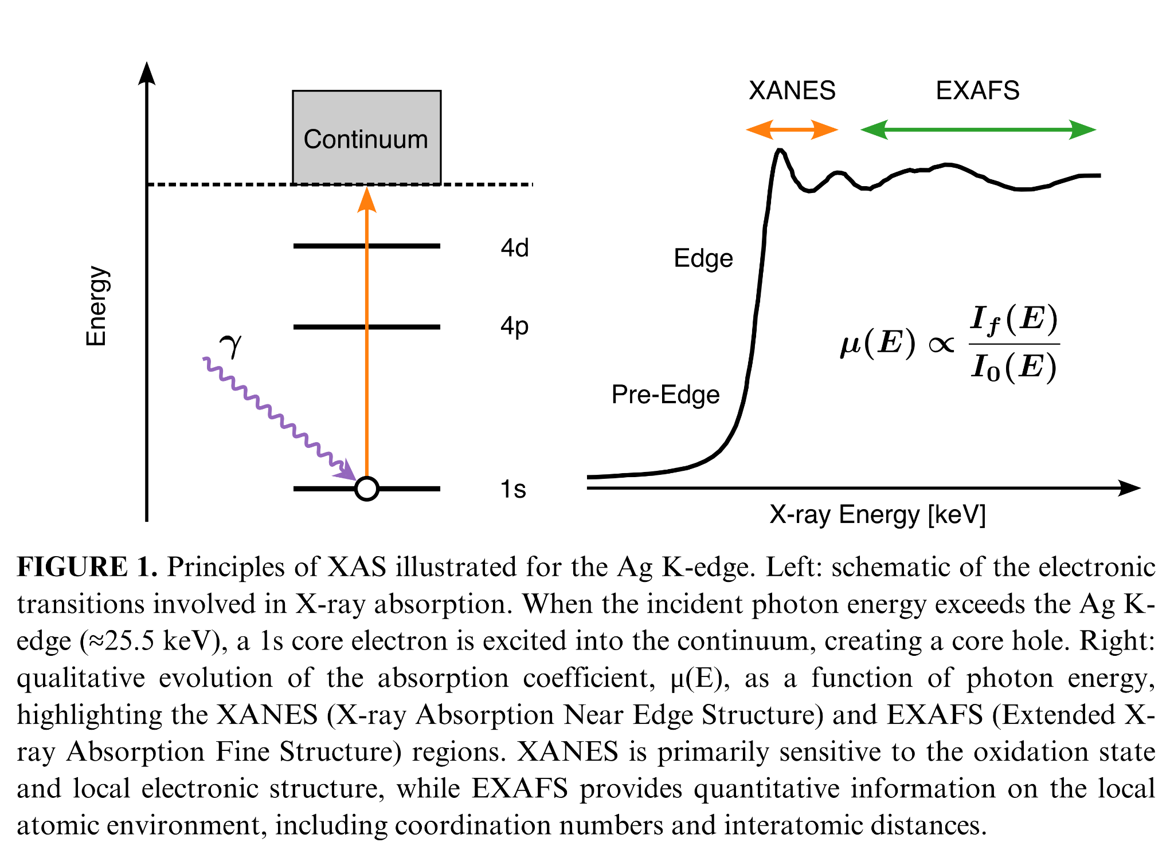
The absorption coefficient μ(E) can be acquired in transmission or fluorescence mode. In a dispersive transmission arrangement, such as that being explored with VOXES, the broad source spectrum passes through the sample and a monochromator crystal spatially separates the transmitted energies onto a position-sensitive detector. Comparison of the spectra acquired with (I) and without (I₀) the sample provides μ(E). This approach is efficient but requires a homogeneous sample with an appropriate transmission thickness. PRISM will instead operate primarily in fluorescence mode. A crystal placed in front of the sample will select and focus one incident energy at a time, while an energy-resolving detector positioned approximately perpendicular to the incident beam will measure the characteristic fluorescence emitted following core-hole creation. For the Ag K-edge (see Figure 1), I_{f}(E) will be extracted from the Ag Kα line complex at approximately 22.2 keV. This geometry extends XAS to thick, dilute, heterogeneous or geometrically constrained samples that are impractical in transmission. In the thin or dilute limit, after background, live-time and detector-response corrections, the absorption spectrum is proportional to the ratio μ(E) ∝ I_{f}(E) / I₀(E) where I₀(E) is the incident monochromatic intensity.
The incident energy, impinging on the sample, will be selected from the X-ray-tube continuum by Bragg diffraction on a cylindrically bent germanium crystal in a VOXES-derived von Hamos geometry. The rotation will be coordinated with the axis motors so that the source–crystal–sample geometry and the position of the focused spot are maintained throughout the scan. At each energy set point, a complete fluorescence spectrum will be acquired for a defined dwell time, and I_{f}(E) will be obtained by fitting or integrating the selected fluorescence line after local-background subtraction. Finer energy steps will be used around the edge and coarser steps in the extended region, while the dwell time will be adapted to the predicted count rate and target statistical uncertainty.
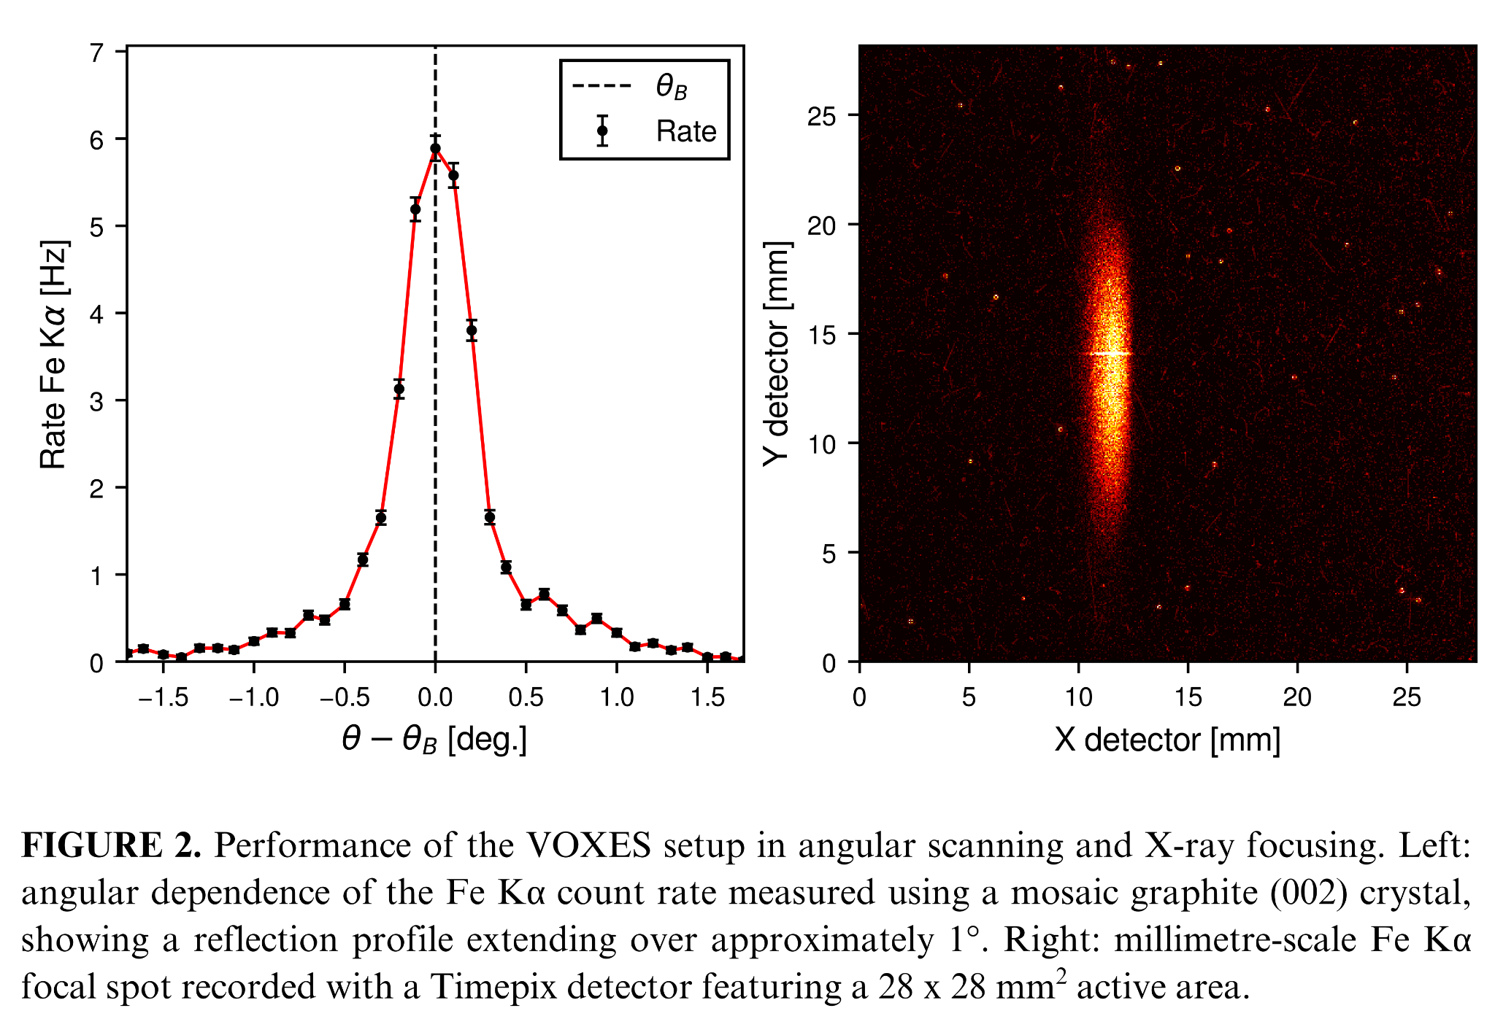The feasibility of the required angular scan and focusing is supported by the existing VOXES experience. For instance, Figure 2 (left) shows the measured Fe Kα rate on the position-sensitive detector as the crystal is rotated through its nominal Bragg angle, demonstrating a controlled Bragg-angle scan. In Figure 2 (right), the same Fe Kα line is shown on a two-dimensional detector, exhibiting millimetric size spot. Although these measurements were performed in an X-ray-emission configuration and do not themselves constitute XAS, they validate two essential instrumental functions for PRISM: precise crystal rotation for energy selection and spatial focusing with a bent crystal. The project will build on this expertise, the available VOXES components and in-kind contributions, specifically the two slits to collimate the flux after the source, existing crystal rotation and translation stages, and the shielded laboratory infrastructure at LNF.

CZT detector and signal reconstruction

The detector represents the key technological bottleneck for laboratory hard-X-ray fluorescence XAS. PRISM will overcome this limitation by developing a custom multichannel CZT detector optimized for laboratory fluorescence-XAS in the 20–50 keV range. The design will build on the experience gained within SIDDHARTA, where CZT detectors were tested at the DAΦNE collider under high-flux conditions [19–22].
The baseline CZT detector will consist of a monolithic 2-mm-thick CZT crystal segmented into a 20-pixel linear array with a 500 μm pitch, common cathode and surrounding guard ring [23]. This geometry will increase the active area and collected solid angle, while distributing the fluorescence rate among independent channels to reduce pile-up and enable channel-resolved background monitoring. Each pixel will be coupled to a dedicated low-noise preamplifier. The system will be characterized in terms of efficiency, energy resolution, gain linearity and stability, dead time, rate capability and channel-to-channel uniformity.
Waveforms will be digitized using a 64-channel, 16-bit, 125 MS/s acquisition platform. Although the detector requires 20 primary channels, the larger channel capacity will accommodate guard-ring, synchronization and diagnostic signals, provide margin for future detector expansion, and allow the reuse of an existing firmware and acquisition framework, thereby reducing integration time and technical risk. A detector-response simulation will couple GEANT4 energy-deposition calculations to electric-field and weighting-potential models. Charge transport will then be simulated to generate channel-resolved current pulses including trapping, incomplete charge collection and charge sharing between adjacent pixels. After convolution with the measured front-end response and addition of realistic electronic noise, the synthetic waveforms will be used to develop and validate the reconstruction algorithms. Waveform processing will provide baseline correction, pulse-amplitude estimation, timing extraction and channel equalization. Conventional pulse-shape observables and machine-learning classifiers, adapted from experience with germanium detectors [24] and ongoing CZT tests at the LNF Beam Test Facility [25] (see Figure 3), will be compared for identifying pile-up, saturation, electronic disturbances and distorted pulses, and for correcting charge-sharing and incomplete-charge-collection events.
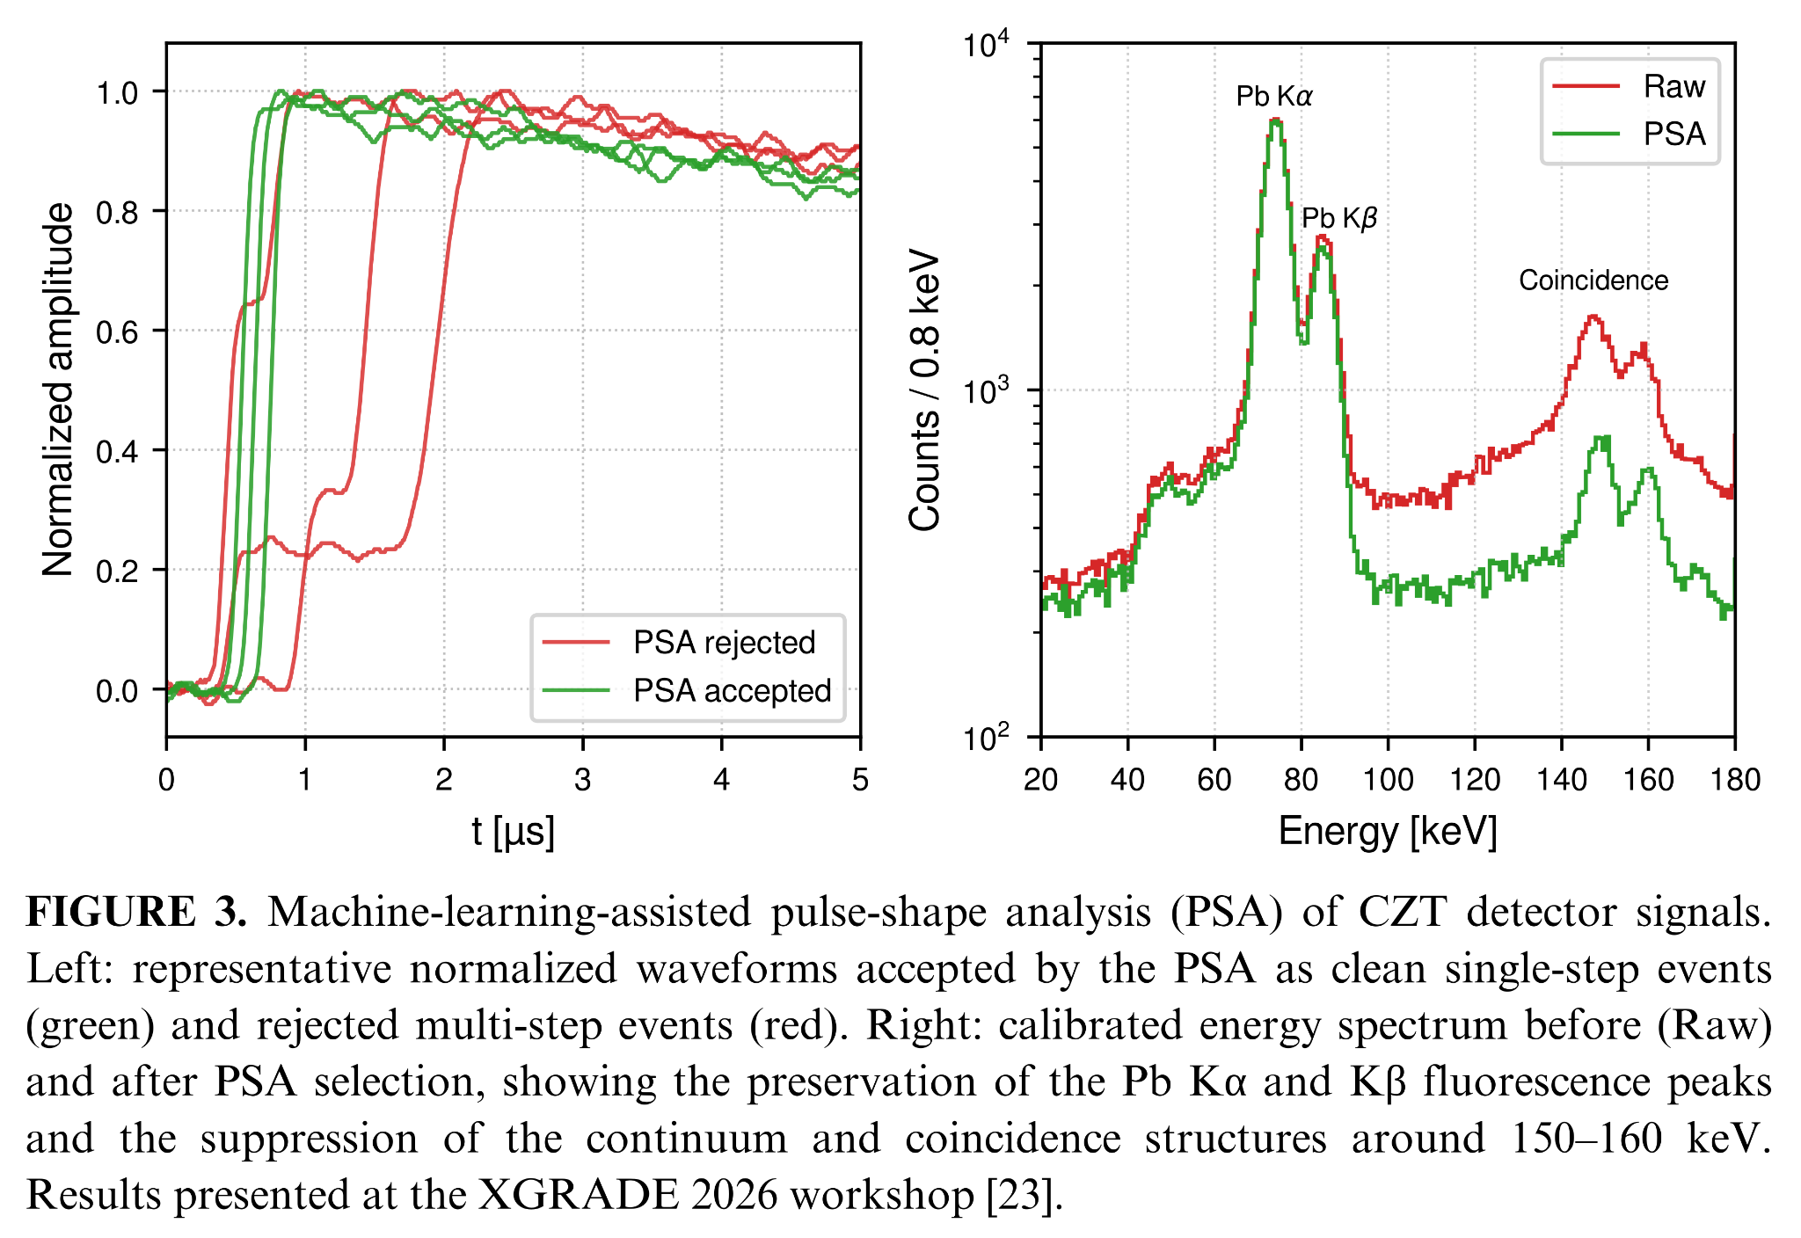
The same CZT detector head will measure both the fluorescence signal I_{f}(E) and the incident intensity I₀(E) through a motorized exchange system. The CZT head and sample holder will each be mounted on independent rotation stages, while a long-travel linear axis will alternate the sample and detector between the two configurations. For I_{f}(E), the sample will be placed at the monochromatic focus and observed by the CZT array at approximately 90∘; for I₀(E), the sample will be translated out and the detector rotated and repositioned into the attenuated direct beam. Calibrated attenuators, shorter dwell times and, when required, reduced tube current or slit aperture will keep the direct-beam rate within the validated linear operating range.

Source to sample simulation
Because laboratory hard-X-ray XAS performance results from the interplay of source brightness, crystal optics, sample geometry and detector response, PRISM will develop an end-to-end source-to-detector simulation framework to optimize the complete measurement chain before construction. The Ag K-edge at approximately 25.5 keV will be used as the reference case for defining the XANES measurement protocol and the required performance in terms of energy resolution, photon flux, SNR and acquisition time. The simulation workflow will consist of two coupled stages. First, SHADOW4 [26] ray-tracing simulations building on the approach previously validated for the VOXES spectrometer [27], which will model photon transport from the X-ray tube through the collimating slits and crystal optics to the sample. Different germanium-based crystal reflections will be investigated in the VOXES-type von Hamos geometry, with the Ge(880) considered as the baseline candidate for measurements around the Ag K-edge [15]. Parametric studies will optimize the crystal material, reflection, curvature radius, dimensions, source–crystal and crystal–sample distances, slit apertures and Bragg geometry. The simulations will quantify the geometrical acceptance, energy bandwidth, photon flux, beam profile and illuminated spot size at the sample, while also evaluating alignment and mechanical tolerances. The SHADOW4 output will then be transferred to GEANT4, which will simulate photon absorption in the sample, fluorescence emission, self-absorption, elastic and inelastic scattering, background contributions and energy deposition in the multichannel CZT detector. The combined simulations will be used in the first months of the project to optimize the source, crystal optics, slit system, sample geometry and detector configuration, balancing count rate, spectral resolution and background rejection. A coordinated motorized scanning scheme will also be defined to vary the incident energy across the Ag K-edge while maintaining the required source–crystal–sample geometry. The final outcome of this activity will be a design freeze specifying the X-ray source, crystal type and dimensions, curvature radius, distances, slit apertures, sample position, CZT geometry, motion stages and required positioning accuracy. The proposed layout of the setup for PRISM is shown in Figure 4, highlighting (not to scale) all the components from the source, the slit system, crystal, sample and the custom CZT detector.
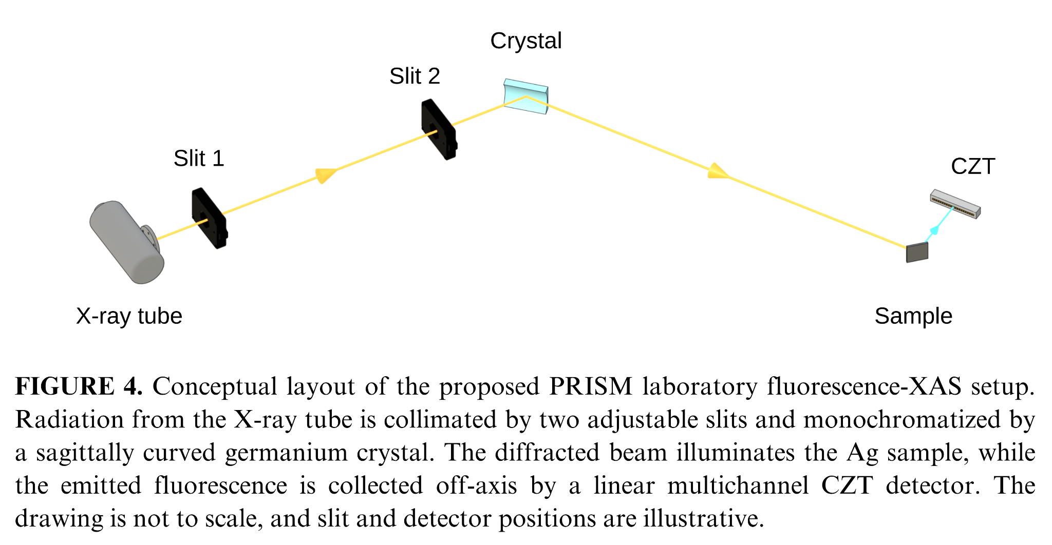

4 Organisation (4000 caratteri)
The PRISM project will have the following organization:

Name | Unit | FTE | Responsibility/WP
Simone Manti | INFN, Section of Frascati | 1.0 | Scientific Coordinator; overall coordination; WP1–WP4
Alessandro Scordo | INFN, Section of Frascati | 0.3 | Crystal optics, ray tracing, integration; WP1/WP3
Massimiliano Bazzi | INFN, Section of Frascati | 0.3 | Electronics/DAQ; WP2
Catalina Curceanu | INFN, Section of Frascati | 0.1 | Scientific review and application validation; WP4
Total |  | 1.7 | -

PRISM will be divided into the following Work Packages (WP):

● WP1 – Requirements, simulations and design freeze (M1–M6): The experimental requirements will be established through an end-to-end SHADOW4–GEANT4 simulation workflow describing the complete measurement chain, from X-ray generation and crystal optics to sample response and CZT detection. The simulations will define the optimized source–optics–sample–detector geometry, performance targets and procurement specifications, minimizing technical risks before construction. Dr. Alessandro Scordo will contribute his expertise in crystal optics, ray tracing and VOXES-based spectrometer design.
● WP2 – Room-temperature multichannel CZT spectroscopy for hard-X-ray fluorescence XAS (M4–M15): A multichannel CZT detector with dedicated low-noise front-end electronics and waveform-based DAQ will be developed and characterized for hard-X-ray fluorescence spectroscopy. Channel calibration, gain equalization, efficiency measurements and evaluation of energy resolution, stability, dead time and pile-up performance will be performed. Pulse-reconstruction and pulse-shape-analysis methods will be implemented to maximize spectral quality and identify distorted events. Ing. Massimiliano Bazzi will support the development and validation of the electronics and DAQ chain.
● WP3 – Instrument integration and commissioning (M10–M18): After the design freeze, the X-ray source, crystal optics, motion stages, slits and mechanical components will be procured and validated through acceptance tests. The complete source–monochromator–sample–detector system will then be mechanically and electronically integrated. Commissioning will include optical alignment, synchronized energy scanning, control-system validation and quantitative comparison of measured flux, spot size and energy resolution with simulation predictions.
● WP4 – Ag reference samples and realistic sample demonstration (M16–M24): The complete instrument will first be validated using Ag foil and reference Ag compounds with different chemical states. Quantitative XANES performance will be assessed through energy calibration, reproducibility, signal-to-noise ratio and comparison with reference spectra. Fluorescence-XAS will then be demonstrated on a realistic thick, diluted or heterogeneous sample, defining the accessible measurement domain. I shall perform crystal-optics optimization, measurements and interpretation of the experimental results, with support from team members.
The project Milestones (MS) are:
● MS1 – Instrument concept validated and design frozen (M6): Optimized source–optics–sample–detector configuration established, with predicted flux, energy resolution, spot size and acquisition performance meeting the XANES requirements.
● MS2 – CZT spectroscopic performance demonstrated (M15): The detector achieves >90% efficiency at 50 keV, ≤2% energy resolution at 25.5 keV, dead time <10%, and pile-up contamination <5% under XAS operating conditions.
● MS3 – Integrated instrument commissioned (M18): Synchronized energy scanning and calibration operational; measured count rates within 20%, and spot size and energy resolution within 10% of simulation predictions.
● MS4 – Fluorescence-XAS capability demonstrated (M24): Ag K-edge XANES measurements achieved with SNR ≥20 and edge-position reproducibility within 1 eV; discrimination of two chemical states demonstrated in a realistic sample with statistical significant discrimination; operating domain fully characterized.

The Work Packages and the Milestones are summarized in the Gantt table in Figure 5:
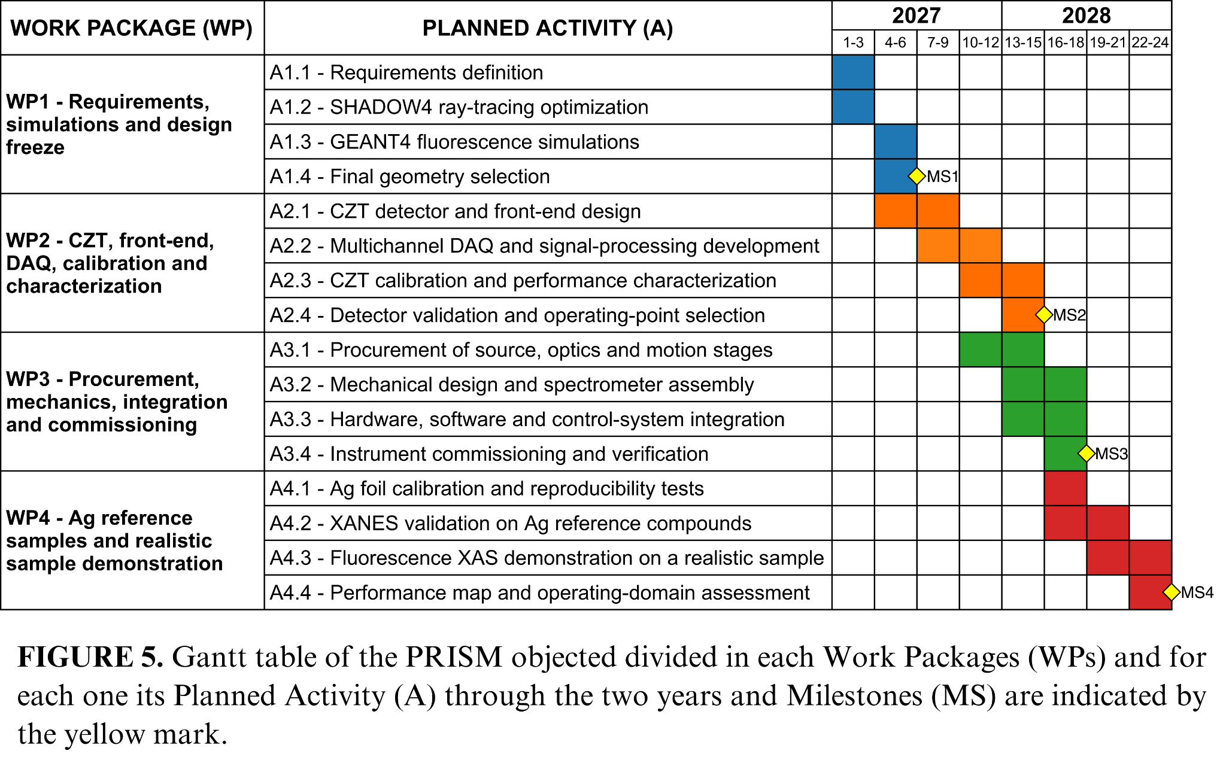

The project Deliverables (D) are:

- D1 – Validated SHADOW4–GEANT4 workflow, optimized instrument design and technical specifications (M6).
- D2 – CZT calibration and performance-characterization dataset with validation report (M15).
- D3 – Ag foil and reference-compound XANES dataset with quantitative validation report (M21).
- D4 – Realistic-sample dataset, operating-domain assessment, documented analysis tools and final project report demonstrating PRISM capabilities (M24).

5 Synergies with Other Activities (3000 caratteri)
The PRISM project will establish extensive synergies with various external projects, institutions and
companies.

Other INFN Scientific Committees

- CSN3: PRISM has synergy with KAONNIS, building on the experience gained with CZT detectors in the SIDDHARTA experiment at DAΦNE, and the VIP experiment at LNGS, which faces similar challenges in the detection of weak X-ray fluorescence lines above 20 keV [28] and employs related pulse shape analysis techniques [24].
- CSN5: Synnergy with VOXES, a former CSN5 Young Researchers project whose expertise in crystal-based X-ray spectroscopy, instrumentation and data analysis provides the technological foundation for PRISM. VOXES will contribute existing equipment and laboratory infrastructure in kind, including facilities for testing and calibration with laboratory X-ray sources. Further synergies are foreseen with SPHINX, particularly in precision angular scanning, optical alignment and the integration of X-ray optics and detectors.
- EuPRAXIA: Synergy with EuAPS and the AQUA beamline, both targeting XAS measurements in different photon-energy ranges. Developing laboratory-based XAS methods within PRISM will provide complementary expertise, instrumentation and procedures useful for preparing and optimizing future experiments at these facilities.
- MITIQO: - se puoi dire 2 parole…anche perche’ hai lavorato in questo prog – va detto da qualceh parte

External institutions and national and international research laboratories

- University of Palermo: PRISM will benefit from the established collaboration with the University of Palermo in the development and testing of CZT detectors within the SIDDHARTA experiment. This synergy will support the optimization of the detector geometry, front-end electronics, calibration procedures and signal-reconstruction methods.
- ENRICH COST Action: PRISM is strongly aligned with the ENRICH COST Action, which promotes a European network for radiation-detection research and its applications to societal challenges. Within this network, the applicant is co-leader of the Working Group on Simulation. A particularly relevant connection is with Manuel Sánchez del Río, leader of the Working Group and principal developer of SHADOW4, the ray-tracing software that will be used to optimize the crystal optics and spectrometer geometry.

Industry and Private Sector
The following companies have provided letters of support for PRISM, confirming industrial interest in the proposed instrumentation and its technology-transfer potential.
- Due2Lab: Due2Lab will contribute expertise in CZT crystal production and detector integration, strengthening the feasibility and scalability of the multichannel system.
- Rigaku: Rigaku will provide an industrial benchmark for laboratory XAS and support the selection of X-ray sources, optics, and key components.

6 Impact and Spin-offs (3000 caratteri)
PRISM will establish at INFN-LNF a validated laboratory capability for quantitative fluorescence-XAS above 20 keV based on room-temperature multichannel detection. By integrating crystal optics, CZT sensors, low-noise electronics, advanced DAQ and SHADOW4–GEANT4 modelling, PRISM will address a currently challenging regime where efficient, non-cryogenic laboratory hard-X-ray spectroscopy is still limited.
For the INFN community, the impact will extend beyond the realization of a single instrument. PRISM will valorize the existing VOXES infrastructure and consolidate LNF expertise in semiconductor radiation detectors, precision X-ray spectroscopy, radiation transport and spectral reconstruction. The modular CZT detector and readout chain, validated source-to-detector simulations, calibration procedures and performance maps will provide reusable technological assets for INFN activities developing hard-X-ray instrumentation. The project will establish a transferable methodology linking predictive simulations, subsystem validation and quantitative performance assessment of integrated spectrometers. After laboratory validation, the resulting design principles may support future developments such as EuAPS. PRISM will also train young researchers and technical staff in optics, detectors, electronics, simulation and data analysis.
For the wider scientific community, PRISM will extend laboratory access to fluorescence-XAS at the K-edges of technologically relevant elements such as Mo, Pd, Ag and Sn. If the targeted performance is achieved, the platform will enable sample screening, method development, cell optimization and long-term in-situ or operando studies of thick, dilute and heterogeneous specimens that are difficult to investigate in transmission. PRISM will complement, rather than replace, synchrotron and XFEL facilities: preliminary characterization and protocol optimization will improve the efficiency of scarce beamtime, while repeated measurements and slowly evolving processes can be performed in the laboratory. Beneficiaries will include catalysis, electrochemistry, energy materials and advanced alloys. Documented workflows, reference datasets and operating-domain maps will support reproducibility and facilitate adoption by other laboratories.
The main technology-transfer opportunities are the modular room-temperature CZT detector, front-end and multichannel DAQ chain, together with the associated calibration and pulse-reconstruction methods, validated source–optics–sample–detector workflows and compact hard-X-ray spectrometer architecture. Following experimental validation, these assets may be evaluated with INFN technology-transfer structures and X-ray instrumentation companies for protection, further development or co-design. Potential applications include materials characterization, quality control and long-duration monitoring of catalysts, batteries and advanced materials. Industrial uptake will depend on demonstrated performance, robustness, manufacturability, cost and market requirements.

7 Costs
The overall cost of PRISM is 112 k€, where 66 k€ are requested for 2027 and 46 k€ for 2028. The detailed costs are presented in Table I.
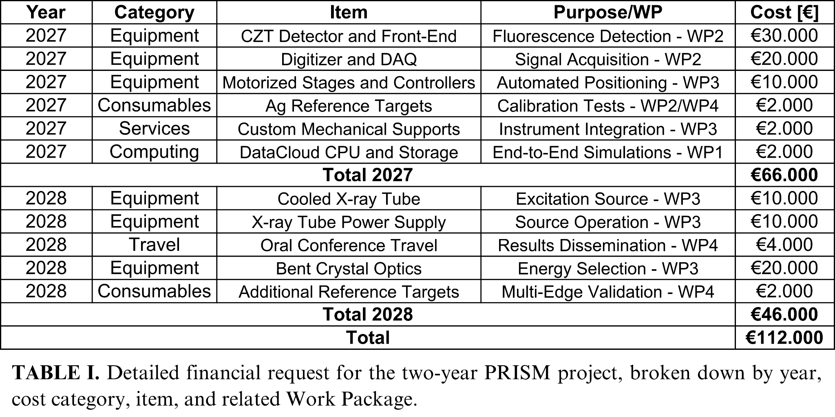
Equipment:
- CZT detector and front-end electronics: custom multichannel detector system for fluorescence measurements in the 20–50 keV range.
- Digitizer and DAQ: multichannel waveform-acquisition system for detector readout, synchronization, and pulse-shape analysis.
- Motorized positioning stages: rotation and translation stages for the sample holder and CZT detector, enabling automated switching between fluorescence, I_{f}(E), and incident-beam, I₀(E), configurations.
- Cooled X-ray tube and power supply: tungsten-anode source providing the excitation spectrum required for measurements above 20 keV.
- Bent germanium crystal optics: custom curved Ge crystals for monochromatization, energy scanning, and focusing of the incident X-ray beam.
Consumables:
- Ag reference samples: metallic Ag foils and oxidized Ag powder standards for calibration, energy-scale verification, and XANES validation.
- Additional reference targets: selected materials containing elements with absorption edges above 20 keV, such as Mo, Pd and Sn, for assessing the broader operating range of the instrument.
Services:
- Custom mechanical design and fabrication: development of dedicated supports and interfaces for integrating the sample holder, CZT detector, positioning stages, and associated components into the spectrometer.
Computing:
- CPU and data storage: computing resources for the SHADOW4–GEANT4 simulations and detector-response studies performed in WP1. The request corresponds to approximately 250,000 core-hours, calculated at a rate of €4.11 per 1,000 core-hours, together with the storage required for simulated events, waveforms, and calibration datasets.
Travel:
- Conference participation: travel for the dissemination of project results through an oral presentation. A possible target conference is the European Conference on X-Ray Spectrometry, EXRS 2028, expected to be held in Paris, subject to confirmation of the final conference programme and location.
In-kind contributions:
- PRISM will benefit from existing VOXES infrastructure and equipment during the development and preliminary integration phases. The estimated in-kind contribution includes an X-ray tube available during the first project year (€10k), the shielded experimental bunker (€5k), existing motorized positioning systems (€15k), and linear translation axes with associated control hardware (€15k). The total estimated in-kind contribution is therefore €45k.

8 Risk Assessment
R1. Delayed delivery of critical components (A3.1–A3.4)
● Risk: Delays in delivery of crystal optics, mechanics or detector components may affect the integration and commissioning schedule.
● Mitigation: Preliminary integration and alignment activities will be performed using compatible in-kind VOXES components, including non-optimized crystals, allowing system validation to proceed while final components are delivered.
R2. Extended CZT optimization phase (A2.1–A2.4)
● Risk: Calibration, characterization and optimization of the CZT detector and electronics may require additional time, delaying the XAS validation phase.
● Mitigation: An in-kind VOXES Si PIN diode will be used for preliminary calibration and reference measurements with reduced efficiency, while CZT optimization and performance improvements proceed in parallel.
R3. Limited accuracy of end-to-end simulations (A1.2–A1.4)
● Risk: SHADOW4–GEANT4 simulations may not fully reproduce the coupled response of source, crystal optics, sample and detector, affecting geometry optimization.
● Mitigation: The simulation workflow will be benchmarked against analytical calculations and existing VOXES measurements. Additional support will be provided through direct interaction with the SHADOW4 developer Manuel Sánchez del Río within COST Action ENRICH WG3.
R4. Longer-than-expected XANES acquisition time (A3.3, A4.1–A4.3)
● Risk: Limited photon flux or signal-to-background ratio may increase the acquisition time required for quantitative XANES measurements.
● Mitigation: Scan strategy, energy steps and dwell times will be optimized using simulation and commissioning data. If required, optical acceptance and detector shaping parameters will be adjusted while preserving the required energy resolution and background rejection performance.

9 References
[1] Bonn, M., Domke, K. F., Sulpizi, M., McCrory, C., and Peng, Z. “In situ and operando characterization: Advancing our understanding of functional materials.” J. Chem. Phys., 162(14), 140402, 2025. doi: 10.1063/5.0270688.
[2] Zaera, F. “In-situ and operando spectroscopies for the characterization of catalysts and of mechanisms of catalytic reactions.” J. Catal., 404, 900–910, 2021. doi: 10.1016/j.jcat.2021.08.013.
[3] Fehse, M., Iadecola, A., Simonelli, L., Longo, A., and Stievano, L. “The rise of X-ray spectroscopies for unveiling the functional mechanisms in batteries.” Phys. Chem. Chem. Phys., 23(41), 23445–23465, 2021. doi: 10.1039/D1CP03263A.
[4] Calvin, S. XAFS for Everyone. Boca Raton: CRC Press, 2013. doi: 10.1201/b14843.
[5] Bunker, G. Introduction to XAFS: A Practical Guide to X-ray Absorption Fine Structure Spectroscopy. Cambridge: Cambridge University Press, 2010. doi: 10.1017/CBO9780511809194.
[6] Cai, M., Sun, S., and Bao, J. “Synchrotron Radiation Based X-ray Absorption Spectroscopy: Fundamentals and Applications in Photocatalysis.” ChemPhysChem, 25(10), e202300939, 2024. doi: 10.1002/cphc.202300939.
[7] Bès, R., Ahopelto, T., Honkanen, A.-P., Huotari, S., Leinders, G., et al. “Laboratory-scale X-ray absorption spectroscopy approach for actinide research: Experiment at the uranium L3-edge.” J. Nucl. Mater., 507, 50–53, 2018. doi: 10.1016/j.jnucmat.2018.04.034.
[8] Zimmermann, P., Peredkov, S., Abdala, P. M., DeBeer, S., Tromp, M., et al. “Modern X-ray spectroscopy: XAS and XES in the laboratory.” Coord. Chem. Rev., 423, 213466, 2020. doi: 10.1016/j.ccr.2020.213466.
[9] Praetz, S., Johansen, M., Kober, D., Tesic, M., Schlesiger, C., et al. “Operando laboratory XAS on battery materials using the DANOISE cell in a von Hámos spectrometer.” J. Anal. At. Spectrom., 40(9), 2447–2461, 2025. doi: 10.1039/d5ja00155b.
[10] Malzer, W., Schlesiger, C., and Kanngießer, B. “A century of laboratory X-ray absorption spectroscopy – A review and an optimistic outlook.” Spectrochim. Acta Part B At. Spectrosc., 177, 106101, 2021. doi: 10.1016/j.sab.2021.106101.
[11] Németh, Z., Szlachetko, J., Bajnóczi, É. G., and Vankó, G. “Laboratory von Hámos X-ray spectroscopy for routine sample characterization.” Rev. Sci. Instrum., 87(10), 103105, 2016. doi: 10.1063/1.4964098.
[12] Scordo, A., Curceanu, C., Miliucci, M., Shi, H., Sirghi, F., et al. “VOXES: a high precision X-ray spectrometer for diffused sources with HAPG crystals in the 2–20 keV range.” J. Instrum., 13(04), C04002, 2018. doi: 10.1088/1748-0221/13/04/C04002.
[13] Manti, S., Napolitano, F., Clozza, A., Curceanu, C., Moskal, G., et al. “Enhancing Performances of the VOXES Bragg Spectrometer for XES Investigations.” Condens. Matter, 9(1), 2024. doi: 10.3390/condmat9010019.
[14] Manti, S. and Scordo, A. “Recent Developments of the VOXES Von Hamos X-Ray Spectrometer for Laboratory XES and XAS Studies.” Eng. Innov., 19, 23–29, 2026. doi: 10.4028/p-rQpe9Z.
[15] Yamamoto, T. “Selection of Monochromator Crystal for Pb L-, Br K-, and Ag K-Edge XANES Using a Laboratory-Based Spectrometer.” X-Ray Spectrom., 55(4), 538–544, 2026. doi: 10.1002/xrs.70076.
[16] Schoepfer, V. A. and Lindsay, M. B. J. “X-ray absorption spectroscopy and X-ray diffraction data for molybdenum minerals and compounds.” Data Brief, 45, 108576, 2022. doi: 10.1016/j.dib.2022.108576.
[17] Chun, W.-J., Asakura, K., and Iwasawa, Y. “Application of a CdTe Solid-State Detector to Polarization-Dependent Total-Reflection Fluorescence XAFS Measurements.” J. Synchrotron Radiat., 3(4), 160–162, 1996. doi: 10.1107/S0909049596005250.
[18] Collonge, M., Baussens, O., Busca, P., Fajardo, P., Fischer, P., et al. “Probing the potential of CdZnTe for high-energy high-flux 2D X-ray detection using the XIDer incremental digital integrating readout.” Front. Phys., 12, 2024. doi: 10.3389/fphy.2024.1304570.
[19] Abbene, L., Artibani, F., Bettelli, M., Buttacavoli, A., Principato, F., et al. “First Stability Characterization for a CZT Detection System in an e+e− Collider Environment.” Sensors, 24(23), 2024. doi: 10.3390/s24237562.
[20] Abbene, L., Buttacavoli, A., Principato, F., Gerardi, G., Bettelli, M., et al. “Potentialities of CdZnTe Quasi-Hemispherical Detectors for Hard X-ray Spectroscopy of Kaonic Atoms at the DAΦNE Collider.” Sensors, 23(17), 2023. doi: 10.3390/s23177328.
[21] Scordo, A., Abbene, L., Artibani, F., Bazzi, M., Bettelli, M., et al. “CdZnTe detectors tested at the DAΦNE collider for future kaonic atoms measurements.” Nucl. Instrum. Methods Phys. Res. Sect. Accel. Spectrometers Detect. Assoc. Equip., 1060, 169060, 2024. doi: 10.1016/j.nima.2023.169060.
[22] Artibani, F., Abbene, L., Buttacavoli, A., Bettelli, M., Gerardi, G., et al. “Time-based selection of kaonic atom x-ray events with quasi-hemispherical CZT detectors at the DAΦNE collider.” Meas. Sci. Technol., 37(3), 035108, 2026. doi: 10.1088/1361-6501/ae3203.
[23] Mele, F., Quercia, J., Abbene, L., Benassi, G., Bettelli, M., et al. “Advances in High-Energy-Resolution CdZnTe Linear Array Pixel Detectors with Fast and Low Noise Readout Electronics.” Sensors, 23(4), 2023. doi: 10.3390/s23042167.
[24] Manti, S., Yip, S. h., Bazzi, M., Bortolotti, N., Bragadireanu, M., et al. “Machine-learning-enhanced event selection for BEGe detectors in the VIP experiment.” J. Instrum., 21(1), 2026. doi: 10.1088/1748-0221/21/01/P01036.
[25] Manti, S. and others. Machine Learning background suppression for CZT detectors using Monte Carlo simulations. Palermo, Italy, 2026. https://indico.global/event/16638/contributions/146849/attachments/68437/132618/XGRADE_2026_03_26.pdf.
[26] Del Rio, M. S., Reyes-Herrera, J., Shi, X., and Rebuffi, L. “SHADOW4: the popular ray tracing revived for evolving synchrotron sources in fourth-generation storage rings.” J. Phys. Conf. Ser., 3010(1), 012071, 2025. doi: 10.1088/1742-6596/3010/1/012071.
[27] Scordo, A., De Leo, V., Curceanu, C., Miliucci, M., and Sirghi, F. “Efficiency measurements and simulations of a HAPG based Von Hamos spectrometer for large sources.” J. Anal. At. Spectrom., 36(11), 2485–2491, 2021. doi: 10.1039/d1ja00214g.
[28] Manti, S., Bazzi, M., Bortolotti, N., Capoccia, C., Cargnelli, M., et al. “Testing the Pauli Exclusion Principle across the Periodic Table with the VIP-3 Experiment.” Entropy, 26(9), 2024. doi: 10.3390/e26090752.

