# Configurations

* 10 experiments of 365 days
* item1 price: 2350 €
* item2 price: 630 € discounted: 630.0, 567.0, 504.0, 441.0 €

|  |  |  |
| --- | --- | --- |
| Test | Configuration | avg cumulative regret after 365 days |
| A | *Delay:* 20  *Max reward pumping:* +10%  *Decimal digits:* 2 | regret > 500K |
| B | *Delay: 2*0  *Max reward pumping:* +2%  *Decimal digits:* 2 | 400K < regret < 500K |
| C | *Delay: 2*0  *Max reward pumping:* +5%  *Decimal digits:* 2 | 400K < regret < 500K |
| D | *Delay: 10*  *Max reward pumping:* +10%  *Decimal digits: 2* | 400K < regret < 500K |
| E | *Delay: 10*  *Max reward pumping:* +2%  *Decimal digits:* 2 | 350K < regret << 400K |
| F | *Delay: 10*  *Max reward pumping:* +5%  *Decimal digits:* 2 | 400K < regret < 500K |
| G | *Delay: 10*  *Max reward pumping:* +2%  *Decimal digits:* 1 | 350K < regret << 400K |
| H | *Delay: 10*  *Max reward pumping:* +2%  *Decimal digits:* 3 | 400K < regret < 500K |
| I | *Delay: 10*  *Max reward pumping:* +2%  *Decimal digits:* 4 | 350K < regret < 400K |
| J | *Delay: 10*  *Max reward pumping:* +0%  *Decimal digits:* 2 | regret ≃ 350K |
| K | *Delay: 10*  *Max reward pumping:* +0%  *Decimal digits:* 1 | regret < 350K |

* 100 experiments of 365 days
* item1 price: 2350 €
* item2 price: 630 € discounted: 630.0, 567.0, 504.0, 441.0 €

|  |  |  |
| --- | --- | --- |
| Test | Configuration | avg cumulative regret after 365 days |
| E-100  (marfo) | *Delay: 10*  *Max reward pumping:* +2%  *Decimal digits:* 2 |  |
| G-100  (marfo) | *Delay: 10*  *Max reward pumping:* +2%  *Decimal digits:* 1 |  |
| J-100  (cava) | *Delay: 10*  *Max reward pumping:* +0%  *Decimal digits:* 2 |  |
| K-100  (mol) | *Delay: 10*  *Max reward pumping:* +0%  *Decimal digits:* 1 |  |

## Test – A

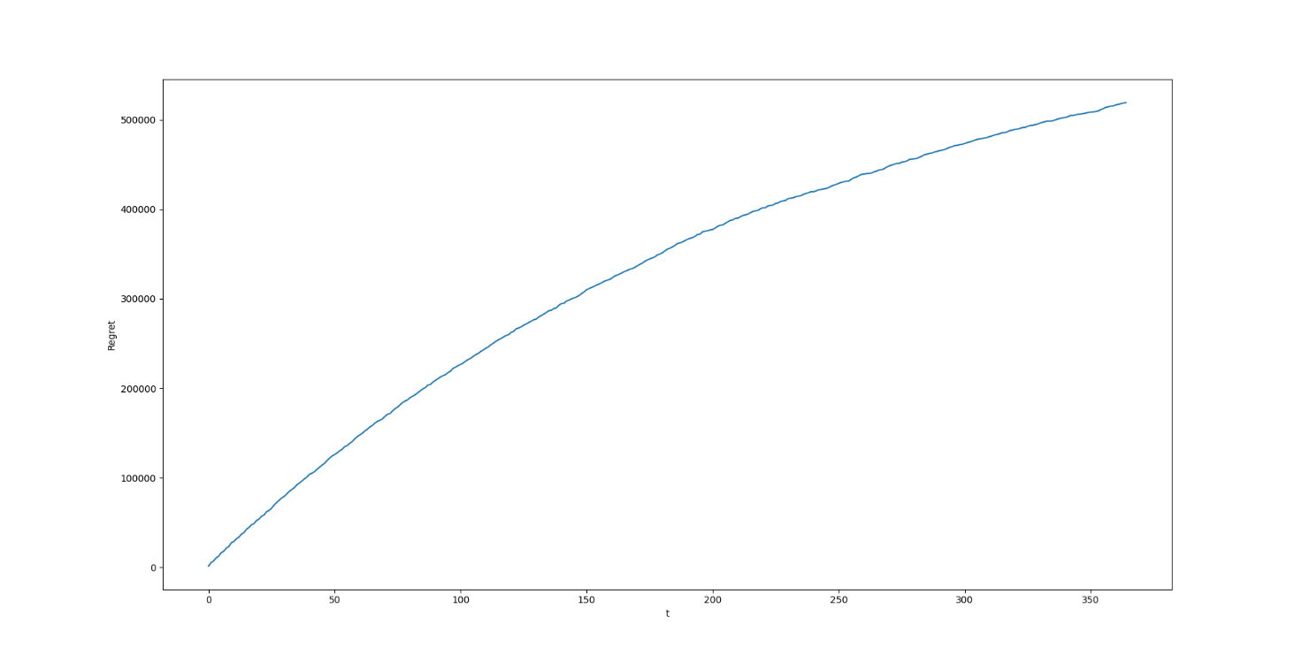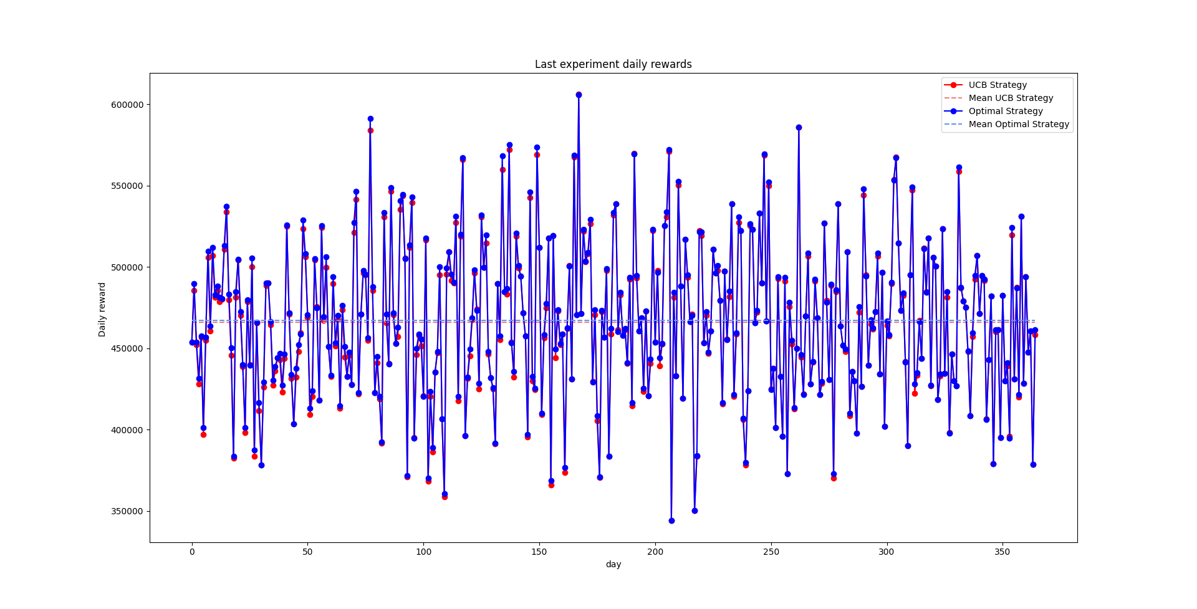

## Test – B

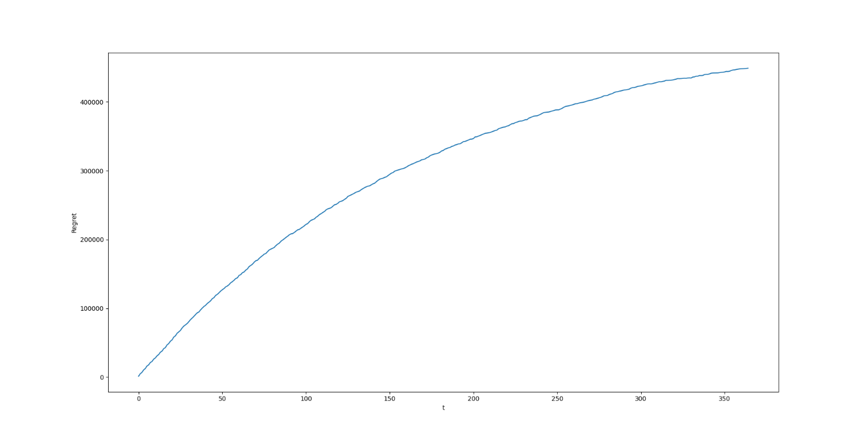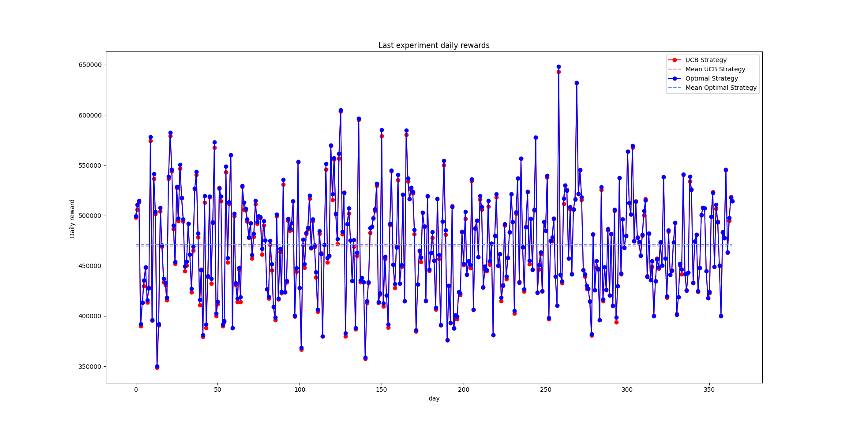

## Test – C

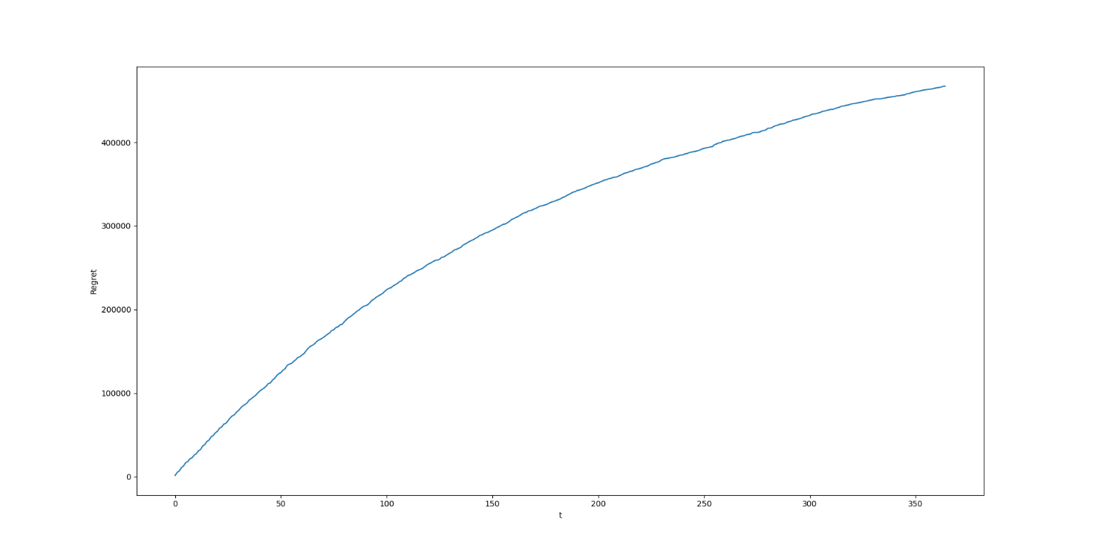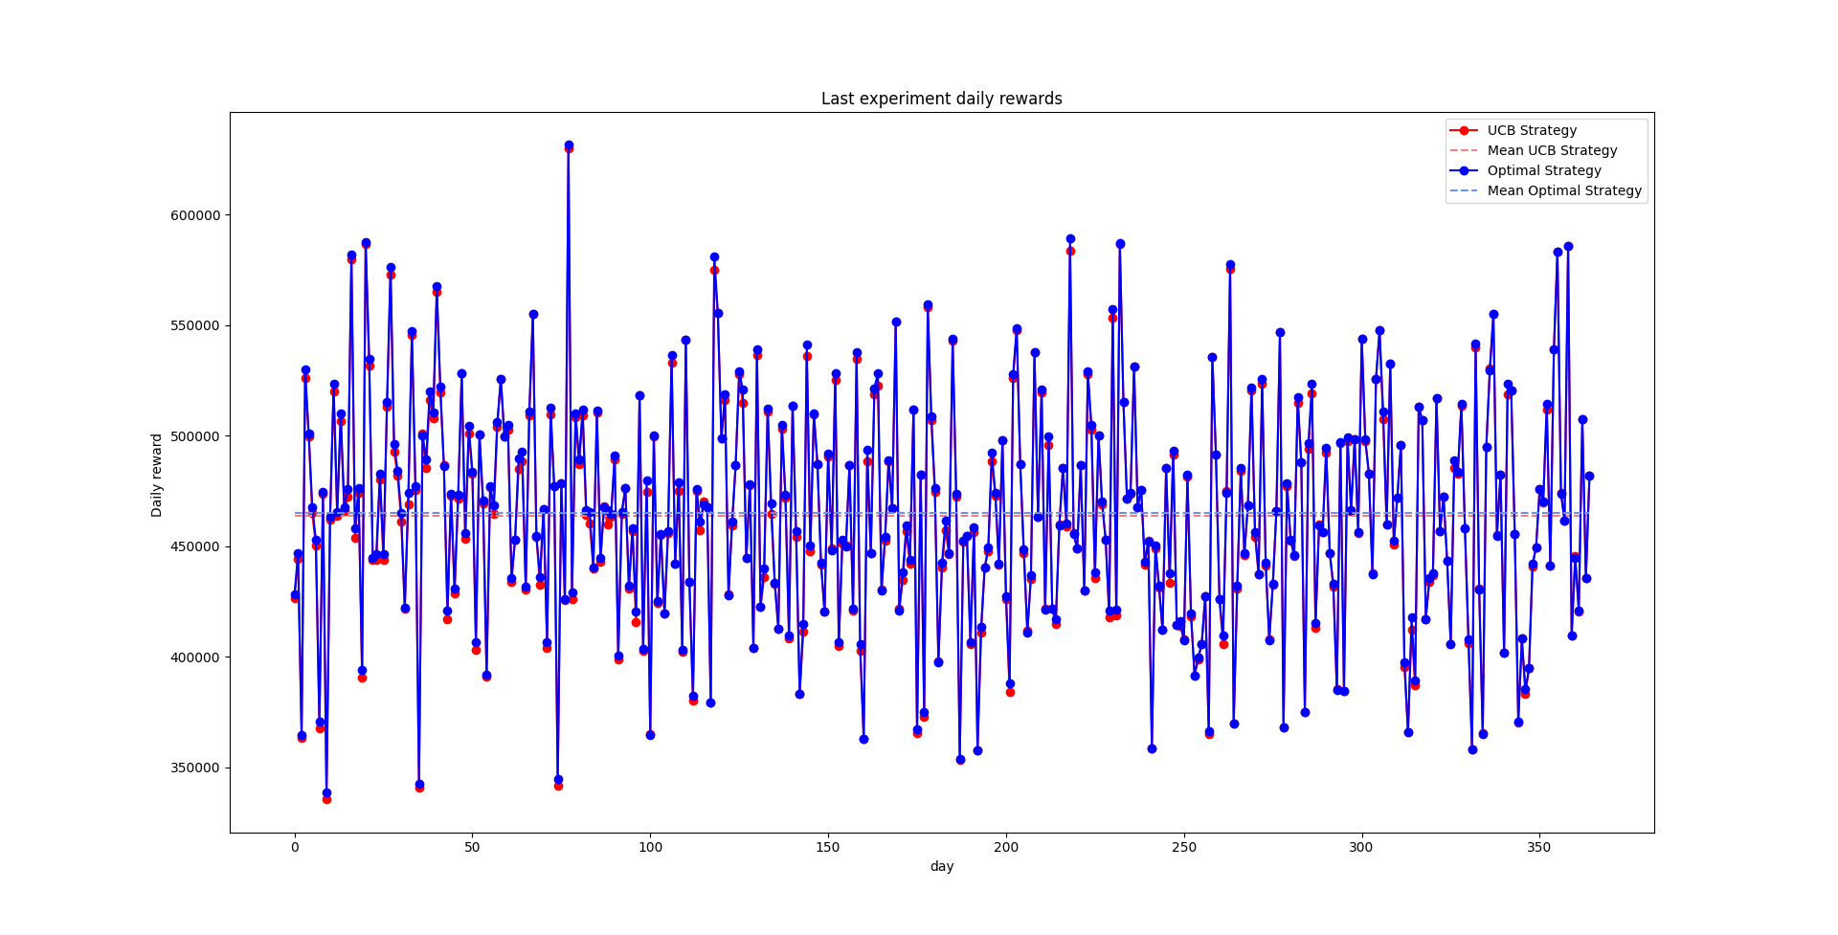

## Test – D

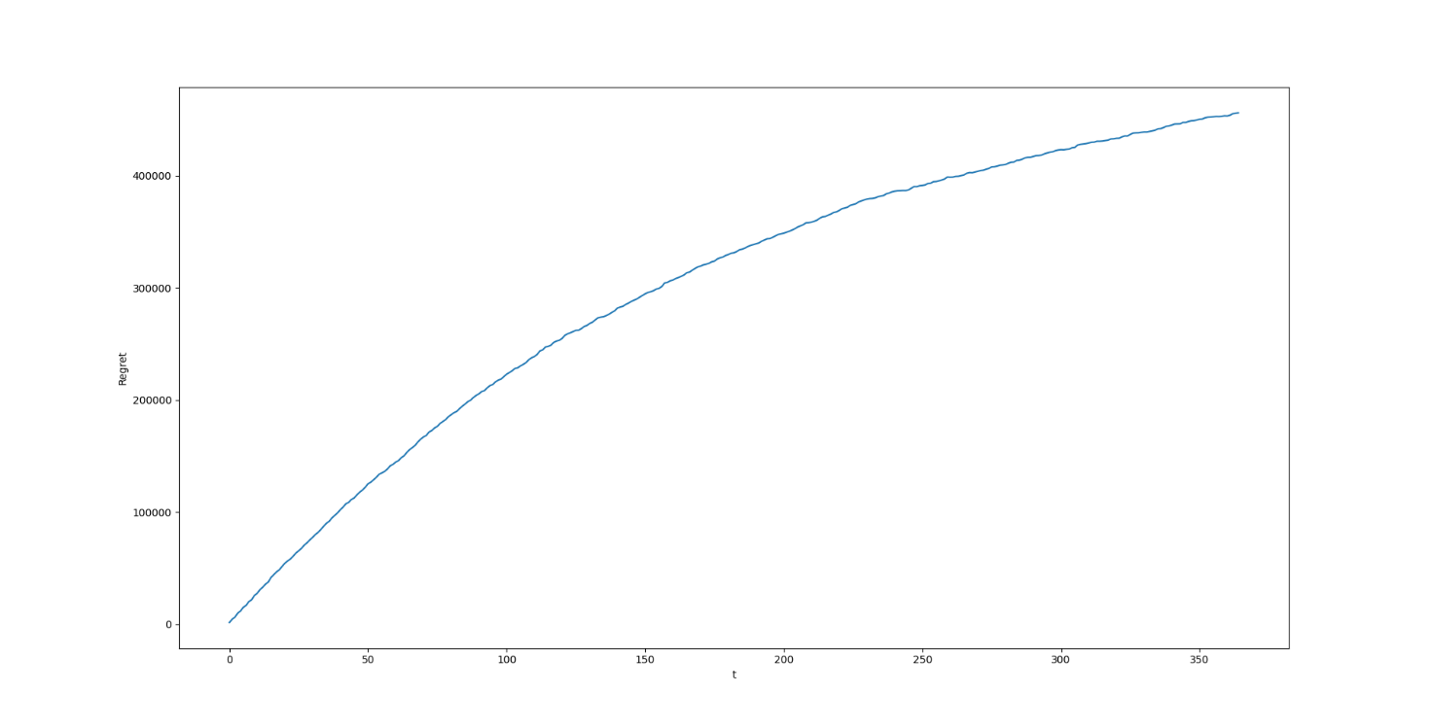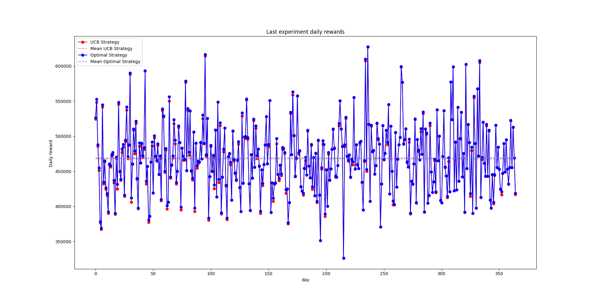

## Test – E

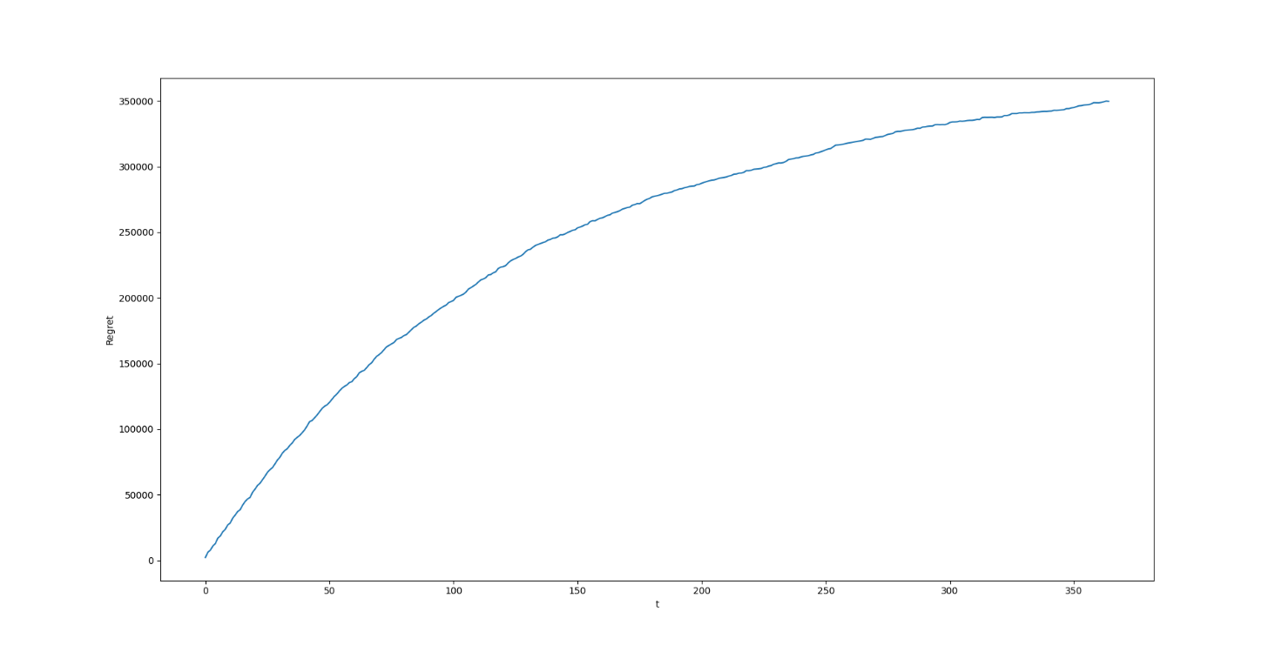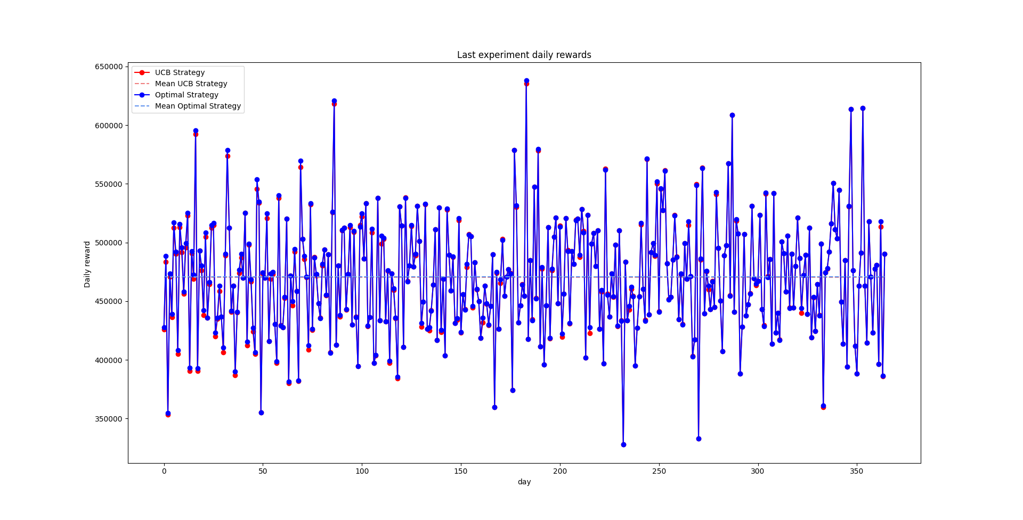

## Test – F

## 

## Test – G

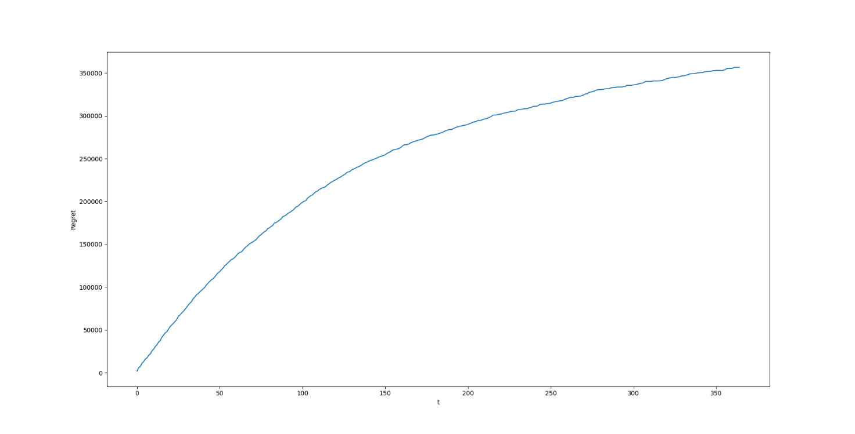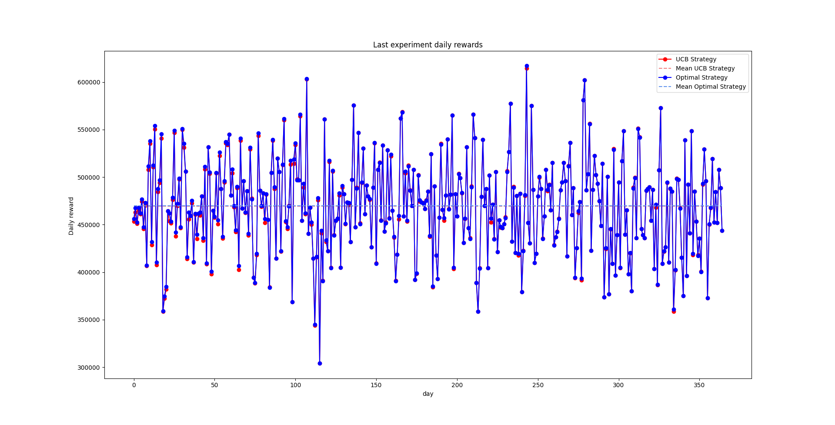

## Test – H

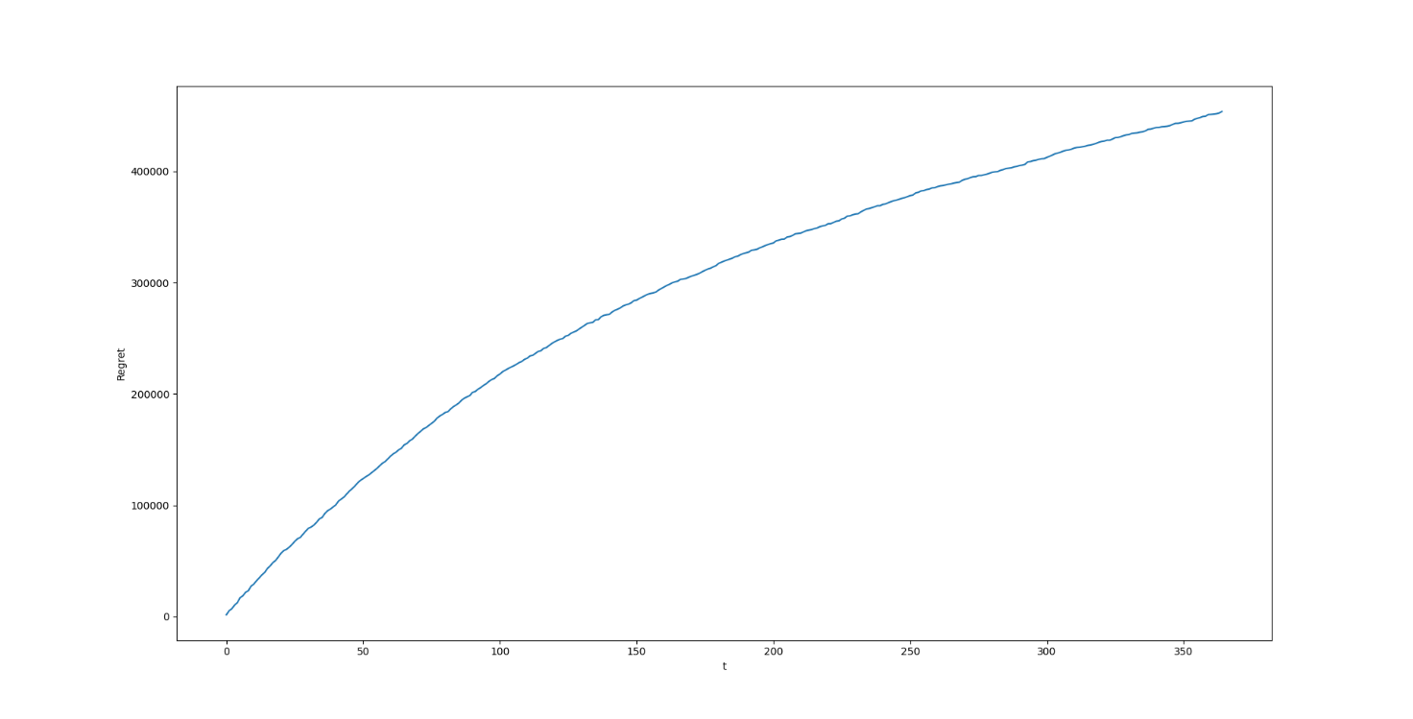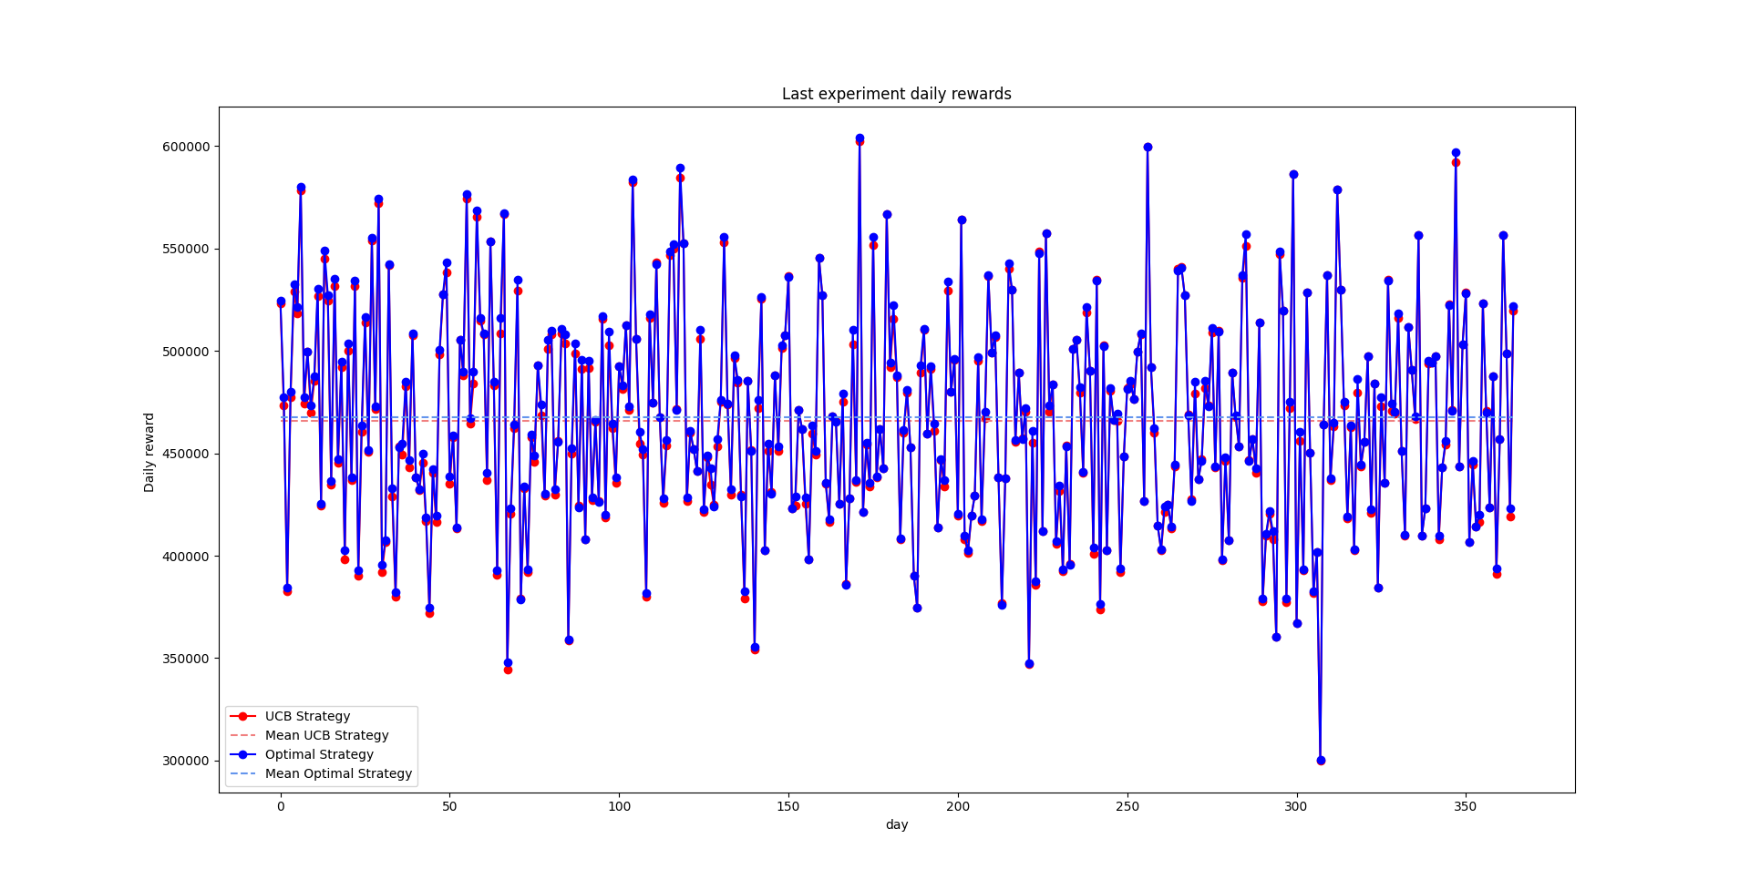

## Test – I

## 

## Test – J

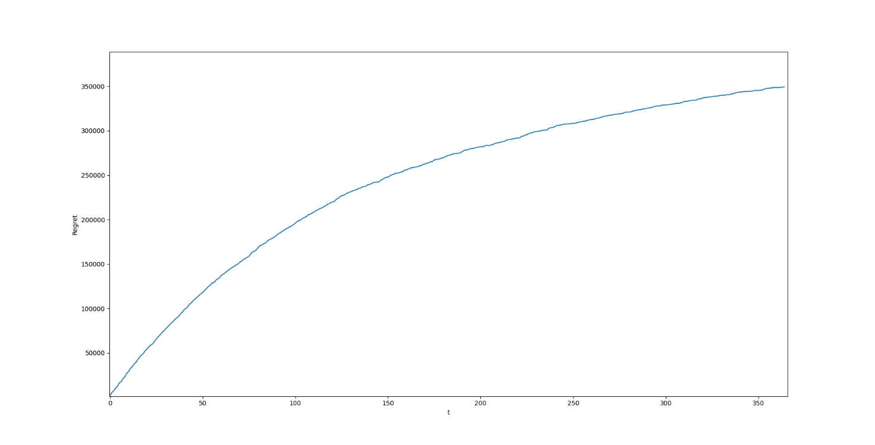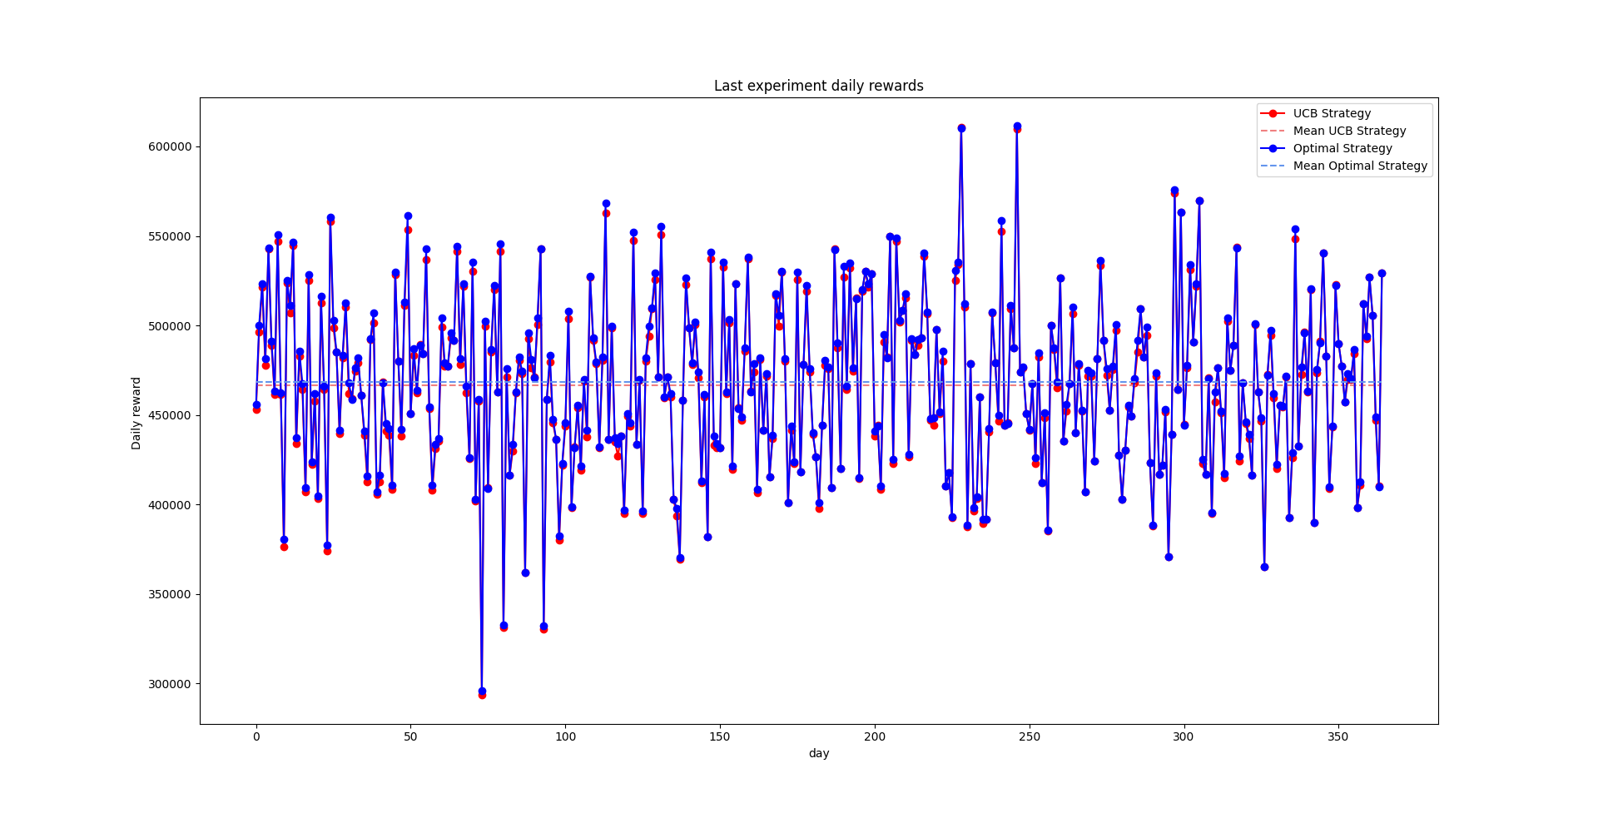

## Test – K

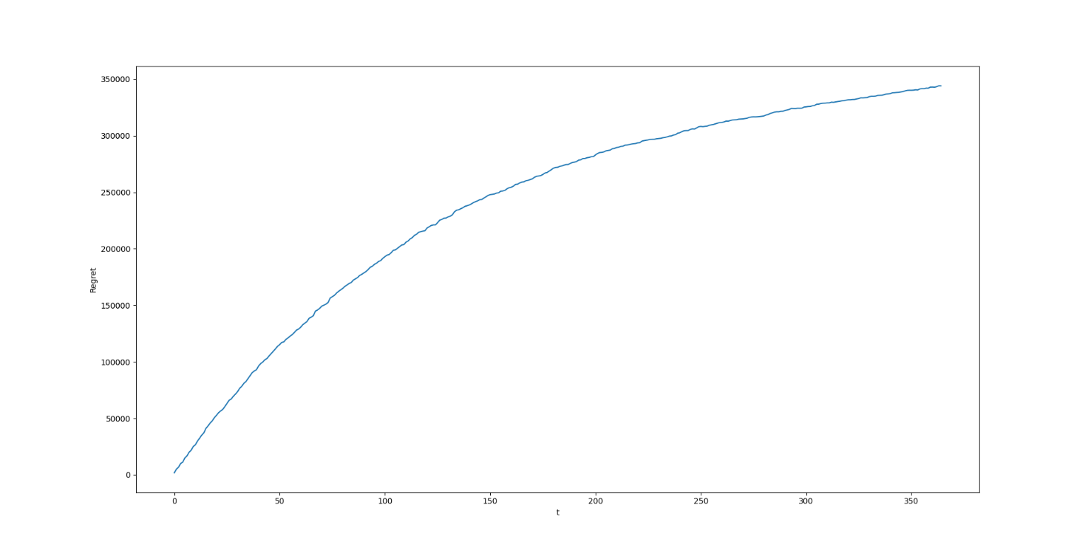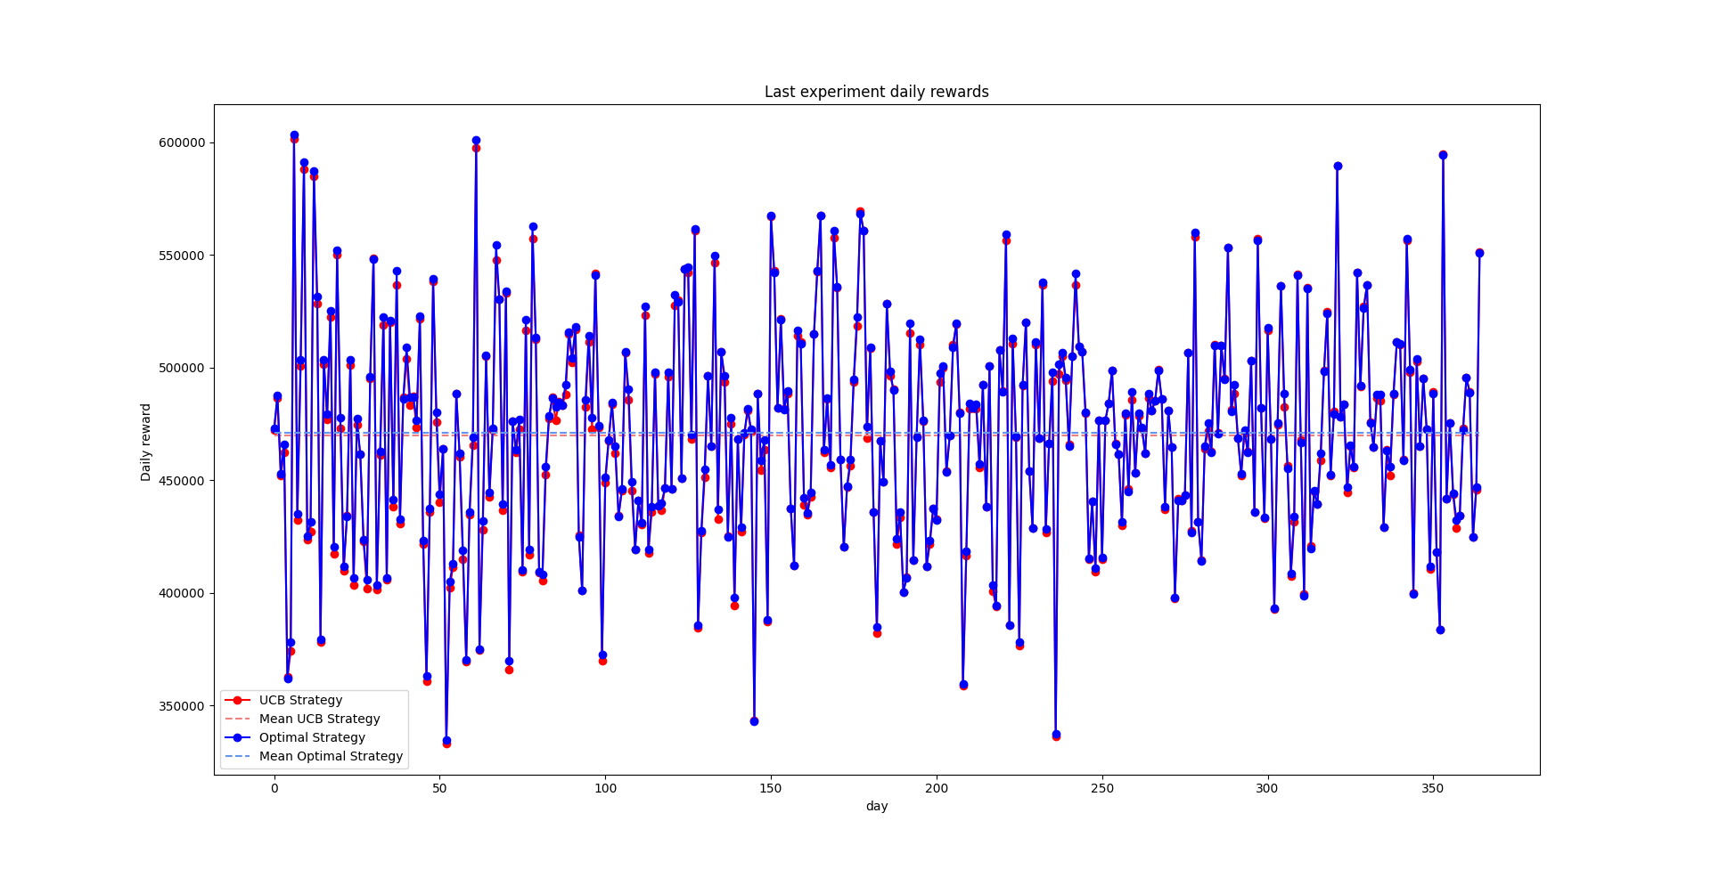

## Test – E-100

## Test – G-100

## Test – J-100

## Test – K-100