Simone Preite 3885035
TASK 1:
Germany is a country whose capital is Berlin.
Bielefeld is a settlement in Germany called Bielefeld or Liebefeld, with population of 327199 founded on 1214.

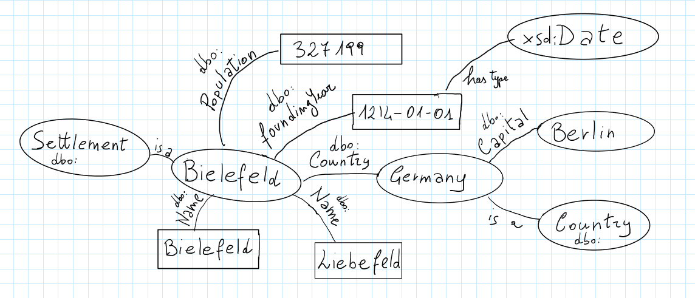

TASK 2:
<!DOCTYPE rdf:RDF [
<!ENTITY person "http://www.uni-bielefeld.de/resource/person/">
]>

<rdf:RDF
xmlns:rdf="http://www.w3.org/1999/02/22-rdf-syntax-ns#"
xmlns:teaching="http://www.uni-bielefeld.de/resource/sw_ss_2018/">

<rdf:Description rdf:about="http://www.uni-bielefeld.de/resource/semanticweb_ws_2018">

<teaching:coursename>Introduction to the Semantic Web</teaching:coursename>

<teaching:topic rdf:resource="http://dbpedia.org/resource/Semantic_Web" />

<teaching:staff rdf:parseType="Collection">

<rdf:Description rdf:about="&person;bell"/>
<rdf:Description rdf:about="&person;cwiljes"/>

</teaching:staff>
</rdf:Description>
</rdf:RDF>

Turtle:
@prefix person: <http://www.uni-bielefeld.de/resource/person/>

@prefix rdf: <http://www.w3.org/1999/02/22-rdf-syntax-ns#>
@prefix dbp: <http://dbpedia.org/resource/>

<http://www.uni-bielefeld.de/resource/semanticweb_ws_2018>;
teaching:coursename “Introduction to the Semantic Web”;
teaching:topic dbp:Semantic_Web;
teaching:staff (
person:bell
person:cwiljes
) .

TASK 3:

@prefix dbo: <http://dbpedia.org/ontology/> .
@prefix dbr: <http://dbpedia.org/resource/> .
@prefix dbp: <http://dbpedia.org/property/> .
@prefix xsd: <http://www.w3.org/2001/XMLSchema#> .

dbr:Italy a dbo:Country ;
dbo:capital dbp:Rome .

dbr:Diso a dbo:Settlement ;
dbo:country dbp:Italy ;
dbo:name "Diso"@it ;
dbo:population "2960" ;
dbo:foundingYear "1800"^^xsd:date .

<http://link.uri/SilvestroPreite> a dbo:Person;
dbp:name "Silvestro";
dbp:surname "Preite";
dbp:birthDate "1967-01-24"^^xsd:date;
dbo:residence dbp:Diso.

<http://link.uri/AddolorataColuccia> a dbo:Person;
dbp:name "Addolorata";
dbp:surname "Coluccia";
dbp:birthDate "1970-05-16"^^xsd:date;
dbo:residence dbp:Diso.

<http://link.uri/SimonePreite> a dbo:Person;
dbp:name "Simone";
dbp:surname "Preite";
dbp:birthDate "1989-12-05"^^xsd:date;
dbo:residence dbp:Diso;
dbp:email "simone.preite@uni-bielefeld.de";
dbp:mother <http://link.uri/AddolorataColuccia> ;
dbp:father <http://link.uri/SilvestroPreite>.

