Exercise 1:

foaf:maid rdfs:domain foaf:Agent
foaf:maid rdfs:range foaf:Document

foaf:Person rdfs:SubClassOf foaf:Agent
p:douge rdf:Type foaf:Person

p:timbl foaf:made l:im

p:timbl rdf:Type foaf:Agent (rdfs 2)
l:im rdf:Type foaf:Document (rdfs 3)
p:douge rdf:Type foaf:Agent (rdfs 9)

p:timbl rdf:Type rdfs:Resources (rdfs 4a)
l:im rdf:Type rdfs:Resources (rdfs 4b)

Exercise 2:
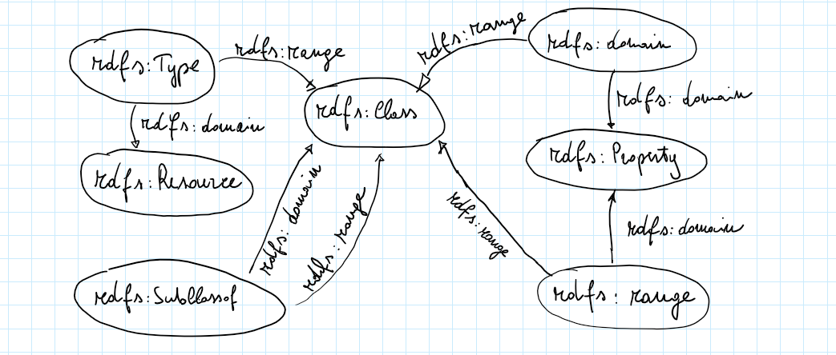
Moreover:
p:dounge rdf:Type rdfs:Resources (rdfs 2)
foaf:Person rdf:Type rdfs:Class (rdfs 3)
foaf:made rdf:Type rdfs:Property (rdfs 2)
foaf:Agent rdf:Type rdfs:Class (rdfs 3)
foaf:Document rdf:Type rdfs:Class (rdfs 3)
foaf: Person rdf:SubClassOf rdfs:Resources (rdfs 8)
foaf:Agent rdf:SubClassOf rdfs:Resources (rdfs 8)
foaf:Document rdf:SubClassOf rdfs:Resources (rdfs 8)

Exercise 3:
1)
ex:HallucinogenicSubstance rdfs:SubClassOf ex:PsycoactiveDrug
ex:PsycoactiveDrug rdfs:SubClassOf ex:Drug
--------------------------------------------------------------------------------------------
ex:HallucinogenicSubstance rdfs:SubClassOf ex:Drug

2)
ex:Mescaline rdfs:Type ex:HallucinogenicSubstance
ex:HallucinogenicSubstance rdfs:SubClassOf ex:PsycoactiveDrug
ex:PsycoactiveDrug rdfs:SubClassOf ex:Drug
--------------------------------------------------------------------------------------------
ex:Mescaline rdfs:Type ex:Drug

3)
ex:isActiveChemicalOf rdfs:SubClassOf ex:occursIn
ex:occursIn rdfs:domain ex:Drug
--------------------------------------------------------------------------------------------
ex:isActiveChemicalOf rdfs:domain ex:Drug

4) Can't be inferred

5)
Reflexivity Property
--------------------------------------------------------------------------------------------
ex:PsycoactiveDrug rdfs:SubClassOf ex:PsycoactiveDrug

