**Boundary Extraction & Region Filling**

4110056030 資工三 鄭詠謙

* **Code**

import numpy as np

import cv2

def dilate(img_matrix=None, kernel=np.ones((3, 3))):

    img_matrix = np.asarray(img_matrix)

    shape = np.asarray(kernel).shape

    dilated_img = np.zeros((img_matrix.shape[0], img_matrix.shape[1]), dtype=img_matrix.dtype)

    origin = (int((kernel.shape[0] - 1) / 2), int((kernel.shape[1] - 1) / 2))

    for i in range(len(img_matrix)):

        for j in range(len(img_matrix[0])):

            overlap = img_matrix[check(i - origin[0]):i + (shape[0] - origin[0]),check(j - origin[1]):j + (shape[1] - origin[1])]

            shp = overlap.shape

            first_row = int(np.fabs(i - origin[0])) if i - origin[0] < 0 else 0

            first_col = int(np.fabs(j - origin[1])) if j - origin[1] < 0 else 0

            last_row = shape[0] - 1 - (i + (shape[0] - origin[0]) - img_matrix.shape[0]) if i + (shape[0] - origin[0]) > img_matrix.shape[0] else shape[0] - 1

            last_col = shape[1] - 1 - (j + (shape[1] - origin[1]) - img_matrix.shape[1]) if j + (shape[1] - origin[1]) > img_matrix.shape[1] else shape[1] - 1

            if shp[0] != 0 and shp[1] != 0 and np.logical_and(kernel[first_row:last_row + 1, first_col:last_col + 1],overlap).any():

                dilated_img[i, j] = 255

    return dilated_img

def erode(img_matrix=None, kernel=np.ones((3, 3))):

    img_matrix = np.asarray(img_matrix)

    shape = np.asarray(kernel).shape

    eroded_img = np.zeros((img_matrix.shape[0], img_matrix.shape[1]), dtype=img_matrix.dtype)

    origin = (int(np.ceil((kernel.shape[0] - 1) / 2.0)), int(np.ceil((kernel.shape[1] - 1) / 2.0)))

    for i in range(len(img_matrix)):

        for j in range(len(img_matrix[0])):

            overlap = img_matrix[check(i - origin[0]):i + (shape[0] - origin[0]),check(j - origin[1]):j + (shape[1] - origin[1])]

            shp = overlap.shape

            first_row = int(np.fabs(i - origin[0])) if i - origin[0] < 0 else 0

            first_col = int(np.fabs(j - origin[1])) if j - origin[1] < 0 else 0

            last_row = shape[0] - 1 - (i + (shape[0] - origin[0]) - img_matrix.shape[0]) if i + (shape[0] - origin[0]) > img_matrix.shape[0] else shape[0] - 1

            last_col = shape[1] - 1 - (j + (shape[1] - origin[1]) - img_matrix.shape[1]) if j + (shape[1] - origin[1]) > img_matrix.shape[1] else shape[1] - 1

            if shp[0] != 0 and shp[1] != 0 and np.array_equal(np.logical_and(overlap, kernel[first_row:last_row + 1,first_col:last_col + 1]),kernel[first_row:last_row + 1,first_col:last_col + 1]):

                eroded_img[i, j] = 255

    return eroded_img

def check(index):

    return 0 if index < 0 else index

def boundary_extraction():

    img_path = "pika.jpg"

    input_img = cv2.imread(img_path)

    # 調整圖像大小

    height, width = input_img.shape[:2]

    new_dimensions = (width // 2, height // 2)

    input_img = cv2.resize(input_img, new_dimensions, interpolation=cv2.INTER_AREA)

    cv2.imshow("input", input_img)

    gray_img = cv2.cvtColor(input_img, cv2.COLOR_BGR2GRAY)

    # 二值化

    thresh = 128

    img_binary = cv2.threshold(gray_img, thresh, 255, cv2.THRESH_BINARY)[1]

    origin_el = np.ones((3, 3))

    # Erosion

    erosion = erode(img_binary, origin_el)

    # Dilation

    dilation = dilate(img_binary, origin_el)

    boundary = dilation - erosion

    # 二值圖畫素取反

    result = 255 - boundary

    cv2.imshow("erode", erosion)

    cv2.imshow("dilate", dilation)

    cv2.imshow("boundary", result)

    # 結束程式

    cv2.waitKey(0)

    cv2.destroyAllWindows()

def region_filling():

    img_path = "images.jpg"

    input_img = cv2.imread(img_path)

    # 調整圖像大小

    height, width = input_img.shape[:2]

    new_dimensions = (width // 3, height // 3)

    input_img = cv2.resize(input_img, new_dimensions, interpolation=cv2.INTER_AREA)

    cv2.imshow("input", input_img)

    gray_img = cv2.cvtColor(input_img, cv2.COLOR_BGR2GRAY)

    # 二值化

    thresh = 128

    img_binary = cv2.threshold(gray_img, thresh, 255, cv2.THRESH_BINARY)[1]

    # 構造Marker圖像

    marker = np.zeros_like(img_binary)

    marker[0, :] = 255

    marker[-1, :] = 255

    marker[:, 0] = 255

    marker[:, -1] = 255

    mask = 255 - img_binary

    cv2.imshow("mask", mask)

    origin_el = np.ones((3, 3))

    while True:

        marker_pre = marker.copy()

        dilation = dilate(marker, origin_el)

        marker = np.minimum(dilation, mask)

        if np.array_equal(marker_pre, marker):

            break

    result = 255 - marker

    cv2.imshow("result", result)

    filling = result - img_binary

    cv2.imshow("region filling", filling)

    # 結束程式

    cv2.waitKey(0)

    cv2.destroyAllWindows()

if __name__ == '__main__':

    boundary_extraction()

    region_filling()

* **Result**

圖片***Boundary Extraction***

邊界提取的應用公式:

    erosion = erode(img_binary, origin_el)

    dilation = dilate(img_binary, origin_el)

    boundary = dilation - erosion

利用膨脹後的圖減掉侵蝕後的圖可以得到一條輪廓，也可以用原圖-侵蝕圖或是用膨脹圖-原圖，只是邊界會稍微細一點。

左上為input原圖，右上為侵蝕圖，左下為膨脹圖，右下為邊界提取結果。

Result1:

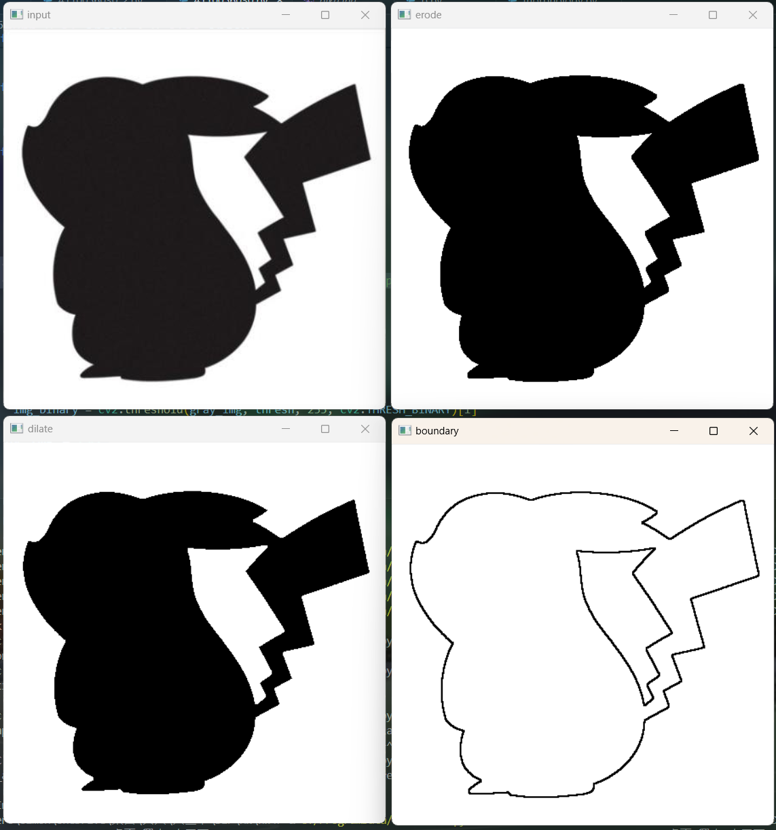

以下是用不同的圖片提取邊界，可以看到最後的結果在右下。

Result2:

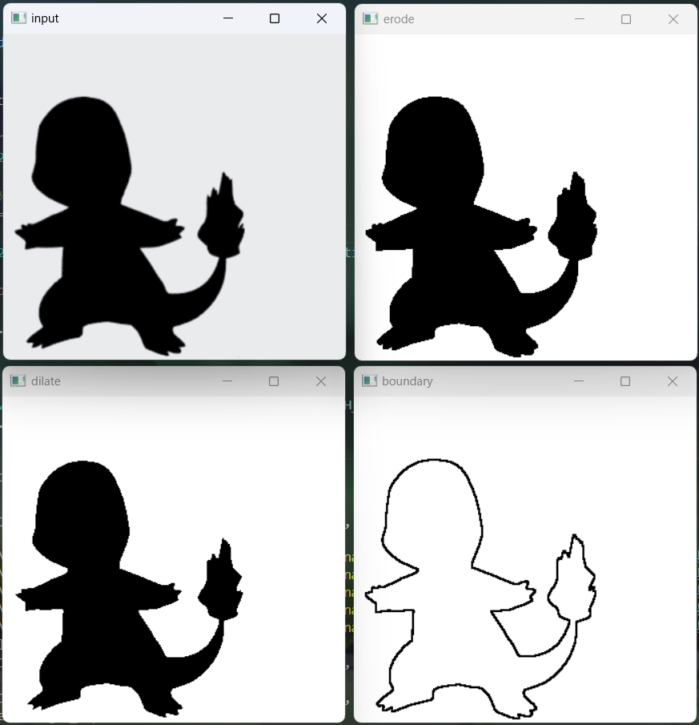

***Region Filling***

利用B圖這種Structures Element逐步移動，直到撞到A補集的邊界就往下一行填滿，直到範圍內都跑完。把X7跟A作聯集就是填滿後的樣子。

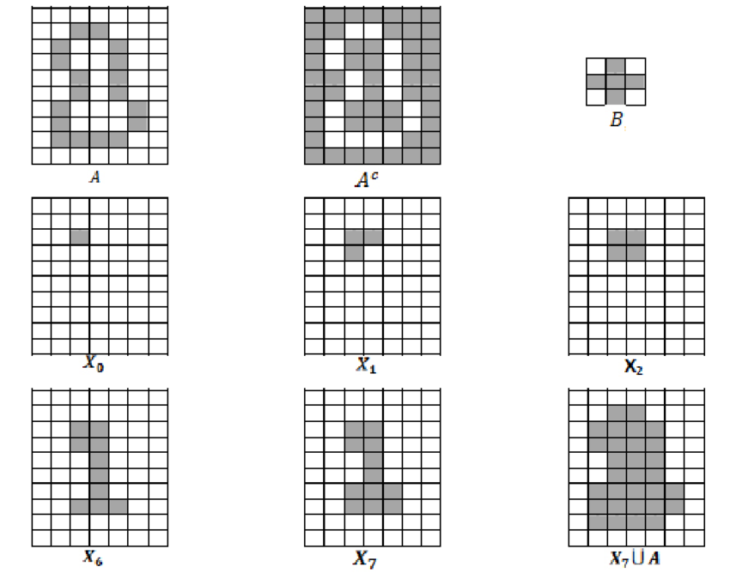

圖源:https://www.researchgate.net/figure/Figure-33-Representation-of-the-region-filling-algorithm_fig7_297585117

Result1:

左上為input原圖，右上為他的補集，左下為類似上圖X7欲填滿的區域，右下是填滿後的結果。

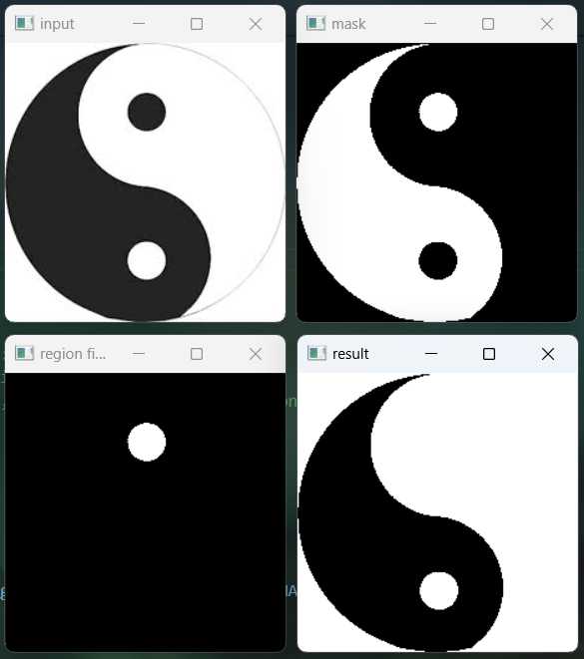

下圖為課本中給的圖片，可以看到右下角是把圈圈填滿的結果。

Result2:

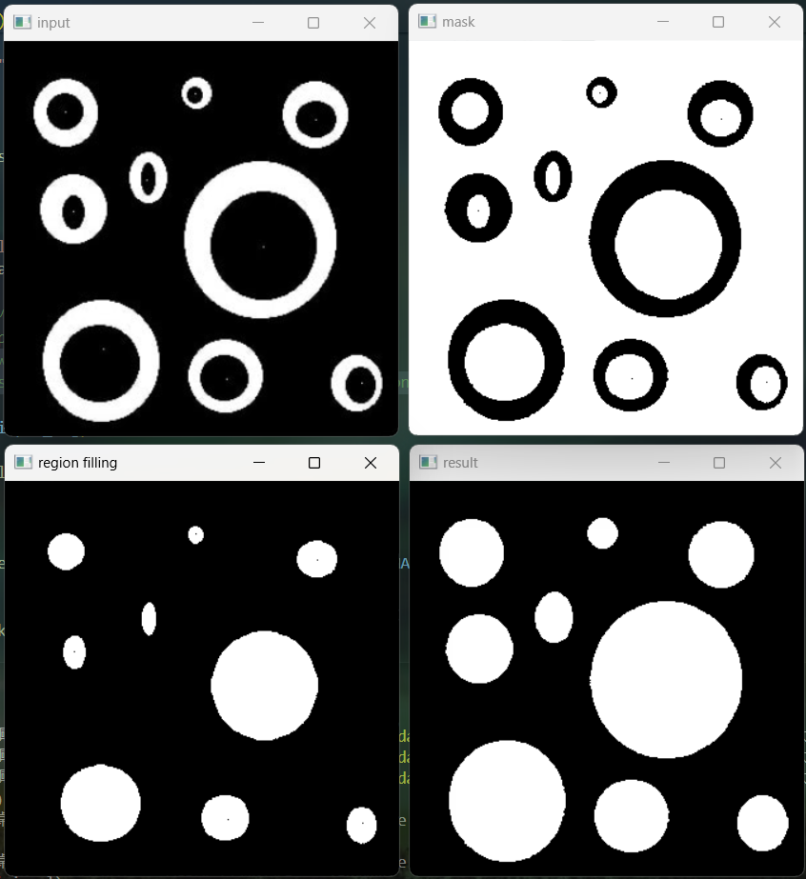

Result3: 填補更加細節的區域。

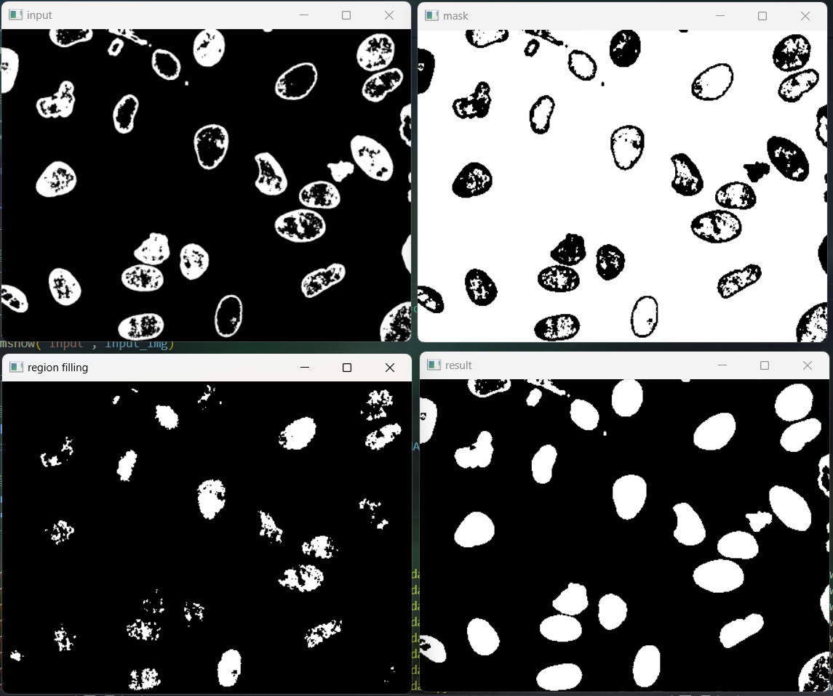

* **Discussion**

***Boundary Extraction***

調整線條粗細，改用原圖減侵蝕或是用膨脹減原圖。

使用原圖減去侵蝕的結果:

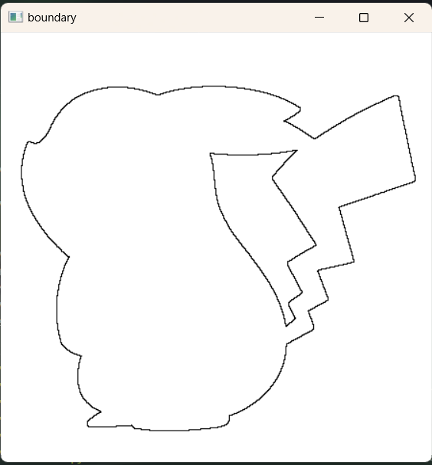

用膨脹減去侵蝕的結果:

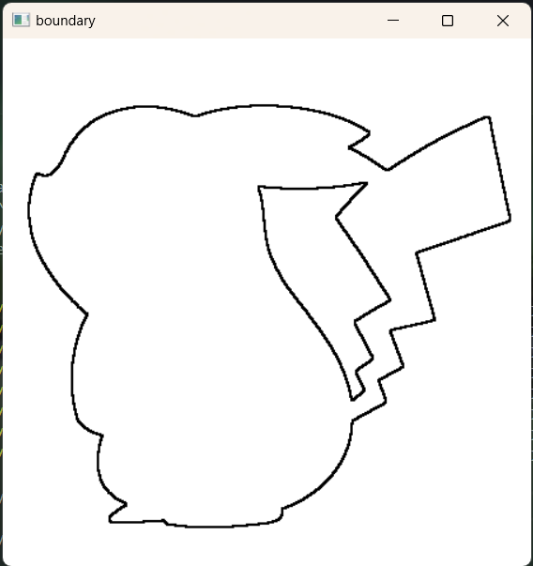

粗細會有明顯的不同。

***Region Filling***

用不同大小的element去填滿區域會有不同的效果

np.ones((3, 3))

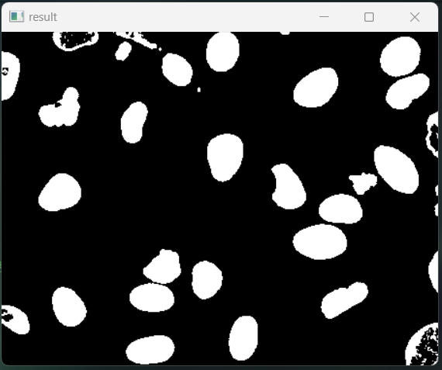

np.ones((5, 5))

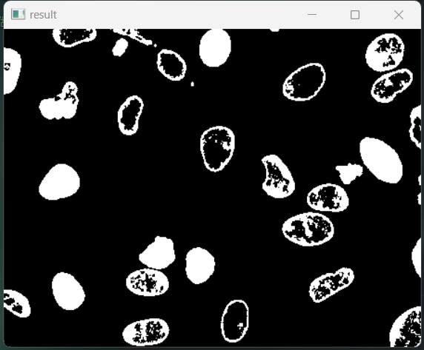

np.ones((7, 7))

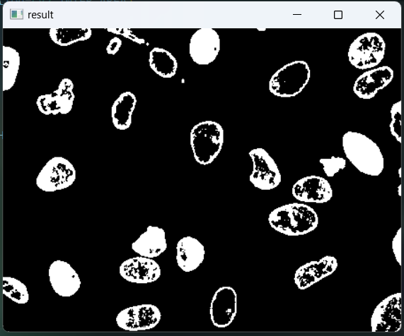  
可以由上三種不同大小的結構elements看出3x3的會是最細節的，而7x7的填滿結果有很多地方都沒有填補到。以下是3x3跟7x7兩種element的filling。

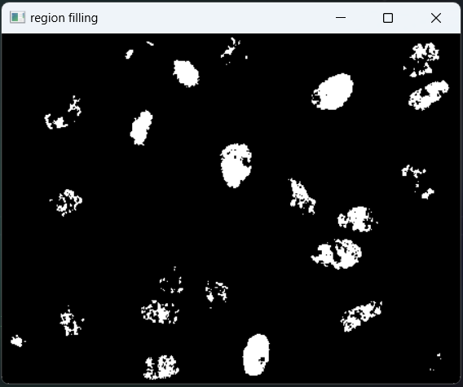 3x3

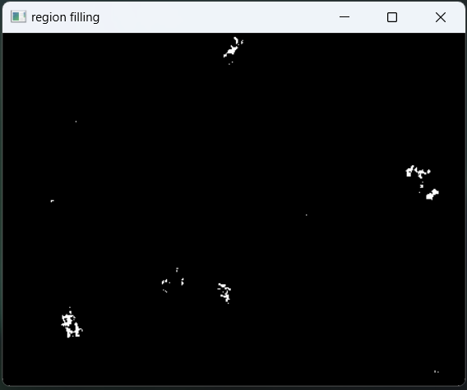 7x7

總結:

Boundary Extraction主要是利用大圖減去小圖，邊緣偵測其實有許多方法例如sobel、canny等等，但是都不如使用Morphology 方法計算來的簡單。

Region Filling也是有用到dilation 跟 mask做比較，以達到filling的效果。