關聯規則練習

1. Compute the **Support**, **Confidence**, and **Lift** for the rules of a, b, and c.

|  |  |  |  |
| --- | --- | --- | --- |
|  | Play-basketball | Not play-basketball | Total |
| Eat-cereal | 100 | 50 | 150 |
| Not eat-cereal | 150 | 300 | 450 |
| Total | 250 | 350 | 600 |

1. Play-basketball → Eat-cereal

Support = 100/600 = 1/6

confidence = 100/250 = 2/5

lift = (100/600)/((150/600)*(250/600))=(1/6)/((1/4)*(5/12)) = 1.599

1. Not play-basketball → Eat-cereal

Support = 50/600 = 1/12

confidence = 50/350 = 1/7

lift = (50/600)/((150/600)*(350/600))=(1/12)/((1/4)*(7/12)) = 0.5714

1. Not play-basketball → Not eat-cereal

Support = 300/600 = 1/2

confidence = 300/350 = 6/7

lift = (300/600)/((450/600)*(350/600))=(1/2)/((3/4)*(7/12)) = 1.1428

2. Given the following set of transactions from a shopping mall, compute the

support, confidence, and lift for each rule:

|  |  |  |  |  |  |  |
| --- | --- | --- | --- | --- | --- | --- |
| Transaction  101 | Clothing  1 | Electronics  1 | Cosmetics  0 | Accessories  1 | Shoes  0 | Books  0 |
| 102 | 0 | 1 | 1 | 0 | 1 | 0 |
| 103 | 1 | 0 | 1 | 1 | 0 | 1 |
| 104 | 0 | 1 | 0 | 1 | 1 | 1 |
| 105 | 1 | 1 | 1 | 0 | 0 | 0 |

|  |  |  |  |
| --- | --- | --- | --- |
| Rules | **Support** | **Confidence** | **Lift** |
| (Clothing & Electronics) -> Cosmetics | 20% | 50% | 0.2/(0.4*0.6)= 83% |
| (Clothing & Cosmetics) -> Accessories | 20% | 50% | 0.2/(0.4*0.6)=  83% |
| (Electronics & Accessories) -> Shoes | 20% | 50% | 0.2/(0.4*0.4)=  125% |
| Cosmetics -> Books | 20% | 33.4% | 0.2/(0.4*0.6)=  83% |

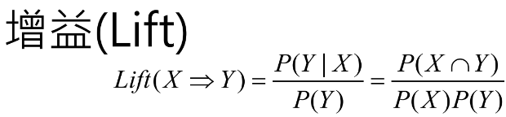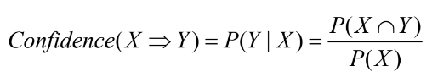



3. Given the transactions and the task of finding association rules with **minimum support of 65%** and **minimum confidence of 75%** using the **Apriori algorithm**, here's a revised question:

Transactions:

|  |  |
| --- | --- |
| T0001 | {Shirt, Shoes, Pants, Hat, Sunglasses, Watch} |
| T0002 | {Shirt, Shoes, Hat, Sunglasses, Watch} |
| T0003 | {Shirt, Pants, Belt} |
| T0004 | {Shoes, Hat, Sunglasses, Watch} |
| T0005 | {Shirt, Shoes, Pants, Belt, Sunglasses} |

(1). 65%*5=3.25 -> (>=3.25)也就是4筆就是Large itemsets

(2). (Shirt) ,(Shoes) ,(Sunglasses)

(3). (Shoes, Sunglasses)

(4). Shoes -> Sunglasses = P(Shoes ∩ Sunglasses) / P(Shoes) = 1 > 75%

Sunglasses -> Shoes = P(Sunglasses ∩ Shoes) / P(Sunglasses) = 1 > 75%

* Shoes -> Sunglasses, Sunglasses -> Shoes

