**Mutex Lock** to protect PID manager before allocate PID

**Mutex Unlock** after allocate PID

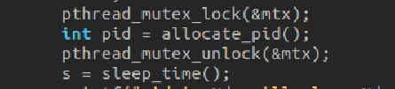

**Mutex Lock** to protect PID manager before releasing PID

**Mutex Unlock** after releasing PID

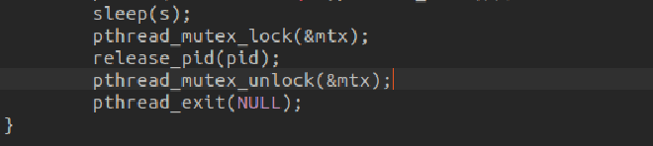

Destroy **Mutex** at the end



執行結果:

