# Perceptive.co.uk feedback 27/11/2012

|  |
| --- |
|  |

## Home

* **LD:** "NetworkError: 404 Not Found - http://79.170.40.242/perceptive.co.uk/style.css"
* **PI:** Ames study manager image looks a bit squashed
* **PI:** I think that the text on the slideshow images is a bit blurred
* **LD:** Searching for “comet” brings Ames Study Manager as top result – it is ordering results alphabetically instead of by relevance
* IE8:
  + **LD:** Top menu item disappears when you select it (white text on a white background)
  + **PI:** Fonts don’t load properly on first pageview – we need to find some way of making this work
  + **LD:** In applications/ames-testing there is an extra box in the related products which links back to this page! How easy is this to do ourselves?
* **PI:** Twitter feed “perceptiveInsts” and any links in the tweets are too faint to see on my browser
* **LD:** When you right-click on twitter links firefox blocks popup opening.
* **LD:** Can’t click on the banner to find out more! Make each slide image a link to its related product.
* **PI:** File size of banner images is too large - the sorcerer image is 3.2MB! When you do a hard refresh (as if someone visits the site for the first time) the slideshow takes a very long time to load (~12s on my machine) which doesn’t look good. The images need compressing.
* **PI:** Terms and conditions in footer needs changing to “User agreement, privacy policy, sitemap”

## About Us

* **PI:** Menu look a bit weird – massive gap between the second and third columns
* **PI:** In “a strong client base”, there’s a link to the clients page – it just takes you to the top of the page
* **PI:** The last two columns in the menu need to be the other way round
* **PI:** the testimonials page is called TESTIMIONIALS.

## Client Portfolio

* **PI:** Only shows clients from A-F!

## Products page

* **PI:** “contact us” in first paragraph needs a link

## News items

* **LD:** We don’t want the facebook, tweet, pinterest and share buttons – they take a long time to load. It looks like this while theyre loading:

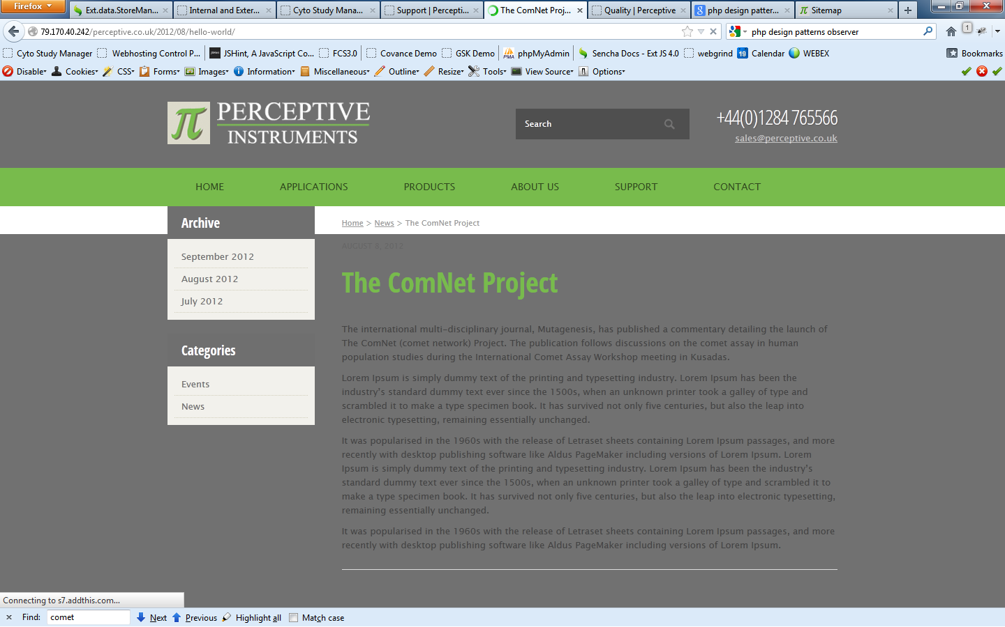

* The URLS for the news items are strange – one’s called ‘hello-world’ and the other is ‘contrary-to-popular-belief’

## Applications/ames-testing

* **PI:** Ames archive manager logo is bigger than other logos in related products section

## Applications/colony-counting

* **PI:** No link to sorcerer – no related products

## Applications/study-management

* **PI:** Related products are not in correct order

## Applications/regulatory-testing-e-g-reach

* **PI:** Can URL and title just be “regulatory testing”?

## Applications/multipoint-mic-antibiotic-sensitivity

* **PI:** Products available should be Sorcerer Image Analysis

## Applications pages

* **LD:** “Send form” button sends you to bottom of page instead of submitting the form

## Generally

* **LD:** Buttons are of inconsistent style. They should all match the “Send Form” button in the contact us form in the footer on the homepage. Some of them have rounded corners.
* **PI:** A lot of the links go to page ids rather than SEO friendly links – we’ll have to sort that out I guess
* **PI:** I think the screenshots bits look a bit strange – can’t tell that there are many more screenshots…
* **LD:** Drop down menus still moving very slightly (~1px)
* Sometimes page loads are extremely slow (~27s)– don’t know if this is the site or the server
* **LD:** Fonts library sometimes takes an eternity to load. In the screenshot below you can see this:

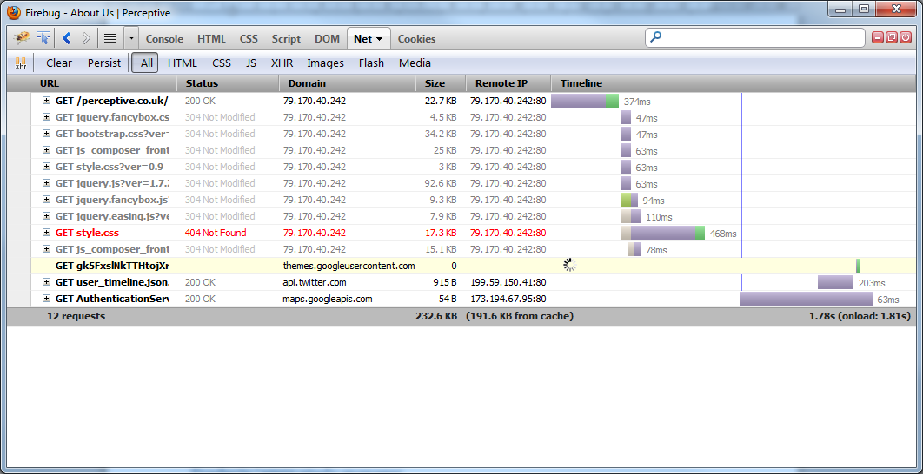

* All pages need contact form footer like homepage except product pages because they already have “enquire” form

## Case Studies

* **PI:** Some pages have the wrong shade of green – **LD** how can we change these?
* **PI:** Comet: doesn’t link to a case study, links to data extractor/spreadsheet generator page
* **PI:** The case studies section does not seem particularly well structured

## Ames archive manager

* **PI:** Image of comet!

## Applications/regulatory-testing

* **PI:** Link to UK health and safety executive is not right

## Applications/comet-assay

* **PI:** Data extractor, comet and SAM all have the same logos – SAM at least needs a different one

## Applications/direct-epifluorescence-microscopy-deft-2/

* **PI:** direct-epifluorescence-microscopy-deft-2/ is a bit long – can it be changed to something shorter?
* Also, why is there a 2 on the end?

## Applications/pulp-paper-analysis

* **PI:** Speckcheck2 needs a logo

## Products/ames-study-manager

* **PI:** Quote is not the same as in Frances’ document
* **PI:** Related products not as in Frances’ document

## Products/comet-assay-iv

* **PI:** Testimonial not the same as in Frances’ document
* **PI:** Related products not as in Frances’ document
* **PI:** Rephrase “range of products” link sentence
* **PI:** No links in regulatory compliance tab
* **PI:** No link to trial page – also I think we need to make it clearer that there is a free trial of CAIV – its not very obvious…

## Products/comet-assay-iv-the-spreadsheet-generator-and-the-data-extractor

* **PI:** How do you even get to this page?

## Products/data-extractor-for-comet-assay-iv

* **PI:** This is a sub-product – doesn’t need 3 columns or tabbed box
* **PI:** Related products not the same as in Frances’ document

## Products/cyto-study-manager

* **PI:** Related products should be other way round

## Products/sorcerer-colony-counter

* **PI:** Related products should be other way round

## Products/sorcerer-colony-counter-in-the-development-of-meningitis-vaccines

* **PI:** Needs to link to sorcerer page when mentions sorcerer or ‘sorcerer colony counter’

## Products/system-access-manager

* **PI:** Cyto study manager, ASM, CAIV and Sorcerer need to be in related products