**How do you go from a completely blank slate to having a plan?**

Starting with a blank slate is exciting, but when you could make just about anything, the range of possibilities can be overwhelming. I came up with a three-step process for producing some coherent business ideas.

The three steps are:

1. Generate lots of ideas
2. Organise the ideas and develop the best ones
3. Criticise the best ideas

**Step 1: Generate ideas - focusing on quantity, not quality.**

It is often hard to tell if an idea is any good at the time you have it. Ideas also sometimes arrive at unexpected times so I find it useful to always have a simple way to capture and record ideas.

To do this, I use the Braintoss app which I have set to automatically sends the ideas to a Trello board.

The Trello board acts as an “Ideas Park” a concept I took from the book [How to be a Productivity Ninja](https://www.amazon.co.uk/How-Be-Productivity-Ninja-Achieve/dp/178578028X/ref=sr_1_1?crid=1Q2IO5G6CY24K&dchild=1&keywords=productivity+ninja&qid=1606306323&sprefix=productivity+nin%2Caps%2C175&sr=8-1). This works by being a place to collect and then organise the flow of ideas.

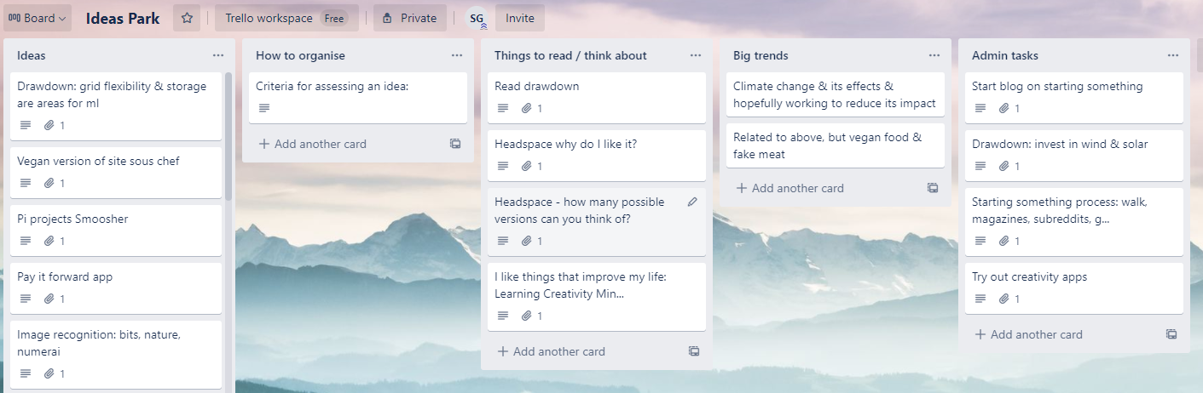

**What if the ideas aren’t flowing?**

I find I have the best ideas when I am relaxed, doing things I like, reading a lot and that they often come after I do new things or visit new places.

My methods for producing ideas are:

* Going for a walk
* Learning about the problems of others through:
  + Google search data
  + Reddit or similar
  + Conferences
* Thinking about products I like and how a similar approach could be applied to new or different domains (for example “[Headspace](https://www.headspace.com/) for parenting” or “[Brilliant](https://brilliant.org/) for cooking”).

**Step 2: Organise the ideas and develop the best ones further**

An ideas park means that your ideas are stored indefinitely until you have the time or inclination to develop them (or discard them).

Leaving a bit of time also ensures that you don’t instantly fall in love with an idea and spend loads of time on it only to realise it wasn’t that good later.

**Step 3: Criticise ideas**

There are certain attributes I want any project I work on to have and also if it is to have any chance of commercial success.

I plan to develop a checklist that will provide a way of assessing ideas - this will provide a way of ranking ideas and should help to make sure that this is something that other people want to use.

Some of the types of things that will be on this list are:

* Will it be fun to work on?
* Will it make people’s lives better?
* Can it be automated/does it require ongoing work to maintain?
* Can you easily explain the idea in one sentence?
* What do my imaginary board of mentors think of this idea?

**Conclusion**

I’m allowing myself plenty of time to come up with as many ideas as I can and I am trying to draw inspiration from a wide range of external sources so I haven’t completed this process yet. After I’m done, I’m hopeful a winner or winners should emerge.