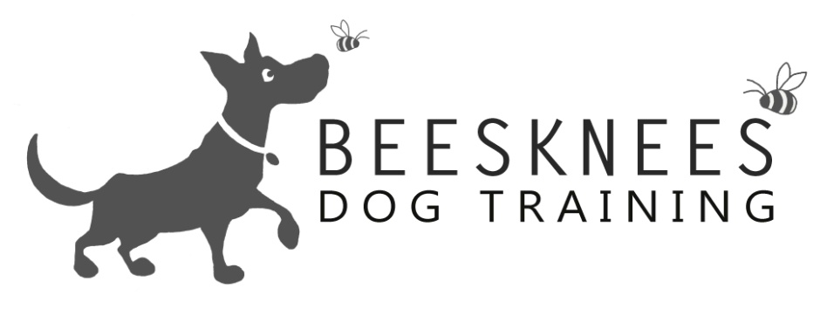

**Welcome to the Basics Class**

Welcome to Bees Knees Dog Training were I offer a variety of dog training options. All the training is Relationship Centred (putting your relationship with your dog at the centre of everything you do) I only use positive training methods focusing on having happy and polite dogs that enjoy training. Here is an overview of what I cover in the Basics Class. Any dog of any age can join the Basics Class as the classes are based on the dogs skill level. My classes are open to all dogs and breeds, also any humans that would like to come along too. I do a mix of obedience with tricks and information so that you get a well-rounded experience. Here is the Basics Class:

|  |  |  |
| --- | --- | --- |
| **Obedience** | **Tricks** | **Information** |
| Sit, realise and Down | Find | What is Relationship Based Training |
| Stand | Through Legs | Training tips |
| Leave: In front of you | Introduction to the Jump | Training excuse me |
| Leave: whilst moving | Targeting a cone | Dealing with jumping up |
| Loose lead walking | Spin | How to do out and off |
| Loose lead walking: Place | Back up | Remembering to praise a good dog |
| Loose Lead Walking: self control |  | Relaxation |
| Getting a heal with no lead |  | Please and a default sit |
| Recall |  | Why punishment doesn't work |
| Wait: in sit and down for 30seconds |  | What not to feed your dog |
| Wait: moving away and around |  | Dogs and children |
| Wait: for dinner |  |  |
| Drop and Gentle |  |  |
| Hand targeting |  |  |
| Watch me |  |  |
| Go to bed |  |  |
| Clicker Training |  |  |
|  |  |  |

Anything that appears above that is also on the Puppy Class curriculum is an advancement of that skill. The Basics Class is a step up from the Puppy Class I would expect the dogs to have been introduced to some training.

The class runs for **eight weeks at a cost of £74** (which works out to £9.25per session) You will get instruction, sheets to take home on each subjects, a certificate and rosette at the end of the course. So please come and check out dates and times at **www.beeskneesdogtraining.co.uk**. If you have any questions don't be afraid to contact me at: **beeskneesdogtraining@gmail.com.**