
ECE Paris 2014 - 2015
ING4 - G1

Advanced Java Lab
Thread-Safe BST

Simon JASPAR - Japheth Kangogo KOSGEI - Vincent RAKOTOMANGA
February 10th 2014
Benchmark

Tests conditions :

- Tests were made with a fixed threads pool of 10.000 threads.
- Threads use a lock mecanism to make node adding in the tree thread safe
- The Dot graph generation was disabled.

We added a total of 1.000.000 nodes to the tree using each time a various number of threads.

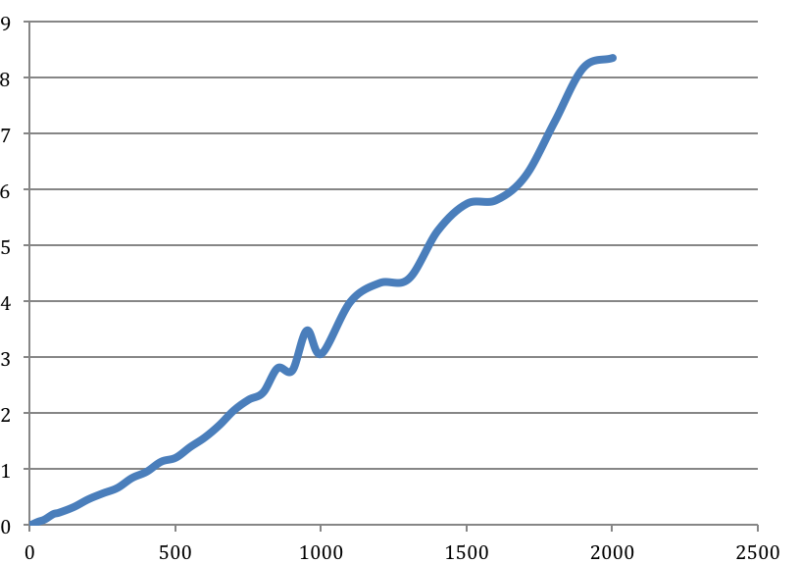
Insertion time in milliseconds (y) according to the number of threads (x)

As we can see on the graph above, the insertion time increase with the number of threads. Actually, threads cannot add nodes concurrently, in order to garanty data consistency. This is why the time of insertion increases with the number of threads. Each time one of the threads wants to make an insertion, it has to wait for the adding function to be released by the threads currently inserting.

