**Title:** Resource availability and organismal traits shape communities in extreme coral reef environments

**Authors:** Simon J. Brandl1,2,3, Jordan M. Casey2,3, Luke Tornabene4, John A. Burt5, Jacob L. Johansen5,6

**Affiliations:**

1 Department of Biological Sciences, Simon Fraser University, Burnaby, BC, Canada

2 PSL Université Paris: CNRS-EPHE-UPVD USR3278 CRIOBE, Université de Perpignan, Perpignan, France

3 Laboratoire d’Excellence “CORAIL,” Perpignan, France

4 School of Aquatic and Fishery Sciences and the Burke Museum of Natural History and Culture, University of Washington, Seattle, WA, USA

5 Marine Biology Laboratory, Centre for Genomics and Systems Biology, New York University Abu Dhabi, Abu Dhabi, United Arab Emirates

6 Hawai’i Institute of Marine Biology, University of Hawai’i at Manoa, Kane’ohe, HI, USA

**Introduction:**

* ­Existence in extreme environments has great challenges; therefore, environments with extreme environmental conditions (e.g. temperature, salinity, pH) frequently harbor highly specialized organismal communities
* An often implicit assumption is that existence in extreme environments is mediated by internal physiological tolerances of species to the dominant environmental filter; adaptation of physiological tolerances is considered a key mechanism for this process
* Coral reefs usually exist within a narrow set of environmental conditions; yet, climate change threatens to shift reefs out of this narrow temperature band inbto more extreme thermal regimes – it is unknown how this will affect coral reef communities, which provide critical services to >500 million people
* Small, cryptobenthic reef fishes are critical to reef fish biomass production but also offer an excellent model system to study the effects of thermal extremes on community structure because they 1) can be sampled holistically to reflect entire communities, 2) should be highly susceptible to temperature extremes due to limited buffering capacity as a function of small body size, but also 3) may adapt relatively rapidly to environmental conditions due to short life-cycles and fast generational turnover
* Here, we study cryptobenthic fish assemblages in two geographically close, but fundamentally different reef systems: the Arabian Gulf, which represents the most thermally extreme coral reef environment in the world, and the Gulf of Oman, which lies within the average thermal regime of coral reefs.

**Results:**

* By combining organismal traits pertaining to thermal tolerance, diet, and growth with community assembly across a clear environmental chasm, we show that basic physiological limits of adult individuals cannot explain striking differences in community structure.
* Similarly, species existing in the Arabian Gulf do not appear more or. less specialized than ecologically similar species in the Gulf of Oman
* Instead, the existence of a limited set of species in the extreme Arabian Gulf appears to be mediated by bottom-up resource availability and species-specific energetic tolerances; to persist in the Arabian Gulf, species exploit a fundamentally different set of resources which appear to stymy growth and decrease body condition
* This shift may not be possible for species with high metabolic demands; cryptobenthic reef fishes have high mass-specific metabolic rates, suggesting that the maintenance of growth and reproduction offers little room for error

**Figures:**

**Figure 1: Diversity, abundance, and biomass of cryptobenthic reef fishes in the Arabian Gulf (AG) and Gulf of Oman (GoO).** Density distributions show the predicted posterior density estimates obtained from Bayesian mixed models comparing species richness (a), abundance (b), and biomass (c) among locations, while jittered dots mark raw values for each site. Black caterpillar plots mark mean estimates and their 50% and 95% credible intervals. All three x-axes are base 10 logarithmic.

**Figure 2: Community composition of cryptobenthic reef fish assemblages in the Arabian Gulf (AG) and Gulf of Oman (GoO).** The biplot shows the results of a non-metric multidimensional scaling ordination derived from the Bray-Curtis dissimilarity matrix of species-specific abundances at each site. Shaded areas mark the convex hull polygons determined by the outermost vertices of both locations. Dots highlight the specific sites at each location.

**Figure 3: Critical thermal minima (a) and maxima (b) of species in the Arabian Gulf and Gulf of Oman.** Density distributions represent the predicted posterior density estimates from Bayesian models comparing thermal limits of species, while jittered dots mark raw values for each population. Black caterpillar plots mark mean estimates and their 50% and 95% credible intervals. Where 95% credible intervals do not intersect mean estimates, statistically clear differences can be assumed.

**Figure 4: Rarefaction curves of OTU and ESV richness across sequences for six species in the Arabian Gulf (blue) and Gulf of Oman (gold).** OTU curves (a) mark the diversity of unique prey taxa for each species and population as obtained from gut content DNA metabarcoding using COI primers, while ESV curves (b) show the diversity of unique prey taxa for 23S primers. Solid lines indicate interpolated richness, while dashed lines indicate extrapolated richness (to the maximum number of sequences across species). Shaded ribbons indicate 95% confidence intervals of extrapolations. ANTESPEA = *Antennablennius speA*, CORYANOM = *Coryogalops anomalus*, ECSEPULC = *Ecsenius pulcher*, ENNEVENT = *Enneapterygius ventermaculus*, EVIOGUTT = *Eviota guttata*, HETEVULG = *Hetereleotris vulgaris*.

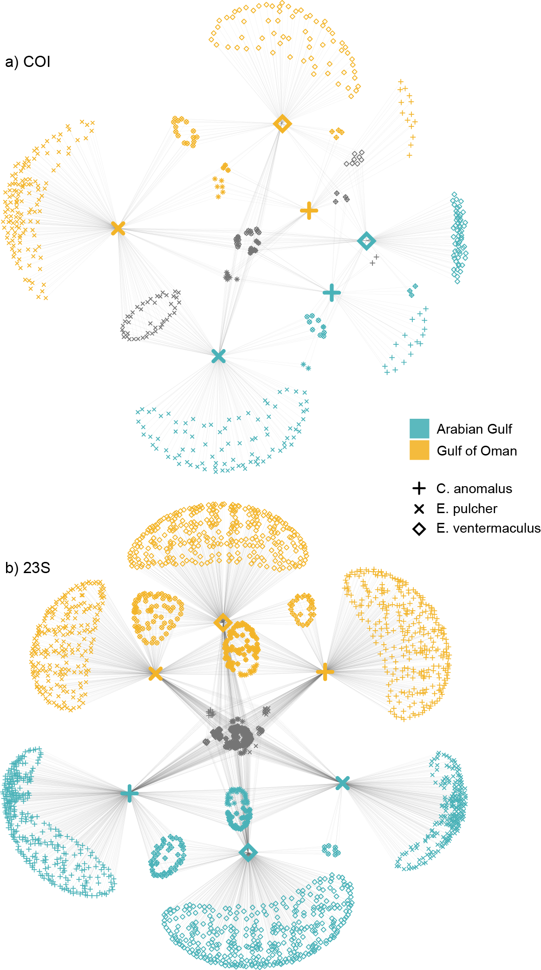**Figure 5: Network plots showing differences in diets for three species across the two locations.** Blue symbols are prey items (small symbols) and host specimens (large symbols) from the Arabian Gulf, while orange symbols are from the Gulf of Oman. Small grey symbols mark prey items shared across both locations. Both COI (a) and 23s (b) networks exhibit clear modularity, with the groups corresponding to the two different locations.

**Figure 6: Relationships between total length (TL) and body weight in populations of *Enneapterygius ventermaculus* (a), *Coryogalops anomalus* (b), and *Ecsenius pulcher* (c) in the Arabian Gulf (blue) and Gulf of Oman (gold).** Lines represent fitted values from 500 separate draws based on the posterior parameters from a Bayesian model regressing length against weight. Diamonds represent raw values for individual fishes.