**Title:** Extreme temperature reduces coral reef biodiversity and functioning by modifying bottom-up energy fluxes

**Authors:** Simon J. Brandl1,2,3, Jordan M. Casey2,3, Luke Tornabene4, John A. Burt5, Jacob L. Johansen5,6

**Corresponding author:** Simon J. Brandl, [simonjbrandl@gmail.com](mailto:simonjbrandl@gmail.com)

**Affiliations:**

1 Department of Biological Sciences, Simon Fraser University, Burnaby, BC, Canada

2 PSL Université Paris: CNRS-EPHE-UPVD USR3278 CRIOBE, Université de Perpignan, Perpignan, France

3 Laboratoire d’Excellence “CORAIL,” Perpignan, France

4 School of Aquatic and Fishery Sciences and the Burke Museum of Natural History and Culture, University of Washington, Seattle, WA, USA

5 Marine Biology Laboratory, Centre for Genomics and Systems Biology, New York University Abu Dhabi, Abu Dhabi, United Arab Emirates

6 Hawai’i Institute of Marine Biology, University of Hawai’i at Manoa, Kane’ohe, HI, USA

**Abstract:**

TBA

**Introduction:**

TBA

**Results:**

We performed the first quantitative comparison of cryptobenthic fishes in the Arabian Gulf and Gulf of Oman. Cryptobenthic reef fish assemblages differed fundamentally between reefs in the Arabian Gulf and the Gulf of Oman. Reefs in the Gulf of Oman sheltered a markedly higher diversity (Bayesian hierarchical model estimate: *GoO β* = 0.74 [0.46, 1.01; lower and upper 95% credible interval]) and density (*GoO* *β* = 1.77 [1.03, 2.58])of cryptobenthic fishes (Fig. 1a,b), but biomass estimates were comparable (*GoO* *β* = 0.63 [-0.54, 1.71]) due to the presence of few larger bodied species in the Arabian Gulf. Similarly, the composition of cryptobenthic communities varied greatly among the two locations (Fig. 1d), with no overlap among convex hull polygons in the nMDS ordination and a strong effect of *Location* in the PERMANOVA on the site-by-species dissimilarity matrix (*Location*: *df* = 1, *F* = 13.57, *P* = 0.001, *R2* = 0.46). There were 33 unique species in the Gulf of Oman, 13 unique species in the Arabian Gulf, and 16 species shared among the two locations. In contrast to the cryptobenthic fish communtiy, there were no differences in coral cover (Bayesian hierarchical model: *GoO β* = 0.02 [-1.30, 1.42]) and the overall benthic community structure as revealed by a PERMANOVA (*Location*: *df* = 1, *F* = 1.63, *P* = 0.187, *R2* = 0.09; Fig. S1). Thus, despite broadly comparable benthic conditions and no differences in live coral cover, the cryptobenthic fish assemblages differ strongly between the two locations.

**Fig. 1 | Community structure and composition of cryptobenthic reef fish communities in the Arabian Gulf (AG) and Gulf of Oman (GoO).** (**a**) Species richness and (**b**) density of cryptobenthic reef fishes was markedly higher on reefs in the GoO, while (**c**) biomass did not differ substantially between the two locations. Density curves represent predicted values based on 1,000 draws from Bayesian hierarchical linear models testing for differences among locations, while black caterpillar plots represent their means, 50% and 95% credible intervals. Circles, squares, and diamonds represent raw values from the respective sites in each location, jittered on the y-axis. (**d**) Biplot of a non-metric multidimensional scaling ordination on the community composition of cryptobenthic fishes. Convex hull polygons delineate the two locations, with shapes matching the sites in (**a-c**). Fish insets highlight three species present in both locations (top) and three species exclusive to the GoO (bottom).

We tested whether inherent individual temperature tolerances can explain the absence of species from the Arabian Gulf. Despite distinct thermal regimes at the two locations and the drastic differences in cryptobenthic fish assemblages, species-specific thermal tolerances had limited explanatory power regarding the absence of three common GoO-species in the much more extreme AG. In terms of critical thermal minima (ctmin), all species easily tolerated the minimum winter temperature in the AG at 16.0 ºC. *Ecsenius pulcher* individuals sampled from the GoO population had the highest cold tolerance (ctmin = 11.3 ± 0.11 ºC) while individuals from the GoO-population of *Enneapterygius ventermaculus* had the lowest tolerance (13.3 ± 0.11 ºC). Although there were species-specific differences, mean predicted posterior tolerances of all GoO-species fell within the 95% credible bounds of the species present in the AG (Fig. 2a). Similarly, mean critical thermal maximum estimates (ctmax) of all species equaled or surpassed the maximum summer temperatures recorded in the AG (36.0 ºC). *Helcogramma fuscopinna* had the lowest mean heat tolerance at 36.0 ± 0.11 ºC, while individuals from the AG-population of *Coryogalops anomolus* had the highest mean tolerance (38.4 ± 0.06 ºC). As for the ctmin, despite considerable interspecific differences, mean predicted posterior heat tolerances of all species restricted to the GoO were within the 95% credible intervals of the species present in the AG.

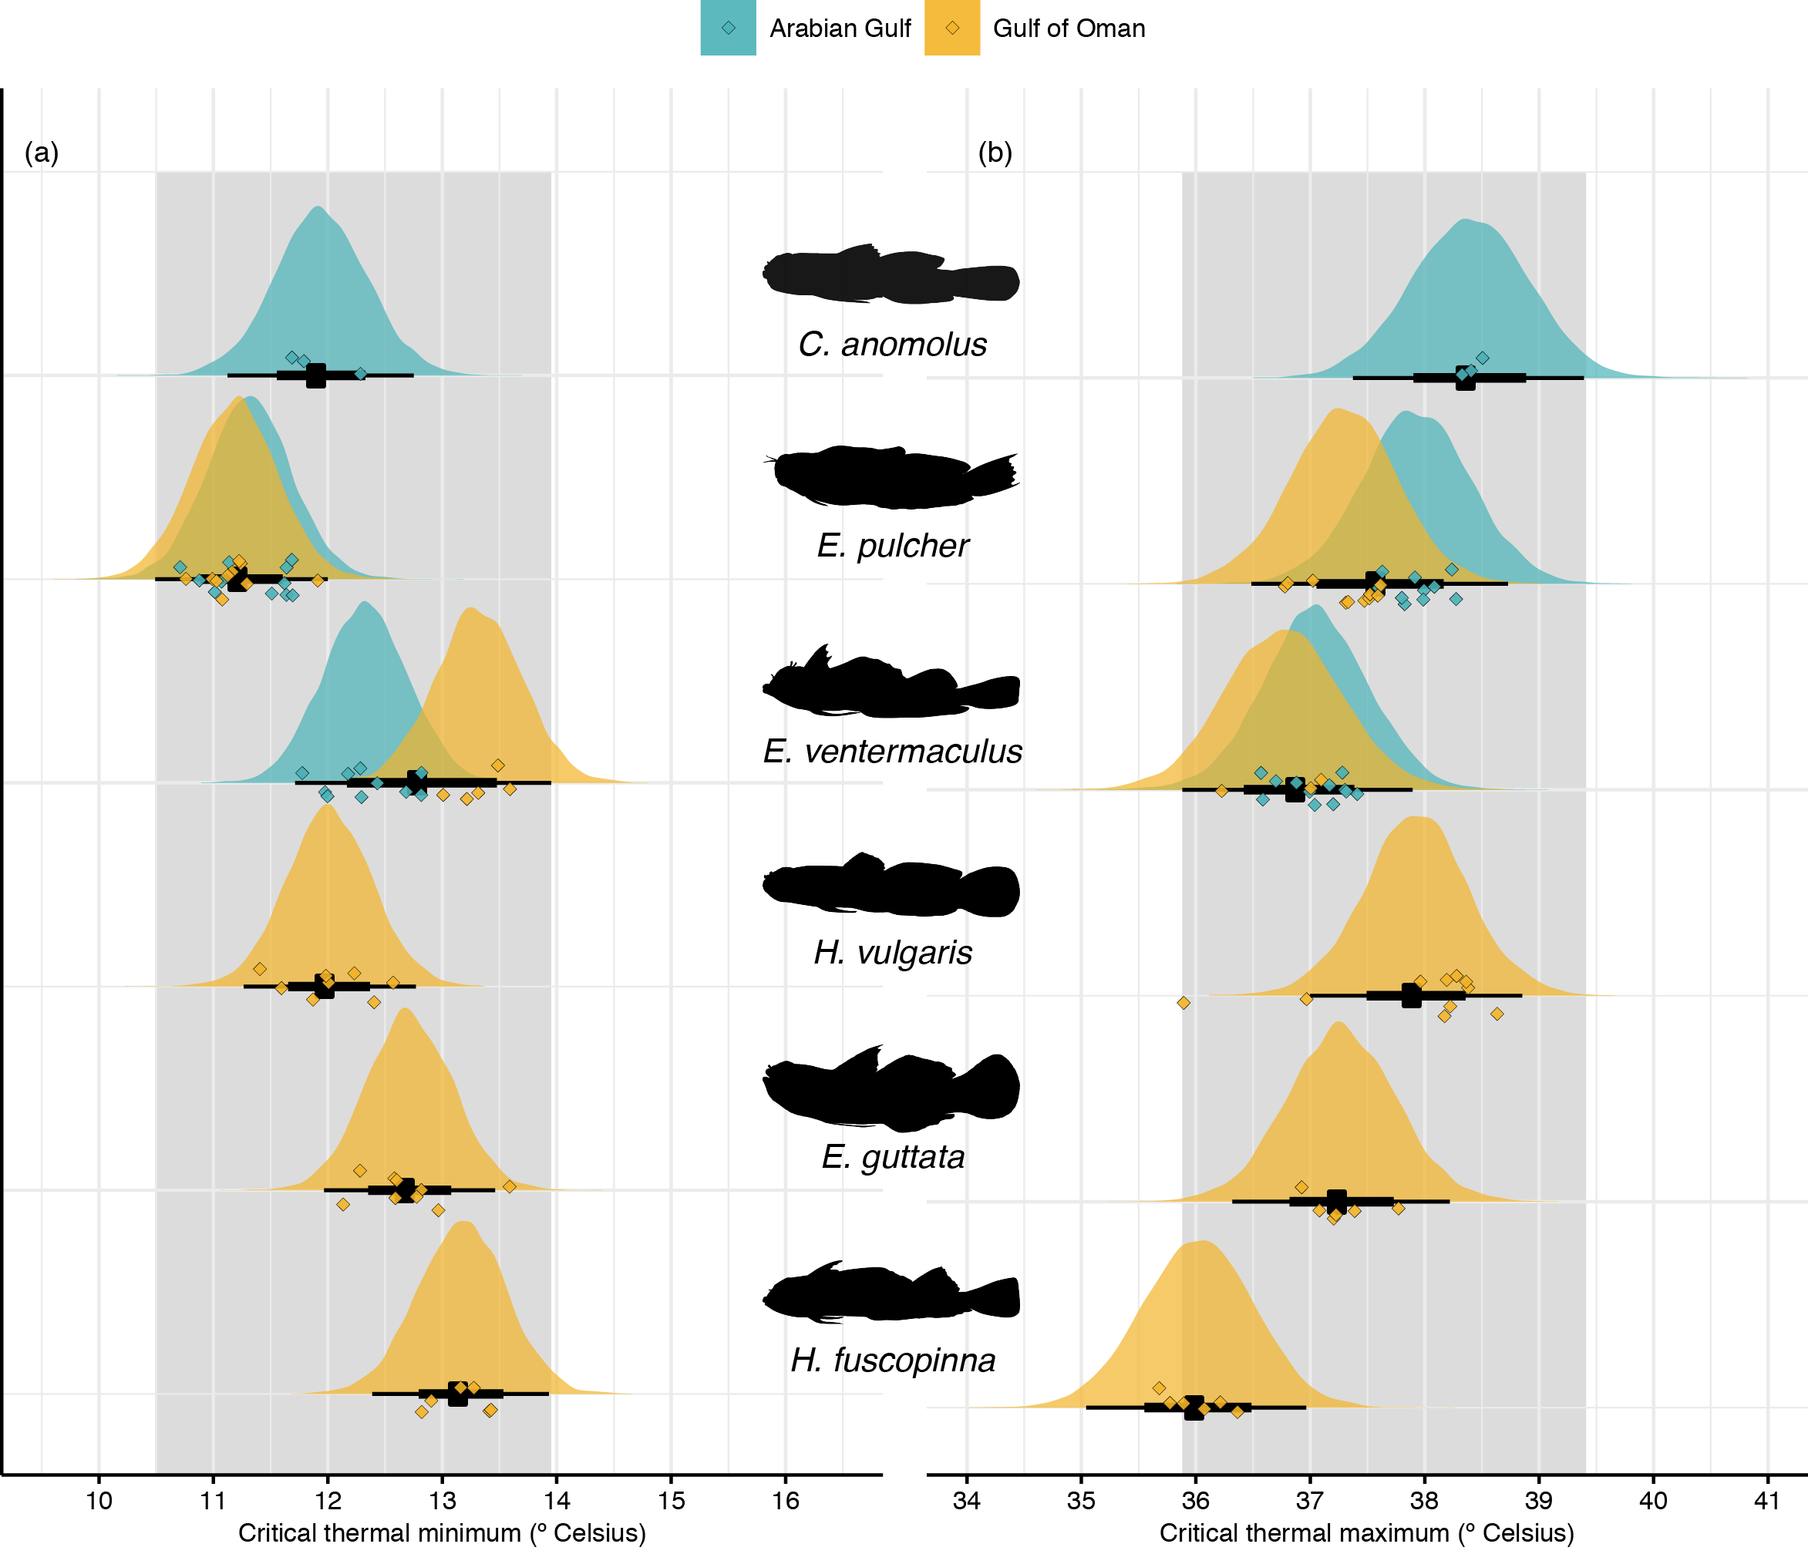

**Fig. 2 | Critical thermal limits of cryptobenthic fish species from the Arabian Gulf and Gulf of Oman.** (**a**) Critical thermal minima ranged between 11.9 and 13.3 ºC, but were well below the minimum recorded winter temperature for the Arabian Gulf (16.0 ºC). (**b**) Critical thermal maxima ranged between 36.0 and 38.4 ºC, but again were above or equal to the maximum recorded summer temperature in the Arabian Gulf (36.0 ºC). Density curves represent predicted values based on 10,000 draws from Bayesian linear models testing for differences among all populations, while black caterpillar plots represent their means, 50% and 95% credible intervals. Diamonds represent raw values, jittered on the y-axis. Grey boxes delineate the range of the 95% credible intervals obtained for the three species present in the Arabian Gulf.

To examine alternative explanations for the filtering effect of the Arabian Gulf reefs on cryptobenthics, we quantifed species’ diets in the two locations via a molecular approach. Using gut content DNA metabarcoding, we identified the presence of unique operational taxonomic units (OTUs) and exact sequence variants (ESVs) for sequences amplified using cytochrome oxidase subunit I (COI) and 23S primers, respectively, for six species (three of which were unique to the GoO, while the other three occurred in both locations). We then used network theory to determine dietary differences among species and locations. For the three species present in both locations, dietary network trees for the COI primer showed each species’ populations to reflect distinct modules (six modules; Fig.3) and modularity (0.534) was invariably higher than when examined individuals were assigned to species and populations at random in a random permutation testing framework (999 permutations: *P* < 0.001). Modules identified for each permutation did not show consistent location- or species-specific clusters (Fig. S1). For the 23S primer, five modules were identified, with GoO-populations of *E. pulcher* and *E. ventermaculus* representing a single module while all other species populations were distinct modules. Nevertheless, modularity was high (0.544) and again invariably higher than random permutations (*P* < 0.001), which did not show any consistent modules. Thus, populations of species occurring in both locations differ strongly in their used prey resources concerning both plant and animal material, with substantial overlap occurring only in the primary resources used by *E. ventermaculus* and *E. pulcher* in the GoO. Within the GoO, all six species examined represented distinct modules for both COI and 23S primers (Fig. S2). Overall modularity of the network was high (0.489 and 0.466, respectively) and consistently higher than random assignments in the permutation testing framework (both *P* < 0.001).

**Figure 3 | Diet network trees showing differences in ingested prey items among species and populations in the two locations for 23S (a) and COI (b) primers.** Fish silhouettes represent the species as nodes in the network tree. Blue symbols are ESVs (23S) or OTUs (COI) found only in the alimentary tracts of populations from the Arabian Gulf, while gold symbols are ESVs/OTUs from the GoO populations. Grey symbols are ESVs/OTUs shared among the two locations. Shapes of the symbols represent the three different species and are superimposed where ESVs/OTUs are shared.

Finally, we examined potential energetic consequences of thermal regimes and resource availability in the two locations by assessing length-weight relationships of three species across the two locations and by modeling individual-based growth and mortality to estimate community-wide biomass production, consumption, and turnover. The Bayesian linear models testing the effects of total length (*TL*) and *Location* on *Weight* showed clear effects of *Location* across all species, with GoO populations having higher weights for a given body length (*E. ventermaculus*: *GoO β*= 0.16 [0.13, 0.19], *C. anomolus*: *GoO β*= 0.15 [0.09, 0.21], and *E. pulcher*: *GoO β*= 0.19 [0.14, 0.25]). Furthermore, modeling individual-based growth and mortality for cryptobenthic fish communities at each site revealed drastic differences in the ecological dynamics that underpin ecosystem functioning in the AG and GoO. Biomass production was almost one order of magnitude higher on reefs in the GoO (0.231 g d-1 m-2 ± 0.025) compared to the AG (0.038 g d-1 m-2 ± 0.014), while production of consumed biomass was more than five times higher (0.039 g d-1 m-2 ± 0.015 vs. 0.007 g d-1 m-2 ± 0.001). Percent turnover per day was also higher in the GoO (0.017 ± 0.005) compared to the AG (0.006 ± 0.005). These results suggest that reefs in the AG and GoO are subject to fundamentally different productivity dynamics at various levels of organization. In the AG, individual fishes accumulate less biomass per mm body size and collectively, cryptobenthic communities produce, provide, and replenish biomass at much lower rates compared to GoO communities.

**Figure 4 | Relationships between total length (TL) and body weight in populations of *Enneapterygius ventermaculus* (a), *Coryogalops anomolus* (b), and *Ecsenius pulcher* (c) in the Arabian Gulf (blue) and Gulf of Oman (gold).** Lines represent fitted values from 500 separate draws based on the posterior parameters from a Bayesian model regressing length against weight. Diamonds represent raw values for individual fishes.

**Figure 5 | Biomass production, consumption, and turnover in cryptobenthic fish assemblages across the two locations.** (**a**) Produced biomass (i.e. grams of fish tissue grown per day and m2). (**b**) Consumed biomass (i.e. grams of fish tissue perished per day and m2). (**c**) Percent turnover (i.e. renewal of produced and consumed biomass per day). Violin plots and lines represent medians and variance estimates (95% quartiles) for the three metrics across the two locations. Diamonds represent values for each sample of cryptobenthic reef fish communities across the six sites (three per site).

**Methods:**

All fieldwork and labwork was performed under permit #XXX and ethics approval #XXX, granted by New York University Abu Dhabi. We studied cryptobenthic fish communities across six distinct coral reefs in two distinct locations that differ dramatically in their yearly temperature fluctuations. The reefs we sampled in the Arabian Gulf (Dhabiya: 24.36383º, 54.10121º; Ras Ghanada: 24.84743º, 54.69235º; Saadiyat: 24.65771º, 54.48691º) are some of the most extreme reefs in the world in terms of the annual temperature gradient, with summer maximum temperatures reaching 36.0 ºC, while winter minimum temperatures fall to 16.0 ºC. In contrast, sampled reefs in the Gulf of Oman (Dibba Rock: ﻿25.55378º, 56.35694º; Sharm Rock: ﻿25.48229º, 56.36695º; Snoopy Rock: ﻿25.49210º, 56.36401º) generally lie within normal coral reef temperature profiles throughout the year, ranging between approximately 32.0 ºC and 22.0 ºC. All fieldwork was performed in April and May 2018.

*Field sampling*

Cryptobenthic fishes are small (generally <50mm), bottom-dwelling reef fishes across 17 families that frequently live deep within the reef framework1. However, due to their high growth rates, rapid mortality, and larval replenishment dynamics, cryptobenthics are a critical component of coral reef trophic dynamics, often supplying a large proportion of consumable biomass to larger fish species2. At each reef, we sampled three distinct reef outcrops for cryptobenthic reef fishes using enclosed clove oil stations3,4, covering an average of 4.63 ± 0.38 and 4.73 ± 0.16 m2 in the Arabian Gulf and Gulf of Oman, respectively. For each station, we covered a reef outcrop with a fine-mesh, bell-shaped net (2.74 m in diameter), weighted by a chain on the bottom. We then covered the same area with an impermeable bell-shaped tarpaulin, also weighted by a chain on the bottom. Then, three to four divers inoculated the area under the net with two liters of clove-oil:ethanol solution (1:5) using collapsible spray bottles (clove bud oil: Jedwards International, Inc., Braintree, MA, USA). Upon emptying the entire solution and a short wait period to allow the clove oil to disperse and take effect (usually 2-3 mins), we removed the tarpaulin and started to gently peel back the net while collecting all fishes found within the sampled area with tweezers. We searched the entire area, including caves and crevices until five minutes were spent by all divers without collecting any additional fishes. We placed all fishes into ziplock-bags, brought them to the surface, euthanized them with a clove-oil overdose, and immediately placed them into and ice-water slurry. At the end of each day, all specimens were brought to the laboratory at New York University Abu Dhabi or to room #211 at the Radisson Blu hotel in Fujairah for processing. We made sure to keep fishes on ice until preservation. For each sampled clove-oil station, we also took five photographs of the benthos to quantify benthic community structure. Specifically, we haphazardly placed a 20×20cm PVC-quadrate onto the outcrop within the area of our sample and took a close-up photograph of the benthos within the frame of the quadrat.

In addition to the quantitative samples obtained from the clove-oil stations, we collected individuals for physiological trials using roving diver collections. Specifically, two divers, each equipped with spraybottles of clove-oil ethanol solution, a dipnet, and ziplock bags, searched the reef for individuals of cryptobenthic fishes across three (Arabian Gulf: *Coryogalops anomolus*, *Ecsenius pulcher*, and *Enneapterygius ventermaculus*) and six (Gulf of Oman: *Coryogalops anomolus*, *Ecsenius pulcher*, and *Enneapterygius ventermaculus* plus *Eviota guttata*, *Helcogramma fuscopinna*, and *Hetereleotris vulgaris*) species. Upon locating an individual or identifying a suitable microhabitat in which a fish was suspected, we carefully applied the clove-oil solution until the fish showed signs of anesthesia. At the earliest opportunity, we scooped up the fish with a dipnet and placed it into a ziplock bag. Upon completion of the dive, all fishes were placed in small holding tanks equipped with air stones and periodically replenished with fresh seawater. Upon completion of all collections, fish were brought to the seawater laboratory facilities at NYUAD in Abu Dhabi. All roving diver collections were performed at Dhabiya Reef (AG) and Snoopy Rock (GoO).

*Laboratory processing*

For samples obtained from the enclosed clove-oil stations, we followed an establish protocol that involves photographing, identifying, recording, measuring, weighing and preserving each specimen. To photograph the fishes, we placed each individual in a small phototank and used a Nikon D300 DSLR camera with an AF-S Micro Nikkor 60mm macro lens (f/2.8G ED; Nikon Inc., Melville, NY, USA) against a black or white background. We measured each individual to the nearest 0.1mm using digital calipers and weighed the individual (wet weight) to the nearest 0.001 grams on a jewelry scale. We preserved all individuals in 95% ethanol, either separately or in lots with its conspecifics. A subset of the samples was then shipped to the University of Washington under export permit #XXX, while the rest was retained and archived at NYUAD.

We processed a subset of individuals (as dictated by sample-availability and sequencing costs) in six species (*Antennablennius species A*, *C. anomolus*, *E. pulcher*, *E. guttata*, *E. ventermaculus*, and *H. vulgaris*) for gut content DNA metabarcoding by removing the entire alimentary tract under sterile conditions at the University of Washington. Specifically, we haphazardly selected ten, ten, and seven individuals of *C. anomolus*, *E. ventermaculus*, and *E. pulcher*, respectively, from the Arabian Gulf, and ten specimens each (with the exception of *E. pulcher*, for which we selected eleven) of *C. anomolus*, *E. ventermaculus, Antennablennius species A*, *E. guttata,* and *H. vulgaris* from the Gulf of Oman. Then, we dissected out the alimentary tract and removed all other organs (e.g. liver, gonads) under a Zeiss V20 SteREO dissecting microscope using micro-surgery tools. We placed the entire gut into an extraction tube filled with C1-buffer from the Qiagen DNEasy PowerSoil DNA extraction kit. After every specimen, we sterilized the work platform and tools using a series of baths consisting of a dish soap solution, a 10% sodium hypochlorite:water solution, and Milli-Q UV-sterilized water. Upon completion of twenty samples, we immediately proceeded to perform DNA-extractions from the dissected gut samples. All DNA extractions were performed according to the protocol outlined in5. We stored all DNA samples at 4ºC until aliquoting them into 96-well plates for library preparation and amplification.

For the benthic photographs, we created a grid with 16 equally-spaced points which we superimposed on every photograph. We then categorized the benthos at each of the points into functional groups, including barnacles, bleached corals, crustose coralline algae, dead coral, hydroids, branching, encrusting, foliose, and massive live coral, mollusks, bare rock, soft sediment, sponges, algal turf, and sea urchins. Whenever no visual identification was possible (due to obstruction, shading, or blurriness), we categorized the point as “unidentifiable” (n = 69 out of 1,440).

*Gut content DNA metabarcoding*

All DNA samples were sent to Jonah Ventures (Boulder, CO) for post-extraction processing.

*Critical thermal maximum and minimum trials*

We examined individual temperature tolerances by using critical thermal maximum (CTmax) and minimum (CTmin) trials. We transported all fishes caught during roving diver collections to the wet laboratory facilities at NYUAD and housed them for at least 24 hours in large holding tanks. Trials took place between May 9th and May 13th 2018. For the trials, a haphazardly selected subset of individuals was moved from the holding tanks into separate chambers filled with seawater at ambient temperatures and salinity. Then, we incrementally decreased (CTmin) or increased (CTmax) the water temperature within the chambers while keeping all other parameters constant. Specifically, we lowered or increased the temperature by 0.3ºC every minute while keeping all fishes under constant observation. Critical endpoints were classified as loss of equilibrium and uncontrolled swimming for two seconds or more. When individuals reached their criticial endpoints, they were immediately removed, euthanized using a clove-oil overdose, measured, weighed, and photographed. In total, we processed 60 individuals across six species for CTmax trials, and 62 individuals across the same species for CTmin trials.

*Data analyses and modeling*

To analyze the community variables, we first calculated the surface area (*SA*) for each sampled outcropfrom the curved surface length (*CSL*) by deriving the sampled outcrop’s radius *r* (*r* = 2*CSL/2π) and then computing available surface area under the assumption that outcrops represent hemispherical constructs (*SA* = 4*πr*2/2). Then, we calculated the sum of individuals, species, and their respective body weight for each station to obtain abundance, diversity, and biomass estimates, which we converted to density estimates by dividing them by the sampled surface area. Using these estimates, we performed three Bayesian hierarchical models, each on the natural logarithm of the response variables (density, species density, and biomass per m2). Models were specified to include a fixed effect of *Location* (*Arabian Gulf vs. Gulf of Oman*) and a random effect of *Site* (*Dhabiya*, *Ras Ghanada*, *Saadiyat*, *Dibba Rock*, *Sharm Rock*, *Snoopy Rock*) and were run with a Gaussian error distribution. For each model, we ran four chains with 4,000 post burn-in samples and we validated chain convergence vidsually. We used the default, non-informative priors set by the *brm* function in the *brms* package6. Then, we used the model parameters to predict distributions based on 1,000 draws from the posterior and plotted the distributions, their mean and confidence bands, and the raw data for each site to evaluate our model fit.

To examine cryptobenthic fish community composition across the two locations, we created a species-by-sample matrix indicating the abundance of each species in a given sample. We then performed a non-metric multidimensional scaling ordination on the Bray-Curtis dissimilarity matrix of the data in two dimensions (stress = 0.101). We performed a permutational analysis of variance (PERMANOVA) on the same distance matrix (using 999 permutations) and extracted the most influential species using the similarity of percentages (SIMPER) routine. We constructed convex hull polygons for the two locations (as determined by the location of each sample) and plotted them in a biplot with the seven most influential species (average contribution > 0.025) superimposed. For benthic community composition, we followed a similar process. After our initial categorization, we first combined live coral categories into “branching” and “other” and omitted all categories with fewer than three records (bleached coral and hydroids) from the data. We also excluded the “unidentifiable” category. We then calculated the proportional contribution of each category to the benthos in a given sampled outcrop and arranged the data into a sample-by-category matrix and performed another nMDS analysis as per above. We also performed a PERMANOVA and visualized the data in the same way as described above, but did not perform the SIMPER routine due to the lower number of categories and scaled the size of the dots representing unique samples by their live coral cover. Finally, we statistically compared live coral cover among the two locations using a Bayesian hierarchical model. We logit-transformed proportional *LiveCoralCover* and specified *Location* as a fixed effect, with *Site* specified to have a random effect. Model and chain specifications were programmed as described above.