**Title:** Organismal responses to extreme temperatures reduce biodiversity and functioning on coral reefs

**Authors:** Simon J. Brandl1,2,3*, Jacob L. Johansen4,5*, Jordan M. Casey2,3, Luke Tornabene6, Renato A. Morais7,8, John A. Burt5

**Corresponding author:** Simon J. Brandl, [simonjbrandl@gmail.com](mailto:simonjbrandl@gmail.com)

**Affiliations:**

1 Department of Biological Sciences, Simon Fraser University, Burnaby, BC, Canada

2 PSL Université Paris: CNRS-EPHE-UPVD USR3278 CRIOBE, Université de Perpignan, Perpignan, France

3 Laboratoire d’Excellence “CORAIL,” Perpignan, France

4 Hawai’i Institute of Marine Biology, University of Hawai’i at Manoa, Kane’ohe, HI, USA

5 Marine Biology Laboratory, Centre for Genomics and Systems Biology, New York University Abu Dhabi, Abu Dhabi, United Arab Emirates

6 School of Aquatic and Fishery Sciences and the Burke Museum of Natural History and Culture, University of Washington, Seattle, WA, USA

7ARC Centre of Excellence for Coral Reef Studies, James Cook University, Townsville, QLD, Australia. 8College of Science and Engineering, James Cook University, Townsville, QLD, Australia.

**Abstract:**

In an era of rapid environmental change, the transformation of ecological communities may critically affect ecosystem functioning. Coral reefs harbor a great diversity and abundance of fishes, which are hypothesized to be particularly vulnerable to changing temperatures. Yet, cascading effects of organismal tolerances on the assembly and functioning of reef fish communities are largely unknown. Here, we use cryptobenthic reef fishes from the world’s most hostile coral reef environment to trace the effects of extreme temperatures from organisms to ecosystems. Cryptobenthic fish assemblages from the thermally extreme southern Arabian Gulf comprise half as many species and less than a quarter of the individuals present in the adjacent Gulf of Oman, despite broadly comparable availability of live coral substrate. The absence of species from the Arabian Gulf is not primarily determined by intrinsic organismal temperature tolerances. Instead, shifts in resource use and declining body condition in species that occur in both locations indicate energetic costs of thermal adaptation that prohibit the persistence of many cryptobenthic species in the Arabian Gulf. This, in turn, causes dramatic reductions in the production, transfer, and replenishment of biomass through cryptobenthic fish assemblages. Future reefs with similar temperature profiles to the Arabian Gulf may therefore lose a critical building block of their characteristic fast-paced, high-turnover dynamics, independent of live coral loss.

**Introduction:**

Why do some species occur in a given location while similar taxa are missing? And how do resulting assemblages of species affect rates of critical ecological processes? As escalating human influence on the biosphere erodes and re-shuffles biological communities across ecosystems1,2, answers to these questions are key to our understanding of nature and our quest to preserve biodiversity and ecosystem services to humanity3,4.

Countless theories on the mechanisms that underpin community assembly and its effects on functioning have been developed5–8 and although the search for broad, general theories continues9,10, there is now consensus that a species’ presence at a given location is mediated by a hierarchical interplay between organismal traits (e.g., temperature tolerance, trophic niches), environmental conditions (e.g., temperature, salinity), and stochastic events (e.g., random walks to extinction, lottery dynamics)10–14. Furthermore, the past three decades have seen ever-strengthening evidence that both the identity and diversity of species and their traits affect rates of ecosystem functioning, including processes that are critical to human well-being such as primary or secondary productivity15–17. However, by modifying abiotic conditions, species’ niches, and biotic interactions, global stressors such as climate change can interfere with these dynamics through almost innumerable pathways18–20. At the most basic level, rapid changes in environmental factors such as temperature will affect internal physiological processes21 in ways that are rarely lethal but inevitably alter organismal energy expenditure22,23. Changes in organismal energy budgets determine the demands on resource acquisition (e.g. feeding rates, prey species) and how resulting energy can be allocated to life-supporting processes, growth, and reproduction24,25. The interaction between these dynamics, which are often investigated through the lens of ecological niches and fitness, are the basis of modern coexistence theory, and are thus critical for our understanding of biodiversity patterns through time and space26 and ultimately, the rate of ecological processes that underpin fluxes of energy and nutrients through ecosystems27. Therefore, if we are to understand the effects global environmental change on our planet’s ecosystems, integration across levels of biological organization is key.

Coral reefs are the most diverse marine ecosystem and their exceptional productivity provides critical services for more than 500 million people worldwide28. Scleractinian corals, the foundations species of tropical reefs, show high thermal sensitivity that has led to the rapid global decline of coral reef ecosystems29,30. In the wake of losing coral habitat, communities of the most prominent group of reef consumers, teleost fishes, are widely reported to decline or shift in composition31–34, which can affect the provision of vital resources to people dependent on reef fisheries35. However, recent evidence suggests that many species of fish will be able to cope without live coral habitat36. In turn, as tropical marine ectotherms, reef fishes are also hypothesized to be vulnerable to direct effects of changing water temperatures, as they have evolved to thrive in a relatively narrow thermal envrionment22,37–39. Consequently, the responses of reef fishes to climate change and their potential to acclimate or adapt to different thermal regimes have been studied intensively40–42. Despite marked differences in species-specific tolerances to higher temperatures43–47, most reef fish species tested to date suffer from non-lethal48, but significant adverse physiological, developmental, or behavioral responses if continuously exposed to temperatures outside of their normal range, which suggests long-term deleterious effects on reef fish populations in the wild40. However, few, if any, cases of direct temperature-mediated population shifts have been documented for *in situ* reef fish communities to date. Since instantaneous plasticity in adult fishes appears rare49, the key to reef fish persistence on reefs may lie transgenerational acclimation and adaptation, which can enhance the performance of offspring in higher temperatures through developmental, genetic, or epigenetic42,50. Nevertheless, transgenerational adaptation has only been shown in few selected model species42,50,51 and carries a range of energetic costs50. Thus, whether this process can truly enhance survival of reef fishes in a competitive, uncontrolled environment, and how species-specific differences in temperature tolerance and adaptational capacity may mediate coexistence in ecological communities remains unresolved.

Cryptobenthic fishes are the smallest of all reef fishes, rarely exceeding 50mm in body size52. Distributed across 17 families of reef-associated fishes, cryptobenthics account for almost half of all reef fish species and are numerically abundant and ubiquitous on reefs worldwide52–55. Due to their small body size, these fishes have evolved a unique life history strategy of rapid growth, high mortality, and instantaneous larval replenishment, which has been identified as an important part of coral reef trophodynamics56. Beyond bestowing a unique ecological role on cryptobenthic fishes, their small body size and associated life-history also promises exceptional traceability concerning the effects of, and responses to, increasing temperatures52. Limited gill surface area, unfavorable mass to surface ratios, high mass-specific metabolism, and a range of other physiological challenges resulting from their minute size suggest that cryptobenthics are particularly susceptibility to extreme temperature fluctuations45,52,57. Furthermore, due to their limited mobility and close association with the benthos58, behavioral avoidance of temperature extremes through migration are an unlikely option for these fishes and previous research has shown marked shifts in their community composition following environmental changes34,59. In turn, however, their extremely high generational turnover (up to seven generations per year56,60), along with the prevalence of benthic clutch spawning and parental care in cryptobenthicss52, may make them ideally suited for transgenerational adaptation to adverse conditions40. In fact, an extremely fast evolutionary clock has been implicated as a driver for rapid speciation in cryptobenthic fishes61, and this may also be responsible for similarly fast microevolutionary changes (i.e. rapid adaption). Thus, cryptobenthic fishes may offer uniquely powerful means to detect adverse effects of extreme conditions on organisms and populations, while promising an excellent test of whether adaptation to different environmental regimes offers a viable pathway to the persistence of coral reef fishes in warming oceans.

Here, we quantify organismal traits, community assembly, and contributions to ecosystem functioning by cryptobenthic fishes in the world’s most extreme coral reef environment, the southeastern Arabian Gulf, and compare the resulting patterns with a spatially proximate, but much more environmentally benign location (the Gulf of Oman). Reefs in the shallow Arabian Gulf are subject to the most extensive annual temperature fluctuations recorded for any reef system, ranging between 16.0º C in the winter months to 36.0º C in the summer62. As such, thermal conditions in large parts of the Arabian Gulf, such as the southeastern region along the United Arab Emirates, mirror those that are forecast for most tropical coral reefs towards the end of the century63. Nevertheless, despite the unfavorable conditions for tropical reef building corals, reefs have persisted in this region for approximately 15,000 years63, making it an exceptional natural laboratory to examine the capacity of reef organisms to exploit transgenerational dynamics to cope with unfavorable conditions and how this influences the diversity and dynamics that underpin modern coral reefs. To date, however, no quantitative surveys of cryptobenthic fishes have been performed in either the Arabian Gulf or the nearby Gulf of Oman. Thus, the goal of our study was to 1) describe cryptobenthic fish assemblages across the two locations, 2) identify organismal traits of cryptobenthic fish species that permit or preclude existence in the extreme thermal environment of the Arabian Gulf, and 3) determine the consequences of these results for a critical ecosystem function, the production, provision, and renewal of cryptobenthic fish biomass64.

**Results:**

Cryptobenthic reef fish assemblages differed fundamentally between reefs in the Arabian Gulf and the Gulf of Oman. Reefs in the Gulf of Oman harbored a markedly higher diversity (Bayesian hierarchical model estimate: *GoO β* = 0.74 [0.46, 1.01; lower and upper 95% credible interval]) and density (*GoO* *β* = 1.77 [1.03, 2.58])of cryptobenthic fishes (Fig. 1a,b), but biomass estimates were comparable (*GoO* *β* = 0.63 [-0.54, 1.71]; Fig. 1c). Similarly, the composition of cryptobenthic communities varied greatly among the two locations (Fig. 2a), with no overlap among convex hull polygons in the nMDS ordination and a strong effect of *Location* in the PERMANOVA on the site-by-species dissimilarity matrix (*Location*: *df* = 1, *F* = 13.57, *P* = 0.001, *R2* = 0.46). There were 33 unique species in the Gulf of Oman, 13 unique species in the Arabian Gulf, and 16 species shared among the two locations. In contrast to the cryptobenthic fish community, there were no differences in coral cover (Bayesian hierarchical model: *GoO β* = 0.02 [-1.30, 1.42]) nor overall benthic community structure as revealed by a PERMANOVA (*Location*: *df* = 1, *F* = 1.63, *P* = 0.187, *R2* = 0.09; Fig. 2b). Thus, despite broadly comparable benthic conditions and no differences in live coral cover, the cryptobenthic fish assemblages differ strongly between the two locations.

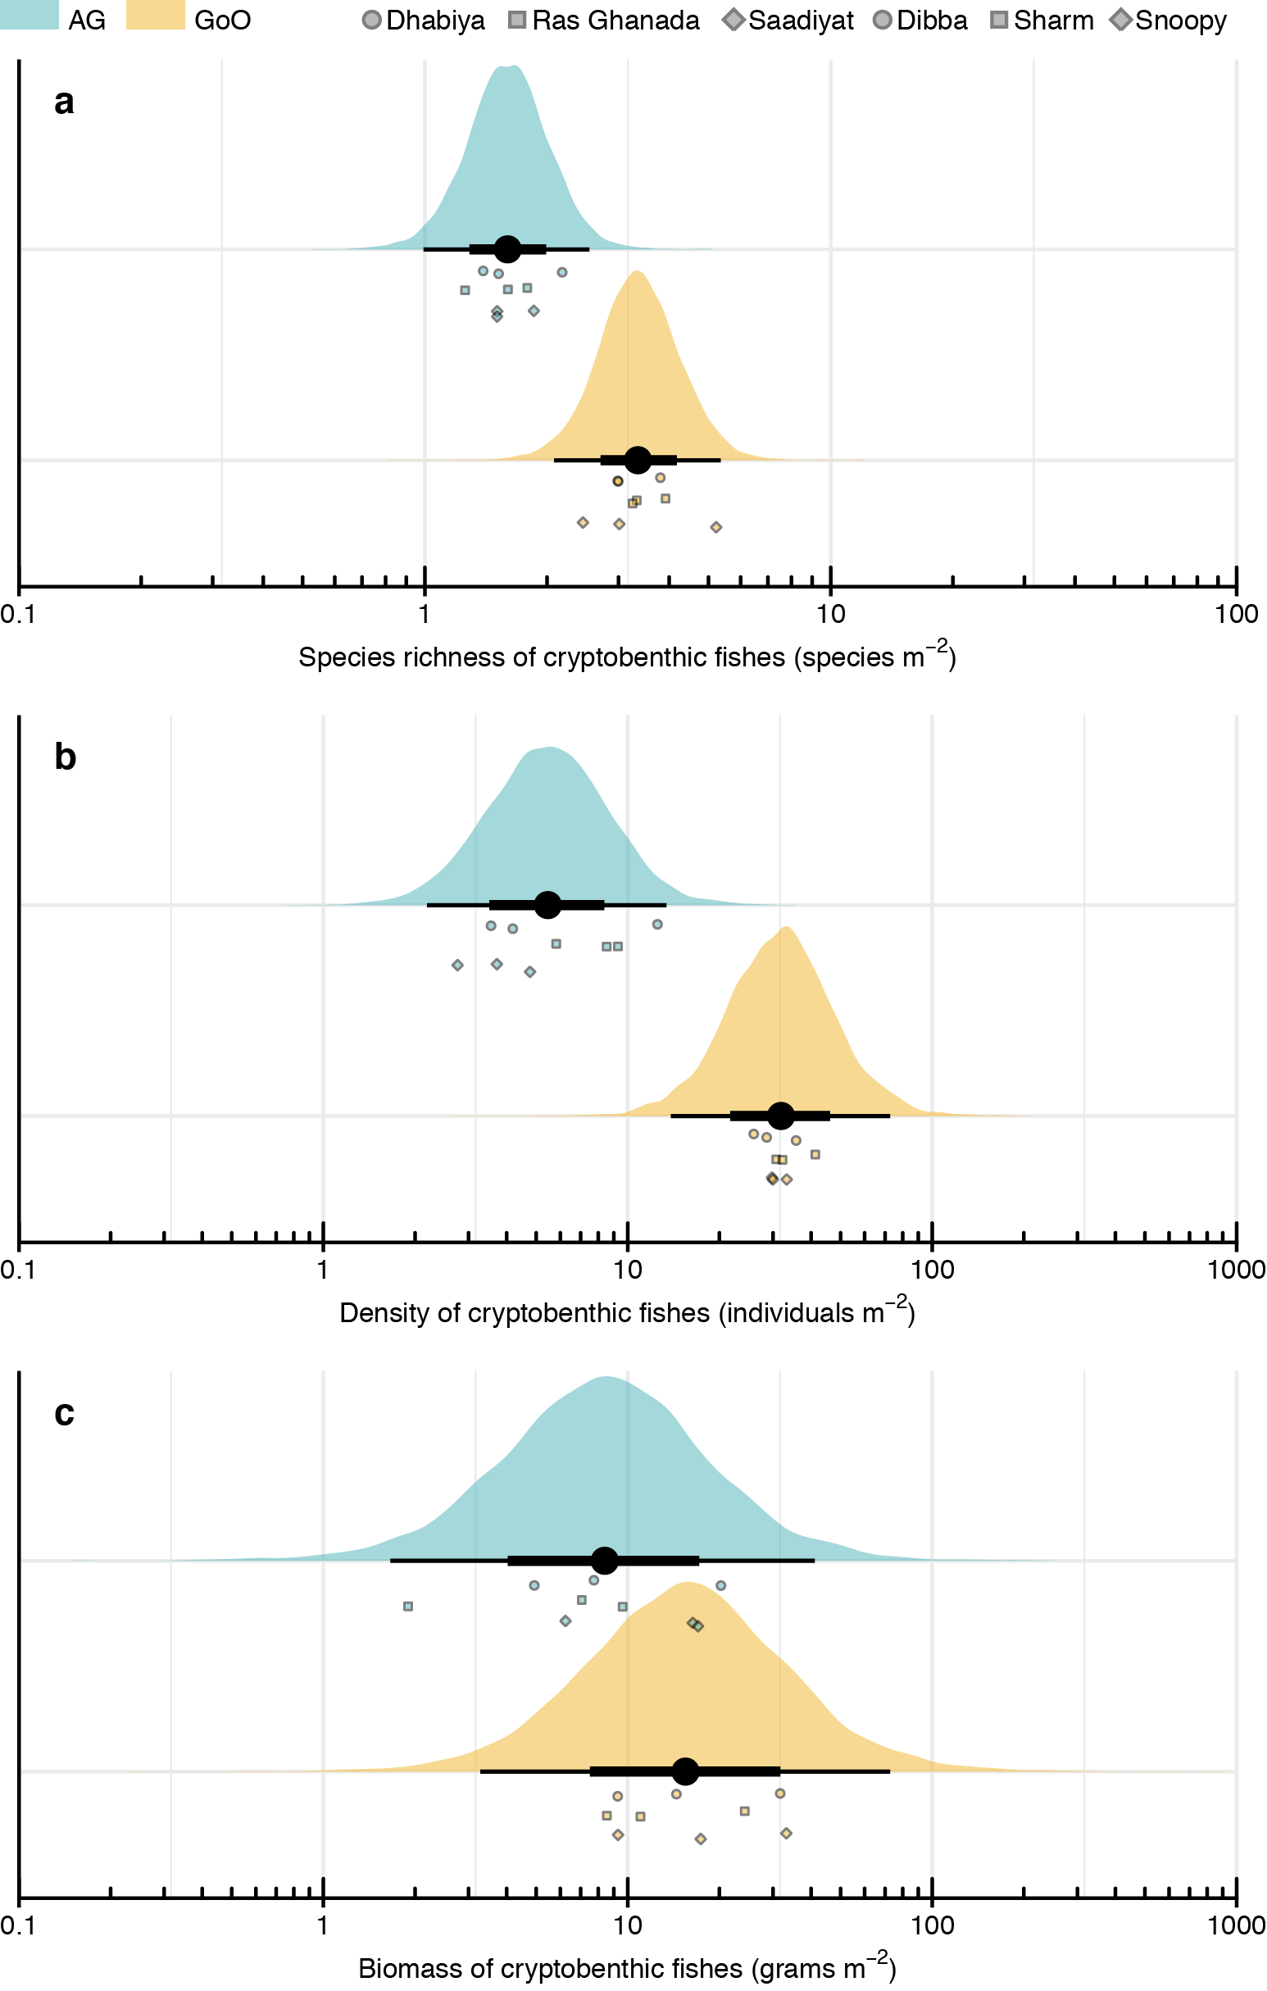

**Fig. 1 | Community structure of cryptobenthic reef fish communities in the Arabian Gulf (AG) and Gulf of Oman (GoO).** (**a**) Species richness and (**b**) density of cryptobenthic reef fishes was markedly higher on reefs in the GoO, while (**c**) biomass did not differ substantially between the two locations. Density curves represent predicted values based on 1,000 draws from Bayesian hierarchical linear models testing for differences among locations, while black caterpillar plots represent their means, 50% and 95% credible intervals. Circles, squares, and diamonds represent raw values from the respective sites in each location, jittered on the y-axis.

**Fig. 2 | Community structure of cryptobenthic reef fishes and benthic functional groups in the Arabian Gulf (AG) and Gulf of Oman (GoO).** (**a**)Biplot of a non-metric multidimensional scaling ordination (nMDS) on cryptobenthic fish communities, with the arrows indicating the position and strength of influence of the seven most important species. (**b**) Biplot of an nMDS on benthic functional groups, with all groups indicated with arrows. Convex hull polygons delineate the two locations. Each symbol represents a sample station (according to site), with shape size in (**b**) scaled by percent live coral cover.

We then tested whether inherent individual temperature tolerances can explain the absence of species from the Arabian Gulf. Despite distinct thermal regimes at the two locations and the drastic differences in cryptobenthic fish assemblages, species-specific thermal tolerances had limited explanatory power regarding the absence of three common GoO-species in the much more extreme AG (albeit being recorded in the northern Arabian Gulf where conditions are more benign65) . In terms of critical thermal minima (ctmin), all species regardless of origin tolerated the minimum winter temperature of the AG at 16.0 ºC. *Ecsenius pulcher* individuals sampled from the GoO population had the highest cold tolerance (ctmin = 11.3 ± 0.11 ºC) while individuals from the GoO-population of *Enneapterygius ventermaculus* had the lowest tolerance (13.3 ± 0.11 ºC). In contrast, however, the AG-population of *E. ventermaculus* had a substantially better cold tolerance that exceeded its GoO-population as well as two other GoO-species (Table S1), providing evidence for enhanced thermal tolerance in this species’ population.Although there were considerable species-specific differences in the critical thermal minimum, mean cold tolerances of all GoO-species fell within the 95% credible bounds of the species present in the AG (Fig. 3a). Mean critical thermal maximum estimates (ctmax) of all species equaled or surpassed the maximum summer temperatures recorded in the AG (36.0 ºC). *Helcogramma fuscopinna* had the lowest mean heat tolerance at 36.0 ± 0.11 ºC, while individuals from the AG-population of *Coryogalops anomolus* had the highest mean tolerance (38.4 ± 0.06 ºC). While there were no population differences in heat tolerance for *E. ventermaculus*, *E. pulcher* populations from the AG showed considerably higher heat tolerance than their GoO-counterparts, providing evidence for enhanced thermal tolerance in a second AG species. As for the ctmin, despite considerable interspecific differences, mean predicted posterior heat tolerances of all species restricted to the GoO were within the 95% credible intervals of the species present in the AG (Fig. 3b).

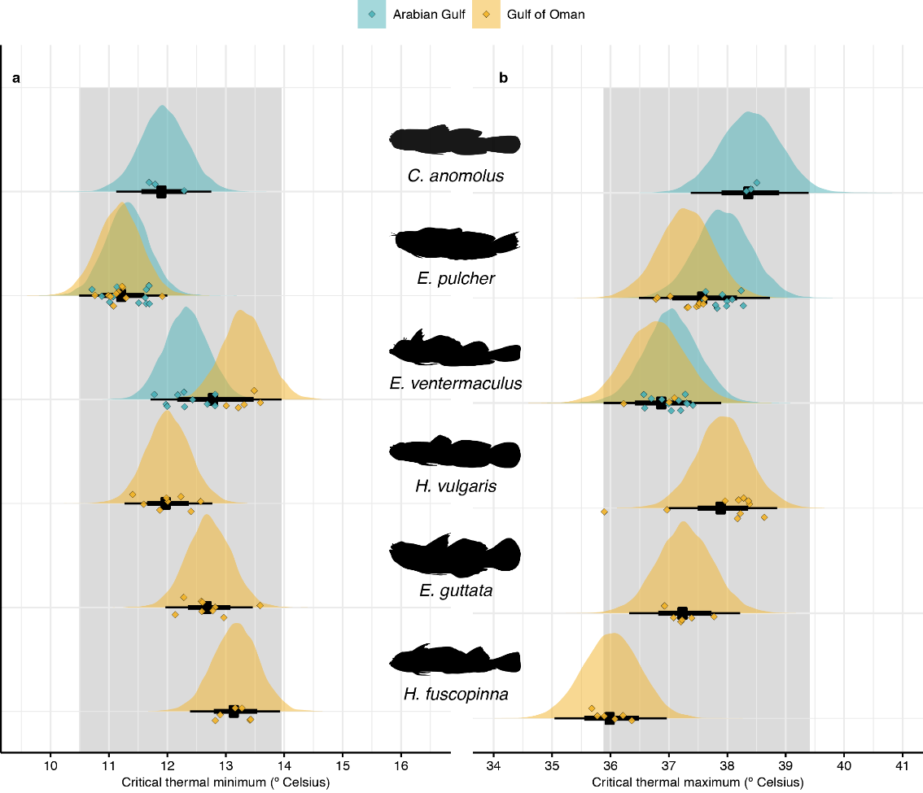

**Fig. 3 | Critical thermal limits of cryptobenthic fish species from the Arabian Gulf and Gulf of Oman.** (**a**) Critical thermal minima ranged between 11.9 and 13.3 ºC, but were well below the minimum recorded winter temperature for the Arabian Gulf (16.0 ºC). (**b**) Critical thermal maxima ranged between 36.0 and 38.4 ºC, but again were above or equal to the maximum recorded summer temperature in the Arabian Gulf (36.0 ºC). Density curves represent predicted values based on 10,000 draws from Bayesian linear models testing for differences among all populations, while black caterpillar plots represent their means, 50% and 95% credible intervals. Diamonds represent raw values, jittered on the y-axis. Grey boxes delineate the range of the 95% credible intervals obtained for the three species present in the Arabian Gulf.

To examine explanations for the filtering effect of the Arabian Gulf reefs on cryptobenthics, we quantified species’ diets in the two locations via a molecular approach. Using gut content DNA metabarcoding66, we identified the presence of unique operational taxonomic units (OTUs) and exact sequence variants (ESVs) for sequences amplified using cytochrome oxidase subunit I (COI), which targets metazoan organisms mostly from the kingdom Animalia, and 23S primers, which target autotrophs, respectively, for six species (three of which were unique to the GoO, while the other three occurred in both locations). We then used network theory to determine dietary differences among species and locations. For the three species present in both locations, dietary network trees for the COI primer showed each species’ populations to reflect distinct modules (six modules; Fig. 4) and modularity (0.534) was invariably higher than when examined individuals were assigned to species and populations at random in a random permutation testing framework (999 permutations: *P* < 0.001). Modules identified for each permutation did not show consistent location- or species-specific clusters (Fig. S1). For the 23S primer, five modules were identified, with GoO-populations of *E. pulcher* and *E. ventermaculus* representing a single module while all other species’ populations were distinct modules. Nevertheless, modularity was high (0.544) and again higher than random permutations (*P* < 0.001), which did not show any consistent modules. Thus, populations of species occurring in both locations differ strongly in their used prey resources concerning both plant and animal material, with substantial overlap occurring only in the primary resources used by *E. ventermaculus* and *E. pulcher* in the GoO. Within the GoO, all six species examined represented distinct modules for both COI and 23S primers (Fig. S2). Overall modularity of the network was high (0.489 and 0.466, respectively) and consistently higher than random assignments in the permutation testing framework (both *P* < 0.001). Furthermore, in terms of prey diversity, rarefactions curves showed that GoO populations of *E. pulcher*, a purportedly herbivorous species67, ingested the widest variety of animal prey species, followed by GoO populations of *E. ventermaculus* (Fig S3)*.* For both species, GoO populations consumed a higher diversity of prey than AG populations, while in *C. anomolus*, there was no clear difference for extrapolated values (although diversity was higher for GoO populations for the interpolated value). For autotroph prey, GoO-populations of *E. ventermaculus* exhibited the highest prey diversity, followed by AG-populations of *C. anomolus*. Prey diversity was again higher for GoO populations of *E. pulcher* and *E. ventermaculus*, while the opposite was evident for *C. anomolus*.

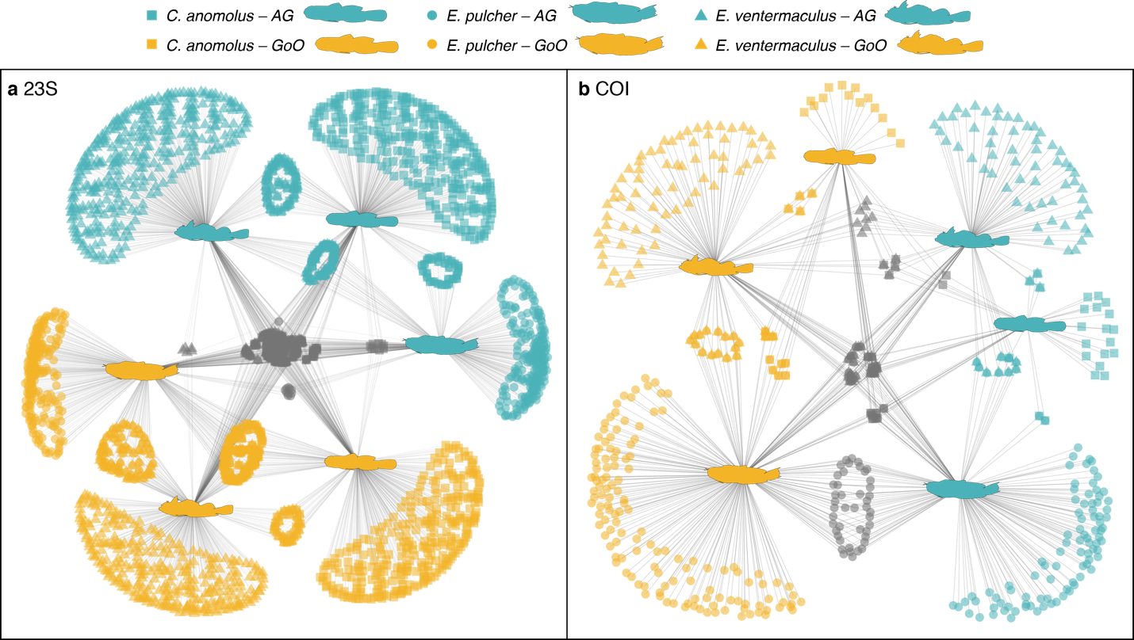

**Figure 4 | Diet network trees showing differences in ingested prey items among species and populations in the two locations for 23S (a) and COI (b) primers.** Fish silhouettes represent the species as nodes in the network tree. Blue symbols are ESVs (23S) or OTUs (COI) found only in the alimentary tracts of populations from the Arabian Gulf, while gold symbols are ESVs/OTUs from the GoO populations. Grey symbols are ESVs/OTUs shared among the two locations. Shapes of the symbols represent the three different species and are superimposed where ESVs/OTUs are shared.

Finally, we examined potential energetic consequences of thermal regimes and resource availability in the two locations by assessing length-weight relationships of three species across the two locations and by modeling individual-based growth and mortality to estimate community-wide biomass production, consumption, and turnover. The Bayesian linear models testing the effects of total length (*TL*) and *Location* on *Weight* showed clear effects of *Location* across all species, with GoO populations having higher weights for a given body length (*E. ventermaculus*: *GoO β*= 0.16 [0.13, 0.19], *C. anomolus*: *GoO β*= 0.15 [0.09, 0.21], and *E. pulcher*: *GoO β*= 0.19 [0.14, 0.25]) (Fig. 5). In contrast, no clear differences were evident in the abundances of the three species’ populations across locations (as effect size uncertainties intersected zero), although *E. ventermaculus* (*GoO β*= 0.89 [-1.08, 2.86) and *E. pulcher* (*GoO β*= 3.46 [-0.42, 9.93]) both showed a trend towards lower abundances in the Arabian Gulf, while *C. anomolus* exhibited the opposite tendency (*GoO β*= -0.94 [-3.82, 1.69]). Furthermore, modeling individual-based growth and mortality for cryptobenthic fish communities at each site revealed drastic differences in the ecological dynamics that underpin ecosystem functioning in the AG and GoO (Fig. 6). Biomass production was almost one order of magnitude higher on reefs in the GoO (0.231 g d-1 m-2 ± 0.025) compared to the AG (0.038 g d-1 m-2 ± 0.014), while production of consumed biomass was more than five times higher (0.039 g d-1 m-2 ± 0.015 vs. 0.007 g d-1 m-2 ± 0.001). Percent turnover per day was also higher in the GoO (0.017 ± 0.005) compared to the AG (0.006 ± 0.005). These results suggest that reefs in the AG and GoO are subject to fundamentally different productivity dynamics at various levels of organization. In the AG, individual fishes accumulate less biomass per mm body size and collectively, cryptobenthic communities produce, provide, and replenish biomass at much lower rates compared to GoO communities.

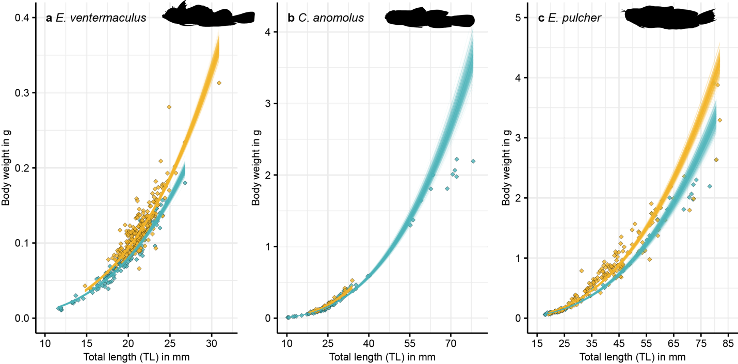

**Figure 5 | Relationships between total length (TL) and body weight in populations of *Enneapterygius ventermaculus* (a), *Coryogalops anomolus* (b), and *Ecsenius pulcher* (c) in the Arabian Gulf (blue) and Gulf of Oman (gold).** Lines represent fitted values from 500 separate draws based on the posterior parameters from a Bayesian model regressing length against weight. Diamonds represent raw values for individual fishes.

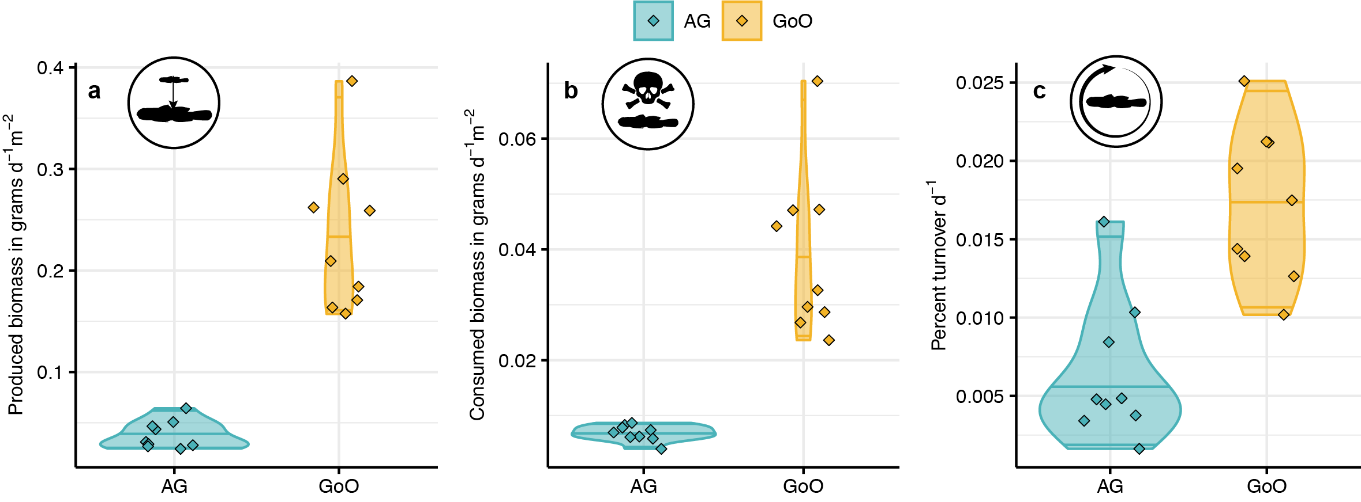

**Figure 6 | Biomass production, consumption, and turnover in cryptobenthic fish assemblages across the two locations.** (**a**) Produced biomass (i.e. grams of fish tissue grown per day and m2). (**b**) Consumed biomass (i.e. grams of fish tissue perished per day and m2). (**c**) Percent turnover (i.e. renewal of produced and consumed biomass per day). Violin plots and lines represent medians and variance estimates (95% quartiles) for the three metrics across the two locations. Diamonds represent values for each sample of cryptobenthic reef fish communities across the six sites (three per site).

**Discussion:**

As rapid environmental change sweeps across the Earth’s ecosystems, understanding the processes that underpin local community structure and ecosystem functioning within a regional species pool has gained renewed urgency. Coral reefs, the ocean’s most diverse ecosystem, generally afford relatively benign environmental conditions to their resident fauna, but anthropogenically-mediated climate change is pushing water temperatures on reefs to new extremes. Here, we show that reefs exposed to the world’s most extreme temperature regime in the Arabian Gulf harbor a community of cryptobenthic fishes with dramatically reduced diversity (Fig. 1a), abundance (Fig. 1b), and body condition (Fig. 5) compared to reefs with more moderate temperatures in the nearby Gulf of Oman, despite similarities in live coral cover and benthic community structure. While the small body size and limited mobility of cryptobenthic fishes promise excellent tractability of thermal filtering effects, species-specific temperature tolerances provide limited evidence for direct temperature effects, although two species appear to exhibit improved thermal tolerances to the Arabian Gulf conditions. Strong intraspecific dietary differences (Fig. 4), alongside poor body condition in Arabian Gulf populations (Fig. 5), suggest that thermal tolerance changes in response to the extreme conditions in the Arabian Gulf harbor energetic costs that can only be borne by species with low intrinsic metabolisms that can be maintained by a fundamentally different set of resources. The difference in body condition, coupled with the dramatic differences in abundances, have far reaching consequences for ecosystem scale fluxes of energy and nutrients, as even generous estimates of cryptobenthic reef fish productivity in the Arabian Gulf are an order of magnitude lower than in the nearby Gulf of Oman. Our results indicate that reef fish assemblages on future coral reefs are likely be determined by a multidimensional energetic filtering mechanism that may severely decrease the rate of bottom-up productivity and turnover on reefs, ultimately resulting in less productive reefs with slower turnover rates.

As the smallest and shortest lived marine vertebrates, cryptobenthic fishes should be particularly traceable concerning the effect of, and response to, extreme temperatures52. Yet, we detected no clear signal of critical thermal tolerances on species presence or absence in the Arabian Gulf, confirming that critical species-specific thermal tolerances obtained in the laboratory have limited explanatory power concerning the assembly of fish communities in their natural environment46,48,68. Furthermore, the swift generational turnover of cryptobenthic fishes harbors the potential for rapid transgenerational adaptation56,60, suggesting that colonization of reefs in the thermally extreme southeastern Arabian Gulf would be feasible even in light of the relatively short geological history of reefs in the Arabian Gulf69. Indeed, several species of cryptobenthic fishes absent in our samples from the southeaster Arabian Gulf, where temperature extremes are most dramatic, are present elsewhere in the Arabian Gulf where fluctuations are less pronounced65,70,71, suggesting that historical biogeography alone cannot account for species absences, and physiological factors may be responsible. While Arabian Gulf populations of *E. ventermaculus* (increased cold tolerance) and *E. pulcher* (increased heat tolerance) showed evidence for improved thermal tolerance, the other species absent in the southeastern Arabian Gulf may be unable to cope with environmental extremes and establish tolerant populations.

Transgenerational acclimation or adaptation has been shown to occur in a limited suite of model reef fish species51,72, but can come with substantial energetic costs42,50,72 that are reflected in reduced body condition73–75. These costs are evident in the lower mass per mm body length of Arabian Gulf populations in the three tested species (Fig. 5). This suggests that, although transgenerational tolerance shifts permits survival and adequate performance in controlled conditions42,50, they may not be a common mechanism in natural systems that impose a range of energetic trade-offs and challenges on individuals and populations73.

Beyond direct effects of temperature, one of the most critical variables concerning species’ energy budgets that is frequently ignored in studies of thermal adaptation (but see76) is the availability of energy sources. Naturally, reduced prey diversity and differing composition can have deleterious effects on consumer species like cryptobenthics74,77,78, especially when energetic requirements are increased under elevated temperatures. Our dietary analysis revealed a different and narrower range of both primary and secondary prey resources ingested by individuals from the Arabian Gulf in two of three species. While we cannot definitely say whether the pronounced dietary differences in OTUs/ESVs shown here (Fig. 4) reflect differences in diet quality (i.e. prey with poor nutrient content), evidence from recent work shows that large reef fish species exhibit unusual diets dominated by nutritiously poor benthic invertebrates in the Arabian Gulf79. Moreover, the single cryptobenthic species to show higher primary prey richness in the Arabian Gulf, *C. anomolus*, was also the only species more abundant and larger in the Arabian Gulf, with a weaker reduction in body condition compared to *E. pulcher* and *E. ventermaculus*. The genus *Coryogalops*, however, differs from some of the taxa that dominate cryptobenthic communities in both the Arabian Gulf and Gulf of Oman (e.g. *Ecscenius, Eviota,* *Enneapterygius*, etc.), in that it belongs to a clade containing many non-reef associated species and many subtropical/temperate species 80,81. Ecologically, the genus *Coryogalops* is more commonly associated with tidepools and other extremely shallow environments exposed to substantially fluctuating temperatures and salinity, where they may be forced to rely on a cryptic, sedentary lifestyle that is more energetically sustainable 82,83. Thus, the persistence of *C. anomolos* in the southeastern Arabian Gulf may reflect preadaptation to more extreme environments (e.g. tidepools with extreme temperature shifts) afforded by its phylogenetic history of belonging to a non-reef lineage.

Persistence in thermally extreme environments is energetically costly, not just because of the increasing energy demands with rising temperatures, but also the stress induced by temperature fluctuations84. Collectively, our evidence suggests that to exist in the Arabian Gulf, cryptobenthic fishes may need to satisfy intensified metabolic demands with a restricted suite of subpar resources: an energetic double-jeopardy. Given that cryptobenthic fishes already have high energetic demands per gram of body mass and have shown limited scope for metabolic adaptations to changing temperatures45,52, this may constitute an insurmountable challenge for species with high intrinsic metabolism43,45. In other words, the cost of metabolic adjustments to the variable and extreme temperature environment of the Arabian Gulf, rather than the direct effects of temperature *per se* or its effect on benthic community structure (cf.68) appear to underpin the reduced diversity and abundance of cryptobenthic fishes on these extreme reefs. Our findings, therefore, provide key evidence from highly-vulnerable tropical ectotherms in natural settings for predicted climate change effects on organismal performance and persistence22,37 and their ramifications for community assembly85.

The evident energetic filtering effect of the Arabian Gulf provides a sobering perspective on coral reef ecosystem functioning in a warming ocean. Coral reefs are some of the most productive marine ecosystems86 that are sustained through a variety of energetic pathways and phenomena87–90. Among these pathways, benthic productivity91 and its assimilation and transfer through cryptobenthic reef fishes and their unique demographic dynamics represents an important bottom-up flux of energy and nutrients to higher trophic levels56. The dramatic differences in biomass production, transfer, and turnover between cryptobenthic fish communities in the Arabian Gulf and Gulf of Oman suggest that this process may be severely compromised where thermal extremes reduce the diversity of cryptobenthics without compensations in abundance by the remaining species. Alarmingly, our modeling approach did not consider the decreased individual level production of biomass per unit body size demonstrated in our study, or the influence of seasonality on daily averages of biomass production. Specifically, previous studies in the Arabian Gulf have shown significant variability in large reef fish abundance across seasons, suggesting that these fishes seek out more benign conditions during extreme conditions in the summer and winter92,93. For cryptobenthics, mediation via migration is highly improbable, leaving little choice but to either adjust basic life-supporting processes to survive (i.e., decreased activity, somatic growth, or reproductive investment), or to bridge seasonal adversity through generational turnover and ontogenetic differences in physiology or habitat occupation94. Either strategy is likely to further stunt the yearly estimates of productivity, suggesting that differences in ecosystem functioning among the two systems may be even more extreme than revealed from our model.

Reefs in the Gulf of Oman used for comparison in this study may be particularly productive environments due to seasonal upwelling95, and indeed, our estimates of cryptobenthic productivity substantially exceed estimates obtained using similar methods for a degraded but species-rich reef on the Australian Great Barrier Reef (GBR) (2.31 g ha-1d-1 vs. 0.64 g ha-1d-1)96. In contrast, even the optimistic estimate of 0.38 g ha-1d-1 we acquired for the Arabian Gulf compares poorly the same GBR-reef. Notably, the GBR-reef had undergone a sequence of severe disturbances96, which greatly reduced space availability and shelter for small bodied fishes; yet, it also retained a diverse assemblage of cryptobenthic fish species able to satisfy their energetic demands due to benign temperature profiles33. Reefs in the Arabian Gulf, at the time of our survey, had also undergone periods of extensive bleaching in previous years97–100, which may have negatively affected the diversity and abundance of cryptobenthic fishes31,101,102. However, the observed lack of differences in live coral cover and overall benthic community structure between locations also suggests that, beyond few specialist species97,103, loss of live coral habitat may not be a primary agent of changes in small reef fish populations and ecosystem productivity34,97. Instead, our results cast a new light on the imminent threats to cryptobenthic reef fishes and their critical role for coral reef functioning: similar to reef corals, which are highly susceptible to extreme temperatures104, many of the world’s smallest marine ectotherms may struggle to meet their energetic demands as they try to adapt to changing temperatures on the world’s coral reefs. As a consequence, heterotrophic productivity, energy transfer, and replenishment of biomass at the bottom of the fish food chain may decrease severely. Analogous to cryptobenthics, large reef fish communities are less diverse and abundant in the Arabian Gulf compared to nearby locations with more moderate temperatures 105,106. Whether these patterns are driven by similar mechanisms as proposed herein (e.g., energetic filtering on large fish species) or instead related to the decreased productivity of cryptobenthic fishes at lower trophic levels remains unresolved. Yet, given the hypothesized importance of small vertebrate consumers in food webs globally107 and the unique ecological role of cryptobenthics for reef fish trophic dynamics56, the apparent effects of temperature on cryptobenthic fish assemblages may considerably hamper ecosystem functioning future coral reefs.

**Methods:**

All fieldwork and labwork was performed under permit #XXX and ethics approval #XXX, granted by New York University Abu Dhabi. We studied cryptobenthic fish communities across six distinct coral reefs in two distinct locations that differ dramatically in their yearly temperature fluctuations. The reefs we sampled in the Arabian Gulf (Dhabiya: 24.36383º, 54.10121º; Ras Ghanada: 24.84743º, 54.69235º; Saadiyat: 24.65771º, 54.48691º) are some of the most extreme reefs in the world in terms of the annual temperature gradient, with summer maximum temperatures reaching 36.0 ºC, while winter minimum temperatures fall to 16.0 ºC. In contrast, sampled reefs in the Gulf of Oman (Dibba Rock: ﻿25.55378º, 56.35694º; Sharm Rock: ﻿25.48229º, 56.36695º; Snoopy Rock: ﻿25.49210º, 56.36401º) generally lie within normal coral reef temperature profiles throughout the year, ranging between approximately 32.0 ºC and 22.0 ºC. All fieldwork was performed in April and May 2018.

*Field sampling*

Cryptobenthic fishes are small (generally <50mm), bottom-dwelling reef fishes across 17 families that frequently live deep within the reef framework52. However, due to their high growth rates, rapid mortality, and larval replenishment dynamics, cryptobenthics are a critical component of coral reef trophic dynamics, often supplying a large proportion of consumable biomass to larger fish species56. At each reef, we sampled three distinct reef outcrops for cryptobenthic reef fishes using enclosed clove oil stations53,108, covering an average of 4.63 ± 0.38 and 4.73 ± 0.16 m2 in the Arabian Gulf and Gulf of Oman, respectively. For each station, we covered a reef outcrop with a fine-mesh, bell-shaped net (2.74 m in diameter), weighted by a chain on the bottom. We then covered the same area with an impermeable bell-shaped tarpaulin, also weighted by a chain on the bottom. Then, three to four divers inoculated the area under the net with two liters of clove-oil:ethanol solution (1:5) using collapsible spray bottles (clove bud oil: Jedwards International, Inc., Braintree, MA, USA). Upon emptying the entire solution and a short wait period to allow the clove oil to disperse and take effect (usually 2-3 mins), we removed the tarpaulin and started to gently peel back the net while collecting all fishes found within the sampled area with tweezers. We searched the entire area, including caves and crevices until five minutes were spent by all divers without collecting any additional fishes. We placed all fishes into ziplock-bags, brought them to the surface, euthanized them with a clove-oil overdose, and immediately placed them into and ice-water slurry until preservation. At the end of each day, all specimens were brought to the laboratory at New York University Abu Dhabi or to room #211 at the Radisson Blu hotel in Fujairah for processing. For each sampled clove-oil station, we also took five photographs of the benthos to quantify benthic community structure. Specifically, we haphazardly placed a 20×20cm PVC-quadrate onto the outcrop within the area of our sample and took a close-up photograph of the benthos within the frame of the quadrat.

In addition to the quantitative samples obtained from the clove-oil stations, we collected individuals for physiological trials using roving diver collections. Specifically, two divers, each equipped with spraybottles of clove-oil ethanol solution, a dipnet, and ziplock bags, searched the reef for individuals of cryptobenthic fishes across three (Arabian Gulf: *Coryogalops anomolus*, *Ecsenius pulcher*, and *Enneapterygius ventermaculus*) and six (Gulf of Oman: *Coryogalops anomolus*, *Ecsenius pulcher*, and *Enneapterygius ventermaculus* plus *Eviota guttata*, *Helcogramma fuscopinna*, and *Hetereleotris vulgaris*) species. Upon locating an individual or identifying a suitable microhabitat in which a fish was suspected, we carefully applied the clove-oil solution until the fish showed signs of anesthesia. At the earliest opportunity, we scooped up the fish with a dipnet and placed it into a ziplock bag. Upon completion of the dive, all fishes were placed in small holding tanks equipped with air stones and periodically replenished with fresh seawater. Upon completion of all collections, fish were brought to the seawater laboratory facilities at NYUAD in Abu Dhabi. All roving diver collections were performed at Dhabiya Reef (AG) and Snoopy Rock (GoO).

*Laboratory processing*

For samples obtained from the enclosed clove-oil stations, we followed an establish protocol that involves photographing, identifying, recording, measuring, weighing and preserving each specimen. To photograph the fishes, we placed each individual in a small phototank and used a Nikon D300 DSLR camera with an AF-S Micro Nikkor 60mm macro lens (f/2.8G ED; Nikon Inc., Melville, NY, USA) against a black or white background. We measured each individual to the nearest 0.1mm using digital calipers and weighed the individual (wet weight) to the nearest 0.001 grams on a jewelry scale. We preserved all individuals in 95% ethanol, either separately or in lots with its conspecifics. A subset of the samples was then shipped to the University of Washington under export permit #XXX, where they are now cataloged, while the rest were retained and archived at NYUAD.

We processed a subset of individuals (as dictated by sample-availability and sequencing costs) in six species (*Antennablennius species A*, *C. anomolus*, *E. pulcher*, *E. guttata*, *E. ventermaculus*, and *H. vulgaris*) for gut content DNA metabarcoding by removing the entire alimentary tract under sterile conditions at the University of Washington. Specifically, we haphazardly selected ten, ten, and seven individuals of *C. anomolus*, *E. ventermaculus*, and *E. pulcher*, respectively, from the Arabian Gulf, and ten specimens each (with the exception of *E. pulcher*, for which we selected eleven) of *C. anomolus*, *E. ventermaculus, Antennablennius species A*, *E. guttata,* and *H. vulgaris* from the Gulf of Oman. Then, we dissected out the alimentary tract and removed all other organs (e.g. liver, gonads) under a Zeiss V20 SteREO dissecting microscope using micro-surgery tools. We placed the entire gut into an extraction tube filled with C1-buffer from the Qiagen DNEasy PowerSoil DNA extraction kit. After every specimen, we sterilized the work platform and tools using a series of baths consisting of a dish soap solution, a 10% sodium hypochlorite:water solution, and Milli-Q UV-sterilized water. Upon completion of twenty samples, we immediately proceeded to perform DNA-extractions from the dissected gut samples. All DNA extractions were performed according to the protocol outlined in66. We stored all DNA samples at 4ºC until aliquoting them into 96-well plates for library preparation and amplification.

For the benthic photographs, we created a grid with 16 equally-spaced points which we superimposed on every photograph. We then categorized the benthos at each of the points into functional groups, including barnacles, bleached corals, crustose coralline algae, dead coral, hydroids, branching, encrusting, foliose, and massive live coral, mollusks, bare rock, soft sediment, sponges, algal turf, and sea urchins. Whenever no visual identification was possible (due to obstruction, shading, or blurriness), we categorized the point as “unidentifiable” (n = 69 out of 1,440).

*Gut content DNA metabarcoding*

All DNA samples were sent to Jonah Ventures (Boulder, CO) for post-extraction processing.

*Critical thermal maximum and minimum trials*

We examined individual temperature tolerances by using critical thermal maximum (CTmax) and minimum (CTmin) trials. We transported all fishes caught during roving diver collections to the wet laboratory facilities at NYUAD and housed them for at least 24 hours in large holding tanks. Trials took place between May 9th and May 13th 2018. For the trials, a haphazardly selected subset of individuals was moved from the holding tanks into separate chambers filled with seawater at ambient temperatures and salinity. Then, we incrementally decreased (CTmin) or increased (CTmax) the water temperature within the chambers while keeping all other parameters constant. Specifically, we lowered or increased the temperature by 0.3ºC every minute while keeping all fishes under constant observation. Critical endpoints were classified as loss of equilibrium and uncontrolled swimming for two seconds or more. When individuals reached their criticial endpoints, they were immediately removed, euthanized using a clove-oil overdose, measured, weighed, and photographed. In total, we processed 60 individuals across six species for CTmax trials, and 62 individuals across the same species for CTmin trials.

*Data analyses and modeling*

To analyze the community variables, we first calculated the surface area (*SA*) for each sampled outcropfrom the curved surface length (*CSL*) by deriving the sampled outcrop’s radius *r* (*r* = 2*CSL/2π) and then computing available surface area under the assumption that outcrops represent hemispherical constructs (*SA* = 4*πr*2/2). Then, we calculated the sum of individuals, species, and their respective body weight for each station to obtain abundance, diversity, and biomass estimates, which we converted to density estimates by dividing them by the sampled surface area. Using these estimates, we performed three Bayesian hierarchical models, each on the natural logarithm of the response variables (density, species density, and biomass per m2). Models were specified to include a fixed effect of *Location* (*Arabian Gulf vs. Gulf of Oman*) and a random effect of *Site* (*Dhabiya*, *Ras Ghanada*, *Saadiyat*, *Dibba Rock*, *Sharm Rock*, *Snoopy Rock*) and were run with a Gaussian error distribution. For each model, we ran four chains with 4,000 post burn-in samples and we validated chain convergence visually. We used the default, non-informative priors set by the *brm* function in the *brms* package109. Then, we used the model parameters to predict distributions based on 1,000 draws from the posterior and plotted the distributions, their mean and confidence bands, and the raw data for each site to evaluate our model fit.

To examine cryptobenthic fish community composition across the two locations, we created a species-by-sample matrix indicating the abundance of each species in a given sample. We then performed a non-metric multidimensional scaling ordination on the Bray-Curtis dissimilarity matrix of the data in two dimensions (stress = 0.101). We performed a permutational analysis of variance (PERMANOVA) on the same distance matrix (using 999 permutations) and extracted the most influential species using the similarity of percentages (SIMPER) routine. We constructed convex hull polygons for the two locations (as determined by the location of each sample) and plotted them in a biplot with the seven most influential species (average contribution > 0.025) superimposed. For benthic community composition, we followed a similar process. After our initial categorization, we first combined live coral categories into “branching” and “other” and omitted all categories with fewer than three records (bleached coral and hydroids) from the data. We also excluded the “unidentifiable” category. We then calculated the proportional contribution of each category to the benthos in a given sampled outcrop and arranged the data into a sample-by-category matrix and performed another nMDS analysis as per above. We also performed a PERMANOVA and visualized the data in the same way as described above, but did not perform the SIMPER routine due to the lower number of categories and scaled the size of the dots representing unique samples by their live coral cover. Finally, we statistically compared live coral cover among the two locations using a Bayesian hierarchical model. We logit-transformed proportional *LiveCoralCover* and specified *Location* as a fixed effect, with *Site* specified to have a random effect. Model and chain specifications were programmed as described above.

To compare intrinsic temperature tolerances, as derived from CTmin and CTmax trials, we ran two separate Bayesian linear models. For both models, we specified an effect of *Population* (i.e., separate levels for each species and their respective Arabian Gulf and Gulf of Oman populations) on the critical thermal limit of individuals and examined differences among pairwise levels using post-hoc contrasts (Tables S1 and S2). Models were run with a Gaussian error distribution and the same specifications as previous models (e.g., burnin, iterations, priors, etc.). As previously, we took 1,000 draws from the posterior parameters to predict posterior distributions and their mean and confidence bands and plotted them alongside the raw data. Furthermore, to examine location-specific differences in length-weight relationships and species-specific abundances, we isolated individuals from three species (*C. anomolus*, *E. pulcher*, *E. ventermaculus*) and ran separate models for each species testing the effects of total length (*TL*) and *Location* on *Weight*, with both *Weight* and *TL* being log-transformed and the effect of location (with a random effect of *Site*) on abundance. We used a Gaussian error distribution for the first set of models, and a negative binomial error distribution for the second set of models. To validated our model performance, we used the posterior parameters to predict values across a sequence of 100 values within the sampled size range of the two populations. We performed this 500 times and plotted each predicted model fit alongside the raw data. Models were again run with the same prior and chain specifications as above.

We examined the composition on prey items in the guts of the examined fishes using a network theory approach on both the 23S and the COI primer results110. First, we focused on the three species that we obtained from both locations to examine differences in resource use among the two locations. We created a presence-absence matrix of all ESVs/OTUs across fish individuals and then transformed this matrix into a data frame that contained each ESV/OTU and its linkage to the individual it was found in two columns. We then substituted the individual identity for a descriptor variable that indicated both the species (*C. anomoluc*, *E. pulcher*, or *E. ventermaculus*) and the respective population the individual was sourced from (*AG* or *GoO*) to create a list of symbolic edges in the network across the two columns. Using this information, we calculated edge density and an edge-betweenness score to decompose the community structure within the network and identify modules (i.e. nodes identified as clusters in the network)111. We then examined the module assignments and membership of nodes and edges to specific modules by visualizing the resulting undirected dietary network tree to examine patterns of prey partitioning among species and populations. We performed the same procedure for populations and species exclusive to the Gulf of Oman. To gauge whether modularity values obtained from the network analyses suggest stronger partitioning than expected at random, we also performed random permutation testing. Specifically, we randomly re-assigned species and population affiliations to each individual fish in the two-column data frame of symbolic edges in the network, resulting in random assignments of OTUs to a certain population. We then performed the same steps as previously, calculating both modularity and module membership of the nodes in the network and repeated the procedure 999 times. We then compared the modularity values obtained from random permutations against the empirical modularity value and calculated a *p*-statistic by dividing the number of occurrences where permuted modularity was equal or higher than the empirical value by the number of permutations. We repeated the permutation testing procedure for the species and populations exclusive to the Gulf of Oman. Furthermore, we investigated the diversity of prey items in each species’ population for both the 23S and COI primer results via a rarefaction analysis on the species richness of prey items given the number of sequences in each species to account for quantitative differences in prey tissues and sequencing depth. Specifically, we rarefied species richness estimates for each species/population to an endpoint defined by the maximum sequences in any population (for 23S and COI, respectively) using 100 bootstraps and 50 knots along the x-axis. We then visualized the rarefaction curves for each species and population separately, marking inter- and extrapolated estimates on the graph.

Finally, we used previously established methods96,112,113 to model growth and mortality dynamics in cryptobenthic fish assemblages from the two locations, ultimately yielding a standing biomass estimate and three rate-based metrics that serve as indicators of energy and nutrient fluxes, and thus, ecosystem functioning64: produced biomass (in g d-1m-2), consumed biomass (in g d-1m-2), and total turnover (percent d-1). Produced biomass represents the amount of fish tissue accumulated by an assemblage (in this case, a cryptobenthic fish assemblage collected in a given sample), thus considering only the growth that will occur on any given day (based on yearly averages). Consumed biomass, in turn, represents the amount of fish tissue that has perished based on our estimates of fish mortality. In this pathway, the energy and nutrients produced by fishes are provided to other consumers or decomposers via predation or detritivory. Finally, total turnover expands on the classic estimate of turnover (the production/standing biomass [P/B] ratio114) by also including consumed biomass (consumed biomass/standing biomass)112. As such, the turnover metric approximates the rate at which particles flow through the system, either via incorporation into fish body mass or via their release to other consumers through mortality.

To perform the modeling, we first accrued information on species-specific information on maximum lengths and a range of coarse ecological traits (pertaining to diet, sociality, habitat association, and prevailing mean sea surface temperatures [SST]) from the literature for each species present in our samples. We also extracted length-weight relationships at the family-level. We then used these data to calculate species-specific growth coefficients (Kmax) to the specified maximum size and modeled individual weight gain based on changes in fish size per day under a Von Bertalanffy Gorwth Model (VBGM)113. By subtracting the observed size of fishes (as obtained from our samples) from the weight obtained by the same fish after one day using the modeling procedure, we calculated the expected biomass production by said individual. We estimated daily mortality rates by calculating species-level mortality risk coefficients via VBGM parameters and SST112,115 and then adjusted the risk based on relationships between mortality and body size116. Using these coefficients, we obtained a daily probability of survival for a given individual in the dataset. By combining this probability with weight gains as obtained from the previous step, we were able to generate the expected loss of biomass due to natural mortality at the individual level. Finally, we summed the individual-level estimates of weight, growth, and mortality for each sample to obtain community-level values of standing biomass, produced biomass and consumed biomass, which we used to calculate total turnover as the combined quotients of produced and consumed biomass and standing biomass.

All data preparation, analyses, and visualization was performed in *R* using the following packages: *tidyverse*, *vegan*, *brms*, *iNEXT*, *igraph*, *tidybayes*, *modelr*, *ggpubr*, *ggrepel*, *scales*, *geomnet*, *xgboost*, and *GGally*. All graphs were made using the *Trimma lantana* color palette in the package *fishualize*117. Growth modeling was performed using the package *rfishprod*. All data and code that underly the results presented in this paper are provided in the supplemental material of the paper and will be made publicly accessible with publication of the article.  
  
Acknowledgments

We thank Katherine Maslenikov and Jonathon Huie for their assistance in cataloging specimens at the University of Washington. Partial funding of fieldwork came from startup funds to LT from the University of Washington.

1. Dornelas, M. *et al.* Assemblage time series reveal biodiversity change but not systematic loss. *Science* **344**, 296–299 (2014).

2. Blowes, S. A. *et al.* The geography of biodiversity change in marine and terrestrial assemblages. *Science* **366**, 339–345 (2019).

3. Johnson, C. N. *et al.* Biodiversity losses and conservation responses in the Anthropocene. *Science* **356**, 270–275 (2017).

4. Mace, G. M., Norris, K. & Fitter, A. H. Biodiversity and ecosystem services: a multilayered relationship. *Trends in ecology & evolution* **27**, 19–26 (2012).

5. Hubbell, S. P. A unified theory of biogeography and relative species abundance and its application to tropical rain forests and coral reefs. *Coral reefs* **16**, S9–S21 (1997).

6. MacArthur, R. & Levins, R. The limiting similarity, convergence, and divergence of coexisting species. *The american naturalist* **101**, 377–385 (1967).

7. Simberloff, D. S. & Wilson, E. O. Experimental zoogeography of islands: the colonization of empty islands. *Ecology* **50**, 278–296 (1969).

8. Lawton, J. H. Are there general laws in ecology? *Oikos* 177–192 (1999).

9. Simberloff, D. Community Ecology: Is It Time to Move On? (An American Society of Naturalists Presidential Address). *The American Naturalist* **163**, 787–799 (2004).

10. Vellend, M. *The theory of ecological communities (MPB-57)*. vol. 75 (Princeton University Press, 2016).

11. Kraft, N. J. *et al.* Community assembly, coexistence and the environmental filtering metaphor. *Functional Ecology* **29**, 592–599 (2015).

12. Kraft, N. J., Valencia, R. & Ackerly, D. D. Functional traits and niche-based tree community assembly in an Amazonian forest. *Science* **322**, 580–582 (2008).

13. Leibold, M. A. *et al.* The metacommunity concept: a framework for multi‐scale community ecology. *Ecology letters* **7**, 601–613 (2004).

14. Sale, P. F. Maintenance of high diversity in coral reef fish communities. *The American Naturalist* **111**, 337–359 (1977).

15. Cardinale, B. J. *et al.* Biodiversity loss and its impact on humanity. *Nature* **486**, 59–67 (2012).

16. Duffy, J. E., Godwin, C. M. & Cardinale, B. J. Biodiversity effects in the wild are common and as strong as key drivers of productivity. *Nature* **549**, 261 (2017).

17. Schweiger, A. K. *et al.* Plant spectral diversity integrates functional and phylogenetic components of biodiversity and predicts ecosystem function. *Nature ecology & evolution* **2**, 976 (2018).

18. Pecl, G. T. *et al.* Biodiversity redistribution under climate change: Impacts on ecosystems and human well-being. *Science* **355**, eaai9214 (2017).

19. Scheffers, B. R. *et al.* The broad footprint of climate change from genes to biomes to people. *Science* **354**, aaf7671 (2016).

20. García, F. C., Bestion, E., Warfield, R. & Yvon-Durocher, G. Changes in temperature alter the relationship between biodiversity and ecosystem functioning. *Proceedings of the National Academy of Sciences* **115**, 10989–10994 (2018).

21. Pörtner, H. O. & Farrell, A. P. Physiology and climate change. *Science* **322**, 690–692 (2008).

22. Deutsch, C., Ferrel, A., Seibel, B., Pörtner, H.-O. & Huey, R. B. Climate change tightens a metabolic constraint on marine habitats. *Science* **348**, 1132–1135 (2015).

23. Bozinovic, F. & Pörtner, H. Physiological ecology meets climate change. *Ecology and evolution* **5**, 1025–1030 (2015).

24. Brown, J. H., Hall, C. A. & Sibly, R. M. Equal fitness paradigm explained by a trade-off between generation time and energy production rate. *Nature ecology & evolution* **2**, 262 (2018).

25. Toseland, A. *et al.* The impact of temperature on marine phytoplankton resource allocation and metabolism. *Nature Climate Change* **3**, 979 (2013).

26. Chesson, P. Mechanisms of maintenance of species diversity. *Annual review of Ecology and Systematics* **31**, 343–366 (2000).

27. Barnes, A. D. *et al.* Energy flux: the link between multitrophic biodiversity and ecosystem functioning. *Trends in ecology & evolution* **33**, 186–197 (2018).

28. Spalding, M. *et al.* Mapping the global value and distribution of coral reef tourism. *Marine Policy* **82**, 104–113 (2017).

29. De’ath, G., Fabricius, K. E., Sweatman, H. & Puotinen, M. The 27–year decline of coral cover on the Great Barrier Reef and its causes. *Proceedings of the National Academy of Sciences* **109**, 17995–17999 (2012).

30. Hughes, T. P. *et al.* Global warming and recurrent mass bleaching of corals. *Nature* **543**, 373–377 (2017).

31. Pratchett, M. S., Hoey, A. S., Wilson, S. K., Messmer, V. & Graham, N. A. Changes in biodiversity and functioning of reef fish assemblages following coral bleaching and coral loss. *Diversity* **3**, 424–452 (2011).

32. Brandl, S. J., Emslie, M. J. & Ceccarelli, D. M. Habitat degradation increases functional originality in highly diverse coral reef fish assemblages. *Ecosphere* **7**, (2016).

33. Fontoura, L. *et al.* Climate‐driven shift in coral morphological structure predicts decline of juvenile reef fishes. *Global change biology* (2019).

34. Bellwood, D. R., Hoey, A. S., Ackerman, J. L. & Depczynski, M. Coral bleaching, reef fish community phase shifts and the resilience of coral reefs. *Global Change Biology* **12**, 1587–1594 (2006).

35. Robinson, J. P. *et al.* Productive instability of coral reef fisheries after climate-driven regime shifts. *Nature ecology & evolution* **3**, 183 (2019).

36. Wismer, S., Tebbett, S. B., Streit, R. P. & Bellwood, D. R. Young fishes persist despite coral loss on the Great Barrier Reef. *Communications Biology* **2**, 456 (2019).

37. Tewksbury, J. J., Huey, R. B. & Deutsch, C. A. Putting the heat on tropical animals. *Science* **320**, 1296–1297 (2008).

38. Pörtner, H. O. & Knust, R. Climate change affects marine fishes through the oxygen limitation of thermal tolerance. *science* **315**, 95–97 (2007).

39. Comte, L. & Olden, J. D. Climatic vulnerability of the world’s freshwater and marine fishes. *Nature Climate Change* **7**, 718 (2017).

40. Munday, P. L., McCormick, M. I. & Nilsson, G. E. Impact of global warming and rising CO2 levels on coral reef fishes: what hope for the future? *Journal of Experimental Biology* **215**, 3865–3873 (2012).

41. Munday, P. L., Jones, G. P., Pratchett, M. S. & Williams, A. J. Climate change and the future for coral reef fishes. *Fish and Fisheries* **9**, 261–285 (2008).

42. Donelson, J., Munday, P., McCormick, M. & Pitcher, C. Rapid transgenerational acclimation of a tropical reef fish to climate change. *Nature Climate Change* **2**, 30 (2012).

43. Johansen, J. & Jones, G. Increasing ocean temperature reduces the metabolic performance and swimming ability of coral reef damselfishes. *Global Change Biology* **17**, 2971–2979 (2011).

44. Rummer, J. L. *et al.* Life on the edge: thermal optima for aerobic scope of equatorial reef fishes are close to current day temperatures. *Global change biology* **20**, 1055–1066 (2014).

45. Nilsson, G. E., Crawley, N., Lunde, I. G. & Munday, P. L. Elevated temperature reduces the respiratory scope of coral reef fishes. *Global Change Biology* **15**, 1405–1412 (2009).

46. Eme, J. & Bennett, W. A. Critical thermal tolerance polygons of tropical marine fishes from Sulawesi, Indonesia. *Journal of Thermal Biology* **34**, 220–225 (2009).

47. Gardiner, N. M., Munday, P. L. & Nilsson, G. E. Counter-gradient variation in respiratory performance of coral reef fishes at elevated temperatures. *PLoS One* **5**, e13299 (2010).

48. Mora, C. & Ospina, A. Tolerance to high temperatures and potential impact of sea warming on reef fishes of Gorgona Island (tropical eastern Pacific). *Marine Biology* **139**, 765–769 (2001).

49. Nilsson, G. E., Östlund-Nilsson, S. & Munday, P. L. Effects of elevated temperature on coral reef fishes: loss of hypoxia tolerance and inability to acclimate. *Comparative Biochemistry and Physiology Part A: Molecular & Integrative Physiology* **156**, 389–393 (2010).

50. Bernal, M. A. *et al.* Phenotypic and molecular consequences of stepwise temperature increase across generations in a coral reef fish. *Molecular Ecology* **27**, 4516–4528 (2018).

51. Grenchik, M., Donelson, J. & Munday, P. Evidence for developmental thermal acclimation in the damselfish, Pomacentrus moluccensis. *Coral Reefs* **32**, 85–90 (2013).

52. Brandl, S. J., Goatley, C. H., Bellwood, D. R. & Tornabene, L. The hidden half: ecology and evolution of cryptobenthic fishes on coral reefs. *Biological Reviews* **93**, 1846–1873 (2018).

53. Brandl, S. J., Casey, J. M., Knowlton, N. & Duffy, J. E. Marine dock pilings foster diverse, native cryptobenthic fish assemblages across bioregions. *Ecology and evolution* **7**, 7069–7079 (2017).

54. Ahmadia, G. N., Tornabene, L., Smith, D. J. & Pezold, F. L. The relative importance of regional, local, and evolutionary factors structuring cryptobenthic coral-reef assemblages. *Coral Reefs* **37**, 279–293 (2018).

55. Coker, D. J., DiBattista, J. D., Sinclair-Taylor, T. H. & Berumen, M. L. Spatial patterns of cryptobenthic coral-reef fishes in the Red Sea. *Coral Reefs* 1–7 (2017).

56. Brandl, S. J. *et al.* Demographic dynamics of the smallest marine vertebrates fuel coral reef ecosystem functioning. *Science* **364**, 1189–1192 (2019).

57. Miller, P. J. Miniature vertebrates. The implications of small body size. in vol. 69 (Oxford University Press, 1996).

58. Depczynski, M. & Bellwood, D. Microhabitat utilisation patterns in cryptobenthic coral reef fish communities. *Marine Biology* **145**, 455–463 (2004).

59. Bellwood, D. R. *et al.* Coral recovery may not herald the return of fishes on damaged coral reefs. *Oecologia* **170**, 567–573 (2012).

60. Depczynski, M. & Bellwood, D. R. Shortest recorded vertebrate lifespan found in a coral reef fish. *Current Biology* **15**, R288–R289.

61. Tornabene, L., Valdez, S., Erdmann, M. & Pezold, F. Support for a ‘Center of Origin’in the Coral Triangle: Cryptic diversity, recent speciation, and local endemism in a diverse lineage of reef fishes (Gobiidae: Eviota). *Molecular phylogenetics and evolution* **82**, 200–210 (2015).

62. Price, A., Sheppard, C. & Roberts, C. The Gulf: its biological setting. *Marine Pollution Bulletin* **27**, 9–15 (1993).

63. Riegl, B. M. & Purkis, S. J. Coral reefs of the Gulf: adaptation to climatic extremes in the world’s hottest sea. in *Coral reefs of the Gulf* 1–4 (Springer, 2012).

64. Brandl, S. J. *et al.* Coral reef ecosystem functioning: eight core processes and the role of biodiversity. *Frontiers in Ecology and the Environment* (2019).

65. Eagderi, S., Fricke, R., Esmaeili, H. & Jalili, P. Annotated checklist of the fishes of the Persian Gulf: Diversity and conservation status. *Iranian Journal of Ichthyology* **6**, 1–171 (2019).

66. Casey, J. M. *et al.* Reconstructing hyperdiverse food webs: Gut content metabarcoding as a tool to disentangle trophic interactions on coral reefs. *Methods in Ecology and Evolution* **10**, 1157–1170 (2019).

67. Depczynski, M. & Bellwood, D. R. The role of cryptobenthic reef fishes in coral reef trophodynamics. *Marine Ecology Progress Series* **256**, 183–191 (2003).

68. Pratchett, M. S., Wilson, S. K. & Munday, P. L. 13 Effects of climate change on coral reef fishes. *Ecology of fishes on coral reefs* 127 (2015).

69. Purkis, S. J. & Riegl, B. M. Geomorphology and Reef Building in the SE Gulf. in *Coral Reefs of the Gulf: Adaptation to Climatic Extremes* (eds. Riegl, B. M. & Purkis, S. J.) 33–50 (Springer Netherlands, 2012). doi:10.1007/978-94-007-3008-3_3.

70. Randall, J., Downing, N., McCarthy, L., Stanaland, B. & Tarr, A. Fifty-one new records of fishes from the Arabian Gulf. *Fauna of Saudi Arabia* **14**, 220–258 (1994).

71. Krupp, F. & Müller, T. The status of fish populations in the northern Arabian Gulf two years after the 1991 Gulf War oil spill. *Courier Forschungsinst Senckenb* **166**, 67–75 (1994).

72. Donelson, J. M., Munday, P. L., McCORMICK, M. I. & Nilsson, G. E. Acclimation to predicted ocean warming through developmental plasticity in a tropical reef fish. *Global Change Biology* **17**, 1712–1719 (2011).

73. Ohlberger, J. Climate warming and ectotherm body size–from individual physiology to community ecology. *Functional Ecology* **27**, 991–1001 (2013).

74. Gardner, J. L., Peters, A., Kearney, M. R., Joseph, L. & Heinsohn, R. Declining body size: a third universal response to warming? *Trends in ecology & evolution* **26**, 285–291 (2011).

75. Peig, J. & Green, A. J. The paradigm of body condition: a critical reappraisal of current methods based on mass and length. *Functional Ecology* **24**, 1323–1332 (2010).

76. Donelson, J., Munday, P., McCormick, M., Pankhurst, N. & Pankhurst, P. Effects of elevated water temperature and food availability on the reproductive performance of a coral reef fish. *Marine Ecology Progress Series* **401**, 233–243 (2010).

77. Duffy, J. E. Biodiversity and ecosystem function: the consumer connection. *Oikos* **99**, 201–219 (2002).

78. Petchey, O. L. Prey diversity, prey composition, and predator population dynamics in experimental microcosms. *Journal of Animal Ecology* **69**, 874–882 (2000).

79. Shraim, R. *et al.* Environmental Extremes Are Associated with Dietary Patterns in Arabian Gulf Reef Fishes. *Frontiers in Marine Science* **4**, 285 (2017).

80. Agorreta, A. *et al.* Molecular phylogenetics of Gobioidei and phylogenetic placement of European gobies. *Molecular Phylogenetics and Evolution* **69**, 619–633 (2013).

81. Thacker, C. E. & Roje, D. M. Phylogeny of Gobiidae and identification of gobiid lineages. *Systematics and Biodiversity* **9**, 329–347 (2011).

82. Kovačić, M., Bogorodsky, S. V. & Mal, A. O. Two new species of Coryogalops (Perciformes: Gobiidae) from the Red Sea. *Zootaxa* **3881**, 513–531 (2014).

83. Rishworth GM, Strydom NA & Perissinotto R. Fishes associated with living stromatolite communities in peritidal pools: predators, recruits and ecological traps. *Mar Ecol Prog Ser* **580**, 153–167 (2017).

84. Parsons, P. A. The energetic cost of stress. Can biodiversity be preserved? *Biodiversity Letters* 11–15 (1994).

85. Sheldon, K. S., Yang, S. & Tewksbury, J. J. Climate change and community disassembly: impacts of warming on tropical and temperate montane community structure. *Ecology Letters* **14**, 1191–1200 (2011).

86. Crossland, C., Hatcher, B. & Smith, S. Role of coral reefs in global ocean production. *Coral reefs* **10**, 55–64 (1991).

87. Gove, J. M. *et al.* Near-island biological hotspots in barren ocean basins. *Nature communications* **7**, 10581 (2016).

88. De Goeij, J. M. *et al.* Surviving in a marine desert: the sponge loop retains resources within coral reefs. *Science* **342**, 108–110 (2013).

89. Wild, C. *et al.* Coral mucus functions as an energy carrier and particle trap in the reef ecosystem. *Nature* **428**, 66–70 (2004).

90. Hamner, W., Jones, M., Carleton, J., Hauri, I. & Williams, D. M. Zooplankton, planktivorous fish, and water currents on a windward reef face: Great Barrier Reef, Australia. *Bulletin of Marine Science* **42**, 459–479 (1988).

91. Hatcher, B. G. Coral reef primary productivity: a beggar’s banquet. *Trends in Ecology & Evolution* **3**, 106–111 (1988).

92. Coles, S. L. & Tarr, B. A. Reef fish assemblages in the western Arabian Gulf: a geographically isolated population in an extreme environment. *Bulletin of Marine Science* **47**, 696–720 (1990).

93. Burt, J., Bartholomew, A., Usseglio, P., Bauman, A. & Sale, P. F. Are artificial reefs surrogates of natural habitats for corals and fish in Dubai, United Arab Emirates? *Coral Reefs* **28**, 663–675 (2009).

94. Komoroske, L. M. *et al.* Ontogeny influences sensitivity to climate change stressors in an endangered fish. *Conservation Physiology* **2**, (2014).

95. Coles, S. L. Coral species diversity and environmental factors in the Arabian Gulf and the Gulf of Oman: a comparison to the Indo-Pacific region. *Atoll Research Bulletin* (2003).

96. Morais, R. A. & Bellwood, D. R. Pelagic Subsidies Underpin Fish Productivity on a Degraded Coral Reef. *Current Biology* **29**, 1521–1527 (2019).

97. Riegl, B. Effects of the 1996 and 1998 positive sea-surface temperature anomalies on corals, coral diseases and fish in the Arabian Gulf (Dubai, UAE). *Marine biology* **140**, 29–40 (2002).

98. Riegl, B. & Purkis, S. Coral population dynamics across consecutive mass mortality events. *Global change biology* **21**, 3995–4005 (2015).

99. Burt, J., Al-Harthi, S. & Al-Cibahy, A. Long-term impacts of coral bleaching events on the world’s warmest reefs. *Marine environmental research* **72**, 225–229 (2011).

100. Burt, J. A., Paparella, F., Al-Mansoori, N., Al-Mansoori, A. & Al-Jailani, H. Causes and consequences of the 2017 coral bleaching event in the southern Persian/Arabian Gulf. *Coral Reefs* **38**, 567–589 (2019).

101. Coker, D. J., Wilson, S. K. & Pratchett, M. S. Importance of live coral habitat for reef fishes. *Reviews in Fish Biology and Fisheries* **24**, 89–126 (2014).

102. Pratchett, M. S., Hoey, A. S. & Wilson, S. K. Reef degradation and the loss of critical ecosystem goods and services provided by coral reef fishes. *Current Opinion in Environmental Sustainability* **7**, 37–43 (2014).

103. Munday, P. L. Habitat loss, resource specialization, and extinction on coral reefs. *Global Change Biology* **10**, 1642–1647 (2004).

104. Brown, B. E. Coral bleaching: causes and consequences. *Coral reefs* **16**, S129–S138 (1997).

105. Burt, J. A. *et al.* Biogeographic patterns of reef fish community structure in the northeastern Arabian Peninsula. *ICES Journal of Marine Science* **68**, 1875–1883 (2011).

106. Feary, D. A., Burt, J. A., Cavalcante, G. H. & Bauman, A. G. Extreme Physical Factors and the Structure of Gulf Fish and Reef Communities. in *Coral Reefs of the Gulf: Adaptation to Climatic Extremes* (eds. Riegl, B. M. & Purkis, S. J.) 163–170 (Springer Netherlands, 2012). doi:10.1007/978-94-007-3008-3_9.

107. Brose, U. *et al.* Predator traits determine food-web architecture across ecosystems. *Nature ecology & evolution* **3**, 919 (2019).

108. Ackerman, J. L. & Bellwood, D. R. Reef fish assemblages: a re-evaluation using enclosed rotenone stations. *Marine Ecology-Progress Series* **206**, 227–237 (2000).

109. Bürkner, P.-C. Advanced Bayesian Multilevel Modeling with the R Package brms. *arXiv preprint arXiv:1705.11123* (2017).

110. Wasserman, S. & Faust, K. *Social network analysis: Methods and applications*. vol. 8 (Cambridge university press, 1994).

111. Newman, M. E. & Girvan, M. Finding and evaluating community structure in networks. *Physical review E* **69**, 026113 (2004).

112. Brandl, S. J. *et al.* Supplemental Materials for Demographic dynamics of the smallest marine vertebrates fuel coral reef ecosystem functioning. *Science* **364**, 1189–1192 (2019).

113. Morais, R. A. & Bellwood, D. R. Global drivers of reef fish growth. *Fish and Fisheries*.

114. Allen, K. R. Relation between production and biomass. *Journal of the Fisheries Board of Canada* **28**, 1573–1581 (1971).

115. Pauly, D. On the interrelationships between natural mortality, growth parameters, and mean environmental temperature in 175 fish stocks. *ICES Journal of Marine Science* **39**, 175–192 (1980).

116. Gislason, H., Daan, N., Rice, J. C. & Pope, J. G. Size, growth, temperature and the natural mortality of marine fish. *Fish and Fisheries* **11**, 149–158 (2010).

117. Schiettekatte, N. M., Brandl, S. J. & Casey, J. M. *fishualize: Color palettes based on fish species*. (2019).

Supplemental Material:

**Table S1 | Contrasts between levels of the explanatory variable for the model testing CTmin differences in cryptobenthic reef fishes.** Population columns highlight the contrast estimated in the model, whereas the estimate and its confidence intervals indicate estimated differences.

|  |  |  |  |  |
| --- | --- | --- | --- | --- |
| **Population I** | **Population II** | **Estimate** | **LCI** | **UCI** |
| *CORYANOM.AG* | *ECSEPULC.AG* | *0.6125* | *0.1733* | *1.0686* |
| *CORYANOM.AG* | *ENNEVENT.AG* | *-0.3991* | *-0.8505* | *0.0541* |
| *CORYANOM.AG* | *ECSEPULC.GoO* | *0.7474* | *0.3159* | *1.2112* |
| *CORYANOM.AG* | *ENNEVENT.GoO* | *-1.3907* | *-1.8869* | *-0.8881* |
| *CORYANOM.AG* | *EVIOGUTT.GoO* | *-0.7844* | *-1.2413* | *-0.3167* |
| *CORYANOM.AG* | *HELCFUSC.GoO* | *-1.2349* | *-1.7358* | *-0.7539* |
| *CORYANOM.AG* | *HETEVULG.GoO* | *-0.0802* | *-0.5491* | *0.3837* |
| *ECSEPULC.AG* | *ENNEVENT.AG* | *-1.0113* | *-1.3128* | *-0.7094* |
| *ECSEPULC.AG* | *ECSEPULC.GoO* | *0.1369* | *-0.1653* | *0.4461* |
| *ECSEPULC.AG* | *ENNEVENT.GoO* | *-2.0027* | *-2.4018* | *-1.6412* |
| *ECSEPULC.AG* | *EVIOGUTT.GoO* | *-1.3937* | *-1.7043* | *-1.0756* |
| *ECSEPULC.AG* | *HELCFUSC.GoO* | *-1.8474* | *-2.2056* | *-1.489* |
| *ECSEPULC.AG* | *HETEVULG.GoO* | *-0.6942* | *-1.01* | *-0.3582* |
| *ENNEVENT.AG* | *ECSEPULC.GoO* | *1.1485* | *0.8472* | *1.4592* |
| *ENNEVENT.AG* | *ENNEVENT.GoO* | *-0.9895* | *-1.3817* | *-0.6104* |
| *ENNEVENT.AG* | *EVIOGUTT.GoO* | *-0.3807* | *-0.7057* | *-0.0654* |
| *ENNEVENT.AG* | *HELCFUSC.GoO* | *-0.8356* | *-1.2014* | *-0.4747* |
| *ENNEVENT.AG* | *HETEVULG.GoO* | *0.3175* | *-0.0158* | *0.6481* |
| *ECSEPULC.GoO* | *ENNEVENT.GoO* | *-2.1378* | *-2.5262* | *-1.7657* |
| *ECSEPULC.GoO* | *EVIOGUTT.GoO* | *-1.5304* | *-1.8429* | *-1.2127* |
| *ECSEPULC.GoO* | *HELCFUSC.GoO* | *-1.9849* | *-2.341* | *-1.6151* |
| *ECSEPULC.GoO* | *HETEVULG.GoO* | *-0.8317* | *-1.1741* | *-0.5185* |
| *ENNEVENT.GoO* | *EVIOGUTT.GoO* | *0.6074* | *0.2314* | *1.0176* |
| *ENNEVENT.GoO* | *HELCFUSC.GoO* | *0.1519* | *-0.2596* | *0.5822* |
| *ENNEVENT.GoO* | *HETEVULG.GoO* | *1.3069* | *0.8947* | *1.6913* |
| *EVIOGUTT.GoO* | *HELCFUSC.GoO* | *-0.4533* | *-0.8216* | *-0.088* |
| *EVIOGUTT.GoO* | *HETEVULG.GoO* | *0.6995* | *0.3598* | *1.0406* |
| *HELCFUSC.GoO* | *HETEVULG.GoO* | *1.1531* | *0.7994* | *1.5425* |

**Table S1 | Contrasts between levels of the explanatory variable for the model testing CTmax differences in cryptobenthic reef fishes.** Population columns highlight the contrast estimated in the model, whereas the estimate and its confidence intervals indicate estimated differences.

|  |  |  |  |  |
| --- | --- | --- | --- | --- |
| **Population I** | **Population II** | **Estimate** | **LCI** | **UCI** |
| *CORYANOM.AG* | *ECSEPULC.AG* | *0.4855* | *-0.079* | *1.054* |
| *CORYANOM.AG* | *ENNEVENT.AG* | *1.3601* | *0.8084* | *1.949* |
| *CORYANOM.AG* | *ECSEPULC.GoO* | *1.1135* | *0.5806* | *1.726* |
| *CORYANOM.AG* | *ENNEVENT.GoO* | *1.6326* | *0.9394* | *2.342* |
| *CORYANOM.AG* | *EVIOGUTT.GoO* | *1.1434* | *0.5336* | *1.759* |
| *CORYANOM.AG* | *HELCFUSC.GoO* | *2.3923* | *1.7579* | *2.992* |
| *CORYANOM.AG* | *HETEVULG.GoO* | *0.4924* | *-0.0616* | *1.078* |
| *ECSEPULC.AG* | *ENNEVENT.AG* | *0.8793* | *0.5091* | *1.252* |
| *ECSEPULC.AG* | *ECSEPULC.GoO* | *0.6356* | *0.2436* | *1.016* |
| *ECSEPULC.AG* | *ENNEVENT.GoO* | *1.159* | *0.6237* | *1.737* |
| *ECSEPULC.AG* | *EVIOGUTT.GoO* | *0.6557* | *0.2274* | *1.134* |
| *ECSEPULC.AG* | *HELCFUSC.GoO* | *1.9046* | *1.4633* | *2.341* |
| *ECSEPULC.AG* | *HETEVULG.GoO* | *0.0112* | *-0.3677* | *0.417* |
| *ENNEVENT.AG* | *ECSEPULC.GoO* | *-0.2446* | *-0.6403* | *0.118* |
| *ENNEVENT.AG* | *ENNEVENT.GoO* | *0.2766* | *-0.2595* | *0.815* |
| *ENNEVENT.AG* | *EVIOGUTT.GoO* | *-0.2252* | *-0.6804* | *0.212* |
| *ENNEVENT.AG* | *HELCFUSC.GoO* | *1.0237* | *0.5782* | *1.449* |
| *ENNEVENT.AG* | *HETEVULG.GoO* | *-0.8776* | *-1.2653* | *-0.508* |
| *ECSEPULC.GoO* | *ENNEVENT.GoO* | *0.5187* | *-0.0288* | *1.073* |
| *ECSEPULC.GoO* | *EVIOGUTT.GoO* | *0.0197* | *-0.4264* | *0.494* |
| *ECSEPULC.GoO* | *HELCFUSC.GoO* | *1.2739* | *0.8389* | *1.726* |
| *ECSEPULC.GoO* | *HETEVULG.GoO* | *-0.6275* | *-1.0373* | *-0.253* |
| *ENNEVENT.GoO* | *EVIOGUTT.GoO* | *-0.5021* | *-1.1252* | *0.106* |
| *ENNEVENT.GoO* | *HELCFUSC.GoO* | *0.7498* | *0.1295* | *1.344* |
| *ENNEVENT.GoO* | *HETEVULG.GoO* | *-1.1483* | *-1.7098* | *-0.584* |
| *EVIOGUTT.GoO* | *HELCFUSC.GoO* | *1.2516* | *0.7346* | *1.778* |
| *EVIOGUTT.GoO* | *HETEVULG.GoO* | *-0.6473* | *-1.0941* | *-0.148* |
| *HELCFUSC.GoO* | *HETEVULG.GoO* | *-1.9064* | *-2.3629* | *-1.449* |



**Fig S1 | Group membership of the three species’ populations in the AG and GoO in the random simulations**. X-axis values correspond to 99 permutations, while y-axis levels correspond to group labels (1 through 7). The random arrangement of blue and gold symbols suggest no pattern in module membershiop in the permuted data.

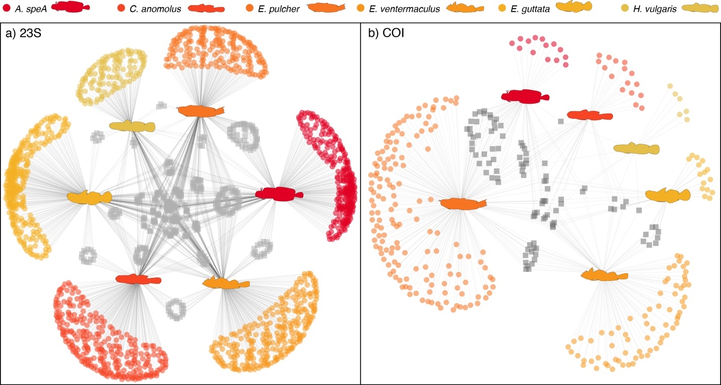

**Fig. S2 | Diet network trees showing differences in ingested prey items among species and populations in the two locations for 23S (a) and COI (b) primers.** Fish silhouettes represent the species as nodes in the network tree. Blue symbols are ESVs (23S) or OTUs (COI) found only in the alimentary tracts of populations from the Arabian Gulf, while gold symbols are ESVs/OTUs from the GoO populations. Grey symbols are ESVs/OTUs shared among the two locations. Shapes of the symbols represent the three different species and are superimposed where ESVs/OTUs are shared.

**Figure S3 | Rarefaction curves of OTU and ESV richness across sequences for six species in the Arabian Gulf (blue) and Gulf of Oman (gold).** OTU curves (a) mark the diversity of unique prey taxa for each species and population as obtained from gut content DNA metabarcoding using COI primers, while ESV curves (b) show the diversity of unique prey taxa for 23S primers. Solid lines indicate interpolated richness, while dashed lines indicate extrapolated richness (to the maximum number of sequences across species). Shaded ribbons indicate 95% confidence intervals of extrapolations. ANTESPEA = *Antennablennius speA*, CORYANOM = *Coryogalops anomalus*, ECSEPULC = *Ecsenius pulcher*, ENNEVENT = *Enneapterygius ventermaculus*, EVIOGUTT = *Eviota guttata*, HETEVULG = *Hetereleotris vulgaris*.