Planning - Graphs

x <- read.csv(file = "Results.csv", as.is=TRUE)  
#x <- x[!is.na(x$t5),]  
x

## X.locs X.set.time  
## 1 15 0  
## 2 15 0  
## 3 15 20  
## 4 15 20  
## 5 15 50  
## 6 15 50  
## 7 15 80  
## 8 15 80  
## 9 30 0  
## 10 30 0  
## 11 30 20  
## 12 30 20  
## 13 30 50  
## 14 30 50  
## 15 30 80  
## 16 30 80  
## 17 100 0  
## 18 100 0  
## 19 100 20  
## 20 100 20  
## 21 100 50  
## 22 100 50  
## 23 100 80  
## 24 100 80  
## 25 NA NA  
## 26 NA NA  
## 27 NA NA  
## 28 NA NA  
## Locations  
## 1 [(14, 3), (26, 17), (33, 15), (47, 30), (3, 39), (49, 30), (16, 23), (43, 36), (39, 9), (36, 10), (22, 16), (22, 0), (30, 43), (26, 35), (49, 47), (14, 3)]  
## 2 [(19, 44), (43, 19), (33, 43), (41, 21), (21, 35), (44, 14), (39, 35), (17, 38), (24, 40), (36, 34), (19, 36), (11, 44), (3, 44), (5, 17), (20, 42), (19, 44)]  
## 3 [(17, 27), (7, 15), (49, 38), (43, 25), (36, 44), (25, 1), (31, 44), (20, 26), (2, 9), (39, 1), (4, 30), (18, 9), (18, 4), (35, 29), (27, 15), (17, 27)]  
## 4 [(9, 18), (40, 5), (32, 39), (36, 44), (48, 44), (43, 34), (37, 19), (32, 24), (19, 10), (33, 16), (9, 35), (26, 0), (2, 16), (29, 41), (26, 34), (9, 18)]  
## 5 [(33, 3), (10, 36), (7, 8), (21, 16), (27, 34), (44, 31), (24, 24), (3, 1), (17, 16), (14, 3), (33, 34), (10, 30), (48, 47), (4, 37), (36, 25), (33, 3)]  
## 6 [(43, 29), (18, 29), (22, 35), (36, 40), (6, 49), (3, 30), (36, 25), (17, 2), (15, 35), (29, 11), (4, 45), (43, 40), (48, 7), (22, 11), (27, 20), (43, 29)]  
## 7 [(48, 49), (49, 36), (5, 30), (3, 8), (42, 35), (3, 29), (33, 45), (20, 4), (17, 19), (5, 31), (21, 6), (14, 14), (20, 47), (26, 19), (35, 41), (48, 49)]  
## 8 [(1, 27), (39, 7), (27, 32), (44, 45), (1, 7), (38, 26), (37, 21), (34, 28), (37, 39), (39, 30), (11, 22), (45, 12), (45, 23), (48, 30), (20, 35), (1, 27)]  
## 9 [(4, 47), (19, 2), (22, 31), (12, 5), (4, 3), (48, 7), (43, 33), (4, 12), (12, 2), (30, 28), (48, 0), (23, 42), (31, 22), (12, 45), (11, 25), (1, 19), (19, 38), (14, 45), (40, 28), (14, 1), (29, 7), (49, 7), (49, 22), (29, 23), (17, 1), (14, 37), (44, 42), (37, 32), (1, 2), (25, 17), (4, 47)]  
## 10 [(25, 49), (30, 33), (9, 15), (12, 9), (27, 13), (17, 4), (6, 2), (10, 36), (6, 39), (44, 26), (23, 18), (9, 37), (24, 15), (19, 8), (6, 44), (25, 16), (19, 38), (22, 32), (28, 34), (13, 6), (6, 20), (13, 26), (17, 7), (3, 42), (30, 46), (9, 33), (7, 42), (9, 23), (6, 10), (32, 36), (25, 49)]  
## 11 [(18, 1), (12, 2), (8, 47), (25, 34), (20, 6), (47, 17), (34, 33), (41, 39), (41, 10), (29, 31), (45, 11), (0, 38), (41, 2), (31, 41), (17, 35), (6, 35), (37, 16), (2, 15), (16, 49), (15, 19), (41, 9), (13, 6), (37, 4), (49, 45), (17, 42), (4, 26), (24, 1), (14, 38), (49, 9), (36, 2), (18, 1)]  
## 12 [(8, 19), (49, 18), (13, 10), (27, 23), (44, 43), (5, 33), (17, 28), (8, 28), (24, 48), (4, 20), (7, 10), (0, 40), (47, 6), (11, 4), (16, 34), (18, 13), (34, 8), (32, 27), (43, 0), (8, 16), (35, 24), (0, 14), (40, 19), (37, 5), (34, 24), (37, 0), (5, 9), (17, 4), (24, 2), (43, 35), (8, 19)]  
## 13 [(26, 11), (9, 32), (45, 48), (49, 17), (6, 44), (17, 23), (7, 20), (42, 11), (41, 9), (28, 17), (0, 36), (48, 5), (43, 35), (45, 21), (26, 32), (31, 40), (38, 26), (44, 16), (8, 17), (0, 34), (17, 21), (26, 30), (34, 20), (41, 8), (32, 28), (6, 4), (47, 43), (29, 18), (49, 13), (49, 47), (26, 11)]  
## 14 [(44, 18), (4, 12), (10, 19), (31, 32), (45, 34), (9, 47), (25, 10), (35, 29), (28, 12), (38, 41), (2, 23), (9, 14), (42, 35), (4, 44), (39, 24), (34, 45), (38, 38), (39, 27), (28, 3), (48, 14), (21, 44), (40, 7), (21, 0), (17, 2), (4, 16), (14, 15), (11, 27), (9, 31), (39, 41), (27, 44), (44, 18)]  
## 15 [(14, 1), (26, 22), (5, 16), (37, 45), (10, 23), (40, 24), (35, 44), (49, 46), (11, 44), (39, 24), (37, 32), (45, 39), (20, 33), (43, 5), (49, 9), (46, 37), (49, 38), (12, 28), (20, 34), (30, 27), (23, 8), (44, 25), (43, 18), (38, 7), (27, 18), (36, 9), (32, 23), (46, 9), (42, 10), (22, 27), (14, 1)]  
## 16 [(18, 3), (28, 13), (16, 23), (7, 15), (0, 36), (18, 11), (38, 18), (40, 41), (39, 36), (27, 17), (5, 14), (4, 32), (41, 1), (20, 45), (9, 7), (8, 19), (24, 8), (17, 40), (18, 16), (48, 2), (41, 16), (37, 6), (45, 48), (13, 10), (1, 48), (35, 44), (40, 21), (28, 23), (45, 44), (25, 14), (18, 3)]  
## 17 [(17, 6), (34, 10), (41, 15), (1, 49), (4, 43), (27, 38), (5, 1), (7, 21), (24, 46), (38, 4), (42, 12), (45, 7), (41, 21), (28, 10), (25, 23), (15, 7), (47, 27), (37, 24), (12, 22), (22, 2), (26, 4), (14, 30), (29, 20), (33, 12), (10, 1), (11, 0), (42, 22), (42, 21), (15, 5), (3, 15), (49, 14), (15, 8), (16, 19), (19, 33), (0, 20), (1, 15), (6, 15), (25, 20), (35, 42), (37, 25), (17, 4), (44, 40), (40, 37), (43, 21), (18, 30), (48, 47), (20, 29), (33, 4), (33, 48), (31, 6), (37, 12), (5, 2), (39, 26), (25, 40), (9, 11), (18, 22), (22, 48), (40, 4), (37, 8), (32, 8), (19, 29), (3, 25), (29, 42), (11, 31), (6, 16), (35, 27), (4, 48), (47, 7), (4, 32), (20, 12), (43, 25), (9, 31), (23, 43), (48, 2), (48, 25), (22, 21), (31, 34), (30, 10), (2, 34), (32, 31), (27, 49), (14, 12), (9, 9), (34, 31), (15, 6), (0, 17), (21, 17), (22, 0), (42, 45), (20, 11), (13, 23), (13, 3), (31, 31), (18, 26), (40, 45), (0, 21), (25, 8), (6, 13), (47, 22), (2, 30), (17, 6)]  
## 18 [(39, 12), (16, 44), (33, 29), (21, 32), (37, 46), (5, 41), (25, 33), (46, 40), (46, 28), (33, 26), (7, 16), (24, 12), (18, 46), (40, 19), (27, 3), (24, 15), (13, 24), (20, 9), (13, 49), (20, 33), (37, 44), (25, 7), (36, 39), (28, 31), (26, 0), (46, 10), (38, 27), (41, 37), (43, 27), (38, 23), (46, 45), (1, 14), (27, 31), (42, 32), (45, 25), (49, 9), (27, 48), (33, 42), (6, 35), (21, 19), (41, 8), (38, 14), (6, 5), (11, 44), (22, 8), (44, 18), (45, 49), (40, 31), (34, 30), (11, 43), (2, 9), (30, 16), (35, 26), (7, 35), (2, 27), (43, 6), (21, 24), (10, 1), (36, 2), (37, 19), (16, 13), (34, 34), (1, 32), (1, 26), (21, 12), (16, 7), (28, 26), (0, 32), (35, 9), (39, 26), (19, 2), (20, 2), (1, 27), (6, 45), (35, 5), (39, 32), (35, 1), (48, 40), (17, 20), (7, 38), (9, 33), (9, 41), (23, 12), (8, 26), (20, 46), (17, 13), (37, 34), (46, 32), (41, 24), (3, 48), (46, 8), (34, 10), (22, 18), (6, 42), (16, 31), (4, 10), (1, 17), (47, 44), (43, 31), (20, 18), (39, 12)]  
## 19 [(0, 31), (41, 20), (15, 28), (7, 0), (47, 14), (34, 10), (18, 16), (20, 19), (26, 21), (13, 36), (38, 24), (13, 24), (15, 12), (47, 19), (30, 27), (6, 7), (31, 0), (36, 17), (37, 17), (35, 38), (21, 2), (38, 4), (43, 18), (31, 24), (30, 10), (20, 20), (6, 37), (7, 18), (41, 45), (42, 1), (2, 4), (2, 29), (18, 31), (36, 38), (32, 28), (19, 16), (8, 24), (27, 30), (13, 46), (47, 1), (19, 10), (18, 3), (23, 48), (0, 44), (35, 47), (7, 20), (39, 43), (48, 32), (32, 9), (36, 49), (18, 46), (35, 27), (26, 39), (29, 25), (0, 37), (37, 39), (42, 18), (1, 26), (17, 37), (34, 40), (31, 44), (6, 19), (7, 36), (39, 4), (36, 25), (39, 14), (5, 0), (27, 36), (37, 0), (17, 32), (38, 12), (37, 31), (14, 18), (19, 35), (17, 6), (4, 4), (29, 37), (13, 12), (44, 8), (20, 36), (3, 36), (38, 23), (24, 48), (39, 40), (3, 46), (17, 12), (30, 32), (48, 11), (20, 25), (32, 25), (19, 0), (20, 13), (25, 24), (14, 39), (20, 28), (12, 41), (20, 18), (42, 24), (14, 48), (40, 8), (0, 31)]  
## 20 [(21, 24), (11, 31), (31, 17), (40, 11), (47, 25), (0, 47), (0, 1), (33, 9), (32, 7), (15, 27), (16, 4), (49, 3), (31, 2), (5, 11), (45, 14), (46, 18), (32, 28), (25, 5), (1, 46), (43, 8), (47, 17), (25, 43), (7, 49), (26, 34), (1, 48), (33, 21), (30, 27), (4, 35), (2, 32), (18, 18), (45, 16), (22, 22), (9, 27), (15, 7), (19, 47), (27, 48), (47, 21), (11, 25), (43, 29), (19, 38), (0, 42), (26, 7), (23, 22), (33, 24), (19, 10), (49, 43), (37, 10), (33, 32), (43, 48), (6, 16), (20, 43), (18, 32), (17, 17), (15, 37), (6, 31), (19, 23), (42, 11), (44, 28), (27, 47), (32, 40), (9, 32), (41, 2), (35, 48), (27, 37), (10, 33), (9, 23), (46, 14), (45, 40), (4, 20), (35, 14), (44, 49), (44, 41), (18, 22), (30, 17), (24, 9), (12, 3), (22, 13), (30, 10), (42, 5), (42, 14), (33, 43), (18, 6), (23, 32), (45, 15), (29, 34), (1, 34), (4, 19), (40, 18), (47, 46), (24, 3), (21, 20), (12, 22), (6, 11), (48, 22), (28, 24), (47, 35), (6, 37), (27, 42), (18, 20), (20, 6), (21, 24)]  
## 21 [(37, 16), (37, 22), (35, 23), (22, 14), (43, 37), (5, 47), (39, 5), (6, 41), (25, 18), (0, 19), (0, 15), (17, 11), (10, 20), (38, 39), (24, 30), (24, 24), (44, 33), (38, 43), (23, 19), (26, 49), (41, 8), (45, 5), (30, 3), (28, 14), (16, 22), (34, 17), (8, 14), (31, 20), (13, 44), (28, 6), (8, 19), (24, 13), (20, 25), (17, 36), (19, 10), (16, 42), (0, 37), (24, 4), (7, 44), (12, 38), (7, 31), (16, 31), (36, 46), (34, 34), (16, 34), (42, 26), (34, 4), (15, 0), (41, 34), (11, 39), (23, 44), (30, 2), (14, 34), (8, 2), (45, 25), (3, 24), (9, 16), (5, 34), (37, 29), (25, 5), (5, 31), (29, 24), (25, 15), (37, 17), (11, 38), (47, 14), (23, 47), (44, 20), (25, 48), (25, 7), (22, 18), (45, 13), (47, 40), (22, 1), (17, 48), (29, 10), (16, 38), (1, 43), (18, 32), (46, 45), (45, 23), (12, 14), (33, 29), (48, 44), (19, 23), (6, 47), (0, 48), (4, 28), (0, 42), (43, 20), (16, 17), (34, 42), (46, 13), (30, 31), (27, 45), (49, 22), (6, 38), (35, 4), (7, 27), (44, 19), (37, 16)]  
## 22 [(6, 21), (6, 4), (2, 35), (15, 36), (9, 33), (39, 1), (35, 41), (23, 29), (18, 13), (30, 36), (5, 25), (44, 33), (28, 41), (22, 8), (14, 12), (27, 26), (13, 41), (33, 8), (15, 21), (21, 39), (40, 5), (13, 14), (41, 13), (14, 28), (43, 23), (33, 27), (10, 1), (21, 26), (2, 15), (33, 15), (2, 6), (47, 7), (26, 18), (6, 16), (6, 40), (44, 18), (31, 49), (15, 6), (3, 30), (1, 34), (30, 24), (46, 5), (38, 19), (12, 46), (12, 49), (0, 23), (37, 1), (12, 28), (10, 2), (12, 21), (24, 24), (36, 48), (8, 45), (8, 38), (45, 45), (40, 0), (22, 25), (22, 1), (27, 13), (0, 15), (20, 43), (45, 30), (39, 13), (7, 17), (12, 24), (11, 5), (33, 9), (10, 3), (28, 25), (3, 0), (10, 13), (28, 26), (42, 28), (15, 12), (27, 12), (2, 13), (10, 19), (27, 45), (49, 14), (17, 6), (47, 22), (47, 21), (41, 20), (9, 22), (25, 48), (19, 48), (27, 47), (7, 27), (31, 33), (49, 28), (23, 15), (23, 6), (10, 10), (36, 47), (26, 9), (33, 21), (3, 27), (40, 24), (9, 47), (42, 19), (6, 21)]  
## 23 [(0, 33), (40, 22), (34, 18), (45, 10), (7, 2), (25, 4), (24, 37), (21, 41), (4, 48), (3, 26), (40, 47), (29, 2), (28, 37), (38, 38), (36, 23), (0, 6), (25, 31), (19, 25), (37, 30), (18, 8), (38, 3), (46, 19), (9, 13), (35, 1), (37, 39), (12, 36), (3, 16), (31, 0), (44, 49), (24, 19), (12, 15), (4, 12), (12, 45), (23, 18), (13, 16), (20, 45), (33, 23), (44, 24), (49, 36), (40, 36), (2, 24), (45, 16), (32, 32), (34, 48), (6, 4), (40, 15), (25, 41), (20, 0), (22, 42), (27, 34), (1, 40), (15, 41), (13, 19), (15, 5), (44, 14), (5, 49), (31, 47), (35, 32), (2, 43), (15, 17), (38, 15), (11, 14), (29, 8), (4, 39), (35, 34), (39, 20), (20, 4), (34, 35), (8, 15), (28, 18), (41, 12), (1, 5), (22, 27), (1, 17), (22, 45), (40, 34), (32, 0), (16, 22), (13, 15), (33, 26), (19, 18), (14, 26), (45, 6), (42, 32), (21, 10), (44, 23), (13, 49), (14, 45), (30, 34), (2, 31), (1, 46), (21, 27), (22, 24), (15, 14), (16, 26), (28, 10), (41, 45), (39, 2), (42, 15), (1, 36), (0, 33)]  
## 24 [(11, 19), (3, 31), (23, 23), (5, 34), (31, 45), (3, 12), (27, 33), (29, 35), (17, 32), (17, 38), (1, 46), (40, 20), (40, 33), (27, 49), (10, 19), (12, 7), (10, 12), (9, 10), (28, 27), (8, 31), (1, 17), (12, 29), (4, 43), (39, 0), (17, 37), (1, 37), (23, 38), (45, 5), (13, 14), (19, 47), (42, 38), (23, 42), (11, 17), (40, 15), (38, 44), (44, 47), (16, 49), (25, 39), (28, 11), (22, 37), (16, 12), (6, 15), (34, 16), (7, 22), (17, 14), (49, 23), (40, 25), (26, 22), (31, 34), (22, 10), (30, 44), (37, 43), (31, 14), (31, 21), (29, 3), (22, 12), (12, 17), (25, 41), (39, 23), (16, 41), (48, 21), (22, 26), (8, 46), (7, 29), (14, 45), (24, 30), (11, 3), (13, 27), (21, 30), (2, 8), (46, 44), (7, 28), (46, 48), (7, 44), (0, 16), (17, 49), (30, 3), (32, 21), (1, 28), (30, 4), (41, 21), (48, 39), (17, 2), (20, 8), (15, 23), (8, 30), (16, 24), (9, 7), (19, 36), (6, 31), (32, 31), (22, 20), (27, 29), (13, 5), (5, 41), (30, 35), (26, 21), (18, 11), (40, 48), (26, 44), (11, 19)]  
## 25   
## 26   
## 27   
## 28   
## Time.Windows  
## 1 [(0, 0), (0, 1000), (0, 1000), (0, 1000), (0, 1000), (0, 1000), (0, 1000), (0, 1000), (0, 1000), (0, 1000), (0, 1000), (0, 1000), (0, 1000), (0, 1000), (0, 1000), (0, 1000)]  
## 2 [(0, 0), (0, 1000), (0, 1000), (0, 1000), (0, 1000), (0, 1000), (0, 1000), (0, 1000), (0, 1000), (0, 1000), (0, 1000), (0, 1000), (0, 1000), (0, 1000), (0, 1000), (0, 1000)]  
## 3 [(0, 0), (25, 26), (129, 130), (155, 156), (0, 1000), (0, 1000), (0, 1000), (0, 1000), (0, 1000), (0, 1000), (0, 1000), (0, 1000), (0, 1000), (0, 1000), (0, 1000), (0, 1000)]  
## 4 [(0, 0), (78, 79), (164, 165), (174, 175), (0, 1000), (0, 1000), (0, 1000), (0, 1000), (0, 1000), (0, 1000), (0, 1000), (0, 1000), (0, 1000), (0, 1000), (0, 1000), (0, 1000)]  
## 5 [(0, 0), (100, 101), (157, 158), (228, 229), (296, 297), (365, 366), (414, 415), (502, 503), (0, 1000), (0, 1000), (0, 1000), (0, 1000), (0, 1000), (0, 1000), (0, 1000), (0, 1000)]  
## 6 [(0, 0), (58, 59), (91, 92), (119, 120), (169, 170), (210, 211), (277, 278), (353, 354), (0, 1000), (0, 1000), (0, 1000), (0, 1000), (0, 1000), (0, 1000), (0, 1000), (0, 1000)]  
## 7 [(0, 0), (40, 41), (135, 136), (194, 195), (273, 274), (362, 363), (434, 435), (527, 528), (564, 565), (614, 615), (657, 658), (676, 677), (732, 733), (0, 1000), (0, 1000), (0, 1000)]  
## 8 [(0, 0), (91, 92), (130, 131), (185, 186), (279, 280), (336, 337), (349, 350), (385, 386), (406, 407), (431, 432), (482, 483), (539, 540), (594, 595), (0, 1000), (0, 1000), (0, 1000)]  
## 9 [(0, 0), (0, 1000), (0, 1000), (0, 1000), (0, 1000), (0, 1000), (0, 1000), (0, 1000), (0, 1000), (0, 1000), (0, 1000), (0, 1000), (0, 1000), (0, 1000), (0, 1000), (0, 1000), (0, 1000), (0, 1000), (0, 1000), (0, 1000), (0, 1000), (0, 1000), (0, 1000), (0, 1000), (0, 1000), (0, 1000), (0, 1000), (0, 1000), (0, 1000), (0, 1000), (0, 1000)]  
## 10 [(0, 0), (0, 1000), (0, 1000), (0, 1000), (0, 1000), (0, 1000), (0, 1000), (0, 1000), (0, 1000), (0, 1000), (0, 1000), (0, 1000), (0, 1000), (0, 1000), (0, 1000), (0, 1000), (0, 1000), (0, 1000), (0, 1000), (0, 1000), (0, 1000), (0, 1000), (0, 1000), (0, 1000), (0, 1000), (0, 1000), (0, 1000), (0, 1000), (0, 1000), (0, 1000), (0, 1000)]  
## 11 [(0, 0), (16, 17), (71, 72), (124, 125), (202, 203), (257, 258), (316, 317), (0, 1000), (0, 1000), (0, 1000), (0, 1000), (0, 1000), (0, 1000), (0, 1000), (0, 1000), (0, 1000), (0, 1000), (0, 1000), (0, 1000), (0, 1000), (0, 1000), (0, 1000), (0, 1000), (0, 1000), (0, 1000), (0, 1000), (0, 1000), (0, 1000), (0, 1000), (0, 1000), (0, 1000)]  
## 12 [(0, 0), (47, 48), (135, 136), (198, 199), (252, 253), (327, 328), (344, 345), (0, 1000), (0, 1000), (0, 1000), (0, 1000), (0, 1000), (0, 1000), (0, 1000), (0, 1000), (0, 1000), (0, 1000), (0, 1000), (0, 1000), (0, 1000), (0, 1000), (0, 1000), (0, 1000), (0, 1000), (0, 1000), (0, 1000), (0, 1000), (0, 1000), (0, 1000), (0, 1000), (0, 1000)]  
## 13 [(0, 0), (57, 58), (138, 139), (203, 204), (273, 274), (352, 353), (371, 372), (460, 461), (504, 505), (541, 542), (605, 606), (731, 732), (790, 791), (849, 850), (905, 906), (927, 928), (0, 1000), (0, 1000), (0, 1000), (0, 1000), (0, 1000), (0, 1000), (0, 1000), (0, 1000), (0, 1000), (0, 1000), (0, 1000), (0, 1000), (0, 1000), (0, 1000), (0, 1000)]  
## 14 [(0, 0), (65, 66), (116, 117), (198, 199), (262, 263), (338, 339), (397, 398), (468, 469), (498, 499), (554, 555), (648, 649), (671, 672), (748, 749), (815, 816), (911, 912), (960, 961), (0, 1000), (0, 1000), (0, 1000), (0, 1000), (0, 1000), (0, 1000), (0, 1000), (0, 1000), (0, 1000), (0, 1000), (0, 1000), (0, 1000), (0, 1000), (0, 1000), (0, 1000)]  
## 15 [(0, 0), (75, 76), (128, 129), (194, 195), (245, 246), (298, 299), (332, 333), (371, 372), (412, 413), (487, 488), (527, 528), (552, 553), (595, 596), (664, 665), (718, 719), (797, 798), (806, 807), (862, 863), (923, 924), (980, 981), (1044, 1045), (1084, 1085), (1105, 1106), (1145, 1146), (1215, 1216), (0, 10000), (0, 10000), (0, 10000), (0, 10000), (0, 10000), (0, 10000)]  
## 16 [(0, 0), (25, 26), (51, 52), (118, 119), (163, 164), (215, 216), (250, 251), (275, 276), (287, 288), (338, 339), (406, 407), (465, 466), (580, 581), (673, 674), (767, 768), (808, 809), (847, 848), (891, 892), (920, 921), (983, 984), (1045, 1046), (1076, 1077), (1163, 1164), (1238, 1239), (1330, 1331), (0, 10000), (0, 10000), (0, 10000), (0, 10000), (0, 10000), (0, 10000)]  
## 17 [(0, 0), (0, 10000), (0, 10000), (0, 10000), (0, 10000), (0, 10000), (0, 10000), (0, 10000), (0, 10000), (0, 10000), (0, 10000), (0, 10000), (0, 10000), (0, 10000), (0, 10000), (0, 10000), (0, 10000), (0, 10000), (0, 10000), (0, 10000), (0, 10000), (0, 10000), (0, 10000), (0, 10000), (0, 10000), (0, 10000), (0, 10000), (0, 10000), (0, 10000), (0, 10000), (0, 10000), (0, 10000), (0, 10000), (0, 10000), (0, 10000), (0, 10000), (0, 10000), (0, 10000), (0, 10000), (0, 10000), (0, 10000), (0, 10000), (0, 10000), (0, 10000), (0, 10000), (0, 10000), (0, 10000), (0, 10000), (0, 10000), (0, 10000), (0, 10000), (0, 10000), (0, 10000), (0, 10000), (0, 10000), (0, 10000), (0, 10000), (0, 10000), (0, 10000), (0, 10000), (0, 10000), (0, 10000), (0, 10000), (0, 10000), (0, 10000), (0, 10000), (0, 10000), (0, 10000), (0, 10000), (0, 10000), (0, 10000), (0, 10000), (0, 10000), (0, 10000), (0, 10000), (0, 10000), (0, 10000), (0, 10000), (0, 10000), (0, 10000), (0, 10000), (0, 10000), (0, 10000), (0, 10000), (0, 10000), (0, 10000), (0, 10000), (0, 10000), (0, 10000), (0, 10000), (0, 10000), (0, 10000), (0, 10000), (0, 10000), (0, 10000), (0, 10000), (0, 10000), (0, 10000), (0, 10000), (0, 10000), (0, 10000)]  
## 18 [(0, 0), (0, 10000), (0, 10000), (0, 10000), (0, 10000), (0, 10000), (0, 10000), (0, 10000), (0, 10000), (0, 10000), (0, 10000), (0, 10000), (0, 10000), (0, 10000), (0, 10000), (0, 10000), (0, 10000), (0, 10000), (0, 10000), (0, 10000), (0, 10000), (0, 10000), (0, 10000), (0, 10000), (0, 10000), (0, 10000), (0, 10000), (0, 10000), (0, 10000), (0, 10000), (0, 10000), (0, 10000), (0, 10000), (0, 10000), (0, 10000), (0, 10000), (0, 10000), (0, 10000), (0, 10000), (0, 10000), (0, 10000), (0, 10000), (0, 10000), (0, 10000), (0, 10000), (0, 10000), (0, 10000), (0, 10000), (0, 10000), (0, 10000), (0, 10000), (0, 10000), (0, 10000), (0, 10000), (0, 10000), (0, 10000), (0, 10000), (0, 10000), (0, 10000), (0, 10000), (0, 10000), (0, 10000), (0, 10000), (0, 10000), (0, 10000), (0, 10000), (0, 10000), (0, 10000), (0, 10000), (0, 10000), (0, 10000), (0, 10000), (0, 10000), (0, 10000), (0, 10000), (0, 10000), (0, 10000), (0, 10000), (0, 10000), (0, 10000), (0, 10000), (0, 10000), (0, 10000), (0, 10000), (0, 10000), (0, 10000), (0, 10000), (0, 10000), (0, 10000), (0, 10000), (0, 10000), (0, 10000), (0, 10000), (0, 10000), (0, 10000), (0, 10000), (0, 10000), (0, 10000), (0, 10000), (0, 10000), (0, 10000)]  
## 19 [(0, 0), (63, 64), (126, 127), (191, 192), (289, 290), (348, 349), (380, 381), (421, 422), (472, 473), (508, 509), (571, 572), (601, 602), (625, 626), (691, 692), (756, 757), (840, 841), (919, 920), (947, 948), (997, 998), (1025, 1026), (1097, 1098), (0, 10000), (0, 10000), (0, 10000), (0, 10000), (0, 10000), (0, 10000), (0, 10000), (0, 10000), (0, 10000), (0, 10000), (0, 10000), (0, 10000), (0, 10000), (0, 10000), (0, 10000), (0, 10000), (0, 10000), (0, 10000), (0, 10000), (0, 10000), (0, 10000), (0, 10000), (0, 10000), (0, 10000), (0, 10000), (0, 10000), (0, 10000), (0, 10000), (0, 10000), (0, 10000), (0, 10000), (0, 10000), (0, 10000), (0, 10000), (0, 10000), (0, 10000), (0, 10000), (0, 10000), (0, 10000), (0, 10000), (0, 10000), (0, 10000), (0, 10000), (0, 10000), (0, 10000), (0, 10000), (0, 10000), (0, 10000), (0, 10000), (0, 10000), (0, 10000), (0, 10000), (0, 10000), (0, 10000), (0, 10000), (0, 10000), (0, 10000), (0, 10000), (0, 10000), (0, 10000), (0, 10000), (0, 10000), (0, 10000), (0, 10000), (0, 10000), (0, 10000), (0, 10000), (0, 10000), (0, 10000), (0, 10000), (0, 10000), (0, 10000), (0, 10000), (0, 10000), (0, 10000), (0, 10000), (0, 10000), (0, 10000), (0, 10000), (0, 10000)]  
## 20 [(0, 0), (17, 18), (99, 100), (117, 118), (181, 182), (287, 288), (361, 362), (432, 433), (480, 481), (517, 518), (582, 583), (642, 643), (664, 665), (706, 707), (780, 781), (814, 815), (873, 874), (926, 927), (1033, 1034), (1148, 1149), (1207, 1208), (0, 10000), (0, 10000), (0, 10000), (0, 10000), (0, 10000), (0, 10000), (0, 10000), (0, 10000), (0, 10000), (0, 10000), (0, 10000), (0, 10000), (0, 10000), (0, 10000), (0, 10000), (0, 10000), (0, 10000), (0, 10000), (0, 10000), (0, 10000), (0, 10000), (0, 10000), (0, 10000), (0, 10000), (0, 10000), (0, 10000), (0, 10000), (0, 10000), (0, 10000), (0, 10000), (0, 10000), (0, 10000), (0, 10000), (0, 10000), (0, 10000), (0, 10000), (0, 10000), (0, 10000), (0, 10000), (0, 10000), (0, 10000), (0, 10000), (0, 10000), (0, 10000), (0, 10000), (0, 10000), (0, 10000), (0, 10000), (0, 10000), (0, 10000), (0, 10000), (0, 10000), (0, 10000), (0, 10000), (0, 10000), (0, 10000), (0, 10000), (0, 10000), (0, 10000), (0, 10000), (0, 10000), (0, 10000), (0, 10000), (0, 10000), (0, 10000), (0, 10000), (0, 10000), (0, 10000), (0, 10000), (0, 10000), (0, 10000), (0, 10000), (0, 10000), (0, 10000), (0, 10000), (0, 10000), (0, 10000), (0, 10000), (0, 10000), (0, 10000)]  
## 21 [(0, 0), (8, 9), (13, 14), (35, 36), (81, 82), (133, 134), (210, 211), (283, 284), (328, 329), (356, 357), (361, 362), (382, 383), (399, 400), (450, 451), (478, 479), (487, 488), (520, 521), (538, 539), (577, 578), (613, 614), (674, 675), (684, 685), (703, 704), (717, 718), (739, 740), (767, 768), (796, 797), (826, 827), (871, 872), (929, 930), (962, 963), (984, 985), (1002, 1003), (1016, 1017), (1045, 1046), (1082, 1083), (1105, 1106), (1166, 1167), (1227, 1228), (1239, 1240), (1254, 1255), (1264, 1265), (1302, 1303), (1317, 1318), (1338, 1339), (1373, 1374), (1405, 1406), (1429, 1430), (1493, 1494), (1531, 1532), (1549, 1550), (0, 10000), (0, 10000), (0, 10000), (0, 10000), (0, 10000), (0, 10000), (0, 10000), (0, 10000), (0, 10000), (0, 10000), (0, 10000), (0, 10000), (0, 10000), (0, 10000), (0, 10000), (0, 10000), (0, 10000), (0, 10000), (0, 10000), (0, 10000), (0, 10000), (0, 10000), (0, 10000), (0, 10000), (0, 10000), (0, 10000), (0, 10000), (0, 10000), (0, 10000), (0, 10000), (0, 10000), (0, 10000), (0, 10000), (0, 10000), (0, 10000), (0, 10000), (0, 10000), (0, 10000), (0, 10000), (0, 10000), (0, 10000), (0, 10000), (0, 10000), (0, 10000), (0, 10000), (0, 10000), (0, 10000), (0, 10000), (0, 10000), (0, 10000)]  
## 22 [(0, 0), (20, 21), (55, 56), (69, 70), (78, 79), (124, 125), (168, 169), (187, 188), (206, 207), (232, 233), (263, 264), (306, 307), (325, 326), (360, 361), (369, 370), (391, 392), (413, 414), (454, 455), (477, 478), (498, 499), (539, 540), (570, 571), (601, 602), (632, 633), (663, 664), (675, 676), (713, 714), (742, 743), (767, 768), (798, 799), (834, 835), (880, 881), (906, 907), (930, 931), (956, 957), (1001, 1002), (1036, 1037), (1084, 1085), (1114, 1115), (1119, 1120), (1151, 1152), (1179, 1180), (1196, 1197), (1237, 1238), (1240, 1241), (1270, 1271), (1317, 1318), (1357, 1358), (1386, 1387), (1409, 1410), (1424, 1425), (0, 10000), (0, 10000), (0, 10000), (0, 10000), (0, 10000), (0, 10000), (0, 10000), (0, 10000), (0, 10000), (0, 10000), (0, 10000), (0, 10000), (0, 10000), (0, 10000), (0, 10000), (0, 10000), (0, 10000), (0, 10000), (0, 10000), (0, 10000), (0, 10000), (0, 10000), (0, 10000), (0, 10000), (0, 10000), (0, 10000), (0, 10000), (0, 10000), (0, 10000), (0, 10000), (0, 10000), (0, 10000), (0, 10000), (0, 10000), (0, 10000), (0, 10000), (0, 10000), (0, 10000), (0, 10000), (0, 10000), (0, 10000), (0, 10000), (0, 10000), (0, 10000), (0, 10000), (0, 10000), (0, 10000), (0, 10000), (0, 10000), (0, 10000)]  
## 23 [(0, 0), (56, 57), (67, 68), (91, 92), (139, 140), (159, 160), (198, 199), (210, 211), (236, 237), (260, 261), (323, 324), (383, 384), (419, 420), (431, 432), (450, 451), (504, 505), (557, 558), (574, 575), (599, 600), (643, 644), (671, 672), (699, 700), (742, 743), (783, 784), (824, 825), (856, 857), (886, 887), (934, 935), (998, 999), (1048, 1049), (1069, 1070), (1081, 1082), (1123, 1124), (1163, 1164), (1180, 1181), (1218, 1219), (1256, 1257), (1272, 1273), (1290, 1291), (1300, 1301), (1353, 1354), (1408, 1409), (1439, 1440), (1458, 1459), (1530, 1531), (1580, 1581), (1622, 1623), (1670, 1671), (1719, 1720), (1732, 1733), (1768, 1769), (1786, 1787), (1814, 1815), (1833, 1834), (1874, 1875), (1953, 1954), (1986, 1987), (2008, 2009), (2054, 2055), (2096, 2097), (2123, 2124), (2152, 2153), (2177, 2178), (2235, 2236), (2272, 2273), (2290, 2291), (2330, 2331), (2379, 2380), (2425, 2426), (2452, 2453), (2475, 2476), (2527, 2528), (2573, 2574), (2609, 2610), (2661, 2662), (2690, 2691), (2735, 2736), (2773, 2774), (2788, 2789), (2823, 2824), (2846, 2847), (0, 10000), (0, 10000), (0, 10000), (0, 10000), (0, 10000), (0, 10000), (0, 10000), (0, 10000), (0, 10000), (0, 10000), (0, 10000), (0, 10000), (0, 10000), (0, 10000), (0, 10000), (0, 10000), (0, 10000), (0, 10000), (0, 10000), (0, 10000)]  
## 24 [(0, 0), (17, 18), (40, 41), (63, 64), (94, 95), (138, 139), (173, 174), (176, 177), (190, 191), (198, 199), (217, 218), (265, 266), (280, 281), (301, 302), (336, 337), (351, 352), (358, 359), (363, 364), (390, 391), (413, 414), (430, 431), (450, 451), (468, 469), (525, 526), (571, 572), (587, 588), (612, 613), (654, 655), (691, 692), (728, 729), (755, 756), (776, 777), (805, 806), (835, 836), (865, 866), (875, 876), (907, 908), (924, 925), (953, 954), (980, 981), (1008, 1009), (1019, 1020), (1050, 1051), (1078, 1079), (1093, 1094), (1127, 1128), (1138, 1139), (1154, 1155), (1167, 1168), (1195, 1196), (1232, 1233), (1240, 1241), (1271, 1272), (1278, 1279), (1297, 1298), (1309, 1310), (1321, 1322), (1352, 1353), (1376, 1377), (1409, 1410), (1450, 1451), (1480, 1481), (1505, 1506), (1526, 1527), (1546, 1547), (1565, 1566), (1595, 1596), (1623, 1624), (1633, 1634), (1664, 1665), (1724, 1725), (1767, 1768), (1813, 1814), (1855, 1856), (1885, 1886), (1923, 1924), (1974, 1975), (1996, 1997), (2028, 2029), (2069, 2070), (2091, 2092), (0, 10000), (0, 10000), (0, 10000), (0, 10000), (0, 10000), (0, 10000), (0, 10000), (0, 10000), (0, 10000), (0, 10000), (0, 10000), (0, 10000), (0, 10000), (0, 10000), (0, 10000), (0, 10000), (0, 10000), (0, 10000), (0, 10000), (0, 10000)]  
## 25   
## 26   
## 27   
## 28   
## d1 t1 d2 t2 d3 t3 d4 t4 d5 t5 d6  
## 1 226 3.48918700 182 6.77580309 226 2.20 182 3.40 246 0.02 193  
## 2 166 2.76238513 145 8.40367913 172 3.20 145 6.30 184 0.02 180  
## 3 265 1.69952416 223 1.91766000 275 3.20 241 3.20 289 0.02 224  
## 4 247 0.62327695 219 0.74449110 247 3.50 225 2.70 253 0.02 219  
## 5 534 0.20561695 532 0.13901210 534 0.20 532 0.40 534 0.02 532  
## 6 406 0.14508700 390 0.13056803 406 0.20 390 0.40 416 0.02 390  
## 7 762 0.05595303 760 0.06642103 762 0.20 760 0.30 762 0.02 760  
## 8 642 0.05019999 638 0.05224013 642 0.10 638 0.50 642 0.02 638  
## 9 NA NA NA NA 310 4.60 259 8.30 336 0.02 292  
## 10 NA NA NA NA 252 3.30 208 5.80 354 0.02 213  
## 11 414 34.16411996 352 45.95307803 462 2.30 404 4.00 464 0.02 431  
## 12 382 14.46367002 357 112.33730600 398 7.20 395 5.75 570 0.02 469  
## 13 961 2.73413897 956 3.28941798 961 0.40 956 0.40 961 0.02 956  
## 14 997 0.99049401 989 2.57590103 997 0.50 989 0.40 997 0.02 989  
## 15 1245 0.25983190 1236 0.29477596 1245 0.50 1236 0.60 1245 0.02 1236  
## 16 1392 0.34066987 1378 0.24263906 1392 0.40 1378 0.60 1392 0.02 1378  
## 17 NA NA NA NA 500 7.30 410 7.19 634 0.02 566  
## 18 NA NA NA NA 492 6.40 392 7.50 556 0.02 536  
## 19 NA NA NA NA 1309 7.10 1252 6.90 1263 0.02 1163  
## 20 NA NA NA NA 1240 5.50 1234 6.20 1288 0.02 1234  
## 21 NA NA NA NA 1871 6.76 1580 4.26 1847 0.02 1604  
## 22 NA NA NA NA NA NA 1715 8.83 NA NA 1654  
## 23 2880 29.19658613 NA NA 2880 1.42 2870 2.51 2880 0.02 2870  
## 24 NA NA 2140 23.71159887 NA NA 2267 5.07 NA NA 2177  
## 25 NA NA NA NA NA NA NA NA NA NA NA  
## 26 NA NA NA NA NA NA NA NA NA NA NA  
## 27 NA NA NA NA NA NA NA NA NA NA NA  
## 28 NA NA NA NA NA NA NA NA NA NA NA  
## t6 d7 t7 d8 t8 d9 t9 d10 t10 X  
## 1 0.02 226 1.43 182 1.45 226 0.55 183 0.52 NA  
## 2 0.02 166 1.44 145 1.45 168 0.52 145 0.51 NA  
## 3 0.02 265 1.55 224 1.03 267 1.37 224 1.12 NA  
## 4 0.02 247 1.95 219 0.95 253 1.07 219 0.90 NA  
## 5 0.02 534 1.01 532 0.98 534 1.18 532 1.18 NA  
## 6 0.02 406 1.16 390 1.10 406 2.23 390 1.88 NA  
## 7 0.02 762 1.99 760 2.01 762 1.39 760 1.24 NA  
## 8 0.02 642 2.13 638 1.88 642 1.57 638 1.61 NA  
## 9 0.02 300 2.63 241 4.64 314 1.07 262 0.85 NA  
## 10 0.02 252 3.38 193 3.03 284 0.82 213 0.71 NA  
## 11 0.02 414 7.34 357 3.28 462 3.40 389 3.07 NA  
## 12 0.02 398 1.54 357 1.58 408 2.56 357 2.19 NA  
## 13 0.02 961 1.40 956 1.26 961 2.79 956 1.92 NA  
## 14 0.02 997 1.29 989 1.26 997 2.22 989 1.67 NA  
## 15 0.02 1245 2.30 1236 1.88 1245 2.11 1236 2.10 NA  
## 16 0.02 1392 2.28 1378 2.21 1392 2.66 1378 2.27 NA  
## 17 0.02 494 10.70 404 20.35 634 1.33 566 1.35 NA  
## 18 0.02 494 12.74 403 15.45 556 1.33 536 1.38 NA  
## 19 0.03 1181 21.92 1133 12.92 1181 12.40 1133 8.15 NA  
## 20 0.02 1240 17.19 1234 9.82 1240 11.78 1234 12.81 NA  
## 21 0.02 1677 10.61 1580 13.12 1689 26.32 1580 15.40 NA  
## 22 0.03 NA NA 1579 12.12 NA NA 1587 31.27 NA  
## 23 0.02 2880 5.19 2870 5.80 2880 13.93 2870 8.87 NA  
## 24 0.02 NA NA 2177 7.57 NA NA 2177 22.94 NA  
## 25 NA NA NA NA NA NA NA NA NA NA  
## 26 NA NA NA NA NA NA NA NA NA NA  
## 27 NA NA NA NA NA NA NA NA NA NA  
## 28 NA NA NA NA NA NA NA NA NA NA

## Manhattan Distance:

0% Appointments:

plot(x$X.locs[x$X.set.time == 0], x$t1[x$X.set.time == 0], type = "b", col = "red", pch = 19, xlab = "Number of Locations (with 0% appointments)", ylab = "Compute Time", ylim = c(0, 20), lwd=1.5, main = "Time vs. Num Tasks (Manhattan)")  
lines(x$X.locs[x$X.set.time == 0], x$t3[x$X.set.time == 0], col="orange", type = "b", pch = 19, lwd=1.5)  
lines(x$X.locs[x$X.set.time == 0], x$t5[x$X.set.time == 0], col="yellow", type = "b", pch = 19)  
lines(x$X.locs[x$X.set.time == 0], x$t7[x$X.set.time == 0], col="green", type = "b", pch = 19, lwd=1.5)  
lines(x$X.locs[x$X.set.time == 0], x$t9[x$X.set.time == 0], col="blue", type = "b", pch = 19, lwd=1.5)  
legend(15, 20, legend = c("LP", "Adapted", "NN", "ACO", "Simplified Genetic"), col = c("red", "orange", "yellow", "green", "blue"), lty=1, cex=1)

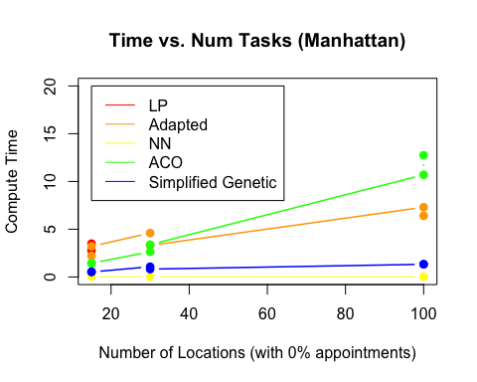

plot(x$X.locs[x$X.set.time == 0], x$d1[x$X.set.time == 0], type = "b", col = "red", pch = 19, xlab = "Number of Locations (with 0% appointments)", ylab = "Time Finished Last Job", ylim = c(0, 650), lwd=1.5, main = "Completion Time vs. Num Tasks (Manhattan)")  
lines(x$X.locs[x$X.set.time == 0], x$d3[x$X.set.time == 0], col="orange", type = "b", pch = 19, lwd=1.5)  
lines(x$X.locs[x$X.set.time == 0], x$d5[x$X.set.time == 0], col="yellow", type = "b", pch = 19)  
lines(x$X.locs[x$X.set.time == 0], x$d7[x$X.set.time == 0], col="green", type = "b", pch = 19, lwd=1.5)  
lines(x$X.locs[x$X.set.time == 0], x$d9[x$X.set.time == 0], col="blue", type = "b", pch = 19, lwd=1.5)  
legend(70, 300, legend = c("LP", "Adapted", "NN", "ACO", "Simplified Genetic"), col = c("red", "orange", "yellow", "green", "blue"), lty=1, cex=1)

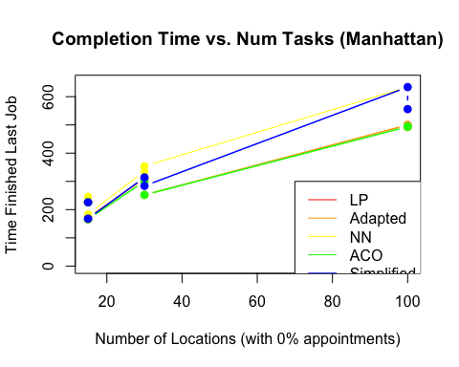 20% Appointments:

plot(x$X.locs[x$X.set.time == 20], x$t1[x$X.set.time == 20], type = "b", col = "red", pch = 19, xlab = "Number of Locations (with 20% appointments)", ylab = "Compute Time", ylim = c(0, 40), lwd=1.5, main = "Time vs. Num Tasks (Manhattan)")  
lines(x$X.locs[x$X.set.time == 20], x$t3[x$X.set.time == 20], col="orange", type = "b", pch = 19, lwd=1.5)  
lines(x$X.locs[x$X.set.time == 20], x$t5[x$X.set.time == 20], col="yellow", type = "b", pch = 19)  
lines(x$X.locs[x$X.set.time == 20], x$t7[x$X.set.time == 20], col="green", type = "b", pch = 19, lwd=1.5)  
lines(x$X.locs[x$X.set.time == 20], x$t9[x$X.set.time == 20], col="blue", type = "b", pch = 19, lwd=1.5)  
legend(45, 40, legend = c("LP", "Adapted", "NN", "ACO", "Simplified Genetic"), col = c("red", "orange", "yellow", "green", "blue"), lty=1, cex=1)

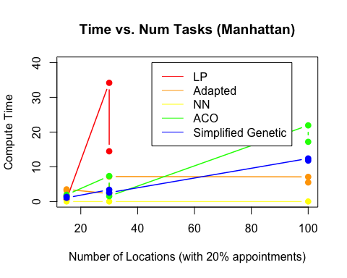

plot(x$X.locs[x$X.set.time == 20], x$d1[x$X.set.time == 20], type = "b", col = "red", pch = 19, xlab = "Number of Locations (with 20% appointments)", ylab = "Time Finished Last Job", ylim = c(0, 1300), lwd=1.5, main = "Completion Time vs. Num Tasks (Manhattan)")  
lines(x$X.locs[x$X.set.time == 20], x$d3[x$X.set.time == 20], col="orange", type = "b", pch = 19, lwd=1.5)  
lines(x$X.locs[x$X.set.time == 20], x$d5[x$X.set.time == 20], col="yellow", type = "b", pch = 19)  
lines(x$X.locs[x$X.set.time == 20], x$d7[x$X.set.time == 20], col="green", type = "b", pch = 19, lwd=1.5)  
lines(x$X.locs[x$X.set.time == 20], x$d9[x$X.set.time == 20], col="blue", type = "b")  
legend(70, 600, legend = c("LP", "Adapted", "NN", "ACO", "Simplified Genetic"), col = c("red", "orange", "yellow", "green", "blue"), lty=1, cex=1)

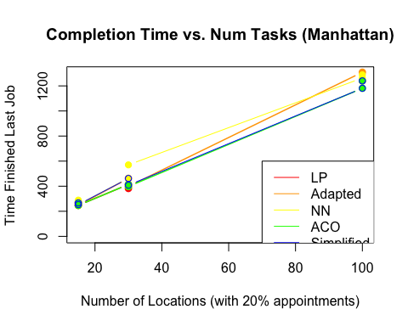 50% Appointments:

plot(x$X.locs[x$X.set.time == 50], x$t1[x$X.set.time == 50], type = "b", col = "red", pch = 19, xlab = "Number of Locations (with 50% appointments)", ylab = "Compute Time", ylim = c(0, 40), lwd=1.5, main = "Time vs. Num Tasks (Manhattan)")  
lines(x$X.locs[x$X.set.time == 50], x$t3[x$X.set.time == 50], col="orange", type = "b", pch = 19, lwd=1.5)  
lines(x$X.locs[x$X.set.time == 50], x$t5[x$X.set.time == 50], col="yellow", type = "b", pch = 19)  
lines(x$X.locs[x$X.set.time == 50], x$t7[x$X.set.time == 50], col="green", type = "b", pch = 19, lwd=1.5)  
lines(x$X.locs[x$X.set.time == 50], x$t9[x$X.set.time == 50], col="blue", type = "b", pch = 19, lwd=1.5)  
legend(45, 40, legend = c("LP", "Adapted", "NN", "ACO", "Simplified Genetic"), col = c("red", "orange", "yellow", "green", "blue"), lty=1, cex=1)

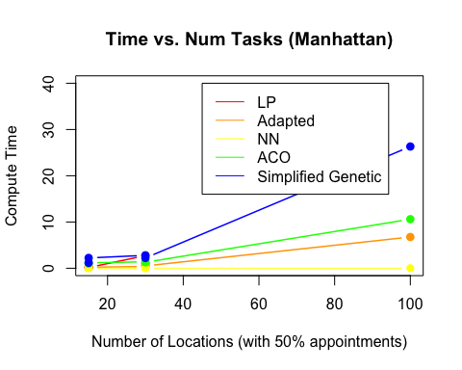

plot(x$X.locs[x$X.set.time == 50], x$d1[x$X.set.time == 50], type = "b", col = "red", pch = 19, xlab = "Number of Locations (with 50% appointments)", ylab = "Time Finished Last Job", ylim = c(0, 1900), lwd=1.5, main = "Completion Time vs. Num Tasks (Manhattan)")  
lines(x$X.locs[x$X.set.time == 50], x$d3[x$X.set.time == 50], col="orange", type = "b", pch = 19, lwd=1.5)  
lines(x$X.locs[x$X.set.time == 50], x$d5[x$X.set.time == 50], col="yellow", type = "b", pch = 19)  
lines(x$X.locs[x$X.set.time == 50], x$d7[x$X.set.time == 50], col="green", type = "b", pch = 19, lwd=1.5)  
lines(x$X.locs[x$X.set.time == 50], x$d9[x$X.set.time == 50], col="blue", type = "b", pch = 19, lwd=1.5)  
legend(70, 800, legend = c("LP", "Adapted", "NN", "ACO", "Simplified Genetic"), col = c("red", "orange", "yellow", "green", "blue"), lty=1, cex=1)

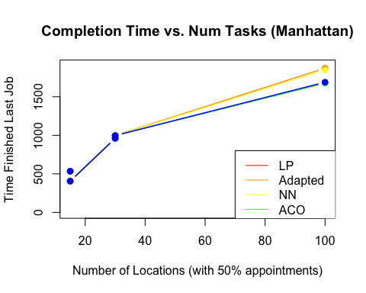

80% Appointments:

plot(x$X.locs[x$X.set.time == 80], x$t1[x$X.set.time == 80], type = "b", col = "red", pch = 19, xlab = "Number of Locations (with 80% appointments)", ylab = "Compute Time", ylim = c(0, 40), lwd=1.5, main = "Time vs. Num Tasks (Manhattan)")  
lines(x$X.locs[x$X.set.time == 80], x$t3[x$X.set.time == 80], col="orange", type = "b", pch = 19, lwd=1.5)  
lines(x$X.locs[x$X.set.time == 80], x$t5[x$X.set.time == 80], col="yellow", type = "b", pch = 19)  
lines(x$X.locs[x$X.set.time == 80], x$t7[x$X.set.time == 80], col="green", type = "b", pch = 19, lwd=1.5)  
lines(x$X.locs[x$X.set.time == 80], x$t9[x$X.set.time == 80], col="blue", type = "b", pch = 19, lwd=1.5)  
legend(45, 40, legend = c("LP", "Adapted", "NN", "ACO", "Simplified Genetic"), col = c("red", "orange", "yellow", "green", "blue"), lty=1, cex=1)

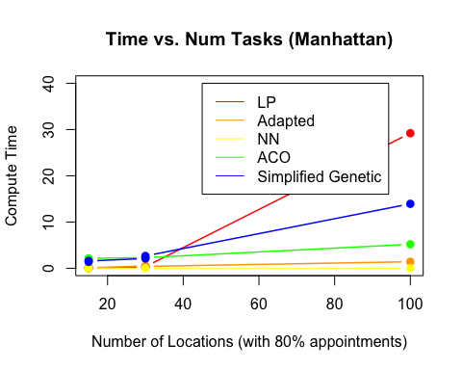

plot(x$X.locs[x$X.set.time == 80], x$d1[x$X.set.time == 80], type = "b", col = "red", pch = 19, xlab = "Number of Locations (with 80% appointments)", ylab = "Time Finished Last Job", ylim = c(0, 2900), lwd=1.5, main = "Completion Time vs. Num Tasks (Manhattan)")  
lines(x$X.locs[x$X.set.time == 80], x$d3[x$X.set.time == 80], col="orange", type = "b", pch = 19, lwd=1.5)  
lines(x$X.locs[x$X.set.time == 80], x$d5[x$X.set.time == 80], col="yellow", type = "b", pch = 19)  
lines(x$X.locs[x$X.set.time == 80], x$d7[x$X.set.time == 80], col="green", type = "b", pch = 19, lwd=1.5)  
lines(x$X.locs[x$X.set.time == 80], x$d9[x$X.set.time == 80], col="blue", type = "b", pch = 19, lwd=1.5)  
legend(70, 1300, legend = c("LP", "Adapted", "NN", "ACO", "Simplified Genetic"), col = c("red", "orange", "yellow", "green", "blue"), lty=1, cex=1)

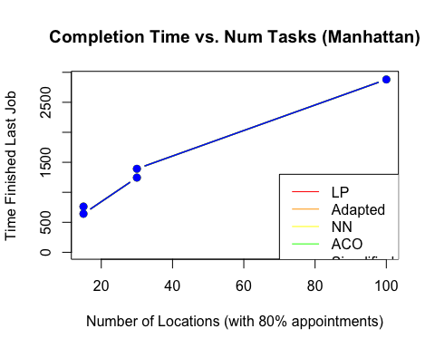 ## Euclidean Distance:

plot(x$X.locs[x$X.set.time == 0], x$t2[x$X.set.time == 0], type = "b", col = "red", pch = 19, xlab = "Number of Locations (with 0% appointments)", ylab = "Compute Time", ylim = c(0, 20), lwd=1.5, main = "Time vs. Num Tasks (Euclid)")  
lines(x$X.locs[x$X.set.time == 0], x$t4[x$X.set.time == 0], col="orange", type = "b", pch = 19, lwd=1.5)  
lines(x$X.locs[x$X.set.time == 0], x$t6[x$X.set.time == 0], col="yellow", type = "b", pch = 19)  
lines(x$X.locs[x$X.set.time == 0], x$t8[x$X.set.time == 0], col="green", type = "b", pch = 19, lwd=1.5)  
lines(x$X.locs[x$X.set.time == 0], x$t10[x$X.set.time == 0], col="blue", type = "b", pch = 19, lwd=1.5)  
legend(15, 20, legend = c("LP", "Adapted", "NN", "ACO", "Simplified Genetic"), col = c("red", "orange", "yellow", "green", "blue"), lty=1, cex=1)

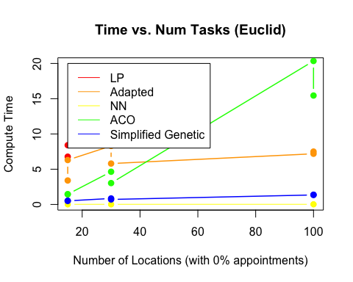

plot(x$X.locs[x$X.set.time == 0], x$d2[x$X.set.time == 0], type = "b", col = "red", pch = 19, xlab = "Number of Locations (with 0% appointments)", ylab = "Time Finished Last Job", ylim = c(0, 650), lwd=1.5, main = "Completion Time vs. Num Tasks (Euclid)")  
lines(x$X.locs[x$X.set.time == 0], x$d4[x$X.set.time == 0], col="orange", type = "b", pch = 19, lwd=1.5)  
lines(x$X.locs[x$X.set.time == 0], jitter(x$d6[x$X.set.time == 0], 10), col="yellow", type = "b", pch = 19)  
lines(x$X.locs[x$X.set.time == 0], x$d8[x$X.set.time == 0], col="green", type = "b", pch = 19, lwd=1.5)  
lines(x$X.locs[x$X.set.time == 0], x$d10[x$X.set.time == 0], col="blue", type = "b", pch = 19, lwd=1.5)  
legend(70, 300, legend = c("LP", "Adapted", "NN", "ACO", "Simplified Genetic"), col = c("red", "orange", "yellow", "green", "blue"), lty=1, cex=1)

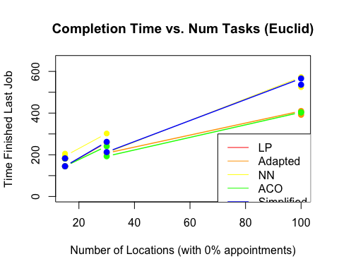

plot(x$X.locs[x$X.set.time == 20], x$t2[x$X.set.time == 20], type = "b", col = "red", pch = 19, xlab = "Number of Locations (with 20% appointments)", ylab = "Compute Time", ylim = c(0, 120), lwd=1.5, main = "Time vs. Num Tasks (Euclid)")  
lines(x$X.locs[x$X.set.time == 20], x$t4[x$X.set.time == 20], col="orange", type = "b", pch = 19, lwd=1.5)  
lines(x$X.locs[x$X.set.time == 20], x$t6[x$X.set.time == 20], col="yellow", type = "b", pch = 19)  
lines(x$X.locs[x$X.set.time == 20], x$t8[x$X.set.time == 20], col="green", type = "b", pch = 19, lwd=1.5)  
lines(x$X.locs[x$X.set.time == 20], x$t10[x$X.set.time == 20], col="blue", type = "b", pch = 19, lwd=1.5)  
legend(60, 100, legend = c("LP", "Adapted", "NN", "ACO", "Simplified Genetic"), col = c("red", "orange", "yellow", "green", "blue"), lty=1, cex=1)

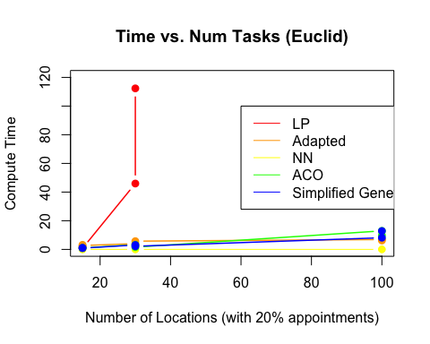

plot(x$X.locs[x$X.set.time == 20], x$d2[x$X.set.time == 20], type = "b", col = "red", pch = 19, xlab = "Number of Locations (with 20% appointments)", ylab = "Time Finished Last Job", ylim = c(0, 1300), lwd=1.5, main = "Completion Time vs. Num Tasks (Euclid)")  
lines(x$X.locs[x$X.set.time == 20], x$d4[x$X.set.time == 20], col="orange", type = "b", pch = 19, lwd=1.5)  
lines(x$X.locs[x$X.set.time == 20], jitter(x$d6[x$X.set.time == 20], 10), col="yellow", type = "b", pch = 19)  
lines(x$X.locs[x$X.set.time == 20], x$d8[x$X.set.time == 20], col="green", type = "b", pch = 19, lwd=1.5)  
lines(x$X.locs[x$X.set.time == 20], x$d10[x$X.set.time == 20], col="blue", type = "b")  
legend(70, 700, legend = c("LP", "Adapted", "NN", "ACO", "Simplified Genetic"), col = c("red", "orange", "yellow", "green", "blue"), lty=1, cex=1)

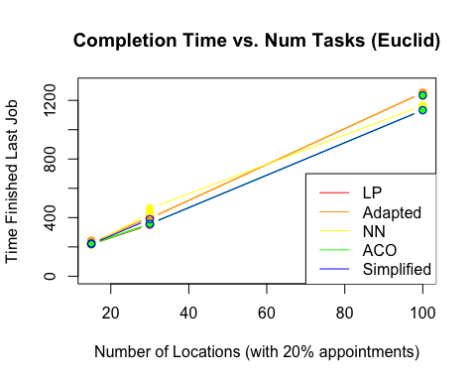

plot(x$X.locs[x$X.set.time == 50], x$t2[x$X.set.time == 50], type = "b", col = "red", pch = 19, xlab = "Number of Locations (with 50% appointments)", ylab = "Compute Time", ylim = c(0, 35), lwd=1.5, main = "Time vs. Num Tasks (Euclid)")  
lines(x$X.locs[x$X.set.time == 50], x$t4[x$X.set.time == 50], col="orange", type = "b", pch = 19, lwd=1.5)  
lines(x$X.locs[x$X.set.time == 50], x$t6[x$X.set.time == 50], col="yellow", type = "b", pch = 19)  
lines(x$X.locs[x$X.set.time == 50], x$t8[x$X.set.time == 50], col="green", type = "b", pch = 19, lwd=1.5)  
lines(x$X.locs[x$X.set.time == 50], x$t10[x$X.set.time == 50], col="blue", type = "b", pch = 19, lwd=1.5)  
legend(20, 35, legend = c("LP", "Adapted", "NN", "ACO", "Simplified Genetic"), col = c("red", "orange", "yellow", "green", "blue"), lty=1, cex=1)

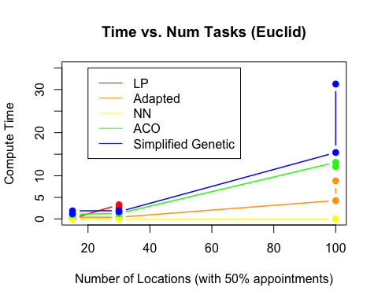

plot(x$X.locs[x$X.set.time == 50], x$d2[x$X.set.time == 50], type = "b", col = "red", pch = 19, xlab = "Number of Locations (with 50% appointments)", ylab = "Time Finished Last Job", ylim = c(0, 1700), lwd=1.5, main = "Completion Time vs. Num Tasks (Euclid)")  
lines(x$X.locs[x$X.set.time == 50], x$d4[x$X.set.time == 50], col="orange", type = "b", pch = 19, lwd=1.5)  
lines(x$X.locs[x$X.set.time == 50], jitter(x$d6[x$X.set.time == 50], 10), col="yellow", type = "b", pch = 19)  
lines(x$X.locs[x$X.set.time == 50], x$d8[x$X.set.time == 50], col="green", type = "b", pch = 19, lwd=1.5)  
lines(x$X.locs[x$X.set.time == 50], x$d10[x$X.set.time == 50], col="blue", type = "b")  
legend(70, 900, legend = c("LP", "Adapted", "NN", "ACO", "Simplified Genetic"), col = c("red", "orange", "yellow", "green", "blue"), lty=1, cex=1)

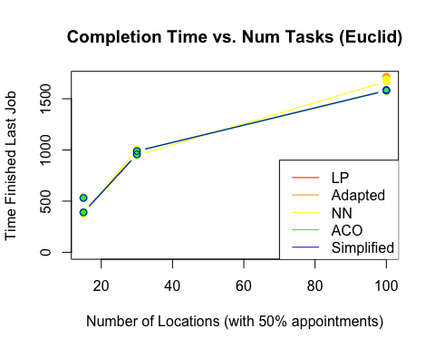

plot(x$X.locs[x$X.set.time == 80], x$t2[x$X.set.time == 80], type = "b", col = "red", pch = 19, xlab = "Number of Locations (with 80% appointments)", ylab = "Compute Time", ylim = c(0, 28), lwd=1.5, main = "Time vs. Num Tasks (Euclid)")  
lines(x$X.locs[x$X.set.time == 80], x$t4[x$X.set.time == 80], col="orange", type = "b", pch = 19, lwd=1.5)  
lines(x$X.locs[x$X.set.time == 80], x$t6[x$X.set.time == 80], col="yellow", type = "b", pch = 19)  
lines(x$X.locs[x$X.set.time == 80], x$t8[x$X.set.time == 80], col="green", type = "b", pch = 19, lwd=1.5)  
lines(x$X.locs[x$X.set.time == 80], x$t10[x$X.set.time == 80], col="blue", type = "b", pch = 19, lwd=1.5)  
legend(20, 28, legend = c("LP", "Adapted", "NN", "ACO", "Simplified Genetic"), col = c("red", "orange", "yellow", "green", "blue"), lty=1, cex=1)

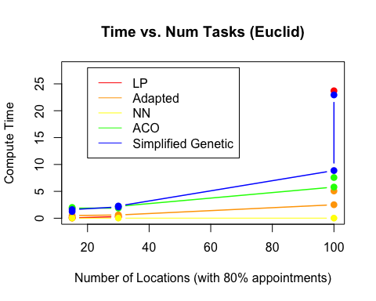

plot(x$X.locs[x$X.set.time == 80], x$d2[x$X.set.time == 80], type = "b", col = "red", pch = 19, xlab = "Number of Locations (with 80% appointments)", ylab = "Time Finished Last Job", ylim = c(0, 2900), lwd=1.5, main = "Completion Time vs. Num Tasks (Euclid)")  
lines(x$X.locs[x$X.set.time == 80], x$d4[x$X.set.time == 80], col="orange", type = "b", pch = 19, lwd=1.5)  
lines(x$X.locs[x$X.set.time == 80], jitter(x$d6[x$X.set.time == 80], 10), col="yellow", type = "b", pch = 19)  
lines(x$X.locs[x$X.set.time == 80], x$d8[x$X.set.time == 80], col="green", type = "b", pch = 19, lwd=1.5)  
lines(x$X.locs[x$X.set.time == 80], x$d10[x$X.set.time == 80], col="blue", type = "b")  
legend(70, 1200, legend = c("LP", "Adapted", "NN", "ACO", "Simplified Genetic"), col = c("red", "orange", "yellow", "green", "blue"), lty=1, cex=1)

