**Simona Georgieva**

**1900745**

**CM4110**

**Human Computer Interaction**

**Word count:1985**

**Date: 20 April 2023**

**An app that helps people have a more sustainable lifestyle**

**Section 1: Introduction 205/200**

Over the last few years, our society has witnessed not only the technological advancements that make our everyday lives easier but also the development of sustainable lifestyles. According to a magazine, the UAE has made an investment of 15 USD billion in building the Masdar community. This state-of-the-art city aims to offer the highest quality of life with the lowest environmental footprint. Instead of establishing brand new cities, another approach is to adapt to the "greener future" by using mobile apps to encourage a more sustainable lifestyle and improve people's welfare through the protection of Earth's resources.

After conducting a [survey](https://docs.google.com/forms/d/1IBIZfFxj5nDhSeTMPsNYbryKvikE69PB_zCREBomc4k/viewform?fbclid=IwAR1xHa85B6SiohpHs9d5tBWso9lHmHoa5ncp5JMxkg_Xhp7d1lIeksqJ7WI&edit_requested=true), the main idea of the app is to enhance the interaction between the user and the "green" world around them. Users were particularly interested in environmentally safe alternatives for zero-waste living. As a result, the app will offer them an intuitive map of the nearest organic cosmetic stores and shops, hydrogen-powered public transport, meat-free restaurants, and refill stations. To boost user productivity, a point system for rewards will be implemented. This added functionality will allow users to complete daily tasks and earn points, which can be redeemed for vouchers. Additional functionality recommended during the survey was a page with simple tips and useful tricks.

**Section 2: User profiling 184/150**

2.1 User 1:



*“In the last 6 months, I have been trying to keep a vegan lifestyle. I became more conscious about what I am consuming after I spent many months eating fast food at the airports. As a flight attendant, I travel all over the world and I spend days in new locations. I want to have a more practical combination between my veggie habits and work travels.”*

2.2 User 2:



*“I can see more and more influencers on TikTok using organic cosmetics in their night skin routine and it is a trend. You heard about Kylie Jenner`s vegan lipstick, right? If there is an app where I can earn discounts for these types of products, I will use it for sure. Who does not love cosmetics and discounts?”*

2.3. User 3:



*"I am trying to teach my grandchildren to take care of our planet. As a 65-year-old woman, I do realize the need to live in a cleaner environment. I find that the app very useful for all age groups, especially if it is not very complex to use and I can clearly see the elements and colors on the screen."*

**Section 3: Design**

**3.1. Conceptual Design -** [Link for better quality.](https://miro.com/app/board/uXjVMTwjY18=/?share_link_id=524240007289)

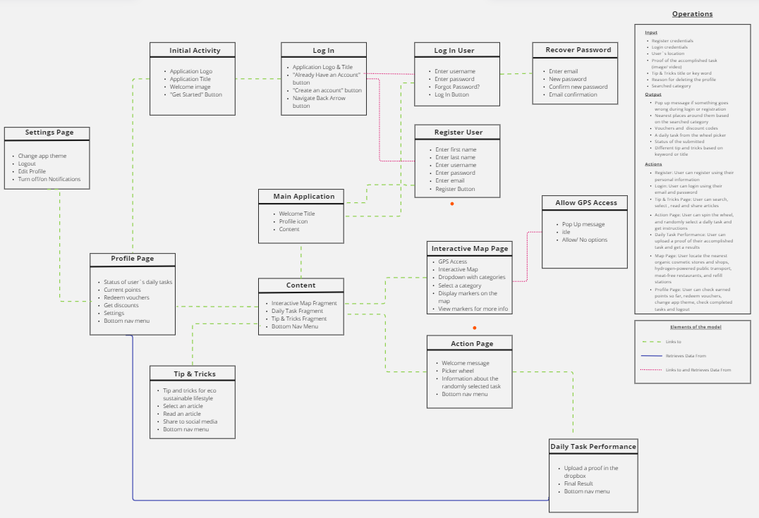

**Figure 2:** *Screenshot of the conceptual design*

**Section 3b: Mockups 241/200**

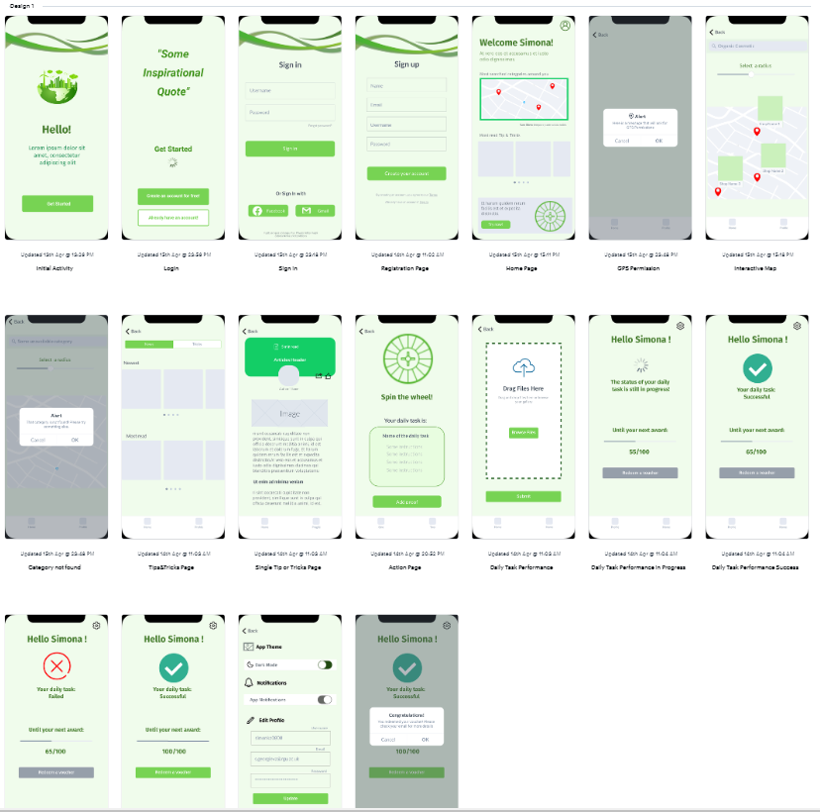**3.2 Design 1** [Link for better quality](https://marvelapp.com/prototype/ee6b2bd/section/1758235)

**Figure 3:** *Screenshots of the mockups created for Design 1*

**3.3 Design 2 –** [Link for better quality](https://marvelapp.com/prototype/ee6b2bd/section/1758454)

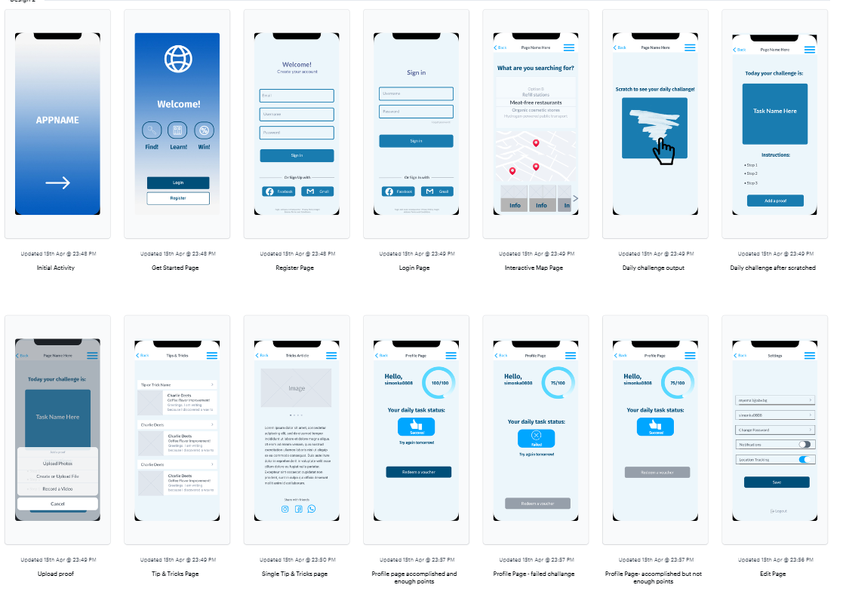

**Figure 4:** *Screenshots of the mockups created for Design 2*

According to UGEM - a research-driven UI/UX design agency, the minimalist mobile app design has lots of white spaces and few elements on the screen. Consequently, the user interacts with fewer widgets, reducing the chances of confusion or finding wrong navigation paths. For this reason, both designs rely on a clean and intuitive front end to offer an easy-to-use experience, no matter the age group.

Both designs have been created to meet a wide range of users' needs. For example, an intriguing way of accessing daily tasks using a spinning wheel or scratching a card is highly likely to attract attention among younger users and teach them how to keep the planet clean

Integrating a point system and gaining discounts will involve not only the current users but also might attract new ones. Moreover, redeeming points for discounts that can be used in organic stores will appeal to people who want to move not only to chemical-free skincare but also to a natural lifestyle.

Using an interactive map to bring up options of nearby healthy places will help users with the characteristics presented in 2.1. They can easily maintain the same lifestyle because the map will guide them during their journeys no matter the location.

Both app themes allow the mobile application to be used by people with colour-blind disabilities by combining white colour with either different green shades, as shown in Design 1, or using dark blue in Design 2.

**Section 4: Evaluation**

**4.1 Human evaluation**

Evaluation is crucial in gathering feedback from users and allows us to look at how the proposed system works in relation to their interaction. For this purpose, a human evaluation survey has been conducted based on participants with similar backgrounds to the user groups.

To view the full survey, please open that [link](https://docs.google.com/forms/d/1SmLrgi-0iRxv8ZI2Y1OO-sfwR2MugExbDtCz3_HP5_E/edit#question=1287712303&field=447206407). The survey instructions at the beginning provide important information to the participants for the correct completion.

A Quota sampling method was utilized to achieve the project goal. The survey was sent to pre-defined groups of people with similar backgrounds to the user profiles. During the planning stage, the number of participants for each group has been determined and the survey was subsequently sent to 15 people. These participants answered 16 questions that were related to accessibility, effectiveness, and interface.

The format of the survey was split into two parts. The first part required interaction with Design 1 and answering a set of questions. The second part followed the same steps. This was done to provide a structured and intuitive survey(e.g. asking the questions in the same way) and keep them motivated during the process.

The elements used in the survey include:

* A Linear scale to provide a numeric response to questions related to the difficulty levels of some functionalities.
* Multiple choice questions to select one Design
* Text boxes to collect short answers from the participants.

In order to get weighted responses the multiple-choice survey questions were marked as required. The text box answers were optional because making them required might lead to survey fatigue(GAVIN, 2021). It is characterized by low enthusiasm and unwillingness to complete the survey.

**4.1.1. Accessibility**

Both designs share different ways of navigation between the screens. Design 1 implements a bottom navigation menu, whereas Design 2 offers the traditional hamburger menu. To examine the user preference regarding clear and easy navigation they were asked the following question for both designs:

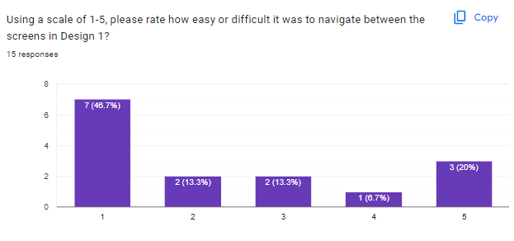

**Figure 5***: Design 1 navigation between the screens*

**Figure 6***: Design 2 navigation between the screens*

Analyzing the results from Figure 5 and Figure 6 we can clearly see that majority of the respondents find the bottom navigation menu easier to navigate through the screens. 7.1% of the users think it is very easy to use a burger menu to reach different content, whereas 46.7% of the respondents marked their interaction with the bottom menu as not challenging.

**4.1.2 Effectiveness**

In this project, effectiveness could be described as the ability to successfully produce the intended results(e.g. submitting an image or a video of the accomplished task or spinning the wheel).

When asked how difficult they find the way of adding proof of their daily task, responses indicated that 46.7% of the users checked scale 2 “Very Easy” for Design 2 whereas only 33% voted with scale 1 “Very Easy”.

**Figure 7***: Design 2 adding a proof*

**Figure 8***: Design 1 adding a proof*

Both designs offer two completely different ways of engaging the user with the daily task. When asked to choose which one is more interesting to them 60% of the responses indicates that users prefers scratching a card rather than spinning a wheel.

**Figure 9***: Spinning a wheel VS Scratching a card*

After interacting with both designs the user faced two different ways of searching for a category using the interactive map. According to the results from the graph using a search bar with user typing (Design 1) seems to be more difficult to use compared with the dropdown picker.

**4.1.3 Interface**

When asked for their feedback about the app theme 53.3% said they prefer Design 1 colours which is a combination between green and white.

**Figure 10***: Most liked colour theme*

Both prototypes use different visual elements for tracking the collected points. Design 1 makes use of a progress slider, whereas Design 2 uses a circular gauge. With the unprecedented 72.2% design 1`s visual is most preferred among the users.

**Figure 11***: Most liked point tracker*

**4.2 CogTool Analysis**

**4.2.1 Main functionality**

|  |  |
| --- | --- |
| **Predictions for Main Functionality** | |
| Design 1 – 25.1 | Design 2 – 27.1s |

**Table 1***: Results from CogTool*

**Figure 11***: Design 1(top) vs Design 2 (bottom)*

To compare the two designs using CogTool, I created predictive models for each to estimate task completion times based on cognitive psychology principles. Both models tested the main functionality and obtained predicted completion times(see Table 1) using the same steps:

1. Open the app
2. Login
3. Accessing the daily task
4. Uploading a proof
5. Redeeming points
6. Using the interactive map
7. Opening main fun facts page
8. Opening a single fun fact
9. Navigating back to the home page using a menu

The first three steps consist of the same design for both prototypes just different colour themes with no difference in cognitive load. For this purpose, the section will discuss the

Based on the predicted task completion times, we can analyze how efficient and effective is the user interaction. In this scenario, Design 1 has a lower predicted completion time of 25.1 seconds compared to Design 2. This is due to factors such as a simpler navigation structure, different sequences of steps for the completion of the daily task. Design 1 uses a bottom navigation menu and requires only one click to be redirected to another page. On the other hand, Design 2 has a burger menu implemented, which requires 2-3 extra clicks (1-> open the menu, 2-> select a page) or (1-> open the menu, 2-> decide they want to stay on the same page, 3-> close the menu). Figure 12 proves the statement above, extra cognitive time is added to design 2 when switching between frames.

**Figure 12***: Design 1(top) vs Design 2 (bottom) - navigation*

**4.2.2 Daily Task Process**

An increased cognitive load time is detected when accessing the daily task. Figure 12 shows that the user is redirected via 3 screens to obtain, upload, check the status of the daily task and redeem a voucher. Whereas in Design 2 these steps could be done on 2 screens only.

**Figure 13***: Design 1(top) vs Design 2 (bottom) – daily task functionalities*

**4.2.3 Searching Category**

**Figure 14***: Design 1(top) vs Design 2 (bottom) – searching categories on the interactive map*

There is a difference in cognitive load on the interactive page. This could indicate that using an input text box (design 1) might be more complex and could increase cognitive load because users spend time typing. To enhance the user experience, a simple dropdown menu, which does not require extra mental demand like in Design 2, might be a better option.

**4.2.4 Filtering tip & tricks page**

The presence of multiple buttons on the "Tips & Tricks" page in Design 1 indicates increased cognitive load by 2 seconds compared to Design 2, where these buttons are missing. Users need extra time to read the labels on the icons and make decisions, which requires mental resources. However, both buttons use the same design patterns and are visually distinctive and highlighted. This section serves as an example of how cognitive load might be increased initially, but users will quickly understand the outcome of their actions and improve the overall experience by filtering the content they want to see – either tricks or tips.

**Figure 15***: Design 1(top) vs Design 2 (bottom) – tip & tricks page*

**Discussion:**

Based on the results gathered from the two evaluations, we can clearly see that both designs have their own advantages and disadvantages. The strengths of both designs have been combined to create a “winning design”.

53.3% of the respondent preferred the white and green theme. For this purpose, the “winning design” uses that colour design to provide an eco-friendly atmosphere. Based on the predicted task completion times, a bottom navigation bar is implemented to effortlessly switch between different sections of the app and access desired features. Furthermore, the third design uses the Design 2 way of completing the daily task based on the results from Table 2. The radius slider from Design 1 will be combined with the dropdown picker from Design 2 to offer an aesthetic view similar to many social apps nowadays.

[Link for the winning design](https://marvelapp.com/prototype/ee6b2bd/section/1758235)

**Section 5: Conclusion**

The aim of the project was to develop an eco-sustainable mobile appto incentivize sustainable behaviour among different age groups. The created prototype offers a range of different activities to keep the users motivated to adopt sustainable behaviours and contribute to a greener future. These include completion of a daily task, gaining points, and locating nearby sustainable places and interesting articles.

Two different designs were tested using cog tool analysis and a human evaluation survey. Analyzing different factors such as usability, effectiveness, user interaction and visual appearance contributed to the creation of a third final design.

In the project, several aspects went well that I am proud of. Using MarvellApp allowed the creation of interactive and aesthetic prototypes. They were in-depth tests using cogtool analysis and user assessment. One aspect that could have been done better is the survey. Instead of Quota Sampling, I would use simple random sampling which should be more effective but time-consuming.

References:

DIACHENKO, A., n.d. What are the core features of minimalist app design? UGEM [online]. Available from: https://ugem.design/blog/minimal-app-design [Accessed 19 Apr 2023].

GAVIN, 2021. Survey fatigue. [online]. Customer Thermometer. Available from: https://www.customerthermometer.com/customer-surveys/survey-fatigue/ [Accessed 19 Apr 2023].

Masdar City in Abu Dhabi, 2023. [online]. Centre For Public Impact (CPI). Available from: https://www.centreforpublicimpact.org/case-study/masdar-city [Accessed 19 Apr 2023].