1. 8 PUZZLE USING ITERATIVE DEEPENING DEPTH FIRST SEARCH ALGORITHM 1

**Code:**

class PuzzleState:

def finite(self, boa rd, empty_tile_pos, depth=0, path=[]):

self.board = board

self.empty_tile_pos = empty_tile_pos # (row, col) self.depth = depth

self.path = path # Keep track of the path taken to reach this state

def is_goal(self, goal):

return self.board == goal

def generate_moves(self):

row, col = self.empty_tile_pos moves = []

directions = [(-1, 0, ’Up'), (1, 0, 'Down’), (0, -1, 'Left'), (0, 1, ’Right')] # up, down, left, right for dr, dc, move_name in directions:

new_row, new_col = row + dr, col + dc

if 0 <= new_row < 3 and 0 <= new_col < 3:

new_board = self.board[:]

new_board[row * 3 + col], new_board[new_row * 3 + new_col] = new_board[new_row * 3 + new_col], new_board[row * 3 + col]

new_path = self.path + [move_name] # Update the path with the new move

moves.append(PuzzleState(new_board, (new_row, new_col), self.depth + 1, new_path))

return moves

def display(self):

# Display the board in a matrix form

for i in range(0, 9, 3): print(self. board[i:i + 3])

print(f"Moves: (self.path}") # Display the moves taken to reach this state

print() # Newline for better readability

def iddfs(initial_state, goal, max_depth): for depth in range(max_depth + 1):

print(f"Searching at depth: {depth}")

found = dls(initial_state, goal, depth) if found:

print(f"Goal found at depth: (found.depth}") found.display()

return found

print("Goal not found within max depth.") return None

def dls(state, goal, depth):

if state.is_goal(goal):

return state if depth <= 0: return None

for move in state.generate_moves():

print("Current state:")

move.display() # Display the current state

result = dls(move, goal, depth - 1)

if result is not None:

return result

return None

def main():

# User input for initial state, goal state, and maximum depth

initial_state_input = input("Enter initial state (0 for empty tile, space-separated, e.g. '1 2 3 4 5 6 7 8 0'): ")

goal_state_input = input("Enter goal state (0 for empty tile, space-separated, e.g. ’1 2 3 4

5 6 7 8 0’): ")

max_depth = int(input("Enter maximum depth: ")) initial_board = list(map(int, initial_state_input.split())) goal_board = list(map(int, goal_state_input.split()))

empty_tile_pos = initial_board.index(0) // 3, initial_board.index(0) % 3 # Calculate the

**position of** the **empty tile**

initial_state= PuzzleState(initial_board, empty_tile_pos) solution = iddfs(initial_state, goal_board, max_depth)

if enamel == " main ":

main()

OUTPUT :

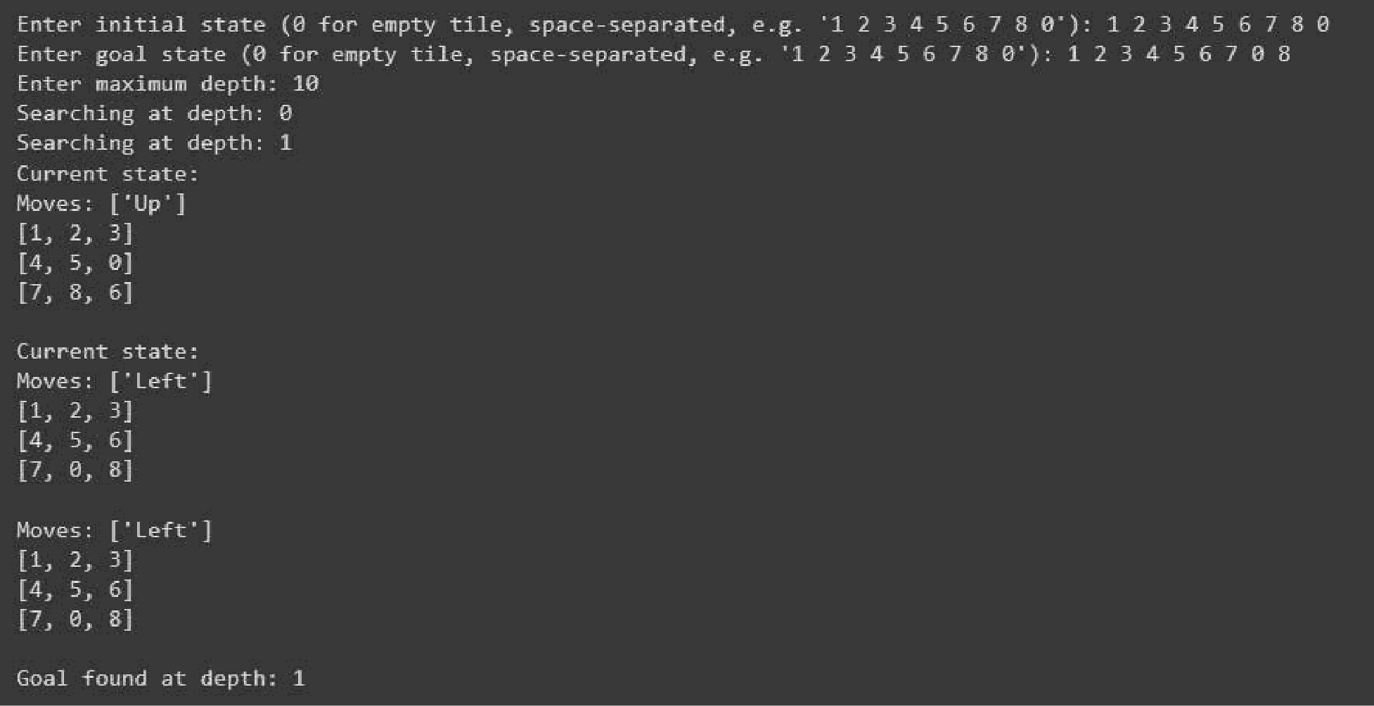

1. N QUEENS PROBLEM USING HILL CLIMBING METHOD

Code:

import random

def calculate_cost(board):

n = len(board) attacks = 0

for i in range(n):

forj in range(i + 1, n):

if board[i] == board[j]: # Same column attacks += 1

if abs(board[i] - board[j]) == abs(i -j): # Same diagonal attacks += 1

return attacks

def get_neighbors(board):

neighbors = [] n = len(board)

for col in range(n):

for row in range(n):

if row != board[col]: # Only change the row of the queen

new_board = board[:] new_board[col] = row neighbors.append(new_board)

return neighbors

**def** hill_climb(board, **max_resta** rts=100):

current_cost = **calculate_cost(board)** print("Initialboard configuration:") print_board(board, current_cost) iteration = 0

restarts = 0

while restarts < max_restarts: # Add limit to the number of restarts while current_cost != 0: # Continue until cost is zero

neighbors = get_neighbors(board) best_neighbor = None

best_cost = current_cost

for neighbor in neighbors:

cost= calculate_cost(neighbor)

if cost < best_cost: # Looking for a lower cost best_cost = cost

best_neighbor = neighbor

if best_neighbor is None: # No better neighbor found

break # Break the loop if we are stuck at a local minimum

board = best_neighbor current_cost = best_cost iteration += 1 print(f"Iteration(iteration}:")

print_boa rd(board, current_cost)

if current_cost == 0:

break # We found the solution, no need for further restarts else:

# Restart with a new random configuration

board = [random.randint(0, len(board)-1) for_ in range(len(board))]

current_cost = calculate_cost(board)

resta rts += 1

print(f"Resta rt(resta rts}:")

print_boa rd(board, current_cost)

return board, current_cost

def print_board(boa rd, cost):

n = len(board)

display_board = [[’.’] * n for_ in range(n)] # Create an empty board

for col in range(n):

display_boa rd[board[col]][col] = 'Q' # Place queens on the boa rd

for row in range(n):

print(' ’.join(display_board[row])) # Print the board

print(f"Cost: (cost}\n")

if enamel == " main ":

n = int(input("Enter the number of queens (N): ")) # User input for N

initial_state = list(map(int, input(f"Enter the initial state (row numbers for each column, space-sepa rated): ").split()))

if len(initial_state) != n or any(r < 0 or r >= n for r in initial_state):

print("Invalid initial state. Please ensure it has N elements with values from 0 to N -1.") else:

solution, cost = hill_climb(initial_state) if cost == 0:

print(f"Solution found with no conflicts:") else:

print(f"No solution found within the restart limit:")

print_boa rd(solution, cost)

Output:

