Week 1
MagPilot | Lab update
28 September–4 October 2026 · reviewed 5 October · paper branch
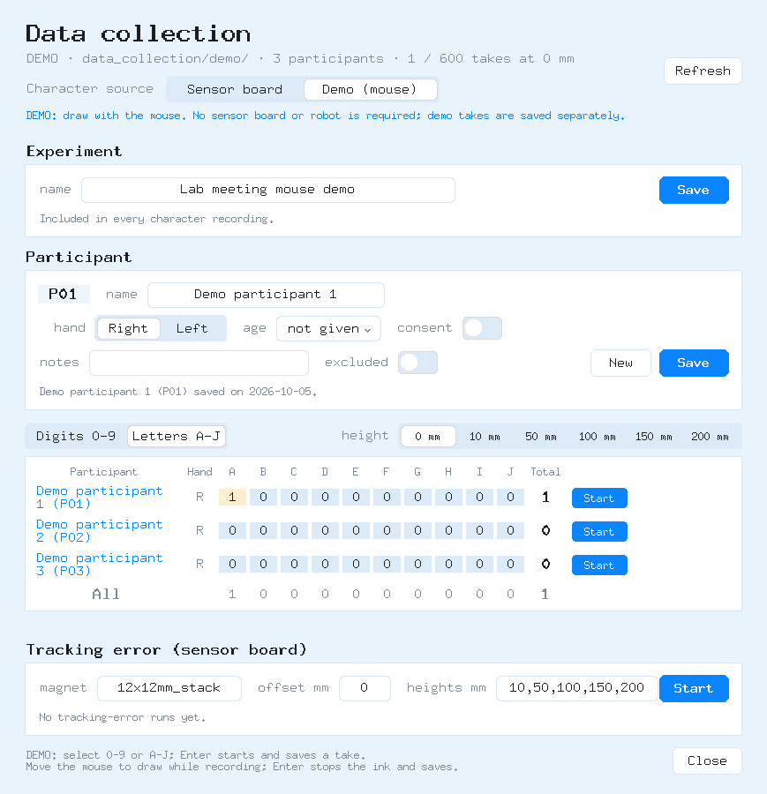  DEMO · fictitious participant names; synthetic mouse input. | Collection foundations  - Protocol: 0–9 / A–J; ten takes each (200 per participant).  - Participant names and stable IDs; experiment names accompany takes.  - Enter marks capture boundaries; CSV/PNG/JSON use frozen rows.  - Separate demo files/counts; software checks + GUI rehearsal passed.  Week 2 handoff  - Week 2 begins 5 October: board repair and magnet diagnostics.  - Compare one-, two- and three-magnet configurations; document geometry and orientation.  - Prototype a reloadable pen; check writing and teleoperation heights.  Next milestones  - Start virtual target reaching in Week 2; log completion times and endpoint errors.  - Character pilot: 40–60 takes/person (2–3 repetitions); myself + 1–2 colleagues. Not collected.  - Next: review/resume, preprocessing and participant-separated splits.  Proposed ten-week plan  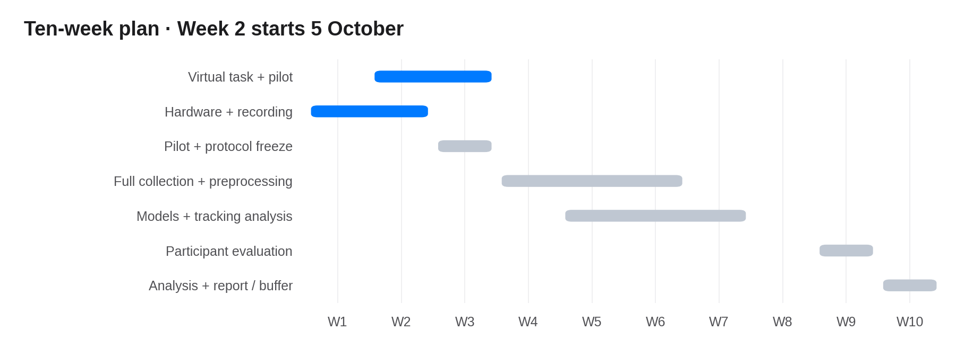  Reference: K&J Magnetics: magnetic moment / geometry

Week 1
Explicit one-character capture
Select label → operator Enter: start → participant draws → operator Enter: stop/save → inspect.
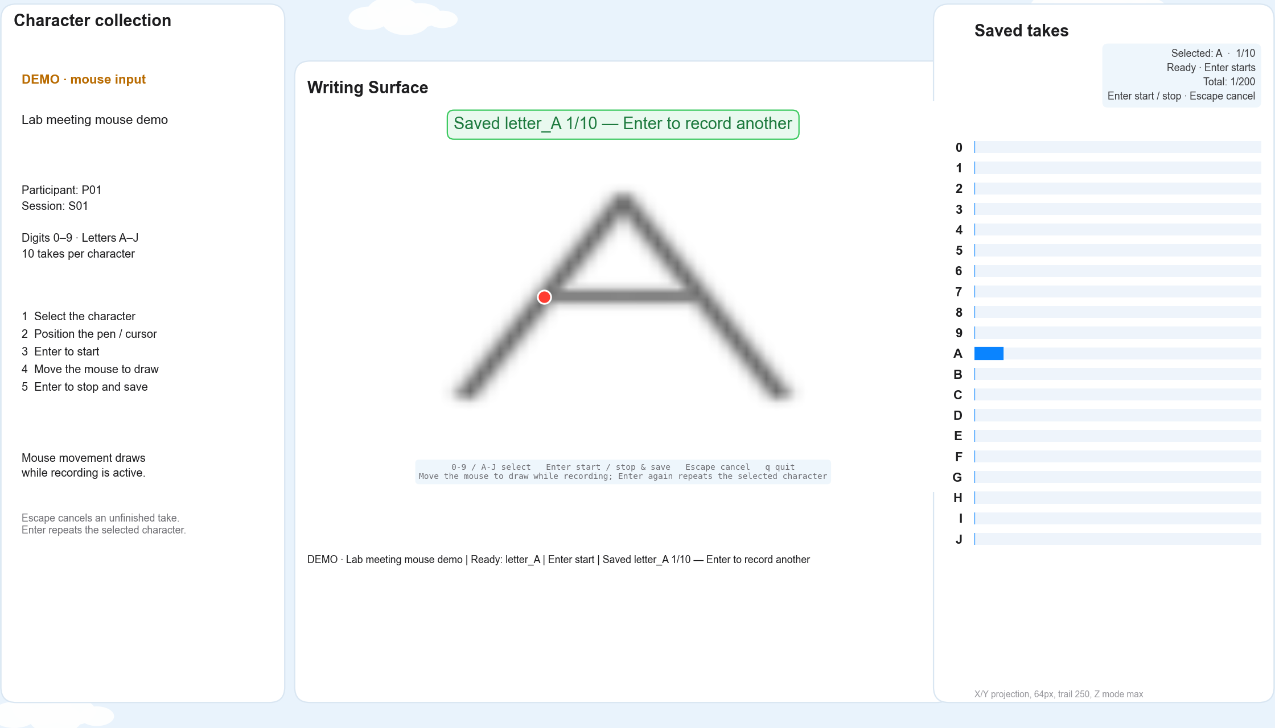
Actual GUI rehearsal: synthetic A; one of ten takes saved.
- Operator uses Enter for recording and demo ink; participant only moves the mouse.
- Demo mouse input; no sensor board needed.
- Stop freezes rows before matched artifacts are saved.
- Hardware pilot and new-pen validation remain pending.

