WEEK 2 · IN PROGRESS
The teleoperation pipeline.
5–11 October 2026 · meeting 12 October · draft as of 6 October
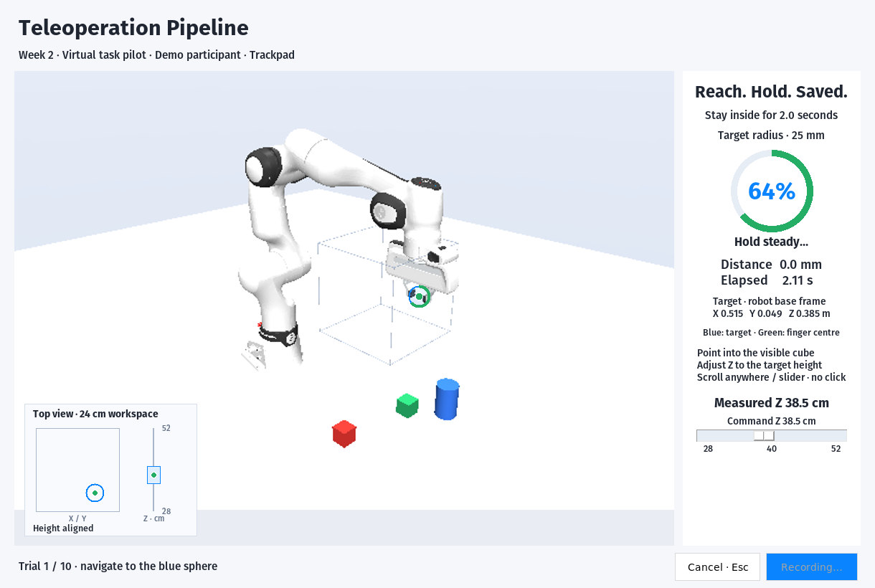  Implemented GUI · participant timing comparison not collected. | Data pipeline  - MuJoCo target-reaching lives in Data → Teleoperation Pipeline.  - Trackpad + board inputs; Enter starts; a stable 2 s hold saves.  - Participant progress; time, path and endpoint error logged.  Next checks  - Validate board mapping with the assembled pen.  - Rehearse identical targets and start pose for both inputs.
Priority for 12 October: a repeatable target-reaching pilot.

WEEK 2 · IN PROGRESS
Board repaired. Pen printing.
5–11 October 2026 · meeting 12 October · draft as of 6 October
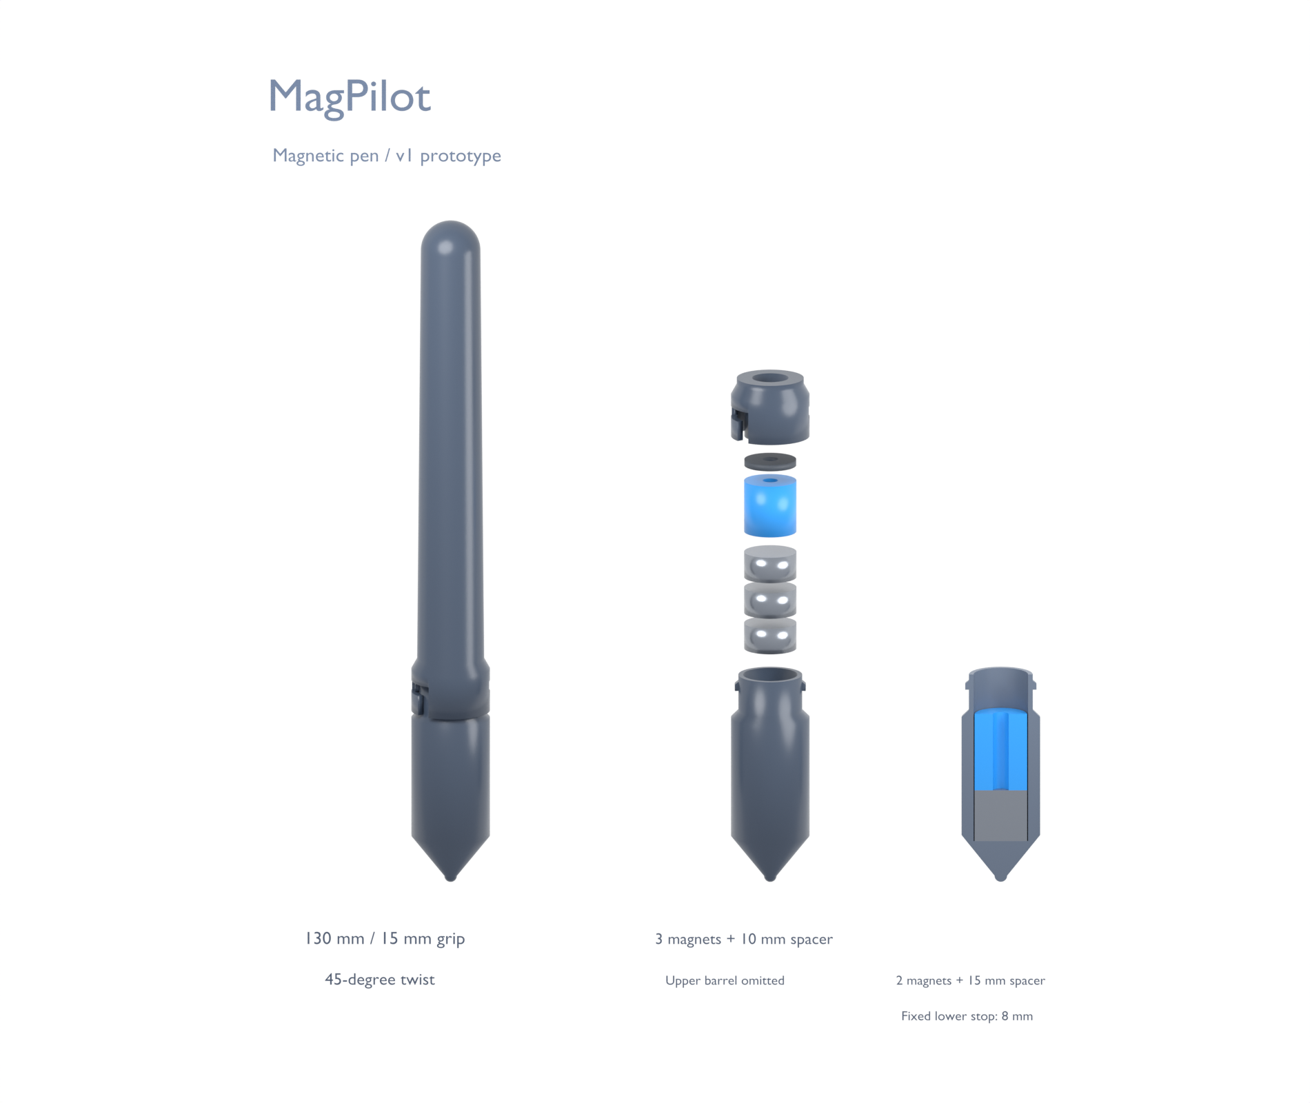  CAD prototype · print and tracking validation pending. | Magnet diagnosis  - Board repaired; 1/2/3 magnets × 3 repeats completed.  - Approx. 5 mm cardboard; placements by hand.  - One magnet: practical surface baseline; no accuracy winner established.  Reloadable pen  - 1–5 disks; spacers above shorter stacks.  - PLA printing started; fit and assembled tracking untested.  Next checks  - Check fit coupons and closure; measure pen geometry.  - Compare heights with a placement template, then freeze setup.
Surface tests do not validate operation at greater heights.

