Fshikta Dental
Clinic User Manual
Patient Workflow Guide:
Patient Registration → Appointment → Visit → Billing
Version 2.1.0 — July 2026

Fshikta Dental — Clinic User Manual

Patient Workflow Guide: Registration → Appointment → Visit → Billing
Version 2.1.0 — July 2026

Table of Contents

- Section 1: Reception Guide
  - Patient Registration
  - Booking Appointments
  - Managing Appointments
  - Patient Check-in
  - Payment Collection
  - Daily Tasks Checklist
- Section 2: Dentist Guide
  - Starting a Visit
  - Clinical Notes (SOAP)
  - Vital Signs
  - Procedures
  - Prescriptions
  - Imaging & Lab Orders
  - Completing a Visit
- Section 3: Manager Guide
  - Dashboard Overview
  - Reports & Analytics
  - Financial Management
  - Staff Management
  - System Settings & Audit4. Appendix
A: Status Flow Diagrams
B: Glossary of Terms

Section 1: Reception Guide

This section covers all front-desk tasks: registering patients, scheduling appointments, checking patients in, and collecting payments.

1.1 Patient Registration

Navigation: Sidebar → Patients → Click "New Patient"
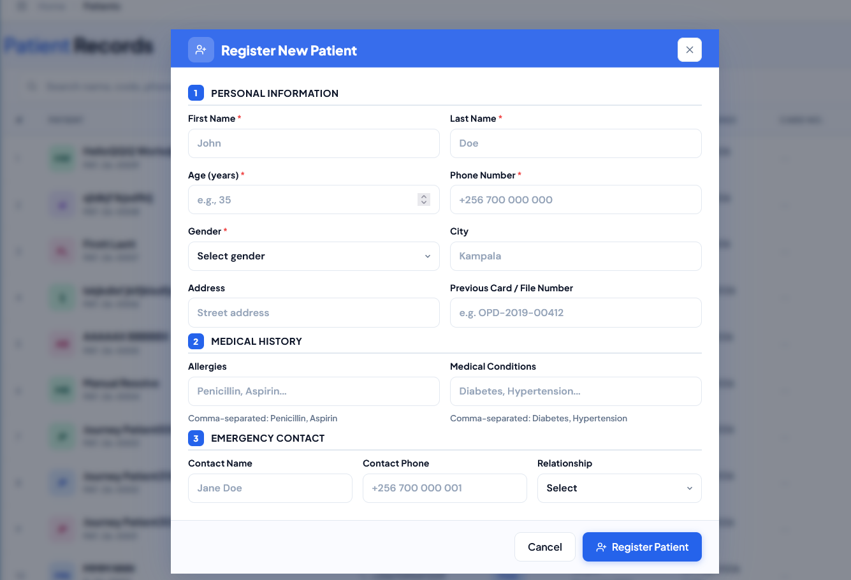
The "Register New Patient" modal contains three sections:

Personal Information
Field | Required | Notes
First Name | Yes | e.g., "John"
Last Name | Yes | e.g., "Doe"
Age (years) | Yes | Must be 0–120
Phone Number | Yes | e.g., "+256 700 000 000"
Gender | Yes | Male / Female
City | No | e.g., "Kampala"
Address | No | Street address
Previous Card / File No. | No | For legacy card migration

Medical History
Field | Notes
Allergies | Comma-separated, e.g., "Penicillin, Aspirin"
Medical Conditions | e.g., "Diabetes, Hypertension"

Emergency Contact
Field | Notes
Contact Name | e.g., "Jane Doe"
Contact Phone | e.g., "+256 700 000 001"
Relationship | Spouse / Parent / Child / Sibling / Friend / Other
After submission: System auto-generates a patient code ( PAT-YY-NNNN ). The patient appears in the patient list immediately.
To edit: Click the patient's row → click "Edit" pencil icon.
Active/Inactive: Patients can be marked inactive via their detail page. Inactive patients are hidden from most searches by default.

Patient List Screen
Search: by name, patient code, or phone number
Filters: Gender dropdown, registration date range
Columns: #, Patient, Contact, Gender, D.O.B / Age, Registered, Card No., Visits, Actions Bulk actions: None currently — each patient is managed individually.

1.2 Booking Appointments

Navigation: Sidebar → Appointments → Click "New"
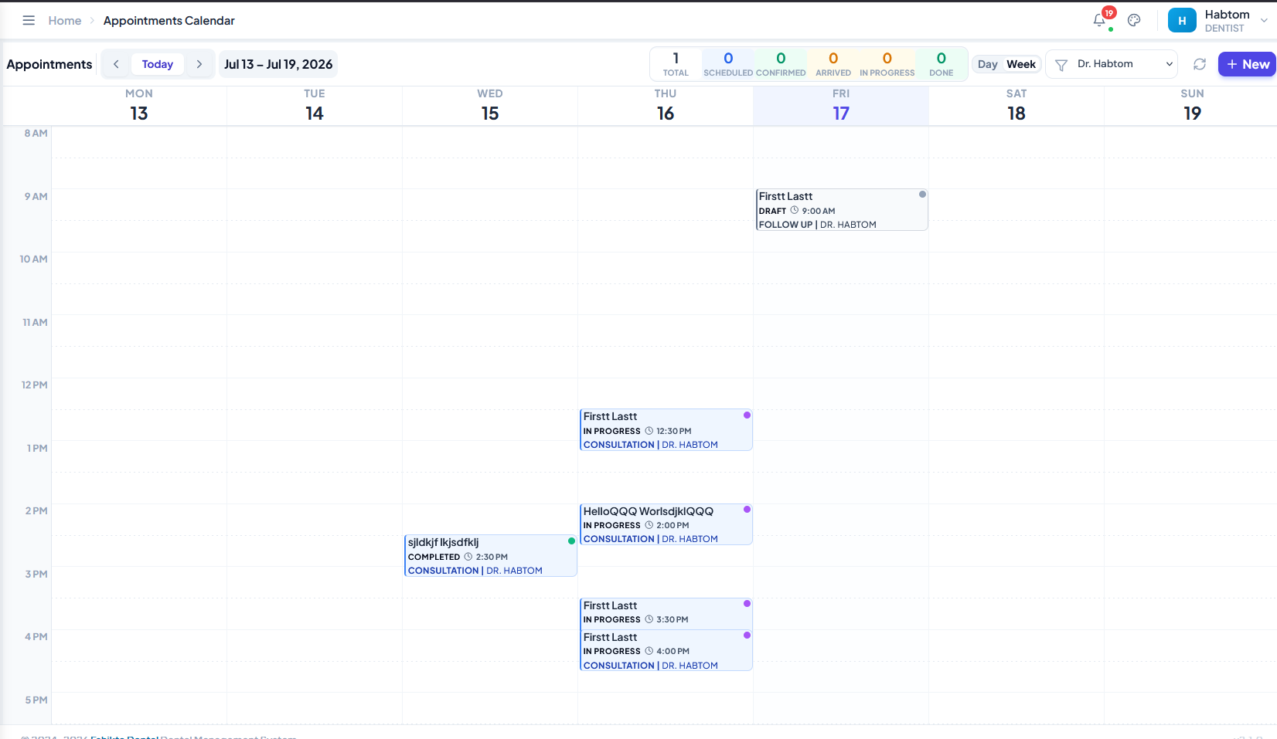
The "Book New Appointment" modal:
Step | Field | Details
1 | Select Patient | Search by name, code, or phone
2 | Dentist | Dropdown of all available dentists
3 | Appointment  Type | Regular Checkup, Cleaning, Filling, Extraction, Root Canal, Crown, Implant,  Orthodontic, Emergency, Consultation
4 | Duration | 15 / 20 / 30 / 45 / 60 / 90 / 120 minutes
5 | Walk-in | Check if patient arrived without prior booking
6 | Date | Date picker
Step | Field | Details
7 | Time | Time picker (slots shown based on dentist schedule)
8 | Chief Complaint | Brief reason for visit
9 | Additional  Notes | Any extra information
Calendar view: Toggle between day and week view. Appointments are colour-coded by dentist.
Use the "Today" button to jump to the current date.
Walk-in appointments: Toggle the "Walk-in" checkbox when a patient arrives without a prior booking. The system will find the next available slot.
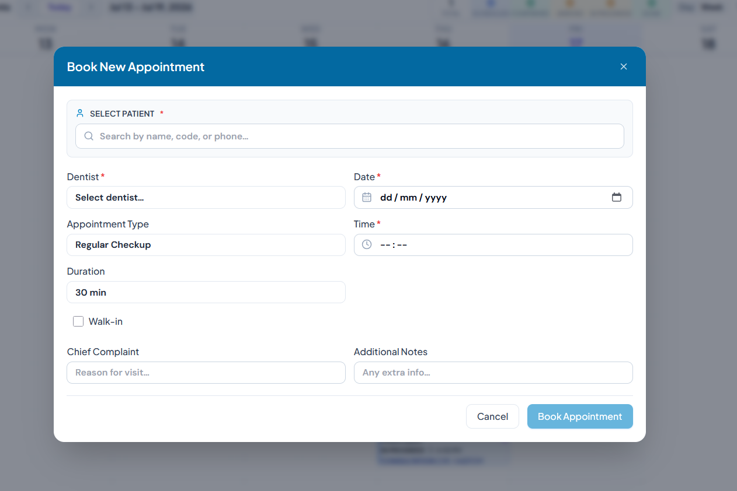

Appointment Statuses
Status | Meaning
Draft | Unsaved placeholder, not yet confirmed
Scheduled | Booked, awaiting confirmation
Confirmed | Confirmed by reception
Arrived | Patient checked in at front desk
In Progress | Dentist has started the visit
Completed | Visit finished
Cancelled | Appointment cancelled
No Show | Patient did not arrive
Rescheduled | Moved to a different time

1.3 Managing Appointments

Appointment Drawer
Click any appointment on the calendar to open the appointment drawer (slide-out panel). It shows:
Patient info (name, code, gender, phone, age)
Time & Dentist
Appointment Type
Chief Complaint
Active Visit link (if visit started)
Notes
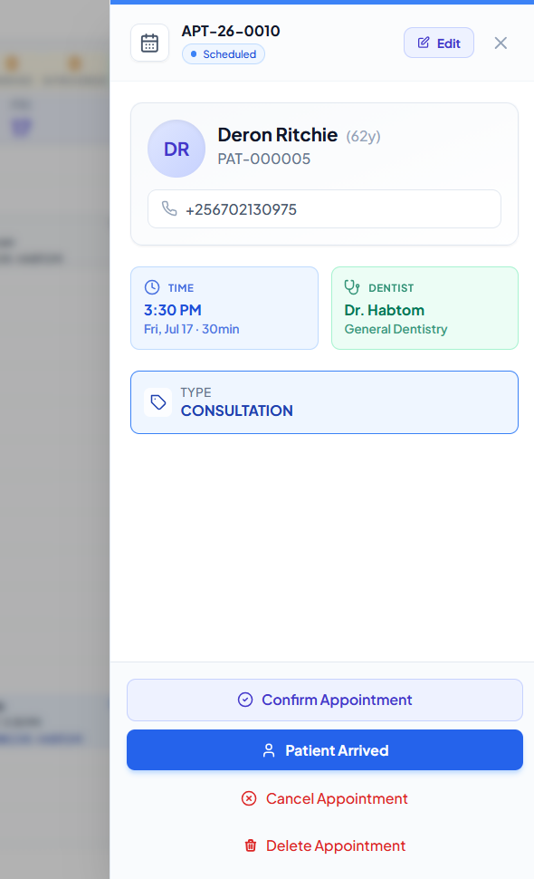

Context-sensitive actions
Current Status | Available Actions
Scheduled / Rescheduled | Confirm Appointment, Cancel
Confirmed / Scheduled / Rescheduled | Patient Arrived (check-in), Cancel
Arrived (no visit yet) | Start Visit
Arrived / In Progress (has visit) | Continue Visit
Any cancellable status | Cancel Appointment (prompts for reason)

Editing an Appointment
Click the Edit pencil icon in the drawer to open the "Edit Appointment" modal. You can change dentist, type, date, time, duration, and notes. The patient field is locked once set.

Draft Appointments
Access via Appointments → Draft Appointments in the sidebar. Drafts are unconfirmed placeholders that do not affect the dentist's schedule.

1.4 Patient Check-in

When a patient arrives at the clinic:
- Find their appointment in the calendar or search the appointment list
- Click the appointment to open the drawer
- Click "Patient Arrived"
Appointment status changes to "ARRIVED"
The system records actualStartAt timestamp
A real-time notification is sent to the dentist's dashboard
- If no appointment exists, create a Walk-in appointment first
After check-in: The dentist will see the patient on their visit list. No further reception action is needed until check-out/payment.

1.5 Payment Collection

At check-out, the receptionist handles billing.
Navigation: Go to the visit → click the "Bills" icon, or navigate through Invoices & Receipts → Invoices.

Steps
- Open the patient's invoice (status should be Posted — blue badge)
- Click "Receive {amount}" (green button)

Record Payment Receipt Dialog
Field | Details
Payment Amount | Enter the amount being paid
Currency | UGX (default) or USD
Payment Method | Cash, MTN Mobile Money, Airtel Money, Visa Card, Mastercard, Bank Transfer,  Cheque
Transaction  Reference | Optional — e.g., TXN-2024-XYZ, Check #1234
Received By | Auto-filled with your name
Partial payments are supported. The invoice status will update to Partially Paid (amber badge) until the balance is cleared.
Payment Methods explained:
Method | When to use
Cash | Physical cash payment
MTN Mobile Money | Mobile money transfer via MTN
Method | When to use
Airtel Money | Mobile money transfer via Airtel
Visa Card / Mastercard | Card payments at POS terminal
Bank Transfer | Direct bank deposit or transfer
Cheque | Physical or digital cheque

Receipts
After payment, a receipt is auto-generated. Access receipts via Invoices & Receipts → Receipts.
Receipts can be printed.
Voiding a receipt: If a payment was recorded in error, void the receipt (this also reverses the associated ledger entries).

1.6 Daily Tasks Checklist

Opening:
Log in to the system
Check today's appointments on the Calendar
Confirm any Scheduled appointments that need confirmation
Throughout the day:
Register new patients as they arrive
Book appointments (scheduled and walk-in)
Check in arriving patients
Process payments at check-out
Closing:
Reconcile cash drawer against receipts
Verify no appointments are left in "Arrived" status
Confirm next day's appointments if needed

Section 2: Dentist Guide

This section covers clinical workflows: starting a visit, documenting findings, performing procedures, writing prescriptions, and completing a visit.

2.1 Starting a Visit

From the appointment drawer: When a patient's status is ARRIVED, click "Start Visit".
The system creates a Visit record with a unique code ( VIS-YY-NNNN ) and loads the Visit Dashboard.
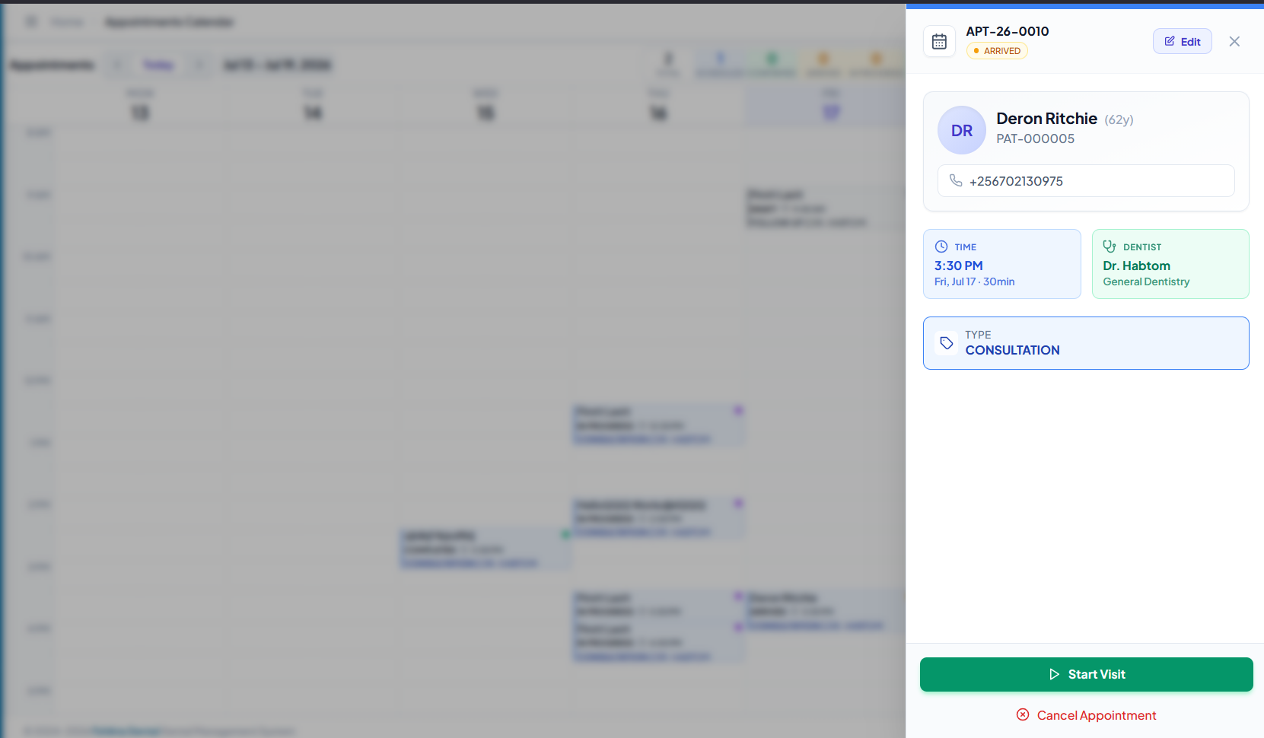

Visit Dashboard Layout
The visit dashboard shows:
Header strip: Patient name, patient code, visit code, dentist name, appointment type, DOB, gender
Status badge: CHECKED_IN / IN_PROGRESS / COMPLETED
Action buttons: "Start Examination" (if ARRIVED), "Complete Visit" (if IN_PROGRESS)
Tabs: Dental Chart, Treatment Plans, Exam/Notes, Appointments, Prescriptions, Imaging, Progress Report, Procedure Sessions, Patient Report
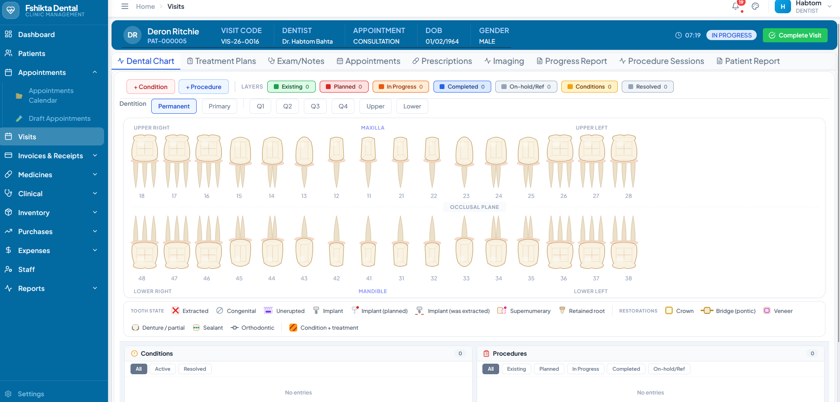

Visit statuses
Status | Meaning
ARRIVED | Patient checked in, visit record created
IN_PROGRESS | Dentist actively examining/treating
COMPLETED | All clinical work done
CANCELLED | Visit cancelled

2.2 Clinical Notes (SOAP)

Tab: Exam/Notes
The SOAP system is split into four sections. All fields auto-save as you type.

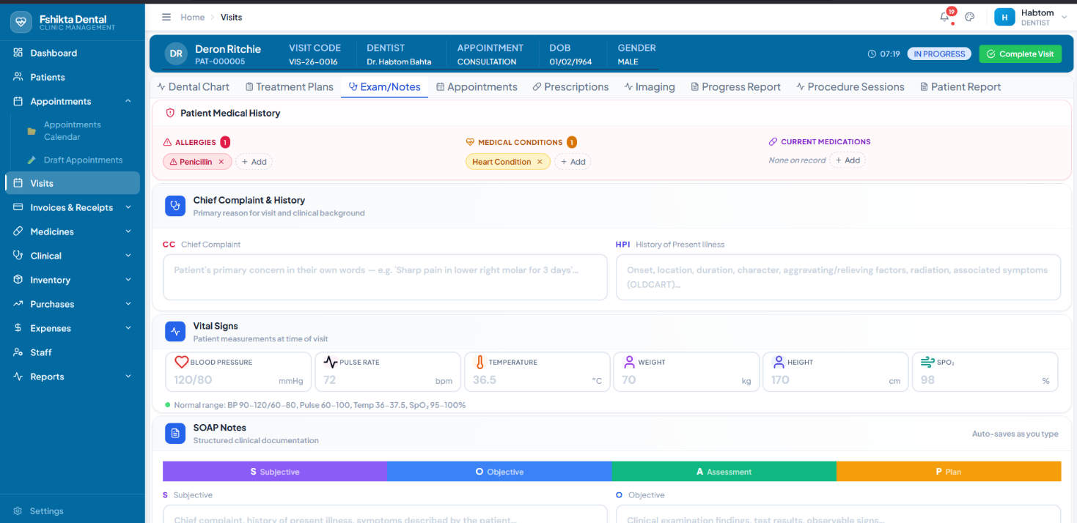

S — Subjective
What the patient tells you:
Chief Complaint (CC) — the patient's main reason for visiting
History of Present Illness (HPI) — onset, duration, severity, aggravating/relieving factors

O — Objective
Clinical examination findings:
Intra-oral and extra-oral examination
Radiographic observations
Test results
Any measurable or observable signs

A — Assessment
Your clinical judgment:
Diagnosis / clinical impression
Differential diagnoses
ICD-10 codes (searchable dropdown)

P — Plan
Treatment plan:
Procedures to perform
Prescriptions needed
Referrals
Follow-up instructions
Completeness indicator: A progress bar at the top shows "X/4 fields filled". All four should be completed before finishing the visit.
Read-only mode: Once a visit is COMPLETED, clinical notes become read-only.

Findings & Recommendations
Field | Purpose
Clinical Findings | Detailed intra-oral and extra-oral findings
Patient  Recommendations | Post-treatment instructions, dietary advice, hygiene recommendations, follow-up schedule

2.3 Vital Signs

Section within Exam/Notes tab
Six vital sign cards, each with a unit and normal range helper text:
Vital | Placeholder | Unit | Normal Range
Blood Pressure | 120/80 | mmHg | 90–120 / 60–80
Pulse Rate | 72 | bpm | 60–100
Temperature | 36.5 | °C | 36–37.5
Weight | 70 | kg | —
Height | 170 | cm | —
SpO₂ | 98 | % | 95–100
Values outside normal ranges are flagged visually. All vitals auto-save when entered.

2.4 Procedures

Tab: Treatment Plans or add directly from the visit dashboard.

Adding a Procedure
- Search the procedure catalog (or browse by category)
- Select the procedure (e.g., "Composite Filling — Posterior")
- Assign tooth numbers (FDI notation) if applicable
- Assign surfaces (Mesial, Occlusal, Distal, Buccal, Lingual) if applicable
- The system calculates the cost based on the pricing model (Fixed / Per Tooth / Per Arch / Per Session)
- Click Add to attach to the visit

Procedure pricing models
Model | Description
Fixed | One price per procedure regardless of quantity
Per Tooth | Price × number of teeth
Per Arch | Price per dental arch
Per Session | Price per treatment session
Per Bracket | Price per orthodontic bracket
Per Unit | Price per unit quantity

Procedure Categories
Consultation, Procedure, Diagnostic, Medication, Therapy, Surgical, Preventive, Administrative, Other

Tooth Chart (Dental Chart tab)
The interactive dental chart (odontogram) uses FDI numbering. Each tooth can be marked with:
Conditions: Decayed, Missing, Filled, etc.
Status colours: Healthy (green), Decayed (red), Filled (blue), Missing (grey), Treated (purple), Crown (amber), Implant (cyan)
Click a tooth to add chart entries (condition, existing work, planned treatment, completed procedure).

2.5 Prescriptions

Tab: Prescriptions Creating a Prescription
- Click "New Prescription"
- Search the drug catalog by name
- For each drug, set:
Dosage (e.g., "500mg")
Frequency (e.g., "Twice daily", "Every 8 hours")
Duration (e.g., "7 days")
Quantity (e.g., "14 tablets") Refills (if applicable)
- The system generates a prescription code ( RX-YY-NNNN )
- Print or send to the pharmacy

Drug Catalog
Accessible via Medicines → Drugs. Drugs are categorised (Antibiotics, Analgesics, Anaesthetics, etc.) and linked to inventory stock levels.
Important: Prescriptions check inventory availability. If a drug is out of stock, the system will alert you.

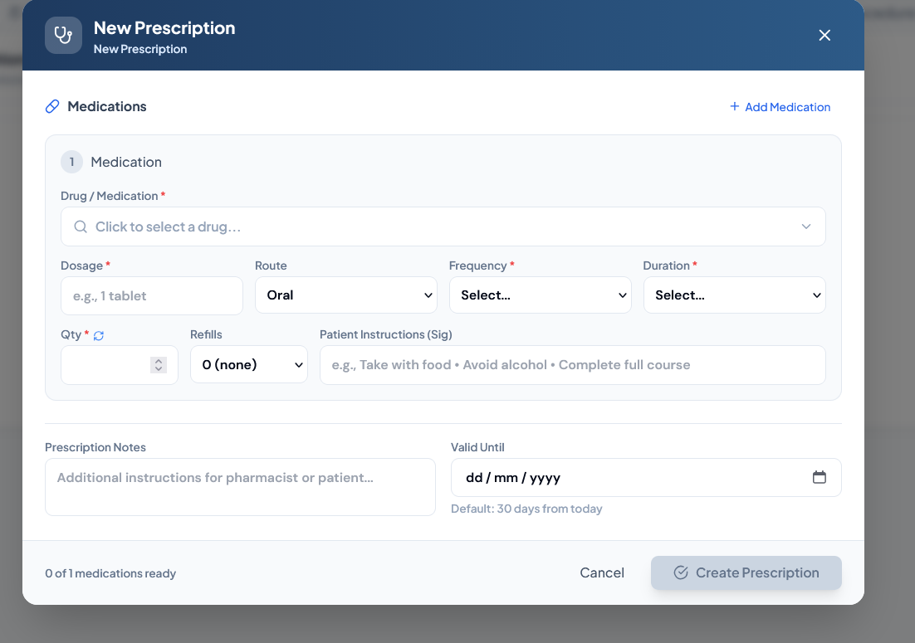

2.6 Imaging & Lab Orders

Imaging
Tab: Imaging
Upload radiographic images directly to the patient's record:
Field | Details
Image Type | Periapical, Bitewing, Panoramic, CBCT, Cephalometric, Intraoral Photo, Extraoral Photo
Stage | Pre-treatment, Post-treatment, Review, Emergency
Classification | Normal, Abnormal, Pathological
All images are stored in the local file system and linked to the visit. Previous imaging is available for comparison.

Lab Orders
Tab: Create lab test orders linked to the visit. Each order tracks its status (Pending → In Progress → Completed). Results can be attached once returned.

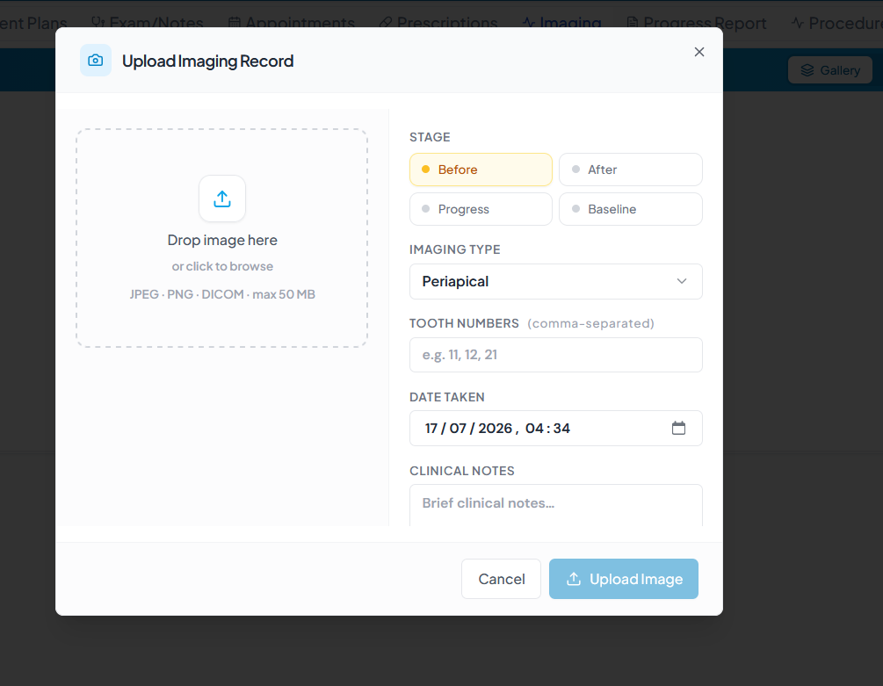

2.7 Completing a Visit

When all clinical work is done:
- Verify all SOAP fields are filled
- Confirm all procedures are added
- Click "Complete Visit"
Visit status → COMPLETED completedAt timestamp is recorded
Appointment status → COMPLETED actualEndAt timestamp is recorded
- Optional: Set a follow-up date and notes
This will suggest a follow-up appointment when the receptionist views the patient record
After completion: The visit data is locked for editing. Ledger entries are generated for each procedure, ready for billing by reception.

Section 3: Manager Guide

This section covers oversight functions: monitoring KPIs, generating reports, financial management, staff administration, and system configuration.

3.1 Dashboard Overview

Navigation: Sidebar → Dashboard
The dashboard provides a real-time snapshot of clinic operations:
KPI | What it shows
Today's Appointments | Total appointments scheduled for today
Revenue (Today) | Total payments collected today
Active Patients | Total registered and active patients
KPI | What it shows
Appointment Breakdown | Scheduled / Confirmed / Arrived / In Progress / Completed counts
Use the dashboard as your morning check-in to see what the day looks like.

3.2 Reports & Analytics

Navigation: Sidebar → Reports

Available Reports
Report | Description
Medical Report | Clinical outcomes, treatments performed
Patients Report | Registration trends (daily/weekly/monthly), demographics (age/gender), insurance breakdown, city distribution, month-over-month growth
Sales &  Receipts | Revenue by dentist, by procedure, by period, by payment method
Expenses &  Payments | Operational costs, supplier payments, expense categories
Inventory  Report | Stock levels, valuation, usage trends, waste
General Ledger | Chart of accounts, journal entries, trial balance
Audit Log | All system state changes (who did what and when)

Patient Reports Detail
The Patients Report page ( /patients/reports ) provides:
Registration Trend chart — new patients over time
Age/Gender Distribution — demographics pie/bar charts
Insurance Breakdown — how many patients have insurance vs. not
City Distribution — geographic spread
Growth Rate — percentage change in registrations month-over-month

Exporting Reports
Reports can be printed or exported (where implemented). Financial reports are available in PDF and CSV formats.

3.3 Financial Management

Invoice Lifecycle
DRAFT ──► POSTED ──► (fully paid) ──► closed
│ │
└── Delete └── VOID (with reason + audit trail)
Status | Meaning
DRAFT | Invoice is being built. Not yet reflected in accounting. Can be edited freely.
POSTED | Invoice activated. Ledger entries are created. Affects Accounts Receivable and Revenue.
VOID | Invoice cancelled. Must include a reason. Voiding reverses ledger entries and voids any associated receipts.

Creating an Invoice
- Open a visit → click Bills icon
- Click "Add Items" to include procedures, drugs, or manual line items
- Adjust quantities, discounts, and set tax percentage as needed
- Click "Post Invoice" to activate it
This creates the double-entry journal: DR Accounts Receivable, CR Revenue Any patient deposits are applied automatically

Payment Statuses
Status | Badge Colour
Unpaid | Slate
Partially Paid | Amber
Paid | Green

Multi-currency
The system supports UGX (base) and USD (and other currencies). Each invoice has a currency selector. Exchange rates are tracked at the time of payment and recorded on the receipt for audit purposes.

Discounts
Two types available:
Fixed amount — subtract a specific value
Percentage — subtract a % of the subtotal

General Ledger
Navigation: Reports → General Ledger
The system uses double-entry accounting. Key accounts:
Account | Type | Purpose
Accounts Receivable (A/R) | Asset | Tracks what patients owe
Revenue (Treatment) | Income | Income from procedures
Patient Deposits | Liability | Prepayments by patients
Tax Payable | Liability | VAT/sales tax collected
Cash/Bank Accounts | Asset | Physical money locations
Closing periods: At the end of each day/week/month, reconcile accounts using the Account Period system. This locks transactions for the period and produces a summary.

Expenses
Navigation: Sidebar → Expenses Track operational costs:
Dynamic expense categories (rent, utilities, supplies, etc.)
Link expenses to suppliers
Post to General Ledger automatically

3.4 Staff Management

Navigation: Sidebar → Staff

Staff Records
Each staff member has:
Personal details (name, contact, role)
Linked User account for system login
Role-based permissions

Roles
Role | Typical Access
Super Admin | Full system access, user management
Admin | Full access (practice owner / general manager)
Dentist | Clinical: visits, SOAP, procedures, prescriptions, treatment plans, dental chart, patient records (read/write)
Nurse | Assist with visits, vitals, stock usage; limited billing
Receptionist | Patient registration, appointments, check-in/out, payment collection
Pharmacist | Drug management, dispensing, pharmacy sales
Lab  Technician | Lab orders, imaging records

Dentist Schedules
Navigation: Staff → Dentist profile → Schedule
Set each dentist's working hours and days. The appointment system uses this to determine available time slots.

Performance Notes
Navigation: Staff → Dentist profile → Performance Record performance reviews, KPIs, and notes.

3.5 System Settings & Audit

Clinic Settings
Navigation: Sidebar → Settings (gear icon) Configure:
Clinic name and branding
Default appointment duration
Tax rate
Currency settings
Receipt/invoice numbering prefix

Audit Log
Navigation: Reports → Audit Log
Every state change in the system is recorded:
Who made the change
What was changed (old value → new value)
When it happened
IP address / session info
This is append-only and cannot be modified. Use it for compliance, troubleshooting, and dispute resolution.

Notifications
The notification bell (top header) shows real-time alerts for:
Appointment status changes
Billing events
Inventory low-stock warnings
Click a notification to navigate to the relevant record.

Appendix

A: Status Flow Diagrams

Appointment Status Lifecycle
┌─────────────────────────────┐
│ DRAFT │
└─────────────┬───────────────┘
│ Save
▼
┌─────────────────────────────┐
│ SCHEDULED │
└─────────────┬───────────────┘
│ Confirm
▼
┌─────────────────────────────┐
│ CONFIRMED │
└─────────────┬───────────────┘
│ Patient arrives
▼
┌─────────────────────────────┐
│ ARRIVED │
└─────────────┬───────────────┘
│ Dentist starts
▼
┌─────────────────────────────┐
│ IN_PROGRESS │
└─────────────┬───────────────┘
│ Visit completed
▼
┌─────────────────────────────┐
│ COMPLETED │
└─────────────────────────────┘
CANCELLED ◄── (any status above)
NO_SHOW ◄── SCHEDULED or CONFIRMED (patient didn't arrive)
RESCHEDULED ◄── SCHEDULED or CONFIRMED (moved to new time)

Invoice Lifecycle
┌─────────────────────────────┐
│ DRAFT │
│ (editable, no accounting) │
└─────────────┬───────────────┘
│ Post Invoice
▼
┌─────────────────────────────┐
│ POSTED │
│ (DR A/R, CR Revenue) │
└─────────────┬───────────────┘ │ Payments received
▼
┌──────────────────────────────────────────┐
│ UNPAID ──► PARTIALLY_PAID ──► PAID │
└──────────────────────────────────────────┘
VOID ◄── DRAFT or POSTED (with reason + audit trail)

Visit Status Lifecycle
ARRIVED ──► IN_PROGRESS ──► COMPLETED
└──► CANCELLED

B: Glossary of Terms

Term | Definition
A/R | Accounts Receivable — money owed by patients
CC | Chief Complaint — patient's primary reason for visit
Chart Entry | A record on the dental odontogram (per-tooth data)
Cuid | Collision-resistant unique identifier used for database IDs
FDI Notation | Two-digit tooth numbering system (11–18, 21–28, etc.)
GL | General Ledger — the clinic's chart of accounts
HPI | History of Present Illness
ICD-10 | International Classification of Diseases, 10th revision
Invoice | Bill for services rendered
Ledger Entry | Individual financial transaction on a patient's account
Odontogram | Dental chart showing all teeth and their conditions
SOAP | Subjective, Objective, Assessment, Plan — clinical documentation format
SpO₂ | Blood oxygen saturation level
Treatment Plan | Grouped procedures for ongoing/multi-visit care
Visit | A single clinical encounter from check-in to check-out

End of manual. For support, contact your system administrator.

© 2024–2026 Fshikta Dental Dental Management System — v2.1.0

© 2024–2026 Fshikta Dental Dental Management System — v2.1.0

