Machine Learning Algorithms
Association Analysis Report – Café Bakery Dataset
Tool: WEKA, Algorithms: Apriori & FP-Growth
- Introduction
A café business has provided transaction data spanning several months. The goal is to extract meaningful purchasing patterns using Association Analysis. This report documents the full process: exploratory data analysis (EDA), data preparation, and the application of two algorithms in WEKA — Apriori and FP-Growth. The findings provide actionable insights for product placement, promotions, and bundling strategies.

2.Dataset Description an Exploratory Data Analysis
Dataset Overview
The CafeBakeryDataset contains transaction records with four columns: Date, Time, Transaction (unique integer ID), and Item (product purchased). The table below summarises the key statistics after initial exploration:
Metric | Value
Total records | 21,293
Data Range | 30 Oct 2016 – 9 Apr 2017
Total Unique Transactions | 9,531
Unique items | 95
Average items per transaction | 2.23
Max items in one Transaction | 12
Most Popular item | Coffee (5,471 purchases)
‘NONE’ Records removed | 786

Top 10 Most Frequent items
Coffee dominates with 26% of all individual item purchases, followed by Bread and Tea. These high-frequency items naturally appear in many rules. Using lift (rather than confidence alone) as the primary metric helps filter out associations driven purely by Coffee's volume.
 | Item | Occurrences
1 | Coffee | 5471
2 | Bread | 3325
3 | Tea | 1435
4 | Cake | 1025
5 | Pastry | 856
6 | Sandwich | 771
7 | Madialuna | 616
8 | Hot Chocolate | 590
9 | Cookies | 540
10 | Brownie | 379

Temporal Patterns
Peak trading hours are between 10:00 AM and 1:00 PM, with 11:00 AM being the busiest hour (1,439 transactions). Saturday is the busiest day of the week with 2,059 transactions, followed by Friday with 1,475. These patterns suggest that morning and weekend promotions would achieve the highest customer reach.

3.Data Preparation for WEKA
The following steps were carried out to prepare the data for WEKA:

- Data Cleaning: 786 records labelled 'NONE' were removed as they represented void or unknown transactions.
- Item Filtering: Only the top 20 most frequently purchased items were retained. This reduced sparsity — with 95 items, most transactions share very few items, making it difficult for WEKA to find meaningful patterns across all items simultaneously.
- ARFF Conversion: A Python script converted the cleaned data into WEKA's ARFF (Attribute-Relation File Format). Each transaction is one row; each of the 20 items is a boolean attribute (t = purchased, f = not purchased). The file was saved in sparse format to handle the high proportion of 'f' values efficiently.
- File Used: cafe_bakery_sparse.arff — 9,037 instances, 20 attributes (as shown in the Preprocess screenshot below).
- WEKA Settings: metricType set to 'lift' with minimum lift of 1.1 to surface only genuine associations. lowerBoundMinSupport set to 0.02 (2% of transactions).

Figure 1- WEKA Preprocess Tab (café_bakery_sparse. arff loaded):
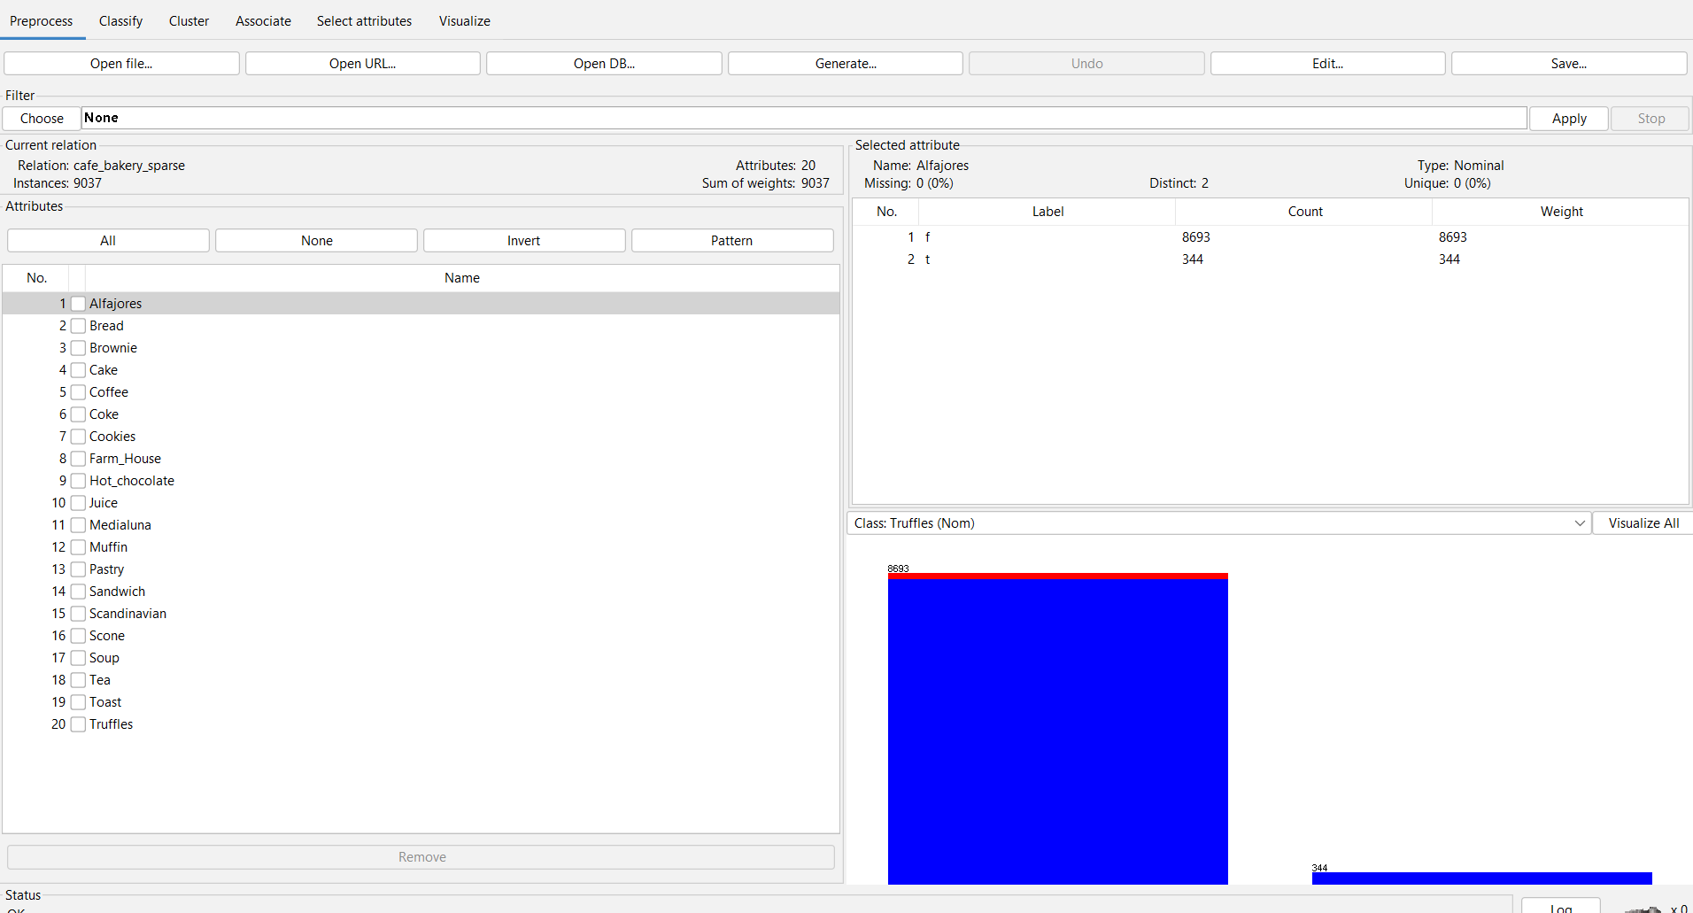
The Preprocess tab confirms: Relation = cafe_bakery_sparse, Instances = 9,037, Attributes = 20. The attribute panel on the right shows Alfajores selected, with 8,693 instances as 'f' (not purchased) and 344 as 't' (purchased), illustrating the sparse nature of the data.

4. Association Analysis
Both Apriori and FP-Growth were run in WEKA Explorer under the Associate tab. Identical parameters were used for both algorithms to allow a fair comparison:
Parameter | Value
lowerBoundMinSupport | 0.02
MetricType | lift
minMetric(lift) | 1.1
numRules | 10
treatZeroAsMissing | True

Algorithm 1: Apriori
The Apriori algorithm works iteratively. It first finds all items that meet the minimum support threshold (L1 itemsets), then combines them into pairs (L2), triples (L3), and so on. At each level, any itemset that falls below minimum support is pruned — this is the 'Apriori principle': if an itemset is infrequent, all its supersets must also be infrequent. While easy to understand, Apriori makes multiple passes over the dataset, which can be slow for very large data.

WEKA Apriori Output Summary:
- Instances: 9,037 | Attributes: 20
- Minimum support: 0.02 (181 instances)
- Minimum metric (lift): 1.1
- Cycles performed: 20
- L(1) itemsets: 20 | L(2) itemsets: 16
- Rules generated: 8

Figure 2 – WEKA Apriori Output
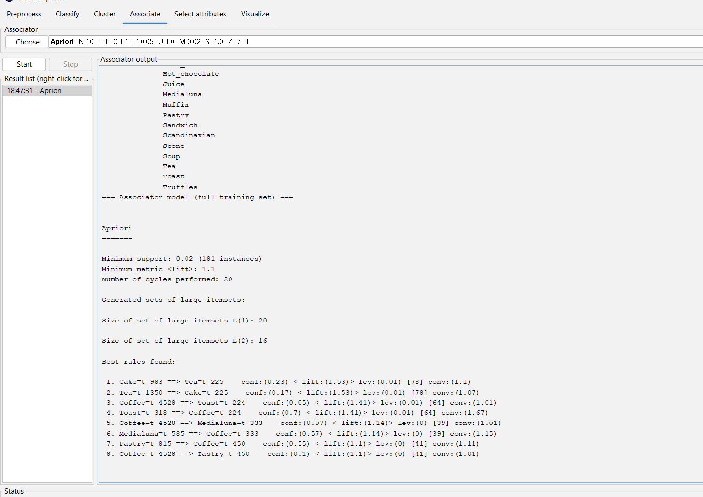

Algorithm 2: FP-Growth
FP-Growth (Frequent Pattern Growth) takes a different approach. Instead of generating candidates, it compresses the entire transaction database into a tree structure called an FP-Tree in just two passes. It then mines the tree recursively using conditional pattern bases to extract all frequent patterns. This avoids the costly candidate generation step and is significantly faster than Apriori on large datasets, while producing identical results.

WEKA FP-Growth Output Summary:
- Instances: 9,037 | Attributes: 20
- FPGrowth found 8 rules (displaying top 8)
- Same parameters: support = 0.02, lift ≥ 1.1

Figure 3 – WEKA FP-Growth Output:

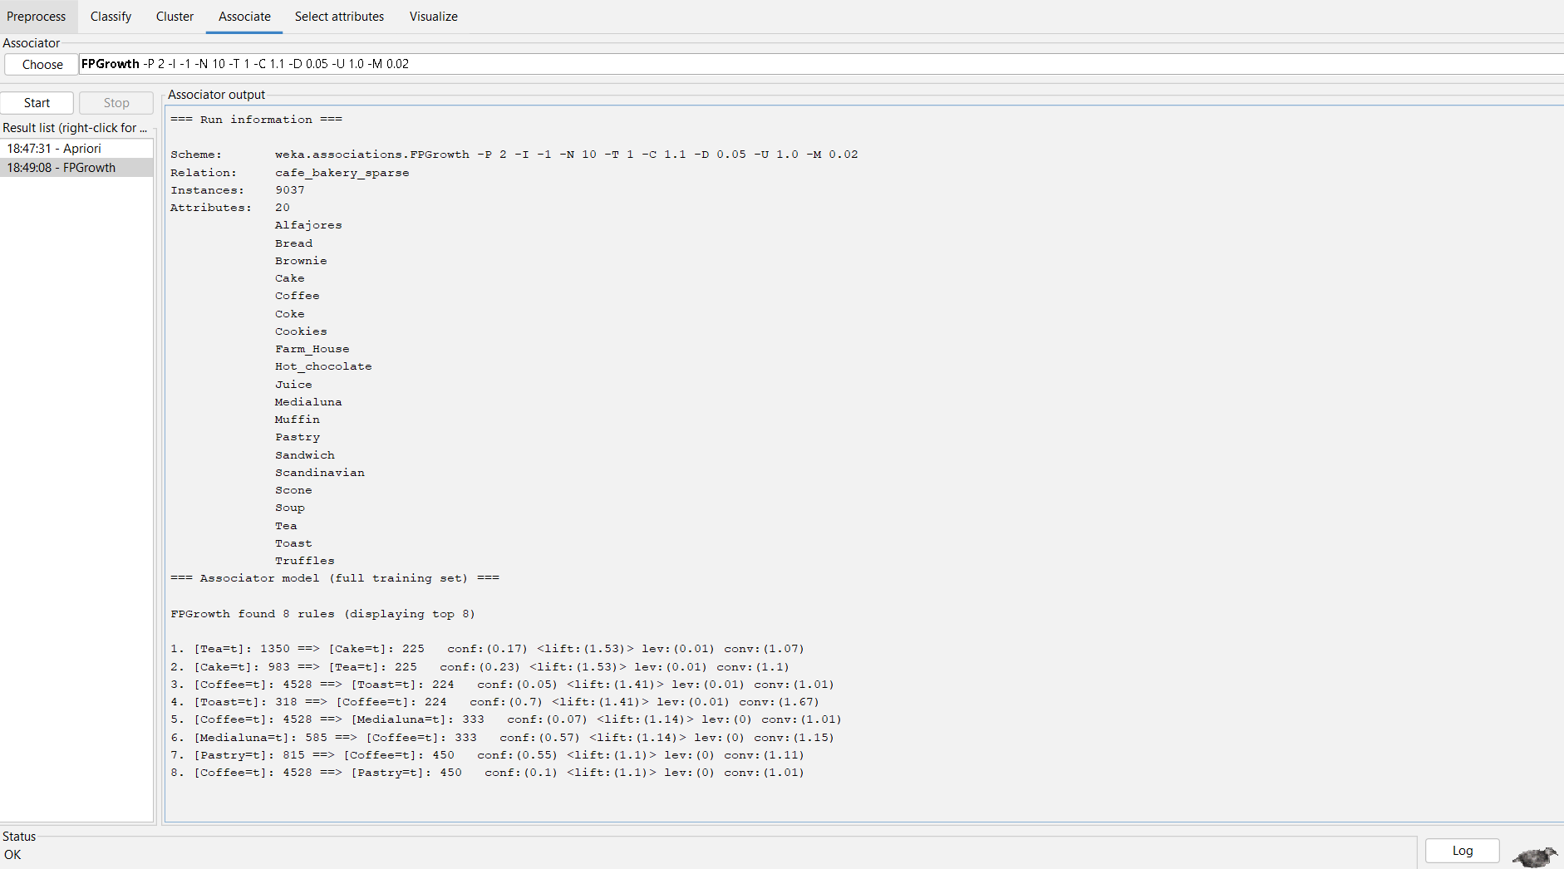

Comparison: Apriori vs FP-Growth
Both algorithms were run with identical parameters and produced identical results — 8 rules with the same support, confidence, lift, and conviction values. The only observable difference was the ordering of rules in the output (FP-Growth listed Tea→Cake first; Apriori listed Cake→Tea first). This is a display difference only and does not affect the rules themselves.
Aspect | Apriori | FP-Growth
Rules Found | 8 rules | 8 rules (identical)
Itemset Levels | L1: 20, L2: 16 | Same itemsets
Approach | Candidate generation + pruning | FP-Tree + recursive mining
Dataset Passes | Multiple (once per itemset level) | Two passes only
Speed on Large Data | Slower | Faster
Memory Usage | Higher (stores many candidates) | Lower (compressed FP-Tree)
Output Order | Cake Tea first | Tea Cake first (same rules)
Best Used when | mall/medium data, teaching | Large datasets, production

5. Key Findings and Business Insights
The 8 rules generated by both algorithms reveal the following actionable patterns:

- Cake ↔ Tea (Lift: 1.53) — The strongest association found. 23% of cake buyers also buy tea, and 17% of tea buyers also buy cake. Both directions have lift of 1.53, meaning this co-purchase is 53% more likely than random chance. A 'Cake & Tea' afternoon bundle would directly exploit this pattern.
- Toast ↔ Coffee (Lift: 1.41) — The highest confidence rule: 70% of toast buyers also buy coffee. This is a classic breakfast pairing. Placing toast near the coffee station or offering a breakfast deal would capture this behaviour.
- Coffee → Medialuna (Lift: 1.14) and Medialuna → Coffee (Lift: 1.14, Conf: 57%) — Over half of customers buying Medialuna (an Argentine croissant) also buy coffee. A natural pairing to feature on signage or a 'morning pastry' deal.
- Coffee ↔ Pastry (Lift: 1.10) — 55% of pastry buyers also buy coffee. While lift is modest at 1.10, the high confidence (55%) makes this a reliable cross-sell opportunity at the counter.

6. Observations and Limitations
- Coffee dominance: Coffee appears in the majority of transactions (4,528 out of 9,037 — 50%). This is why many rules involve Coffee. Setting lift ≥ 1.1 ensures we only surface rules where the association is stronger than Coffee's baseline frequency.
- Only L(2) itemsets found: No 3-item frequent itemsets met the support threshold. This reflects the average transaction size of ~2.23 items — most customers buy only 2 items at a time, limiting multi-item rule depth.
- Top-20 item focus: Restricting to the 20 most popular items was necessary to reduce sparsity. A full 95-item analysis would produce almost no rules because most item pairs co-occur in far fewer than 2% of transactions.
- No customer data: The dataset contains no customer IDs, loyalty information, or demographics. All rules apply to the general customer base and cannot be personalised further without additional data.

7.Conclusion
This report applied Association Analysis to the Café Bakery Dataset using WEKA's Apriori and FP-Growth algorithms. Both algorithms produced the same 8 rules, with lift values ranging from 1.10 to 1.53. The strongest findings are the Cake–Tea pairing (lift: 1.53), the Toast–Coffee breakfast pairing (confidence: 70%), and the Medialuna–Coffee morning pairing (confidence: 57%). These patterns present clear, evidence-based opportunities for the café to introduce targeted bundle promotions and improve product placement.
Both algorithms are equally valid for this dataset size. For future analyses involving more data, FP-Growth is the recommended choice due to its computational efficiency and lower memory footprint, while Apriori remains preferred in educational or exploratory contexts where step-by-step transparency is valuable.

