

FACULTY OF SCIENCE AND TECHNOLOGY
DEPARTMENT OF COMPUTING AND INFORMATICS

Final Report : PROJECT ALLOCATION AND SUPERVISION SYSTEM (PASS)

SUBMITTED BY:
SIMON MUNG’ARA MWAURA
REGISTRATION NUMBER: SCS3/148082/2024

SUPERVISOR:
DR WANJIKU NG’ANG’A

A Final Project Report Submitted in Partial Fulfillment of the Requirements for the Award of Bachelor of Science in Computer Science of the University of Nairobi

JUNE 2026

DECLARATION
I declare that this project report is my original work and has not been submitted for a degree in any other university.
Signature: ________________________ Date: ________________________
Simon Mung’ara Mwaura
This report has been submitted for review with my approval as the University Supervisor.
Signature: ________________________ Date: ________________________
Wanjiku Ng’ang’a

ABSTRACT
The University of Nairobi offers a comprehensive BSc Computer Science course that includes both the second year project and the fourth year project.The second year project is used to test if a student has the required software engineering, database design and programming skills whereas the fourth year project is used to assess whether a student can define a problem, design its solution and then implement and test the programming project prototype.
Currently the department of Computing and Informatics is using an open access Google Spreadsheet to manage the programming projects. This has led to a host of issues such as plagiarism of projects among students, a breakdown in communication between the students and the supervisors and an ever increasing workload on the project coordinator. The project coordinator in particular would not have to constantly check which members of faculty are fully booked and which ones are not.
The proposed Project Allocation and Supervision System (PASS) will be used to solve some of these challenges .The system will be used to solve the plagiarism problem by ensuring that each student can only see their own project title and project pitch and not everyone's project title. PASS will be a web based portal that will allow for the project pitching process to be as simple and as straightforward as possible between the students,supervisor, project coordinator and the system administrator.It will make the process of managing the project much simpler from the initial stage of submitting a project pitch to the final stage of submitting the milestones.

TABLE OF CONTENTS
DECLARATION 2
ABSTRACT 3
TABLE OF CONTENTS 4
ABBREVIATIONS 6
CHAPTER 1 : INTRODUCTION 7
1.1 Background 7
1.2 Problem Statement 8
1.3 Objectives for the Project 8
1.3.1 Main Objective 8
1.3.2 Specific Objective 8
1.4 Scope 9
1.5 Justification 9
1.6 Constraints 10
CHAPTER 2: REVIEW OF SIMILAR SYSTEM 11
2.1 Introduction 11
2.2 Theoretical Framework: Academic Workflow Management 11
2.3 Review of Manual and Informal Coordination Systems 12
2.3.1 Static Spreadsheets 12
2.3.2 Generalized Broadcast Platforms (Google Classroom) 12
2.3.3 Use of school emails 12
2.4 Review of Generic Learning Management Systems (LMS) 13
2.5 Evaluation of Enterprise Project Management Tools 13
2.6 Review of University Enterprise Systems (e.g., SMIS) 13
2.7 Summary of Identified Gaps 13
CHAPTER 3: SYSTEM ANALYSIS AND DESIGN 15
3.1 System Development Methodology 15
3.2 System Analysis 15
3.2.1 Requirements Elicitation (Findings) 17
Data and system requirements were gathered by analyzing the limitations of the current open-access Google Spreadsheet and interviewing department stakeholders. Key findings include: 17
3.2.2 Functional Requirements 17
3.2.3 Non-Functional Requirements 17
3.2.4 Technical Requirements 18
3.3 System Design 18
3.3.1 Architectural Design 19
3.3.2 Processes Design 20
3.3.3 Class Diagram 29
3.3.4 Database Design 30
3.3.5 Application (UI) Design 31
1. Supervisor Onboarding & Setup 32
3.3.6 Integration Design 37
3.4 Project Schedule and Gantt Charts 37
CHAPTER 4: SYSTEM IMPLEMENTATION AND TESTING 40
4.1 SYSTEM IMPLEMENTATION 40
4.1.1 Hardware Resources 40
4.1.2 Software Resources 40
4.1.3 Programming Tools 41
4.2 SOFTWARE TESTING 43
4.2.1 Test Plan 43
4.2.2 Functional Testing 44
4.2.3 Usability Testing 47
CHAPTER 5: CONCLUSION AND RECOMMENDATIONS 49
5.1 ACHIEVEMENTS 49
5.2 LIMITATIONS AND CONSTRAINTS 50
5.3 CONCLUSION 50
5.4 RECOMMENDATIONS FOR FUTURE WORK 51
REFERENCES 52

ABBREVIATIONS
Abbreviation Definitions
PASS - Project Allocation and Supervision System
UoN - University of Nairobi
BSc - Bachelor of Science
M1 - Milestone 1
CRUD - Create, Read, Update, Delete
SDLC - Software Development Life Cycle
ERD - Entity Relationship Diagram
DFD - Data Flow Diagram
UX / UI - User Experience / User Interface
PDF - Portable Document Format

CHAPTER 1 : INTRODUCTION

1.1 Background
The University of Nairobi BSc Computer Science course requires that all undergraduate students must complete a second year project equivalent to one course unit and a fourth year project equivalent to four course units. The second year project is used to mainly test if a student can use their software engineering skills, database design and programming techniques to build a comprehensive computer system. The fourth year project is used to assess if a student is able to define a problem and design a suitable solution, and implement and test the programming project prototype. It is crucial for the stakeholders of the system to coordinate seamlessly to ensure that the process moves forward smoothly to its culmination.

Currently, the Department of Computing and Informatics is using an open access Google Spreadsheet to manage the selection of projects by students and the allocation of supervisors and panelists. In order for a student to get a faculty member to confirm that they will be their supervisor, they must write them an email pitching their project. The student must go to the spreadsheet and update the ‘Proposed Supervisor’ and the ‘Proposed Project Title’ columns , and wait for the faculty member to fill in the ‘Confirmed Supervisor’ column . The project coordinator has to manually update the number of proposed students in the spreadsheet by going row by row through each student's ‘Proposed Supervisor’ column . The coordinator also has to tally and update the number of confirmed students by emailing the supervisors to see how many students they have agreed to supervise. The spreadsheet lacks the ability to show that a specific supervisor has a specific area of interest such as Internet of Things or Artificial Intelligence. It also leads to the students being stranded the moment a student writes an email and is left without any feedback. Because all the project titles are in such close proximity, the students are able to see the project titles of other students and copy or slightly modify the ideas of their peers.

This current use of open access Google spreadsheets and emails has caused several additional problems. The use of an open access spreadsheet means that a student can edit the project titles and proposed supervisors of other students. They can also edit the confirmed supervisor column, which is only supposed to be done by the supervisors or the coordinator. There is no way for the project coordinator or supervisors to determine who is a student. This means that a student that has not registered for the course can simply add themselves to the spreadsheet and get their desired supervisor before a student that has registered for the course. In the selection of projects by supervisors, the students need to know which faculty members are interested in a specific area of study so they can target those to be their supervisor. For example, a student whose project is based on embedded systems should know which supervisors are in that field. The use of emails has led to students getting delayed feedback, or even worse, no feedback from faculty members. This leaves those students stranded as they simply do not know what to do, leading to them sending emails to multiple faculty members in a bid to get the go ahead signal. The lack of real-time updates means that the load of supervisors has to be manually updated, leading to students approaching lecturers who have exceeded their capacity. The manual updates can also be incorrect or prone to human error. After students are successfully allocated, tracking their progress remains highly fragmented. The current use of a single Google Classroom for an entire cohort forces supervisors to sift through hundreds of irrelevant student submissions just to find the specific documents belonging to their assigned students.

PASS is proposed to solve these administrative challenges. It is a web based platform that will replace the manual, open access Google spreadsheet with a semi-automated role based system . For example, the number of confirmed students will be incremented automatically if a supervisor confirms a student. It will ensure that the process of managing the project from the initial stage of pitching an idea to the final stage of submitting the required documents is met.

1.2 Problem Statement
The current project allocation architecture possesses a fundamental flaw: a complete lack of user permission separation. Because students and faculty share identical access levels, the system provides an unrestricted view of all departmental data. Without a restricted view of project submissions, there is no mechanism to encapsulate student data or protect intellectual property, leaving the system highly vulnerable to unauthorized edits and plagiarism.
Furthermore, the lack of dynamic data management severely hampers the coordinator's workflow. The department cannot efficiently track unallocated students or instantly monitor supervisor capacity because the system lacks any reporting capability in real-time. Relying on manual checks instead of automated computational constraints to prevent students from selecting fully-booked lecturers creates a severe bottleneck, consistently resulting in supervisor over-allocation.
To resolve these structural issues, the department must transition from static files to a secure, automated software solution. There is a critical computing need to engineer a centralized system that strictly enforces restricted and role-based access to a web platform. By implementing this architecture with a relational database and automated logic, the department can securely and efficiently manage the entire allocation lifecycle.

1.3 Objectives for the Project

1.3.1 Main Objective

The primary objective of this project is to design and implement a web based application that will handle the second and fourth year projects from the initial stage of students picking a project to the submission of projects to the supervisors.

1.3.2 Specific Objective

- To analyze both the current project management process as well as the undergraduate project guidelines provided by the department.

- To design the entire system architecture including the role specific user interfaces for the Students, Supervisors, the Project Coordinator, and the System Administrator.

- To integrate Google authentication for supervisors and students who have registered for the course.

- To implement the following features: a simple student verification system and supervisor tracking during the project pitching process.

- To implement a module for supervisors to only access documents that are relevant to their allocated students.

- To test the system to determine if it has met the requirements set by the undergraduate project guidelines.

1.4 Scope
The Project Allocation and Supervision System (PASS) covers the management of the second and fourth year programming projects .

- This system is designed for undergraduate students, specifically those undertaking their second-year and fourth-year computing projects, alongside their supervising faculty.
- The system acts strictly as a document repository. It does not handle grading, the calculation of final scores, or the routing of mark sheets from panel members to the Project Coordinator.
- The system does not manage the scheduling, execution, or logistics of defense presentations. Tracking attendance and capturing panelist feedback during these physical presentations will continue to be handled externally.
- The platform is designed solely for project allocation and milestone tracking. It will not function as a general repository for course materials or templates, nor will it support real-time chat, meeting scheduling, or messaging outside of formal project pitch feedback.
- The system is designed to manage one active academic cycle at a time. It will not maintain tracking for deferred students or archive data across multiple academic years.
- The system will operate independently and will not feature direct API connections with external platforms like Google Classroom or the university’s Student Management Information System (SMIS). Official student data will be imported manually by the system administrator.

1.5 Justification
The Project Allocation and Supervision System (PASS) will make a difference in managing second and fourth-year programming projects. It will improve the results and make the process easier.For students, PASS will make it easier to pitch project ideas without stress. They can focus on making their project good instead of finding a supervisor.For supervisors, PASS will help them work with students who are in the course. They can see all student documents in one place.For the coordinator, PASS will make it simpler to manage students and supervisors. It will automate tasks like tracking how many students a supervisor has.For the system administrator, managing students and technical issues will be easy.
PASS helps not only the department but also its stakeholders by meeting the need for digitization in higher education. The increase in demand for education requires the automation and simplification of complex educational workflows. By streamlining these administrative processes, PASS enables students to focus on their projects and produce quality work. This ensures a quality product for all stakeholders involved.

1.6 Constraints
The Project Allocation and Supervision System (PASS) is made to be easy to use for everyone in the Computer Science department. There are some rules that the system has to follow.
The system is web-based. This means that it does not need a specific operating system like Windows or macOS to work. However, PASS only works with some browsers like Google Chrome or Mozilla Firefox. These browsers must support HTML5 and JavaScript.
PASS needs devices that can connect to the internet. These devices can be desktop computers, laptops, or even smartphones. The device must have memory so the system works well and people can upload files easily.
The Project Allocation and Supervision System is made to work with the internet all the time. This means it does not work without the internet. People need the internet to log in to PASS, to update their project status, and to upload files.
The system has some rules for uploading files. This is so the database works well and does not get too full. PASS only allows types of files like PDF files for documents and PPTX files for slides. The Project Allocation and Supervision System also has a limit on how big files can be. This limit is 10 MB for each file that people upload to the system.

CHAPTER 2: REVIEW OF SIMILAR SYSTEM

2.1 Introduction
This chapter looks at the literature and checks the digital and manual systems that are used now to manage undergraduate academic projects. The main goal of this review is to find the problems with these systems, such as what they cannot do and what is hard to do when using them for the University of Nairobi (UoN) Computer Science Undergraduate Programming Projects.
To compare these systems, the review is divided into four areas:
- Manual and Informal Coordination Systems: This looks at how things are done now using things like spreadsheets, email, and instant messaging.
- Generic Learning Management Systems (LMS): This checks platforms like Google Classroom and Moodle to see if they can handle the small details of project pitching.
- Enterprise Project Management Tools: This reviews tools like Jira and Trello to see if they work well with the way academics are organized.
- Core University Enterprise Systems: This assesses the systems used by the university, like the Student Management Information System (SMIS), to see if they can supervise projects from start to finish.
By looking at these areas, this chapter will show why the Project Allocation and Supervision System (PASS) is needed as a system that is easy to use and works well with the workflow of the University of Nairobi (UoN) Computer Science Undergraduate Programming Projects. PASS will be a great way to manage projects because it is designed specifically for this purpose. It will help solve the problems that the other systems have.

2.2 Theoretical Framework: Academic Workflow Management
When it comes to managing undergraduate projects, there are two processes for second and fourth-year students. The department has its guidelines for both groups. For second-year students, they follow a two-part process: they submit a proposal in Week 2, and then they have to do a presentation and report in Week 15. Fourth-year students have a three-part process that takes place over two semesters: they submit a proposal in Semester 1, a progress report in Semester 2, and a final presentation and report in Week 15. Even though the timelines are different, the main tasks are the same for Academic Workflow Management. These tasks include brainstorming, assigning supervisors, and submitting documents.

The Fragmentation Problem: Information Silos and Lack of Auditability The way the department handles project stages is a problem. The current workflow is very fragmented. They use a spreadsheet to track supervisor assignments. Students often submit project documents by email to their supervisors. Because these emails are not organized, it is hard to track progress centrally. The Project Coordinator does not have a system to check if a student submitted a proposal on time or if a supervisor gave feedback promptly. This means the coordinator has to manually contact faculty members to get updates.

The Centralization Solution The idea of Centralized Academic Workflow Management is to have one system that handles the core allocation and submission processes, creating a single source of truth. This way, there are no information silos. By combining supervisor allocation and a centralized document repository, the system manages the lifecycle of these projects internally. When a student uploads a document, the system creates a record automatically. This gives the coordinator real-time updates on every student's progress without needing to send emails. Ultimately, storing all documents in one place allows the coordinator to track progress easily and improves the way academic projects are managed for everyone involved.

2.3 Review of Manual and Informal Coordination Systems
Currently, the department depends a lot on unofficial methods to handle project assignments and submissions. These methods are easy to use and everyone knows them, but they cause big problems with organization .They slow down the process of assigning projects and they make it hard to keep track of submissions.These problems make it clear that a better system is needed to manage projects. The department needs an organized way to handle project allocations and submissions.

2.3.1 Static Spreadsheets
Currently, our department relies heavily on static spreadsheets, such as Microsoft Excel and Google Sheets, to handle supervisor assignments.

Limitation: Allocation and Load Balancing: Because we use spreadsheets to assign supervisors, the coordinator is forced to do a lot of manual data entry. Spreadsheets do not have a built-in feature to automatically enforce capacity limits. This makes it very hard to track and control how many students each supervisor has at any given time (for example, ensuring no lecturer exceeds a strict maximum of seven or eight students).

2.3.2 Generalized Broadcast Platforms (Google Classroom)
Alongside spreadsheets, the department uses Google Classroom to handle coordinator announcements and project submissions.
Limitation: Fragmented Workflow and The Cohort Gap: Using Google Classroom and spreadsheets together is a major hassle. Google Classroom is designed with a "one-to-many" approach (one teacher broadcasting to a whole class). It is highly inefficient for a "one-to-few" approach, where a supervisor only needs to monitor the specific students assigned to them. Because the platform cannot isolate a supervisor's specific group, lecturers are forced to sift through the submissions of the entire undergraduate cohort just to find the files belonging to their students.

2.3.3 Use of school emails
Because the official tools are all over the place, students often use their school emails to send documents directly to their supervisors.
The "Lost Submission" Problem: Lecturers get hundreds of emails every day. Important submissions from students sometimes get missed or lost in their inboxes. Using emails also mixes up work communication and makes it hard to keep track of project approvals.
Lack of Central Oversight: Since students submit documents privately through email the Project Coordinator has no way of knowing what is going on. They cannot verify if a student submitted their work on time or if a supervisor gave feedback. This creates gaps in the administration's knowledge, so they have to rely on checking in manually instead of using reliable records.

2.4 Review of Generic Learning Management Systems (LMS)
Most universities rely on platforms like Moodle, Canvas, or Blackboard for their day-to-day teaching. These systems are great for hosting lecture notes, giving multiple-choice tests, and tracking overall grades.
The Workflow Gap: However, these general tools fall short when it comes to the specific needs of a Computer Science project. For starters, they don't have a dedicated "pitching" module where a student can propose an idea and wait for a supervisor's green light. Another major issue is that Moodle and Blackboard don't allow lecturers to set a "hard cap" on their workload. There is no automated way to stop a popular supervisor from being overwhelmed by too many students at once. Standard LMS platforms just aren't built to handle this specific sequence—from the initial pitch to the final report—even if the department spends a fortune on custom plugins.

2.5 Evaluation of Enterprise Project Management Tools
In the software industry, tools like Jira, Trello, and Asana are the gold standard for tracking development. However, these platforms are not a perfect fit for a university environment:
Professional Overkill: While these systems are fantastic for full-scale DevOps teams, they are far too complex for a single-unit undergraduate project. The learning curve for Jira alone would likely distract students from their actual research and coding.
Misalignment with Academic Roles: These corporate tools are built for "Scrum Masters" and "Product Owners," roles that simply don't exist in a department. They lack the specific hierarchy needed for a "Project Coordinator" to oversee an entire year's cohort or for an "Academic Panel" to access specific milestone documents. Because these tools follow a corporate logic, they don't support the specific administrative flow required by university guidelines.

2.6 Review of University Enterprise Systems (e.g., SMIS)
SMIS functions as the university’s main administrative hub. It is a terminal data repository, focusing on high-level data like admissions, fee processing, and final academic records.
The Micro-Level Gap: The biggest downside of SMIS is that it isn't meant for the day-to-day project workflow. It lacks the setup for students to upload large, evolving files—like a 10 MB PDF proposal—or for supervisors to manage various document versions.
Static vs. Active Records: SMIS is strictly for permanent records. It doesn't provide a "workspace" where a student can move through the project stages, from a pitch to a final submission. Because SMIS handles high-level admin tasks, it cannot give the detailed, step-by-step oversight a department needs during the 15-week project cycle.

2.7 Summary of Identified Gaps
The literature review shows a major disconnect between the department's needs and the tools currently in use. Manual methods lack a clear paper trail, standard Learning Management Systems cannot handle supervisor allocations, and professional tools like Jira are far too complex for academic projects. Even university-level systems like SMIS are only meant for final records, failing to track the active stages of a project lifecycle.
PASS fills these gaps with a lightweight, custom-built portal. The core differences include:
- Hard-Capped Supervisor Load: Unlike manual spreadsheets, PASS programmatically enforces a supervisor's capacity. This makes it impossible for a lecturer to be accidentally assigned more than seven students.
- Supervisor Data Isolation: Unlike Google Classroom, PASS gives supervisors a filtered view. They only see their specific group, removing the need to sift through the submissions of the entire second-year cohort.
- UoN-Specific Milestone Tracking: PASS uses a database structure that follows the department’s actual workflow (Project Pitch → Proposal → Progress Report → Final Report). It also sets technical limits, like 10 MB caps for PDF and PPTX files.
- Centralized Activity Logs: Every pitch approval and file submission is recorded within the system. This gives the Project Coordinator the proof they need to enforce late penalties or deadlines.

CHAPTER 3: SYSTEM ANALYSIS AND DESIGN

3.1 System Development Methodology
This project will follow the Rapid Application Development (RAD) methodology. The core of this approach is building functional prototypes quickly to get immediate feedback from users. Since the 15-week semester is a tight timeline, RAD is the most practical choice. It allows for the creation of a Minimum Viable Product (MVP)—a base version of the system that can be tested and refined through multiple iterations. Instead of waiting until the end of the semester to see if the system works, RAD ensures that the "Project Pitch" and "Allocation" modules are developed and improved early in the process.

3.2 System Analysis
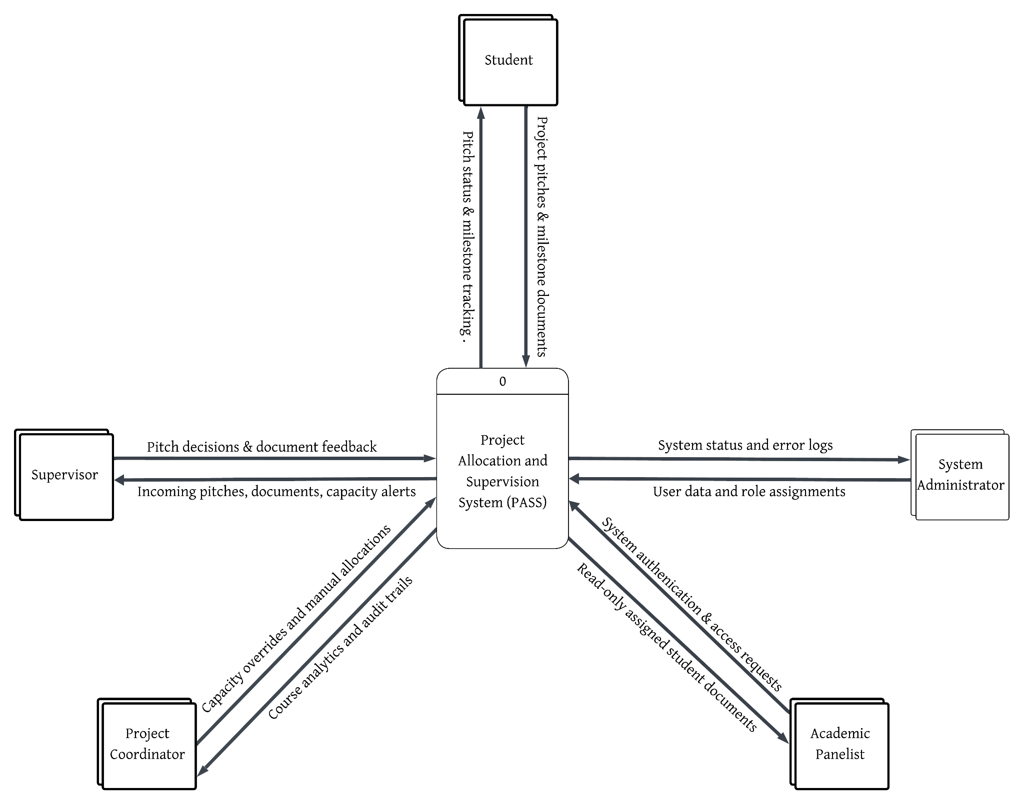-
Fig1 : Context diagram for the Project Allocation and Supervision System (PASS)

1. Student Role (The Applicant)
Pitch Submission: At the start of the project cycle, students can submit a project title and a brief description to a specific supervisor. This acts as a formal request for supervision.
Milestone Repository: Once a supervisor approves a pitch, the student’s portal expands to allow the submission of official milestones, including the Proposal, Progress Report, and Final Report.
Status Tracking: A real-time progress bar allows the student to see exactly where they stand whether a document has been received, is pending review, or has been officially approved.
2. Supervisor Role (The Mentor)
Pitch Management: Supervisors have a centralized "Review Queue" where they can examine incoming project ideas and either accept or reject them based on the project's merit.
Automatic Capacity Control: To maintain quality, the system enforces strict, automated capacity tracking, automatically disabling a supervisor's 'Accept' function once they reach a configurable maximum student threshold defined in the system settings. Once this limit is reached, the ‘Accept’ button is automatically disabled for that supervisor.
Document Access: Supervisors can view and download the milestone documents only for the specific students they have officially accepted into their group.
3. Project Coordinator Role (The Overseer)
Cohort Visibility: The Coordinator has a high-level view of all students in the second-year cohort, allowing them to track who has been allocated a supervisor and who is still unassigned.
Audit Trail: The system records exact timestamps for every file upload. This allows the Coordinator to verify if students are meeting deadlines without having to manually sift through hundreds of emails.
Capacity Overrides: If necessary, the Coordinator has the authority to make exceptions and manually adjust a supervisor's student limit beyond the standard cap of seven.
4. Academic Panelist Role (The Examiner)
Panel Access: During presentation weeks, panelists can log in to view the documents of the specific students they are assigned to examine. This allows them to prepare for the presentations in advance.
Read-Only Access: To protect the integrity of the data, panelists can download Proposals and Final Reports but cannot change any project statuses or allocation details.
5. Administrator Role (The System Manager)
User Management: The Admin is responsible for creating accounts, updating the student/staff lists, and assisting users with password resets.
Role Assignment: The Admin ensures that every user is assigned the correct permissions (e.g., ensuring a lecturer is given "Supervisor" rights rather than "Student" rights).

3.2.1 Requirements Elicitation (Findings)

Data and system requirements were gathered by analyzing the limitations of the current open-access Google Spreadsheet and interviewing department stakeholders. Key findings include:
- Data Privacy and Plagiarism Prevention: Students expressed concern that an open spreadsheet allows peers to see and copy their proposed project titles. The system must isolate student data.
- Automated Capacity Control: Coordinators reported that manual tallying of supervisor workloads is highly error-prone. The system must programmatically prevent students from pitching to a supervisor who has reached their maximum limit.
- Centralized Document Tracking: Supervisors reported losing student submissions in crowded email inboxes. The system must provide a unified repository where documents are automatically tied to the correct student and milestone

3.2.2 Functional Requirements
Formal Definition: Functional Requirements describe the specific behaviors, tasks, and functions the system MUST DO.
- Role-Based Authentication: The system must authenticate users via Google OAuth 2.0 (restricted to @students.uonbi.ac.ke for students) and strictly enforce role-based access control (Student, Supervisor, Coordinator, Admin).
- Project Pitching Module: Students must be able to submit a project title and abstract to a specific supervisor. The system must enforce a maximum limit of 3 pending pitches per student.
- Allocation and Capacity Management: Supervisors must be able to Accept or Decline pitches. Upon acceptance, the system must automatically assign the student, withdraw their other pending pitches, and increment the supervisor's workload counter.
- Milestone Submission: Students must be able to upload document files (PDF, DOCX) for specific milestones. The system must automatically classify the submission as "On Time" or "Late" based on the milestone due date.
- Panel Management: The Project Coordinator must be able to generate presentation panels, assign a Chair, and allocate panel members.

3.2.3 Non-Functional Requirements
Formal Definition: Non-Functional Requirements describe HOW WELL the system must perform, focusing on system architecture, security, and usability.
- Security & Data Integrity: The system must use JSON Web Tokens (JWT) for secure session management. Database operations must handle concurrent writes (via PostgreSQL) to prevent data corruption when multiple students submit simultaneously on deadline day.
- Performance & Storage Limits: To optimize server storage and database query speeds, the system must enforce a strict 10 MB file size limit on all document uploads.
- Usability: The user interface must be fully responsive (mobile-first) to allow students to check pitch statuses on smartphones. The system must also provide non-blocking visual feedback (toast notifications) for all user actions.

3.2.4 Technical Requirements
The required technical stack is divided into server-side and client-side components.
Category | Specification
Backend Framework | Python 3.x with Flask, SQLAlchemy ORM, and Flask-JWT-Extended
Database | PostgreSQL
Web Frontend | React.js, Tailwind CSS, React Router v6
Hosting & Deployment | Render (Backend/Database) and Netlify (Frontend)

3.3 System Design
This section translates the requirements into technical blueprints that guide the coding of PASS.

3.3.1 Architectural Design
Formal Definition: Architectural Design outlines the high-level structure of the system, illustrating how the presentation layer, application logic, and database communicate.
PASS employs a decoupled, Three-Tier Client-Server architecture. The client application (a React.js Single Page Application for students and faculty) communicates asynchronously with a centralized Flask backend server via a RESTful API.

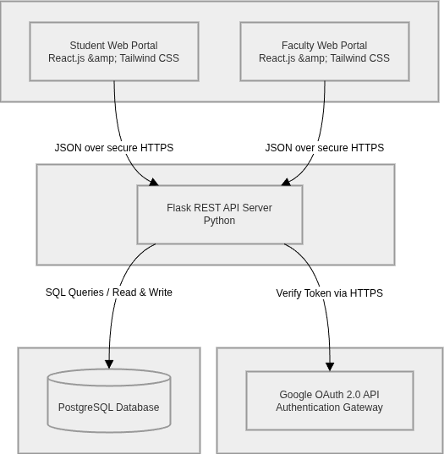
Figure: System Architecture Diagram

3.3.2 Processes Design
Process models graphically illustrate how data flows through the system and how various actors initiate those flows.
A. Use Case Diagrams
Use Case diagrams map out the interactions between the system's primary actors and the core features.
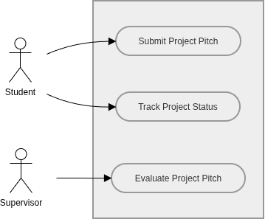
Figure: Use Case Diagram 1: Pitching & Allocation (Student vs Supervisor)

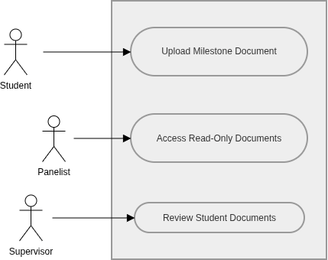
Figure: Use Case Diagram 2: Milestone Management (Student, Panelist, Supervisor)

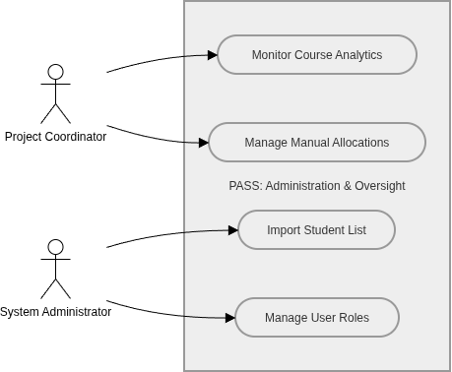
Figure: Use Case Diagram 3: Administration & Oversight (Coordinator vs Admin)

B. Activity Diagrams
Formal Definition: Activity Diagrams are visual flowcharts that show the step-by-step actions and decisions a user takes to complete a specific task.
Activity Diagram 1 ( Student First Login and Onboarding)
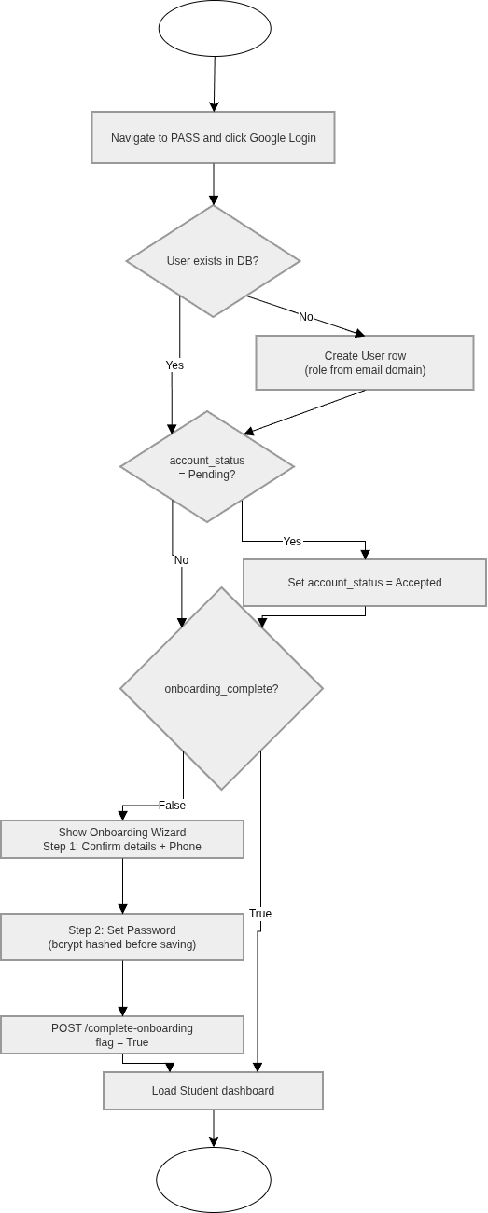
Figure 3.1 Activity Diagram: Student First Login & Onboarding
Activity Diagram 2 (Student Submitting a Project Pitch)

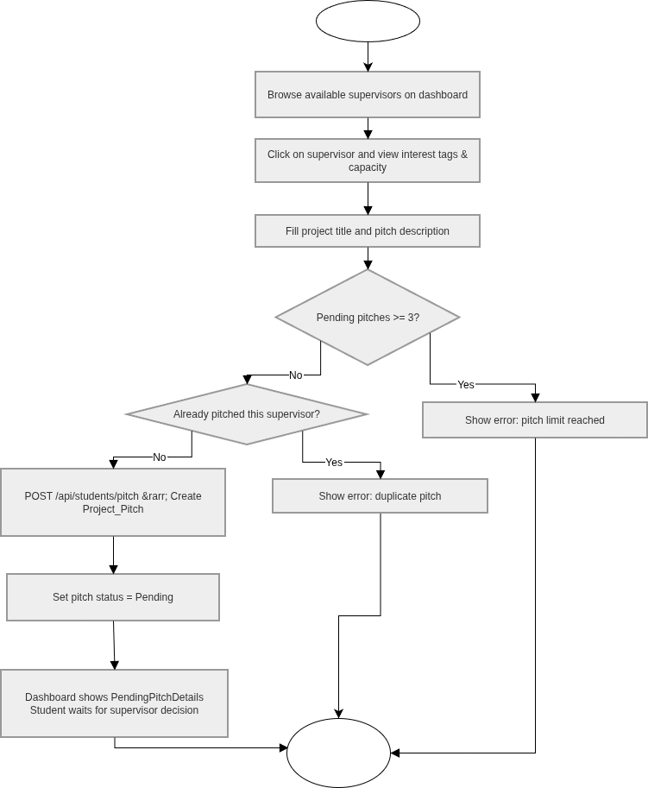
Figure 3.2 Activity Diagram: Student Pitch Submission

Activity Diagram 3 ( Supervisor Reviewing a Pitch)
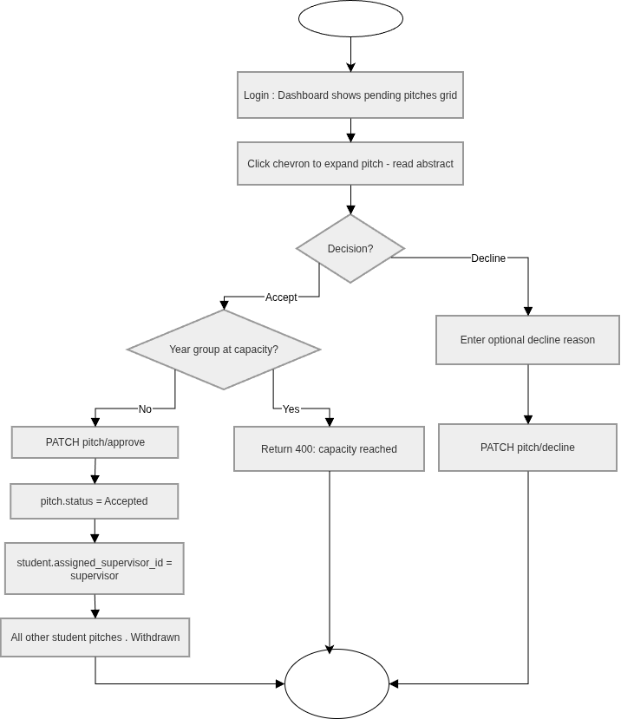
Figure 3.3 — Activity Diagram: Supervisor Pitch Review

Activity Diagram 4 ( Student Document Upload)

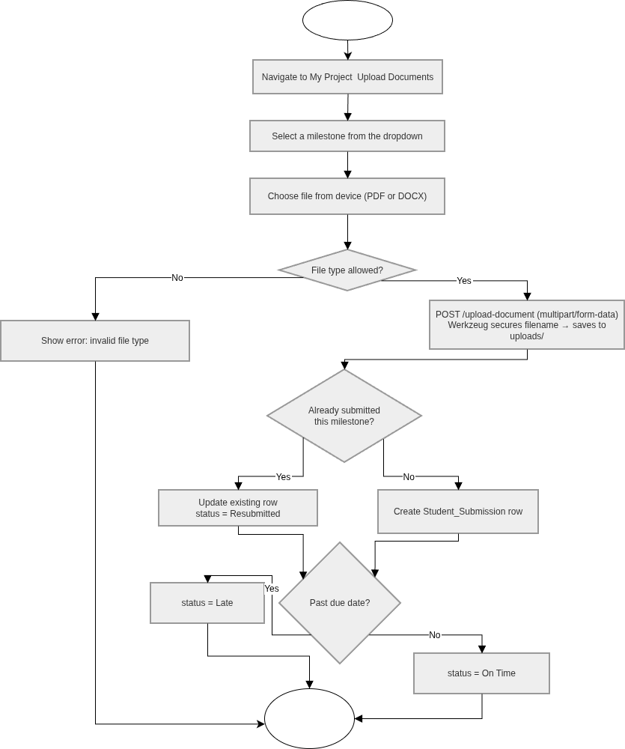
Figure 3.4 Activity Diagram: Milestone Document Upload

C. Sequence Diagrams
Formal Definition: Sequence Diagrams show how different parts of a system communicate with each other over time, mapping out the exact order of messages.

Sequence Diagram 1 (Google OAuth Login Flow)

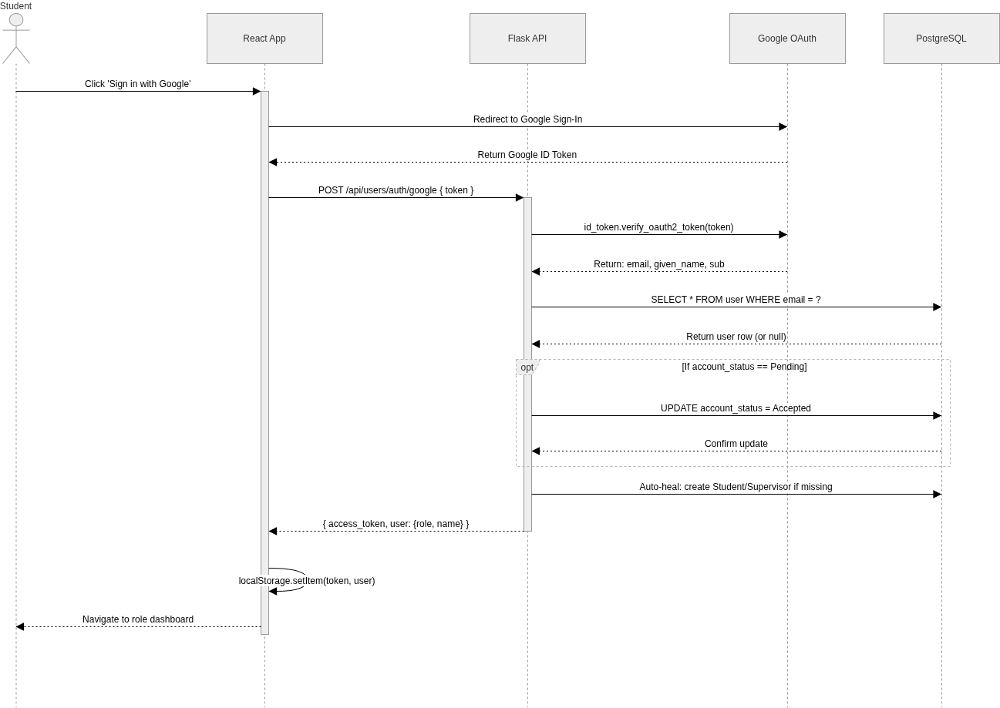
Figure 4.5 Sequence Diagram: Google OAuth Login

Sequence Diagram 2 ( Pitch Submission and Supervisor Approval)

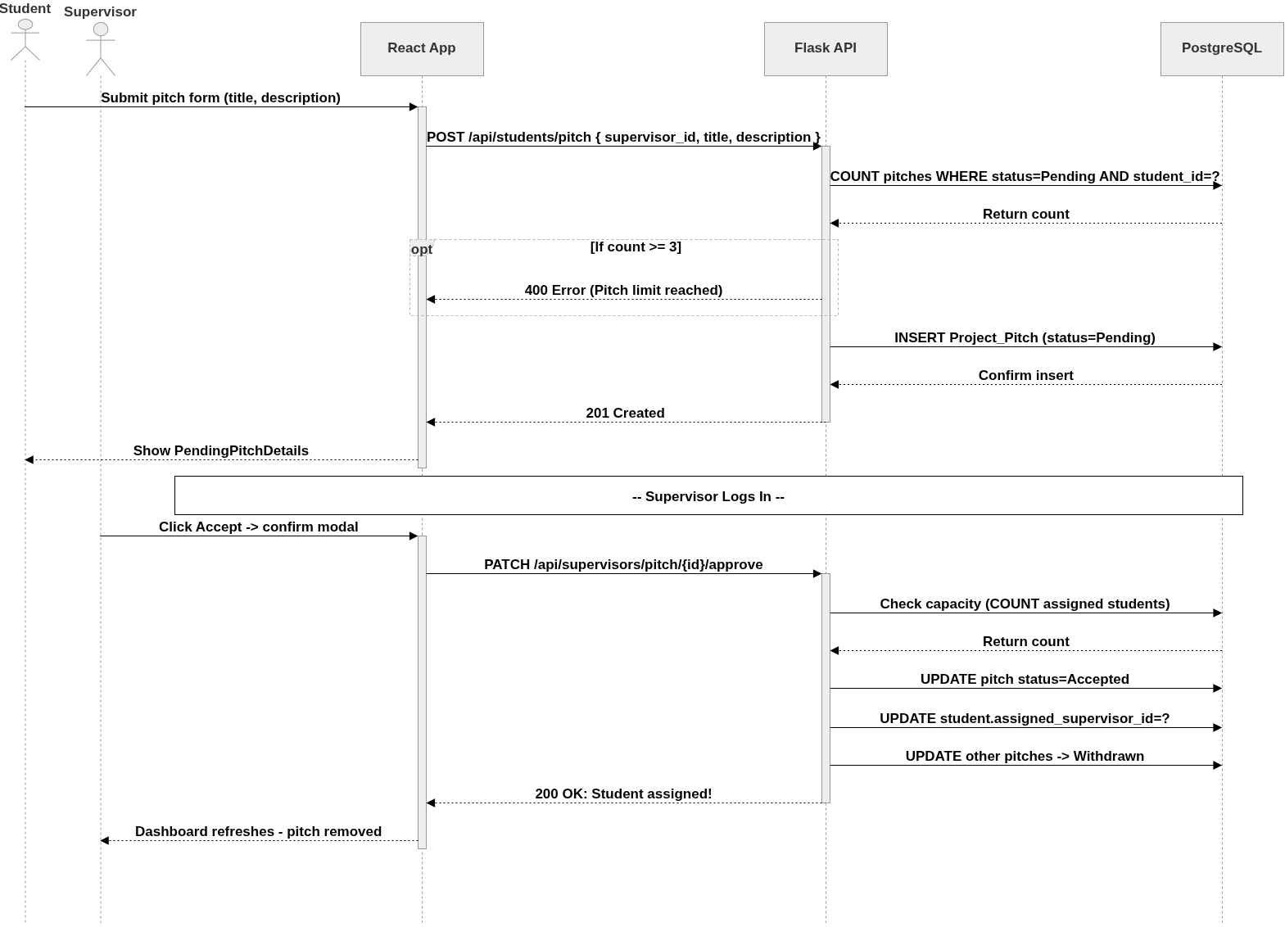

Figure 3.5 Sequence Diagram: Pitch Submission & Approval

Sequence Diagram 3 (Milestone Document Upload)

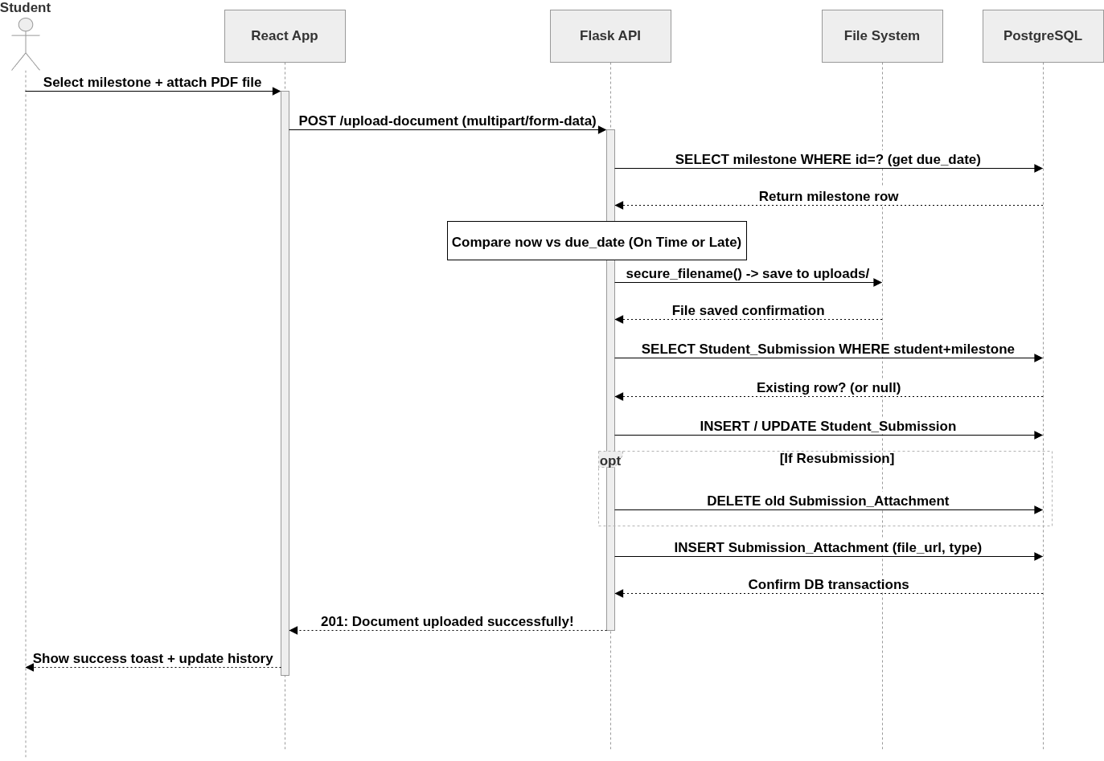
Figure 3.6 Sequence Diagram: Document Upload

3.3.3 Class Diagram
Formal Definition:A Class Diagram is a visual map of the system's code structure, showing the objects, their attributes, methods, and inheritance relationships.

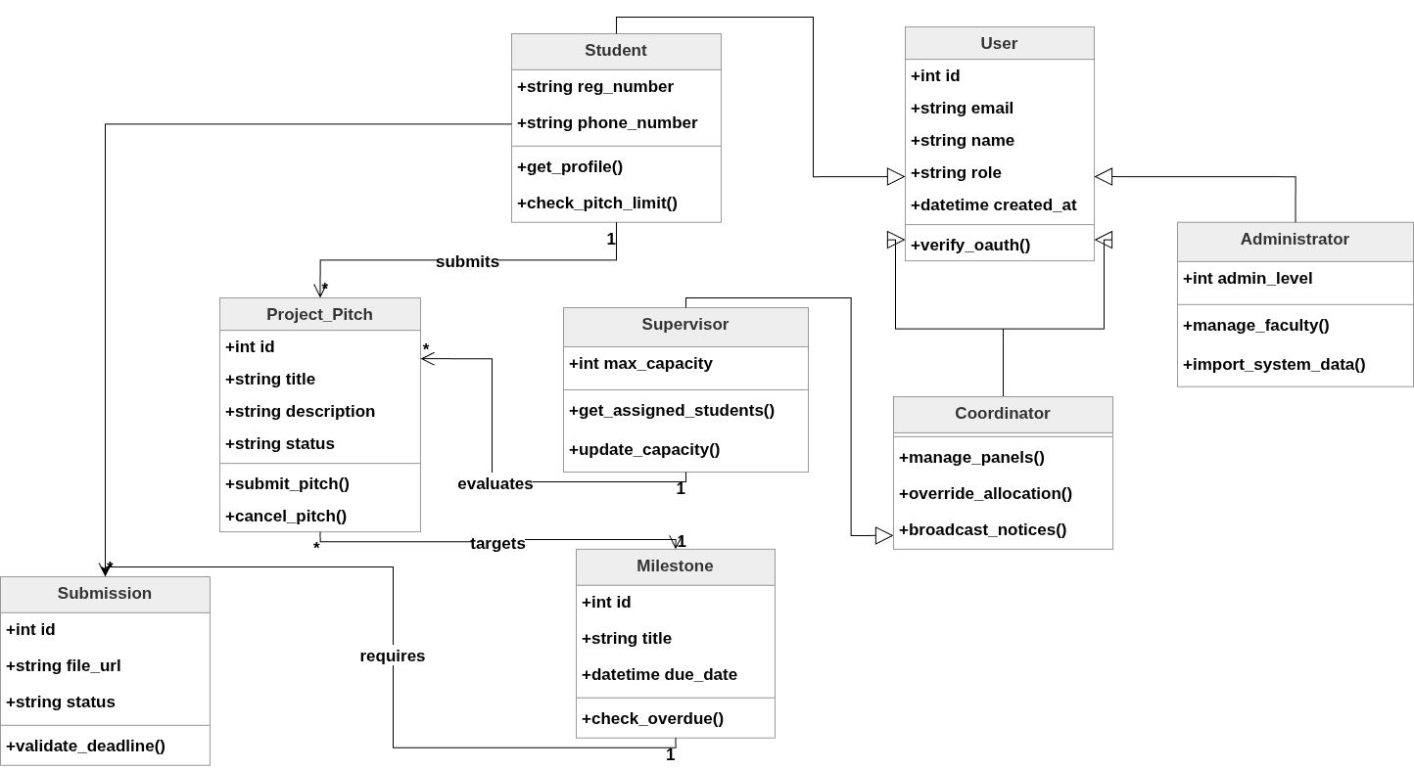

Figure: System Class Diagram

3.3.4 Database Design
Formal Definition: Database Design defines how data is logically organized, stored, and cross-referenced to ensure integrity.
The Project Allocation and Supervision System (PASS) utilizes PostgreSQL for its relational database management. The Entity Relationship Diagram (ERD) below details the primary keys, foreign keys, constraints, and cardinalities between the core entities: Users (Students, Supervisors, Coordinators, Administrators), Academic Cycles, Project Pitches, Milestones, and Student Submissions.
This project requires two different database environments. The goal is to bridge the gap between building the prototype on a laptop and running it on a live server.
SQLite (Local Development): For the initial coding phase, SQLite makes the most sense. It comes pre-packaged with Python, so I can test the allocation logic without installing a massive, standalone database server on my own machine. It speeds up the initial build process by keeping everything local.
PostgreSQL (Live Production): Pushing the application to the web changes the requirements entirely. SQLite locks the entire database file during a single "write" operation. If two students hit the "Submit Pitch" button at the exact same millisecond, the system crashes. PostgreSQL solves this by allowing concurrent writes. This upgrade is mandatory for deadline days when the entire second-year cohort logs in at once to upload their final reports.

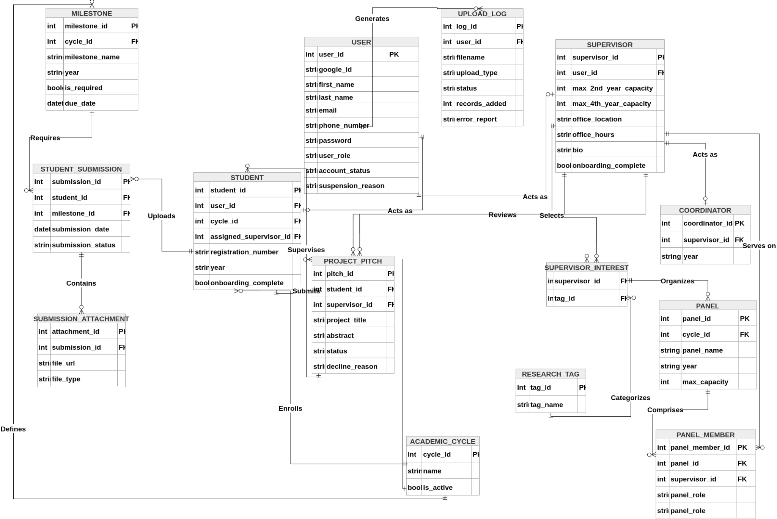
Figure: Database Entity Relationship Diagram (ERD

3.3.5 Application (UI) Design
Application design focuses strictly on User Interface (UI) and User Experience (UX). Using Material Design 3 guidelines and a mobile-first responsive approach, the core system interfaces are mapped out via high-fidelity wireframes to validate the system's functional requirements.
At this stage of the proposal, the user interface is conceptualized through high-level wireframes and planned interaction flows. The primary design objective is to minimize cognitive load, ensuring that students and supervisors can navigate their distinct workflows without friction.
Proposed Information Architecture The system relies on a strictly role-based navigation model. Upon login, the React frontend evaluates the user's permission level and conditionally renders a customized workspace.
Student View: Anticipated to center around a dynamic "Milestone Tracker" and a dedicated submission form for project documents.
Supervisor View: Designed to prioritize a central "Review Queue" for incoming pitches, alongside a prominent counter tracking their current supervision capacity.
Initial Visual & Interaction Design The visual layer will be constructed using Tailwind CSS. The planned aesthetic is minimalist and highly functional, prioritizing data scannability over heavy graphics.
Responsive Layout: The interface will adopt a "mobile-first" approach. Since students will likely check their pitch status via smartphones, Tailwind's utility classes ensure that data tables and progress bars scale perfectly to smaller screens without breaking the layout.
Interaction Flow: To maintain database integrity, the interface incorporates preventative state management. For instance, once a supervisor hits their seven-student allocation limit, the React component will physically disable and grey out the "Accept" button. This stops over-allocation at the client level before a server request is even made.

1. Supervisor Onboarding & Setup
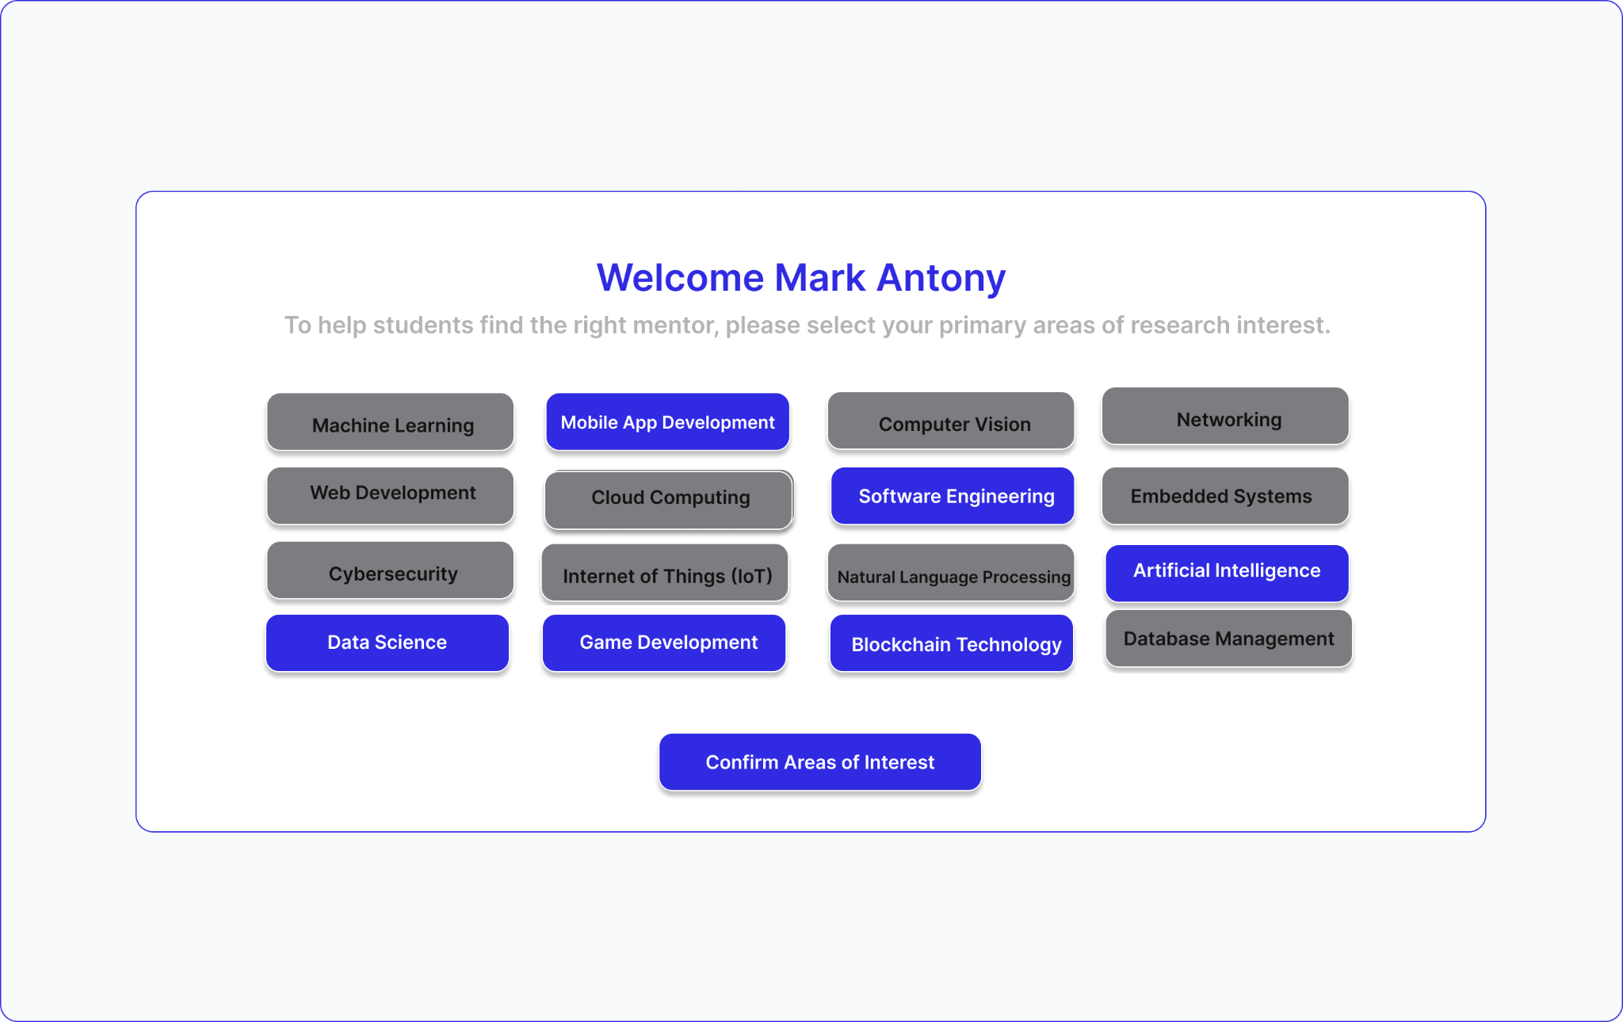
Figure 3.8 UI Wireframe: Supervisor Research Interests Setup
Design Rationale: This screen validates the onboarding logic defined in Activity Diagram 1. It forces newly authenticated supervisors to declare their research tags (e.g., Artificial Intelligence, Software Engineering) before accessing the main system, ensuring students can filter faculty accurately.

2. Student Pitch Submission Flow

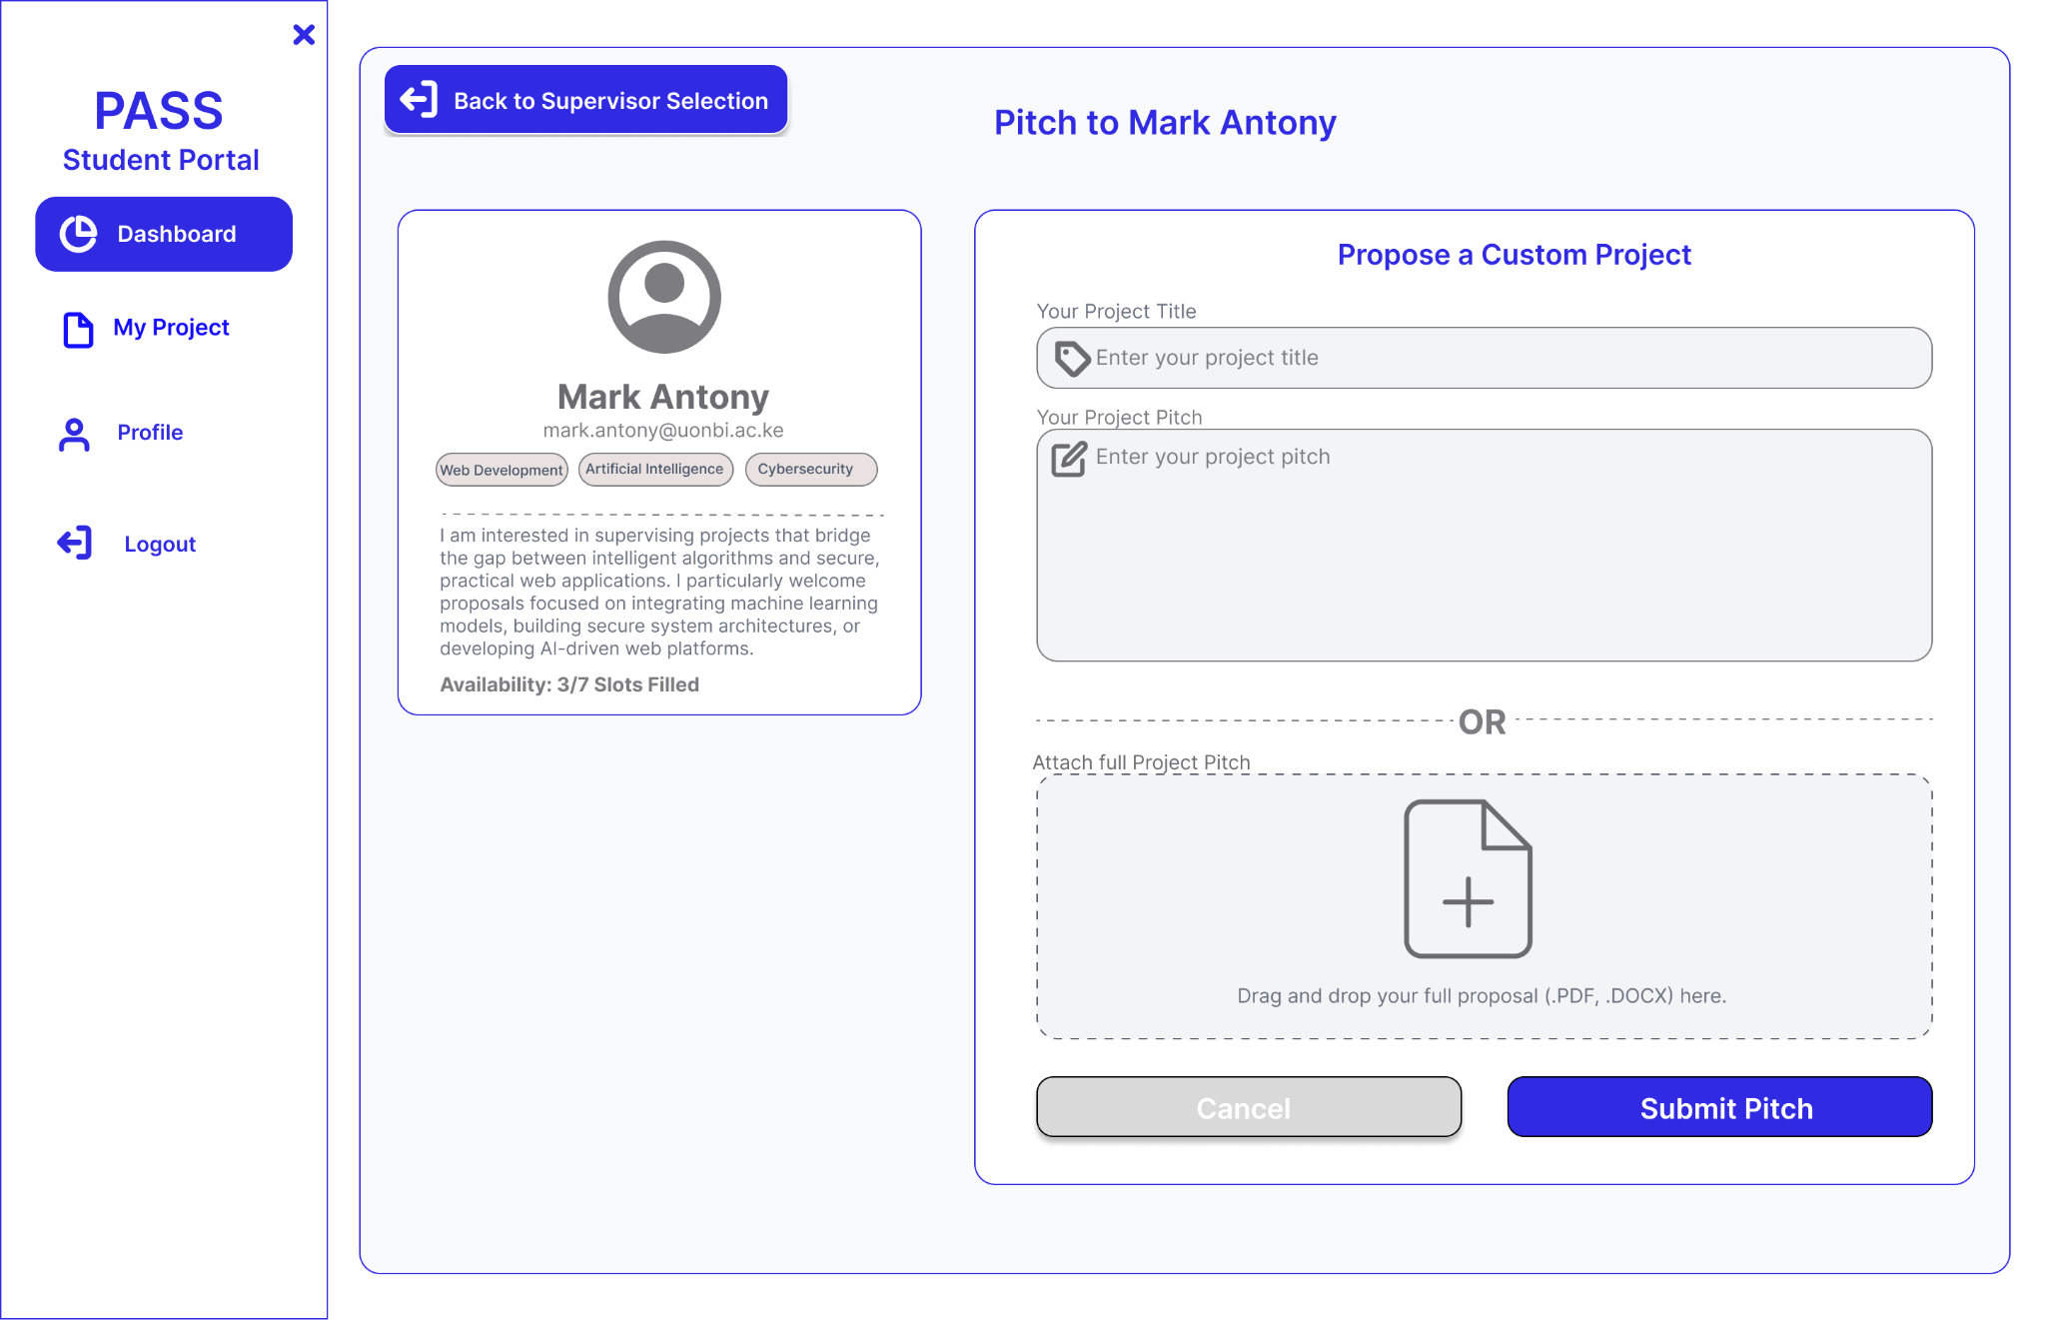
Figure 3.9 UI Wireframe: Student Pitch Submission Form

Design Rationale: Corresponding directly to Activity Diagram 2, this interface allows students to submit a custom project title and abstract. The UI intentionally restricts students from pitching if their pending limit is reached, maintaining database integrity.

3. Supervisor Pitch Review & Capacity Management

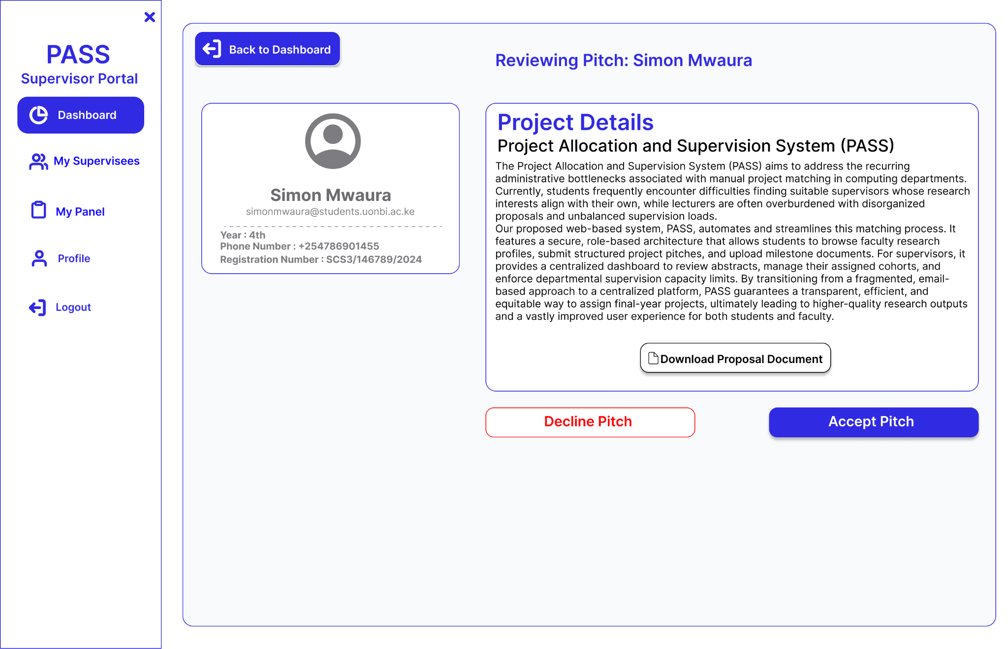
Figure 3.10 UI Wireframe: Supervisor Pitch Evaluation & Allocation

Design Rationale: This fulfills the workflow mapped in Sequence Diagram 2. The interface provides the supervisor with the student's abstract and explicit 'Accept' or 'Decline' actions. Crucially, the system tracks the supervisor's strict capacity limit (e.g., 1 of 7 slots) before allowing an acceptance.

4. Student Post-Allocation Workspace

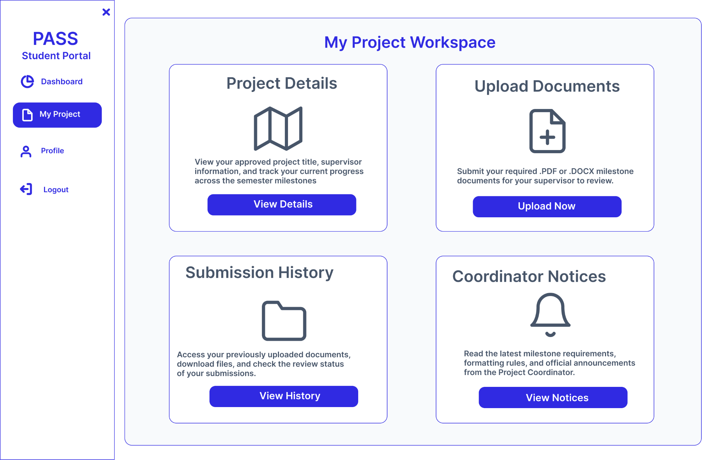

Figure 3.11 UI Wireframe: Active Project Workspace

Design Rationale: Once a pitch is approved, the student's dashboard dynamically transforms from a "Supervisor Selection" view into an active workspace, encapsulating their project details, submission history, and coordinator notices in a clean, grid-based layout.

5. Milestone Document Upload

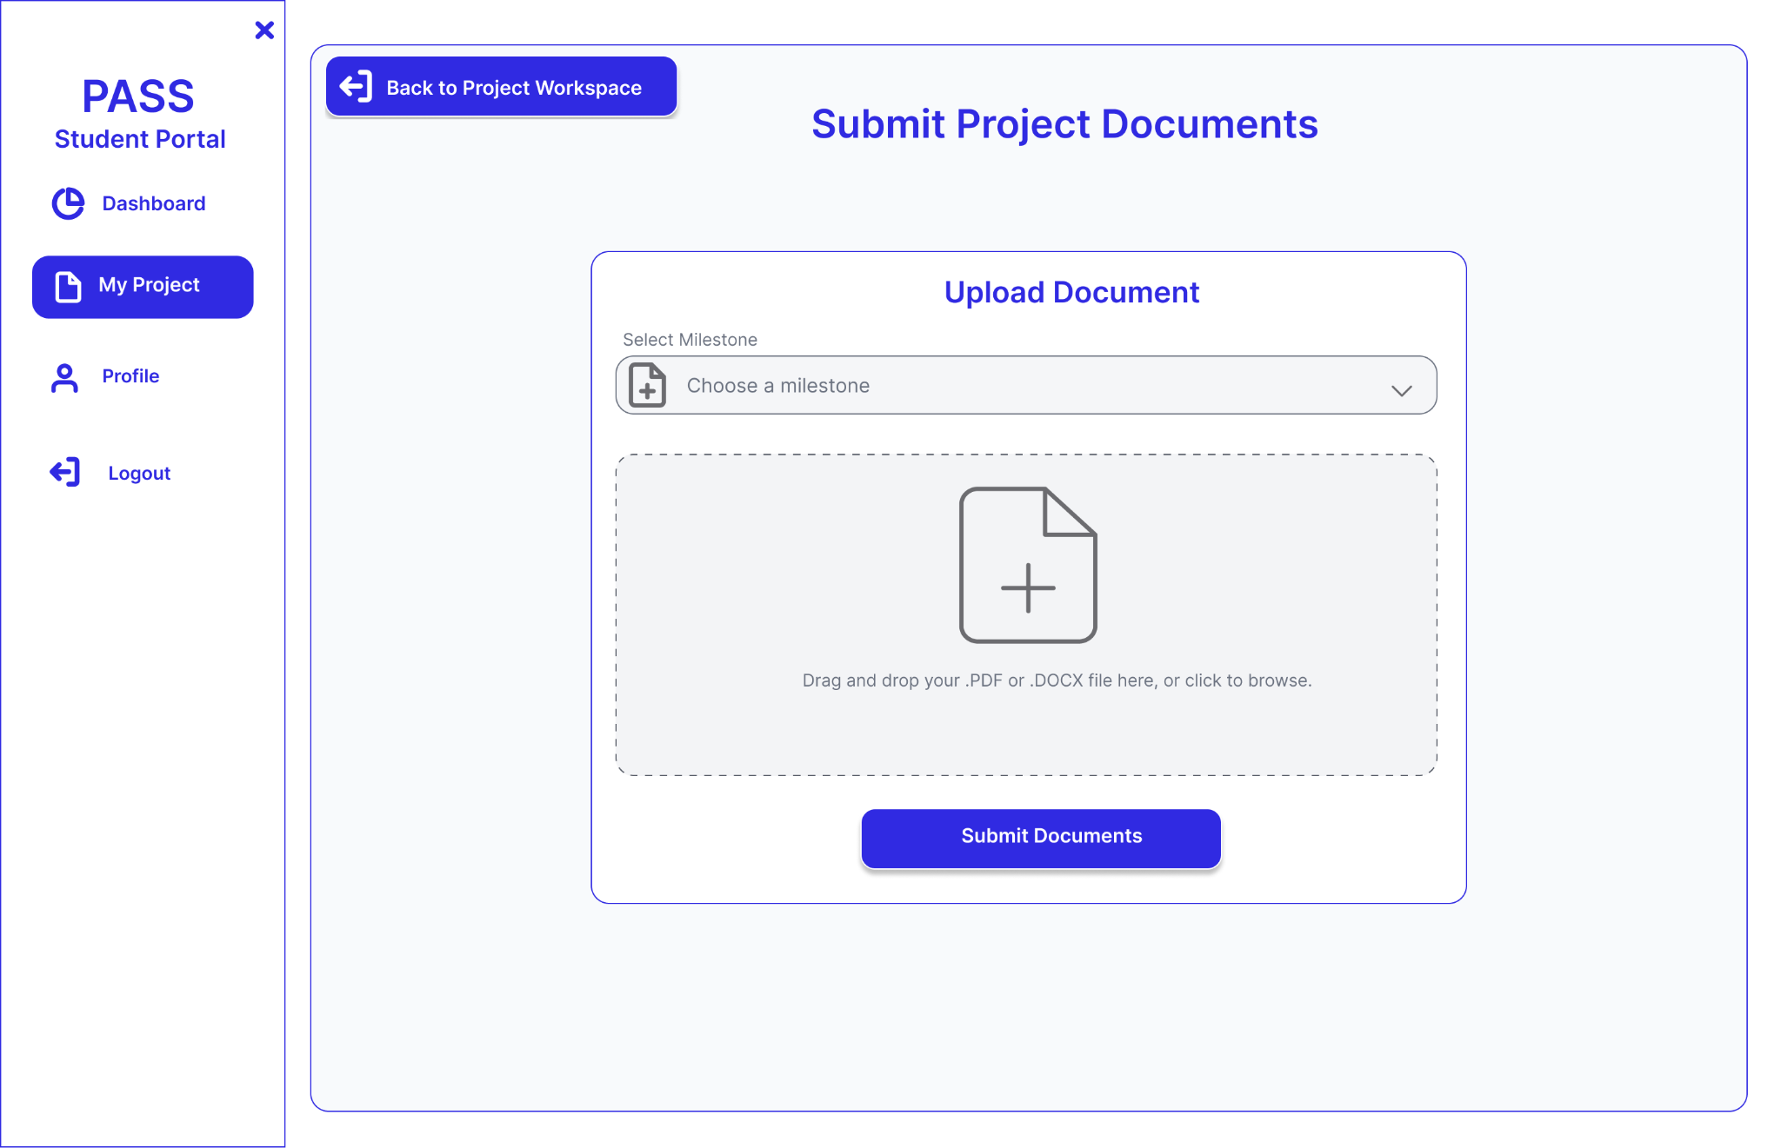
Figure 3.12 UI Wireframe: Milestone File Submission

Design Rationale: Validating Sequence Diagram 3, this modal handles the physical file upload process. It restricts inputs to specific file types (PDF, DOCX) and links the uploaded document directly to a specific academic milestone configured by the Project Coordinator.

3.3.6 Integration Design
Formal Definition: Integration design specifies how the system securely connects and communicates with external third-party services and APIs.
The Project Allocation and Supervision System (PASS) operates primarily as an independent platform, but it requires one critical external integration: Google OAuth 2.0.
To ensure secure, passwordless authentication and verify institutional identity, PASS integrates directly with the Google Identity API. When a user attempts to log in, the React frontend requests an Identity Token from Google. This token is securely transmitted via a POST request to the Flask backend. The backend verifies the token's cryptographic signature against Google's OAuth endpoints. To enforce institutional security, the system specifically parses the validated payload to ensure students are logging in with their official university domain (e.g., @students.uonbi.ac.ke) before granting role-based access.

3.4 Project Schedule and Gantt Charts

Module | Task Name | Planned Hours | Planned Start | Planned End
Module 1: Design | UI/UX Wireframing & Information Architecture) | 15 | 05/03/2026 | 09/03/2026
 | Database Schema Design (PostgreSQL) | 15 | 10/03/2026 | 13/03/2026
Module 2: Onboarding | SMIS List Upload & Reg No/Email Extraction | 20 | 16/03/2026 | 19/03/2026
 | Password Reset & Email Recovery Feature | 15 | 20/03/2026 | 24/03/2026
 | Basic Homepage & Role-Based Routing | 15 | 25/03/2026 | 27/03/2026
Module 3: Pitching | Student Pitching Form & Supervisor Interests | 20 | 30/03/2026 | 03/04/2026
 | Approval/Rejection Logic & Feedback System | 20 | 06/04/2026 | 10/04/2026
 | Coordinator Audit Trail & Pitch Data Storage | 20 | 13/04/2026 | 17/04/2026
Module 4: Submission | Project Submission Portal & File Uploads | 20 | 20/04/2026 | 24/04/2026
 | Milestone Repository (Supervisor/Panel View) | 20 | 27/04/2026 | 01/05/2026
Module 5: Quality | Comprehensive System Testing & Bug Fixing | 20 | 01/05/2026 | 08/05/2026
 | Final Technical Documentation & Report Writing | 20 | 11/05/2026 | 15/05/2026
Total | Project Lifecycle | 220
The project schedule

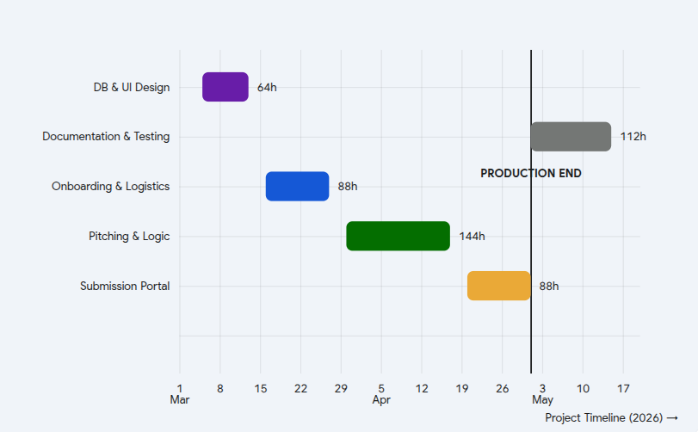
The Gantt Chart

CHAPTER 4: SYSTEM IMPLEMENTATION AND TESTING
This chapter details the translation of the PASS system design blueprints into a fully functional, role-based web application. It provides a comprehensive overview of the hardware and software resources utilized during development, documents the complete database schema and API surface, and outlines the rigorous testing methodologies applied to validate the system against its functional and non-functional requirements.

4.1 SYSTEM IMPLEMENTATION
System implementation encompasses the practical realization of the theoretical design through writing code, configuring the PostgreSQL database, and integrating the Google OAuth authentication gateway. This section details the specific environment in which PASS was constructed.

4.1.1 Hardware Resources
The development and local testing of PASS , involving the simultaneous execution of the React (Vite) frontend development server and the Flask API backend , demanded a reliable computational setup. The primary development was conducted on a machine with the following specifications:
- Laptop: HP Pavilion, Intel Core i3 11th Gen, 8GB DDR4 RAM, 512GB SSD, running Ubuntu 24.04 LTS.
For client-side execution, the target hardware environments are desktop computers, laptops, and smartphones running modern, HTML5-compatible web browsers (e.g., Google Chrome, Mozilla Firefox), equipped with standard internet connectivity to access the hosted platform.

4.1.2 Software Resources
To facilitate efficient coding, database management, and version control, industry-standard development tools and frameworks were employed:
- Visual Studio Code: Utilized as the primary Integrated Development Environment (IDE) for writing both the Python-based Flask backend and the React (JSX) frontend, offering efficient terminal integration and extension support.
- pgAdmin 4: Employed as the graphical user interface (GUI) for PostgreSQL database administration, allowing for schema inspection, relationship verification, and executing diagnostic SQL queries.
- EchoAPI (VS Code Extension): Utilized for rigorous API endpoint testing and JSON payload validation, specifically for simulating HTTP requests and verifying Bearer Token authentication prior to full frontend integration.
- Flask-Migrate (Alembic): Integrated into the backend environment to manage database schema migrations, ensuring that structural updates to the database could be applied incrementally without the risk of data loss.
- Git & GitHub: Git was employed for distributed version control, enabling structured, per-feature commits. The entire codebase was securely hosted in repositories on GitHub to maintain code integrity throughout the development lifecycle.

4.1.3 Programming Tools
The technical stack for the Project Allocation and Supervision System (PASS) was selected based on criteria of scalability, secure role separation, and adherence to modern web development standards.
Frontend: React.js and Tailwind CSS
The client-side interface was constructed as a Single-Page Application (SPA) using React.js. To enforce strict role-based access control, React Router v6 was implemented to manage protected route trees (e.g., /student/*, /supervisor/*, /coordinator/*, /admin/*), ensuring users can only access their designated workspaces. Tailwind CSS, a utility-first CSS framework, was leveraged to provide a consistent, highly responsive design language without the overhead of heavy custom stylesheets. To enhance the User Experience (UX) during asynchronous network operations, the 'React Toastify' library was integrated to deliver seamless, non-blocking visual feedback to users following API actions.
Backend: Python and Flask
The server-side infrastructure was developed using Python, employing the lightweight Flask framework to operate strictly as a decoupled RESTful API. Security and session management were handled via the 'Flask-JWT-Extended' library to protect all authenticated routes. Every protected endpoint utilizes @jwt_required() decorators, extracting the user_id and role from the JSON Web Token (JWT) identity payload before securely querying the database. Crucial departmental business rules—such as the three-pitch limit per student, supervisor capacity ceilings, and the automatic cascading withdrawal of pending pitches upon an acceptance—are enforced exclusively on the server to prevent client-side manipulation. Additionally, Werkzeug's secure_filename utility is utilized to rigorously sanitize incoming milestone document uploads before saving them securely to the server's local uploads/ directory.
Database: PostgreSQL
PostgreSQL was selected as the primary relational database to guarantee transactional data integrity during concurrent user activity, which is highly critical during final submission deadlines. Database interactions and schema definitions were managed via SQLAlchemy (an Object-Relational Mapper), which securely translates Python classes into SQL queries and natively enforces the strict relational constraints between Users, Project Pitches, and Milestone Submissions.
4.1.4 Hosting and Deployment
To transition PASS from a local development environment to a live, internet-accessible platform, the decoupled architecture was deployed across specialized cloud hosting providers.
- Frontend Hosting (Netlify): The React SPA is hosted on Netlify, which provides automated Continuous Integration and Continuous Deployment (CI/CD) pipelines directly from the main GitHub repository. Critical configuration parameters, including the backend API base URL and the Google OAuth Client ID, are securely injected as Netlify build environment variables to protect sensitive credentials.
- Backend and Database Hosting (Render): The Flask API and the PostgreSQL database instance are securely hosted on Render, which offers native Python environment support and automatic SSL encryption. The backend is served via Gunicorn, a production-grade WSGI HTTP server, designed to efficiently handle concurrent user requests. Furthermore, a persistent disk volume is attached to the Render web service to safely retain the uploads/ directory, ensuring that all submitted PDF and DOCX milestone files remain accessible across server restarts and deployments.

4.2 SOFTWARE TESTING
Software testing is a critical phase of the Software Development Life Cycle (SDLC) ensuring that the developed system is free of defects and strictly adheres to the specifications outlined in Chapter 3. For the Project Allocation and Supervision System (PASS), three complementary testing methodologies were applied: Unit Testing of isolated Flask API routes utilizing Postman; Integration Testing to verify secure end-to-end data flows between the React frontend and the backend; and System/Functional Testing to rigorously evaluate the complete user workflows and role-based constraints.

4.2.1 Test Plan
- Objective: The primary objective of this test plan is to verify that PASS successfully manages the complete academic project lifecycle ,from initial student onboarding and project pitching, to supervisor capacity enforcement and milestone document submission. It ensures data integrity, secure Google OAuth authentication, and the strict enforcement of role-based access controls across the application.
- Test Environment: Local testing was conducted utilizing Google Chrome on a machine running Ubuntu 24.04 LTS. The environment consisted of a React development server (Vite) communicating with a local Flask API server, backed by a local PostgreSQL database instance. Google OAuth 2.0 callback flows were tested using both standard Gmail accounts and official university domains (@students.uonbi.ac.ke) to verify institutional authentication constraints.
- Approvals: This test plan was formulated and executed by the primary developer. Final review and validation of the testing outcomes are pending under the guidance of the project supervisor.

4.2.2 Functional Testing
Functional testing was conducted to strictly validate the software against the functional requirements established in Chapter 3. The table below outlines the core test cases covering role-based authentication, the student pitching and supervisor allocation workflows, custom business logic (such as automated capacity limits and cascading pitch withdrawals), milestone document submissions, and panel administration.
Test ID | Scenario | Test Steps | Test Data | Expected Results | Actual Results | Pass/Fail
TC-01 | Student Authentication & Role Verification | 1. Access PASS landing page.  2. Authenticate via Google OAuth.  3. Select official university email. | Valid student email (@students.uonbi.ac.ke) | Backend verifies token and returns JWT. Account status updates to 'Accepted'. System verifies onboarding flag and routes to the Onboarding wizard. | OAuth token successfully verified; system correctly routes new users to the onboarding interface. | Pass
TC-02 | Student Onboarding & Profile Completion | 1. Verify pre-populated database details.  2. Input phone number.  3. Set and confirm secure password.  4. Submit form. | Phone: +254712345678  Password: Pass@1234 | POST request securely hashes password using bcrypt. Onboarding flag is updated to True, and user is redirected to the Student Dashboard. | Data successfully persisted in PostgreSQL; dashboard renders correctly on subsequent logins. | Pass
TC-03 | Student Pitch Submission | 1. Navigate to Supervisor Selection.  2. Select an available supervisor.  3. Input project title and abstract.  4. Submit pitch. | Title: "Smart Water Monitor"  Valid text abstract | POST request creates a Project_Pitch record with a 'Pending' status. Dashboard UI updates to display PendingPitchDetails. | Pitch record accurately saved; UI successfully displays pending state and supervisor details. | Pass
TC-04 | Supervisor Pitch Evaluation & Allocation | 1. Authenticate as Supervisor.  2. Expand pending pitch card.  3. Execute 'Accept' action.  4. Confirm via modal. | Valid pitch_id  Supervisor under capacity limit | PATCH request updates pitch status to 'Accepted'. Student's assigned_supervisor_id is updated. All other pending pitches for this student cascade to 'Withdrawn'. | Student successfully assigned; automated withdrawal of alternate pitches executed flawlessly. | Pass
TC-05 | Milestone Document Upload (On-Time) | 1. Authenticate as assigned student.  2. Navigate to 'My Project'.  3. Select 'Milestone 1'.  4. Upload PDF document. | proposal.pdf (Valid PDF < 10MB), submitted prior to deadline | File secured via Werkzeug and saved to /uploads. Student_Submission record created with 'On Time' status. | File successfully written to server storage; submission history UI updates accurately. | Pass
TC-06 | Document Upload (Late Resubmission) | 1. Upload document after milestone deadline.  2. Re-upload revised document to the same milestone. | Valid PDF, submitted past due date | Initial upload marked 'Late'. Subsequent upload updates status to 'Resubmitted' and automatically deletes the legacy file from the server to optimize storage. | Status correctly updated to 'Resubmitted'; legacy file successfully purged from the file system. | Pass
TC-07 | Panel Member Access & Visibility | 1. Authenticate as Panel Member.  2. Navigate to 'My Panel'. | Authenticated Supervisor assigned to 'Panel 1, Year 2' | GET request fetches panel members, assigned students, and read-only milestone submissions. The user's specific section automatically expands. | Panel data retrieved successfully; expandable UI elements function as expected. | Pass
TC-08 | Automated Panel Generation | 1. Authenticate as Coordinator.  2. Navigate to 'Panels' > 'Setup'.  3. Input desired number of panels.  4. Execute generation. | Generation count: 3 | POST request instantiates 3 new empty Panel records in the database. UI grid renders the new panels immediately. | 3 distinct panel cards rendered successfully, initializing with 0/3 members. | Pass
TC-09 | Panel Member Assignment | 1. Open 'Setup Panel' modal.  2. Select target supervisor.  3. Assign 'Chair' role.  4. Confirm assignment. | Valid supervisor_id  Role: Chair | POST request creates a Panel_Member record. Target panel card increments capacity counter and lists the supervisor with a 'Chair' badge. | Supervisor successfully mapped to panel; UI capacity counters and role badges update accurately. | Pass
TC-10 | Administrator Account Suspension | 1. Authenticate as Admin.  2. Navigate to User Details.  3. Input suspension rationale.  4. Execute 'Suspend'. | Target user_id  Reason: "Academic misconduct" | PATCH request updates account status to 'Suspended' and logs the reason. Subsequent login attempts by the user are blocked by the authentication gateway. | Account successfully suspended; user access forcefully revoked upon next session validation. | Pass

4.2.3 Usability Testing
Usability testing assesses the user interface and overall user experience (UX) by observing representative users interacting with the application to achieve specific goals. The feedback gathered evaluates the intuitiveness of the React components, Tailwind CSS layouts, and the role-based navigation flows.

Scenario 1: Student Project Pitching

Task / Goal | Things to look out for | Observations & Notes
A 2nd-year student must browse available faculty and pitch a project idea to a supervisor for the first time. | 1. Does the student understand the two-stage flow (select supervisor, then pitch)?  2. Is the research interest filter visible and useful?  3. Does the student notice the year-specific capacity indicators? | Participant: Participant A (2nd-Year Student).  Observation: The supervisor grid was highly intuitive, and the interest filter effectively helped narrow down options. The student initially overlooked the capacity indicators but noticed them upon closer inspection. Recommended UI change: Update the submission button label from 'Submit Pitch' to 'Send to Supervisor' to clarify the action.

Scenario 2: Supervisor Onboarding & Review

Task / Goal | Things to look out for | Observations & Notes
A first-time supervisor logs in, completes the initial interest onboarding, and reviews an incoming project pitch. | 1. Is the multi-step onboarding flow clear?  2. Can the supervisor easily expand a pitch card to read the abstract before deciding?  3. Is the 'Decline Reason' text area obvious to the user? | Participant: Participant B (Faculty Member).  Observation: The step indicator effectively communicated onboarding progress. The user seamlessly expanded the pitch cards to evaluate the abstracts. The decline reason field was initially missed; adding a sub-label reading "Reason (visible to student)" immediately improved clarity. Accept/Decline modals felt appropriately confirmatory.

Scenario 3: Coordinator Dashboard & Panel Setup
Task / Goal | Things to look out for | Observations & Notes
A project coordinator needs to monitor the 2nd-Year cohort dashboard and dynamically generate presentation panels. | 1. Are the dashboard donut charts immediately readable?  2. Can the coordinator easily distinguish between 'Student Pitching Status' and 'Active Pitch Outcomes'?  3. Is the panel generation sequence self-explanatory? | Participant: Participant C (Administrative Staff).  Observation: The visualization charts were interpreted correctly, though the two distinct charts were briefly confused until the legend labels were consulted. The panel generation workflow (Dropdown ➔ Generate ➔ Setup Panel ➔ Add Supervisor) was completed swiftly without requiring external assistance.

CHAPTER 5: CONCLUSION AND RECOMMENDATIONS

5.1 ACHIEVEMENTS
The primary objective of the PASS project was to architect, develop, and deploy a secure, role-based web application to replace the Department of Computing and Informatics's legacy open-access Google Spreadsheet with a centralized, automated platform. The successful completion of the V1 prototype demonstrates the effective application of full-stack software engineering principles to resolve the administrative fragmentation and data privacy vulnerabilities documented in Chapter 1.
On the client side, the project achieved a responsive and intuitive user experience through the utilization of React.js and Tailwind CSS. By engineering a decoupled Single-Page Application (SPA), the system successfully implements strict role-based navigation, dynamically rendering customized workspaces for Students, Supervisors, Coordinators, and Administrators. Key frontend achievements include the integration of non-blocking visual feedback via React Toastify, dynamic dashboard filtering based on faculty research interests, and client-side preventative state management—such as visually disabling submission buttons when a supervisor reaches capacity—to minimize server load and user friction.
A critical technical triumph was the robust engineering of the pitch lifecycle management within the Python Flask backend. The supervisor approval route executes a rigorous three-step atomic database transaction: accepting the chosen pitch, updating the student's assigned supervisor, and simultaneously cascading all other pending pitches to a 'Withdrawn' state. This server-side logic entirely eradicates the "ghost-allocation" vulnerability where multiple supervisors could inadvertently claim the same student. Furthermore, capacity enforcement is strictly processed at both the PostgreSQL query level and the API level, making departmental over-allocation computationally impossible.
The milestone-aware document upload system represents a significant operational improvement. The backend seamlessly intercepts multipart/form-data uploads, utilizing Werkzeug utilities to rigorously sanitize filenames before securely saving PDF and DOCX files to the server's local storage. The system automatically classifies each submission as 'On Time' or 'Late' by programmatically comparing the upload timestamp against the milestone due date, providing the Project Coordinator with a highly verifiable audit trail. Moreover, resubmissions are elegantly handled by updating the existing database row and physically purging the legacy attachment, thereby maintaining a clean, one-record-per-student history and optimizing server storage.
Finally, the project successfully translated complex departmental rules into an automated Panel Management module. Supervisors are granted secure, read-only access to the milestone documents of all students assigned to their specific panel, enabling thorough pre-presentation preparation without compromising data integrity. The project coordinator is empowered with a self-contained management interface to instantly generate panels, control composition, and assign chairs, completely removing the need for manual database administration and greatly streamlining the examination phase of the academic cycle.

5.2 LIMITATIONS AND CONSTRAINTS
Despite the successful deployment of the core functionalities, an objective technical evaluation of the V1 prototype reveals several boundaries and architectural constraints inherent to the current iteration.
Primarily, the application currently lacks an automated external notification system. Consequently, PASS cannot programmatically dispatch email alerts or deadline reminders to students and supervisors. The platform relies entirely on active user engagement; users must manually authenticate and navigate to their respective dashboards to discover pitch decisions, allocation updates, or coordinator broadcasts.
Additionally, the system architecture is presently constrained to managing a single active academic cycle. The database does not currently support the archiving or partitioning of historical data across multiple academic years. As a result, historical project pitches, milestone submissions, and panel assignments are effectively overwritten or lost when a new academic cycle is initialized by the administrator.
Furthermore, the current file handling mechanism exhibits a vulnerability regarding long-term scalability. Milestone submission files are currently saved directly to the Flask server's local filesystem. While functional for testing, this approach will not scale efficiently in a production environment where an entire cohort of students may simultaneously upload 10MB PDF and DOCX files on deadline day. Transitioning to a dedicated cloud object storage service, such as AWS S3, is required for future robust production deployments.
Finally, due to the constrained development timeline of the academic semester, certain administrative interface features were deprioritized to focus on the core pitching and submission flows. While the backend API fully supports dynamic capacity overrides, the Coordinator’s React frontend does not yet expose the graphical forms required to manually edit a supervisor's max_2nd_year_capacity and max_4th_year_capacity parameters.

5.3 CONCLUSION
The Project Allocation and Supervision System (PASS) successfully achieves its mandate to digitize, centralize, and strictly enforce the second-year and fourth-year project management workflows within the Department of Computing and Informatics. Historically, this academic workflow has been fragmented and highly vulnerable due to reliance on an open-access Google Spreadsheet. This project proves that a role-enforced, permission-separated platform can significantly optimize the allocation lifecycle while protecting student intellectual property.
By synthesizing a robust technological stack comprising React.js, Python Flask, PostgreSQL, Google OAuth 2.0, and JWT-based session management, the resulting application provides a highly scalable and maintainable foundation for academic administration. The successful implementation of atomic database transactions, milestone-aware file routing, and automated capacity enforcement validates the architectural choices made during the system design phase.
Most critically, the system definitively resolves the fundamental structural flaw identified at the project's inception: the complete lack of user permission separation. PASS operates on strict data encapsulation where every action is gated behind a verified institutional identity. A student is restricted to viewing only their own documents; a supervisor sees only the pitches directly addressed to them and the milestone submissions of their officially assigned cohort; a coordinator is granted cohort-level visibility; and an administrator can manage accounts without altering core academic project data. PASS stands as a comprehensive, technically sound solution that empowers the department to manage the project lifecycle securely and efficiently

5.4 RECOMMENDATIONS FOR FUTURE WORK
To evolve the Project Allocation and Supervision System (PASS) from the current V1 prototype into a fully comprehensive, commercial-grade academic administration platform, the following technical and functional enhancements are recommended for future iterations:
- Email and In-App Notification Engine: Integration of a dedicated email delivery service, such as SendGrid or AWS SES, is highly recommended to implement an automated notification engine. This would proactively alert students and supervisors regarding pitch decisions, impending milestone deadlines, and system-wide coordinator broadcasts, effectively closing the current passive-feedback loop.
- Cloud File Storage Migration: To guarantee system scalability and high availability during peak submission periods, the local filesystem handler must be replaced with a robust cloud object storage solution, such as AWS S3 or Google Cloud Storage. The Flask backend should be engineered to generate secure, pre-signed URLs to facilitate time-limited, direct client downloads, thereby optimizing server bandwidth and protecting intellectual property.
- Administrative Capacity Override Interface: The Coordinator's frontend dashboard should be expanded to expose the UI forms necessary to interact with the backend override endpoints. This would allow the project coordinator to dynamically adjust a supervisor's year-specific capacity constraints on a case-by-case basis, automatically generating a permanent audit log of the manual intervention for departmental records.
- Multi-Cycle Archival and Data Retention: To support longitudinal academic tracking, the database architecture should be updated to manage multiple consecutive academic cycles. Implementing a comprehensive archival mechanism would preserve historical project pitches, milestone submissions, and presentation panel data in a secure, read-only state across multiple academic years without cluttering the active workflow.
- Real-Time Dashboard Updates via WebSockets: To eliminate the latency of client-side polling, the integration of Socket.IO or native WebSockets is recommended for the Supervisor and Coordinator dashboards. This would establish a persistent, bidirectional connection, ensuring that incoming project pitches, document uploads, and critical capacity alerts render instantaneously upon submission.
- Plagiarism Detection Integration: To directly address the academic integrity concerns and plagiarism risks identified in Chapter 1, the milestone submission workflow should seamlessly integrate with a commercial similarity-checking API (e.g., Turnitin API). This would automatically scan uploaded proposals and final reports against both legacy system submissions and external sources prior to panel review.
- Mobile Progressive Web App (PWA) Conversion: To maximize accessibility and student engagement, the React SPA frontend should be converted into a Progressive Web App (PWA). This architectural upgrade would allow the application to be installed directly onto users' mobile home screens and enable native push notifications during critical pitching windows and impending document deadline

REFERENCES
Elmasri, R., & Navathe, S. B. (2015). Fundamentals of Database Systems (7th ed.). Pearson.
Hardt, D. (Ed.). (2012). The OAuth 2.0 Authorization Framework (RFC 6749). Internet Engineering Task Force. Retrieved from https://datatracker.ietf.org/doc/html/rfc6749
Jones, M., Bradley, J., & Sakimura, N. (2015). JSON Web Token (JWT) (RFC 7519). Internet Engineering Task Force. Retrieved from https://datatracker.ietf.org/doc/html/rfc7519
Martin, J. (1991). Rapid Application Development. Macmillan Publishing Co., Inc.
Meta Platforms, Inc. (2024). React Documentation. Retrieved from https://react.dev/
Pallets Projects. (2024). Flask Documentation (3.0.x). Retrieved from https://flask.palletsprojects.com/
The PostgreSQL Global Development Group. (2024). PostgreSQL 16 Documentation. Retrieved from https://www.postgresql.org/docs/
Sommerville, I. (2015). Software Engineering (10th ed.). Pearson.
Tailwind Labs Inc. (2024). Tailwind CSS Documentation. Retrieved from https://tailwindcss.com/docs
University of Nairobi, Department of Computing and Informatics. (2025). Undergraduate project guidelines.

