Aarohi's Class Schedule

Sem: 5 Section: A

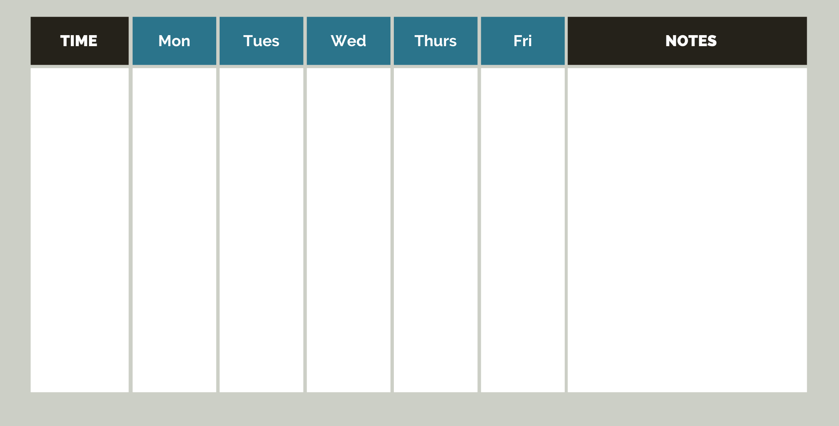

Shekhar's Class Schedule

Sem: 5 Section: A

