**DATA 604: Simulation and Modeling Techniques, Fall 2016**

**Project Name: Data Center Relocation**

**Team: Mohamed Elmoudni, Shazia Khan, & Sekhar Mekala**

***Project Proposal***

**Introduction**

This project is about simulating a Data Center Relocation from location A to location B. A data center relocation (DCR) is not just about moving servers and plugging them in at their new locale. In reality, DCR can be one of a company’s most complex and challenging endeavors. With mission critical information and high-stakes money on the line, the failure of any key steps in the process can have potentially devastating repercussions. Valuable data can be lost. Expensive IT equipment can be damaged. Critical systems may remain offline for hours, days or even weeks as problems are resolved. Such issues can end up costing a company thousands–or even millions–of dollars in lost productivity and lost revenue.

**A summary of two key journal papers relevant to your work:**

[**https://www.hpe.com/h20195/V2/GetPDF.aspx/4AA5-1861ENW.pdf**](https://www.hpe.com/h20195/V2/GetPDF.aspx/4AA5-1861ENW.pdf)

Based on technical paper written by HP, 88% of enterprises are currently in the early phases of either consolidating servers or executing a major data center relocation. These consolidations and relocations bring measurable benefits. For example, they reduce information technology (IT) costs, improve business continuity and information security, optimize service management, and help organizations comply with federal and industry regulations.

With so many benefits, why haven’t more companies completed such initiatives? According to Gartner, the primary factors inhibiting these beneficial projects include internal politics and pressures, often based on business owners’ concerns that their critical applications and services will be adversely affected by such moves.

In addition a technical paper titled " the successful data center migration “ written by Server Central, stated that when we ask customers, partners, prospects, and colleagues about data center migrations, they all respond that migrations are a pain. They also stated:

>50% of migrations exceed budget, exceed migration windows, and result in disruption

>60% of companies have delayed a migration after planning.

>50% cited concerns about downtime associated with the migration.

>40% cited concerns about downtime associated with the migration.

>20% cited a lack of resources

<https://go.servercentral.com/hubfs/PDFs/The_Successful_Data_Center_Migration-A_ServerCentral_White_Paper.pdf?t=1475680065154>

**• A problem formulation.**

To minimize cost, consolidate our assets, and comply with federal and state laws, we are planning to migrate our production data center from A to location B. The problem is we would like to migrate 200 applications from location A to location B. The locations are at least 500 miles apart. The 200 applications are business critical applications in which 50 are customer facing, 100 are financial application, and 50 are planning applications. The challenge is we would like to plan the migration with minimal downtime.

**• A statement of objectives**

The objective is to consolidate all production systems and create a disaster recovery site by migrating all CRM and point of sale (POS) systems, financial and human capital management systems, and planning systems from A to location B with minimal downtime without compromising functionality or service.

**• Proposed methodology**

We are proposing two ways to achieve our goals. Each method carries specific costs and risks.

1. Our first method is to shut down all 200 systems in location A. Then load them into trucks. Then drive them to destination B. The execution cost is relatively cheap. However, risks are high as systems can be damaged while transit. In addition, this method wills a major impact on business as systems will unavailable for long time.
2. The second method is called an asset swap method in which we lease equipment on the destination side, we transfer data across the wide area network WAN, and then promote the destination as production site.

This method carries a heavy cost as we need to lease assets in the destination site. However, it is less intrusive and has minimal impact to business. We will probably select this option.

**• *Evaluation measure for the performance of the proposed methodology.***

Evaluation will be based on the below measurements:

* How many systems we relocate at each maintenance window
* How much data we transfer by minute, day, and week
* Application downtime
* Business impact in dollars
* Application Latency before and after the move

**Assumptions:**

We will be making the following assumptions.

* We will assume a phased migration. In other words, we will migrate systems as small business units. We won’t migrate all systems at the same time (not a big bang approach).
* The data will be transferred first and we keep sending deltas to synch systems.
* All the data is in storage area network (SAN). In other words, there are no internal disks in servers. All servers are SAN boot enabled. The servers only consist of cpu and memory.
* The WAN network bandwidth is 1 GB/Sec consistently
* The LAN network bandwidth is 10GB/Sec consistently
* Servers have different maintenance windows.
* Servers will be migrated during their maintenance windows.
* All license agreements and support contracts are being updated to reflect the new location.
* Finally business is sponsoring the Data Center relocation project

**Below is high level diagram showing different data and system entities with respective location and data transmission rates.**

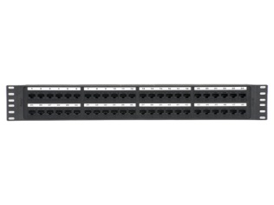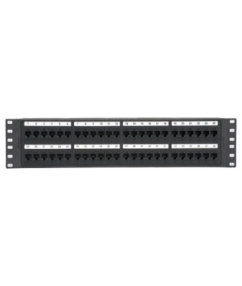

Target B

500TB

500TB

Storage A

Storage B

SAN Switch A

SAN Switch B

10GB/sec

10GB/sec

10GB/sec

10GB/sec

1GB/sec

1GB/sec

**WAN Replication 1GB/sec**

**200 Servers**

Source A

WAN Switch A

WAN Switch B

**200 Servers**