A Public Domain Database for Computational Anatomy
Greg Sharp, Paolo Zaffino, and Karl Fritscher
Version 1.0
June 6, 2014

This document describes the data and markup protocol used in the Public Domain Database for Computational Anatomy (PDDCA).

The original CT data is derived from the Radiation Therapy Oncology Group (RTOG) 0522 study, a multi-institutional clinical trial led by Dr Kian Ang [1]. These data are made available to the public domain via The Cancer Imaging Archive (TCIA) [2]. The RTOG 0522 protocol was activated in 2005, closed in 2009, accrued 940 patients, and had 370 participating sites.

The TCIA database includes multiple image studies from 111 patients with stage III or IV squamous cell carcinoma of the oropharynx, hypopharynx, or larynx. PDDCA version 1.0 comprises 40 patient CT images from the original set, together with manual segmentation of left and right parotid glands, brainstem, and manual identification of bony landmarks. Although most of TCIA images include RT Structure Sets, a standardized contouring protocol for organs at risk was not yet developed when the trial was activated. As a result, the TCIA structures contain considerable variation in contouring. For this reason, we have re-contoured the images based on current best practices as described by RTOG and scientific literature.

We give this data to the community in the hopes that it will be helpful. Any errors in delineation and markup are ours, and are not the fault of participating doctors.

Image and structure formats

Image files will be stored in compressed NRRD format. Conversion to and from DICOM-RT or other tools can be accomplished using open source tools. Landmark data is stored in the ASCII FCSV format.

Naming convention for structures follows current recommended practices, as developed for use in both RTOG and European clinical trials [3].

Brainstem segmentation

Segmentation protocol for the brainstem follows specific recommendations of current RTOG protocols, such as 0920 and 1216 [4, 5]:

- The inferior border of the brainstem is at the top of C1.
- The superior border of the brainstem is at the level of the posterior clinoid.

In radiation oncology, it is standard practice to truncate brainstem borders at a discrete axial slice, rather than tilting the boundary across several axial slices. To identify the correct slice to transition from brainstem to spinal cord, we mentally draw line from anterior to posterior on the C1 vertebra, and note the location where line crossed brainstem. This point marks the bottom slice which is included in brainstem, as illustrated in Fig. 1. It is expected that there is an uncertainty of about one slice in this determination.
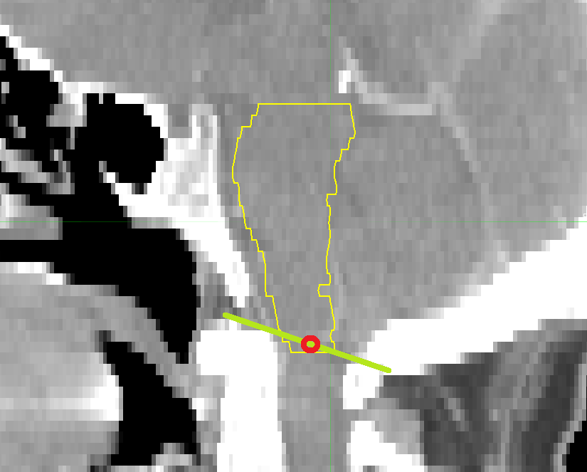Figure 1. The inferior border of the brainstem includes the center of a line connecting the top of the C1 vertebra in saggital view.

The superior extent of brainstem includes top slice containing posterior clinoid, including when posterior clinoid is visible through partial volume averaging. Again, we truncate this as a single slice, and never tilt the boundary across several slices. Figure 2 illustrates this principle, by including slices in the brainstem when the posterior clinioid is visible within the slice.

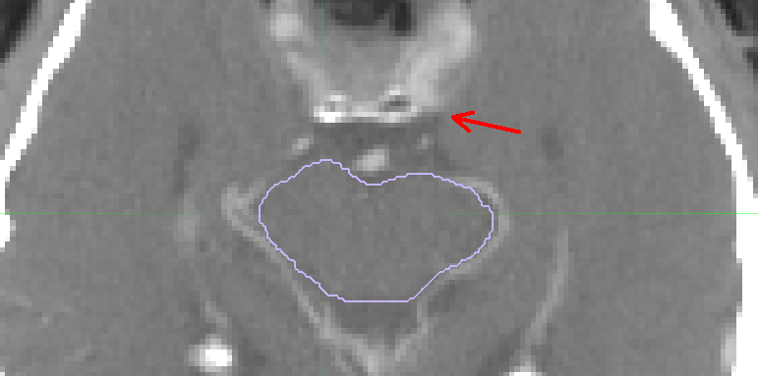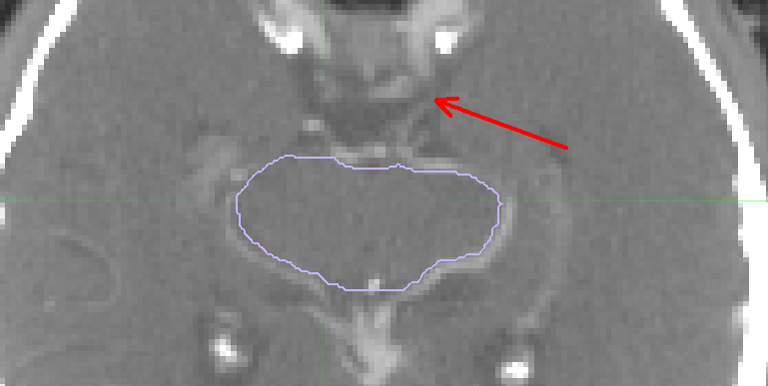
Figure 2. The brainstem is contoured up to and including all slices that contain the clinoid. In the right image, the brainstem is contoured because there is a “partial volume” posterior clinioid visible in the slice.
Parotid segmentation

The parotid glands are salivary glands located below the ears on either side of the face. Contouring of the parotid gland follows the van der Water et al. [6], who define the following borders:

- Cranial boundary at external auditory canal, mastoid process
- Caudal boundary at posterior part of submandibular space
- Anterior boundary at masseter muscle, posterior border of mandibular bone, medial and lateral pterygoid muscle
- Posterior boundary at anterior belly of the sternocleidomastoid muscle, lateral side of posteror belly of the digastric muscle (posterior-medial)
- Lateral boundary at subcutaneous fat and platysma
- Medial boundary at the posterior belly of the digastric muscle, styloid process, and parapharyngeal space

Several vessels that pass through the parotid gland, including facial nerve, external carotid artery, and retromandibular vein. These vessels are included in the contour when they are contained within the enclosing envelope. An example of this is shown in Fig. 3, where following the gland boundary includes half of the vessel.
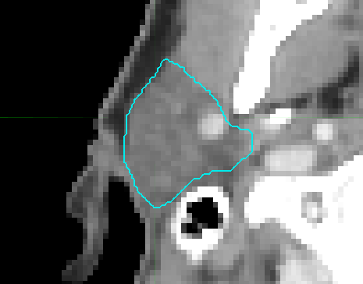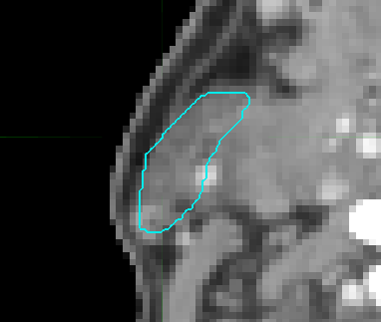
Figure 3. The vessels contained within the parotid gland should be included in the segmentation. It is allowed to include half of a vessel.

It is allowed to include the enclosing capsule in the segmentation, care should be taken to exclude the skin. See Fig 4 (left).

The parotid gland sometimes extends anteriorly over the surface of the masseter muscle. Similarly, in some cases there is an accessory parotid gland which is separated from the main gland. In all cases these should be included in the contour.

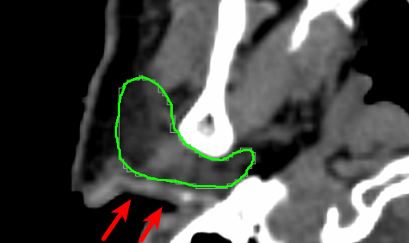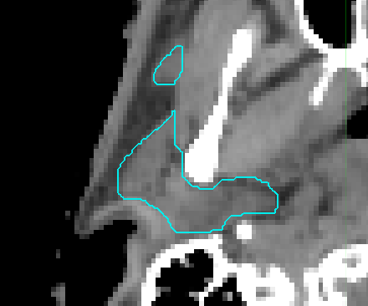
Figure 4. Exclude the skin (left). Include any extensions along the masseter muscle, and accessory parotid gland tissue (right).

Bony landmarks

Five bony landmarks are included for evaluation of gross alignment.

- Chin (chin)
- Right condyloid process (mand_r)
- Left condyloid process (mand_l)
- Odontoid process (odont_proc)
- Occopital bone (occ_bone)
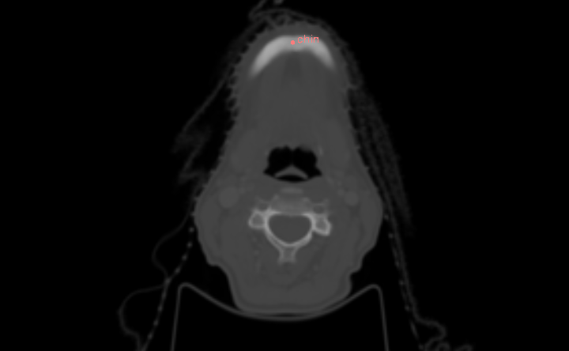
Chin: in axial view, on the last slice in cranio-caudal direction where the chin is visible, click in the center of the mandible bone along its symmetrical centerline.

mand_r and mand_l: in axial view, on the first slice in cranio-caudal direction where the right/left condyloid process is full visible, click in the center of the condyle.

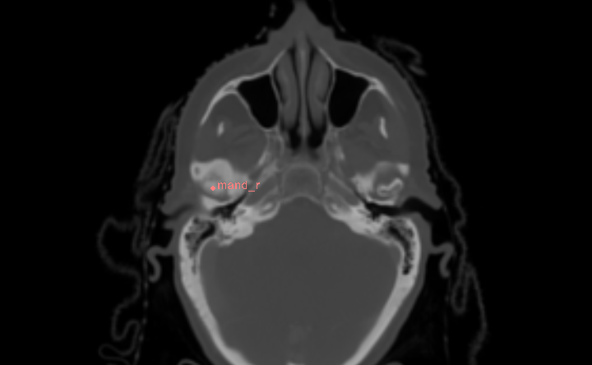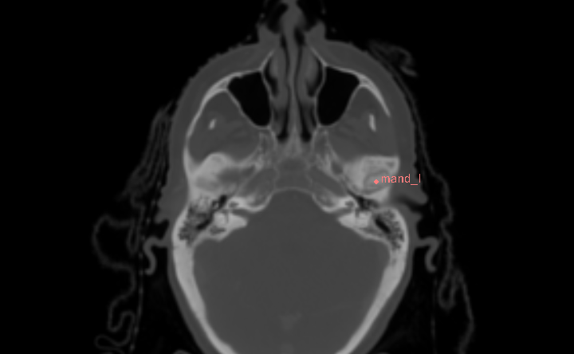

odont_proc: in axial view, on the first slice in cranio-caudal direction where the odontoid process is full visible, click in the center of the dens.

occ_bone: in sagittal view, on the same slice where the chin landmark lies, click the occipital bone as shown below.

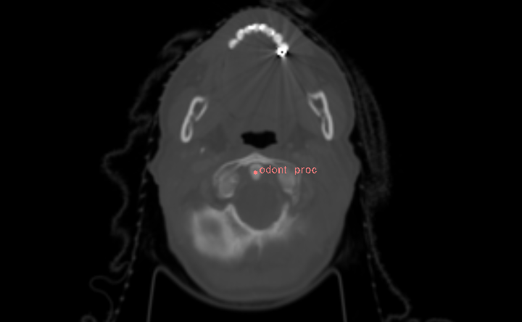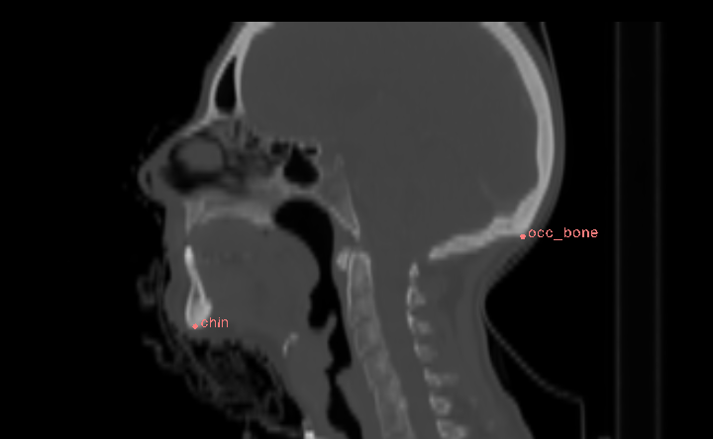
Odontoid process (left) and occipital bone (right)
Acknowledgements

For basic navigation of head and neck anatomy, we recommend the excellent interactive guide developed by Dr. Brett Young [7].

This work was supported in part by the National Alliance of Medical Image Computing (NA-MIC), funded by the National Institutes of Health through the NIH Roadmap for Medical Research, Grant U54-EB005149. Information on the National Centers for Biomedical Computing can be obtained from http://nihroadmap.nih.gov/bioinformatics.

References

[1] Kian Ang et al. A randomized phase III trial of concurrent accelerated radiation and cisplatin versus concurrent accelerated radiation, cisplatin, and cetuximab (C225) [followed by surgery for selected patients] for stage III and IV head and neck carcinomas. RTOG 0522, 2014. http://www.rtog.org/ClinicalTrials/ProtocolTable/StudyDetails.aspx?study=0522

[2] The Cancer Imaging Archive.
http://www.cancerimagingarchive.net/

[3] Santanam, et al. Standardizing Naming Conventions in Radiation Oncology . Int J Rad Onc Biol Phys, 83(4):1344-1349, 2012.

[4] Matchtay, et al. A Phase III Study of Postoperative Radiation Therapy (IMRT) +/- Cetuximab for Locally-Advanced Resected Head and Neck Cancer. RTOG 0920, 2014. http://www.rtog.org/ClinicalTrials/ProtocolTable/StudyDetails.aspx?study=0920

[5] Harani, Rosenthal, et al. Randomized Phase II/III Trial of Surgery and Postoperative Radiation Delivered with Concurrent Cisplatin versus Docetaxel versus Docetaxel and Cetuximab for High-Risk Squamous Cell Cancer of the Head and Neck. RTOG 1216, 2014. http://www.rtog.org/ClinicalTrials/ProtocolTable/StudyDetails.aspx?study=1216

[6] Tara A van de Water, Henk P Bijl, Henriette E Westerlaan, and Johannes A Langendijk. Delineation guidelines for organs at risk involved in radiation-induced salivary dysfunction and xerostomia. Radiother Oncol, 93(3):545–552, Dec 2009.

[7] http://headneckbrainspine.com/web_flash/Neck%20CT%20with%20IV%20contrast.swf

