Plastimatch Users Guide

Gregory C. Sharp
Revision 311
December 15, 2009
Table of Contents
1Getting Started 1
1.1Downloading the code 1
1.2Description of programs 1
2Plastimatch Registration 3
2.1Example registration parameter file 3
2.2Listing of registration parameters 5
3DRR and CBCT 9
3.1DRR Geometry 9
3.2HND Geometry 12
4Appendices 13
4.1CXT File Format 13
4.2DICOM Conformance 15
4.2.1CT Export in plastimatch 15
4.2.2RT Structures 16
4.2.3RT Dose export 16

Getting Started

Downloading the code

The web site at plastimatch.org has instructions on how to download the code.

Description of programs

These are all written in C or C++, and run on Windows or Linux.

Name | Purpose
compose_vector_fields | Compose two vector fields
compute_distance | Compute the distance between a point cloud and a mesh
cxt_to_mha | Render a CXT file into a binary MHA
dice_stats | Compute Dice coefficient for 2 or more volumes
dicom_to_mha | Converter
dicom_uid | Make a new, unique dicom UID
drr | Generate DRR from image volume
fdk | Perform FDK cone-beam reconstruction
mask_mha | Mask out a portion of an image
merge2 | Compose affine and vector field (obsolete?)
merge_vfs | Combine two vector fields (e.g. moving and non moving)
mha_to_raw | Converter
mha_to_rtog_dose | Converter
mha_to_vox | Converter
patient_mask | Generate binary mask for patient boundary
plastimatch | Main registration program
point_path | Fast point trajectory solver
raw_to_mha | Slap an MHA header onto a RAW file
resample_mha | Crop, resize, or resample 3D image or vector field
rtog_to_mha | Converter
shuffle_mha | Reshuffle (x,y,z) axes in certain ways
tps_interp | Make a VF from a set of landmark correspondences
tps_update | Modify registration with thin-plate spline
union_mask | Combine masks with union operation
vf_compare | Compare two vector fields
vf_stats | Print statistics of a vector field
vf3d_to_mha | Converter
vox_to_mha | Converter
xf_to_xf | Converter, can convert XF to VF, or XF to XF

The following driver programs are available. They are used for development.

Name | Purpose
bspline | Run native B-spline registration
demons | Run native demons registration

The following scripts are available. They are written in perl, batch, or matlab. Not every utility program is listed.

Name | Purpose
cms_to_mha | Matlab converter
read_mha | Matlab program to load MHA format
write_mha | Matlab program to save MHA format
write_nrrd | Matlab program to save NRRD format
patient_mask | Matlab program to generate a patient mask if it is missing

Plastimatch Registration

Plastimatch is the main executable program. It is used for image registration, image warping, image resampling, and file format conversion.

Example registration parameter file
## Comments begin with '#', blank lines are ignored
## A "GLOBAL" section is required, and specifies the inputs
## and optional outputs.
##
## For the output files, it is similar, but not exactly the same
## as putting them in the last stage.
##
## The use of xform_out is undefined when xform=vf,
## such as demons registration. Use vf_out instead.
[GLOBAL]
fixed=t0p_221.mha
moving=t5p_221.mha
xform_in=my_bsp.txt
vf_out=my_output_vf.mha
xform_out=my_output_bsp.txt
img_out=my_output_img.mha

## Use a "STAGE" section for each stage of processing.
## You can get outputs (vf_out, xform_out, and img_out) if
## you like.
## Default values will be used for each option unless you
## override them here.
[STAGE]
xform=bspline
optim=lbfgsb
# Use GPUIT implementation
impl=gpuit_cpu
# Use ITK implementation
impl=itk
# Quit after 50 iterations
max_its=50
# Quit if change in score differs by less than 3
convergence_tol=3
# Quit if gradient norm is less than 0.1
grad_tol=0.1
# B-spline grid spacing (in mm)
grid_spac=30 30 30
# Subsample by 4,4,2 in x,y,z directions
res=4 4 2
# At the end of this stage, output the final xform
xform_out=stage_1_output_bsp.txt

## For each subsequent stage, add another "STAGE" section.
## You only need to include parameters that you want to change.
## Any unspecified parameter is inherited from the
## previous stage.
[STAGE]
max_its=20
convergence_tol=4
grad_tol=0.2
res=2 2 1

## To run demons, set optim to "demons" and xform to "vf."
[STAGE]
xform=vf
optim=demons
impl=itk
vf_out=output_2.mha

## If you want to, you can use a "COMMENT" section
## to comment out a stage.
[COMMENT]
xform=bspline
max_its=200

## GPU acceleration requires brook
[STAGE]
optim=demons
xform=vf
impl=gpuit_brook
res=4 4 2
max_its=200
# Std dev of smoothing kernel (in mm)
demons_std=10
# "Gain" factor, higher gains are faster but less robust
demons_acceleration=5
# Homogenezation is the tradeoff between gradient
# and image difference. Values should increase for larger
# voxel sizes, going down to about 1 for 1mm voxels.
demons_homogenization=30
# This is the size of the filter (in voxels)
demons_filter_width=5 5 5

Listing of registration parameters
The parameter file has two sections: a GLOBAL section at the top of the file, and one or more STAGE section. Parameters such as input files are put only in the GLOBAL section. Output files can be put in the GLOBAL section or any STAGE section (which will write out intermediate output).

option | stage | value
fixed | GLOBAL | Name of fixed image
moving | GLOBAL | Name of moving image
xform_in | GLOBAL, STAGE | Initial guess of transform
xform_out | GLOBAL, STAGE | Final solution, as transform
vf_out | GLOBAL, STAGE | Final solution, as vector field
img_out | GLOBAL, STAGE | Warped image
img_out_fmt | GLOBAL, STAGE | “auto” (default)  Output format  Must be either “auto”, which uses filename extenstion to determine, or “dicom”, which iterprets img_out as a directory name to output the dicom files
img_out_type | GLOBAL, STAGE | “auto” (default)  Data type of the output image, usually either float, short, or uchar
background_max | GLOBAL | -1200.0 (default)  Units: image intensity  This is used to automatically determine a region of interest

Optimization parameters. There are three key parameters that decide which algorithm is used for optimization.

xform | optim | impl
align_center | --- | itk
translation | rsg  amoeba | itk
rigid | versor  amoeba | itk
affine | rsg  amoeba | itk
vf | demons | itk  gpuit_cpu  gpuit_brook
bspline | steepest  lbfgs  lbfgsb | itk  gpuit_cpu

Notes:

- Default values are: xform=rigid, optim=versor, impl=itk.
- Amoeba is reported not to work.
- B-spline with steepest descent optimization is only supported on gpuit_cpu implementation.
- B-spline with lbfgs optimization is only supported on itk implementation.

The following specific parameters are used to refine the optimization. Depending on the choice of xform, optim, and impl, a different set of specific parameters are available.

option | xform+optim+impl | value
res | any+any+any | [4 4 1] (default)  [1 1 1] (minimum)  Units: voxels  Must be integers
metric | any+not demons+any | mse (default)  mse, mi, mattes (impl=itk)  mse, mi (impl=gpuit_cpu)
background_val | any+any+any | -999.0 (default)  Units: image intensity
min_its | any+any+any | 2 (default)  Units: iterations
max_its | any+any+any | 25 (default)  Units: iterations
convergence_tol | any+not demons+any | 5.0 (default)  Units: score
grad_tol | any+{lbfgsb or lbfgs}+any | 1.5 (default)  Units: score per unit parameter
max_step | any+{versor or rsg}+itk | 10.0 (default)  Units: scaled parameters
min_step | any+{versor or rsg}+itk | 0.5 (default)  Units: scaled parameters
grid_method | Bspline+any+any | Obsolete
mi_histogram_bins | any+any+any | 20 (default)  Number of histogram bins  Only for gpuit or itk Mattes mutual information
mi_num_spatial_samples | any+any+itk | 10000 (default)  Number of spatial samples.  Only for itk Mattes mutual information
num_grid | Bspline+any+any | Obsolete
grid_spac | Bspline+any+any | [20. 20. 20.] (default)  Units: mm  Must be not less than 4*(Pixel Size) in case of GPUIT implementation. Should not be that small for ITK either.
histoeq | vf+demons+ITK | 0 (default)  Not used. Means don't equalize intensity histograms.
demons_std | vf+demons+any | 6.0 (default)  Units: mm
demons_acceleration | vf+demons+GPUIT | 1.0 (default)  Units: percent
demons_homogenization |  | 1.0 (default)  Units: ??
demons_filter_width |  | [3 3 3] (default)  Units: voxels

DRR and CBCT

DRR Geometry

The DRR code generates images from a volume, using the following geometry description:

Inputs | Units | Default
SID | mm | 1630
SAD | mm | 1000
Angle | degrees | 0
Target | 3d position (mm) | (0,0,0)
Camera | 3d position (mm) | Computed from Target, Angle and SAD
CT Zero | 3d position (vox) | Read from input volume
Panel resolution | pixels | 1024 x 768
Panel size | mm | 400 x 300
Window | pixels | Same as resolution
NRM | 3d direction | Computed from Target and Camera
VUP | 3d direction | Hard coded to (0,0,1)
Panel Orientation | 3d direction | Computed from NRM and VUP

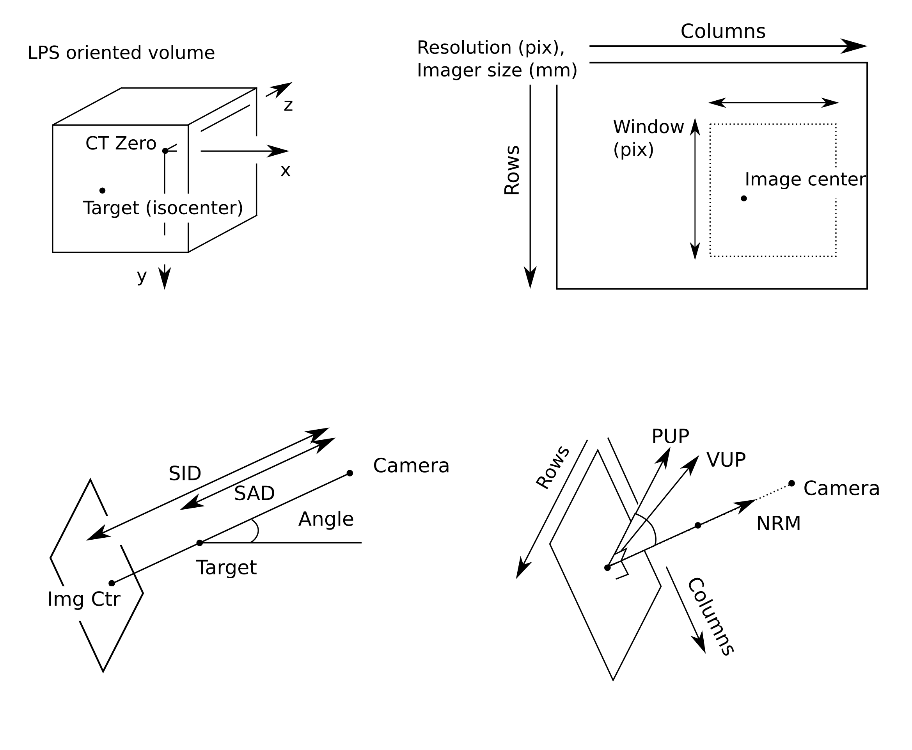
Figure XX: Geometry attributes for DRR calculation

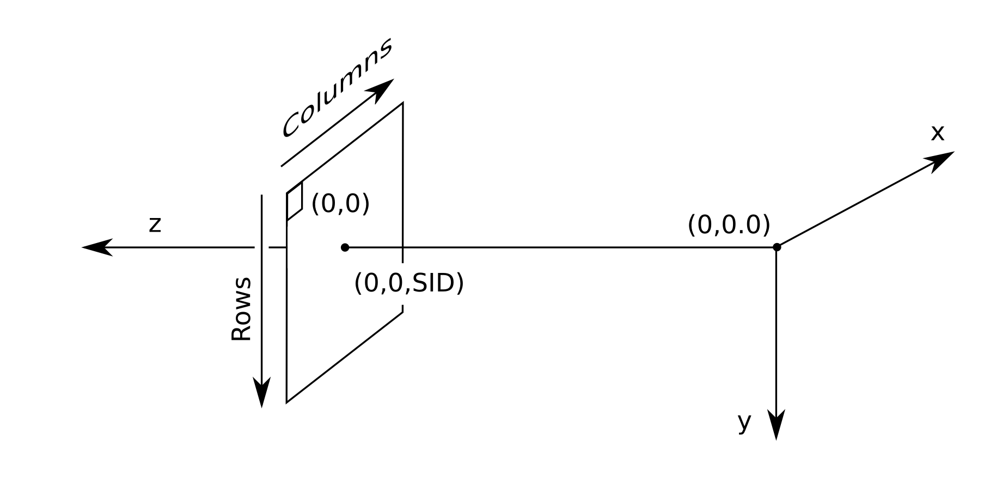
Figure XX: Intrinsic geometry

HND Geometry
By default, when you generate a DRR, the image is oriented as if the virtual x-ray source were a camera. That means that for a right lateral film, the columns of the image go from inf to sup, and the rows go from ant to post. The Varian OBI system produces HND files, which are oriented differently. For a right lateral film, the columns of the HND images go from ant to post, and the rows go from sup to inf. An illustration of this idea is shown in the figure below.

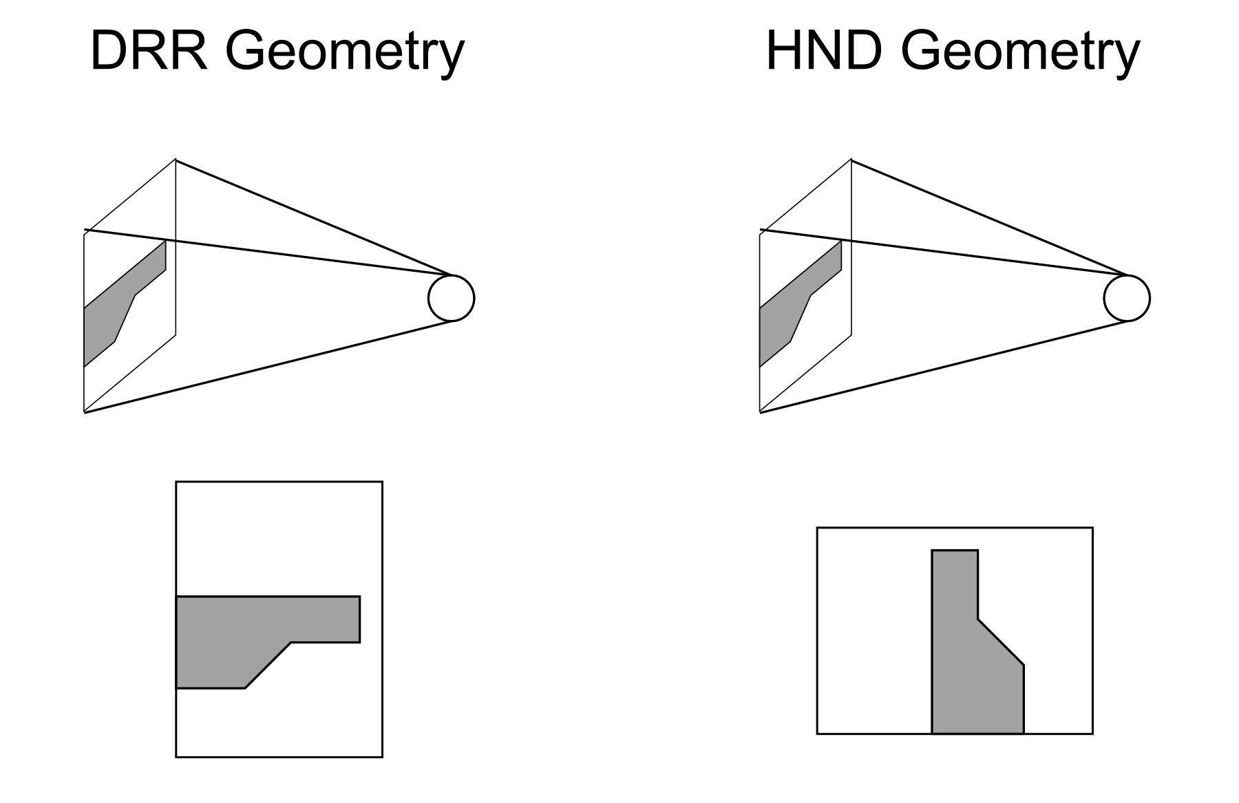
Figure XX: Comparison of DRR and HND geometry.

Appendices

CXT File Format
The cxt file format is an ASCII format that mirrors the DICOM-RT structure set format. The perl utility make_dicomrt.pl converts from CXT to DICOM-RT.
The following sections
Header section | Various flexible ascii fields
ROI section | List of ROI's in the structure set, along with a fixed set of information on each
Contour section | List of contours, with a fixed set of information about each

The header section contains mostly information about the associated volume:
SERIES_CT_UID uid | The uid field specifies the UID for the associated CT volume
OFFSET x y z | The x y z fields specify the position of the first (upper left) voxel in the image
DIMENSION x y z | The x y z fields specify the size of the volume
SPACING x y z | The x y z fields specify the inter-voxel spacing

Each line of the ROI section contains three fields, separated by the ASCII space “ ”.
Field | Value | Example
Number | A postitive integer | 1
Color | RGB tuple, separated by backslashes | 0\255\0
Name | ascii string | gtv_primary

Each line of the contour section has 6 fields, separated by the pipe symbol “|”.

Field | Value | Example
ROI Number | A postitive integer, referring to the ROI | 1
Contour thickness | This is used by GE. Not sure how useful it is | 2.5
Number of points | How many points in the contour? | 3
Slice index | Which slice does this contour belong to within the CT series of interest? The numbering start with 0 for the first slice sorted by Z. | 20
Associated slice UID | Which slice does this contour belong to within the CT series of interest? | 2.16.840.1.114362.1.90609.1196125535718.935
Points | Sequence of x\y\z tuples, separated by backslashes. Units are mm. z value should be the same for all of the points. | 5.4\-63.2\10\8.4\-66.2\10\1.8\-49.0\10

DICOM Conformance
Obviously, this section is under development.

The DICOM prefix for plastimatch is 1.2.826.0.1.3680043.8.274.1. This is a subrange of the prefix 1.2.826.0.1.3680043.8.274 which was assigned by Medical Connections.

Plastimatch defines UIDs the following sub-subrange(s). All other uses are reserved.

1.2.826.0.1.3680043.8.274.1.Y.ZZZZZZZZZZZZ

Y = 1 Reserved for non-clinical data (phantoms, special projects, software development)
Y = 2 Clinical data
Z Up to 33 digits and dots

Mondoshot uses the following scheme:

Y = 1.200.ZZZZZZZZZZZ Non-clinical
Y = 2.200.ZZZZZZZZZZZ Clinical

Plastimatch uses two different dicom engines. GDCM for itk-related routines, and DCMTK for non-itk routines (dicom_uid.exe, mondoshot.exe, perl scripts, etc.). These engines have different default conformance properties.

CT Export in plastimatch

IE | Module | Reference (Dicom 2004)
Patient | Patient | C.7.1.1
Study | General Study | C.7.2.1
Series | General Series | C.7.3.1
Frame of Reference | Frame of Reference | C.7.4.1
Equipment | General Equipment | C.7.5.1
Image | General Image | C.7.6.1
 | Image Plane | C.7.6.2
 | Image Pixel | C.7.6.3
 | CT Image | C.8.2.1
 | SOP Common | C.12.1

Patient Module
Attribute Name | Tag | Type | Notes
Patient Name | (0010,0010) | 2
Patient ID | (0010,0020) | 2
Patient's Birth Date | (0010,0030) | 2 | No value assigned
Patient's Sex | (0010,0040) | 2 | No value assigned

Frame of Reference Module

Attribute Name | Tag | Type | Notes
Frame of Reference UID | (0020,0052) | 1
Position Reference Indicator | (0020,1040) | 2 | No value assigned

RT Structures
To be written.

RT Dose export
To be written.

