plastimatch digitally reconstructed radiographs (DRR) application programming interface (API)

Version | Author | Subject | Date
0.8 | Phil, Markus | initial proposal based on online-meeting from 07/05/11 | 07/09/11
0.85 | Greg, Brian, Guy, Markus, Phil | Careful review of version 0.8; in addition: no support of volumes with unequal slice spacing, clarification of ITF, array-like DRR-masks and projection properties required | 07/28/11

Content

1. Coordinate System 3
2. Specification of the DRR projection geometry 3
3. Specification of the volumetric data set to be imaged 5
4. Transformation of the volume 6
5. Intensity transfer functions 7
6. Conversion of the projection geometry to matrix form 8
7. Resultant source code interfaces 10
a. Geometry definition 10
b. Intensity transfer function (ITF) definition 11
c. Computation of digitally reconstructed radiographs (DRRs) 12

Coordinate System
Basically, all geometrical definitions (point/vector/transformation specifications) refer to a fixed, global, right-handed coordinate system formed by an orthonormal basis in 3D space. This coordinate system is referred to as world coordinate system (WCS). Furthermore, coordinates/distances/vectors are expressed in terms of "physical units". It is the user's responsibility to provide consistency. However, we suggest using millimeters (mm). Rotations are expressed in degrees (deg, °) and restricted (and wrapped if necessary) to the range [-180.0; +180.0] deg. The first WCS axis is referred to as x_{W}, the second y_{W} and the third z_{W}.

Specification of the DRR projection geometry
The essential specification of the DRR projection geometry is based on coordinate (point) and vector specifications in WCS. The specification does not presume a certain class of projective imaging devices (e.g. rotational C-arm systems). However, the following assumptions are inherent:
- The perspective projection emerges from an infinitesimally small point source (focal spot) located at a specified position in WCS.

- The projection rays emerging from the source are "imaged" by a digital reception area (detector). The discretized 2D grid of the detector is flat and rectilinear with a certain finite pixel size. Physical effects in the detector are not contributed for; i.e. the detector is infinitesimally thin.
- The position and orientation of the 2D detector in (3D) WCS is well-defined by providing its origin (center of the first detector pixel) and orientation (row direction, column direction).
- There is no explicit collimation of the source rays. We rather use the rectangular collimation which is implicitly given by the fact that solely rays that intersect with the digital reception area are considered.
- There is no general restriction on the position and pose of the imaging detector related to the source and the WCS origin. Certainly, the detector plane is not required to be orthonormal to the central axis (ray that passes from source through WCS origin). Each concrete DRR engine must provide this general flexibility.
- There is no general restriction on the position of the source and the position and pose of the imaging detector relative to the imaged volumetric data set. It is thinkable that the source position is located within the volumetric data set. It is equally possible that the whole detector or parts of it intersect the volumetric data set. A concrete DRR engine does not necessarily have to implement these requirements as some of these considerations potentially harm DRR computation performance. The only important thing is that voxels “after” the detector plane do not contribute to the generated DRR.
Summing up, the projection geometry is fully defined by a set of six information parameters:
- The source position S_{W} is defined by the WCS coordinate 3-tuple (x_{S},y_{S},z_{S}).
- The detector origin D_{W} is defined by the WCS coordinate 3-tuple (x_{D},y_{D},z_{D}). It indicates the center of the first detector image pixel.
- The detector orientation is defined by two normalized vectors r_{W} and c_{W}. The row vector r_{W} indicates the direction of the detector pixel rows (horizontal lines), and the column vector c_{W} indicates the direction of the detector pixel columns (vertical lines). As the detector defines a rectilinear grid, r_{W} · c_{W} = 0 must be fulfilled. The components of r_{W} and c_{W} are also referred to as direction cosines.
- The 2-tuple s_{D} specifies the size (spacing) of the detector pixels along its row (first component, s_{Dx}) and column (second component, s_{Dy}) direction, respectively.
- The 2-tuple d_{D} specifies the dimension of the detector along its directions in pixels. The first component d_{Dx} is the detector width (along its row direction), and the second d_{Dy} is the detector height (along its column direction).

The following two figures summarize the nature of the projection geometry, and show how an exemplary point P_{W} of the imaged volumetric data set is pro

jected onto the point p_{D} on the detector plane according to the projection geometry.
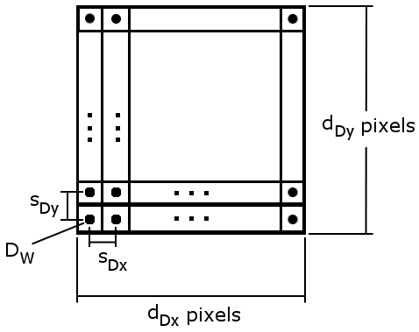

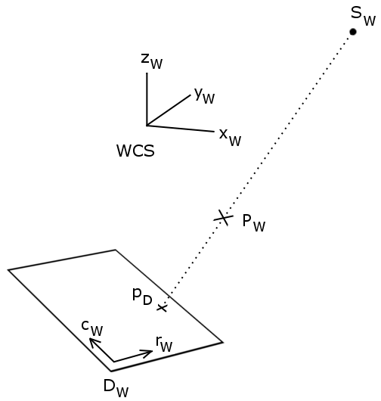

Specification of the volumetric data set to be imaged
The volumetric data set which is imaged by a DRR algorithm (which uses the projection geometry as mentioned above) is assumed being defined on a rectilinear voxel grid. The volume's basic position and orientation in the WCS is defined by a set of five information parameters:
- The volume origin V_{W} is defined by the WCS coordinate 3-tuple (x_{V},y_{V},z_{V}). It indicates the center of the first volume voxel.
- The volume orientation is defined by two normalized vectors r_{VW} and c_{VW}. The row vector r_{VW} indicates the direction of the volume voxel rows, and the column vector c_{VW} indicates the direction of the volume pixel columns. As the volume is defined on a rectilinear grid, r_{VW} · c_{VW} = 0 must be fulfilled. The third direction of the volume, along the “slicing” direction, is given by r_{VW} x c_{VW}.
- The 3-tuple s_{V} specifies the size (spacing) of the volume voxels along its row (first component, s_{Vx}), column (second component, s_{Vy}) and slicing (third component, s_{Vz}) directions.
- The 3-tuple d_{V} specifies the dimension of the volume along its directions in voxels. The first component d_{Vx} is the volume width (along its row direction), and the second d_{Vy} is the volume height (along its column direction) and the third d_{Vz} is the volume depth (along its slicing direction).
The following figure illustrates the volume specification in WCS.
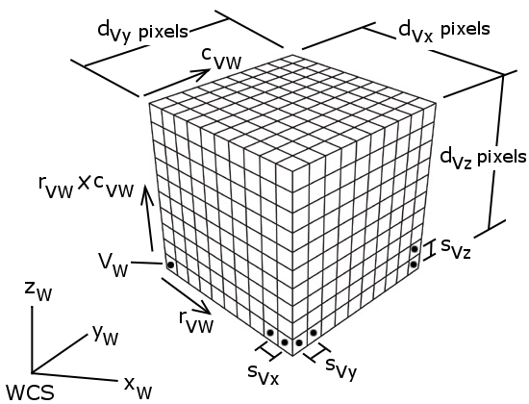

NOTE: The is currently no support for volumes that are defined by slices having unequal slice distances!

Transformation of the volume
However, the volume as defined above is in general not what is really imaged by a DRR algorithm. The volume is rather transformed before the virtual rays emerging from S_{W} intersect the voxels in the WCS. This is achieved by applying a spatial 3D transformation T to the volume. The transformation may vary in its complexity (rigid, affine, deformable). A concrete DRR engine implementation may support solely a subclass of general 3D transformations (e.g. only rigid ones).
A rigid transformation T_{R} is for example defined by an orthogonal rotation matrix R_{R} and a translation vector t_{R}. Hence, the effective volume which is imaged is given by the origin R_{R}V_{W} +t_{R} and the orientation R_{R} r_{VW} , R_{R} c_{VW} .
Furthermore, the transformation T may essentially be a composition of different sub-transformations T=T₁○T₂○... . For example, a first transformation T₁ could model a basic “setup” which aligns the patient and the imaging system in terms of a specified “frame of reference”. A second consecutive transformation T₂ could explain an actual misalignment compared to the planned position and pose. The following figure illustrates such a scenario.

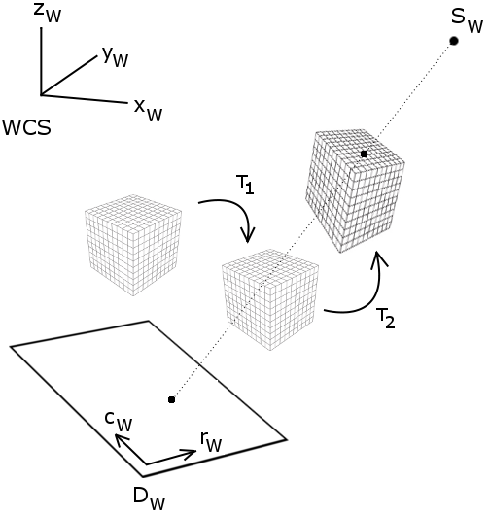

HINT: If a DRR engine supports only rigid transformations of the imaged volume, it may be more efficient to transform the projection geometry (source position, detector origin and orientation) inversely than transforming each voxel coordinate.

Intensity transfer functions
Basically, DRR algorithms collect the volume's voxel intensities along the virtual rays and sum them up to generate projective output intensities on the detector. In order to enable extended “radiometric calibration” and modeling of occurring physical effects, it may be useful to have an intensity transfer function (ITF) which maps the original volume intensities onto a different scale. A simple but flexible way to define an ITF is pairwisely specifying the mapped volume input and output intensities, and linearly interpolating between the specified pairs.
The following graph shows an exemplary ITF mapping input volume intensities between 0 and 255 to output intensities between 0 and 230 by defining a set of 11 intensity pairs (supporting points) and interpolating linearly between them. The mapped intensities between 0 and 230 are finally summed up during DRR computation.
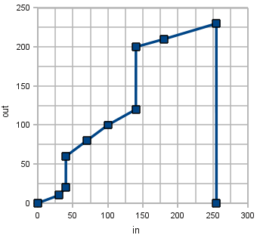
NOTE: By definition, input values out of the ITF’s supporting point list range (below minimum input / above maximum input supporting point value) are clamped to 0 (no contribution)! For example, the input values -5 and +300 in the example below would be mapped to 0.
This document does not urge any DRR implementation to integrate ITF-capabilities; it can be rather considered optional.
Moreover, this document does not regulate whether a DRR implementation applies the ITF-mapping to each sampled volume “on the fly” or it first applies the ITF to the whole volumetric data set and then samples (and possibly interpolates) the already mapped volume voxels during DRR computation. There may, however, be a considerable difference between those implementations which first collectively apply an ITF and then interpolate, and those implementations which apply an ITF to natively sampled (and possibly interpolated) voxel intensities.

Conversion of the projection geometry to matrix form
Given the projection geometry as mentioned above, the according homogeneous projection matrix can be derived as outlined below. Multiplying an arbitrary point coordinate of the imaged volumetric data set (in WCS) with this matrix, and performing the “homogeneous divide” or “perspective divide”, gives the projected coordinates of that point on the virtual detector plane.
For some concrete DRR engine implementations the projection matrix might be helpful or required. We, however, suggest to keep things simple and to avoid using the projection matrix for DRR computation.

There are several ways on how to derive a 3×4 projection matrix, which computes the linear transformation from homogenous 3D space to 2D space based on the DRR projection geometry.
One approach is to solve the homogeneous system of linear equations for the perspective projection matrix M. Each correspondence between a 3D point and a 2D image point gives one equation: 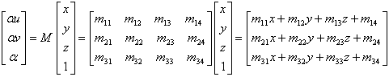
This means every known point correspondence gives two linear equations with 12 unknowns each. Actually 11 unknown variables need to be solved due to an unknown scaling factor:
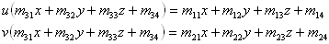
At n known point correspondences a linear system can be defined by a 2n×12 matrix:
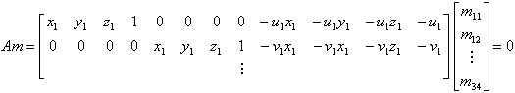
With 6 corresponding points the system is overdetermined, and can be solved for m. The linear system Am=0 then has 11 unknowns in 12 equations. There is always a trivial solution m=0 because A·0=0. We are interested in m≠0, which implies that A has to have a rank of at least 11. The solution is to find the right zero space m, because A maps to zero. The zero space can be found by singular value decomposition (SVD). SVD is a linear algebraic technique to solve linear equations in a least square sense (closest possible solution) and works on general matrices (even singular and close to singular matrices). Any m×n matrix A, with m≥n can be decomposed into three matrices A=UDV^{T}. Matrix U has orthonormal columns, D is a non-negative diagonal matrix and V^{T} has orthonormal rows. The solution is the column of V with the smallest singular value σ_{n} in D. The smallest singular value would be zero if all data is exact, which is generally not the case in floating point arithmetics.
Another approach is to use known geometric projection properties and only solve for the plane to plane homography H (3×3matrix) after perspective projection P (3×4 matrix): M=HP. P is the projective part (SAD=source axis distance, SID=source image distance, both on source-axis direction) in combination with scaling factors to accommodate for detector spacing (s):
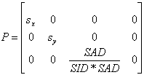
After projection of the 3D points X, the resultant homogenuous 2D coordinates are used to solve for the homography matrix H, which has 8 degrees of freedom (requires 4 corresponding point pairs).
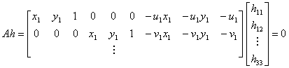

Resultant source code interfaces

Geometry definition

The ITK-based class which is responsible for modeling the projection geometry as mentioned above is ora::ProjectionGeometry.

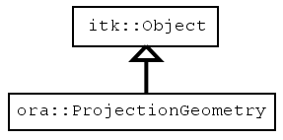

It provides the following public methods (interface):

// Setter/getter for the source position
void SetSourcePosition(double position[3])
double *GetSourcePosition()
// Setter/getter for the detector origin
void SetDetectorOrigin(double origin[3])
double *GetDetectorOrigin()
// Setters/getters for the detector orientation
void SetDetectorOrientation(double row[3], double column[3])
void SetDetectorRowOrientation(double row[3])
void SetDetectorColumnOrientation(double column[3])
double *GetDetectorRowOrientation()
double *GetDetectorColumnOrientation()
// Setter/getter for the detector pixel spacing
void SetDetectorPixelSpacing(double spacing[2])
double *GetDetectorPixelSpacing()
// Setter/getter for the detector size (in pixels)
void SetDetectorSize(int size[2])
int *GetDetectorSize()
// Return whether the currently configured projection geometry is valid (e.g.
// whether row and column vectors are orthogonal)
bool IsGeometryValid()
// Compute the 3x4-projection matrix from the currently configured projection
// geometry settings (if not up-to-date) and return its 12 components as
// flat double-array where the column moves fastest
double *Compute3x4ProjectionMatrix()

In order to enable easy configuration of concrete imaging devices, one can easily derive from ora::ProjectionGeometry and implement a subclass which provides a simpler (device-specific) geometry configuration interface. For example, one could implement a class ora::LinAcMVGeometry which derives from ora::ProjectionGeometry. This class could then provide a public method SetGantryAngle(double) which internally computes the source position, detector origin and orientation from the specified gantry angle by internally knowing the nominal source-to-axis distance, source-to-film distance and flexmap calibration data.

Intensity transfer function (ITF) definition

The ITK-based class which is responsible for modeling the ITF as mentioned above is ora::IntensityTransferFunction. It defines the ITF by using input-output-pairs as supporting points and interpolating between them linearly as described earlier in this document. Besides the fact that this class is capable of reflecting the definition of an ITF, it is also capable of mapping input-values to output-values according to the ITF-definition.

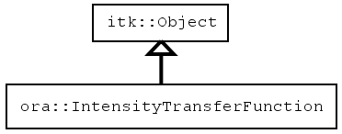

It provides the following public methods (interface):
// Manipulation methods for adding/removing/retrieving supporting points
void AddSupportingPoint(double in, double out)
int GetNumberOfSupportingPoints()
void RemoveSupportingPoint(int i) // i is 0-based supporting point index
void RemoveAllSupportingPoints()
void InsertSupportingPoint(int i, double in, double out)
double *GetInValues()
double *GetOutValues()
// Mapping methods which map in values to out values according to the supporting
// points and computing values between the supporting points using
// linear interpolation
template<typename TPixel> inline TPixel MapInValue(TPixel in)
template<typename TPixel> inline void MapInValue(TPixel in, TPixel &out)
template<typename TPixel> inline void MapInValues(int count, TPixel *ins,
TPixel *outs)

Computation of digitally reconstructed radiographs (DRRs)

The abstract ITK-based base class for DRR computation is ora::DRRFilter. It is templated over the input pixel type (pixel type of the volumetric data set to be imaged) and the output pixel type (pixel type of the output DRR containing summed intensities). It is worth being noted that the output DRR is not 2-dimensional, it is rather a 3D image with a default slice thickness of 1.0 physical units (spacing) having the configured origin and orientation in 3D space.
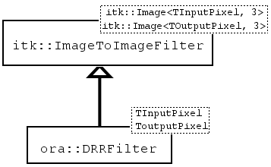

As this interface is inherited from itk::ImageToImageFilter and the behavior needs to be adapted, the following methods must be reimplemented:

void SetInput(InputImagePointer image)
virtual void GenerateOutputInformation()
virtual void GenerateInputRequestedRegion()
virtual unsigned long GetMTime()
virtual void PrintSelf(std::ostream &os, itk::Indent indent) const
virtual void EnlargeOutputRequestedRegion(itk::DataObject *data)
virtual void GenerateOutputRequestedRegion(itk::DataObject *data)
virtual void GenerateData()
// in case of CPU-based multi-threading:
virtual void ThreadedGenerateData(const OutputImageRegionType&
outputRegionForThread, int threadId)
virtual void BeforeThreadedGenerateData()
virtual void AfterThreadedGenerateData()

In addition to the pure itk::ImageToImageFilter interface, the base class provides the following public interface:

// Setter/getter for the number of independent outputs; the base class assumes
// that a DRR engine can manage more than just one output (e.g. one output per
// projection geometry; mainly interesting for n-way 2D/3D registration)
void SetNumberOfIndependentOutputs(int numOutputs)
int GetNumberOfIndependentOutputs()
// Define to which output the next Update() refers to
void SetCurrentOutputIndex(int currIndex)
// Setter/getter for the volume transformation object (DRR engines can or cannot
// handle NULL-pointers for the transform)
void SetTransform(itk::Transform<double,3,3>::Pointer transform)
itk::Transform<double,3,3>::Pointer GetTransform()
// Setter/getter for the projection geometry to be used for DRR generation; must // not be NULL when calling Update()!
void SetProjectionGeometry(ora::ProjectionGeometry::Pointer geometry)
ora::ProjectionGeometry::Pointer GetProjectionGeometry()
// Setter/getter for pixel mask defining which output pixels should be generated
// at the next Update(); mask images must have the same number of pixels and
// dimension as defined by the current projection geometry (dimension); pixels
// are of type unsigned char; pixels which are non-zero indicate pixels in the
// DRR that should be generated, other pixels will be constantly set to zero
void SetDRRMask(MaskImagePointer mask)
MaskImagePointer GetDRRMask()
// Indicate whether the DRR engine supports masking or not
virtual bool IsSupportingDRRMasks()
// Setter/getter for the intensity transfer function to be used; optional
void SetITF(ora::IntensityTransferFunction::Pointer itf)
ora::IntensityTransferFunction::Pointer GetITF()
// Indicate whether the DRR engine supports ITFs or not
virtual bool IsSupportingITF()
// Indicate whether all current settings are satisfactory so that the next
// Update() will succeed
virtual bool DRRCanBeComputed()

NOTE:
Concrete DRR implementations can be based on the CPU (single-threaded or multi-threaded) and/or on the GPU (single instruction multiple threads, SIMT). If the implementation is based on the GPU or is single-threaded on the CPU, the GenerateData() method should be used to initiate/execute the Update(). Otherwise, the ThreadedGenerateData(), BeforeThreadedGenerateData() and AfterThreadedGenerateData() should be used. Many specific DRR implementations may require additional configuration items (e.g. uniform ray-casting requires a sampling-distance along the casted rays) – these configurations (and the associated setters/getters) are however specific to these implementations and are, therefore, not implemented in the basic interface.

