Autolabel T-spine “HOWTO”

STEP 0
Load image
Fiducials -> Create new fiducial list
File -> Save (set names for fiducial and mrml)

STEP 1
Locate C7 in axial view. It is the one with a foramen in the transverse process
Locate T1 in axial view. It is the one with that connects to the first rib

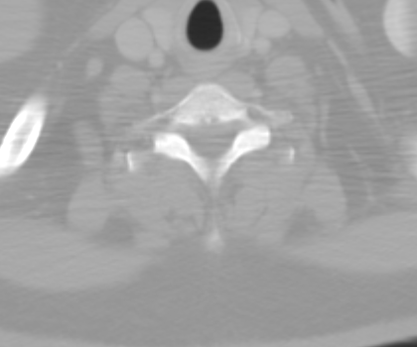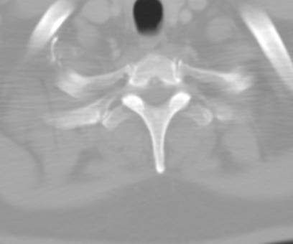
C7 T1

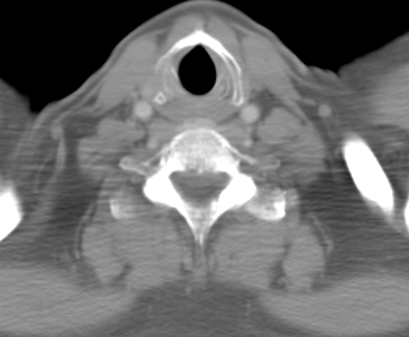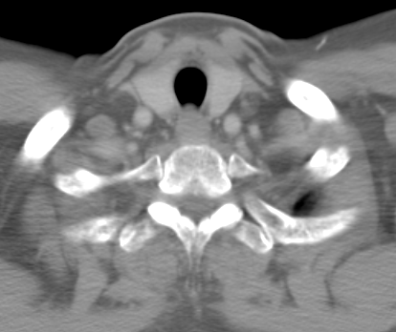
C7 T1
STEP 2
Mark T1 in center of body.
Switch to sagittal view

STEP 3
Mark T2-T12 in sagittal view

STEP 4
Renumber and rename fiducials

STEP 5
Double check work:
T10 is last vertebra where transverse process articulates with ribs
T12 is last vertebra which articulates with rib

STEP 6
Save

