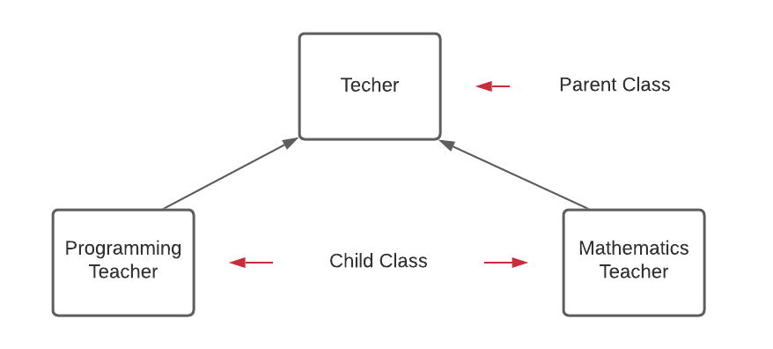

The type of inheritance used in the activity is Hierarchical. Hierarchical inheritance by definition is when one or more than one classes inherit the same parent class. As you can see in the picture above, the class has more than one child classes which are programming teacher and mathematics teacher that have the same parent class which is Teacher class. Teachers teach, but its a generic statement. Students take multiple different field classes such as mathematics,science, history,programming and etc. This is why we have specialized teachers based on a specific field.

In the case of my activity, a Programming Teacher is-a Teacher and specializes in teaching programming. On the other hand , a Mathemathics teacher is also a teacher and specializes in teaching the field of mathematics. Similarly, there are many more specialized field of teacher and each of them specialized in one specific field.

The parent class, teacher, have one global property which is specialization. The class will also have methods such as field, a latter overloaded method for its childclass to specifiy their own field, and love (what they love to do).

To establish the relationship between the teacher and its child class, I use the extends keyword. By just adding it ,the child class can inherit all instance members from the parent class. Thus, this allow to add more specialization.

That being said, in my activity, A Programming Teacher is-a Teacher and inherit the attributes and methods from Teacher class. The same goes for mathemetics teacher. But, both Programming and Mathematics are extending from Teacher class and share the is-a relationship with Teacher, but there is no relationship between them. Programming Teacher is not a Mathematics Teacher and vice versa.

Lastly, in addition to the attributes and methods inherited from parent class, the child class being a more specialized version of its parent class can also add its own methods. In the case of my activity, I add the topic method for mathematics teacher while knowlanguage method for the programming teacher. Moreover, an overridden method was used in the love method of parent class to specify one’s love. For instance, a love method with “I love coding” was used in the Programmign teacher class while, a love method with “ I love solving” was used in the Mathematics teacher class.