Data analysis

3/16/2022

**Introduction**

In recent decades, carbon footprints and greenhouse gases have had a substantial influence on climate change. Governments and environmental organizations have worked hard with contemporary technology to create a more positive picture of the environment. The purpose of this study is to re-analyze secondary data acquired by the Green Supply Chain organization; data evaluations will be studied for the link between an organization's success and its environmental performance. The Economic and Social Research Council funded the original study (ESRC). The FAME database was used to collect 1848 samples of manufacturing enterprises with more than 250 employees; the companies' functions varied and were grouped into 32 categories. 250 manufacturers were chosen at random from the sample and were contacted to conduct an online survey, with a hired group assessing their performance; in the end, 53 respondents completed the study (ReShare, 2015)

**Part_I: Internal_Integration**

Frequency distribution of Internal integration of the concept of green

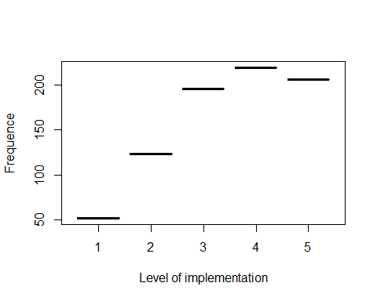

What is the less implemented? from the 15Th? By the mean of values we can get the results. we need this to help them or advise them to advance in their green policy.

## Q round(colMeans(data_1))  
## Q1_1_a Q1_1_a 4  
## Q1_2_a Q1_2_a 4  
## Q1_3_a Q1_3_a 4  
## Q1_4_a Q1_4_a 2  
## Q1_5_a Q1_5_a 4  
## Q1_6_a Q1_6_a 3  
## Q1_7_a Q1_7_a 3  
## Q1_8_a Q1_8_a 4  
## Q1_9_a Q1_9_a 3  
## Q1_10_a Q1_10_a 4  
## Q1_11_a Q1_11_a 4  
## Q1_12_a Q1_12_a 4  
## Q1_13_a Q1_13_a 4  
## Q1_14_a Q1_14_a 3  
## Q1_15_a Q1_15_a 3

From the analysis, the participants have integrated the green comcept in their business but they *rarely emphasis* on the green concept when it comes to business strategies which reward top management based on successful achievement of environmental goals.

**Part_II:_Supplier_integration Frequency distribution of Supplier_integration of the concept of green**

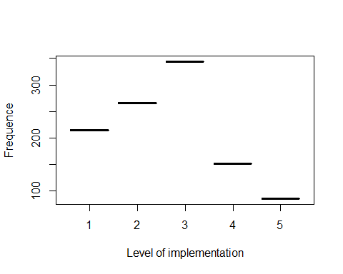 Most of the respondant do not implement the green concept when it comes to Supplier_integration. Let’s see inside

## Q round(colMeans(data_2))  
## Q2_1_a Q2_1_a 3  
## Q2_2_a Q2_2_a 3  
## Q2_3_a Q2_3_a 4  
## Q2_4_a Q2_4_a 3  
## Q2_5_a Q2_5_a 3  
## Q2_6_a Q2_6_a 3  
## Q2_7_a Q2_7_a 3  
## Q2_8_a Q2_8_a 2  
## Q2_9_a Q2_9_a 2  
## Q2_10_a Q2_10_a 2  
## Q2_11_a Q2_11_a 2  
## Q2_12_a Q2_12_a 2  
## Q2_13_a Q2_13_a 2  
## Q2_14_a Q2_14_a 2  
## Q2_15_a Q2_15_a 3  
## Q2_16_a Q2_16_a 3  
## Q2_17_a Q2_17_a 3  
## Q2_18_a Q2_18_a 3  
## Q2_19_a Q2_19_a 3  
## Q2_20_a Q2_20_a 3

The only one thing they use to do well with their supliers is to exchange information about cleaner production and cleaner technologies with supliers. For the rest they did it rarely or sometimes.

**Part III**

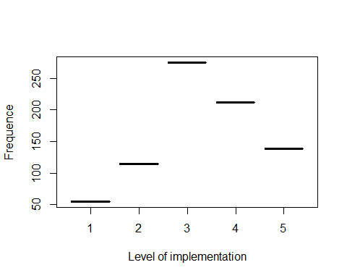

They integrate the green concept with their customers sometimes. No need to go deeper here.

**Part Iv: Stakeholder coordination engagement**

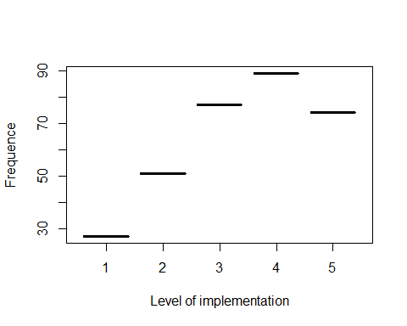

**Part V: Environnemental management pratices**

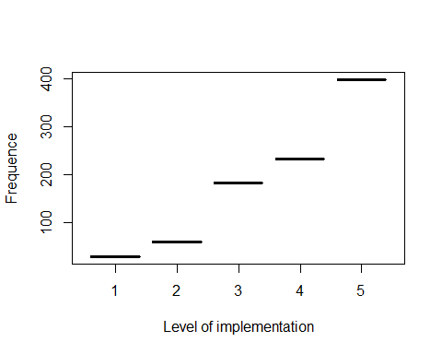 **Part VI: Company business performance**

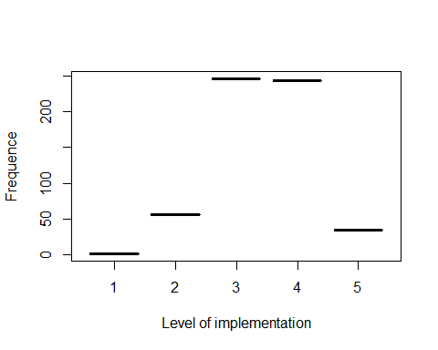

**Part Vii Company environnement performance acheived in the past two years**

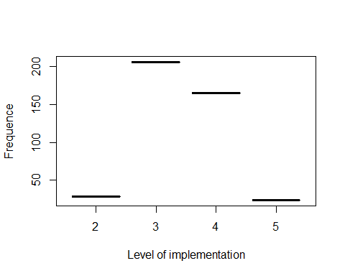

**Part Viii: Company environnement performance**

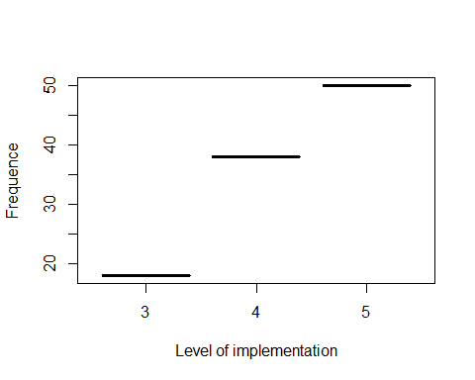

Contact me at [simkitegi@gmail.com](mailto:simkitegi@gmail.com) for any further details