Data analysis

Simon Pierre

3/16/2022

Part_I: Internal_Integration

Frequency distribution of Internal integration of the concept of green

library(tidyverse)

## -- Attaching packages --------------------------------------- tidyverse 1.3.1 --

## v ggplot2 3.3.5 v dplyr 1.0.7  
## v tibble 3.1.5 v stringr 1.4.0  
## v tidyr 1.1.4 v forcats 0.5.1  
## v purrr 0.3.4

## -- Conflicts ------------------------------------------ tidyverse_conflicts() --  
## x dplyr::filter() masks stats::filter()  
## x dplyr::lag() masks stats::lag()

plot(as.data.frame(table(unlist(data_1))), xlab("Level of implementation"), ylab("Frequence"))

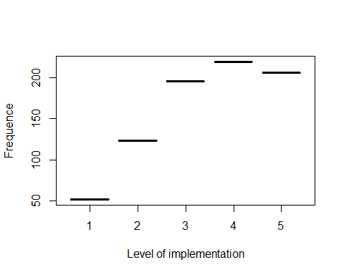 What is the less implemented? from the 15Th? By the mean of values we can get the results. we need this to help them or advise them to advance in their green policy.

library(dplyr)  
means <- as.data.frame(round(colMeans(data_1)))  
means <- cbind(Q=rownames(means),means)  
means

## Q round(colMeans(data_1))  
## Q1_1_a Q1_1_a 4  
## Q1_2_a Q1_2_a 4  
## Q1_3_a Q1_3_a 4  
## Q1_4_a Q1_4_a 2  
## Q1_5_a Q1_5_a 4  
## Q1_6_a Q1_6_a 3  
## Q1_7_a Q1_7_a 3  
## Q1_8_a Q1_8_a 4  
## Q1_9_a Q1_9_a 3  
## Q1_10_a Q1_10_a 4  
## Q1_11_a Q1_11_a 4  
## Q1_12_a Q1_12_a 4  
## Q1_13_a Q1_13_a 4  
## Q1_14_a Q1_14_a 3  
## Q1_15_a Q1_15_a 3

From the analysis, the participants have integrated the green comcept in their business but they *rarely emphasis* on the green concept when it comes to business strategies which reward top management based on successful achievement of environmental goals.

Part_II:_Supplier_integration Frequency distribution of Supplier_integration of the concept of green

plot(as.data.frame(table(unlist(data_2))), xlab("Level of implementation"), ylab("Frequence"))

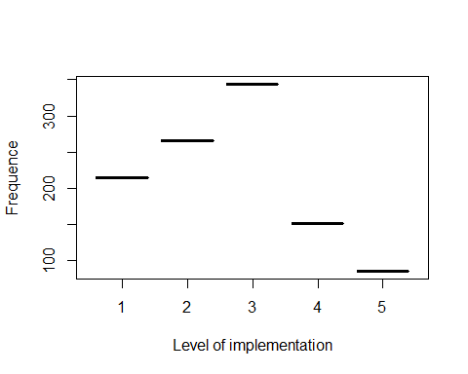 Most of the respondant do not implement the green concept when it comes to Supplier_integration. Let’s see inside

means_2 <- as.data.frame(round(colMeans(data_2)))  
means_2 <- cbind(Q=rownames(means_2),means_2)  
means_2

## Q round(colMeans(data_2))  
## Q2_1_a Q2_1_a 3  
## Q2_2_a Q2_2_a 3  
## Q2_3_a Q2_3_a 4  
## Q2_4_a Q2_4_a 3  
## Q2_5_a Q2_5_a 3  
## Q2_6_a Q2_6_a 3  
## Q2_7_a Q2_7_a 3  
## Q2_8_a Q2_8_a 2  
## Q2_9_a Q2_9_a 2  
## Q2_10_a Q2_10_a 2  
## Q2_11_a Q2_11_a 2  
## Q2_12_a Q2_12_a 2  
## Q2_13_a Q2_13_a 2  
## Q2_14_a Q2_14_a 2  
## Q2_15_a Q2_15_a 3  
## Q2_16_a Q2_16_a 3  
## Q2_17_a Q2_17_a 3  
## Q2_18_a Q2_18_a 3  
## Q2_19_a Q2_19_a 3  
## Q2_20_a Q2_20_a 3

The only one thing they use to do well with their supliers is to exchange information about cleaner production and cleaner technologies with supliers. For the rest they did it rarely or sometimes.

Part III

plot(as.data.frame(table(unlist(data_3))), xlab("Level of implementation"), ylab("Frequence"))

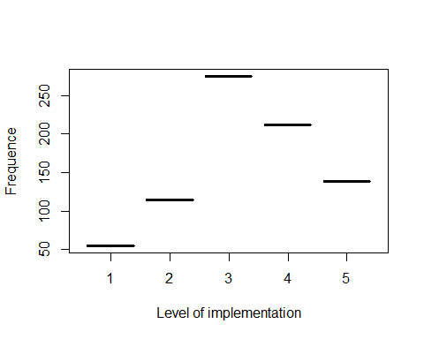 They integrate the green concept with their customers sometimes. No need to go deeper here.

*Part Iv:* Stakeholder coordination engagement

plot(as.data.frame(table(unlist(data_4))), xlab("Level of implementation"), ylab("Frequence"))

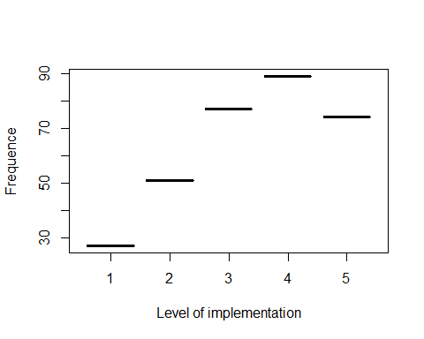 Part V: Environnemental management pratices

plot(as.data.frame(table(unlist(data_5))), xlab("Level of implementation"), ylab("Frequence"))

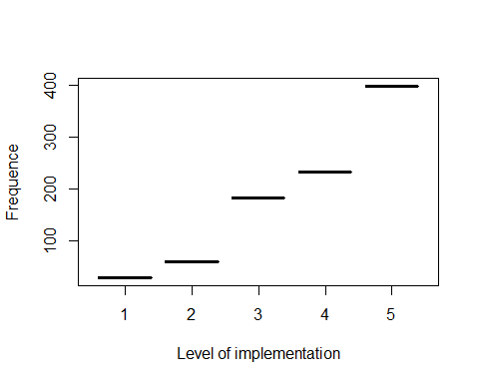 Part VI: Company business performance

plot(as.data.frame(table(unlist(data_6))), xlab("Level of implementation"), ylab("Frequence"))

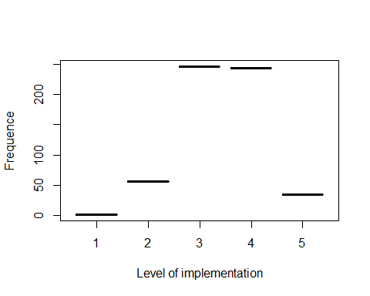

Part Vii Company environnement performance acheived in the past two years

plot(as.data.frame(table(unlist(data_7))), xlab("Level of implementation"), ylab("Frequence"))

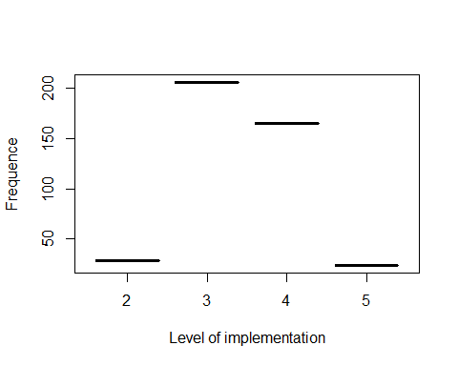 Part Viii: Company environnement performance

plot(as.data.frame(table(unlist(data_8))), xlab("Level of implementation"), ylab("Frequence"))

