 | print("Hallo Welt")
 | print(vornamen)
 | import time  time.sleep(10)
 | from random import randint  randint(1, 10)
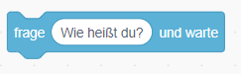 | input("Wie heißt du?")
 | vornamen += ["Heike"]
 | print(100 + 100)
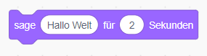 | import time  print("Hallo Welt")  time.sleep(2)

Quelle: https://scratch.mit.edu/discuss/topic/772848/

