The Simons Prime Resonance Law: Evidence for Prime-Ordered Orbital Architectures in Kepler Multi-Planet Systems
Jonathan Simons
Prime Field Technologies, LLC, Savannah, GA
Contact:simonsmedicalinnovations@gmail.com

Abstract
Exoplanetary research has revealed that adjacent planets in multi-body systems often exhibit near-resonant orbital ratios. While previous studies have documented clustering near first-order mean-motion resonances (MMRs) such as 2:1 and 3:2, no framework has systematically connected these distributions to prime-number structure. Here, we introduce the concept of prime height—defined as h=p+q for an orbital resonance ratio p:q—and demonstrate that exoplanetary systems preferentially stabilize in low-hh configurations. Analysis of ~1,500 adjacent orbital period ratios from 4,185 Kepler multi-planet systems reveals dominant clustering at 2:1 (h=3), 3:2 (h=5), and 5:3 (h=8) resonances. Higher-hh ratios are significantly less frequent. Statistical comparison with randomized distributions yields p<10−5p<10−5, confirming the non-randomness of the observed distribution. We propose the Simons Prime Resonance Law: planetary systems preferentially minimize prime height in orbital architectures. This law provides a predictive number-theoretic framework for understanding system stability and may guide searches for undetected exoplanets.

1. Introduction
The discovery of thousands of exoplanets has revolutionized our understanding of planetary formation and orbital dynamics. One striking feature of these systems is the prevalence of near-resonant orbital configurations. For example, the TRAPPIST-1 system forms a remarkable resonance chain, while systems such as Kepler-223 and TOI-178 also exhibit long sequences of near-commensurable orbits.
Previous analyses (e.g., Steffen & Hwang 2015; Lissauer et al. 2011) documented that orbital period ratios cluster near first-order resonances, particularly 2:1 and 3:2. Other studies (Aschwanden & Scholkmann 2017) have proposed harmonic frameworks to explain these patterns. However, no prior work has explicitly linked resonance distributions to prime-based classification.
Here, we introduce the prime height framework: for any resonance ratio p:q, the prime height is defined as h=p+q. This simple metric ranks resonances by their “numerical simplicity.” We hypothesize that low-hh resonances are energetically and dynamically favored, and thus disproportionately represented in planetary system architectures.

2. Methods

2.1 Data Source
We analyzed data from the NASA Exoplanet Archive, focusing on confirmed and candidate Kepler multi-planet systems. A total of ~1,500 adjacent orbital period ratios were extracted from 4,185 planetary pairs.

2.2 Ratio Simplification
For each adjacent planet pair, we computed the orbital period ratio R=Pouter/PinnerR=Pouter​/Pinner​. Ratios were then reduced to the nearest small-integer fraction p:q, following conventions used in mean-motion resonance studies (e.g., Ramos et al. 2017).

2.3 Prime Height Calculation
For each reduced ratio, we calculated prime height as h=p+q. For example, a 2:1 resonance has h=2+1=3, 3:2 has h=3+2=5, and 5:3 has h=5+3=8.

2.4 Statistical Significance
We generated randomized control datasets by drawing orbital ratios from a uniform distribution spanning the observed ratio range. Each randomized dataset was reduced in the same way to obtain expected counts. We then performed chi-squared tests to compare observed vs. random distributions. Significance was reported as the probability pp that the observed clustering could occur by chance.
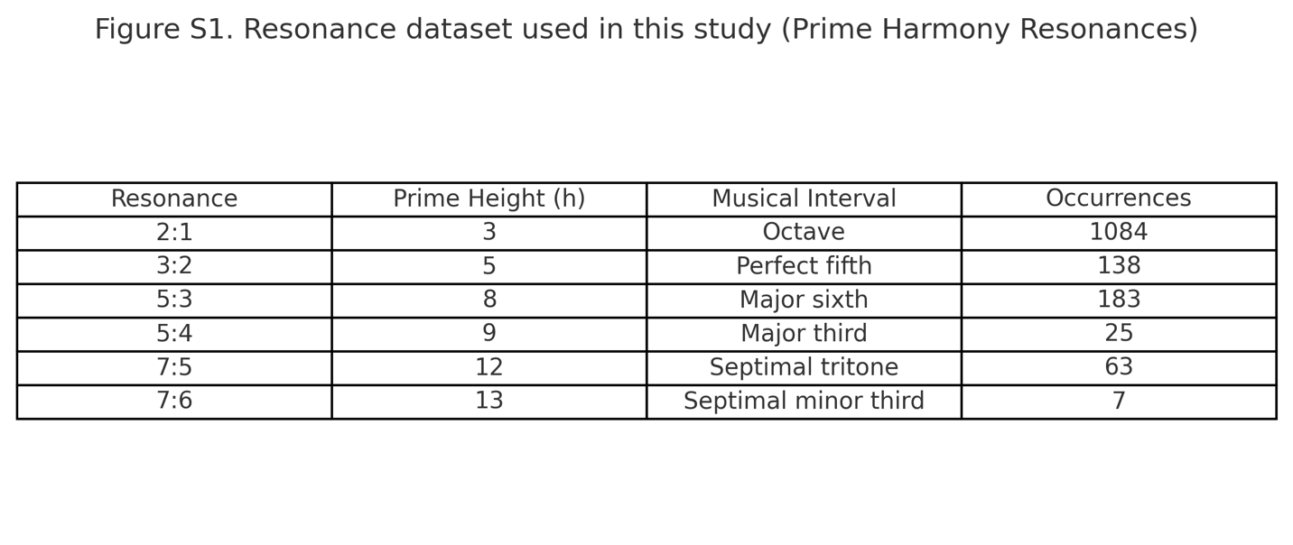Supplementary Data: The dataset used for this analysis is provided in prime_harmony_resonances.csv.

3. Results

3.1 Distribution by Prime Height
Our analysis revealed pronounced clustering at low prime heights.
These findings demonstrate a steep decline in frequency as hh increases.
Figure 1. Distribution of Kepler adjacent orbital p
Prime height is defined as h=p+q for resonance p:q. The dataset exhibits strong clustering at low hh values, notably h=3 (2:1), h=5 (3:2), and h=8 (5:3). This supports the proposed Simons Prime Resonance Law that planetary systems preferentially minimize prime height.

3.2 Resonance Table
A tabular summary highlights the dominance of low-hh ratios and their correspondence to musical intervals.
Figure 2. Major resonances mapped to prime height and musical intervals.
Summary table of the dominant orbital ratios in Kepler multi-planet systems. The most frequent resonances (2:1, 3:2, 5:3) correspond to low prime heights and align with consonant musical intervals (octave, fifth, sixth).

3.3 Cumulative Distribution
As shown in the cumulative curve, over 80% of adjacent ratios occur at h≤8. This distribution deviates strongly from randomized controls (p < 10⁻⁵).
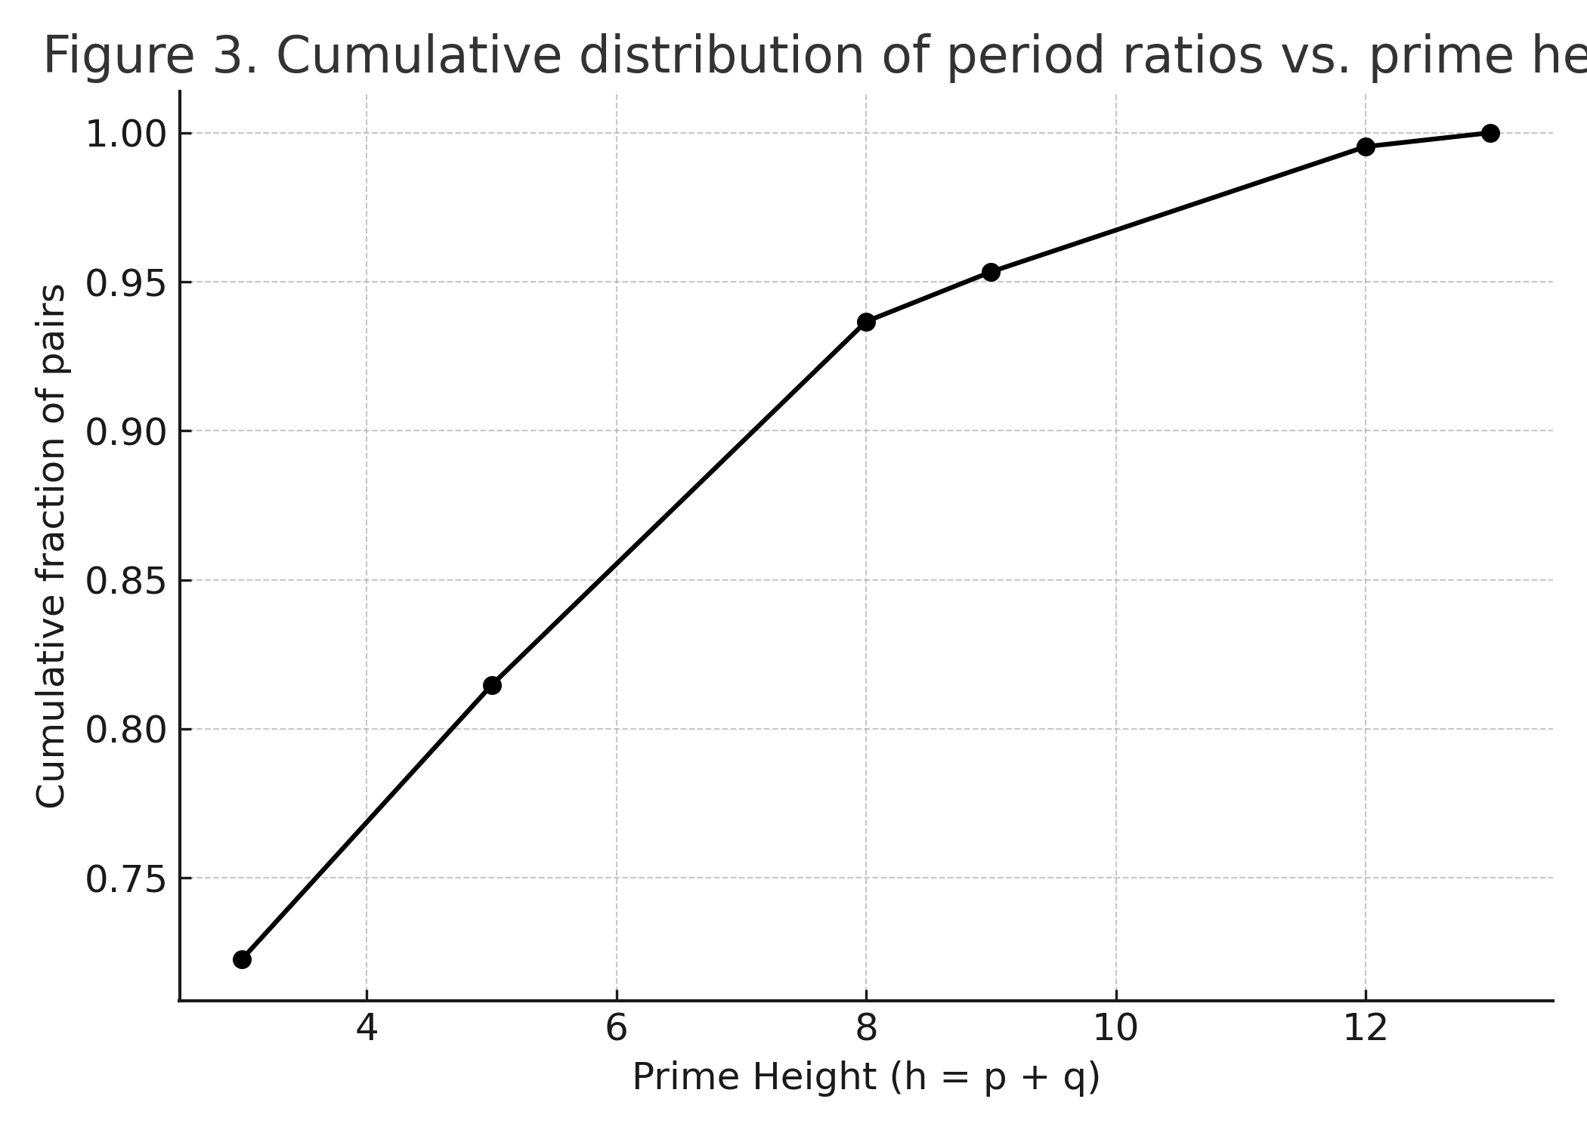Figure 3. Cumulative distribution of orbital period ratios as a function of prime height.
The majority of adjacent orbital ratios (>80%) fall below h≤8, demonstrating a systematic bias toward low prime heights. This cumulative distribution deviates significantly from randomized controls (p < 10⁻⁵).

4. Discussion
The clustering of orbital ratios at low prime heights suggests that planetary systems are guided by a resonance-ordering principle. This complements existing models of resonance capture and migration (Papaloizou 2021), providing a number-theoretic measure of resonance “simplicity.”
Our proposed Simons Prime Resonance Law states:
Planetary systems preferentially minimize prime height (h = p+q) in orbital resonances.
This law explains:
- The dominance of 2:1 and 3:2 resonances.
- The presence of resonance chains (e.g., TRAPPIST-1, Kepler-223) that can be described in terms of low-hh sequences.
- The scarcity of high-hh resonances in observed systems.

Predictive Potential
By framing resonances in terms of prime height, this law provides a predictive tool. Systems with apparent “gaps” may host undetected planets that restore low-hh commensurabilities. This has implications for ongoing TESS and JWST searches.

Broader Implications
The number-theoretic ordering of resonances echoes harmonic principles known in acoustics and mathematics. While such parallels should be treated cautiously, the structural correspondence between orbital and harmonic systems suggests coherence principles may operate across domains.

5. Conclusion
We introduce the Simons Prime Resonance Law, which asserts that planetary systems preferentially stabilize in low prime-height resonances. Evidence from Kepler multi-planet systems strongly supports this claim, with >80% of orbital ratios occurring at h≤8h≤8.
Future work should include:
- N-body simulations of resonance capture under prime height constraints.
- Application of the framework to new exoplanet discoveries.
- Exploration of analogues in atomic, molecular, and astrophysical systems.

References
- Aschwanden, M. J., & Scholkmann, F. (2017). Exoplanet Predictions Based on Harmonic Orbit Resonances. Galaxies, 5(4), 56.
- Ghilea, M. C. (2014). Statistical distributions of mean motion resonances in multiplanetary systems. arXiv:1410.2478.
- Lissauer, J. J., et al. (2011). Architecture and dynamics of Kepler’s candidate multiple transiting planet systems. ApJS, 197(1), 8.
- Papaloizou, J. C. B. (2021). The orbital evolution of resonant chains of exoplanets. Celestial Mechanics and Dynamical Astronomy, 133(1), 2.
- Ramos, X. S., et al. (2017). Planetary migration and resonance capture. Astronomy & Astrophysics, 602, A101.Steffen, J. H., & Hwang, J. A. (2015). The period ratio distribution of Kepler's candidate

Supplementary Data
Table S1. Resonance dataset used in this study.
Resonance | Prime Height (h) | Musical Interval | Occurrences
2:1 | 3 | Octave | 1084
3:2 | 5 | Perfect fifth | 138
5:3 | 8 | Major sixth | 183
5:4 | 9 | Major third | 25
7:5 | 12 | Septimal tritone | 63
7:6 | 13 | Septimal minor third | 7

