SOLVING SIMPLE PROBLEMS IN C

LAB 02
SECTION H

SUBMITTED BY:
Simon Samuel

SUBMISSION DATE:
9/23/2025

Problem
In this lab we were tasked with writing simple C programs and learning how to compile and run them. We had to complete a set of five problems, most of which were practice for using “scanf” and “printf” commands, doing math using double and integer variables, and fixing code that produced errors when ran.
Analysis
Each problem had different tasks and solutions. Each used C, and gave us practice in using basic commands, math, and errors. The problems allowed for practice, and obtaining necessary skills that will be fundamental to creating, running, and fixing code. Providing skill for future and more complex code.
Design
To solve each problem, I used the files provided that already had code on them. Also, the lab instruction file had extra code and information that was vital to solving the problem. I then altered and created code, based on the files and problems to create solutions.
For Problem 1, I used printf with line breaks to separate each piece of information in it’s own line. In Problem 2, I used scanf to read integers and doubles, which was then input into equations, also printf was used to identify which input to obtain and output the solution. Problem 3, I was given faulty code, which I ran the code for errors, then I went through the original code to identify a variety of prinf errors which I then corrected. Problem 4, I created variables that were equal to each equation, which then output the answers through printf, also for the more complex equations I referred to the original formulae for each problem, then altered them to format code better. In Problem 5, I used the Pythagorean theorem and pow() and sqrt() from “<math.h>”, to help solve for one side when given the values of the other two sides in a right triangle.
Testing
When creating a specific equation or solving for values, I made sure to do the math on my own to make sure the outputs were correct, as well as testing with multiple variables to make sure the outputs were consistent. Also, when I had to write a large chunk of code, I made sure to test it after a few lines to make sure I didn’t make any mistakes, and so it would be less of a headache later one when I have dozens of lines.
Comments
This lab helped me to implement the practice of printf and scanf learned from the textbook. Same with proper methods for completing math and equations within code. I also learned proper coding practices, through debugging and making sure my code was correct as I wrote it.
Implementation
Problem 1: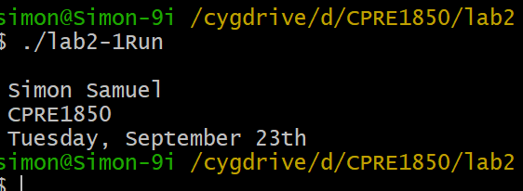

Problem 2.1: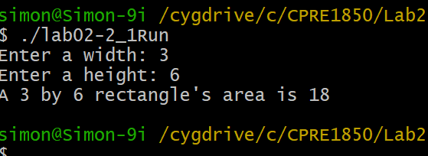

Problem 2.2: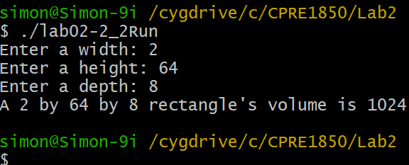

Problem 3: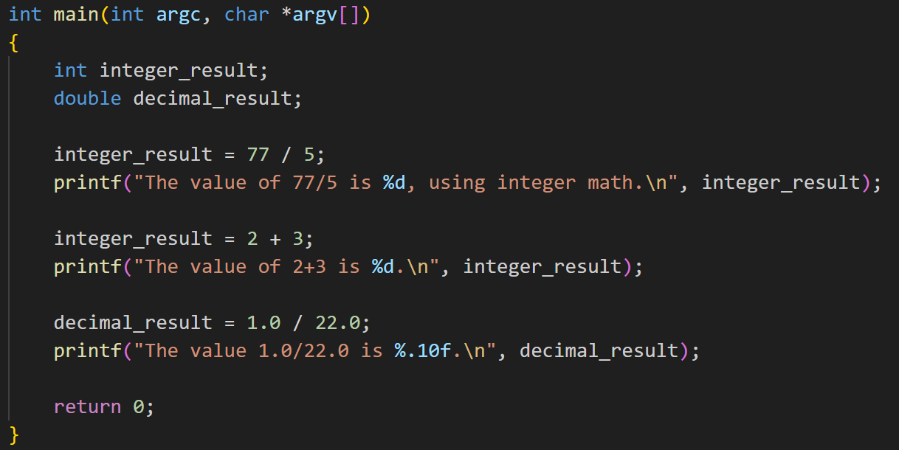
In the first prinf, %lf was used originally which is only used for double variables, unlike the integer variable that is being used
In the second printf it isn’t specified which integer %d is referring to in the code.
In the last printf, the issue is the same as the first but in reverse. %d used when there is a double integer, instead of %lf.

Problem 4: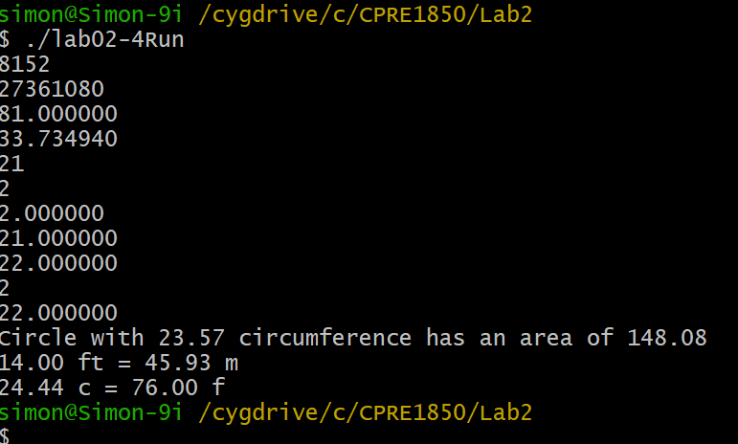

Problem 5:
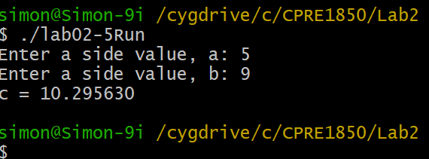

Source Code
Problem1:
int main(int argc, char *argv[])
{
/* Put your code after this line */
printf("\n Simon Samuel");
printf("\n CPRE1850");
printf("\n Tuesday, September 23th");

return 0;
}

Problem 2.1:
int main(int argc, char *argv[])
{
/* Put your code after this line */
int x, y;
printf("Enter a width: ");
scanf("%d", &x);
printf("Enter a height: ");
scanf("%d", &y);
printf("A %d by %d rectangle's area is %d\n", x, y, x*y);
return 0;
}

Problem 2.2:
int main(int argc, char *argv[])
{
/* Put your code after this line */
int x, y, z;
printf("Enter a width: ");
scanf("%d", &x);
printf("Enter a height: ");
scanf("%d", &y);
printf("Enter a depth: ");
scanf("%d", &z);
printf("A %d by %d by %d rectangle's volume is %d\n", x, y, z, x*y*z);
return 0;
}

Problem 3:
int main(int argc, char *argv[])
{
int integer_result;
double decimal_result;

integer_result = 77 / 5;
printf("The value of 77/5 is %d, using integer math.\n", integer_result);

integer_result = 2 + 3;
printf("The value of 2+3 is %d.\n", integer_result);

decimal_result = 1.0 / 22.0;
printf("The value 1.0/22.0 is %.10f.\n", decimal_result);

return 0;
}

Problem 4:
int main(int argc, char *argv[])
{
/* Put your code after this line */
int a = 6427 + 1725;
int b = (6971 * 3925) - 95;
double c = 79 + 12 /5;
double d = 3640.0 / 107.9;
int e = (22 /3 ) * 3;
int f = 22 / (3 * 3);
double g = 22 / (3* 3);
double h = 22 / 3* 3;
double i = (22.0 /3) * 3.0;
int j = 22.0 / (3*3.0);
double k = 22.0 / 3.0 *3.0;

printf("%d\n", a);
printf("%d\n", b);
printf("%lf\n", c);
printf("%lf\n", d);
printf("%d\n", e);
printf("%d\n", f);
printf("%lf\n", g);
printf("%lf\n", h);
printf("%lf\n", i);
printf("%d\n", j);
printf("%lf\n", k);

//area of circ w/ circumference of 23.567

double area;
double CIRCLE_CIRCUMFERENCE = 23.567;
area = 2 * M_PI * CIRCLE_CIRCUMFERENCE;
printf("Circle with %.2f circumference has an area of %.2f\n", CIRCLE_CIRCUMFERENCE, area);

// convert 14ft to m
double meterConversion;
double FT_PER_METER = 3.28084;
double feet = 14;
meterConversion = FT_PER_METER * feet;
printf("%.2f ft = %.2f m\n", feet, meterConversion);

// Fareheit to Celicius
double farenheit = 76;
double celcius = (farenheit - 32)/1.8;
printf("%.2f c = %.2f f", celcius, farenheit);
return 0;
}

Problem 5:
int main(int argc, char *argv[])
{
double a, b, c;
double filler;

/* Put your code after this line */
printf("Enter a side value, a: ");
scanf("%lf", &a);

printf("Enter a side value, b: ");
scanf("%lf", &b);

/* This next line will calculate the square root of whatever value is
* inside the parenthesis and assigns it to the variable filler. */
filler = sqrt((pow(a, 2) + pow(b, 2)));
printf ("c = %lf\n", filler);
return 0;
}

