

International Journal of Serious Games

ISSN: 2384-8766
https://journal.seriousgamessociety.org/

Article
Title of your manuscript
First Name Last Name¹, First Name Last Name² and First Name Last Name²

¹Department, University, City, Country; ²Department, University, City, Country
{FirstName.Last Name} @asdf.ch ; {FirstName.Last Name, FirstName.Last Name} @asdf.ch

Keywords:

Keyword 1
Keyword 2
...
Up to 8 keywords

Received: XXXX
Accepted: XXXX
Published: XXXX
DOI: 10.17083/ijsg.XXXX
Abstract
As the Abstract may be presented separately from the article, it should stand on its own. Avoid references and abbreviations in the Abstract.
Briefly present the context and the importance of your research. Present your research question and give a summary of your experimentation. Present your main results and implications.

General instructions for authors
This Template propose a standard structure that, depending on the research, may be adapted by authors.
All XXXX will be completed by the Editor.

Sections and paragraphs
Use up to 3 levels of titles and subtitles.

Subsections
Use the "Article normal text first paragraph" style at the beginning of each section or subsections.
Then use the "Article normal text" style.

Table and figures
Refer to tables and figures as following.
As describe in Figure 1, ...

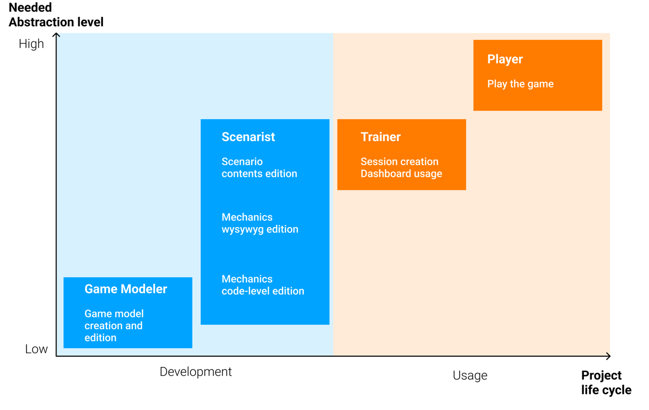
- The two dimensions "Project life cycle" and "Needed abstraction level" are used to classify the users of authoring tools into four main roles. Low abstraction levels correspond to interfaces near the programming code, while high abstraction levels correspond to simple user interfaces.
Table 1 presents results of ...

- Synthesis of uses cases
Game Models | Start Date | Game Modelers | Scenarists | Trainers | Students
Project Management | 2012 | 5 | 10 | 50 | 15’000
Crime Scene Investigation | 2012 | 2 | 2 | 1 | 300
Computational thinking | 2012 | 3 | 3 | 10 | 1’500
Psychological tests | 2014 | 1 | 10 | 10 | 1’200
Clinical assessment | 2015 | 3 | 2 | 2 | 1’600
Corporate law | 2015 | 2 | 4 | 5 | 1’100
Oncology care | 2016 | 2 | 2 | 8 | 850
Energy management | 2017 | 2 | 10 | 10 | 400
Mobile treasure hunt | 2018 | 2 | 4 | 2 | 100
Emergency triage | 2018 | 3 | 3 | 1 | 110
Media engineering | 2018 | 3 | 4 | 3 | 250
Patients' Rights | 2020 | 4 | 3 | 2 | 270

Refere\nces
References should be in IEEE style.
Example of a reference in the text [1] and other references [2]–[4]. In the References section, use the style "References" (Times New Roman, size 10). Include DOI for each reference.

Introduction
The introduction should be written for a general audience.
Provide a specific background, linked with your research, presenting the general context and what is already known in this field. Define the knowledge gap, your hypothesis, and the aim of your research. Define the approach used in your study and how it is different from what has been done before.
Avoid a general literature survey, focus on the specific field of your research. Do not include the results in this section.
If needed, the introduction should be divided into subsections such as
- Background
- Knowledge gap
- Objectives of the study or Research questions.

Methods and Material
Explain what has been done in your study. Provide enough information to allow your study to be reproduced.
If you refer to existing methods, a summary and a reference is sufficient. Describe the changes done to existing methods.

Results
Present what you have found. You may use subsections to group results by themes. In this section, present only your results, and thus do not include references.

Discussion
Describe what your Results means. Base the discussion on your Results, but do not repeat them.
Use subsections such as :
- Main Results
- Limitations
- Comparison with previous research
- Future research

Conclusions
Write a conclusion that present your main findings and highlight the significance of your study. The conclusion should not exceed ½ page.

Acknowledgments
Individuals' acknowledgements and funding sources.

Conflicts of interest
Declare any possible conflicts of interest.

References
[1] P. Rooney, “A Theoretical Framework for Serious Game Design,” International Journal of Game-Based Learning, vol. 2, no. 4, pp. 41–60, 2012, doi: 10.4018/ijgbl.2012100103.
[2] A. De Gloria, F. Bellotti, and R. Berta, “Serious Games for education and training,” International Journal of Serious Games, vol. 1, no. 1, 2014, doi: 10.17083/ijsg.v1i1.11.
[3] F. Bellotti, R. Berta, A. De Gloria, and E. Lavagnino, “Towards a Conversational Agent Architecture to Favor Knowledge Discovery in Serious Games,” Proceedings of the 8th International Conference on Advances in Computer Entertainment Technology, p. Article No.: 17-Article No.: 17, 2011, doi: 10.1145/2071423.2071444.
[4] M. Laurent, S. Monnier, A. Huguenin, P.-B. Monaco, and D. Jaccard, “Design Principles for Serious Games Authoring Tool,” International Journal of Serious Games, vol. 9, no. 4, pp. 63–87, 2022, doi: 10.17083/ijsg.v9i4.458.

