

International Journal of Serious Games

ISSN: 2384-8766
https://journal.seriousgamessociety.org/

Article
From Building-Energy Models to Game Mechanics: The Renovation Game
Simon Schneider¹, Thomas Verweyen² and First Name Last Name²

¹Department, University, City, Country; ²Department, University, City, Country
{FirstName.Last Name} @asdf.ch ; {FirstName.Last Name, FirstName.Last Name} @asdf.ch

Keywords:

serious games;
building renovation;
energy education; decarbonization;
simulation;
game-based learning

Received: XXXX
Accepted: XXXX
Published: XXXX
DOI: 10.17083/ijsg.XXXX
Abstract
Building renovation involves interacting decisions concerning the building envelope, heat supply, electricity demand, renewable generation, storage, costs, and user needs. These interactions are difficult to communicate through isolated descriptions of individual technologies. This paper presents The Renovation Game, a serious board game that translates selected building-energy and greenhouse-gas relationships into a discrete decision model. The game represents a 1,000 m² reference building over four five-year renovation rounds and includes 56 measure cards in nine categories. Engineering quantities are mapped to bounded game states while preserving the direction, ranking, approximate magnitude, and relevant interactions of real-world effects. The development method combines model abstraction, technical calibration, iterative game design, and computational testing. A Python implementation reproduces the central game rules and is used to explore score distributions, card frequencies, timing effects, and dominant strategies across 10,000 randomized games. The study shows how an engineering model can be reduced to a transparent tabletop system without reducing renovation to independent technology choices. The game is intended as a learning environment for systems thinking rather than as a substitute for building simulation or renovation planning.

Introduction
Decarbonizing buildings is a coupled decision problem: the effect of a renovation measure depends on the existing building, other measures, available resources, and the future energy system. For example, heat-pump performance depends on both heat demand and heat-distribution temperature, while photovoltaic generation interacts with electricity demand and storage. This makes renovation difficult to communicate to non-specialists who want to understand not only which measures are available, but which combinations are effective under different conditions.

Serious games provide one way to represent such relationships. Instead of presenting technologies as isolated facts, a game can make their interactions part of the rules and consequences of player decisions. Players observe a system state, select an intervention, receive feedback, and adapt subsequent decisions. This judgment-action-feedback cycle is a common basis for learning through games and simulations [1].
The use of an engineering model in a game, however, creates a central design challenge. Building-energy models can include detailed geometry, hourly time series, component properties, control systems, and economic assumptions, whereas a physical board game must reduce this complexity to a small number of understandable and manageable states. The relevant question is therefore whether the abstraction preserves the relationships that matter for the intended learning process.
The Renovation Game addresses this problem by translating selected building-energy and greenhouse-gas relationships into a discrete tabletop model. The game represents renovation through linked states for heat demand, heat generation, electricity demand and production, storage, costs, user satisfaction, and cumulative emissions. This paper describes the abstraction and calibration process and examines whether the resulting model retains a strategically differentiated decision space.
The principal contribution of the work is methodological. It describes a process for translating quantitative engineering relationships into game mechanics through controlled discretization. The approach aims to preserve four properties of the underlying problem: the direction of effects, the ordering of comparable measures, approximate differences in magnitude, and important interactions between technologies.
The paper addresses two research questions:
- RQ1: How can selected energy, emission, cost, and user-related relationships of building renovation be represented in a discrete tabletop model while retaining their strategically relevant interactions?
- RQ2: Does the resulting model create a sufficiently differentiated decision space in which outcomes depend on combinations and timing of measures rather than on a single dominant intervention?
The present paper focuses on model development and computational validation. It does not yet make claims about measured learning gains. A matched pre- and post-game evaluation is planned as a subsequent study.

Background

Serious games as simplified system models (too wordy? Or even strike section?
Serious games are games developed or applied for purposes beyond entertainment, including education, training, communication, and participatory decision-making. Game-based learning uses such games within an educational process, which can also include instruction, peer discussion, and debriefing.
A simulation represents selected properties of a real system, while a game adds goals, constraints, player decisions, feedback, and usually some form of uncertainty or competition. Serious simulation games therefore combine two forms of abstraction. The simulation determines which parts of reality are represented, while the game determines how players interact with that representation.
Garris et al. describe educational games as repeated cycles of player judgment, behavior, and system feedback [1]. This concept is particularly relevant to renovation because the technical content can be expressed through consequences. A player does not only read that insulation reduces heating demand; the state of the building changes and alters subsequent operational emissions. Similarly, the benefit of low-temperature heat distribution becomes relevant when it changes the performance of an installed heat pump.
The Mechanics-Dynamics-Aesthetics framework provides another useful distinction [2]: Mechanics are the implemented rules and data structures. Dynamics are the patterns that emerge when players use these mechanics. The resulting experience is shaped by both. For The Renovation Game, card effects, prerequisites, state tracks, round-dependent emission factors, and scoring are mechanics. The sequencing of renovation measures, competition for investment resources, and creation of technical combinations are intended dynamics.
For educational use, this relation must be extended by an explicit link to learning goals. Kalmpourtzis and Romero argue for alignment between game mechanics and learning mechanics [3]. A game can contain substantial factual information without requiring players to use it. Conversely, a relatively simple rule can represent an important concept when understanding the rule improves decisions.

Serious games in energy and sustainability
Serious games have been used for energy behavior, renewable-energy planning, urban transitions, circular economy, and stakeholder negotiation. Reviews of serious-game research generally show positive potential for cognitive and affective outcomes, although effects vary substantially between game designs and study contexts [4], [5]. This variation makes it important to distinguish between an engaging game and an educationally meaningful model.
Energy-transition games often represent stakeholder interests and collective decision-making. Existing energy serious games have addressed household behaviour [7], stakeholder interaction, and urban energy-transition pathways [8]. Such approaches address important aspects of the transition, but they do not necessarily expose the coupled physical relationships within a building renovation.
The present game instead focuses on the coupled techno-physical configuration of a single building renovation: how much heat demand remains after envelope measures, which heat source supplies that demand, how much additional electricity a heat pump requires, how local photovoltaic production changes grid imports, and how embodied and operational emissions interact across time are guiding questions.
This creates a direct connection between serious-game design and engineering model reduction. The challenge is to simplify the engineering relationships far enough for manual gameplay without reducing the underlying problem to an arbitrary set of points.

Methods and Material

Design method

Target group and learning objectives
The game is intended for players from approximately 14 years of age upwards. Potential applications include upper-secondary education, university courses, professional training, public workshops, and climate-awareness events. No previous knowledge of building-energy calculation is required.
The game can be used in a short exploratory format of approximately 20–30 minutes or in a longer workshop of approximately 90–120 minutes. In the longer format, gameplay is combined with an introduction, comparison of renovation strategies, and debriefing.
The intended learning objectives informed the selection of model variables and measures. Players should be able to identify major renovation categories, distinguish demand reduction from energy generation and storage, recognize important technology interactions, and understand that the effect of a measure depends on context. Particular attention was given to concepts that can be embedded directly in the mechanics. Table 1 summarizes examples.

- Alignment of engineering concepts and game mechanics
Engineering concept | Game representation | Intended interpretation
Envelope renovation reduces useful heat demand | Insulation and window cards change the thermal-demand state | Operational demand depends on building quality
Construction causes immediate emissions | Selected cards add construction-emission values | Renovation has embodied as well as operational impacts
Heat-pump performance depends on system temperature | Heat-generation and heat-distribution cards jointly affect efficiency | Technologies can create synergies
PV generates electricity | PV cards increase local electricity production | Production is distinct from efficiency
Storage does not generate electricity | Storage changes the grid-import relation but not production | Flexibility is distinct from generation
Some measures require infrastructure | Selected cards contain prerequisites | Renovation sequence can matter
Building surfaces are limited | Selected measures are mutually exclusive | Physical constraints affect strategy
Electricity decarbonizes over time | Grid-emission values decrease between rounds | Timing changes operational emissions
User-oriented measures have non-energy value | Satisfaction affects available resources | Renovation is not a pure energy optimization problem

The game therefore does not rely primarily on explanatory text to communicate these relationships. Where possible, a concept changes the consequences of player actions.

Scope and boundary of the reference model
The game represents a nominal residential building with 1,000 m² of floor area. The reference case does not correspond to a specific property but provides a common scale for converting area-specific engineering quantities into manageable game values.
One game round represents approximately five years. Four scored rounds therefore correspond to a renovation period of about twenty years. This temporal scale allows one-time construction-related emissions to be considered alongside recurring operational effects.
The model describes the building through a limited set of discrete states, as shown in
- financial resources;
- thermal demand;
- heat-generation technology;
- heat-pump efficiency;
- electricity demand;
- local electricity production;
- electricity storage and flexibility;
- grid electricity import;
- user satisfaction, which influences financial resources;
- miscellaneous recurring emission effects and reductions, such as cooking-gas emissions or biogenic uptake; and
- cumulative greenhouse-gas score.
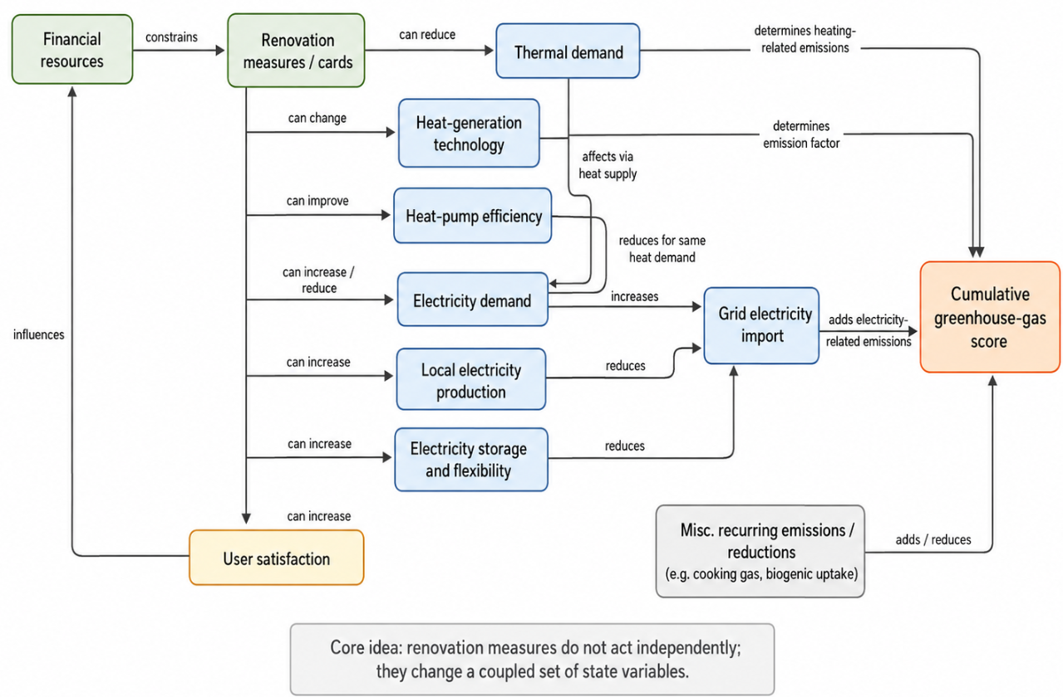
- Discrete game states and main influences
The model boundary follows decision relevance rather than completeness. Variables were retained when they create an important dependency between renovation choices. They were aggregated or excluded when their representation would substantially increase calculation effort or game complexity without creating a comparably relevant decision.
Accordingly, the model does not explicitly simulate hourly thermal behavior, weather, detailed geometry, distribution losses, individual component performance, or control systems. Their effects are either incorporated into the reference assumptions or lie outside the intended level of abstraction.
Domestic hot water is included only in aggregated form. A baseline demand of approximately 10–20 kWh/m²a is included in the thermal demand, but DHW generation and distribution are not represented as separate states. During development, few sufficiently distinct renovation choices were identified to justify an additional DHW subsystem at the current level of abstraction.
Cooling was considered but excluded from the current game. A useful representation would have to account for cooling demand, passive measures, active cooling systems, and their interaction with electricity consumption. No sufficiently simple mechanic was identified that retained these relationships without adding substantial complexity. Cooling was therefore omitted rather than represented through a potentially misleading proxy and remains an option for future extensions.

Measure categories and card structure
The current version contains 51 active measure cards grouped into nine intervention categories:

Category | Examples of represented measures | Main affected states
Envelope insulation | façade insulation, roof insulation | thermal demand, embodied emissions, cost
Windows | glazing replacement, full window replacement | thermal demand, embodied emissions, cost
Heat generation | gas replacement, biomass, district heating, heat pumps | heating technology, emissions, electricity demand
Heat distribution | radiator replacement, low-temperature systems | heat-pump efficiency, cost
Ventilation | ventilation with heat recovery | thermal demand, electricity demand, cost
Roof use | photovoltaic systems, roof uses | electricity production, cost, constraints
Electricity efficiency | appliances, LED lighting | electricity demand
Flexibility and storage | batteries, load shifting, bidirectional charging | storage/flexibility, grid import
Satisfaction and amenities | balconies, lift, user-oriented upgrades | satisfaction, cost, possibly electricity demand

A card can modify several state variables at the same time. A renovation measure can therefore have both positive and negative effects. For example, a construction measure can reduce future heating demand while causing an immediate greenhouse-gas burden. A user-oriented measure can improve satisfaction while increasing investment requirements or electricity demand.
Cards can also change the heat-generation technology or heat-pump efficiency. Selected cards contain prerequisites or mutual exclusions. Bidirectional vehicle charging, for example, requires corresponding charging infrastructure, while measures that use the same building surface can exclude each other.
This structure was chosen to avoid representing each measure through one generic score. A single score would simplify the game further, but it would remove the causal relations between measures and building states.

Gameplay cycle
Players act as project developers who improve an existing building over successive renovation rounds. They have limited financial resources and must decide which interventions to implement.
The card system introduces constrained choice. Measures are organized by category. In the current computational implementation, a category is selected, up to three available cards are drawn, and one affordable card is selected. Cards that occupy a single-use slot prevent later use of the same slot. Played cards are removed from the available card pool.
After the renovation phase of a round, the game evaluates the resulting building state. Construction emissions, heating emissions, operational heating costs, electricity imports, electricity costs, and user satisfaction are converted into changes in score and budget. The new budget then affects the options available in subsequent rounds.
The final objective is greenhouse-gas reduction. Money is not a separate victory condition, but financial resources constrain the feasible path and should not be exhausted. Satisfaction influences financial resources and therefore indirectly affects the capacity for continued renovation. This design creates a repeated cycle.

The game result therefore emerges from a sequence of building states rather than from the sum of independent card points.

Translation of Engineering Values into Game Mechanics

Discretization principles
The central methodological step is the translation from engineering values to game units. The objective is not numerical equivalence at all levels of detail. Instead, the mapping aims to preserve the structure of the relevant decision space. Three main criteria were used:
- Directional preservation requires that the sign of an effect remains correct. A measure that reduces annual heating demand in the reference model must improve the corresponding game state.
- Order preservation requires that clearly different alternatives remain distinguishable. A major insulation package should generally produce a larger reduction in heating demand than a minor package.
- Approximate ratio preservation is used where the relative magnitude is important for strategy. If one technology causes several times the operational emissions of another under the same demand, this difference should remain visible after discretization.
A fourth criterion was introduced during iterative calibration: decision relevance. Differences that exist in engineering calculations but disappear after discretization cannot influence gameplay. Conversely, very large differences can create dominant choices. Values were therefore adjusted within technically plausible reference interpretations to retain a useful strategic range. The principal current mappings are shown in Table 2.

- Principal engineering-to-game mappings
Quantity | Symbol / game representation | Physical value represented by one game unit | Unit
Reference building area | $${(A}_{ref})$$ | 1,000 | m²
Duration of one round | $$\left(T_{r}\right)$$ | 5 | years
Greenhouse-gas score | 1 score unit | 1 | kg CO₂e/m²
Electricity demand | $$\left(d\right)$$ | 5 | kWh/m²a
Local electricity generation | $$\left(p\right)$$ | 5 | kWh/m²a
Storage / flexibility | $$\left(s\right)$$ | 5 | kWh/m²
Grid electricity import | $$\left(g\right)$$ | 5 | kWh/m²a
Thermal demand | $$\left(w\right)$$ | 20 | kWh/m²a
Heat-pump efficiency |  | discrete COP levels | –
Note: The mappings define the scale of the game model. Investment costs are represented on a discrete relative scale. Card-cost levels were calibrated to preserve broad differences in investment intensity rather than to reproduce project-specific costs.

- Discrete state tracks and their downstream effects
State | Level range | Initial level | Lookup contribution at levels 0–9 | Affects
Construction-related emissions | 0–9 | 9 | (-45,-40,-35,-30,-25,-20,-15,-10,-5,0) score units | cumulative GHG score
Electricity demand (d) | 0–9 | 4 | (4,5,6,7,8,9,10,11,12,13) grid-import units | grid electricity import
Local generation (p) | 0–9 | 0 | (0,0,-1,-1,-2,-2,-3,-3,-4,-4) grid-import units | grid electricity import
Storage / flexibility (s) | 0–9 | 0 | (0,-1,-2,-3,-4,-5,-6,-7,-8,-9) grid-import units | grid electricity import
User satisfaction | 0–9 | 3 | (2,3,3,4,4,5,5,6,6,7) budget units | financial resources
These lookup functions intentionally use different response curves. Electricity demand has an approximately linear effect on grid import, whereas the benefit of local generation is compressed to reflect limited direct self-consumption, and storage provides an additional flexibility effect. Satisfaction is converted into financial resources rather than directly into greenhouse-gas score.

Thermal demand
Thermal demand is represented through a discrete state. The game starts from a relatively poor existing-building condition and allows several levels of improvement. A simplified representation of useful heating demand is:

$$Q_{H}\left(w\right)=Q_{H,0}-wΔQ_{H},$$

where ($Q_{H,0}$) is the reference useful heating demand, set to 200 kWh/m²a, ($w$) is the current thermal-protection level, and $(ΔQ_{H}$) is the nominal change associated with one level, which uses increments of approximately 20 kWh/m²a. This range was selected so that the board can represent a transition from an inefficient existing building to a highly renovated state with around ten steps. Annual heating expenditure is:

$$C_{H}=Q_{H}\left(w\right)c_{H}$$

The thermal-demand state is modified primarily by insulation, windows, and selected ventilation measures. A key design objective was to make the remaining demand visible because this state affects the performance of every subsequent heating technology.

- Energy-carrier parameters used for operational heating
Heat-generation system | Heating emission factor $\left(EF_{H}\right)$ | Energy price $\left(c_{H}\right)$ | Representation in the game
Natural gas | 0.20 kg CO₂e/kWh | 0.10 €/kWh | Direct heating emissions
Biomass | 0.05 kg CO₂e/kWh | 0.08 €/kWh | Direct heating emissions
District heating | 0.05 kg CO₂e/kWh | 0.20 €/kWh | Direct heating emissions
Green gas | 0.00 kg CO₂e/kWh | 0.50 €/kWh | No direct operational GHG emissions in the current scenario
Heat pump | via electricity balance | 0.15 €/kWh electricity | Heat demand converted to electricity through COP

Heat generation and heat-pump efficiency
The model distinguishes several heating systems, including gas, biomass, district heating, green gas, and heat pumps. These systems are not represented by fixed points alone. Their operational effects depend on the current thermal-demand state.
For a non-electric heating system, operational emissions for round (r) can be represented as:

$$G_{H,r}{=Q}_{H}\left(w\right)⋅EF_{H}⋅T_{r},$$

where ($EF_{H}$) is the emission factor of the heat carrier and ($T_{r}$) is the duration of the round.

Heat pumps introduce an additional coupling. Useful heating demand is first converted into electricity demand:
$E_{HP}=\frac{Q_{H}\left(w\right)}{COP\left(e\right)}$,

where ($COP\left(e\right)$) depends on the current heat-pump efficiency state. Efficiency can be improved by the heat source and by compatible low-temperature heat-distribution systems. This representation is important educationally because a heat pump is not treated as an isolated replacement card. Its result depends on the building and on other interventions.
The game consequently distinguishes between three different actions: reducing useful heat demand, changing the heat-generation technology, and improving heat-pump efficiency. These actions affect different state variables even when all three ultimately influence operational emissions.

- Heat-pump efficiency levels
Efficiency level (e) | COP used in the model
1 | 2.00
2 | 2.50
3 | 3.33
4 | 4.55
5 | 6.66

Electricity demand, local generation storage and flexibility
Electricity demand includes a base level for user plug-loads as well as changes caused by electrification renovation measures and heat-pump operation. Electricity-efficiency measures reduce the demand state, while other interventions can increase it.
Photovoltaic cards change a separate production state. The active card set represents systems ranging from small balcony systems to larger roof and facade installations. One production unit corresponds approximately to 5 kWh/m²a.
Keeping demand and production separate has an important consequence for gameplay. Efficiency measures and photovoltaic systems can both reduce grid imports, but they act through different physical mechanisms: efficiency measures reduce demand, whereas photovoltaics increase local generation. This distinction becomes relevant when storage and flexibility are introduced, because their effect depends on the balance between demand and available local generation. The resulting grid-import state can be represented conceptually as:

$$E_{grid}=E_{demand}(d)+E_{HP}(w)-E_{PV}(p)-min(E_{PV}(p), S\left(s\right)),$$

where ($d$) is the discrete electricity-demand level, ($p$) is the local electricity-generation level, ($s$) is the storage and flexibility level, and ($E_{HP}$) is the additional electricity demand associated with heat-pump operation. Increasing ($d$) or ($E_{HP}$) tends to increase grid import, whereas increasing ($p$) or ($s$) tends to reduce it.
In the physical board, predefined lookup relationships translate the discrete levels of demand, generation, heat-pump electricity use, and storage into a simplified grid-import state. This preserves the main interaction between electricity demand, local generation, and flexibility while keeping the calculation suitable for manual gameplay.
Storage and flexibility measures include stationary batteries, thermal flexibility, flexible electrical loads, and bidirectional electric-vehicle charging. The model prevents storage from being treated as electricity production. Storage can only reduce effective grid dependence when sufficient local electricity production is available. In the computational implementation, the effect is limited by the smaller of the production and storage states. This is a simplified representation of self-consumption. It does not model battery state of charge, hourly profiles, round-trip efficiency, or control strategies, as such a model would be inappropriate for manual gameplay. The simplification nevertheless preserves the main conceptual relationship: storage has little value without energy that can be shifted, while local generation can have greater value when temporal mismatch is reduced.

Temporal electricity decarbonization
Operational greenhouse-gas emissions from electricity depend on the current and future electricity mix. The game changes the grid-emission conversion accordingly every round, which represent approximately 5 years.
This mechanic represents a decarbonization scenario rather than a forecast of future market electricity. Its purpose is to expose a temporal relationship that is often omitted in static comparisons: an electric technology does not have the same operational carbon intensity throughout a multi-decade transition.
The underlying approach is consistent with life-cycle and Positive Energy District assessment methods in which operational conversion factors decrease towards 2050 and embodied emissions occur primarily at the time of construction [6]. The board game compresses this longer assessment horizon into four rounds.

- Emission intensities of future grid electricity
Round | ($EF_{grid})$
1 (2030) | 0.100 kg CO₂e/kWh
2 (2035) | 0.050
3 (2045) | 0.030
4 (2050) | 0.015

Embodied Emissions
Construction-related emissions are represented separately from recurring operational emissions. Measures that require substantial material inputs can increase the construction-emission state at the time of implementation.
The distinction is important because renovation is not emission-free at the point of installation. Deep envelope renovation, replacement of components, and new technical systems can create a short-term emission burden that is only compensated through later operational savings.
The game does not implement a full life-cycle assessment according to EN 15978. Instead, selected embodied-emission effects are mapped to discrete card values. The objective is to preserve the temporal distinction between immediate construction impacts and repeated operational impacts.
This also creates a trade-off between early and late intervention. A measure implemented early causes its construction impact immediately but can influence more operational rounds. The same measure installed late affects fewer rounds.

Costs and financial feedback
Investment costs are represented through discrete card costs. The current values primarily express relative investment barriers. Although the general scale is approximately EUR 5 to 20,000 per budget unit, the card costs should not be interpreted as validated project-level cost estimates.
Operational energy costs create a second financial mechanism. Heating-system type, thermal demand, and grid electricity import affect the budget at the end of a round. Efficient renovation can therefore increase the resources available for later interventions.
This creates a feedback loop that is common in real renovation planning but is often absent from simple technology-ranking exercises. A low-cost measure can enable later investments, while an expensive intervention can restrict the remainder of the renovation pathway.

User satisfaction
The satisfaction state represents non-energy outcomes such as comfort, accessibility, noise, private outdoor space, and architectural quality. Satisfaction does not directly win you the game, but it affects available financial resources. The mechanism can be interpreted as a simplified representation of willingness to invest, property value, or acceptance of the renovation. In real life, occupant preferences are heterogeneous and cannot be represented through one universal scale. The purpose of the variable is prevents the simulated project developer from optimizing emissions while ignoring all user-oriented consequences and discover co-benefits, as well as hidden costs of unpopular measures.

Calibration and Computational Validation

Calibration process
The conversion of real renovation measures into game cards required several stages of interpretation. Technical sources and renovation catalogues were used to define plausible measure types and engineering effects. The values were then converted to the discrete board scale and tested within the complete game.
This process contains unavoidable degrees of freedom. A “large roof photovoltaic system,” for example, has no universal physical size. Its output depends on the available roof area, building density, module efficiency, shading, orientation, and design constraints. Similarly, an insulation package can represent different materials and thicknesses.
Each card therefore represents a reference intervention for the nominal building rather than a complete engineering specification. Calibration was considered acceptable when five conditions were met:
- the direction of the technical effect remained correct;
- similar measures retained a plausible relative order;
- important differences remained large enough to affect decisions;
- combined building states remained within recognizable physical ranges; and
- the discrete values did not make one intervention universally dominant.
The last condition is specifically a game-design requirement. A technically credible numerical model can still create a poor game if one action dominates all alternatives.

Computational implementation
A Python implementation reproduces the main state variables, card effects, slot restrictions, budget rules, and round scoring of the physical game.
The current Monte Carlo model simulates 1,000,000 games. Each simulation begins from the same reference state. During each renovation phase, the model selects an available card category, draws up to three unused cards from that category, filters the cards according to affordability, and randomly selects one affordable option. The selected card updates the relevant state variables:
$$x_{t+1}=x_{t}+Δx_{c}$$
where (x) represents the vector of building states and ($Δx_{c}$) is the state-change vector of card (c). If a card changes the heating system, the heat-generation state is replaced rather than incremented. Single-use slots become occupied after installation. A card cannot be played twice.
At the end of each round, the model evaluates construction emissions, heat-related emissions and costs, heat-pump electricity use, other electricity demand, photovoltaic production, storage, satisfaction, and final grid electricity import. The score and budget are then updated before the next round.
The computational implementation is not an optimization model and does not reproduce human decision-making. Its main purpose is structural testing of the rule system under many possible card sequences.

Analysis indicators
The analysis evaluates the final state after round four and records the complete card history of each game. The following indicators are calculated:
- distribution of final greenhouse-gas scores;
- distribution of final budgets;
- relation between score and satisfaction;
- card frequencies;
- average round in which each card is played;
- card frequencies within the highest-scoring games;
- average final score in games with and without a given card;
- frequency of each reason for ending the renovation phase; and
- complete card sequences of the highest-scoring simulations.
For a card (c), a simple descriptive association is calculated as:
$$ΔSP_{c}={\overline{SP}}_{c,played}- {\overline{SP}}_{c,not played}$$

This value is useful for identifying suspiciously strong or weak cards, but it is not interpreted as a causal card effect. Card occurrence is correlated with available budget, previous card selections, occupied slots, and random draw order.
Similarly, the frequency of a card among the top 100 games is used as a balancing indicator rather than as evidence that the card is universally optimal.

Expected validation logic
Computational validation is used to identify three types of model problem:
- The first is state-space failure. Examples are unreachable areas of the board, systematic budget collapse, or excessive clamping of state values.
- The second is dominance. If one card or technology combination appears in nearly all high-scoring games and substantially outperforms alternatives independently of context, the calibration requires review.
- The third is irrelevance. If a measure has no observable effect on outcomes or is almost never playable, it adds complexity without contributing to strategy.
A well-calibrated game should produce a broad score distribution and multiple successful pathways. Strong cards are not inherently problematic, because real renovation measures also differ in effectiveness. The design criterion is that effectiveness should depend on the state of the building and available resources.

Results

Resulting game model
The resulting model contains 51 active renovation measures distributed across nine intervention categories. Each card can change between one and several building states.
The model maintains separate representations of thermal demand, heat-generation technology, heat-pump efficiency, electricity demand, photovoltaic generation, storage, embodied emissions, satisfaction, and budget. These variables are connected through the round scoring model rather than combined into one card-level effectiveness score.
This structure makes several important interactions endogenous to gameplay: A heat-pump card changes the heat-generation technology, but its subsequent electricity demand depends on both the current heat demand and heat-pump efficiency. Photovoltaics can reduce grid demand, but storage can only further reduce effective grid dependence when local production is present. Envelope renovation can reduce operational heating emissions over several rounds while simultaneously adding construction emissions. The game therefore retains the qualitative causal structure of a building-energy model while reducing the amount of information handled directly by players.

Simulated outcome space
The computational analysis produced 126,806 game trajectories that reached the fourth and final scored round. The resulting terminal states covered a broad range of renovation outcomes rather than converging on a narrow set of building configurations.
Figure X shows the distributions of the principal final-state variables. Thermal-demand, electricity-demand, electricity-production, satisfaction, and construction-emission states all occupied substantial parts of their available ranges. The final greenhouse-gas score showed a strongly right-skewed distribution: most simulated games were concentrated at comparatively moderate emission scores, while a smaller number of trajectories produced substantially higher cumulative emissions. The lowest observed score in the analyzed sample was (-141).
The distribution of storage and flexibility differed from the other state variables. A pronounced accumulation occurred at the upper end of the state scale, indicating that storage and flexibility measures frequently reached the current model limit. This ceiling effect suggests that the corresponding state range or card effects should be reviewed during final calibration.
Final financial resources were concentrated close to zero, but extended into both positive and negative values. This reflects the strong role of the budget constraint in determining how many measures can be implemented. Because negative terminal budgets are currently retained in the exploratory analysis, all subsequent results concerning the best-performing games should be considered preliminary until the financial-validity criterion is applied consistently.
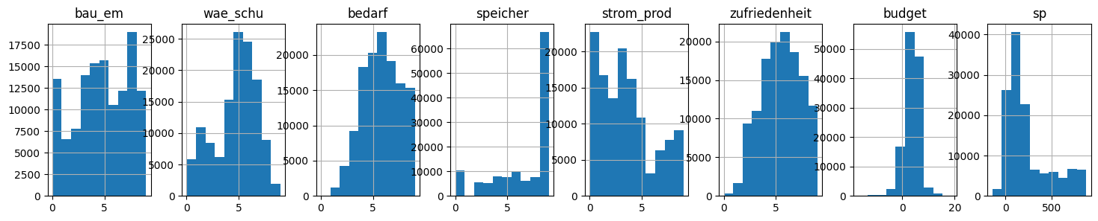
Figure X. Distribution of the principal model states after round four for 126,806 simulated games.

Relationship between emissions and satisfaction
The joint distribution of final greenhouse-gas score and satisfaction is shown in Figure Y. The simulation did not produce a single fixed trade-off between the two outcomes. Low-emission trajectories occurred over several satisfaction levels, while games with similar satisfaction values could result in substantially different emission scores.
The densest region of the outcome space combined moderate to relatively high satisfaction with comparatively low-to-moderate greenhouse-gas scores. High satisfaction was therefore not inherently incompatible with strong emission performance in the current calibration. This is consistent with the game design, in which satisfaction does not directly reduce emissions but can influence the financial resources available for subsequent renovation measures.
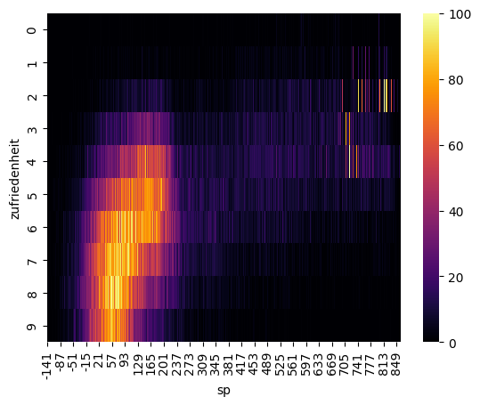
Figure Y. Joint distribution of final satisfaction and cumulative greenhouse-gas score.

Composition of the best-performing games
For exploratory analysis, the lowest-scoring 1% of final game states were selected, corresponding to 1,268 games. These trajectories did not converge on one complete renovation configuration. Instead, high-performing games combined measures from several categories, including envelope renovation, heating systems, electricity efficiency, flexibility, renewable generation, and user-oriented measures.
Several repeatable or enabling cards nevertheless occurred very frequently in this subset. A house-wide electric-car charging port was installed in 1,202 of the 1,268 games (94.8%). Bidirectional charging occurred in 849 games (67.0%), car sharing in 847 (66.8%), LED lighting in 840 (66.2%), external solar shading in 765 (60.3%), and flexible storage management in 754 (59.5%). Barrier-free access, balcony photovoltaics, intensive roof greening, and electric cooking were each present in more than half of the best-performing trajectories.
This concentration does not by itself demonstrate that these cards are individually responsible for low emissions. Their occurrence is conditional on card availability, prerequisites, available budget, and previous decisions. In particular, several highly frequent measures form enabling relationships with subsequent cards. Nevertheless, the near-universal occurrence of the house-wide electric-car charging card in the current best-performing subset warrants specific calibration review, as it may indicate either a strong intended synergy or an overly favorable combined effect.
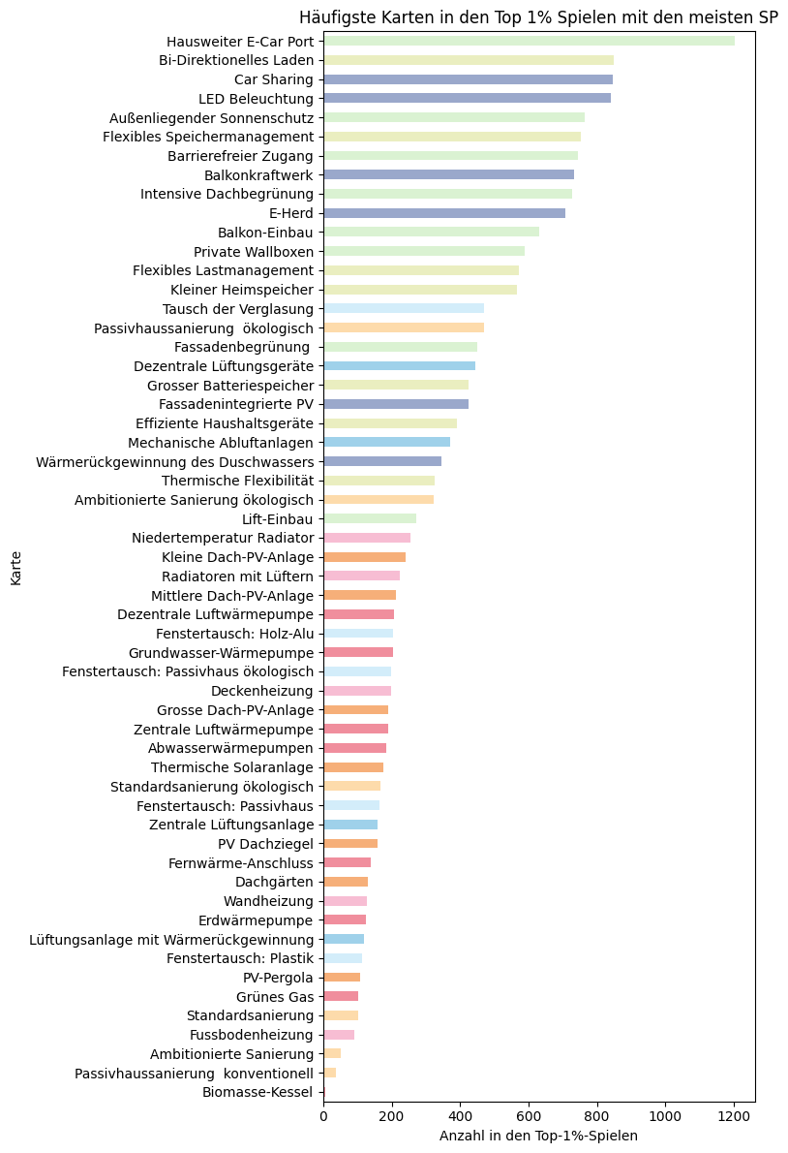
Figure Z. Frequency of installed measures within the lowest-scoring 1% of simulated games.

But this only measuresif the card was played, which was often just because it COULD be played, because it was cheap or without cost.
A better gauge of effectiveness is the previously introducedKPI of average “victory point lift” from games with a card vs games without the card:
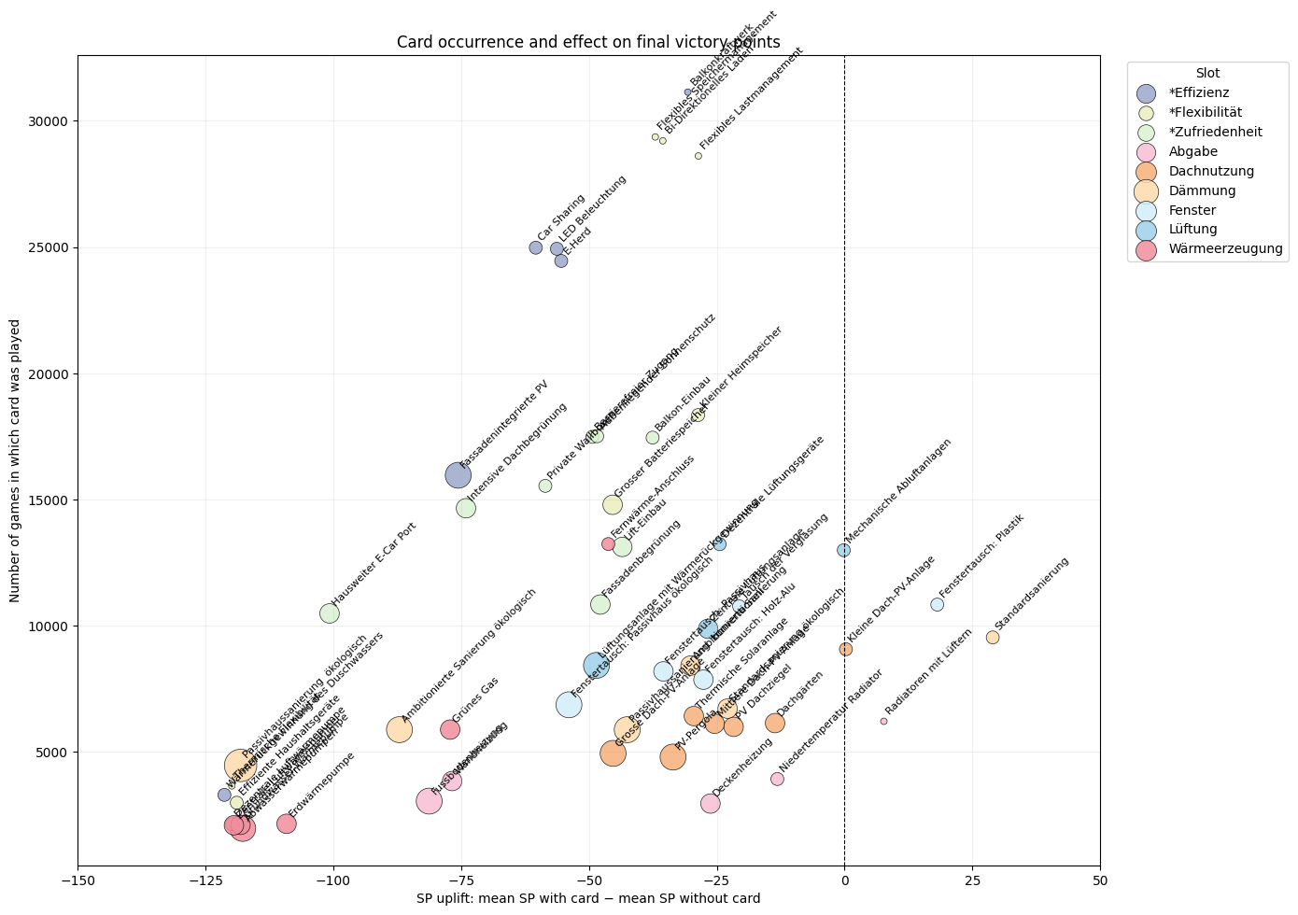

Diversity within single-use renovation categories
A different pattern was observed for measures occupying mutually exclusive building-system slots. No individual card in these categories occurred in a majority of the best-performing games.
The most frequent single-use measure was replacement of the glazing, which appeared in 471 of the 1,268 best-performing games (37.1%). Ecological passive-house renovation occurred in 470 games (37.1%), decentralized ventilation in 445 (35.1%), mechanical exhaust ventilation in 372 (29.3%), and ambitious ecological renovation in 322 (25.4%).
The heating and heat-distribution pathways were similarly diverse. Low-temperature radiators occurred in 20.2% of the best-performing games, decentralized air-source heat pumps in 16.4%, groundwater heat pumps in 16.1%, central air-source heat pumps in 15.0%, and wastewater heat pumps in 14.4%. Roof-use strategies were also distributed across several options, including small photovoltaic systems (19.1%), medium photovoltaic systems (16.7%), large photovoltaic systems (15.1%), and solar thermal systems (14.0%).
These results indicate that high emission performance was compatible with several alternative configurations of the major building systems. In contrast to the highly recurrent enabling and efficiency measures described above, the simulation did not identify a single envelope, heating, ventilation, or roof-use technology that was necessary for a high-performing trajectory.

4.5 Evidence for interaction rather than independent card ranking
The simulated high-performing games generally contained combinations of measures from multiple state dimensions rather than only repeated selection from one category. For example, the best observed trajectory combined envelope renovation, window improvement, heat-distribution and heat-generation measures with photovoltaic generation, electrical efficiency, flexibility, and user-oriented interventions.
This pattern is consistent with the intended structure of the model, in which the result of a measure can depend on other states. Heat-pump outcomes depend on thermal demand and efficiency; storage interacts with local generation; and budget effects influence the availability of later measures. Consequently, the frequency of an individual card cannot be interpreted as an independent measure of technical effectiveness.
The exploratory card-level analysis confirms this limitation. Comparing the mean final score of games with and without a specific card produces large apparent differences for some measures, but these differences include selection effects from budget, prerequisites, card availability, and previous measures. Such comparisons are therefore useful as balancing diagnostics rather than causal estimates of card effectiveness.

Implications for model calibration
Overall, the simulation provides two complementary findings. First, the major single-use building systems show substantial pathway diversity: several envelope, heat-generation, ventilation, heat-distribution, and roof-use options occur among the best-performing trajectories. This supports the design objective of avoiding one universally prescribed renovation pathway.
Second, the analysis identifies specific areas for further calibration. Storage and flexibility frequently reach the maximum state, indicating a possible ceiling effect. Several enabling cards occur disproportionately often among the best-performing trajectories, particularly the house-wide electric-car charging infrastructure. These findings provide concrete targets for the next balancing iteration rather than evidence that the current calibration is final.
The computational analysis therefore serves primarily as a structural validation of the game model. It demonstrates that the rules generate a broad range of outcomes and multiple successful building-system configurations, while also identifying individual state mappings and card interactions that require additional review.

Discussion

Preserving relationships rather than numerical detail
The central design problem of The Renovation Game is model reduction. A building-energy model can become more accurate by adding variables and temporal resolution. A tabletop learning model faces the opposite constraint: each additional variable requires additional explanation, state tracking, or arithmetic.
The design therefore does not attempt to maximize physical detail. It preserves selected relationships that are both technically important and suitable for decision-based learning. This distinction can be described as preservation of solution-space geometry. The term does not imply exact mathematical equivalence between the engineering model and the game. It refers to the attempt to retain the direction and relative structure of decisions. Measures that are complementary in the technical system should tend to be complementary in the game. Measures that affect different physical quantities should remain distinct. Large differences should remain visible, while minor differences can be removed.
The approach is particularly suitable for introductory systems education. Learners can work with the causal structure before they learn the equations needed for a detailed simulation.

Endogenous learning content
A central design decision was to make technical content endogenous to the mechanics. A card could simply state, for example, that low-temperature heating improves heat-pump performance. In the present design, this information is also implemented as a change in the heat-pump efficiency state. The relationship therefore affects electricity demand, operational emissions, and future budget.
The same principle applies to storage. Players cannot obtain the benefit of a battery by treating it as generation because the game stores electricity production and storage in separate states.
Embodied emissions provide another example. Their presence in the construction-emission state creates an immediate penalty that is conceptually different from recurring operational emissions. This makes the difference visible without requiring players to understand a full life-cycle assessment.
These mechanics do not prove that players learn the intended concepts. They do, however, establish a direct relationship between the concepts and successful interaction with the model.

Balance between realism and playability
Calibration repeatedly required trade-offs between physical interpretation and game clarity. Some simplifications are straightforward: A continuous heat-demand range can be converted into discrete increments without changing the basic relationship between insulation and demand.
Other simplifications are more problematic: Electricity storage, for example, is inherently temporal. An annual state cannot reproduce charging constraints or mismatches between production and demand. The current solution therefore preserves only the general effect of storage on local self-use.
Costs create another challenge: Real renovation costs vary with location, building geometry, procurement, condition, and construction market. The current game therefore uses relative card costs. This is sufficient to create investment constraints but not to teach detailed renovation economics.
User satisfaction is even more abstract: It represents multiple social and comfort-related outcomes through one state. This is useful for preventing a purely technical optimization but should not be interpreted as a quantitative model of occupant behavior.
These examples suggest a general principle for engineering serious games: a simplified value should only be given a precise physical interpretation when the underlying assumptions support that precision. Where this is not possible, the game should preserve the relationship while clearly communicating the limitation.

Computational testing as part of serious-game development
Monte Carlo simulation is often used for physical or economic models, but it also has a useful role in serious-game development. A physical playtest gives information about comprehension, interaction, pacing, and player behavior. It provides limited coverage of the combinatorial state space. Computational simulation provides the opposite strengths. It can test thousands of game paths but cannot determine whether the rules are understandable or engaging.
For a model-driven serious game, these methods should therefore be complementary. The current randomized policy is intentionally simple. It gives a baseline for structural behavior under card availability and budget constraints. Future versions of the simulation could include heuristic decision policies, such as maximum immediate emission reduction, maximum expected cumulative emission reduction, or emission reduction per budget unit.
Such policies would permit stronger tests of strategic differentiation. They could establish whether knowledge of technical interactions provides a systematic advantage over simple greedy selection.

Educational evaluation as a separate question
The present work evaluates the representation and internal behavior of the game, not learning effectiveness. This separation is important. Technical credibility does not guarantee learning, and positive participant feedback does not establish technical validity. A serious-game evaluation should therefore distinguish at least three questions:
1. Does the model represent the intended technical relationships?
2. Does the game produce understandable and meaningful decisions?
3. Does interaction with the game improve knowledge or other intended outcomes?
The first question is addressed through model construction, source values, and domain review. The second can be addressed through computational analysis and formative playtesting. The third requires participant data.
A matched pre- and post-game questionnaire has been prepared for future evaluation. The planned study includes objective questions on renovation measures and technical relationships as well as self-reported rule confidence, strategy confidence, perceived learning, enjoyment, and willingness to play again. These data are intentionally excluded from the present analysis until a sufficient participant sample is available.

Game design as learning method
It can be argued that we learned a lot about the importance and relevance of different measures by constraining ourselves to the limitations of a board game. What needs preserving and why? This paper stands testament to the increased clarity . It can be argued that DESIGNING a game can be an effective, if very advanced learning technique. As albert einstein put it: if you cant explain something in simple terms, you have not understood it.

Transferability of the method
The method is not limited to one building type. The same architecture can represent different reference buildings by changing the starting states and lookup tables. A newer building can start with lower heating demand. A dense building can have less photovoltaic production per unit of floor area. Different climates can modify the range of useful heating demand. Different electricity scenarios can modify the round-dependent grid factors.
This is important because the game is intended to teach that renovation decisions depend on context. A future extension could explicitly provide several starting archetypes and ask players to compare strategies between them.
The broader method could also be applied to other engineering education problems. Suitable systems share several characteristics: they contain multiple interacting states, interventions have both direct and indirect effects, and the full engineering model is too complex for the target audience.

Limitations
The current model has several limitations:
- First, it represents a nominal reference building rather than a specific property. Card values should not be used for project design or investment decisions.
- Second, the model uses discrete annual states. It omits weather, hourly demand profiles, thermal mass, detailed component performance, hydraulic behavior, and building controls.
- Third, the electricity-storage representation is a proxy for self-consumption and flexibility. It does not implement state of charge, charging losses, or hourly dispatch.
- Fourth, the current costs are relative game values. The nominal conversion to euros is useful for scale but does not provide validated cost estimates for individual measures.
- Fifth, the electricity decarbonization pathway is scenario-dependent. Different assumptions can change the relative value of electrification and flexibility.
- Sixth, embodied emissions are simplified card effects rather than a complete component-based life-cycle assessment.
- Seventh, user satisfaction combines multiple social and comfort outcomes in one state and therefore cannot represent the diversity of actual occupant preferences.
- Eighth, the present computational validation uses randomized card selection. It can identify dominance and structural problems, but it cannot determine whether knowledgeable human players find better strategies.
- Finally, the present paper does not evaluate learning outcomes. The game is described as being designed for renovation education, not as an empirically proven educational intervention.

Conclusions
This paper presents a method for translating selected building-energy relationships into the mechanics of a serious board game.
The Renovation Game represents renovation through interacting states for heat demand, heat supply, heat-pump efficiency, electricity demand, renewable generation, storage, construction emissions, budget, and user satisfaction. Fifty-one renovation cards modify these states over four five-year rounds. The translation from engineering model to game model follows four main principles: preservation of effect direction, preservation of the relative ordering of measures, retention of strategically relevant differences, and explicit representation of important technology interactions.
The resulting game does not attempt to reproduce a detailed building simulation. Its purpose is to provide a transparent decision environment in which the consequences of envelope renovation, heating-system choices, photovoltaic generation, flexibility, embodied emissions, costs, and user-oriented measures remain connected.
A computational implementation reproduces the principal game rules and permits large numbers of randomized game sequences to be evaluated. This provides a practical method for identifying dominant cards, irrelevant measures, unreachable states, and calibration problems before or alongside physical playtesting.
The main contribution is therefore not a claim that a board game can replace engineering calculation. It is a method for using engineering relationships as the basis of game mechanics rather than as supplementary educational content.
Future work will complete the computational sensitivity analysis, test alternative building archetypes and decision policies, and evaluate learning outcomes using matched pre- and post-game questionnaires.

Acknowledgments
The development of The Renovation Game was carried out within the City of Vienna competence team for climate-fit urban renovation (“KlimSta”), funded by the City of Vienna Municipal department MA23.

Data and Software Availability
The game model is implemented in Python for automated simulation and balancing. The repository contains the simulation code, analysis notebooks, print material, and associated game data and is available at https://github.com/simonschaluppe/klimsta-Brettspiel

Conflicts of interest
The authors declare no conflicts of interest.

References
[1] R. Garris, R. Ahlers, and J. E. Driskell, “Games, motivation, and learning: A research and practice model,” Simulation & Gaming, vol. 33, no. 4, pp. 441–467, 2002, doi: 10.1177/1046878102238607.
[2] R. Hunicke, M. LeBlanc, and R. Zubek, “MDA: A formal approach to game design and game research,” in Proc. AAAI Workshop on Challenges in Game AI, San Jose, CA, USA, 2004.
[3] G. Kalmpourtzis and M. Romero, “Constructive alignment of learning mechanics and game mechanics in serious game design in higher education,” International Journal of Serious Games, vol. 7, no. 4, pp. 75–88, 2020, doi: 10.17083/ijsg.v7i4.361.
[4] T. M. Connolly, E. A. Boyle, E. MacArthur, T. Hainey, and J. M. Boyle, “A systematic literature review of empirical evidence on computer games and serious games,” Computers & Education, vol. 59, no. 2, pp. 661–686, 2012, doi: 10.1016/j.compedu.2012.03.004.
[5] R. L. Lamb, L. Annetta, J. Firestone, and E. Etopio, “A meta-analysis with examination of moderators of student cognition, affect, and learning outcomes while using serious educational games, serious games, and simulations,” Computers in Human Behavior, vol. 80, pp. 158–167, 2018, doi: 10.1016/j.chb.2017.10.040.
[6] S. Schneider, T. Zelger, R. Drexel, M. Schindler, P. Krainer, and J. Baptista, “Declaration-ready climate-neutral PEDs: Budget-based, hourly LCA including mobility and flexibility,” Designs, vol. 9, no. 6, Art. no. 123, 2025.
[7] C. Boomsma, R. J. Hafner, S. Pahl, R. V. Jones, and A. Fuertes, “Should we play games where energy is concerned? Perceptions of serious gaming as a technology to motivate energy behaviour change among social housing residents,” Sustainability, vol. 10, no. 6, Art. no. 1729, 2018, doi: 10.3390/su10061729.
[8] G. Bekebrede, E. van Bueren, and I. Wenzler, “Towards a joint local energy transition process in urban districts: The GO2Zero simulation game,” Sustainability, vol. 10, no. 8, Art. no. 2602, 2018.
[9] M. Sailer and L. Homner, “The gamification of learning: A meta-analysis,” Educational Psychology Review, vol. 32, pp. 77–112, 2020, doi: 10.1007/s10648-019-09498-w.
[10] S. Schneider, T. Zelger, D. Sengl, and J. Baptista, “A quantitative positive energy district definition with contextual targets,” Buildings, vol. 13, no. 5, Art. no. 1210, 2023, doi: 10.3390/buildings13051210.
[11] [ADD SOURCE FOR AUSTRIAN BUILDING RENOVATION / KLIMAAKTIV MEASURE CATALOGUE.]
[12] [ADD SOURCE FOR ENERGY PRICES USED IN THE GAME.]
[13] [ADD SOURCE FOR HEATING-SYSTEM GHG FACTORS.]
[14] [ADD SOURCE FOR THE ELECTRICITY DECARBONIZATION PATHWAY IF DIFFERENT FROM REF. 6.]
[15] [ADD SOURCE FOR EMBODIED-EMISSION VALUES USED FOR INDIVIDUAL CARDS.]

Data Supplement
- Supplementary Table S1. Complete card definitions and game-state effects.

