Modelling With MATLAB

Assignment 2.

Simon Stead

**Question 1:** I created three functions “randmutual.m” “randpred.m” and “randrand.m” to generate matrices to model (mixed) mutualism, predator-prey and random interactions respectively. Each function generates upper and lower triangular matrices and adds them to a diagonal matrix, ensuring each has the required form. All diagonal entries were set to -1. All elements of the upper triangle were generated as normally distributed random values with variance defined as a function argument. Entries were 0 with probability also given as an argument. The lower triangle is then calculated and given the appropriate sign structure for the given model.

“question1.m” then calls these functions a number of times (n is set to 1 by default) and plots the eigenvalue spectra.

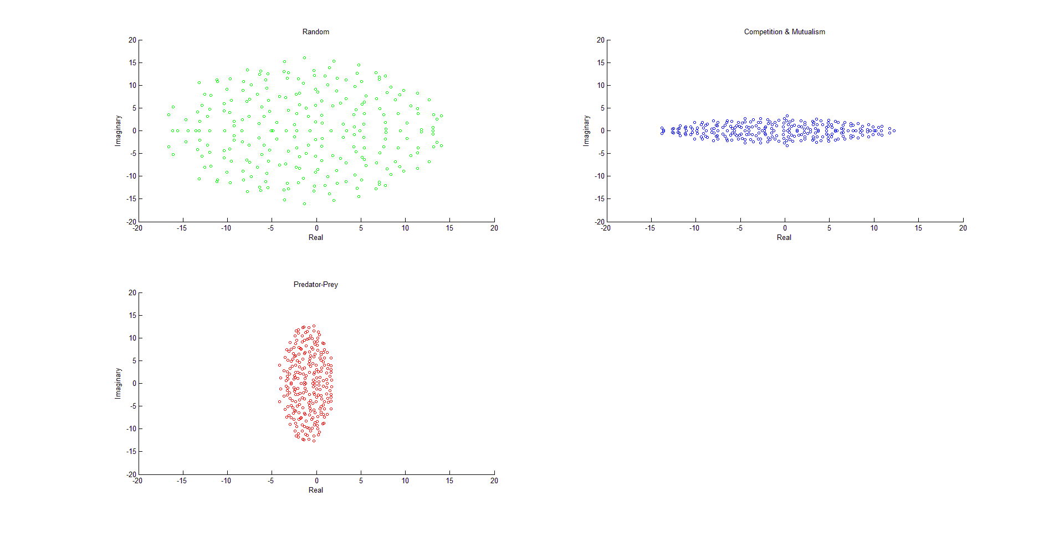

**Question 2:** “question2.m” simply repeats the process of question 1, multiplying each matrix by a diagonal matrix of uniformly random values [0,2], to scale each row independently. We observe a clustering near the origin for these ‘stripey’ eigenvalues.

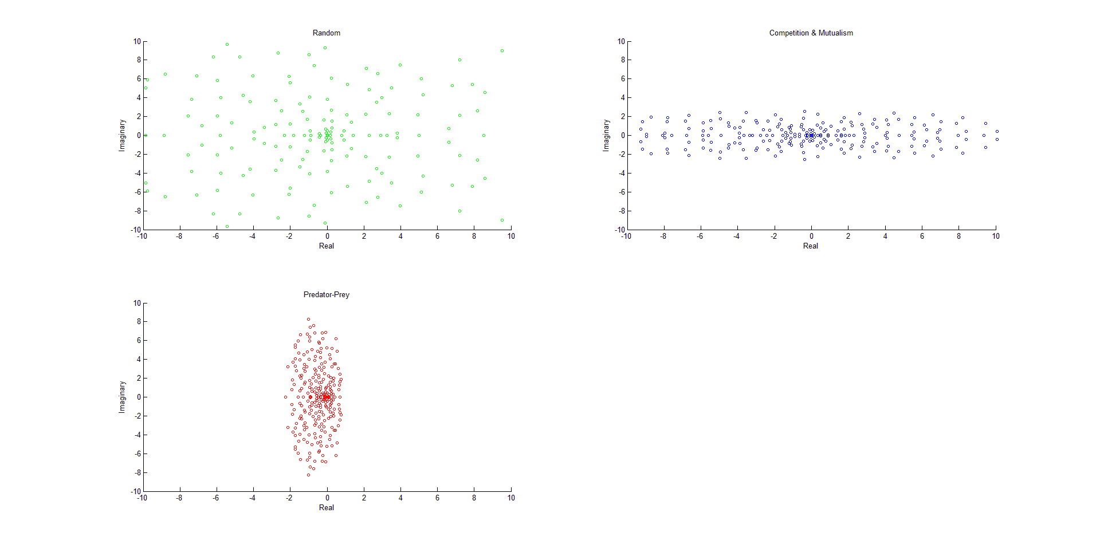

**Question 3:** I set up the obligate mutualism model as shown in James et al (2012), with uniformly random paramaters scaled to the appropriate intervals given in the supplementary information. These can be found in “obligate1dweak.m” “obligate1dstrong.m”. “question3.m” then integrates both ODEs through time, incrementing a counter if the probabilities both drop below 0.01. The counter is then divided by the number of iterations performed to obtain the probability.

Over 500 iterations, the extinction probability for the weak mutualism model was found to be 0.946, and the extinction probability for the strong mutualism model was found to be 0.992. The latter is consistent with the claim in the text.

**Question 4:** The 2 animal and 2 plant species model can be found in “obligate2dweak.m” and “obligate2dstrong.m” for weak and strong mutualism respectively. “question4.m” performs 100 iterations of ODE45 on each function, with a counter for each that increments when all populations persist.

Over these 100 iterations, we obtained a probability of 0 that all populations persist in weak obligate mutualism, and a persistence probability of 0.29 in the strong case.