**Title page**

**Title**

Atolls are globally significant hubs for tropical seabirds

**Author list**

Sebastian Steibl1, *, +

Simon Steiger2, +

Alex S. Wegmann3

Nick D. Holmes3

Hillary S. Young4

James C. Russell1

**Affiliation**

1 School of Biological Sciences, University of Auckland, Auckland, 1010, New Zealand

2 Karolinska Institute, Solna, 17177, Sweden

3 The Nature Conservancy, Sacramento, CA 95811, USA

4 Ecology, Evolution and Marine Biology, University of California Santa Barbara, CA, USA

+ shared first-authorship

**ORCiD**

Sebastian Steibl: <https://orcid.org/0000-0003-4819-8581>

Simon Steiger:

Alex S. Wegmann: <https://orcid.org/0000-0002-0595-7552>

Nick D. Holmes: <https://orcid.org/0000-0003-1740-2404>

Hillary S. Young: <https://orcid.org/0000-0003-0449-8582>

James C. Russell: <https://orcid.org/0000-0002-5901-6416>

* corresponding author: Sebastian Steibl; **Email:** [sebastian.steibl@auckland.ac.nz](mailto:sebastian.steibl@auckland.ac.nz)

**Author contributions**

Se.S. and Si.S. designed the study, conducted the model development and data analysis; Se.S. compiled the datasets; all authors contributed to the writing and proofing of the manuscript and have agreed to the submission of the final version.

**Competing Interest Statement**

The authors declare not competing interests.

**Classification**

Biological Sciences – Ecology

**Keywords**

Bayesian predictive modelling; Indo-Pacific; island biodiversity; land-sea connectivity; nutrient input; population

**Abstract**

Atolls are at the forefront of climate change impacts. Local-scale adaptation strategies on atoll islands are motivated to protect human livelihoods against rising sea levels. However, for the majority of uninhabited atoll islands, a general conservation need from a biodiversity perspective is so far absent in the public awareness. This is likely reinforced by received wisdom that atoll islands are depauperate and of low ecological value. Nevertheless, the role of seabirds on atolls has gained growing attention, as they provide critical nutrient subsidies to island and reef ecosystems. *Vice versa*, however, the global relevance of atoll islands for seabirds has not been assessed. In this study, we used Bayesian predictive modelling to quantify seabird colonies on all Indo-Pacific atolls and assess the reciprocal significance between seabirds and atolls on a global scale. We show that ca. 28 million seabirds are using the 280 Indo-Pacific atolls as nesting grounds. 13 seabird species have more than half of their estimated world population nesting on atolls. In turn, atoll seabird colonies act as nutrient pumps of the tropical Indo-Pacific, depositing on average 64 tonnes of nitrogen and 10 tonnes of phosphorous per atoll and year. These findings establish a general conservation case for atoll islands as globally significant sites for tropical seabirds. Protecting atoll islands across the entire Indo-Pacific will be essential to preserve a significant fraction of the world’s seabirds. Reciprocally, the protection of atoll seabird colonies will help maintaining the functioning of atoll ecosystems, thereby amplifying resilience against forecast climate change.

**Significance statement**

Atolls are unique ecosystems of the tropical oceans. Their integrity is increasingly undermined by climate change, making local-scale adaptation essential for their long-term persistence. While the protection of human livelihoods on atoll islands is gaining growing attention, general conservation needs for atoll islands motivated by biodiversity protection have not been institutionalised. We show that ca. 28 million seabirds are nesting on the 280 Indo-Pacific atolls – about as much as the entire seabird population of Europe, or a third of the entire seabird population of North America. Reciprocally, seabird colonies are major nutrient pumps to atoll ecosystems. Future-proofing atoll islands against climate change is globally significant for seabird conservation and critical to maintaining nutrient fluxes in the remote Indo-Pacific.

**Main text**

**Introduction**

Atolls are unique ecosystems of the tropical oceans. They comprise a ring-shaped coral reef that encloses a shallow lagoon, and up to several hundred individual islands along the atoll rim (Goldberg 2016). Over large parts of the Indo-Pacific basin, atolls constitute the most common and numerous island type (Nunn *et al.* 2016). These low-lying islands are at the forefront of climate change impacts and widely recognised as being among the most vulnerable ecosystems to global change (IPCC 2023). While the received wisdom of their inevitable drowning from rising sea levels is increasingly challenged by advances in geoscience (Beetham *et al.* 2017; Masselink *et al.* 2020; Kench *et al.* 2023), major local-scale adaptation and restoration efforts are nevertheless essential to preserve these unique ecosystems beyond the Anthropocene (Steibl *et al.* 2023).

Local-scale adaptation initiatives to future-proof atoll islands against climate change are primarily motivated to protect human livelihoods, indigenous cultures, and economies (Barnett *et al.* 2022; Brown *et al.* 2023). A conservation case for the preservation of atoll islands from a biological diversity perspective, particularly for the vast majority of uninhabited islands, is so far limited to just a handful of atolls, such as Aldabra (UNESCO world heritage) or the North-western Hawai’ian atolls (National Wildlife refuges) (Stoddart 1968). This is likely reinforced by the widespread perception that atoll islands are generally depauperate fringe ecosystems with low terrestrial biodiversity and ecological value – sometimes even dubbed ‘biodiversity cool spots’ (antipodal to the ‘biodiversity hotspot’ classification of most high volcanic island archipelagos) (Myers *et al.* 2000; Thaman 2008).

Indeed, atoll islands may not harbour the same endemism-rich and diverse terrestrial species communities as their large volcanic counterparts (Kier *et al.* 2009). Nevertheless, atoll islands house remarkable species­ communities that play critical roles in the atoll ecosystem’s functioning and resilience (Stoddart 1992). Most readily evident are seabirds, which act as the major nutrient delivery system to atoll islands. Their nutrient input in the form of guano catalyses terrestrial carbon sequestration (Young *et al.* 2011), enhances soil and groundwater enrichment (McMahon & Santos 2017; Young *et al.* 2010), and subsidises adjacent coral reefs and marine consumer communities (Benkwitt *et al.* 2022; Savage2019). Together, numerous case studies across the Indo-Pacific underline that seabirds are significant components of atoll ecosystems. *Vice versa*, however, the global significance of atoll islands as nesting grounds for seabirds has been implied but never directly tested and quantified (Berr *et al.* 2023a).

Assessing the relevance of atoll islands for tropical seabird species would help establishing and institutionalising a global biological conservation case for systematic and comprehensive atoll island protection. Therefore, we quantified and modelled seabird nesting colonies on all 280 Indo-Pacific atolls and tested the hypothesis that atoll islands are major seabird nesting hubs with global significance for species conservation. Additionally, we assessed the seabird-driven nutrient transfer to atoll ecosystems across the entire Indo-Pacific atoll landscape. By quantifying global seabird population sizes on atolls and their role as nutrient pumps to atoll islands, this study establishes the first empirically-tested global conservation argument for atoll islands as sites with exceptional ecological value for seabirds and, reciprocally, for seabird conservation on all atolls across the entire Indo-Pacific to preserve their integrity and functioning on a basin-scale.

**Results**

1. *The significance of atolls for seabirds*

We compiled a global dataset of atoll nesting seabird colonies that comprised data for 199 of the Indo-Pacific’s 280 coral atolls. For 107 atolls, abundance-based nesting censuses were available, while for 92 atolls only incidence-based nesting censuses were available. We used Bayesian modelling to predict seabird presence and breeding population size to generate a global understanding of seabird nesting on all the Indo-Pacific’s atolls.

The 280 atolls of the Indo-Pacific serve as nesting sites to an estimated total of ca. 28 million seabirds [50% HDR confidence interval: 27,059,477 – 30,604,876], comprising 37 different species. Nesting populations range from zero birds (on some Maldivian atolls) to over 3 million birds per atoll (e.g., Europa, Starbuck) (Fig. 1a). Importantly, 25% of the Indo-Pacific’s atolls (70 atolls) house seabird nesting populations above the threshold for Important Bird Areas (B3b, formerly A4iii; KBA 2020). 51 atolls (ca. 18% of all Indo-Pacific atolls) house a seabird colony that constitutes >1% of the estimated global population size of the given species. 12 atolls house a colony that constitutes >10% of the estimated global population size of a seabird species, and two atolls (Kiritimati and Midway) house colonies that constitutes >70% of the estimated global populations of a seabird species (Fig. S1). Species richness on atolls with a seabird nesting population ranges from just single species (e.g., on some Lakshadweep atolls) to 18-19 species (French Frigate Shoals, Kiritimati, Midway) (Fig. 1b). Community composition analysis identified several atolls that significantly contribute to global beta-diversity (a measure for the compositional dissimilarity between atolls). These are atolls that serve as breeding grounds for distinct seabird species assemblages, such as several petrel species (*Pterodroma* spp.) on Ducie and Oeno (Pitcairn Group), or two species of albatross on the North-Western Hawai’ian atolls (Fig. 1c). Together, a large set of atolls can be identified across the entire Indo-Pacific basin, which is significant for tropical seabirds by providing nesting sites for either a large number of birds, often above internationally recognised thresholds for important bird areas (Fig. 1a, S1), or a high diversity of different species (Fig. 1b), or a distinct community of unique species (Fig. 1c).

The biomass of all atoll-nesting seabirds combined totals 11,264,618 kg, with an average seabird biomass of 40,231 kg per atoll [95% quantiles: 0 –164,445]. Using bird biomass conversion factors in Bar-On *et al.* (2018), the total biomass of atoll-nesting seabirds translates to a carbon stock of 3,942,616 kg carbon throughout all Indo-Pacific’s atolls, or 14,081 kg carbon per atoll on average [0 – 57,556].

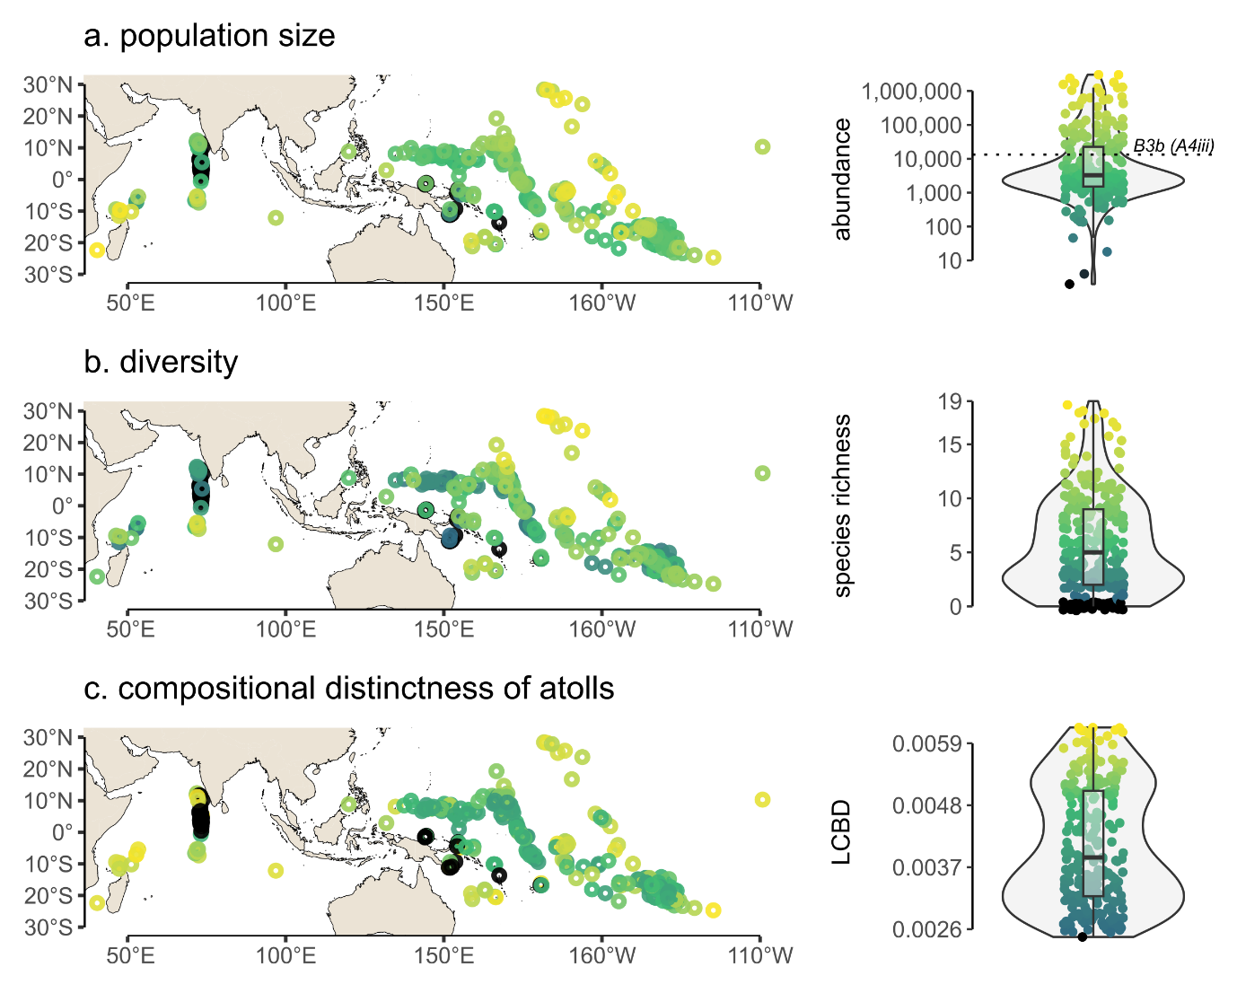**Figure 1: Seabird colonies on the 280 Indo-Pacific coral atolls.** Total seabird colony size (a), seabird species richness (b), and compositional distinctness (local contribution to beta-diversity; LCBD score) (c) were computed using a Bayesian predictive modelling framework. Ca. 25% of the Indo-Pacific’s atolls house seabird nesting colonies greater than the BirdLife International threshold for significant bird areas B3b (formerly A4iii criteria; dashed horizontal line in boxplot a).

We used global population assessments from BirdLife International and Birds of the World (Billerman *et al.* 2020)for each of the 37 atoll-nesting seabird species to estimate how much of their world population is nesting on atolls. For 18 seabird species, more than 25% of their world population is nesting on atolls. For 13 species more than 50%, for eight species more than 75%, and for two species (the Black-footed and Laysan Albatross) more than 95% of their world population is nesting on atolls (Fig. 2). Only one of the principal atoll nesting seabird species, the Polynesian storm-petrel (*Nesofregetta fuliginosa*), is currently recognised by IUCN red list criteria as endangered (BirdLife International 2018).

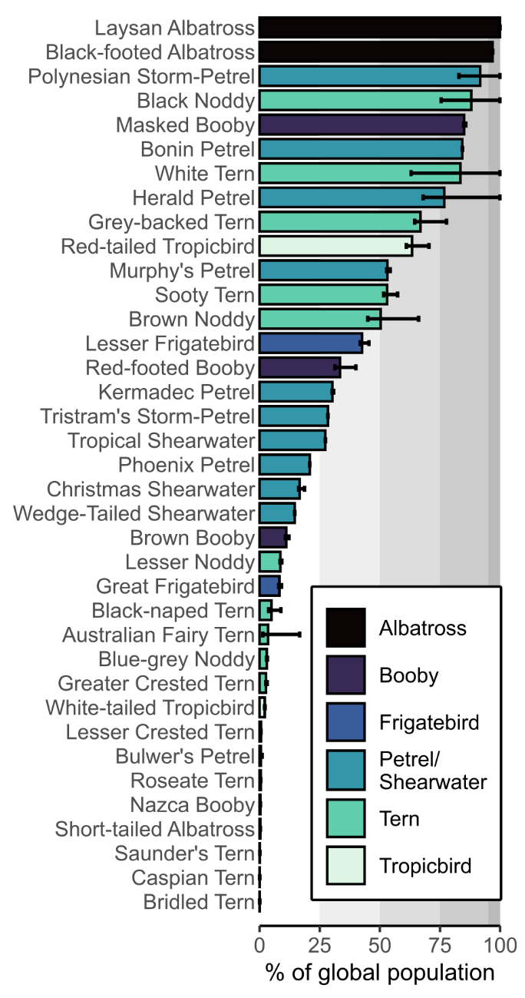**Figure 2: Contribution of atolls to global population sizes of Indo-Pacific seabirds.** For each of the 37 atoll-nesting seabird species, the percentage fraction of atoll-nesting birds is given based on global population size estimates from BirdLife International and Birds Of the World (see supplementary file S1). For 13 seabird species, more than 50% of their estimated global population are nesting on atolls, and for two species more than 95% of their global population is nesting on atolls. Error bars indicate the 50% highest density region confidence interval of the predicted total abundances.

1. *The significance of seabirds for atolls*

By serving as nesting sites for ca. 28 million seabirds, this analysis revealed that atolls are of exceptional significance for seabirds; reciprocally, seabird colonies are also significant for the functioning of the atoll system: to assess the global contribution of seabirds for the nutrient dynamics on atolls we quantified basin-wide nutrient deposition rates using bioenergetic models (Otero *et al.* 2018; Wilson *et al.* 2004).

Seabird colonies import on average 64,480 kg nitrogen [95% quantiles: 0 – 247,391], and 10,746 kg phosphorous per year and per atoll [0 – 45,732] in the form of guano (Fig. 3a, Fig S2). Within a seabird colony, albatross (*Phoebastria* spp.) and booby (*Sula* spp.) colonies contribute the largest amounts of nitrogen per atoll (Fig. 3b). However, we emphasize that albatross colonies and their subsidising role are today confined to the north-western Hawai’ian atolls (yet their historic distribution may have been more widespread across Pacific atolls; Spennemann 1998).

As seabird nesting colonies are usually confined to just a subset of an atoll’s islands, the calculated nutrient inputs are unevenly concentrated to just few of an atoll’s sometimes hundreds of islands (Amerson 1969). However, because island-level information on atoll-seabird colony distribution was not available in most data sources, we did not further adjust nutrient input quantities to land area. Using the entire land area of an atoll would greatly underestimate the uneven and highly concentrated input rates on seabird-colony islands within an atoll.

The relationship between seabird colony size and nutrient input per atoll follows a log-log-linear relationship. For every tenfold increase in seabird colony size, nitrogen inputs per atoll increase roughly tenfold (slope coefficient: 0.938, *R²* = 0.967, *P* < 0.001). Similarly, for every tenfold increase in seabird colony size, phosphorous inputs per atoll also increase roughly tenfold (slope coefficient: 0.799, *R²* = 0.926, *P* < 0.001).

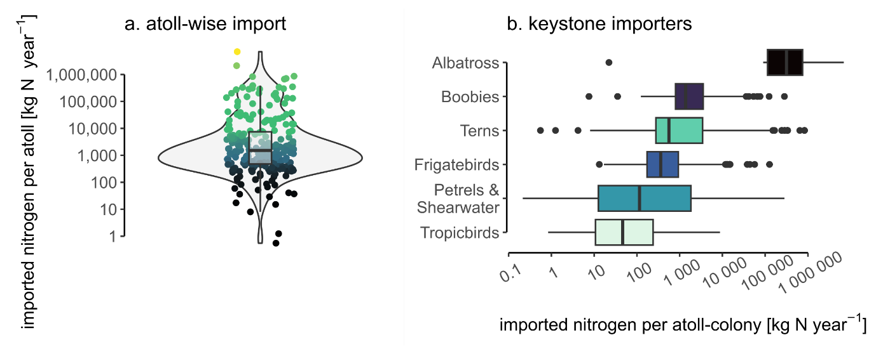**Fig. 3 Seabird-derived nitrogen inputs on atolls.** For each of 280 Indo-Pacific atoll, the estimated seabird-derived nitrogen input in kg N per year is calculated using bioenergetic models (a). For the six species groups of seabirds, the imported nitrogen per atoll-colony is presented (b). Atolls receive on average over 64,000 kg N per year from seabirds, but amounts vary greatly depending on the size of the atoll seabird colony. Albatross and booby colonies import the largest amounts of nitrogen per atoll on average. Phosphorous input rates are summarised in supplementary figure S2.

Seabird guano is rapidly volatilised as ammonia and enters the atmospheric nitrogen cycle. The total annual ammonia emission of atoll seabird colonies across the Indo-Pacific are 2,600,723 kg NH3 per year. The annual average ammonia emissions are 9288 kg NH3 per atoll [0 – 39,983] (Fig. 4).

Using published GPS-tracking data of the atoll seabird species (see supplementary file S1 for data sources), we simulated foraging ranges over which seabirds are integrating nutrients during the breeding season and concentrate them onto the atoll ecosystem (Thaxter *et al.* 2012). Depending on the species, atoll-nesting seabirds forage as close as 2–3 km (Little terns *Sternula* spp.) or as far as 1500 km (Albatross *Phoebastria* spp.) around an atoll during breeding season. For most atolls, seabirds are integrating nutrients over a core area (50% highest density region) of 10,000 – 100,000 km² of ocean around an atoll. For those atolls with large petrel/shearwater and/or albatross colonies (e.g., Ducie, Midway, Oeno), the core nutrient integration area extends to 100,000 – 1,000,000 km² of ocean around an atoll, because these bird species have wider foraging ranges (Fig. 4). As the average atoll land area is 9.7 km² [0.3 – 30.1], seabirds are spatially concentrating nutrients onto the atoll islands by, at least, a factor of 1000-10,000.

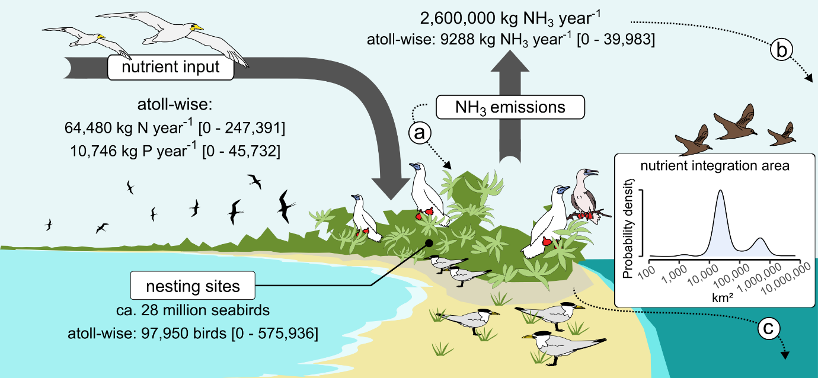**Figure 4: The reciprocal significance between seabirds and atolls.** Atolls provide nesting space for ca. 28 million seabirds throughout the Indo-Pacific. Reciprocally, seabirds are importing enormous quantities of nutrients in the form of guano into the atoll ecosystem, which they integrate over 10,000 – 100,000 km² of ocean around each atoll. A significant amount of reactive nitrogen from guano is rapidly volatilised and enters the atmospheric nitrogen cycle as ammonia. Ammonia emissions can either be directly re-incorporated into the atoll ecosystem via plant uptake (a), or atmospherically wet- or dry-deposited in the surrounding ocean (b). In addition, surface run-off and groundwater discharge directly flush seabird excrements back into the nearshore reef ecosystem (c). Values in brackets are 5% and 95% quantiles, respectively.

**Discussion**

Our global analysis of seabird colonies on all Indo-Pacific atolls demonstrates that these islands are globally significant hubs for seabirds and, reciprocally, seabirds act as major nutrient pumps on a basin-scale. About 28 million seabirds are using atolls as nesting sites, and 13 species have more than half of their entire worldwide population concentrated on atolls. As a result, atoll islands are sites of extraordinary nutrient deposition and the presence of seabirds on these remote landforms likely has relevant effects on the marine and terrestrial element cycles throughout the otherwise barren and nutrient-limited tropical Indo-Pacific (de la Peña-Lastra 2021).

Because of their ecological significance as biological pumps between marine and terrestrial ecosystems, global seabird distribution and conservation priorities have been assessed repeatedly (Chown *et al.* 1998; Paleczny *et al.* 2015; Otero *et al.* 2018; Callaghan *et al.* 2021). However, atolls have been thus far overlooked in large-scale efforts to identify global hotspot areas for seabirds. Global studies estimated total seabird population sizes at ca. 12.6 million seabirds in South America, 30.5 million seabirds in Europe, and 73.9 million seabirds in North America (Otero *et al.* 2018). Our analysis revealed that the 280 atolls of the Indo-Pacific are housing about the same number of seabirds as the European peninsula, or about one third of the total seabird population of entire North America. At the same time, the combined total land area of all 280 atolls is less than 2750 km², or about a quarter of the land area of Hawai’i’s Big Island (ca. 10,430 km²). This unequivocally highlights the global significance of atoll islands as prime focus sites for seabirds and the need to incorporate atoll island protection in global strategies of seabird protection.

While atolls do not harbour critically endangered or range-restricted seabird species, several common seabirds of the tropical Indo-Pacific have a relevant fraction of their global population nesting on atoll islands (Fig. 2). As atolls throughout the Indo-Pacific face the same challenges from climate change (incl. increase in storm surges, marine heatwaves, rising sea levels) (Barnett *et al.* 2022), a significant fraction of many common Indo-Pacific seabird species may thus be considered vulnerable. For example, species such as the White tern (*Gygis alba*) or Black Noddy (*Anous minutus*) are widespread and common, and thus ranked ‘least concern’ under IUCN criteria. However, our analysis suggests more than 75% of their global populations are found on atolls, meaning that the accelerating undermining of atoll islands’ integrity with ongoing global change could globally threaten the persistence of these species (Reynolds *et al.* 2015).

Many features of atoll islands, such as their small land areas, isolation, or low habitat complexity, render them ideal sites for ecological restoration actions. Removal of invasive mammal predators, forest diversification and clearing of abandoned monoculture copra plantations can create safe havens for tropical seabird species throughout the Indo-Pacific (Carr *et al.* 2021). The ecological value of atoll islands for seabirds on a basin-scale thus places a premium on atoll restoration as a highly impactful key conservation tool for seabird protection with global relevance. Additionally, to protect a significant number of the world’s seabirds, nature-based resilience-building measures on atoll islands against climate change will be critical to implement across the entire Indo-Pacific (Steibl *et al.* 2023).

Reciprocally, the protection or active restoration of atoll seabird colonies is an essential instrument for maintaining critical energy and nutrient fluxes throughout the Indo-Pacific (Sandin *et al.* 2022). The large biomasses of atoll seabird colonies may contribute significantly to terrestrial carbon stocks throughout the Indo-Pacific. One case study on Palmyra, a palm-dominated atoll in Eastern Polynesia, assessed the entire aboveground carbon biomass of the atoll’s vegetation at ca. 692,000 kg carbon (Longley-Wood *et al.* 2022). Our analysis showed that the average seabird carbon biomass is around 14,000 kg carbon per atoll, suggesting that large atoll seabird colonies can constitute a relevant proportion to terrestrial aboveground carbon stocks even on densely-vegetated humid atolls. This relevance is likely further amplified on arid, sparsely vegetated atolls with only grass and/or shrub vegetation (e.g., Malden, Starbuck). The seabird carbon biomass can be readily integrated into the terrestrial element cycle of atolls, as seabird carcasses are rapidly consumed by land crabs (Alexander 1979).

More important to the atoll’s element cycles is the enormous concentration of nitrogen and phosphorous, integrated over 10,000 – 100,000 km² of open ocean around an atoll, onto the comparably small island and reef ecosystem. For example, the seabird colonies of the North-western Hawai’ian islands consume an estimated 400,000 tonnes of fish, squid, and crustaceans annually and thereby concentrate these protein- and nutrient-rich marine resources onto the islands (Schreiber & Schreiber 1986). Our assessment of nitrogen and phosphorous inputs throughout all Indo-Pacific atolls offers the opportunity to incorporate atoll ecosystems into basin-wide analysis of element cycles. The estimated total ammonia emissions from atoll seabird colonies of over 2.6 million kg per year makes up as much as 40% of total Indo-Pacific wide emission estimates (ca. 6.28 million kg) (Riddick *et al.* 2018). Case studies on ammonia emissions from atoll seabird colonies suggest that volatilised nitrogen can be rapidly re-integrated into the atoll ecosystem, either through direct uptake by plants or re-deposited within few kilometres into the ocean (Schmidt *et al.* 2004, 2010). Ammonia emissions from seabird colonies, together with the direct run-off of guano into the adjacent coastal ecosystems, can stimulate and amplify oceanic productivity in otherwise nutrient- and particularly nitrogen-limited surface waters (Riddick *et al.* 2012; Martino *et al.* 2014). Our quantifications suggest that atoll seabird colonies may be an important yet overlooked contributor to remote oceanic nitrogen cycles (Altieri *et al.* 2021; Paulot *et al.* 2015).

Atolls are unique trans-boundary ecosystems where marine and terrestrial ecological processes and functioning are tightly intertwined. Seabirds are major nutrient pumps and thus a critical element to atoll ecosystems. Reciprocally, atoll islands are globally significant hubs for tropical seabirds. As many atoll islands are severely degraded from local-scale human impacts, the carrying capacities and seabird colonies on atolls can be even further expanded through ecological restoration (Carr *et al.* 2021). Ultimately, the restoration of atoll seabird colonies will contribute towards restoring the integrity of atoll ecosystems themselves, offering a nature-based opportunity for resilience building against future climate change (Benkwitt *et al.* 2023).

**Materials and Methods**

1. *Data compilation*

We compiled an Indo-Pacific database of seabird colonies on an atoll-level. For a list of references see supplementary file S1. Only seabird censuses were included where authors clearly indicated a complete assessment of the entire seabird population; records of just single species from atolls were excluded. We used the global checklist in Goldberg (2016) for identifying all atolls that fall within the boundaries of the Indo-Pacific basin (*sensu* Nunn *et al.* 2016). A small number of atolls also occur in the South China Sea, the Banda Sea, and the Caribbean but these atolls were excluded from our analysis as not enough seabird census data was available.

For each atoll, we compiled a set of environmental and biogeographic parameters that can be broadly grouped in four dimensions: oceanographic parameters (net primary productivity, chlorophyll concentrations, phytoplankton concentrations, sea surface temperature, and wave velocity;), biogeographic parameters (distance to nearest atoll, distance to nearest high island, distance to nearest content, number of islands per atoll, total land area per atoll), environmental parameters (annual rainfall), and disturbance parameters (hurricane frequency, frequency of tropical storms, ENSO-driven precipitation anomalies, human population size). These parameters have been identified as driving Indo-Pacific seabird colonies, and therefore considered crucial for modelling seabird occurrence and nesting population sizes (Amerson 1969; Berr *et al.* 2023b; Schreiber and Schreiber 1984).

The oceanographic parameters were obtained from the EU Copernicus Marine Service Information data hub (<https://data.marine.copernicus.eu/products> last accessed 24 May 2023) and measured as 30-year long-term average at ca. 100 km circumference around each atoll. Biogeographic and environmental parameters were compiled from literature data and distances measured in Google Earth 10.40.0.2. Disturbance parameters were obtained from the Historical Hurricane Tracks database of the National Oceanic and Atmospheric Administration (NOAA) (<https://coast.noaa.gov/hurricanes/> last accessed 25 Feb 2023) and measured as 90-year cumulative sum at a 50-km polygon around each atoll. Data on ENSO-driven rainfall anomalies were obtained from the Global Precipitation Climatology Project of the Joint Institute for the Study of the Atmosphere and Ocean (JISAO) (<http://research.jisao.washington.edu/data/gpcp/> last accessed 24 May 2023).

To estimate how much of the estimated global population size of each seabird species is nesting on atolls, we obtained global population estimates for each species from BirdLife International and Birds of the World (Billerman *et al.* 2020).

1. *Statistical analyses*

All statistical analysis was done in Julia Programming Language, and the ‘Turing’ ecosystem for Bayesian modelling (Bezanson *et al.* 2017; Ge *et al.* 2018). Incidence-based data on seabird nesting was available for 92 atolls, and abundance-based for 107 atolls, while no data was available for the remaining 81 atolls. We used a two-stage model to first predict the presence/absence and then the population sizes of each seabird species. Both the presence model and the count model use the same independent variables to model outcome (presence or population size) of species *s* of nesting type *n* (burrow-nesting, ground-nesting, vegetation-nesting)on atoll *a*, with environmental parameters *E* (obtained from a principal component feature analysis of the environmental parameters), in region *r* (Indian Ocean, Micronesia, Melanesia, Polynesia)*.*

For predicting seabird presence, we fitted a Bayesian multilevel logistic regression model to presence/absence data from 199 surveyed atolls. The model was specified as follows: Let *Yisn,* where *Y* ϵ {0,1}, denote the presence of species *s* (s = 1, …, S) of nesting type *n* (N ϵ {1,3}) on atoll *a* (a = 1, …, A) with environmental parameters Eaj (J ϵ {1,6}) in region *r* (R ϵ {1,4}).

The parameter *β0sr* encodes the probability that species *s* occurs in region *r* in which atoll *a* is located. The parameter *β1nj* encodes how environmental parameters of atoll *a* affect the probability that species *s* within a nesting type *n* occurs on atoll *a*. This effect is allowed to differ between nesting types, such that the probability that a ground nesting species occurs on atoll *a* increases with some environmental parameter, while the probability of a tree nesting species may decrease. By partially pooling species within nesting types, we express our assumption that species within the same nesting type *ni* are similarly affected by certain environmental parameters.

For predicting seabird population sizes, we specified a Bayesian multilevel model using the same value sets as above, as follows: Let *Yisn* denote the log-transformed count of birds of species *s* of nesting type *n* on atoll *a* in region *r.*

The parameter *β0s* encodes the abundance of species *s* across regions, by nesting regional estimates within species. As such, is the average abundance of species *s* across regions. The hyperparameter on *τ0* encodes the variation between regions across species. By partially pooling regions within species, we express our assumption that species *s* forms colonies of similar size across regions. This is unlike the presence model, where the fixed effect *β0sr* prevents information flow between species *s*’s estimates for different regions.

The parameter  encodes how environmental parameters affect the abundance of species within a nesting type. This effect is allowed to differ between nesting types, such that the abundance of a species of ground nesters may be positively related to some environmental parameters, while the abundance of tree nesters may be negatively related. By partially pooling species within nesting types, we express our assumption that species from the same nesting type *ni* are similarly affected by certain environmental parameters.

We validated model outcomes using standard Bayesian diagnostics, leave-one-out cross-validation, out-of-sample validation, and computed prior predictive checks, prior sensitivity analyses, and posterior predictive checks (see supplementary file S1 for model validation). All statistical code is made freely accessible in a digital repository (insert link).

1. *Estimating annual nutrient inputs*

Annual nitrogen and phosphorous inputs were calculated using the bioenergetic models in Wilson *et al.* (2004) and Otero *et al.* (2018). Body weight measurements for each seabird species were obtained from the AVONET global bird trait database (Tobias *et al.* 2022). Total excreted nitrogen or phosphorous were calculated using

M is the body mass per bird (in g), FEC the energy content of seabird diets (in kJ g-1), Aeff the assimilation of food (in kJ kJ-1) and FNC, or FPC respectively, the nitrogen or phosphorous content of the food (in g N or g P g-1 wet mass). Values were taken from published literature data (Otero *et al.* 2018). Calculated amounts of excreted nitrogen and phosphorous were adjusted for length of breeding period for each species, its attendance time at the colony during breeding, and nesting behaviour (burrow nesting, ground nesting, vegetation nesting), following Wilson *et al.* (2004). We also adjusted for additional fledgling excretion rates using Otero *et al.* (2018).

Ammonia emissions were calculated using the mass ratio of 17/14 of NH3 to nitrogen, and assuming a volatilisation rate of 0.7 based on literature values from *in-situ* measurements on Indo-Pacific reef islands (Schmidt *et al.* 2010). The conversion of total seabird biomass to carbon stock was calculated using the conversion factors in Bar-On *et al.* (2018).

1. *Simulating foraging ranges around atolls*

Data on maximum and mean seabird foraging ranges were obtained from published GPS-tracking studies (see supplementary file S1 for list of data sources). We only included studies that tracked seabird foraging during nesting season. For each seabird species, we used the mean maximum foraging distance and reported variabilities (standard deviations) to simulate foraging distance under a Gaussian distribution, assuming no biased directionality of each simulated foraging trip. We then calculated the 50% highest density region interval around each atoll were its seabird colony forages during breeding season.

**Acknowledgements**

Financial support for Se.S. provided by a Walter Benjamin-fellowship (STE 3139/1) of the German Research Foundation.

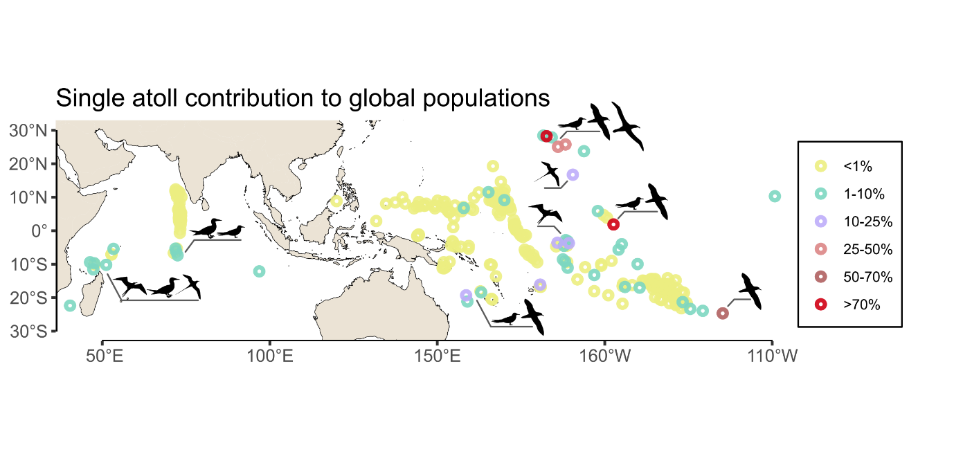***Triaged figures 🡪 for supplementary material***

**Figure S1: Atoll contribution to global seabird populations.** Colour code indicates which atolls house the colony of a seabird species that constitutes >1% of the estimated global population of this species. Bird icons indicate to which taxonomic group the species on a given atoll belongs to (albatross, boobies, frigatebirds, petrel/shearwater, tern, tropicbird).

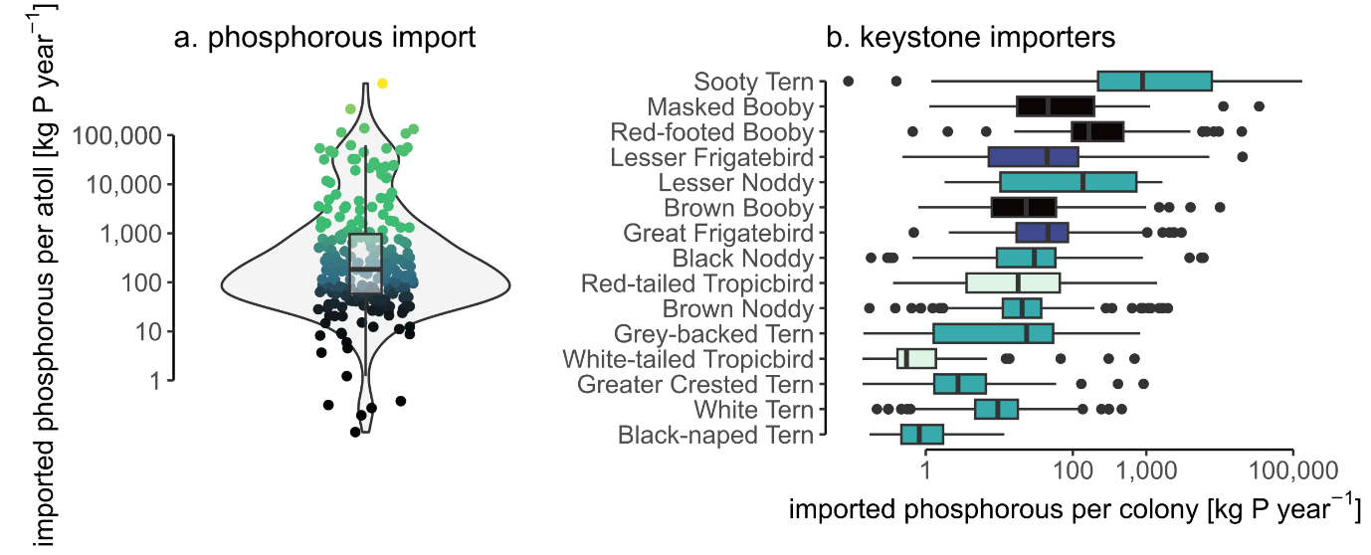**Figure S2: Seabird-driven phosphorous input on atolls.**

**References**

W. M. Goldberg, Atolls of the world: revisiting the original checklist. *Atoll Res. Bull.* **610**, 1-47 (2016).

P.D. Nunn, L. Kumar, I. Eliot, R. F. McLean, Classifying Pacific islands. *Geosci. Lett.* **3**, 7 (2016).

Intergovernmental Panel on Climate Change, “IPCC Climate change 2023: synthesis report. Contribution of working groups I, II and III to the Sixth Assessment Report” H. Lee, J. Romero Eds. (IPCC Geneva, Switzerland, 2023), pp. 35-115.

E. Beetham, P. S. Kench, S. Popinet, Future reef growth can mitigate physical impacts of sea-level rise on atoll islands. *Earth’s Future* **5**, 1002-1014 (2017).

G. Masselink, E. Beetham, P. S. Kench, Coral reef islands can accrete vertically in response to sea level rise. *Sci. Adv.* **6**, eaay3656 (2020).

P. S. Kench, C. Liang, M. R. Ford, S. D. Owen, M. Aslam, E. J. Ryan, T. Turner, E. Beetham, M. E. Dickson, W. Stephenson, A. Vila-Concejo, R. F. McLean, Reef islands have continually adjusted to environmental change over the past two millennia. *Nat. Comm.* **14**, 508 (2023).

S. Steibl, P. S. Kench, H. S. Young, A. S. Wegmann, N. D. Holmes, N. Bunbury, T. H. Teavai-Murphy, N. Davies, F. Murphy, J. C. Russell, Rethinking atoll futures: local resilience to global challenges *Trends Ecol. Evol.* 1-9 (2023).

J. Barnett, S. Jarillo, S. E. Swearer, C. E. Lovelock, A. Pomeroy, T. Konlechner, E. Waters, R. L. Morris, R. Lowe, Nature-based solutions for atoll habitability. *Phil. Trans. R. Soc. B.* **377**, 20210124 (2022)

S. Brown, R. J. Nicholls, A. Bloodworth, O. Bragg, A. Clauss, S. Field, L. Gibbons, M. Pladaité, M. Szuplewski, J. Watling, A. Shareef, Pathways to sustain atolls under rising sea levels through land claim and island raising. *Environ. Res.: Climate* **2**, 015005 (2023).

D. R. Stoddart, The Aldabra affair. *Biol. Conserv.* **1**, 63-69 (1968).

N. Myers, R. A. Mittermeier, C. G. Mittermeier, G. A. B. da Fonseca, J. Kent, Biodiversity hotspots for conservation priorities. *Nature* **403**, 853-858 (2000).

R. R. Thaman, Atolls – the “biodiversity cool spots” vs hot spots: a critical new focus for research and conservation. *Micronesia* **40**, 33-61 (2008).

G. Kier, H. Kreft, T. M. Lee, W. Jetz, P. L. Ibisch, C. Nowicki, J. Mutke, W. Barthlott, A global assessment of endemism and species richness across island and mainland regions. *Proc. Natl. Acad. Sci. U.S.A.* **106**, 9322-9327 (2009).

D. R. Stoddart, Biogeography of the tropical Pacific. *Pac. Sci.* **46**, 276-293 (1992).

H. S. Young, D. J. McCauley, R. Dirzo, Differential responses to guano fertilization among tropical tree species with varying functional traits. *Am. J. Bot.* **98**, 207-214 (2011).

A. McMahon, I. R. Santos, Nitrogen enrichment and speciation in a coral reef lagoon driven by groundwater inputs of bird guano. *J. Geophys. Res. Oceans* **122**, 7218-7236 (2017).

H. S. Young, D. J. McCauley, R. B. Dunbar, R. Dirzo, Plants cause ecosystem nutrient depletion via the interruption of bird-derived spatial subsidies. *Proc. Natl. Acad. Sci. U.S.A.* **107**, 2072-2077 (2010).

C. E. Benkwitt, P. Carr, S. K. Wilson, N. A. J. Graham, Seabird diversity and biomass enhance cross-ecosystem nutrient subsidies. *Proc. R. Soc. B.* **289**, 20220195 (2022).

C. Savage, Seabird nutrients are assimilated by corals and enhance coral growth rates. *Sci. Rep.* **9**, 4284 (2019).

T. Berr, M. P. Dias, S. Andréfouet, T. Davies, J. Handley, M. Le Corre, A. Millon, E. Vidal, Seabird and reef conservation must include coral islands. *Trends Ecol. Evol.* **38**, 490-494 (2023a).

KBA Standards and Appeals Committee, “Guidelines for using a global standard for the identification of key biodiversity areas. Version 1.1”, KBA Standards and Appeals Committee of the IUCN Species Survival Commission and IUCN World Commission on Protected Areas (Gland, Switzerland, 2020), pp. 1-148.

Y. M. Bar-On, R. Phillips, R. Milo, The biomass distribution on Earth. *Proc. Natl. Acad. Sci. U.S.A.* **115**, 6506-6511 (2018).

S. M. Billerman, B. K. Keeney, P. G. Rodewald, T. S. Schulenberg, Data from „Birds of the World” (Ithaca, NY, USA: Cornell Lab of Ornithology, 2020). Available at <https://birdsoftheworld.org/bow/home>.

BirdLife International, IUCN Red List for birds (2018) available at <https://www.birdlife.org>.

X. L. Otero, S. de la Peña-Lastra, A. Pérez-Alberti, T. O. Ferreira, M. A. Huerta-Diaz, Seabird colonies as important global drivers in the nitrogen and phosphorous cycle. *Nat. Comm.* **9**, 246 (2018).

L. J. Wilson, P. J. Bacon, J. Bull, U. Dragosits, T. D. Blackall, T. E. Dunn, K. C. Hamer, M. A. Sutton, S. Wanless, Modelling the spatial distribution of ammonia emissions from seabirds in the UK. *Environ. Poll.* **131**, 173-185 (2004).

D. H. R. Spennemann, Japanese economic exploitation of central Pacific seabird populations, 1898-1915. *Pac. Studies* **21**, 1-41 (1998).

C. B. Thaxter, B. Lascelles, K. Sugar, A. S. C. P. Cook, S. Roos, M. Bolton, R. H. W. Langston, N. H. K. Burton, Seabird foraging ranges as a preliminary tool for identifying candidate Marine Protected Areas. *Biol. Conserv.* **156**, 53-61 (2012).

S. de la Peña-Lastra, Seabird droppings: effects on a global and local level. *Sci. Total Environ.* **754**, 142148 (2021).

S. L. Chown, K. J. Gaston, P. H. Williams, Global patterns in species richness of pelagic seabirds: the Procellariiformes. *Ecography* **21**, 342-350 (1998).

M. Paleczny, E. Hammill, V. Karpouzi, D. Pauly, Population trends of the World’s monitored seabirds, 1950-2010. *PLoS ONE* **10**, e0129342 (2015).

C. T. Callaghan, S. Nakagawa, W. K. Cornwell, Global abundance estimates for 9,700 bird species. *Proc. Natl. Acad. Sci. U.S.A.* **118**, e2023170118 (2021).

M. H. Reynolds, K. N. Courtot, P. Berkowitz, C. D. Storlazzi, J. Moore, E. Flint, Will the effect of sea-level rise create ecological traps for Pacific island seabirds? *PLoS ONE* **10**, e0136773 (2015).

P. Carr, A. Trevail, S. Bárrios, C. Clubbe, R. Freeman, H. J. Koldewey, S. C. Votier, T. Wilkinson, M. A. C. Nicoll, Potential benefits to breeding seabirds of converting abandoned coconut plantations to native habitats after invasive predator eradication. *Restor. Ecol.* **29**, e13386 (2021).

S. A. Sandin, P. A. Becker, C. Becker, K. Brown, N. G. Erazo, C. Figuerola, R. N. Fisher, A. M. Friedlander, T. Fukami, N. A. J. Graham, D. S. Gruner, N. D. Holmes, W. A. Holthuijzen,

K. Longley-Wood, M. Engels, K. D. Lafferty, J. P. McLaughlin, A. Wegmann, Transforming Palmyra atoll to native-tree dominance will increase net carbon storage and reduce dissolved organic carbon reef runoff. *PLoS ONE* **17**, e0262621 (2022).

H. G. L. Alexander, A preliminary assessment of the role of the terrestrial decapod crustaceans in the Aldabran ecosystem. *Phil. Trans. R. Soc. Lond. B.* **286**, 241-246 (1979).

H. P. Jones, M. Rios, A. Samaniego, W. Sechrest, B. X. Semmens, H. E. Thornton, R. V. Thurber, C. N. Wails, C. A. Wolf, B. J. Zgliczynski, Harnessing island-ocean connections to maximize marine benefits of island conservation. *Proc. Natl. Acad. Sci. U.S.A.* **119**, e2122354119 (2022).

R. W. Schreiber, E. A. Schreiber, „Christmas Island (Pacific Ocean) seabirds and the El Nino Southern Oscillation (ENSO): 1984 perspectives” in Mediterranean Marine Avifauna, X. Monbailiu, Ed. (NATO ASI Series, 1986), pp. 397-408.

S. N. Riddick, U. Dragosits, T. D. Blackall, S. J. Tomlinson, F. Daunt, S. Wanless, S. Hallsworth, C. F. Braban, Y. S. Tang, M. A. Sutton, Global assessment of the effect of climate change on ammonia emissions from seabirds. *Atmos. Environ.* **184**, 212-223 (2018).

S. Schmidt, W. C. Dennison, G. J. Moss, G. R. Stewart. Nitrogen ecophysiology of Heron Island, a subtropical coral cay of the Great Barrier Reef, Australia. *Funct. Plant Biol.* **31**, 517-528 (2004).

S. Schmidt, K. Mackintosh, R. Gillett, A. Pudmenzky, D. E. Allen, H. Rennenberg, J. F. Mueller, Atmospheric concentrations of ammonia and nitrogen dioxide at a tropical coral cay with high seabird density. *J. Environ. Monitor.* **12**, 460-465 (2010).

S. N. Riddick, U. Dragosits, T. D. Blackall, F. Daunt, S. Wanless, M. A. Sutton, The global distribution of ammonia emissions from seabird colonies. *Atmos. Environ.* **55**, 319-327 (2012).

M. Martino, D. Hamilton, A. R. Baker, T. D. Jickells, T. Bromley, Y. Nojiri, B. Quack, P. W. Boyd, Western Pacific atmospheric nutrient deposition fluxes, their impact on surface ocean productivity. *Global Biogeochem. Cycles* **28**, 712-728 (2014).

K. E. Altieri, S. E. Fawcett, M. G. Hastings, Reactive nitrogen cycling in the atmosphere and ocean. *Ann. Rev. Earth Planet Sci.* **49**, 523-550 (2021).

F. Paulot, D. J. Jacob, M. T. Johnson, T. G. Bell, A. R. Baker, W. C. Keene, I. D. Lima, S. C. Doney, C. A. Stock, Global oceanic emission of ammonia: constraints from seawater and atmospheric observations. *Global Biogeochem. Cycles* **29**, 1165-1178 (2015).

C. E. Benkwitt, C. D’Angelo, R. E. Dunn, R. L. Gunn, S. Healing, M. L. Mardones, J. Wiedenmann, S. K. Wilson, N. A. J. Graham, Seabirds boost coral reef resilience. *Sci. Adv.* **9**, eadj0390 (2023).

T. Berr, A. Millon, P. Dumas, P. Guehenneuc, F. Perez, H. de Méringo, J. Baudat-Franceschi, M. le Corre, E. Vidal, Human visitation disrupts natural determinants of breeding seabird communities on coral reef islands. *Glob. Ecol. Conserv.* **48**, e02732 (2023b).

A.B. Amerson, Jr., Ornithology of the Marshall and Gilbert islands. *Atoll Res. Bull.* **127**, 1-348. (1969).

R. W. Schreiber, E. A. Schreiber, Central Pacific seabirds and the El Niño Southern Oscillation: 1982 to 1983 perspectives. *Science* **225**, 713-716 (1984).

J. Bezanson, S. Karpinski, V. B. Shah, A. Edelman, Julia: a fast dynamic language for technical computing. Available at <https://doi.org/10.48550/arXiv.1209.5145>.

H. Ge, K. Xu, Z. Ghahramani, Turing: a language for flexible probabilistic inference. *PMLR* **84**, 1682-1690 (2018).

J. A. Tobias, C. Sheard, A. L. Pigot, A. J. M. Devenish, J. Yang, …, M. Schleuning, AVONET: morphological, ecological and geographical data for all birds. *Ecol. Lett.* **25**, 581-597 (2022).

**Figures**

*Move figures here for submission file.*