SNES 2 DB9 Joystick Converter
System specification

Document history
Date | Version | Responsible | Changes
2020-09-20 | V0.1 | Arndt | Initial version
2020-10-12 | V0.2 | Arndt | DB9 joystick idle is HIGH-Z and not pull up | https://github.com/simonsunnyboy/SNES2DB9/issues/1

Table of contents

Document history 1
Table of contents 1
Abstract 1
Functional blocks 2
Hardware requirements 2
Atari DB9 joystick connection 2
SNES Gamepad connection 3
Functional software requirements 3
Hardware abstraction 3
Functional blocks in Software 4
SNESReader 4
SNESMapper 4
DB9 4
SNESReader finite state machine 4
Statechart 5
State function mapping 5
Autofire functionality 6
Configurable SNES button mapping 6
Formal software requirements 6

Abstract
SNES2DB9 is a software package to allow implementation of a converter to connect a SNES style gamepad with shift register to a system using the Atari DB9 joystick standard (Atari 2600, C64, Amiga, Atari ST, etc.)

The converter software runs on any microcontroller and uses hardware abstraction.

Functional blocks
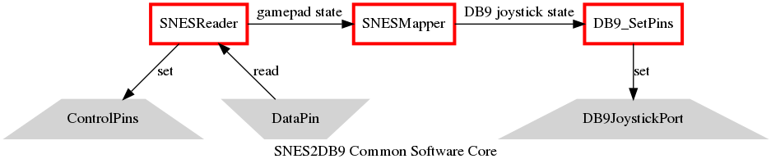

Block type | Description | comment
Red rectangle | Software component | VCC for both microcontroller and SNES gamepad
Grey trapeze | Hardware pin | - Widening trapeze indicates output  - Narrowing trapeze indicates input

Hardware requirements
Resistor configuration shall utilize pull-up resistors internal to the microcontroller if possible.

Atari DB9 joystick connection
Unless mentioned in the table pins are unused and not connected.

Signal | Pin number | Description
UP | 1 | Microcontroller output, data to target system  The signal is active low or HIGH-Z while inactive.
DOWN | 2 | Microcontroller output, data to target system  The signal is active low or HIGH-Z while inactive.
LEFT | 3 | Microcontroller output, data to target system  The signal is active low or HIGH-Z while inactive.
RIGHT | 4 | Microcontroller output, data to target system  The signal is active low or HIGH-Z while inactive.
FIRE | 6 | Microcontroller output, data to target system  The signal is active low or HIGH-Z while inactive.
+5V | 7 | VCC for both microcontroller and SNES gamepad
GND | 8 | Common ground for microcontroller and SNES gamepad

SNES Gamepad connection
Unless mentioned in the table pins are unused and not connected.
Signal | Pin number | Resistor configuration | Description
+5V | 1 | --- | Directly supplied from Atari DB9 joystick
CLOCK | 2 | Pull-up | Microcontroller output, control pin  According to the SNES controller interface protocol, the clock is idle high.
LATCH | 3 | Pull-down | Microcontroller output, control pin  According to the SNES controller interface protocol, the latch is idle low.
DATA | 4 | --- | Microcontroller input, data pin  Data is active low according to the SNES interface protocol.
GND | 7 | --- | Common ground connection

Functional software requirements

Hardware abstraction
The software abstracts hardware access through user supplied functions.
The functions are called through function pointers when needed.
The hardware shall immediately change pin states on call of the hardware abstraction.

Functional blocks in Software

SNESReader
The SNESReader addresses the SNES gamepad through the connection and translates SNES button presses to a bitvector.
- The bitvector is active high. Buttons are mapped in the order of shift register operation to most significant bits.
- The call rate defines the timing of CLOCK and LATCH signals on the hardware pins.
- The reader goes into idle mode after finishing the read cycle.
- A fresh read cycle must be initiated by the calling application by explicit command.

SNESMapper
The SNESMapper consumes a bitvector from the SNESReader and translates SNES button presses to desired Atari joystick operations.

- The resulting Atari joystick state is active high per bit.
- Directions are directly mapped
- Fire button feature:
One or more SNES buttons can be defined by the application to map to the Atari joystick fire button signal
- Jump button feature:
One or more SNES buttons can be defined by the application which act as Atari joystick “up” when pressed.
- Autofire feature:
One or more SNES buttons can be defined by the application to enable autofire functionality.

DB9

The DB9 handling translates a given Atari joystick state from the SNESMapper into hardware signals.

The function sets the pin state for each Atari joystick signal.

SNESReader finite state machine

Reading of the SNES gamepad is accomplished through a state machine.
- 16 bits are read until the state machine reaches IDLE state.
- An internal shift register assembles the read values.
- The system assumes state UPDATE once all bits have been read.

Statechart

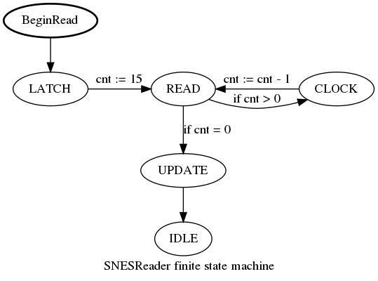

State function mapping
SNES control pins CLOCK and LATCH are set according to the table on entering the state in the order left to right.
Additional actions are performed after setting the new pin states.
State | SNES CLOCK | SNES LATCH | Additional action
IDLE | HIGH | LOW | None
LATCH | HIGH | HIGH | Clear internal shift register
READ | HIGH | LOW | Read SNES data, update shiftregister bit 0  0: button not pressed, data high  1: button pressed, data low
CLOCK | LOW | LOW | Shift register shifted to the left
UPDATE | HIGH | LOW | Carryover shift register contents to result

Autofire functionality

- If enabled, the Atari joystick fire button pulses in application defined time intervals between high and low.
- A time interval of 0s disables the autofire functionality.

Configurable SNES button mapping

The application can define sets of SNES buttons to map jump, fire or autofire functionality.
A mapping may be empty to disable the given functionality.

Formal software requirements
- The software shall be written in C99.
- Each functional block shall be provided as a seperate source file.

