SNES 2 DB9 Joystick Converter
User requirements

Document history
Date | Version | Responsible | Changes
2020-08-24 | V0.1 | Arndt | Initial version
2020-09-20 | V0.2 | Arndt | Add document content heading

Table of contents

Document history 1
Table of contents 1
User stories 1
User requirements 1

User stories
ID | Story
S1 | „I want to connect an SNES controller to an Atari-style DB9 joystick port for the main directions and a fire button. Power supply shall be possible through the DB9 connector“
S2 | „The four main fire buttons on the SNES pad shall be utilized in a sensible fashion.“

User requirements
In addition to the user stories above the following requirements are defined.

ID | Requirement
R1 | The adapter should be small and not exceed 5x7x1cm (WxLxH)
R2 | No buttons or switches outside of SNES controller required.
R3 | 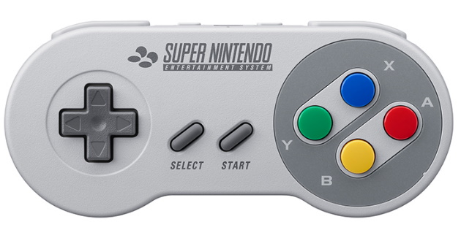  - B button on SNES shall be fire button  - A button on SNES shall be mapped as “Joystick up”, jump button feature  - Y button on SNES shall act as autofire when pressed.  - Directional pad on SNES shall map directly to joystick directions.
R4 | SNES controller polling every 20ms (50Hz) or faster.

