Project Report: Cloud-Native Environmental Monitoring System

1. Introduction and Objectives
The objective of this project is to design and deploy a Cloud-Native distributed system based on a microservices architecture. The scenario implemented is an Environmental Monitoring System simulating IoT sensors that generate, store, and expose data (e.g., Temperature and CO2 levels) through RESTful APIs.
The main goal of the project is to demonstrate the practical application of the core Cloud Computing paradigms studied during the course, specifically: containerization (Docker), declarative orchestration (Kubernetes), Service Discovery, Load Balancing, and Fault Tolerance.
2. System Architecture
To guarantee modularity and scalability, the application has been divided into three decoupled components, deployed within a local Kubernetes cluster (Minikube):
- Sensor Simulator (Writer): A Python-based microservice that acts as an IoT data generator. Every 5 seconds, it computes environmental parameters and pushes the data to a shared storage.
- Storage Layer (Database): A Redis database acting as a message broker and storage. It maintains the recent history of the generated metrics. To preserve data consistency and ensure a stable network identity, this component is deployed in Kubernetes as a StatefulSet and exposed via an Headless Service.
- Data Consumer (Reader REST API): A lightweight web server built with Python Flask. It fetches the telemetry data from Redis and exposes it over the network in standard JSON format at the /api/data endpoint. It is deployed as a Deployment with a replica count of 2, sitting behind a LoadBalancer service.

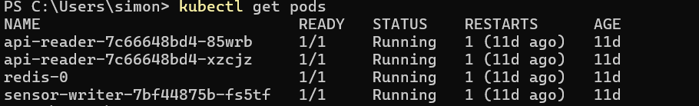
3. Applied Methodology: The Twelve-Factor App
The system has been strictly designed following the Twelve-Factor App methodology to maximize portability and cloud readiness:
- Factor III (Config): Configuration settings, such as the Database host, are not hardcoded but strictly passed through Environment Variables (REDIS_HOST) defined in the Kubernetes YAML files.
- Factor IV (Backing Services): Redis is treated as an external, attached backing service. The Writer and Reader microservices connect to it over the network without sharing any local state.
- Factor VI (Stateless Processes): The API Reader microservices are completely stateless. Any persistent data is safely delegated to the Redis StatefulSet.
- Factor IX (Disposability): Thanks to lightweight OS-level virtualization (python:3.11-slim images), the containers can start and stop gracefully in seconds, facilitating rapid scaling and robust deployments.
4. Key Cloud Features Demonstrated
During the project implementation and testing phase, several key non-functional properties and Kubernetes orchestration capabilities were successfully verified:
4.1. Service Discovery
The microservices communicate internally without using static IPs. The Reader and Writer containers reach the database dynamically by resolving the Kubernetes internal DNS name assigned to the StatefulSet (redis-service).
4.2. High Availability and Load Balancing
The Reader component has been horizontally scaled by setting replicas: 2 in the deployment manifest. Kubernetes automatically provisions multiple instances of the service. Incoming traffic from the external environment (accessed via the Minikube tunnel) is dynamically routed to the healthy pods by the Kubernetes Load Balancer.
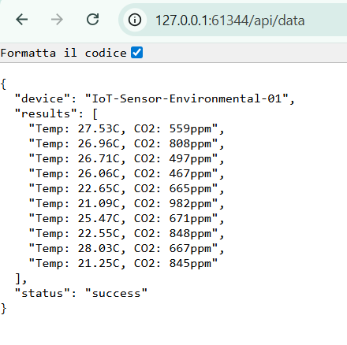
4.3. Fault Tolerance and Self-Healing
A specific Crash Test was performed to demonstrate the resilience of the cluster:
- While the system was generating and serving data, one of the two running api-reader pods was manually killed using the CLI command (kubectl delete pod).
- Because the architecture is strictly decoupled, the Writer continued to push data to Redis seamlessly.
- The Kubernetes control plane instantly detected the discrepancy between the desired state (2 replicas) and the actual state (1 replica).
- The system triggered its Self-healing routine, automatically scheduling and spinning up a replacement container within seconds. No downtime was experienced by the end-user querying the REST API during the process.

5. Conclusion
The implementation of the Environmental Monitoring System proves that migrating to a containerized, orchestrated cloud infrastructure successfully answers the challenges of modern software engineering. By applying Cloud-Native principles, the system inherently provides extreme flexibility, robust fault tolerance, and automated scalability with minimal administrative overhead.

