

GeoViqua – Skeleton-project and example portlet

Reference: SW_3013
Issue: 1_0

Contents

1 Overview 3
2 Dependencies (file and other jars) 3
3 Compile 3
4 Deploy 4
5 Add Portlet to liferay page 4
6 Example Portlet used with Parameter Dispatcher 5

Overview
The goals of this project are:
- To build a demo project called GeoViqua-Skeleton that shall be used by GeoViqua consortium as skeleton-template to develop new portlets. The project contains 1 portlet named GeoViquaExamplePortlet.
- Demonstrate how to declare public render parameters and use them in conjunction with the GeoPortal Parameter Dispatcher portlet (described in a different document)
- Show how to include and use the geoportal-chore.jar API to make calls to DAB (Data Access Broker and pick up the )

The demo skeleton-portlet uses the geoportal business logic provided in a separate jar file called geoportal-chore.jar. This jar is used to pick up the xml from DAB by making a call “SearchRemote.getResources(uuid)” on the results page.

This parameter “uuid” is configured in portlet.xml file as public render parameter.

Dependencies (file and other jars)
The portlet uses maven plugin for the build lifecycle therefore dependencies are configured in pom.xml.
However there is 1 dependency (library) which needs to be manually installed under the Maven developer machine repository. The library is the geoportal-chore1.0.0.jar
Please, consult the maven documentation about how to locally install dependencies. (An example of install command is reported herafter)

mvn install:install-file -DgroupId=com.sapienza -DartifactId=geoportal-cho
re -Dversion=1.0.0 -Dpackaging=jar -Dfile=/path/to/file

Compile
The demo portlet shall be compiled/packaged via maven command.
Once you have the folder structure
run the mvn package command and GeoViqua-skeleton-2.2.war
shall be created and ready to be deployed (see next paragraph)

Deploy
The deployment of example portlet follow liferay deployment general rules and can be accomplished through
- administration portlet
- hot deploy liferay mechanism

The hot deploy consists of dropping the war file under the deployment folder of Jboss-liferay (hot deploy is very handy during portlet development )

To hot deploy:
Copy (or ftp) the war file
under the liferay deploy directory
/{$LIFERAY_DEPLOY_DIR}/

NOTES:
- The {$LIFERAY_DEPLOY_DIR} corresponds to the value set by
property auto.deploy.deploy.dir configured in the following property file
{$Liferay_JBOSS_HOME}/server/default/deploy/liferay-portal.war/WEB-INF/classes/portal-ext.properties

- Sometimes it happens that liferay get stuck during the deployment lifecycle. If this happens restart the liferay-jboss server.

Add Portlet to liferay page
Once a Portal project is visible from the list of Liferay Application it is possible to add portlets to lifeay pages.
The GeoViqua-skeleton-2.2.war shall be visible as
GeoViqua Application and the example portlet has been called GeoViqua too.
See screen shot below
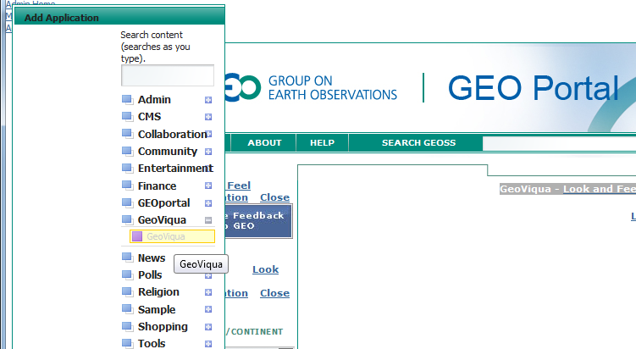

Example Portlet used with Parameter Dispatcher
The portlet of this example has already been placed on a page of GeoPortal-GeoViqua project and can be seen in action from the following URL

http://scgeoviqua.sapienzaconsulting.com/web/guest/param_dispatcher?p_p_id=pdPortlet_WAR_geoportal&p_p_lifecycle=1&p_p_state=normal&p_p_mode=view&uuid=73634129-B361-DA20-06B6648196795917

The portlet is also visible under the VM environment @

http://mydev.sapienzaconsulting.com:8888/web/guest/param_dispatcher?p_p_id=pdPortlet_WAR_geoportal&p_p_lifecycle=1&p_p_state=normal&p_p_mode=view&uuid=73634129-B361-DA20-06B6648196795917

