Webseite - GDC
e-ID Teamspace

Exported on 2026-02-13 15:41:04

Table of Contents

1 Navigation 3
2 01 - GDC Startseite 5
3 02 - GDC Council 8
4 06 - GDC FAQ 10

Navigation
Startseite | Council | GDC25 |  |  | FAQ | Subscribe for Updates
01 - GDC Startseite - e-ID Teamspace - Confluence | 02 - GDC Council - e-ID Teamspace - Confluence |  |  | Link auf Startseite | 06 - GDC FAQ - e-ID Teamspace - Confluence | Link auf Startseite
Footer
Abschnitt | Art | Inhalt
Zeile 1 | Title | Hosted by the Swiss Confederation
 | Bild
Zeile 2 | Title | Quick Links
 | Links | - Council  - GDC26 (Mainpage)  - GDC25 (new page)  - GDC YouTube Channel  - Conference T-Shirts  - FAQ
Zeile 3 | Title | Contact
 | Links | - General Inquiries:info@globaldigitalcollaboration.org
Zeile 4 | Title | Register Now
 | Header | Stay updated on the next Global Digital Collaboration Conference and related developments in wallets, credentials and trusted infrastructure.
 | Button | Subscribe for Updates

01 - GDC Startseite
Abschnitt | Art | Inhalt
Intro | subtitle | 1–3 September 2026 | Geneva, Switzerland
 | Title | Global Digital Collaboration Conference 2026
 | Header | Join us for the next edition as we continue advancing digital trust infrastructure worldwide
 | Button | Get Notified  View Venue  Call for Co-Organizers
 | Infos | Organized by Intergovernmental and Non-governmental Organizations, in particular Standard Development, and Open Source Organizations  2,000 In-person participants from the public and private sector, Participation is free and on approval by Co-Organizers only, application process to be opened in May 2026  3 Days of collaboration, innovation and trust building  Hosted by the Swiss Confederation
 | Infos | Co-Organizers (to be further completed)  Car Connectivity Consortium  Cloud Signature Consortium  Decentralized Identity Foundation  EMVCo  GLEIF  GlobalPlatform  Group for EUDI-Wallets (Aptitude, We Build)  Group for mDL (AAMVA, Austroads)  OpenID Foundation  UN Environment Programme  United Nations International Computing Centre
 | Inos | Would you like to become a sponsor of GDC26? Please find out more here (link to PDF)

GDC25

Inhalt | Bild | 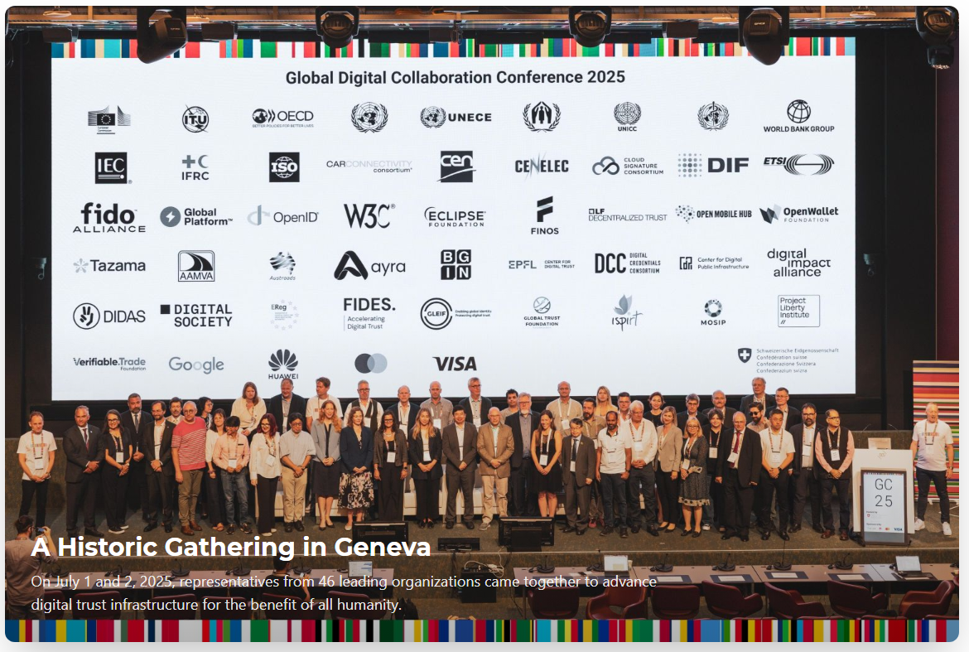
 | Title | A Historic Gathering in Geneva
 | Header | On July 1 and 2, 2025, representatives from 46 leading organizations came together to advance digital trust infrastructure for the benefit of all humanity.
Inhalt | Title | Conference Resources
 | Header | Access presentations, photos, videos, and other materials from the Global Digital Collaboration Conference 2025
 | Kachel 1 | Conference Photos  Relive the moments from GDC25. Browse through our gallery of keynotes, networking sessions, and memorable interactions.  View Photo Gallery
 | Kachel 2 | Day 1 Presentations  Access all slides and presentations from the first day's keynotes and sessions on digital identity systems and use cases.  Download Slides
 | Kachel 3 | Beat Jans Keynote Speech  Read the full text of the opening keynote address by Swiss Federal Councillor Beat Jans on digital collaboration and Switzerland's digital future.  Read Full Speech
 | Kachel 4 | Program & Speakers  Review the complete 2-day program featuring keynotes on digital identity systems, workshops, and presentations from global leaders.  View Full Program
 | Kachel 5 | GDC YouTube Channel  Watch recorded sessions, keynote speeches, and highlights from the conference on our official YouTube channel.  Watch Videos
 | Kachel 6 | Book of Proceedings  The complete conference proceedings including presentations, papers, and workshop outcomes from the Global Digital Collaboration Conference 2025 is now available..  Download Book of Proceedings
Inhalt | Title | Co-organized by Leading Global Organizations
 | Header | Including WHO, World Bank, UNDP, W3C, ISO, Linux Foundation, OpenWallet Foundation, and many more
 | Button | View All Co-Organizers
Inhalt | Title | Our Sponsors
 | Header | Leading organizations supporting the advancement of wallets, credentials and trusted infrastructure in a manner of global collaboration.
 | Bilder

02 - GDC Council
Abschnitt | Art | Inhalt
Intro | Title | Council
 | Header | The GDC Council advances dialogue to support trusted and interoperable digital infrastructure worldwide.
Inhalt | Title | Council Purpose
 | Text | The GDC Council advances dialogue to support trusted and interoperable digital infrastructure—including wallets, credentials, payment systems, and the use of cybersecurity and AI in these contexts—by bringing together UN Member States, companies, Intergovernmental Organizations (IGOs), and Non-Governmental Organizations (NGOs).  Council members are expected to provide independent, non-binding advice to the GDC on the following matters:  - •Overall strategy, priorities, and guidance  - •Nominating co-organizers for the GDC Conference  - •Proposing agenda items for the GDC Conference and the High-Level Meeting  - •Discussing the annual budget and fundraising opportunities  - •Facilitating special projects  Meetings follow the Chatham House Rule, unless the Council agrees otherwise in advance, in accordance with its Terms of Reference.  Summaries of the Council Meetings are published here:  View Council Meeting Summaries
Inhalt | Title | Council Members
 | Header | The Members of the Council are as follows:
 | Gruppe 1 | Group of UN-Member States  - Brazil, represented by Ministry of Management and Innovation in Public ServicesChair  - Canada, represented by Canadian Digital Service / Employment and Social Development Canada / Government of Canada  - China, represented by State Information Center  - France, represented by Agence Nationale des Titres Sécurisés, Ministry of the Interior  - Germany, represented by Federal Ministry of Digital and State Modernization  - Singapore, represented by Government Technology Agency  - Switzerland, represented by Federal Office of Justice  - United Kingdom, represented by the Department for Science, Innovation and Technology
 | Gruppe 2 | Group of Intergovernmental Organizations  - European Union  - United Nations High Commissioner for Refugees (UNHCR)  - United Nations Educational, Scientific and Cultural Organization (UNESCO)  - World Bank GroupChair  - World Health Organization (WHO)
 | Gruppe 3 | Group of Companies  - Ant Group Co. Ltd.  - Apple Inc.  - Consensys Software Inc.  - Google LLCChair  - Huawei Corporation  - Mastercard Inc.  - Microsoft Corporation  - Samsung Electronics Co., Ltd.  - Visa Inc.  - Yubico Inc.
 | Gruppe 4 | Group of Nongovernmental Organizations  - FIDO Alliance  - Gates Foundation  - Global System for Mobile Communications Association (GSMA)  - Institute of International Finance  - International Air Transport AssociationChair  - International Federation of Pharmaceutical Manufacturers and Associations  - Internet Society (ISOC)  - Linux Foundation/Open Wallet  - Mozilla Foundation  - World Wide Web Consortium
 | Hinweis | The remaining seats are in the process of being finalized.
Inhalt | Title | Secretariat
 | Text | - Daniel Goldscheider, Secretary  - Ruth Puente, Senior Advisor  - Rolf Rauschenbach, Liaison Swiss Confederation

06 - GDC FAQ
Abschnitt | Art | Inhalt
Intro | Title | Frequently Asked Questions
 | Header | Find answers to common questions about the Global Digital Collaboration Conference.
Frage | Title | What is the goal of the conference?
 | Text | The goal of the conference is to promote collaboration on specific topics that require the involvement of more than one actor or organistion to be succesful. Sessions may inspire continued collaboration beyond the conference.
Frage | Title | How can I become a co-organizer?
 | Text | Please apply via this form (link)
Frage | Title
 | Text
Frage | Title | What topics will be covered at the conference?
 | Text | The conference covers a wide range of topics related to digital identity, including wallets, verifiable credentials, trust frameworks, technical standards, and regulatory issues. Key areas include health credentials, educational credentials, and cross-border interoperability.
Frage | Title | Who are the speakers?
 | Text | Speakers will include leaders from major international organizations, government agencies, standards bodies, and open-source communities. The conference features representatives from WHO, ITU, OECD, World Bank Group, European Commission, and many other prominent organizations.
Frage | Title | What does the barcode image in the hero section represent?
 | Text | The distinctive barcode pattern visualizes the top 40 countries leading the global open source movement, arranged from west to east. Each bar represents a country's contribution to open source development, with its width corresponding to the relative impact. This unique visualization demonstrates how digital collaboration transcends geographical boundaries and highlights the truly global nature of open source innovation. If you'd like to create your own barcode visualization, you can use this tool: shaheeilyas.com/ow-barcode/
Frage | Title
 | Text

