1. Introduction

Hotel booking web page is a popular method for booking hotel rooms. Travelers can book rooms on a computer by using online security to protect their privacy and by using several online travel agents to compare prices and facilities at different hotels. Prior to the Internet, travelers could write, telephone the hotel directly, or use a travel agent to make a reservation. But hotel booking web page can provide pictures of hotels and rooms, information on prices and deals, and information on local resorts. It also allows reviews of the traveler to be recorded with the online travel agent.

2. Site map

3. Functions developed

1. Get the number of remaining rooms in the selected room type of certain hotel.

Implementation:

To implement this function, the total number of the selected room type of this hotel is fetched from database from the following query.



The number of rooms which are already booked previously in this targeted period is fetched by counting all the records conflicts with this attempted search. The query is shown as following.



b. Get comments and price corresponding to the selected room. The two queries are shown as following.



c. Recommend the user with similar hotels. As all the hotels are located in the same region, hotels with the same room type and similar price will be selected to be shown as recommendation. (If the difference of price is within the 5% region, we consider it to have similar price with the selected one.)



d. Generate a new record reference number and insert the new book record into the database.

Implementation:

As the reference number of booking history is in the format of “total number of booking records” +”X” +”user id” +” random number from 1 to 100000”, a random number is generated in each new record. The character “X” is applied to avoid the possibility that two reference numbers are generated to be same.

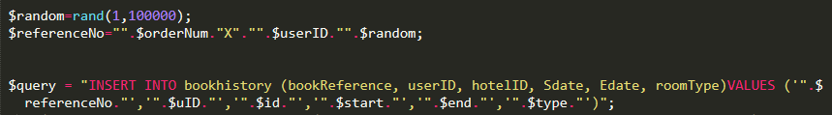

e. Get the room type form database corresponding to the room that user chose before.



f. Then use a while loop to get all the room type and display related room type information and room type picture.

Href is used to let user enlarge the room type picture, which is let user to see another image after user click the image. But href only allow user to go to another page to see the larger picture. So a fancybox tool is used to let picture display in the original page.

More pictures are stored in fancybox class so that user can see more picture to know the detail of room type.

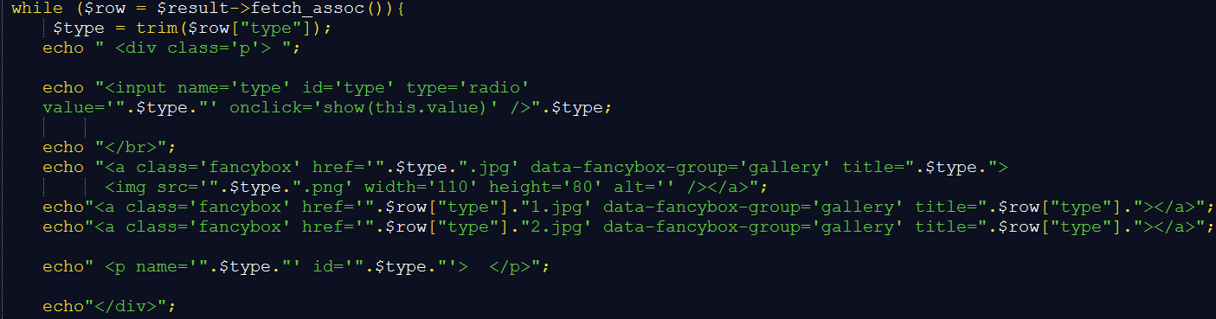

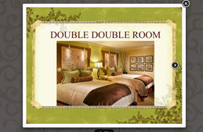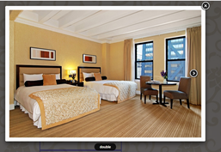

g. A fancybox library is added in room information.php and add a fancybox function.

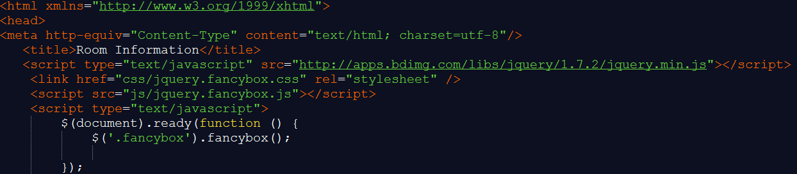

h. Ajx is used to show the detail room information. For very room type, a radio is created to let user to choose room type. Every room type have its own value and have a paragraph with different name and id. A trim function is used to Remove whitespace from both sides of a string.

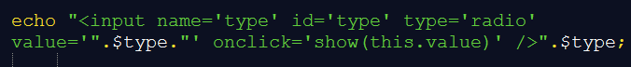



i. When the radio is clicked, it would go to the show function. Show function will pass the value of the room type to the checkRemainRooms.php to find detail room information and then show on the corresponding paragraph.

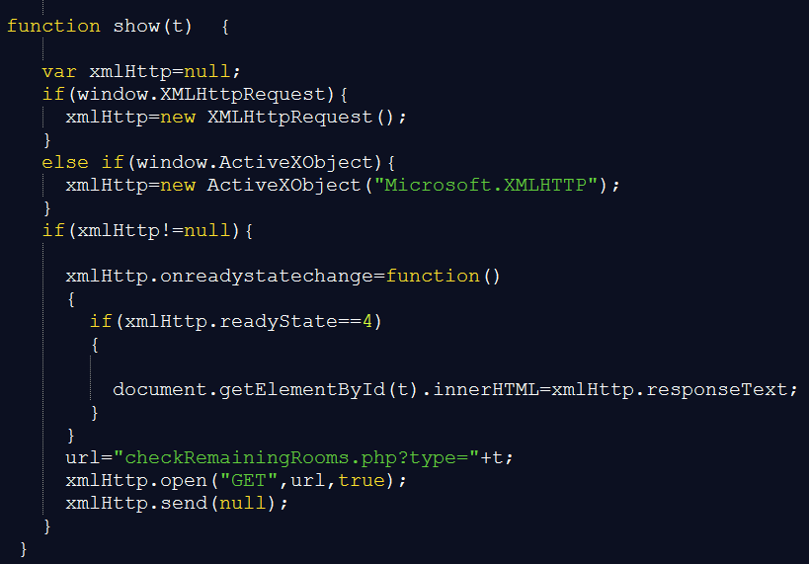

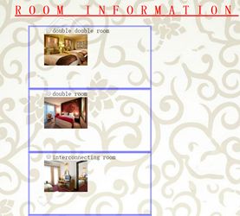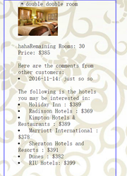

4. Work distribution

|  |  |
| --- | --- |
| **Task** | **Person in charge.** |
| Login page + Sign up page + Map page (Back-end) + Hotel managing page + History order page + Comment page | CHONG Ka Hung |
| Login page + Sign up page + Map page (Front-end) | Yang Tianyu |
| Room details page (Front-end) | CHEN Zhongxing |
| Room details page (Back-end) + Success page | SHOU Junhao |
| Database | LI Yunhao |

5. Peer evaluation

|  |  |  |  |  |  |
| --- | --- | --- | --- | --- | --- |
|  | CHONG Ka Hung | CHEN Zhongxing | LI Yunhao | SHOU Junhao | Yang Tianyu |
| CHONG Ka Hung |  | 5 | 5 | 5 | 5 |
| CHEN Zhongxing | 5 |  | 5 | 5 | 5 |
| LI Yunhao | 5 | 5 |  | 5 | 5 |
| SHOU Junhao | 5 | 5 | 5 |  | 5 |
| Yang Tianyu | 5 | 5 | 5 | 5 |  |