1. 在blog目录下

目录在C / Window / System32/blog

hexo clean

清理database

hexo g

更新博客

hexo d

部署到远端（部署到github）（clean g d 素质三连用）

1.搭建博客需要node js

1.win10系统要下载git ，并且在环境配置下面部署好git，重启

1.hexo init 时，长时间停留在fetchPackageMetaData error for hexo-generator-archive@^1.0.0 request to https处，

此处需要在对应的URL处下载一些文件，只要网络稳定，一般花不了多长时间

但是，最近两次操作都是长时间停留，在网上找了一些原因，才发现后面的URL地址可以由淘宝的源代替，原来是资源问题导致的

方法如下：

更换成淘宝的源

npm config set registry https://registry.npm.taobao.org

– 配置后可通过下面方式来验证是否成功

npm config get registry

– 或npm info express

3. 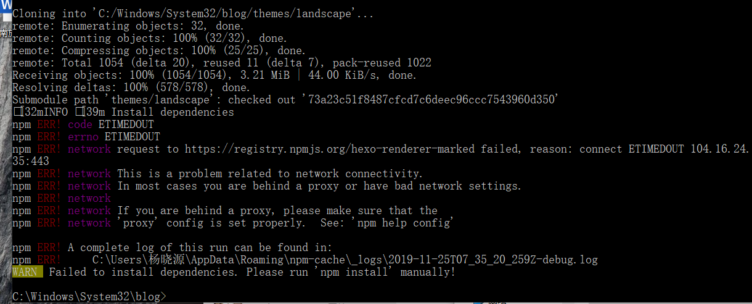

1、背景

使用npm下载@stomp/ng2-stompjs --》

npm install @stomp/ng2-stompjs --save 一直报错

报错信息如下

D:\code\ng-video-ai>npm install @stomp/ng2-stompjs --save

npm ERR! code ETIMEDOUT

npm ERR! errno ETIMEDOUT

npm ERR! network request to https://registry.npmjs.org/@stomp%2fstompjs failed, reason: connect ETIMEDOUT 104.16.16.35:443

npm ERR! network This is a problem related to network connectivity.

npm ERR! network In most cases you are behind a proxy or have bad network settings.

npm ERR! network

npm ERR! network If you are behind a proxy, please make sure that the

npm ERR! network 'proxy' config is set properly. See: 'npm help config'

npm ERR! A complete log of this run can be found in:

npm ERR! D:\Program Files\nodejs\node_cache\_logs\2018-07-26T06_37_54_392Z-debug.log

2、原因：npm配置了代理

使用"npm config list -l"命令查看npm配置

; cli configs

long = true

metrics-registry = "https://registry.npmjs.org/"

scope = ""

user-agent = "npm/5.5.1 node/v8.9.0 win32 x64"

; userconfig C:\Users\cy\.npmrc

cache = "D:\\Program Files\\nodejs\\node_cache"

https-proxy = "http://proxy-server-address:8080/"

prefix = "D:\\Program Files\\nodejs\\node_global"

proxy = null

; builtin config undefined

; prefix = "C:\\Users\\cy\\AppData\\Roaming\\npm" (overridden)

; default values

access = null

allow-same-version = false

also = null

always-auth = false

auth-type = "legacy"

bin-links = true

browser = null

ca = null

; cache = "C:\\Users\\cy\\AppData\\Roaming\\npm-cache" (overridden)

cache-lock-retries = 10

cache-lock-stale = 60000

cache-lock-wait = 10000

cache-max = null

cache-min = 10

cafile = undefined

cert = null

cidr = null

color = true

commit-hooks = true

depth = null

description = true

dev = false

dry-run = false

editor = "notepad.exe"

engine-strict = false

fetch-retries = 2

fetch-retry-factor = 10

fetch-retry-maxtimeout = 60000

fetch-retry-mintimeout = 10000

force = false

git = "git"

git-tag-version = true

global = false

global-style = false

globalconfig = "D:\\Program Files\\nodejs\\node_global\\etc\\npmrc"

globalignorefile = "D:\\Program Files\\nodejs\\node_global\\etc\\npmignore"

group = 0

ham-it-up = false

heading = "npm"

; https-proxy = null (overridden)

if-present = false

ignore-prepublish = false

ignore-scripts = false

init-author-email = ""

init-author-name = ""

init-author-url = ""

init-license = "ISC"

init-module = "C:\\Users\\cy\\.npm-init.js"

init-version = "1.0.0"

json = false

key = null

legacy-bundling = false

link = false

local-address = undefined

loglevel = "notice"

logs-max = 10

; long = false (overridden)

maxsockets = 50

message = "%s"

; metrics-registry = null (overridden)

node-version = "8.9.0"

offline = false

onload-script = null

only = null

optional = true

otp = 0

package-lock = true

parseable = false

prefer-offline = false

prefer-online = false

; prefix = "D:\\Program Files\\nodejs" (overridden)

production = false

progress = true

proxy = null

read-only = false

rebuild-bundle = true

registry = "https://registry.npmjs.org/"

rollback = true

save = true

save-bundle = false

save-dev = false

save-exact = false

save-optional = false

save-prefix = "^"

save-prod = false

scope = ""

script-shell = null

scripts-prepend-node-path = "warn-only"

searchexclude = null

searchlimit = 20

searchopts = ""

searchstaleness = 900

send-metrics = false

shell = "C:\\WINDOWS\\system32\\cmd.exe"

shrinkwrap = true

sign-git-tag = false

sso-poll-frequency = 500

sso-type = "oauth"

strict-ssl = true

tag = "latest"

tag-version-prefix = "v"

timing = false

tmp = "C:\\Users\\cy\\AppData\\Local\\Temp"

umask = 0

unicode = false

unsafe-perm = true

usage = false

user = 0

; user-agent = "npm/{npm-version} node/{node-version} {platform} {arch}" (overridden)

userconfig = "C:\\Users\\cy\\.npmrc"

version = false

versions = false

viewer = "browser"

其中有这条配置https-proxy = "http://proxy-server-address:8080/"

使用"npm config delete https-proxy"命令删除即可正常下载

————————————————

版权声明：本文为CSDN博主「plia」的原创文章，遵循 CC 4.0 BY-SA 版权协议，转载请附上原文出处链接及本声明。

原文链接：<https://blog.csdn.net/ligaoming_123/article/details/81221480>

注意：更新完之后要上github上面的setting去更新网域名