Cheung King Hung 190001623 SE1A

Hello everyone. My name is Cheung King Hung. Today, I would like to show you my EA project of the webpage. THE SUGGESTION OF HOME NETWORK SOLUTION.

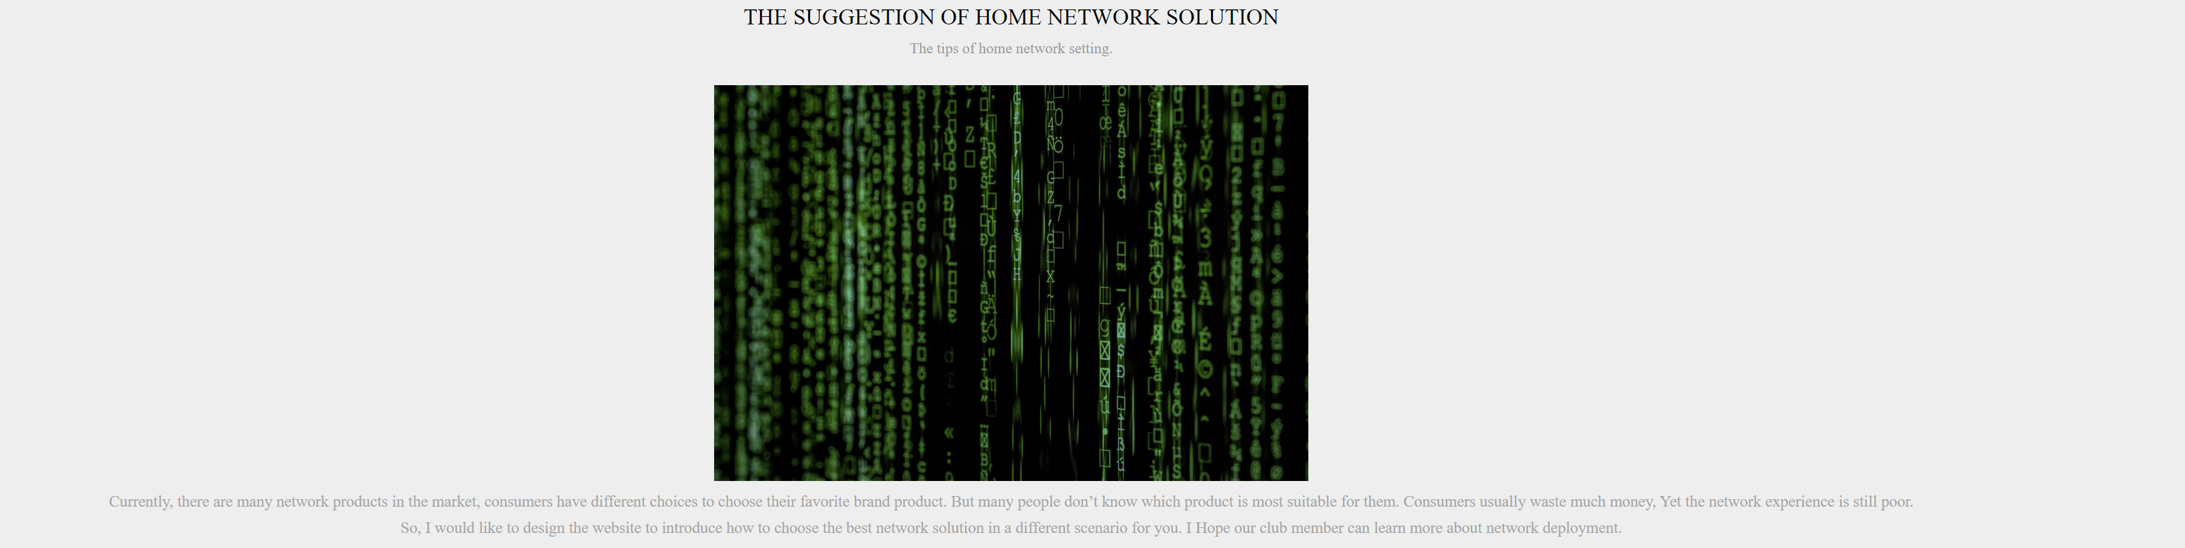

In this website, I will show you the tips of home network setting. It introduces the common network solution. WI-FI and Ethernet. The definition.

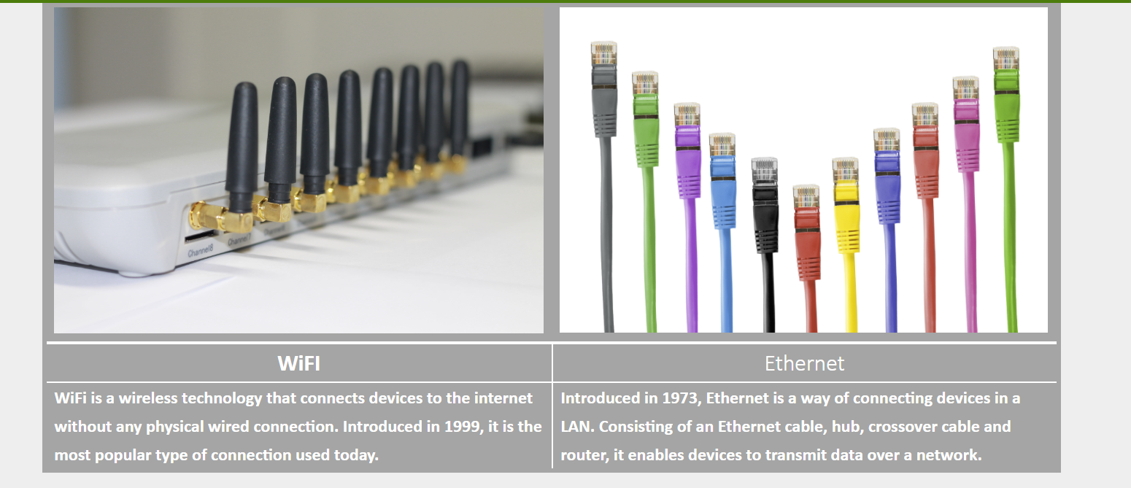

Next, I will show you the recommendation feature of the web page.

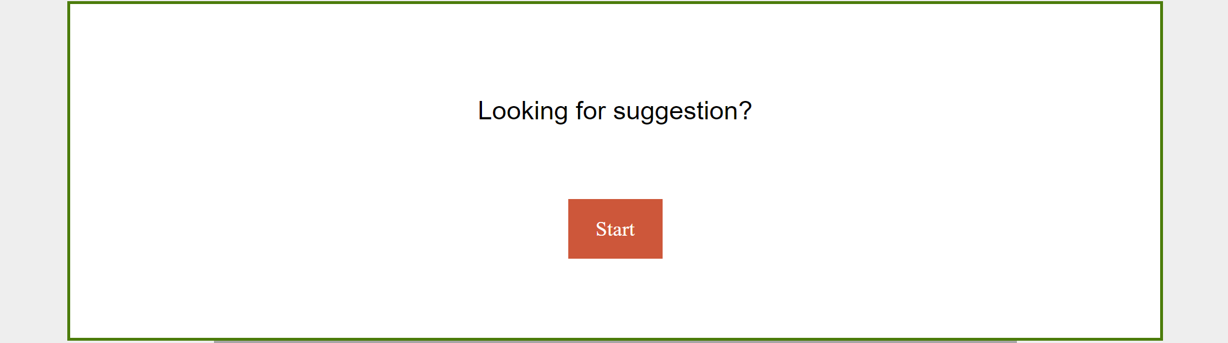

Click start to start the following feature.

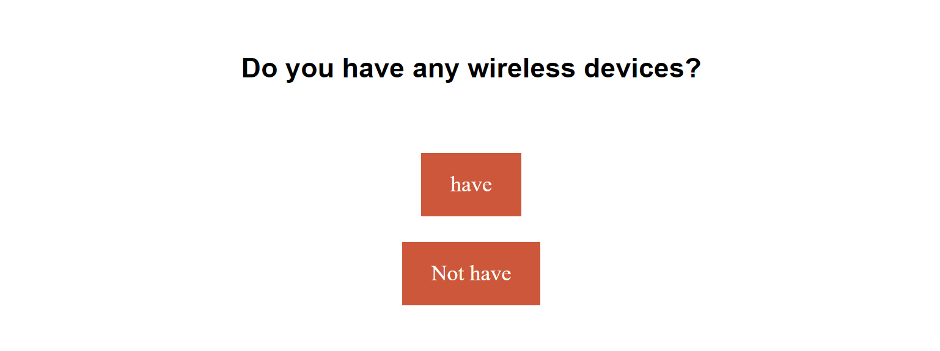

Assume I don’t have any wireless device. Click “not have.”

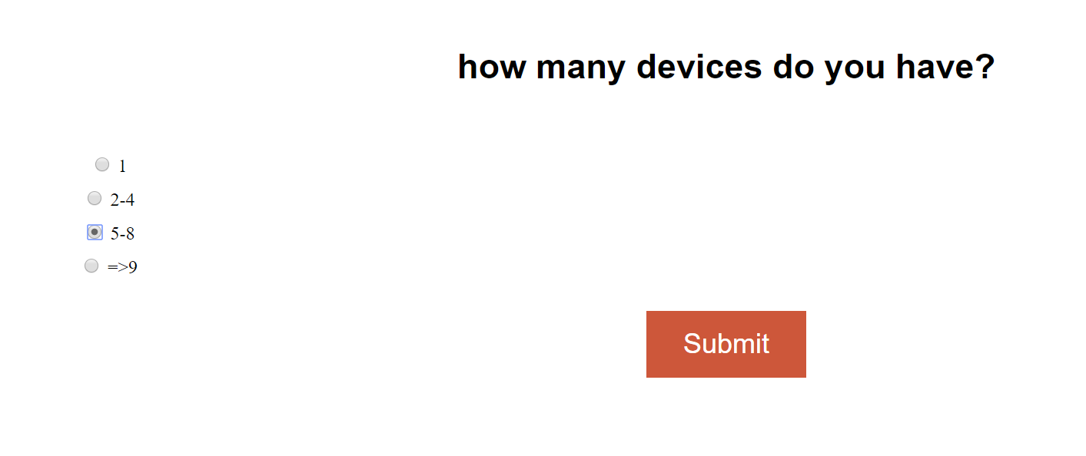

I have around 8 device. I need to choose 5-8. Then, submit this from.

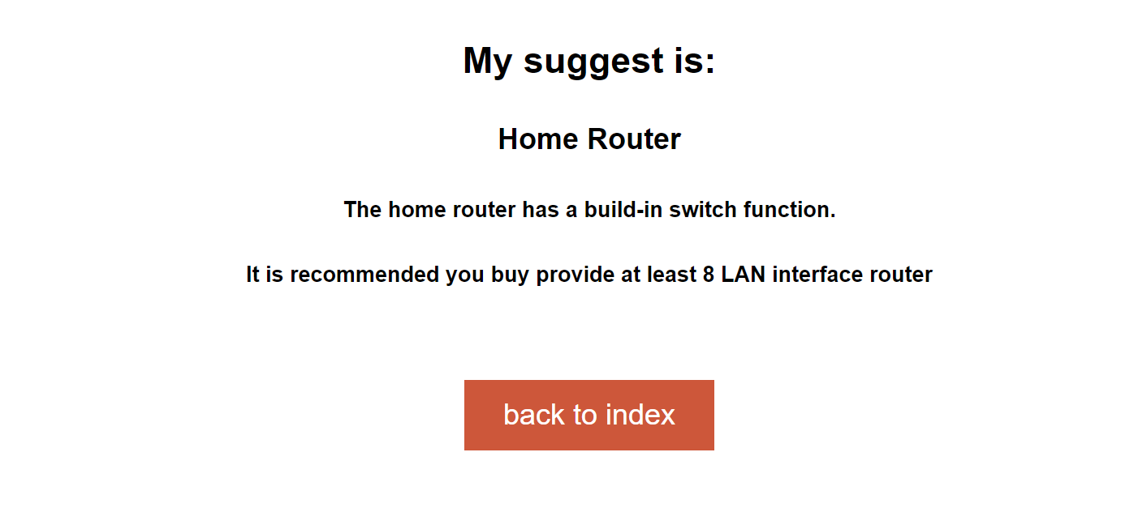

So, I need to buy at least 8 LAN port Router.

That is the end of my presentation, do you have any question?