**TItle: INFORMATION PROVIDING TO USERS**

BRD Created at: 3/11/2017 v.1

GitHub:

|  |  |  |  |  |
| --- | --- | --- | --- | --- |
| Date | GITHUB | Notes | Updated By | Version |
| 01/10/2017 | [LINK](https://github.com/simorava/football_app) |  | Giorgio | 1.0.0.0 |

Business Requirements

Written by:

|  |
| --- |
| Giorgio Macauda |
| Simone Rava |
| Metin Karagöz |
| Amantayev Alikhan |
| Kabytayev Aidos |
| Akhmet Kydyrali |

# Project feature

* Provides latest football news
* Provides latest match scores

# Process scope

Facilitate football fans to find information about their favorite team or not.

# Process Flow

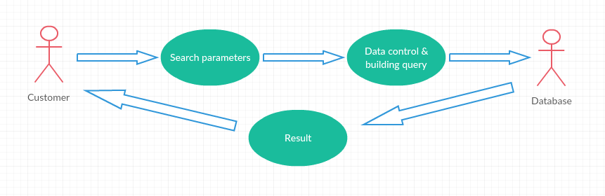

|  |  |  |  |
| --- | --- | --- | --- |
| Use case Id | Action Taken | Main actor | Expected Result |
| 01 | * Search paramater * Formulate the query * Execute the DB query * Show the result | * Customer * Database | Activity with all news and match scores filtered by some parameters |

# Use Cases

# Interface Design

# Simple menu to select some parameters

* Scrollable list to show all the result find into the database

# Data Description

The data will store stored in a remote relational database.

# Integration with other systems

* All the data requested by the users will collected by a web page that uses AJAX and JSON to manage all information.

# Client environment to use

Client will access to the this feature via android smartphone. System has to be intuitive for every kind of person. It has to be support by images when necessary.

# Reference Material

Find more about in the link: https://github.com/simorava/football_app

# Existing Application Impact

Not applicable.

# Security Permissions Impact

Not applicable.